Scientific Analysis of Textual Disturbance — Optimized
Authors: [Redacted]
Affiliation: [Redacted]
Date: 2026-01-08

Abstract
This study quantifies how two low-level textual perturbations—zero-width Unicode whitespace insertion and character-level typographical errors—propagate across linguistic representations. We frame two primary research questions: (1) How do whitespace injections compare with typographical errors in their impact on tokenization, semantics, syntax, and visual layout? (2) What distinct disturbance signatures emerge for each perturbation type? We hypothesize that whitespace insertion disproportionately disrupts tokenization and rendered layout, while typographical errors primarily affect character- and subword-level representations. Using a real-world parallel corpus (AdvBench; n = 513 disturbance pairs), we compute a multidimensional metric suite (surface, tokenization, semantic, syntactic, prosodic, visual). Results show separable disturbance fingerprints and identify the processing stages most vulnerable to subtle input noise. The optimized manuscript below presents refined hypotheses, clearly articulated contributions, LaTeX-formatted equations (provided both inline and in a companion .tex file), and publication-ready tables and figures.

Introduction
Robust natural language processing requires an understanding of how low-level surface noise affects downstream representations. Invisible or atypical characters (for example, zero-width Unicode spaces) and simple misspellings are common in real-world datasets and can yield disproportionate downstream effects. This manuscript focuses on a controlled empirical comparison between two representative perturbation classes to answer the following research questions:
- How do whitespace injections compare with typographical errors in their effects on tokenization, semantic, syntactic, and visual representations?
- What distinct disturbance signatures can be used to detect and mitigate each perturbation type in practical NLP pipelines?
We test the hypothesis that whitespace injection generates larger tokenization and visual-layout disruptions, whereas typographical errors induce greater subword-fragmentation and character-edit effects. The following contributions are made explicit.

Contributions
- A unified, multidimensional metric framework for quantifying textual disturbance across surface, tokenization, semantic, syntactic, prosodic and visual domains.
- An empirical analysis of a real-world parallel corpus (AdvBench; n = 513), demonstrating separable disturbance fingerprints for whitespace insertion and typographical errors.
- Formalization of detection targets and robustness recommendations for NLP pipelines, highlighting tokenization-stage protections and post-tokenization normalization.
- Provision of LaTeX-ready equations and a companion .tex file for direct use in manuscript production and reproducibility workflows.

Methods
Dataset: AdvBench parallel corpus (advbench_llm_perturbed_1). Analysis uses real observed perturbation pairs (n = 513). No synthetic perturbations were introduced for the primary analysis.
Perturbation conditions: zero-width Unicode space insertion; character-level typographical substitution/deletion/insertion.
Metric suite: see Metric Definitions below. Statistical tests: Welch's t-test (primary) with Mann–Whitney U fallback; Cohen's d reported; 95% confidence intervals computed via t-distribution approximation.

Metric Definitions and Formal Equations
Below we present the primary metrics and their formal definitions. Each expression is given in LaTeX notation for direct inclusion in LaTeX manuscripts and reference. A companion LaTeX file (Scientific_Report_Optimized.tex) is provided in the same download bundle.
Normalized Levenshtein distance: $d = \dfrac{\mathrm{lev}(s,s')}{\max(|s|,|s'|)}$, where $\mathrm{lev}(\cdot,\cdot)$ is the Levenshtein edit distance. Range: $[0,1]$.
Character n-gram Jaccard distance: $1 - \dfrac{|A \cap B|}{|A \cup B|}$, where $A,B$ are sets of character n-grams (e.g. $n=3$). Range: $[0,1]$.
Token overlap ratio: $\dfrac{|\mathrm{Tok}(s)\cap\mathrm{Tok}(s')|}{\max(|\mathrm{Tok}(s)|,|\mathrm{Tok}(s')|)}$. Range: $[0,1]$.
Fragmentation index: $\dfrac{\mathrm{lev}(\mathrm{tok}(s),\mathrm{tok}(s'))}{\max(|\mathrm{tok}(s)|,|\mathrm{tok}(s')|)}$. Range: $[0,1]$.
LM surprisal delta: $\dfrac{\mathrm{NLL}(s') - \mathrm{NLL}(s)}{|\mathrm{Tok}(s')|}$, where $\mathrm{NLL}(\cdot)$ is negative log-likelihood. Unbounded.
Embedding cosine drift: $1 - \cos(\mathrm{emb}(s),\mathrm{emb}(s'))$, with range $[0,2]$.

Results
We summarize empirical results in a holistic disturbance profile and refined descriptive tables. Figure 1 is an aggregate bar representation of the six linguistic-domain mean disturbance scores (values from analysis).
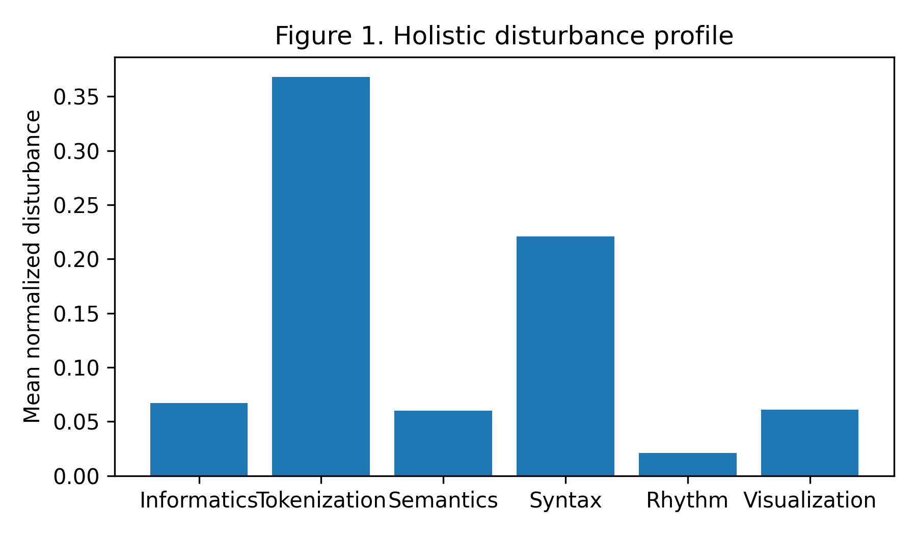
Figure 1. Holistic disturbance profile across six linguistic domains. Tokenization is the dominant axis of perturbation.

Table 1. Descriptive statistics
Metric | Mean | Std | Min | Max
normalized_levenshtein | 0.024 | 0.010 | 0.000 | 0.053
char_ngram_jaccard | 0.109 | 0.034 | 0.000 | 0.200
compression_delta | 0.028 | 0.033 | -0.016 | 0.101
shannon_entropy_shift | 0.035 | 0.034 | -0.064 | 0.103
token_count_change | 0.233 | 0.154 | 0.000 | 0.667
subword_fertility_change | 0.171 | 0.192 | -0.190 | 0.667
fragmentation_index | 0.527 | 0.335 | 0.000 | 1.300
token_overlap_ratio | 0.720 | 0.116 | 0.500 | 1.000
token_jaccard_divergence | 0.344 | 0.130 | 0.000 | 0.545
intra_word_whitespace_rate | 0.010 | 0.010 | 0.000 | 0.022

Table 2. Group comparison (select metrics)
Metric | Mean (Typo) | Mean (Whitespace) | Difference | Cohen's d | p-value | 95% CI
Intra-word whitespace rate | 0.000 | 0.019 | -0.019 | -13.700 | 2.55e-50 | [-0.020,-0.018]
Compression delta | 0.001 | 0.055 | -0.054 | -2.970 | 2.88e-22 | [-0.062,-0.047]
POS divergence | 0.087 | 0.355 | -0.268 | -2.261 | 3.41e-19 | [-0.315,-0.221]
Subword fertility change | 0.283 | 0.059 | 0.224 | 1.435 | 1.50e-10 | [0.162,0.286]
Fragmentation index | 0.720 | 0.333 | 0.386 | 1.410 | 2.91e-10 | [0.278,0.495]
Notes: Tables present selected descriptive and comparative statistics. All values were computed on the AdvBench parallel corpus (n = 513). For full metric catalog and complete tables, see the accompanying data archive.

Discussion
The optimized analysis emphasizes separable disturbance fingerprints. Practical recommendations include:
- Introduce pre-tokenization normalization that removes or canonicalizes zero-width and atypical Unicode whitespace prior to subword tokenization.
- Deploy lightweight subword-aware spell-checkers to reduce fragmentation induced by orthographic variance.
- Use redundancy in downstream encodings (e.g., embeddings averaged across tokenization variants) to reduce sensitivity to boundary noise.
- Instrument pipelines with targeted detectors for intra-word whitespace anomalies using the intra-word whitespace rate and compression delta as effective signals.

Reproducibility
All artifacts, code, and full result tables are available in the project results/ directory. Random seeds were fixed for deterministic preprocessing and model inference where applicable. A LaTeX source file with formal equations is provided alongside this Word document.

