Abstract

Dogs are among the most common companion animals in the world. Catching health issues as early as possible is vital to their well-being. Current veterinary methods typically include checkups, blood tests, x-rays, medical scanning devices, referrals to specialists and more. These approaches are inconvenient and quickly become very expensive.

The goal of our research and development project is to reduce cost and improve early detection. Our wearable tracking device is used to assist veterinarians in diagnosing the underlying cause of an abnormal gait.

We conducted tests using two healthy dogs as subjects:
5 y/o labrador retriever
7 y/o pitbull.

A microcontroller which tracks 6 axes of motion records the movement of the walking dog. The unit is contained in a durable shell which is strapped to a harness on the dog’s back. This data is then fed to a computer running a machine learning algorithm which can detect deviations by comparing it to that of healthy dogs. In addition, the data is passed to a 3d model which provides an animation to visualize the underlying issues.

Goals:
- Collect sufficient data for the ml program to learn how to distinguish the difference between a healthy and unhealthy gait
- Determine which leg is causing the abnormality.
- Identify irregularities for early detection.
- Train the ml system to provide insight for veterinarians.
- 3D animation to visualize the potential cause.

With enough data, this device may assist veterinarians in diagnosing abnormalities within a dog’s stride before it becomes a prominent issue. At this early stage of the project, more research and testing is needed.

Method
Device starts by powering the breadboard with a 450mAh Battery (25C, 7.4V, 3.33Wh) with UBEC (5V Step-Down Converter). The red and black wires from the battery plug into the positive and negative power channels respectively on the breadboard to power the Arduino Nano.

The user then waits approximately 30 seconds for the Arduino to initialize the MicroSD Card Adapter. Assuming the inserted MicroSD card is empty (must have no files named “TEST.txt”) the user then presses the white button on the roof of the device which powers a blue LED to indicate motion recording has started. This begins transmission of data from MPU 9250 to the Arduino Nano over on-board serial ports. From here, that data is stored on the MicroSD card in a file named “TEST.txt”. The resulting data in this file is formatted as acceleration (x, y, z), gyroscope (x, y, z), & magnetometer (x, y, z) respectively. Aside from acceleration which is in m/s, the numbers recorded are in degrees and should be read as degrees of change relative to starting position. The roof button is then pressed again which powers off the blue LED indicator and stopps the MPU 9250 from reading motion as well as closes TEST.txt on the Micro SD card to end the recording. From here, all wires from the battery must be unplugged to power off the unit.
Before any more testing can take place, the MicroSD card must be removed in order to copy data from the recent test. If the file “TEST.txt” is not removed from the MicroSD card before the next recording, no data will be saved during subsequent trials.

Parts List

1 | Arduino Nano
1 | Breadboard (a-j) x (1-30)
1 | Tic-Tac case for battery housing
1 | Battery (450mAh, 25C, 7.4V, 3.33Wh) with UBEC (5V Step-Down Converter)
1 | MPU 9250/6500 (Accelerometer, Gyro, Magnetometer)
1 | MicroSD Card Adapter Component
1 | MicroSD Card
1 | 6-pin male-female ribbon
14 | Wires on breadboard
1 | Blue LED component
1 | 3D Printed button
2 | Wires to hold button
2 | 4.7 kΩ Resistor
1 | 220 Ω Resistor
1 | 10 kΩ Resistor

Pictures

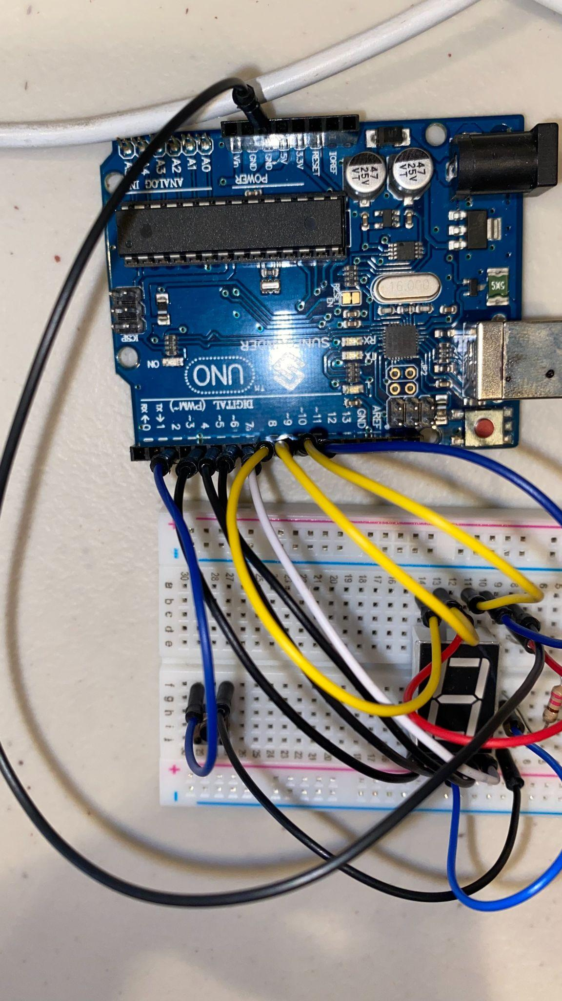
1st version of the project used Arduino uno. This was just so I could learn the arduino better and understand how to use it with a 7 segment display LED.
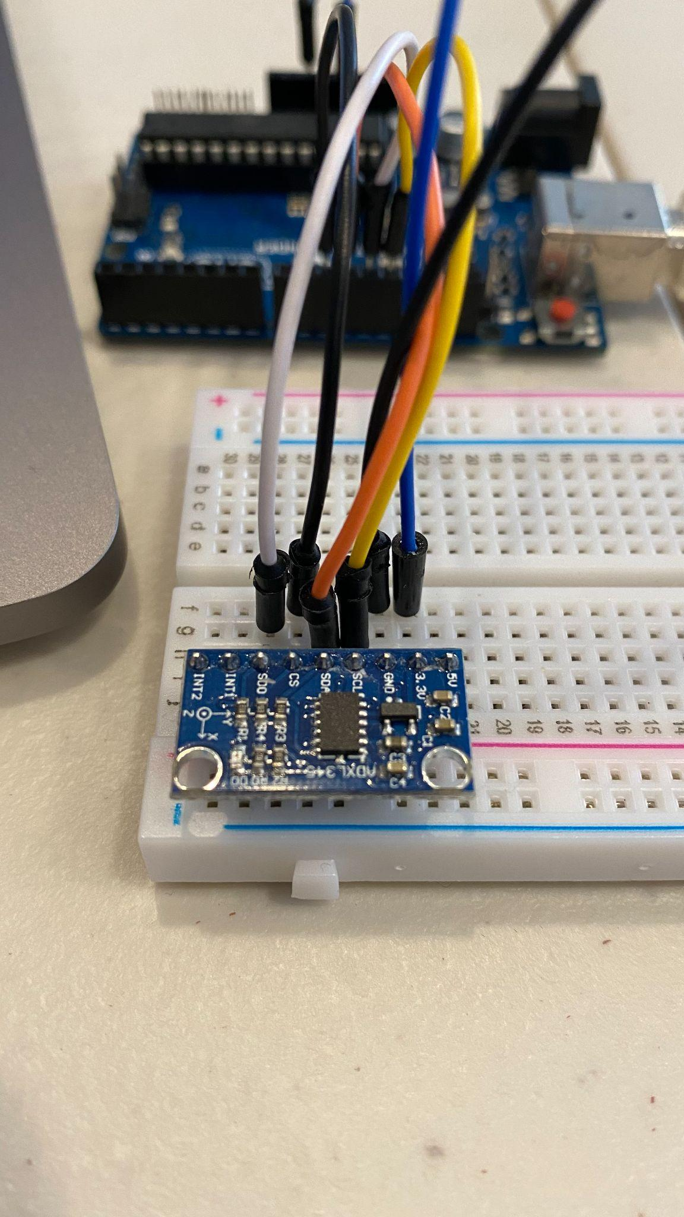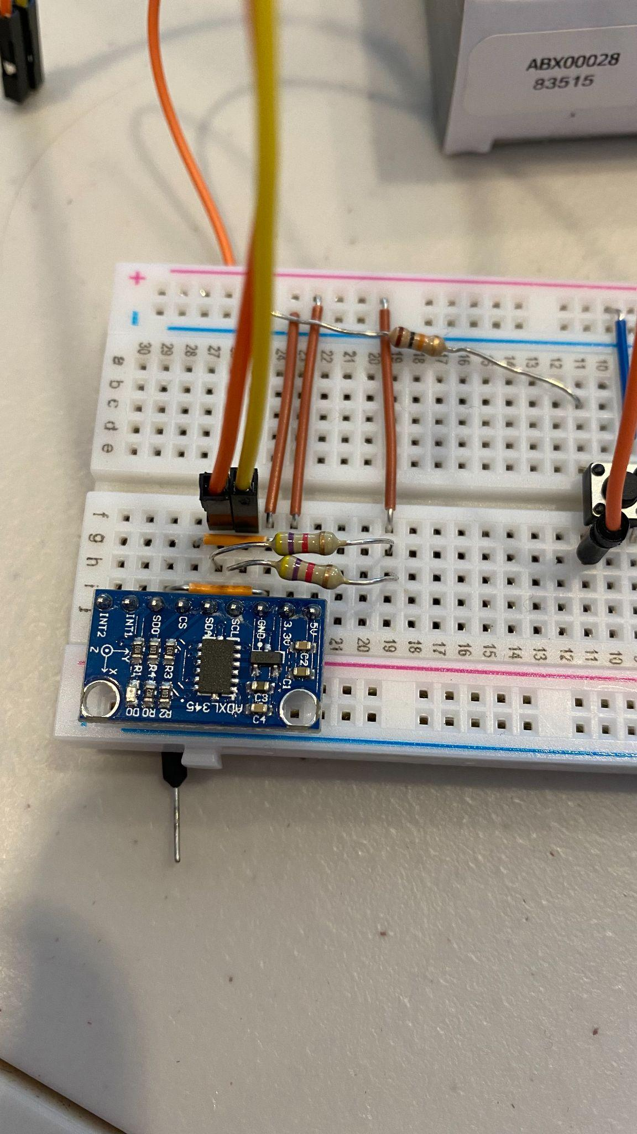
1st time using an accelerometer. This is when we could start seeing how the data collection would look and work.
Added buttons to start and stop recording data.
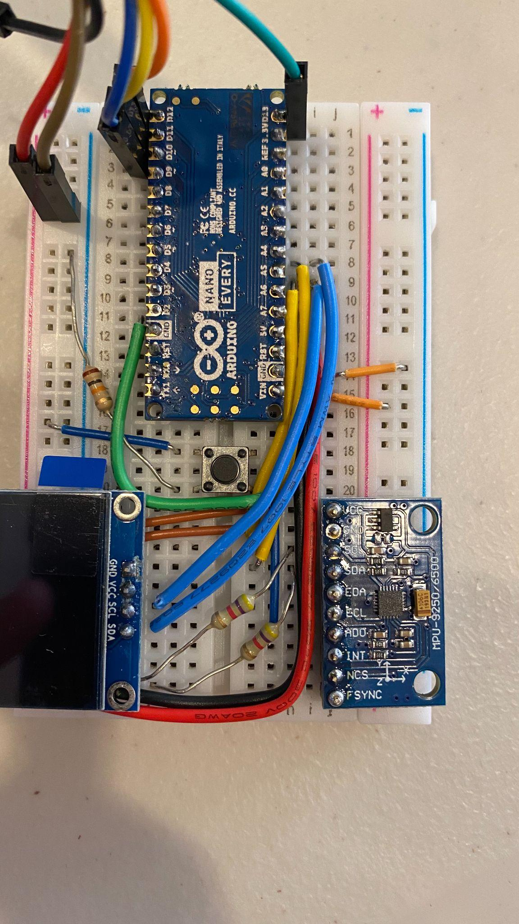
Tried using a OLED display towards the end of the project. This had too much customizability and would take up too much time for the project (still needed a case and data collection at this time)

**Side note** This is where you can see I have all components figured out (smaller arduino nano, buttons and resistors laid out, and the correct chip for data collection).
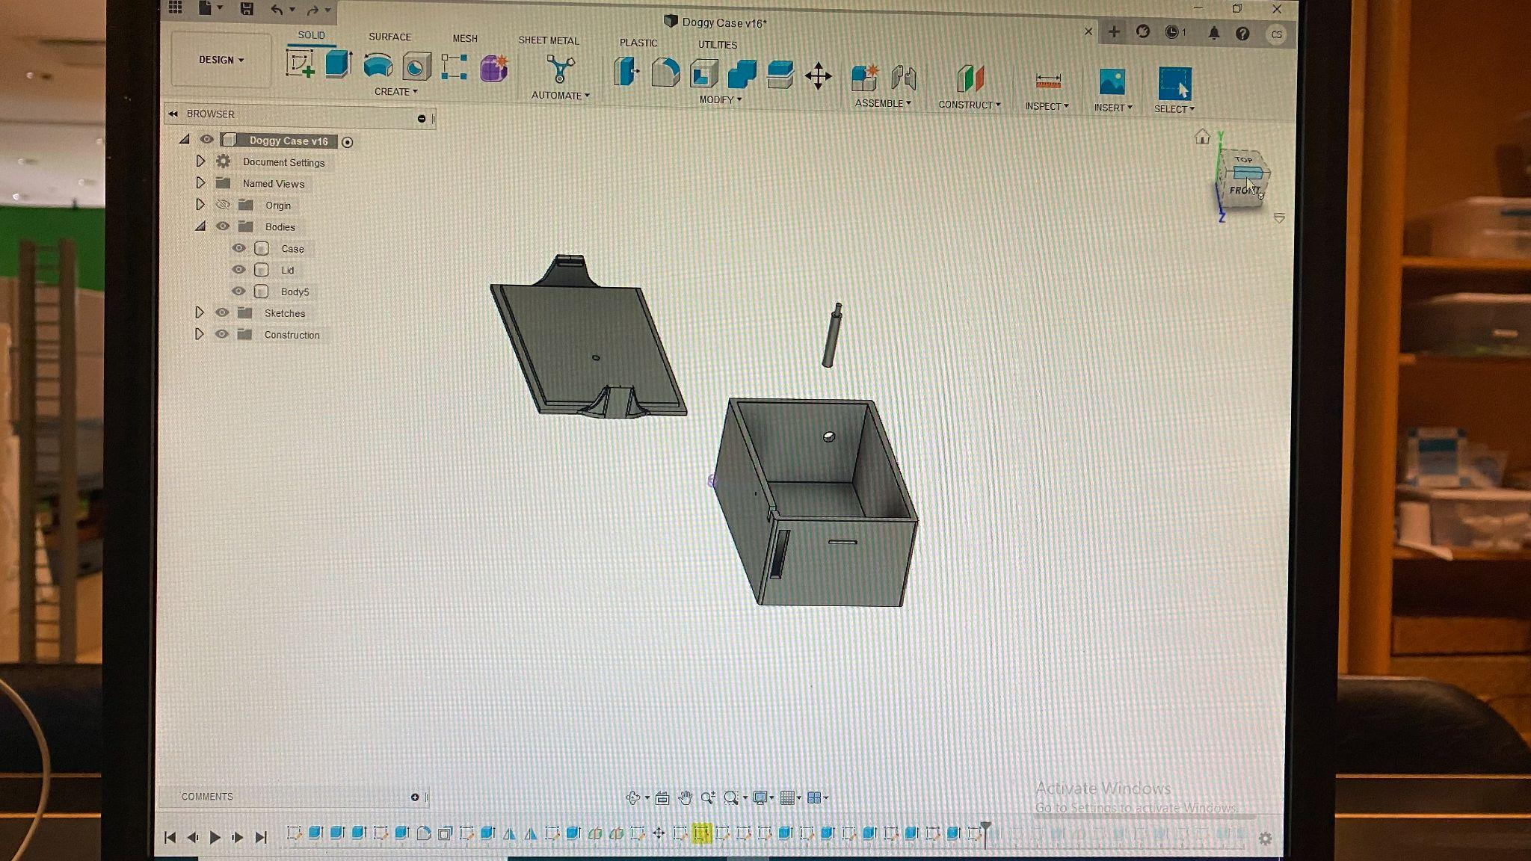
1st design of the case. This took many, MANY iterations of changes.

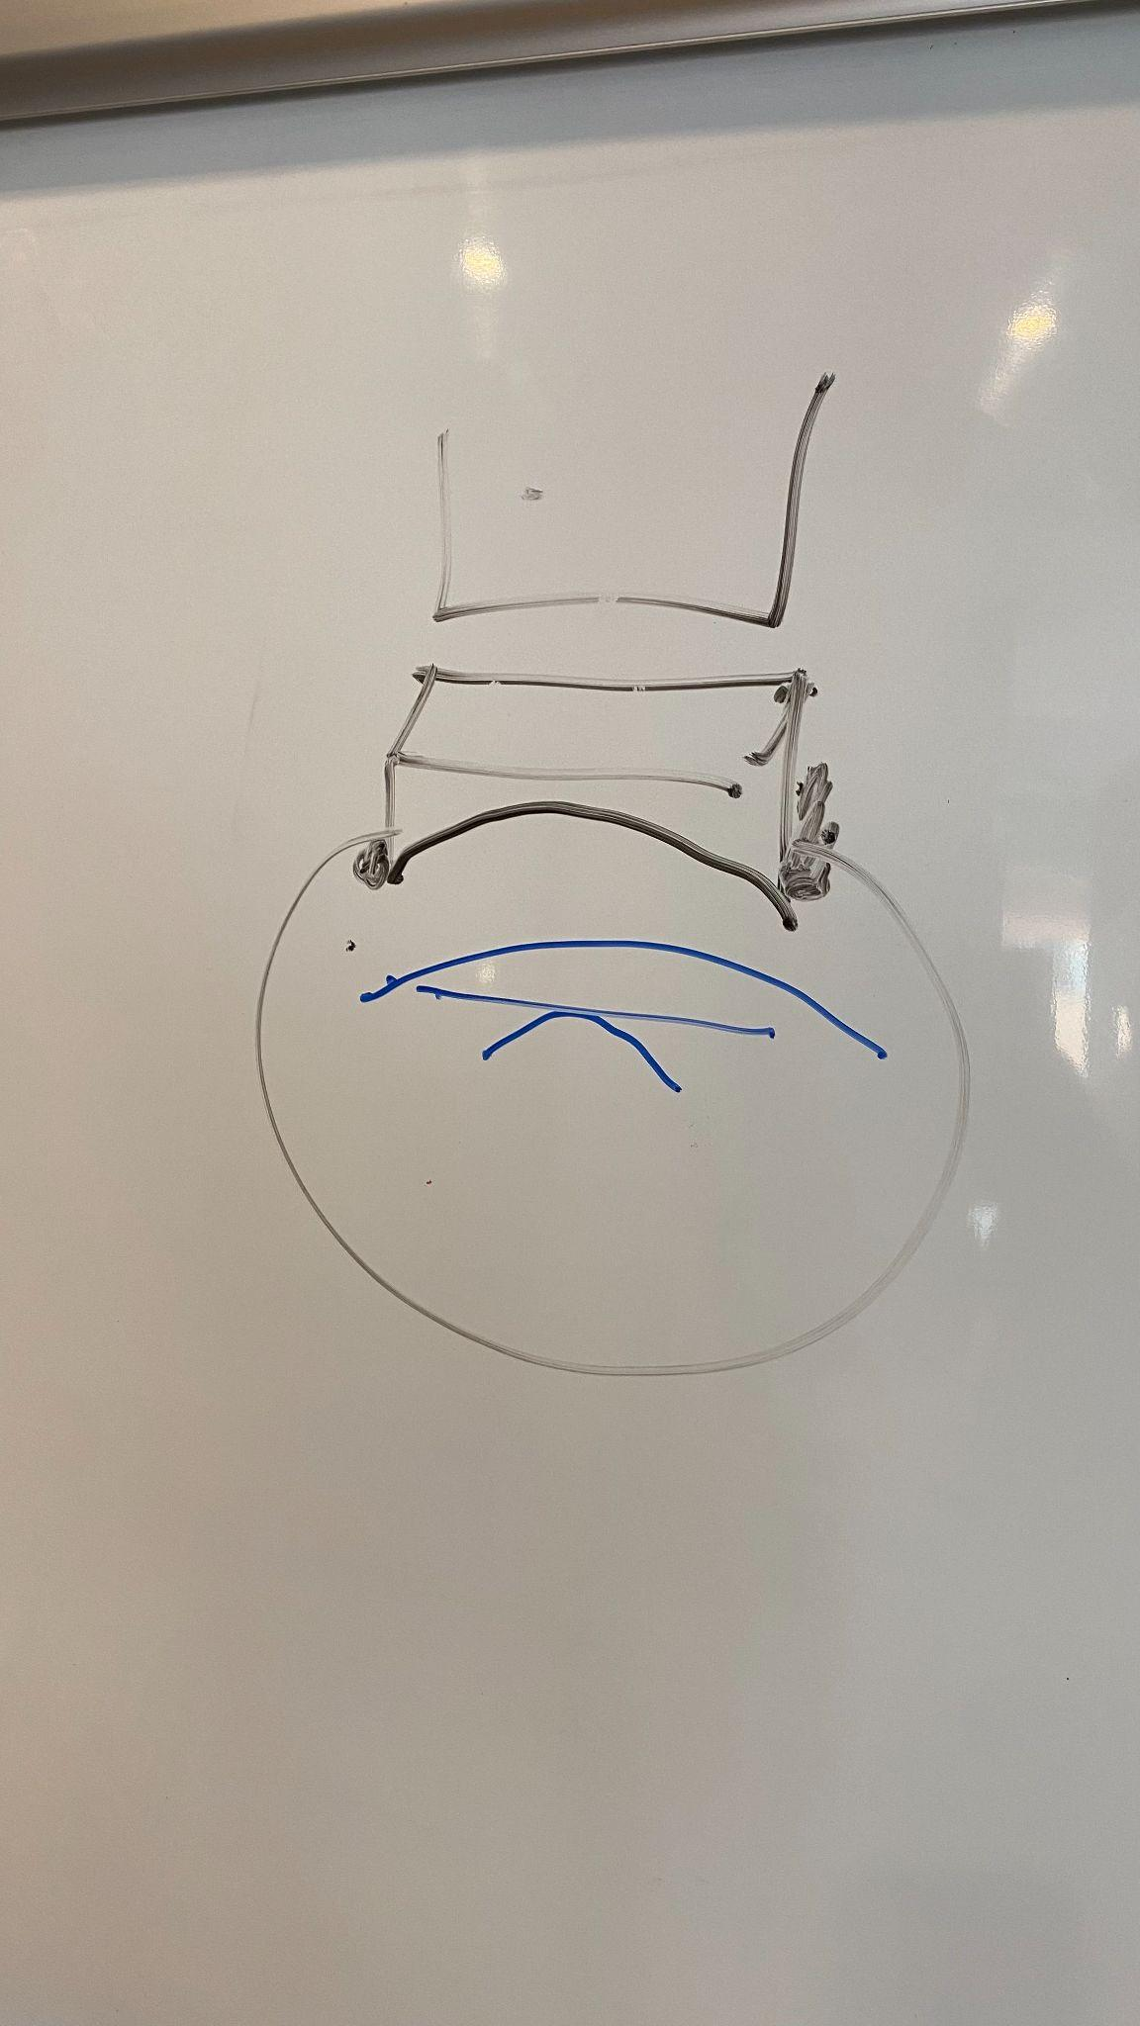
To the whiteboard for designing harness layout and strapping mechanism on the dog.
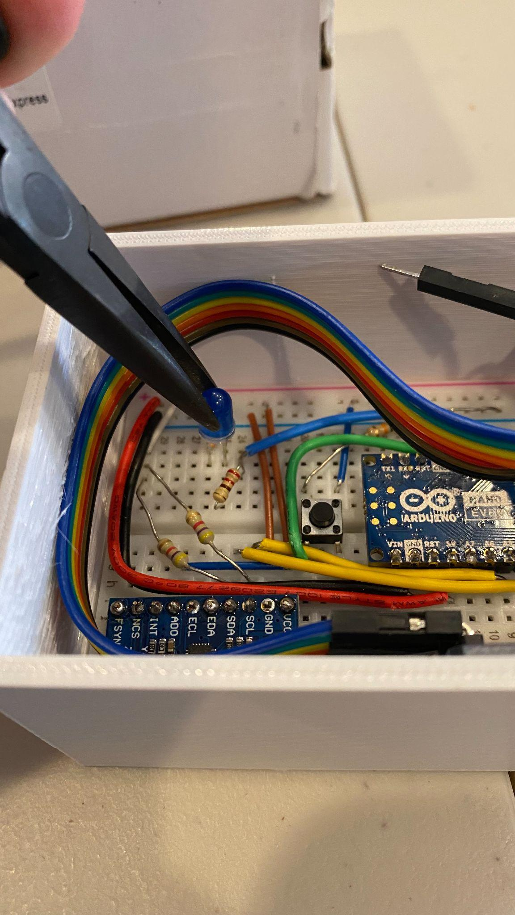
Finally have a good 3d printed case design and all of the components are in their final spots. Just need to improve the case.
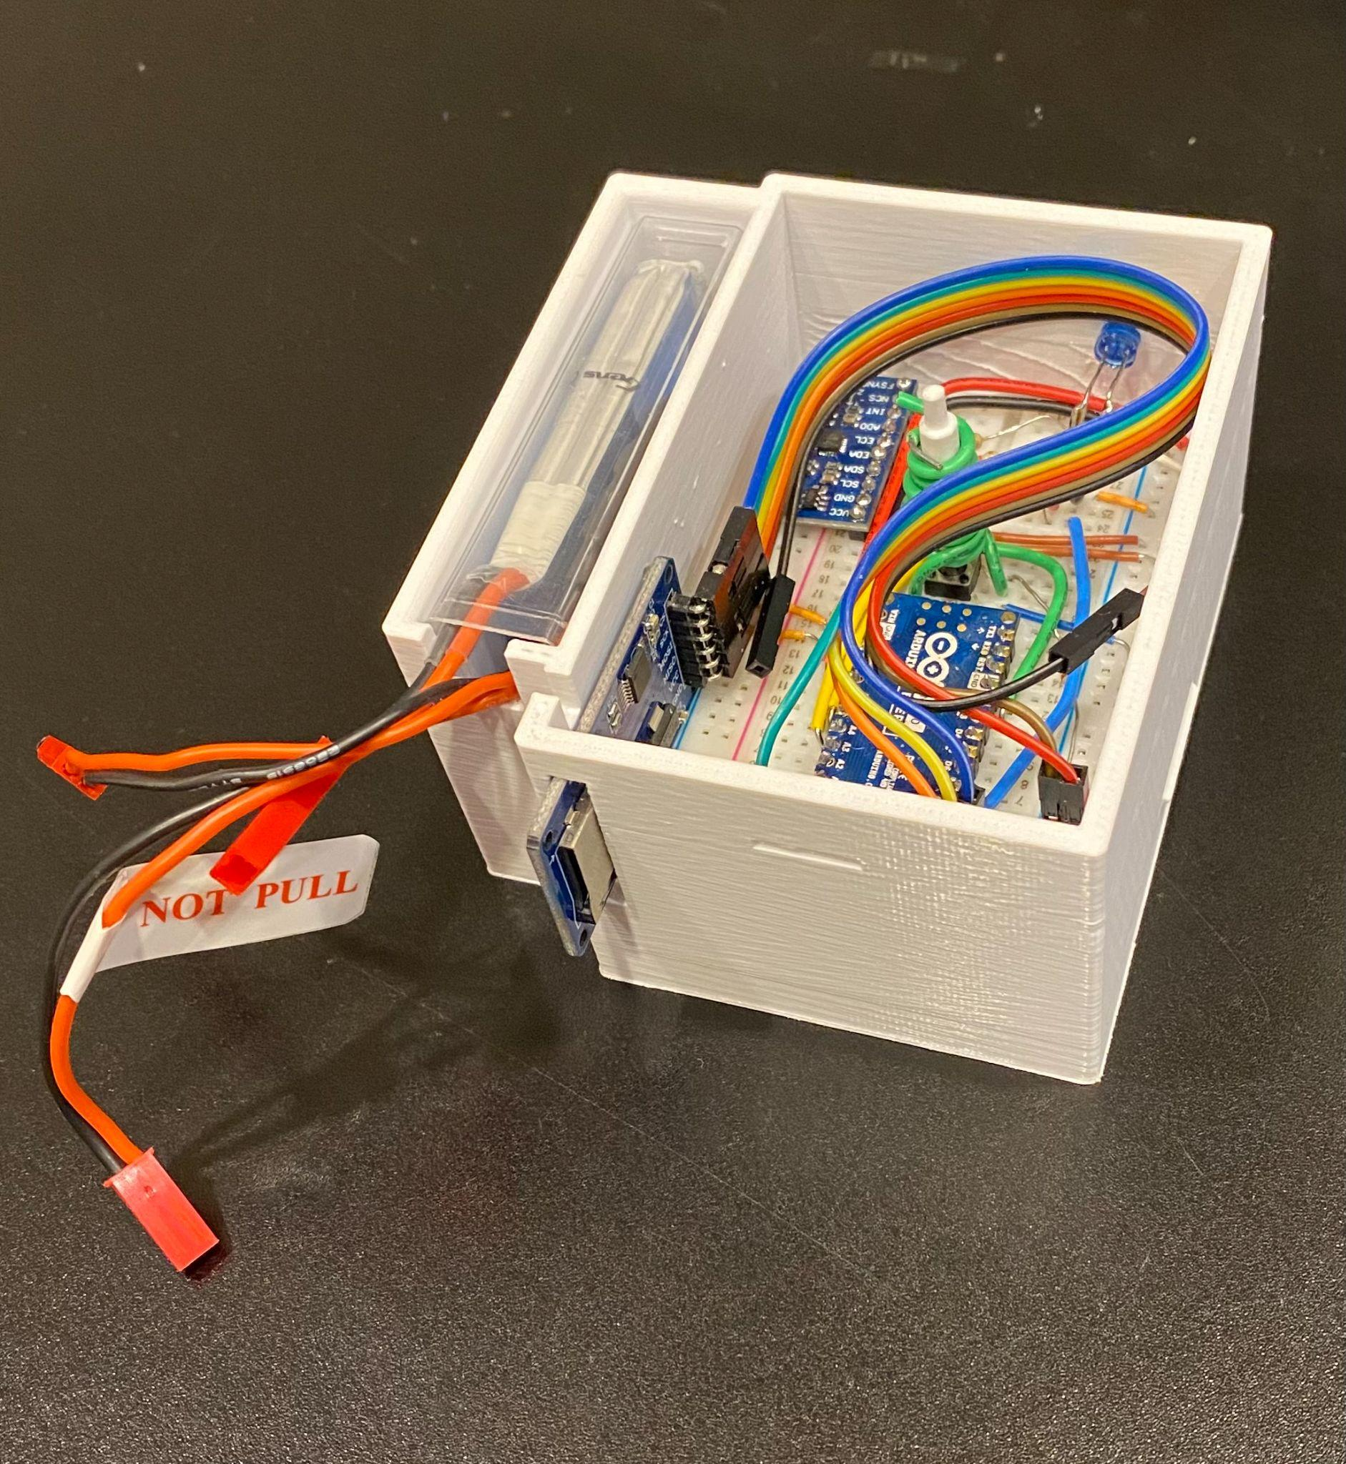
These last shots (including this one ^^^^^) are all of the final product. 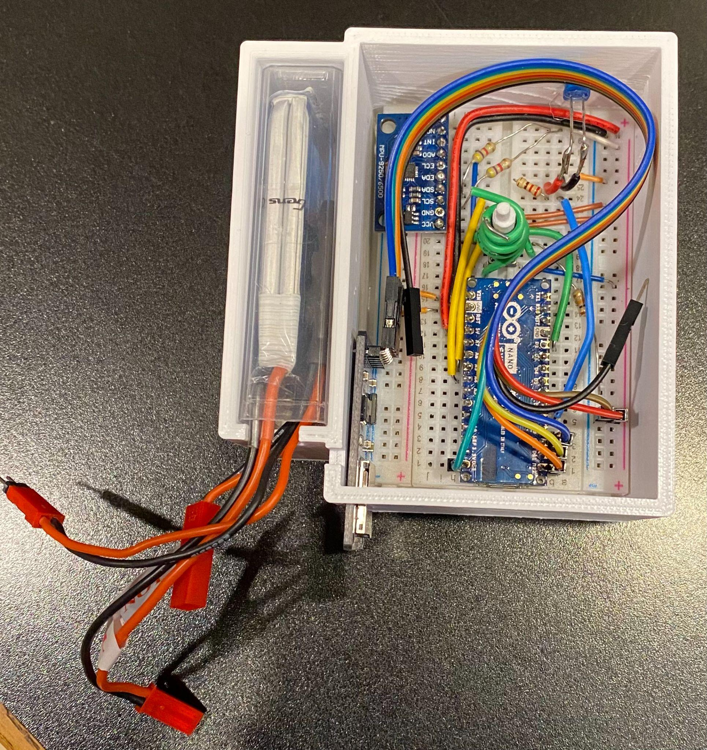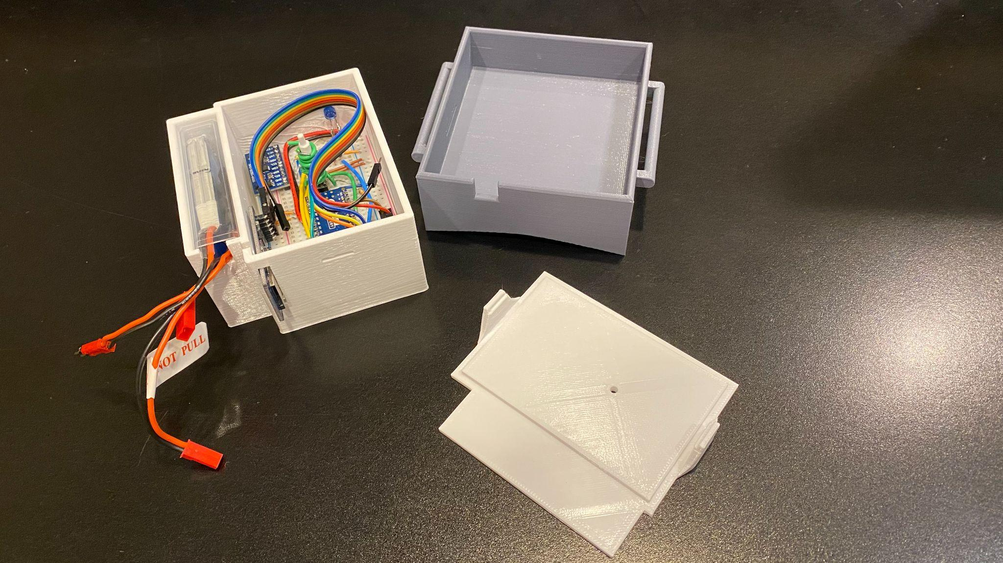
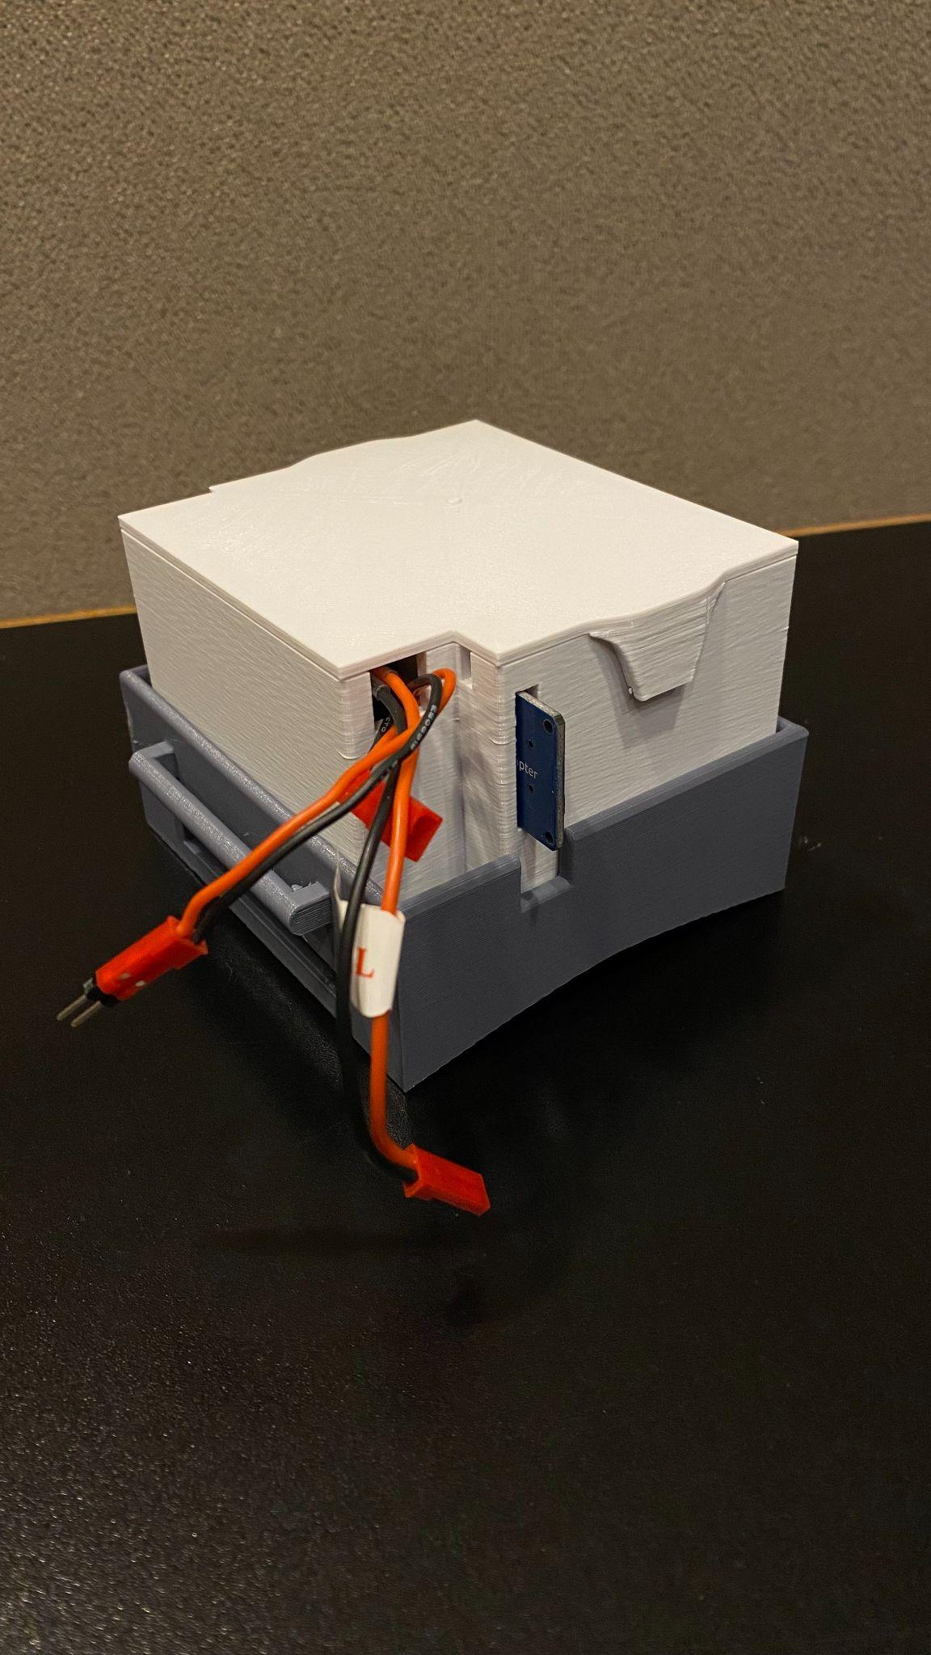
Completed view of the device

