

ALLIANCE UNIVERSITY
Alliance School of Advanced Computing

Student Name: Nitin
Register Number: PROV/ASAC/MCA/7/26/039
Project Name: VisualML: A Node-Based Visual Framework for Building Machine Learning Data Preprocessing Pipelines

ACADEMIC YEAR: 2026–2028

Department of Computer Applications

Program - Master of Computer Applications
Semester 1


ACKNOWLEDGEMENT
I would like to express my sincere gratitude to everyone who supported and guided me throughout the successful completion of this project.
I am thankful to Oleti Durga Bravish, my Project Faculty and Project Guide, for valuable guidance, suggestions, encouragement, and continuous support throughout the development of this project. I also express my gratitude to the faculty members of the Department of Computer Applications and Alliance School of Advanced Computing for providing a supportive academic environment.
I would also like to thank my friends and classmates for their cooperation and support during the completion of this project. Finally, I am deeply grateful to my family for their constant encouragement, motivation, and support.
I sincerely thank everyone who contributed directly or indirectly to the successful completion of this project.
Student Name: Pradeep Kumar

Register Number: PROV/ASAC/MCA/7/26/039

Project Title: VisualML: A Node-Based Visual Framework for Building Machine Learning Data Preprocessing Pipelines

Signature of Student

Signature of Faculty & Project Guide

Project Faculty & Project Guide Name: Oleti Durga Bravish

1. ABSTRACT
This project develops VisualML (codebase ml_node_), a desktop machine-learning workflow builder with a visual node-based editor. Instead of writing every pipeline step as a separate script, the user connects reusable nodes for data loading, inspection, and preprocessing, then executes the graph through a validated scheduling engine. The application is built with PySide6 (Qt for Python) and organizes local artifacts in working folders for data cache, logs, and reports.
The present report covers the system through the preprocessing stage. At this stage the implemented path includes dataset loading from common tabular formats (CSV, Excel, JSON, Parquet, and other pandas readers), data preview and profiling support, missing-value handling, data-type conversion, categorical encoding, numeric scaling, outlier handling, feature selection, and optional text preprocessing. Graph validation, topological scheduling, and pipeline execution orchestrate these nodes so that cleaned feature tables can be produced repeatably from a visual workflow.
Later stages such as train/test splitting, model training, evaluation dashboards, and deployment packaging are present in the codebase as node categories but are outside the detailed scope of this report phase. The contribution documented here is a coherent data-to-preprocessing pipeline that reduces manual spreadsheet and ad-hoc script work while keeping each transformation inspectable as a graph node.
The internal execution design separates the visual graph from node runtime logic. Graph validation checks structural requirements and rejects cyclic or incomplete connections. The scheduler derives dependency levels, while the pipeline executor and node runner pass upstream outputs into registered runtime classes. Each runtime follows a common result contract containing outputs, metadata, execution status, timing information, and an error message when a step cannot complete. This separation allows the editor to remain interactive while preprocessing behavior is organized into reusable components.
A representative workflow begins with the Dataset Loader, which reads a user-selected file and emits raw data, schema information, aggregate statistics, and feature or target candidates. Inspection windows display rows, data types, missing percentages, distributions, and profiling information. Downstream nodes then apply declared operations such as median or mode imputation, type coercion, one-hot encoding, standardization, outlier treatment, and feature selection. Intermediate outputs remain accessible through node ports and output windows, allowing the operator to compare the data before and after each transformation.
The implemented phase was demonstrated with a small mixed-type tabular dataset containing numeric, categorical, and missing values. The loader produced a twelve-row, six-column frame and reported its quality characteristics. A missing-value step generated per-column counts and percentages, categorical fields were converted through one-hot encoding, and numeric fields were scaled. The resulting prepared frame contained eleven columns after encoding. These observations are used as functional evidence of data movement and transformation; they are not presented as predictive accuracy results.
The principal outcome is an inspectable preprocessing environment in which configuration, execution order, transformed data, and supporting metadata can be reviewed together. The approach is intended for academic experimentation and local analytical work where reproducibility and visibility are more important than automated model selection. Future phases can extend the same graph with split, training, evaluation, export, and inference nodes, provided that fitted preprocessing state is consistently reused and validated on holdout data.

2. INTRODUCTION

2.1 Machine-learning workflows and decision support
Modern analytical work typically proceeds as a pipeline: load tabular data, inspect quality, repair missing or inconsistent values, encode categories, scale numeric fields, select useful features, and only then train models. When these steps live in disconnected notebooks or spreadsheets, definitions drift, joins are repeated by hand, and it becomes difficult to replay the same preparation for a new file. A visual node graph makes each transformation explicit: ports carry data between nodes, options are stored on the node, and the execution engine runs the graph in dependency order.
Predictive analytics still depends on sound preprocessing. Scaling choices, imputation strategy, and encoding method change the feature space that any later model will see. Strategic value at this stage is therefore operational: a reusable, inspectable preparation path that documents what was done to the data before modeling begins. VisualML focuses on that path by exposing preprocessing as first-class nodes inside a desktop editor rather than as hidden helper code.

2.2 Project context
VisualML is engineered as a local desktop application. The main window hosts a node editor, node properties panel, data preview/statistics/profiler windows, output views, and settings. Users assemble a directed acyclic graph (DAG) from a palette of nodes. The registry maps visual titles such as Dataset Loader, Missing Value Handler, Categorical Encoder, Feature Scaler, Outlier Handler, Feature Selector, and Text Preprocessor to runtime classes.
In this report phase, strategic capability is bounded to data ingestion and preprocessing. The system does not claim live telemetry ingestion, cloud model serving, or completed end-to-end competition forecasting. Those capabilities belong to later modules (split, model, training, evaluation) and remain outside the detailed narrative until they are documented with verified runs.

2.3 Aim, objectives, and scope
The aim is to provide a desktop environment where tabular datasets can be loaded, inspected, and prepared for modeling through connected preprocessing nodes. The implementation objectives for this phase are to: (1) load datasets through configurable pandas readers; (2) expose preview, schema, and statistics; (3) handle missing values with explicit strategies; (4) convert data types safely; (5) encode categorical columns; (6) scale numeric features; (7) detect and treat outliers; (8) select informative features; and (9) execute the resulting graph with validation and scheduling.
Objectives stated as checklist items:
• Provide a visual node editor with ports, edges, and property configuration.
• Validate the graph for structural errors and produce a topological run order.
• Implement preprocessing nodes that emit cleaned frames plus metadata reports.
• Keep intermediate artifacts and profiling reports in local project folders.
Scope for this report stops after preprocessing. Train/validation splits, classifier/regressor training, metrics dashboards, and export/inference nodes exist in the repository but are not evaluated in depth here.

2.4 Significance of the proposed work
The significance of VisualML lies in making preprocessing decisions visible. In a conventional script, a reader may need to trace several functions to discover which columns were imputed, how categories were encoded, or whether scaling was applied before feature selection. In the node editor, every operation occupies an explicit position in the graph and exposes its configuration through the node card and properties window. This representation supports academic review because the workflow can be discussed step by step rather than treated as a single opaque program.
The project also supports repeatability at the data-preparation stage. A saved graph preserves the intended order of operations, while the validator and scheduler derive an executable dependency order from the connections. Node outputs include not only transformed DataFrames but also evidence such as schemas, missing-value summaries, encoder mappings, scaler state, outlier masks, and feature scores. These artifacts help the user verify what changed and identify unsuitable choices before model training is introduced in a later phase.
A local desktop design is useful for classroom demonstrations and exploratory work. The user can inspect tabular data, construct a pipeline, and review intermediate results without deploying a server or transferring a dataset to a remote service. This does not by itself guarantee privacy or production readiness, but it provides a clear boundary: source files, temporary data, logs, and profiler reports remain under the local project folders controlled by the operator.

2.5 Design principles and expected outcomes
The implementation follows four practical principles. First, composability allows a user to connect small nodes instead of relying on one fixed preprocessing routine. Second, inspectability requires important transformations to expose both their data output and supporting metadata. Third, controlled execution requires the graph to be validated as a directed acyclic graph and scheduled in dependency order. Fourth, graceful failure requires missing files, empty input ports, incompatible options, and other invalid conditions to return clear node errors instead of silently producing a partial result.
For the phase documented in this report, the expected outcome is a prepared feature table whose transformation history can be understood from the graph. A successful demonstration should show that a tabular file is loaded, its shape and quality are inspected, missing values are treated, categorical values are converted into numerical representations, and numeric features are scaled or selected as required. The result is not yet a prediction; it is a consistent input that can be passed to split and modeling nodes in the next project phase.
The expected academic benefit is therefore not merely automation. The system provides a visual record of preprocessing assumptions and makes intermediate evidence available for discussion, correction, and comparison. This encourages users to treat data quality and transformation order as deliberate engineering decisions rather than as hidden setup performed immediately before model training.

3. PROBLEM STATEMENT
The project addresses the difficulty of turning raw tabular files into a consistent, reusable prepared dataset. Manual cleaning in spreadsheets or one-off scripts makes it hard to compare strategies (for example mean versus median imputation), to preserve the same encoding mapping across runs, and to see missingness or outlier decisions before modeling. When preparation steps are not represented as an explicit workflow, leakage, silent type errors, and irreproducible feature sets become likely.
The specific problem implemented in this phase is a visual preprocessing pipeline: load a dataset, inspect it, apply a chosen sequence of cleaning and transformation nodes, and obtain a prepared feature table with accompanying reports (missingness summary, encoder state, scaler state, outlier mask, feature scores). The user remains responsible for choosing strategies; the tool makes those choices visible and repeatable.
The system does not claim to solve model selection or production monitoring in this report phase. Its practical objective is to organize evidence about the data and produce prepared inputs that later modeling stages can consume.

3.1 Operational impact of the problem
Fragmented preparation has a direct operational cost. An analyst repeating the same cleaning for each new CSV must reapply filters, retype conversions, and recheck null rates. Small differences in column names, date parsing, or category handling produce incompatible feature matrices. A node graph with saved options reduces these avoidable inconsistencies and makes the preparation path reviewable by a supervisor or teammate.

3.2 Functional requirements and boundaries
The application needs to accept a file path and reader configuration; preview rows and schema; allow the user to connect preprocessing nodes; execute the graph; and surface node outputs and metadata. It should fail clearly when required inputs are missing (for example no file path on the loader, or no target for a supervised feature-selection method). These requirements describe a decision-support preparation tool: modeling choices remain with the analyst, and no cleaned table is presented as a finished prediction.

3.3 Root causes and problem decomposition
The problem can be divided into four connected causes. The first is data-quality variation: files may contain null values, mixed types, duplicate categories, extreme numeric observations, or columns that are irrelevant to a later model. The second is process fragmentation, where loading, cleaning, and transformation are performed in different tools without a single record of their order. The third is weak observability: a transformed table may be produced without a report explaining which values were changed. The fourth is execution risk, because an invalid dependency or cyclic workflow can prevent a pipeline from producing a reliable terminal output. VisualML addresses these causes through dedicated data and preprocessing nodes, intermediate output inspection, and validation before execution. A missing path, empty required port, or cyclic dependency is therefore reported at the component responsible for it.

4. EXISTING SYSTEM

4.1 Traditional analysis
A conventional workflow for preparing ML data may involve opening CSV files in a spreadsheet, deleting incomplete rows by hand, typing formulas for averages, and exporting a cleaned sheet to a notebook. This can work for a small file, but it requires repeated filtering and arithmetic when formats change or when several preparation strategies must be compared. Definitions for missing-value rules and encoding often remain undocumented.

4.2 Limitations addressed by this project
Relevant limitations are the effort required to chain repeated cleaning steps, the absence of a single visual surface connecting loaders to transformers, and the difficulty of inspecting missingness or outliers before interpreting downstream results. A manual reviewer may also apply inconsistent encodings between training and later reuse. The project responds with a shared node runtime, fitted-state storage on encoding and scaling nodes, missing-value reports, and graph-level execution.
Table 1: Comparison of manual preparation and the implemented system
Aspect | Manual preparation | VisualML (this phase)
Record organization | Files and sheets reviewed separately. | Dataset Loader produces a frame plus schema/stats outputs.
Missing values | Ad-hoc delete/fill without a saved strategy. | Missing Value Handler with mean/median/mode/constant/ffill/bfill/interpolate/drop.
Encoding / scaling | Often rewritten per notebook. | Categorical Encoder and Feature Scaler nodes with stored state.
Outliers / features | Informal visual checks. | Outlier Handler and Feature Selector with scores metadata.
Reproducibility | Hard to replay exact steps. | Graph of nodes executed in topological order by the pipeline engine.
This comparison describes design intent for the preprocessing phase rather than a timed user study.

4.3 Difference from a full AutoML or cloud platform
The supplied implementation should be understood as a local visual pipeline builder rather than a managed cloud AutoML service. It does not automatically choose the best model for every problem, host APIs on the internet, or ingest streaming telemetry. The current report focuses on completed tabular preparation steps that the user configures explicitly.

5. PROPOSED SYSTEM

5.1 System overview
The proposed system is a PySide6 desktop application. The home shell (MainWindow) opens the node editor and supporting windows. The user places nodes from the palette, configures options (file path, imputation strategy, scaler method, and similar), connects ports, and runs either a single node or the full pipeline. The engine validates the graph, schedules levels, and executes node runtimes through the registry.
Figure 1: System architecture — User → Node Editor UI → Graph Validator / Scheduler → Node Runtimes (Loader → Preprocess…) → Local data/cache, logs, and reports.
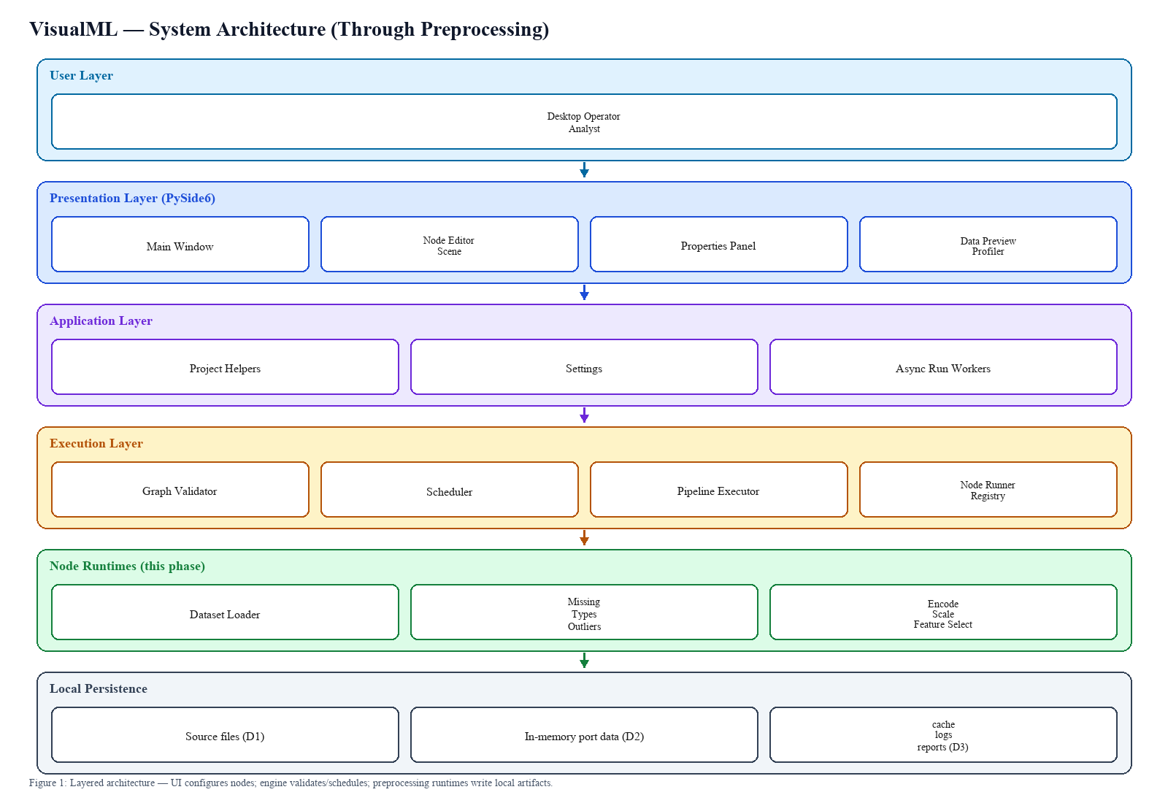

5.2 System modules
Table 2: Modules covered through preprocessing
Module | Role in this phase
UI shell and node editor | Visual graph editing, property panels, async run workers, data preview hooks.
Node registry | Maps titles such as Dataset Loader and Missing Value Handler to runtime classes.
Graph validator / scheduler | Checks structure, detects cycles, builds topological execution levels.
Pipeline executor / node runner | Feeds upstream outputs into nodes, records timing, errors, and terminal outputs.
Data IO nodes | Load, preview, merge, select columns, filter rows.
Preprocessing nodes | Missing values, type conversion, encoding, scaling, outliers, feature selection, text cleanup.
Local artifact folders | data/, logs/, reports/ hold caches, diagnostics, and profiler HTML outputs.

5.3 Data preprocessing (detailed)
Preprocessing is the focus of this report. After the Dataset Loader emits a raw frame with schema and statistics, the user chains transformation nodes. Each node accepts a chunk or feature frame on its input port, applies a configured strategy, and emits a cleaned frame plus optional metadata (reports or fitted state).
Missing Value Handler supports mean, median, mode, constant fill, forward and backward fill, linear interpolation for numeric columns, and dropping rows or columns using a missingness threshold. It can restrict processing to selected columns and always produces a missingness report (counts and percentages by column) before mutation.
Data Type Converter coerces columns to int, float, string, bool, datetime, or category, with optional date formats and error coercion. Categorical Encoder supports one-hot (with max-category capping), label, ordinal, target, binary, and frequency encoding, and stores an encoder state for reuse. Feature Scaler applies StandardScaler, MinMaxScaler, RobustScaler, MaxAbsScaler, Normalizer, PowerTransformer, or QuantileTransformer on numeric columns, with optional outlier clipping after scaling.
Outlier Handler detects anomalies with IQR, Z-score, Isolation Forest, or LOF and can remove, cap, replace with mean/median, or flag rows. Feature Selector offers variance threshold, correlation filtering, SelectKBest, RFE, L1 regularization, tree importance, and mutual information, returning selected columns and score dictionaries. Text Preprocessor lowercases text, strips punctuation, and removes a basic stopword list on a chosen column.
Together these nodes form a configurable preparation path. Typical order is load → (optional filter/column select) → missing-value handling → type conversion → outlier handling → encoding → scaling → feature selection. The graph may differ by dataset; the engine only requires a valid DAG.

5.4 Subsequent modules (deferred in this report)
The codebase also registers split nodes (train/test, train/val/test, cross validation, time-series split), model nodes (classification, regression, clustering, anomaly, neural network), training utilities, and evaluation nodes (metrics, visualization, report, explainer). Those modules are acknowledged for architecture completeness but are not specified, trained, or evaluated in this report phase.

5.5 Preprocessing workflow
• The user opens VisualML and creates or loads a project graph.
• A Dataset Loader node is configured with path and pandas reader options.
• Preview/statistics/profiler windows are used to inspect nulls, dtypes, and distributions.
• Preprocessing nodes are connected according to the chosen cleaning strategy.
• The pipeline is validated and executed; each node writes outputs and metadata.
• The prepared frame is available for later split/model nodes in a future phase.
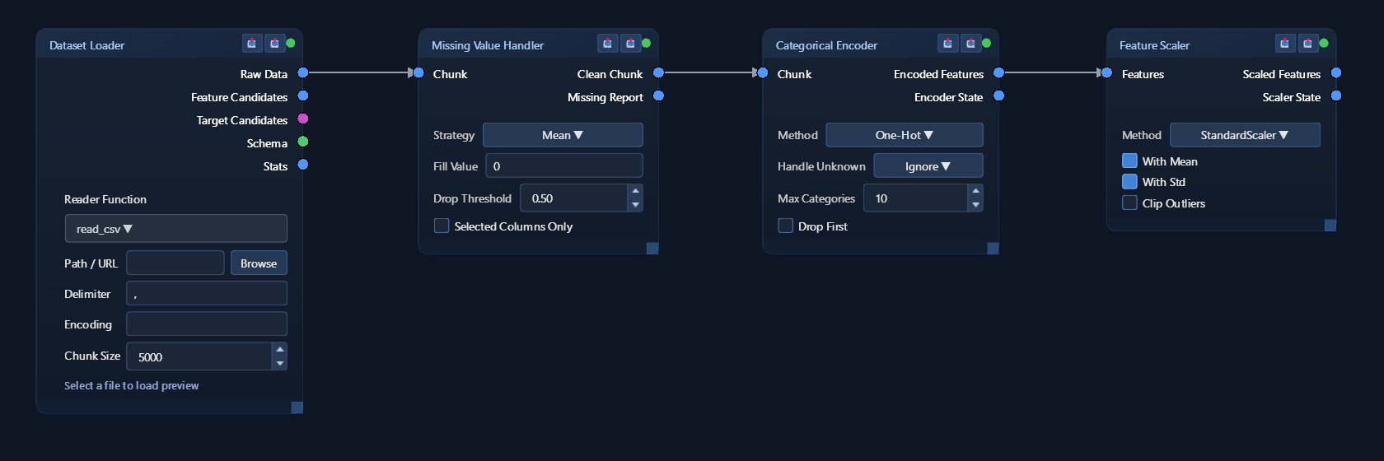
Figure 8: Node editor window — preprocessing graph with Dataset Loader, Missing Value Handler, Categorical Encoder, and Feature Scaler.
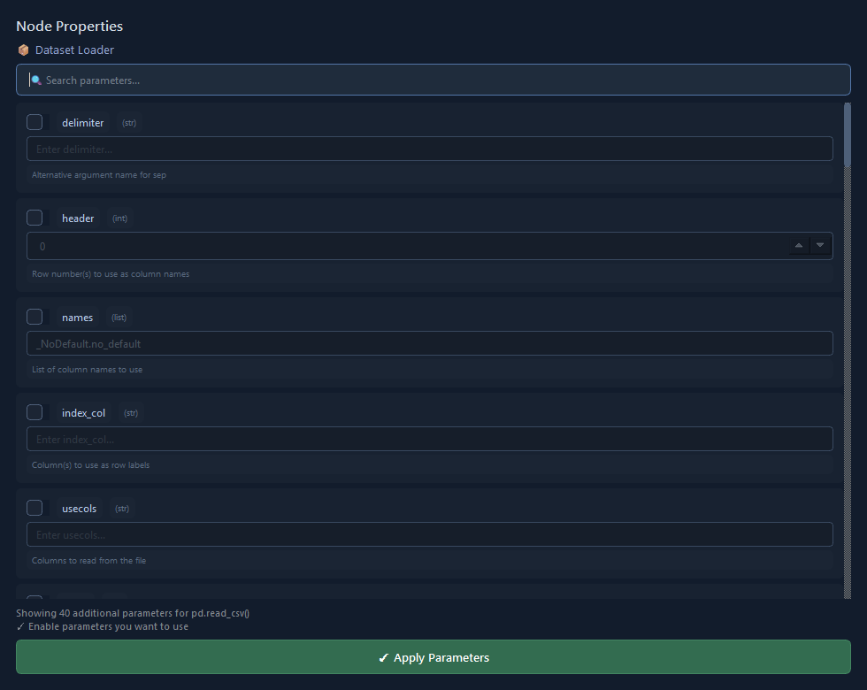
Figure 9: Node properties window for the Dataset Loader (pandas reader parameters).
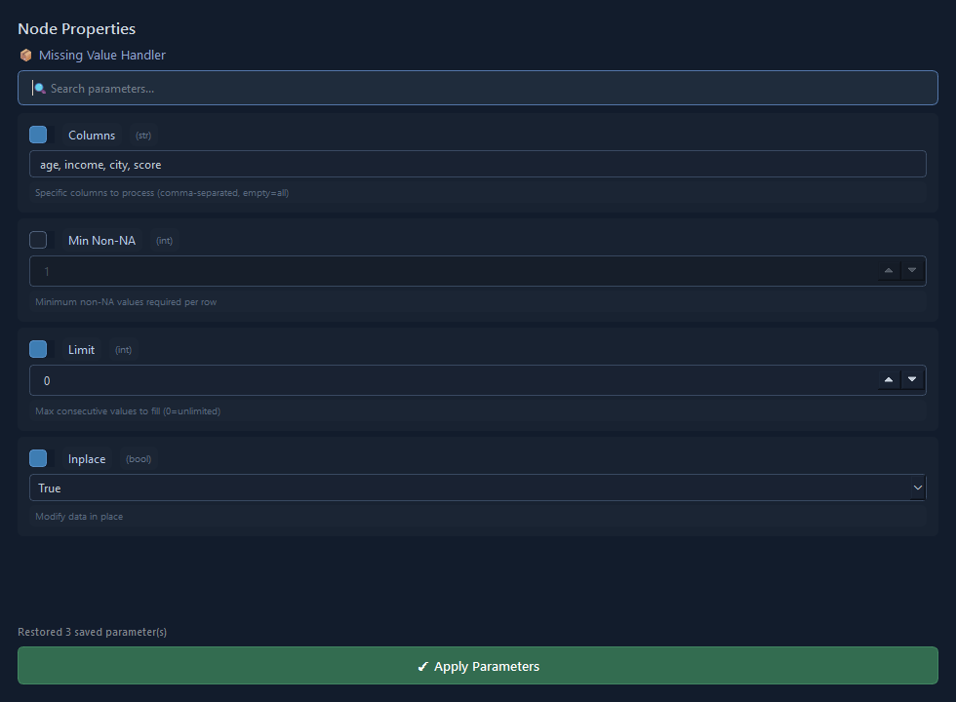
Figure 10: Node properties window for the Missing Value Handler.

5.6 System architecture
The user layer is the desktop operator. The presentation layer is PySide6 (main window, node editor view/scene, palette, toolbars, property and data windows). The application layer includes settings and project helpers. The execution layer comprises graph validation, scheduling, node running, and pipeline orchestration. The node layer implements IO and preprocessing runtimes under a shared NodeRuntime contract (NodeResult, NodeContext). Persistence for this phase is file-based (datasets on disk; caches, logs, and HTML profile reports under project folders). There is no separate cloud database or remote model service in the inspected local design.

5.7 Limitations and safeguards
Preprocessing quality depends on user choices and on the source file. Imputation and encoding cannot invent ground truth; they only apply declared rules. Some advanced options (for example full NLP stemming libraries) are only partially implemented. Large files require attention to chunking settings and available memory. Fitted scaler/encoder state must be reused consistently when a later modeling phase is added.
The application is a local academic prototype. Dependency pinning, automated engine tests, and formal packaging metadata are recommended hardening steps. Users should only load trusted datasets and review node metadata before treating a cleaned table as analysis-ready.

6. ABOUT DATASET

6.1 Dataset handling and scope
VisualML is dataset-agnostic in this phase: the Dataset Loader accepts paths configured by the user and dispatches to pandas readers (for example read_csv, read_excel, read_json, read_parquet, and related functions). The project is not locked to a single domain file. Sample or cached frames may reside under the application's data/ directory for local experiments.
Because this report stops at preprocessing, no competition-specific tournament register or third-party scorecard feed is required. Any tabular file with identifiable columns can be used to demonstrate loading, missing-value reports, encoding, and scaling.
Table 3: Primary data artifacts relevant to preprocessing
Artifact / output | Produced by | Purpose
Raw Data frame | Dataset Loader | Source table for all downstream nodes.
Schema / Stats | Dataset Loader | dtypes, nullability, unique counts, missing totals.
Missing Report | Missing Value Handler | Per-column missing counts and percentages.
Encoder / Scaler State | Encoding / Scaling nodes | Fitted mappings for reproducible transforms.
Outlier Mask | Outlier Handler | Boolean flags of detected extreme values.
Feature Scores | Feature Selector | Ranking used to keep informative columns.
Profiler HTML | Data profiler window / reports/ | Human-readable quality overview.

6.2 Data structure and types
Loaded tables are pandas DataFrames. Numeric columns are the primary input to scaling, outlier detection, and many feature-selection methods. Object and category columns are the primary input to encoding. Datetime conversion is available through the type-converter node. The loader also lists feature and target candidates to help the user plan later supervised steps.
Table 4: Column roles during preprocessing
Role | Typical dtypes | Handled by
Numeric features | int, float | Imputation, scaling, outliers, feature selection
Categorical features | object, category | Mode/constant fill, encoding
Text fields | object (free text) | Text Preprocessor
Temporal fields | datetime (after conversion) | Data Type Converter; later time-series split (deferred)
Target (optional now) | numeric or label | Required only for supervised selection methods

6.3 Data quality
Quality checks in this phase are node- and window-driven rather than a single hard-coded domain validator. The loader reports overall missing percentage and column groups. The Missing Value Handler emits a structured missing report. The data statistics and profiler windows support distribution and type review. Users should still verify source provenance and business definitions outside the tool.

6.4 Inputs and preprocessing outputs
Pipeline inputs are the file path, reader name/kwargs, and the ordered graph of preprocessing options. Outputs are cleaned frames on node ports, plus metadata such as missing reports, encoder/scaler state, outlier masks, and feature scores. No model target metrics are claimed in this phase.
Table 5: Preprocessing node summary
Node | Key options | Main outputs
Dataset Loader | path, reader, chunksize, kwargs | Raw Data, Schema, Stats, candidates
Missing Value Handler | strategy, fill value, drop threshold, columns | Clean Chunk, Missing Report
Data Type Converter | columns, target type, date format | Converted Chunk
Categorical Encoder | method, max categories, drop first | Encoded Features, Encoder State
Feature Scaler | method, with mean/std, clip outliers | Scaled Features, Scaler State
Outlier Handler | method, threshold, action | Clean Chunk, Outlier Mask
Feature Selector | method, k features, threshold | Selected Features, Feature Scores
Text Preprocessor | column, lowercase, punctuation, stopwords | Processed Text

6.5 Transformations in this phase (no train/test claim)
Chronological or random train/test splitting belongs to later split nodes and is not evaluated here. Transformations documented in this phase are imputation, type coercion, categorical encoding, numeric scaling, outlier treatment, unsupervised or supervised feature selection (when a target port is supplied), and light text normalization. When modeling is added in a future report, fitted preprocessing state must be applied consistently to holdout data to avoid leakage.

6.6 Demonstration dataset
The screenshots in Section 9 use a small demonstration file, sample_preprocess.csv, with 12 rows and six columns: age, income, city, plan, score and visits. Four columns are numeric and two are categorical. Ten cells are deliberately left empty across all six columns so that the Missing Value Handler and its Missing Report have visible work to do, and the categorical columns repeat labels such as Bengaluru, Delhi, Mumbai, Chennai, Basic, Plus and Pro so that encoding produces meaningful indicator columns.
After median imputation, one-hot encoding of city and plan, and StandardScaler on the numeric columns, the frame grows from 6 to 11 columns while keeping all 12 rows, because the pipeline fills incomplete records instead of dropping them. The small size lets every value be checked by hand against the preview windows.
Dataset handling in this phase assumes that the file fits in memory, that the first row holds column names, and that each loader node reads one table. Very large files, workbooks whose sheets use different headers, and free-text columns that need tokenization are only partly supported, through reader keyword arguments and light text normalization.

7. TECHNOLOGIES USED
Technologies are taken from the VisualML requirements and source imports relevant to the UI and preprocessing path.
Table 6: Technologies used through preprocessing
Technology | Purpose
Python 3.10+ | Application and node runtime logic.
PySide6 | Desktop UI, windows, widgets, settings.
pandas / NumPy | Tabular IO, cleaning, encoding helpers, arrays.
scikit-learn | Scalers, encoders support, feature-selection utilities, outlier detectors.
SciPy / joblib | Scientific routines and serialization helpers.
PyArrow | Efficient Parquet/Feather-oriented loading support.
ydata-profiling | HTML data-profile reports from the profiler window.
matplotlib | Plotting support used by analysis windows/nodes.
psutil | Resource-related utilities.

7.1 Application and interface technologies
Python provides the application logic. PySide6 maps user actions to the node editor and supporting windows. Application settings persist UI and pipeline preferences. This combination keeps the demonstration self-contained on a local workstation.

7.2 Data preparation technologies
pandas and NumPy support tabular handling. scikit-learn supplies scalers, feature selectors, and outlier estimators used by preprocessing nodes. PyArrow assists columnar file formats. ydata-profiling supports richer quality reports. TensorFlow is listed for later neural/anomaly nodes and is not required to explain the preprocessing phase itself.

7.3 Integration of the technology stack
The technologies are connected through a layered implementation rather than used as isolated libraries. PySide6 provides the main window, node editor, dialogs, property controls, data tables, statistics panels, and output views. User actions in this layer produce graph and node configurations. The execution layer then resolves the selected visual node through the registry and invokes the corresponding Python runtime class. This arrangement keeps interface concerns separate from transformation logic while allowing runtime results to be returned to the visual windows.
pandas carries the DataFrame between nodes, NumPy supports numeric arrays, scikit-learn supplies the preprocessing algorithms, and ydata-profiling produces HTML quality reports, so the whole stack runs locally without a cloud account.

8. DATA FLOW DIAGRAM
The data-flow view for this phase follows the path visible in the node editor and engine: the user configures a loader; data moves through preprocessing nodes; the executor records outputs. Model inference paths are omitted from the detailed flow because they are out of scope here.
Figure 2: Level-0 data flow — External tabular file → VisualML preprocessing pipeline → Prepared feature table + quality metadata.
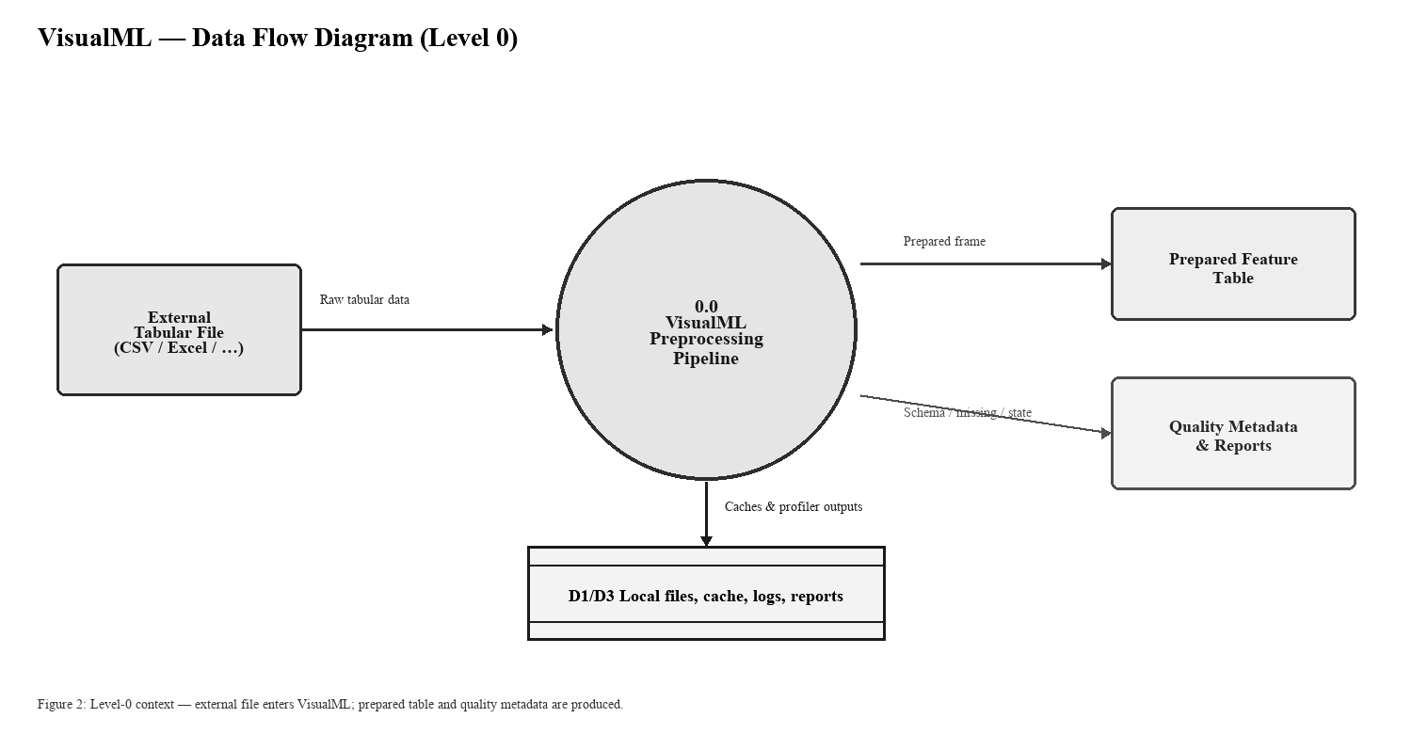

8.1 Level 1 process flow (through preprocessing)
At Level 1, the graph is validated and scheduled. The Dataset Loader reads the file and emits Raw Data with Schema/Stats. Optional Column Selector or Filter nodes reduce the working set. Missing Value Handler cleans nulls and emits a Missing Report. Type conversion, outlier handling, encoding, scaling, and feature selection run in the user-defined order. Terminal outputs are the prepared frame and associated metadata. If a required input port is empty, the node returns a failed NodeResult with an error message rather than a silent partial transform.
Read from left to right, the Level-1 diagram follows the order in which the executor runs the nodes. The loader turns the source file into a DataFrame and records its schema. The preview and profile step only reads that frame to fill the Data Preview, Data Statistics and profiling windows. The cleaning step handles missing values, data types and outliers; encoding and scaling then convert the cleaned columns into numeric features and keep their fitted state on the node; and feature selection optionally narrows the result before it reaches the output ports.
Each arrow corresponds to a port connection in the node editor, and the data carried on it is a pandas DataFrame together with a small metadata dictionary. Because nodes run in topological order, a downstream node never receives a partial result: it gets either the complete output of its upstream node or an error.
The diagram also shows where the user's choices enter the flow. Settings from the Node Properties window, such as the imputation strategy, the encoding method or the scaler type, are read by each node at run time and are not stored in the data itself. Changing a setting and running the graph again therefore repeats the whole flow from the source file, so every output can be traced to a specific configuration.
Figure 3: Level-1 process flow — Loader → Preview/Profile → Missing/Types/Outliers → Encode → Scale → Feature Select → Prepared outputs.
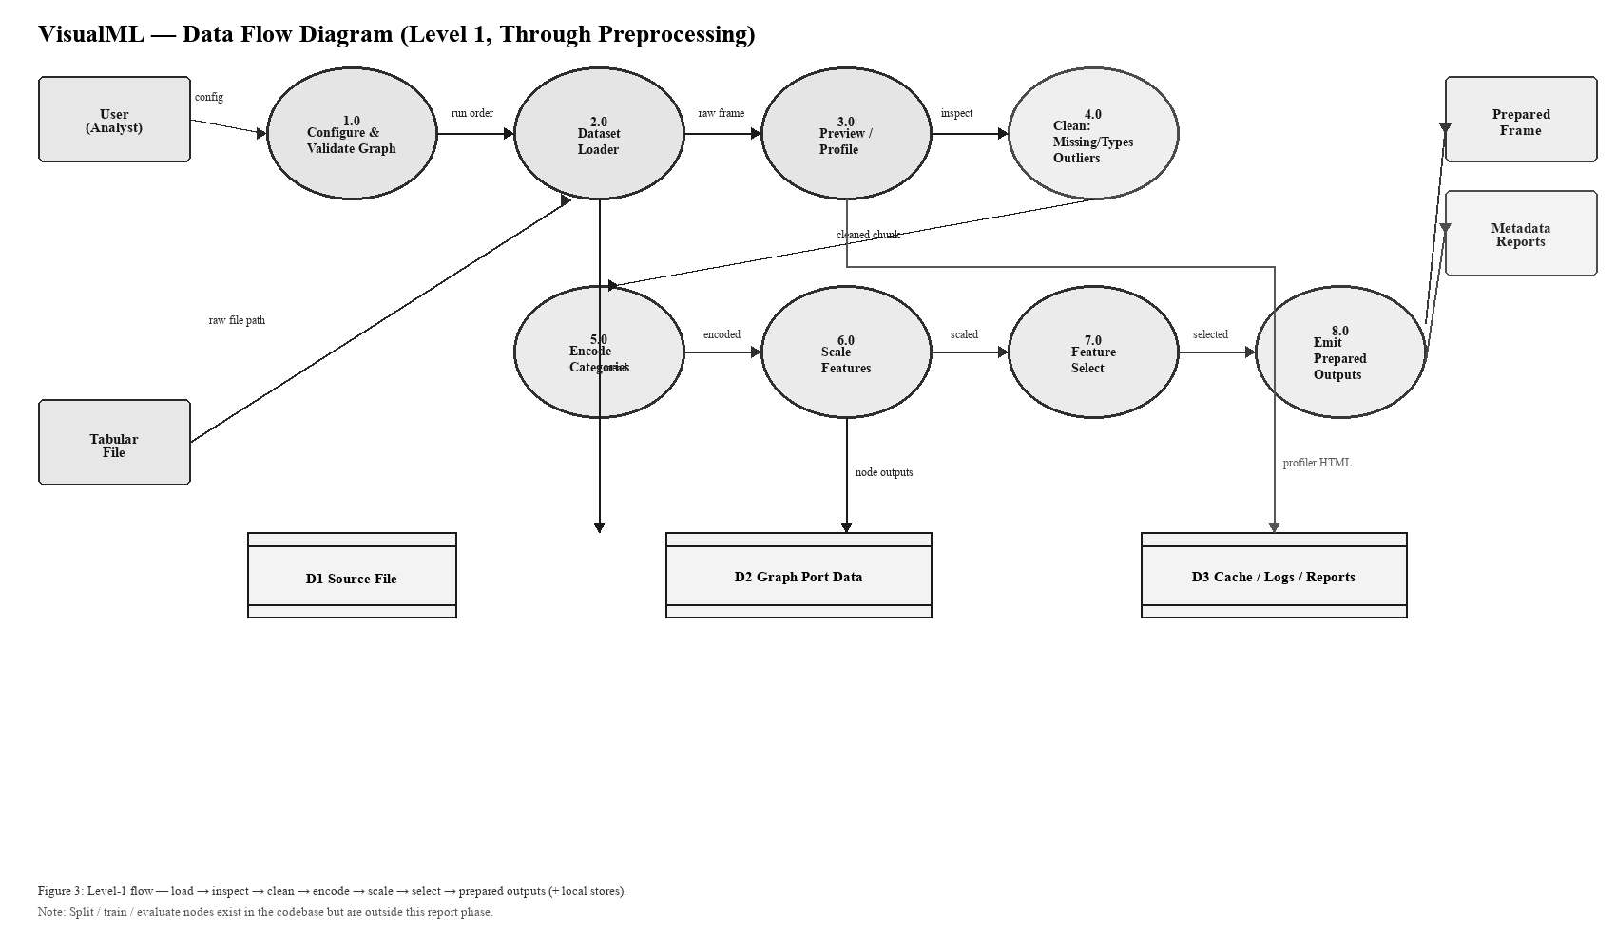

8.2 Data stores and boundaries
D1 is the source file on disk. D2 is the in-memory/graph data flowing between node ports during a run. D3 covers local folders (data/cache, logs, reports) for caches and profiler outputs. Fitted encoder/scaler state is held on node runtimes for the session and is intended to support consistent reuse when modeling is added later. Streaming telemetry sources and remote databases are outside this boundary.

8.3 Data flow rules and error handling
Three rules govern every flow in the diagram. First, data moves only along connected ports, so nodes do not share hidden state. Second, every node returns a NodeResult that carries either output data or an error message, and the executor stops the dependent branch when an error occurs. Third, inspection windows read node outputs but never write back to them, which keeps viewing separate from transformation.
Errors are reported to the user through the failing node's message and are also written to the logs folder with a timestamp for later review. Data leaves the system boundary only when the user asks for it, either through the Export node or as an HTML profiling report saved in the reports folder, so nothing is uploaded or shared automatically.
Together these rules make the diagrams useful for testing as well as documentation. Each arrow can be checked by opening the node output window at that point and comparing row counts, column names and missing-value totals with the previous step. In the demonstration run, this check confirms that the row count stays at 12 throughout and that the column count rises from 6 to 11 after encoding. The same check can be repeated on any new dataset, so the diagrams remain a reliable guide when further preprocessing nodes are added to the pipeline in later phases of the project.

9. PREPROCESSING OUTPUTS

9.1 Loader and inspection outputs
A successful Dataset Loader run returns a Raw Data frame together with feature/target candidate lists, a per-column schema (dtype, nullable, unique count), and aggregate statistics (shape, memory, missing total/percent, numeric vs categorical column lists). Preview nodes and data windows show head rows and dtype summaries for interactive checks.
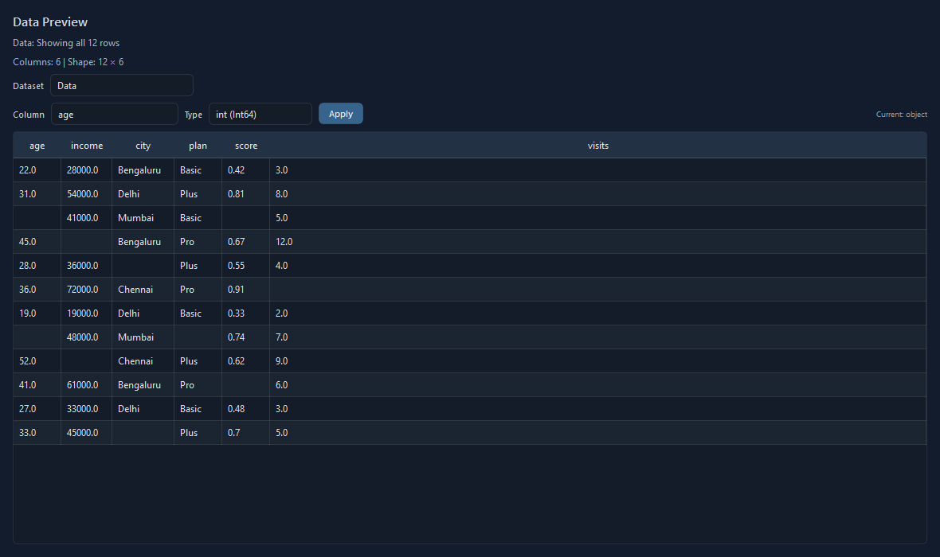
Figure 4: Data Preview window — raw dataset returned by the Dataset Loader (nulls visible before imputation).
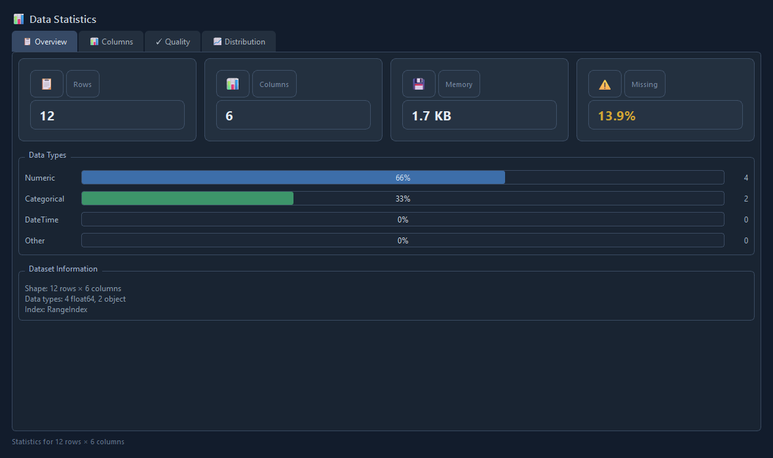
Figure 5: Data Statistics window — row/column counts, memory, missing percentage, and column quality for the loaded dataset.

9.2 Cleaning and transformation outputs
Missing Value Handler returns Clean Chunk plus Missing Report metadata (rows before/after and strategy used). Encoding and scaling nodes return transformed frames and serializable state dictionaries. Outlier Handler returns a cleaned frame and an outlier mask. Feature Selector returns the reduced feature matrix and score map. These outputs are the tangible deliverables of the present report phase.
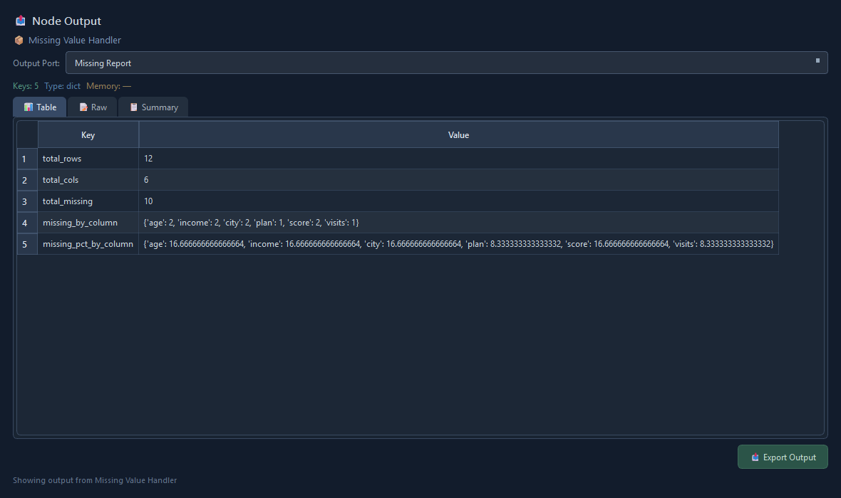
Figure 6: Node Output window — Missing Report from the Missing Value Handler (Median strategy, mode fallback for categories).
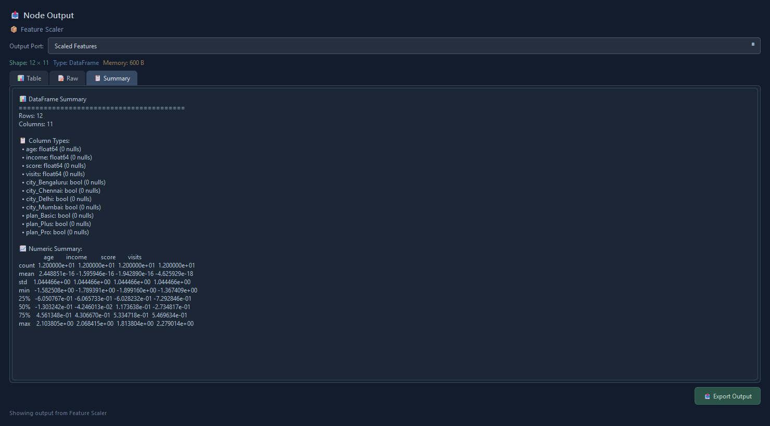
Figure 7: Node Output window — Scaled Features summary after one-hot encoding and StandardScaler.

9.3 Example preprocessing path
A representative academic demonstration path is: load a CSV to inspect missingness in the profiler, impute numeric columns with median and categoricals with mode, one-hot encode categories with a max-category cap, standardize numeric features, then drop low-variance columns. Exact numeric metrics depend on the user-supplied file and should be taken from the live run.
Table 7: Representative preprocessing run checklist
Step | Node | Expected evidence
1 | Dataset Loader | Non-empty Raw Data; schema/stats populated
2 | Missing Value Handler | Missing Report; reduced null counts
3 | Categorical Encoder | Encoded Features; encoder_state stored
4 | Feature Scaler | Scaled Features; scaler_state stored
5 | Feature Selector | Selected Features; feature scores available

9.4 Deferred evaluation results
Classifier and regressor holdout metrics are not applicable to this preprocessing phase and are intentionally omitted. Model comparison tables will be produced in a later report after split and training nodes are exercised on a chosen dataset.

9.5 Functional checks for this phase
Functional verification for this phase focuses on whether loader and preprocessing nodes return successful NodeResult objects for valid inputs and clear errors for missing inputs. Full pytest coverage for the engine is recommended as future work.
Table 8: Preprocessing-oriented test cases
ID | Input condition | Expected behavior
TC-01 | Loader with valid CSV path | Raw Data and schema/stats returned
TC-02 | Loader with empty path | Failed result: no file path specified
TC-03 | Missing-value node with strategy Mean | Numeric nulls filled; report emitted
TC-04 | Encoder on frame with categoricals | Encoded Features and encoder state
TC-05 | Scaler on numeric features | Scaled Features and scaler state
TC-06 | SelectKBest without target | Failed result requesting target

9.6 Output interpretation
Preprocessing outputs should be read as prepared evidence for later modeling, not as predictions. Metadata reports explain what changed. If null rates remain high after imputation choices, or if encoding explodes dimensionality, the graph should be adjusted before any training phase.

10. CONCLUSION
This report phase presents VisualML as a desktop visual ML workflow builder and documents the path from dataset loading through preprocessing. The principal achievement is an inspectable node graph that can load tabular files, report quality signals, and apply explicit cleaning, encoding, scaling, outlier, feature-selection, and text preparation steps under a validated execution engine.
Modeling accuracy claims are deferred until split/train/evaluate nodes are documented with a chosen dataset and recorded metrics. The system at this stage is best understood as an academic prototype for reproducible data preparation inside a node-based desktop environment.

10.1 Future scope
Future report phases should document train/validation splits, model training and comparison, metrics and visualization nodes, export/inference, packaging (requirements/pyproject completion), and automated tests for the validator, scheduler, and executor. Additional work may include stronger persistence contracts for projects and fitted preprocessing state across sessions.

REFERENCES AND PROJECT ARTIFACTS
[1] Project source tree ml_node_/ (VisualML): src/main.py; src/ui/main_window.py; src/ui/windows/node_editor_window.py; src/engine/graph_validator.py; src/engine/scheduler.py; src/engine/node_runner.py; src/engine/pipeline_executor.py; src/nodes/registry.py; src/nodes/io/dataset_loader_node.py; src/nodes/preprocess/*.py; README.md; requirements.txt; reports/project_overview.md.
[2] Qt for Python (PySide6) documentation, https://doc.qt.io/qtforpython/
[3] pandas documentation — IO tools and data cleaning, https://pandas.pydata.org/docs/
[4] scikit-learn documentation — preprocessing and feature selection, https://scikit-learn.org/stable/modules/preprocessing.html
[5] ydata-profiling documentation, https://docs.profiling.ydata.ai/

