DBMS-PROJECT

NAME: JAHIRUL ISLAM
ROLL: CMSA 20-17
…………………………………………………………………………..

Create Database and Use :
create database fakatime;
use database;

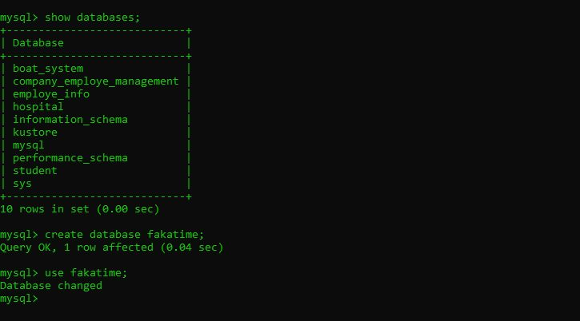

Department Table
create table department(Dno integer primary key not NULL, Dname varchar(50),Location varchar(50) DEFAULT 'New Delhi');

Employee Table
create table employee(Eno char(3) primary key not NULL, Ename varchar(50),Job_Type varchar(50),
Manager char(3),Hire_date date,Dno integer,Commission decimal(10,2),Salary Decimal(7,2),foreign key(Dno) references department(Dno));
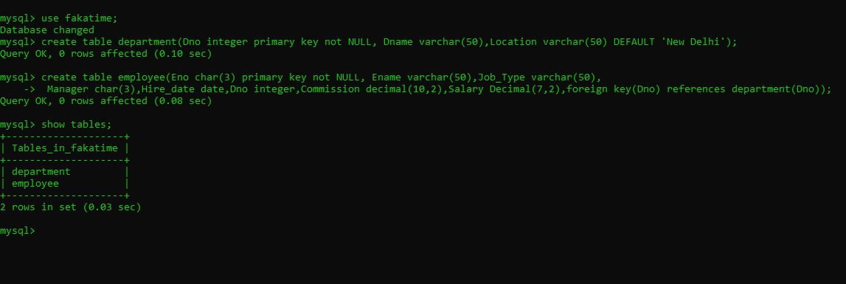

Insert Into Deparment Values :
mysql> insert into department values('30','HR', 'New Delhi');
Query OK, 1 row affected (0.03 sec)

mysql> insert into department values('15','BR', '');
Query OK, 1 row affected (0.00 sec)

mysql> insert into department values('20','PR', 'New Delhi');
Query OK, 1 row affected (0.00 sec)

mysql> insert into department values('10','AC', 'New Delhi');
Query OK, 1 row affected (0.01 sec)

mysql> insert into department values('25','RC', 'New Delhi');
Query OK, 1 row affected (0.00 sec)

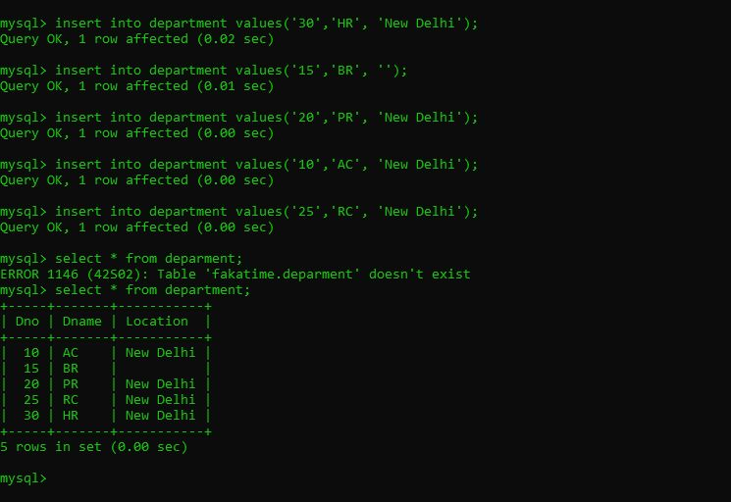

Insert Into Employee Values :
mysql> insert into employee values('790', 'Panda', 'programer', '778', '2021/05/05', '30', '120.00', '2200.00');
Query OK, 1 row affected (0.00 sec)

mysql> insert into employee values('700', 'rahul', 'software engineer', '543', '1981/08/15', '15', '180.00', '2000.00');
Query OK, 1 row affected (0.00 sec)

mysql> insert into employee values('770', 'Raju', 'Manager', 'NO', '2001/04/10', '20', '150.00', '1900.00');
Query OK, 1 row affected (0.00 sec)

mysql> insert into employee values('778', 'Jony', 'software enginner', '132', '1980/07/11', '10', '120.00', '1400.00');
Query OK, 1 row affected (0.00 sec)

mysql> insert into employee values('408', 'Aarzoo', 'Manager', '505', '2003/07/11', '25', '00.00', '3200.00');
Query OK, 1 row affected (0.00 sec)

mysql> insert into employee values('222', 'Pikachu', 'Typer', '605', '1991/04/11', '10', '70.00', '700.00');
Query OK, 1 row affected (0.00 sec)

mysql> insert into employee values('555', 'Alauddin', 'Typer', '615', '1999/12/12', '15', '160.00', '650.00');
Query OK, 1 row affected (0.00 sec)

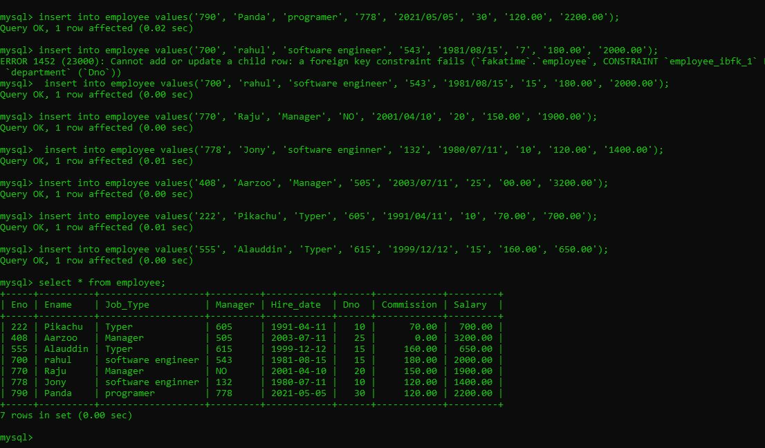

QUERY:

QUERY 1: Query to display Employee Name, Job, Hire Date, Employee Number; for each
employee with the Employee Number appearing first.
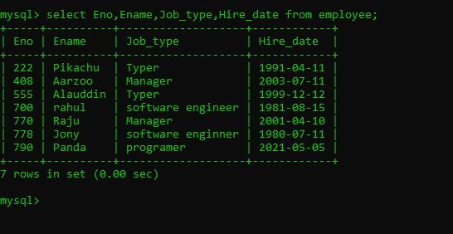

QUERY 2: Query to display unique Jobs from the Employee Table

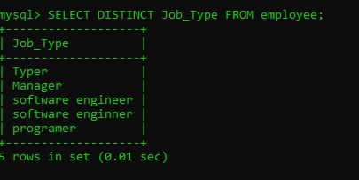

QUERY 3: Query to display the Employee Name concatenated by a Job separated by a comma

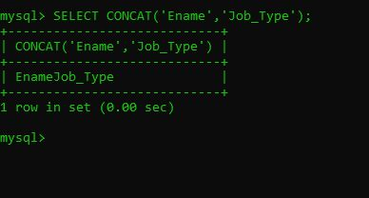

QUERY 4: Query to display all the data from the Employee Table. Separate each Column by a comma and name the said column as THE_OUTPUT

QUERY 5: . Query to display the Employee Name and Salary of all the employees earning more than $2850.

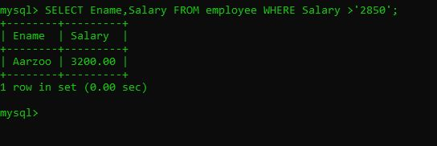

QUERY 6: Query to display Employee Name and Department Number for the Employee No= 7900

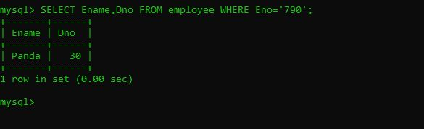

QUERY 7: Query to display Employee Name and Salary for all employees whose salary is not in the range of $1500 and $2850
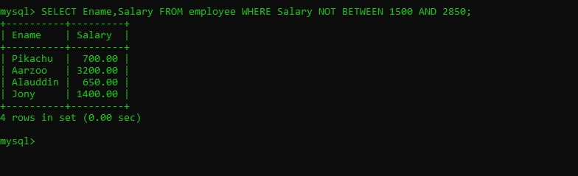

QUERY 8: Query to display Employee Name and Department No. of all the employees in Dept 10 and Dept 30 in the alphabetical order by name

QUERY 9: Query to display Name and Hire Date of every Employee who was hired in 1981
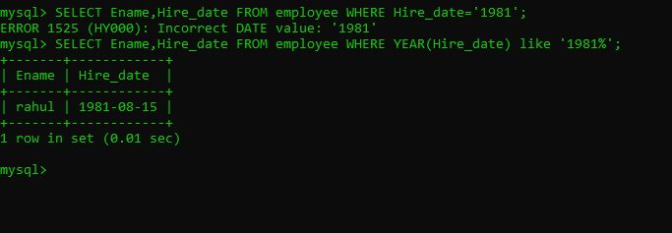

QUERY 10: Query to display Name and Job of all employees who don‘t have a current Manager.

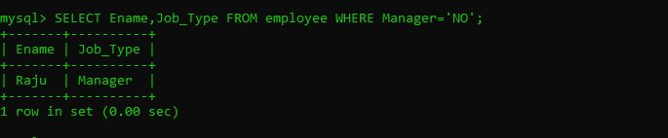

QUERY 11: Query to display the Name, Salary and Commission for all the employees who earn commission
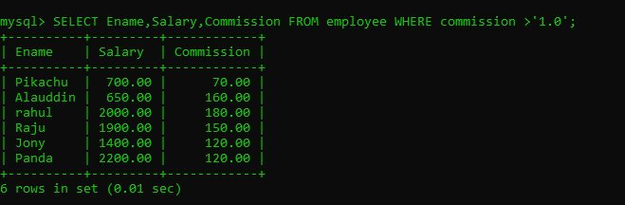

QUERY 12: Sort the data in descending order of Salary and Commission

