TRƯỜNG ĐẠI HỌC TÀI NGUYÊN VÀ MÔI TRƯỜNG
KHOA CÔNG NGHỆ THÔNG TIN
Môn: Cơ Sở Dữ Liệu Nâng Cao

BÁO CÁO THỰC HÀNH
ORACLE SQL - BUỔI 3

Sinh viên thực hiện: Trần Thành Trung
MSSV: 1250080217
Lớp: 12_ĐH_CNTT4
Giảng viên hướng dẫn: Phạm Trọng Huynh
Ngày nộp báo cáo: 4/13/2026

Mục Lục
Phần A: Quan ly Khoa Hoc 2
1. Tạo bảng : 2
2. Nhập dữ liệu mẫu 3
3. Khối lệnh: 4

Phần A: Quan ly Khoa Hoc
LAB3

1. Tạo bảng :
CREATE TABLE COURSE (
CourseNo NUMBER(8, 0) NOT NULL PRIMARY KEY,
Description VARCHAR2(50) NULL,
Cost NUMBER(9, 2) NULL,
Prerequisite NUMBER(8, 0) NULL,
CreatedBy VARCHAR2(30) NOT NULL,
CreatedDate DATE NOT NULL,
ModifiedBy VARCHAR2(30) NOT NULL,
ModifiedDate DATE NOT NULL
);

CREATE TABLE INSTRUCTOR (
InstructorID NUMBER(8) NOT NULL PRIMARY KEY,
Salutation VARCHAR2(5) NULL,
FirstName VARCHAR2(25) NULL,
LastName VARCHAR2(25) NULL,
Address VARCHAR2(50) NULL,
Phone VARCHAR2(15) NULL,
CreatedBy VARCHAR2(30) NOT NULL,
CreatedDate DATE NOT NULL,
ModifiedBy VARCHAR2(30) NOT NULL,
ModifiedDate DATE NOT NULL
);

CREATE TABLE CLASS (
ClassID NUMBER(8, 0) NOT NULL PRIMARY KEY,
CourseNo NUMBER(8, 0) NOT NULL,
ClassNo NUMBER(3) NOT NULL,
StartDateTime DATE NULL,
Location VARCHAR2(50) NULL,
InstructorID NUMBER(8, 0) NOT NULL,
Capacity NUMBER(3, 0) NULL,
CreatedBy VARCHAR2(30) NOT NULL,
CreatedDate DATE NOT NULL,
ModifiedBy VARCHAR2(30) NOT NULL,
ModifiedDate DATE NOT NULL
);

CREATE TABLE STUDENT (
StudentID NUMBER(8, 0) NOT NULL PRIMARY KEY,
Salutation VARCHAR2(5) NULL,
FirstName VARCHAR2(25) NULL,
LastName VARCHAR2(25) NOT NULL,
Address VARCHAR2(50) NULL,
Phone VARCHAR2(15) NULL,
Employer VARCHAR2(50) NULL,
RegistrationDate DATE NOT NULL,
CreatedBy VARCHAR2(30) NOT NULL,
CreatedDate DATE NOT NULL,
ModifiedBy VARCHAR2(30) NOT NULL,
ModifiedDate DATE NOT NULL
);

CREATE TABLE ENROLLMENT (
StudentID NUMBER(8, 0) NOT NULL,
ClassID NUMBER(8, 0) NOT NULL,
EnrollDate DATE NOT NULL,
FinalGrade NUMBER(3, 0) NULL,
RegistrationDate DATE NOT NULL,
CreatedBy VARCHAR2(30) NOT NULL,
CreatedDate DATE NOT NULL,
ModifiedBy VARCHAR2(30) NOT NULL,
ModifiedDate DATE NOT NULL,
PRIMARY KEY (StudentID, ClassID)
);

CREATE TABLE GRADE (
StudentID NUMBER(8) NOT NULL,
ClassID NUMBER(8) NOT NULL,
Grade NUMBER(3) NOT NULL,
Comments VARCHAR2(2000) NULL,
CreatedBy VARCHAR2(30) NOT NULL,
CreatedDate DATE NOT NULL,
ModifiedBy VARCHAR2(30) NOT NULL,
ModifiedDate DATE NOT NULL
);

2. Nhập dữ liệu mẫu
INSERT INTO COURSE VALUES (101, 'Introduction to Programming', 1500.00, NULL, 'admin', TO_DATE('2025-01-01', 'YYYY-MM-DD'), 'admin', TO_DATE('2025-01-01', 'YYYY-MM-DD'));
INSERT INTO COURSE VALUES (102, 'Data Structures', 1800.00, 101, 'admin', TO_DATE('2025-01-02', 'YYYY-MM-DD'), 'admin', TO_DATE('2025-01-02', 'YYYY-MM-DD'));
INSERT INTO COURSE VALUES (103, 'Database Systems', 2000.00, 102, 'admin', TO_DATE('2025-01-03', 'YYYY-MM-DD'), 'admin', TO_DATE('2025-01-03', 'YYYY-MM-DD'));
INSERT INTO COURSE VALUES (104, 'Web Development', 1700.00, 101, 'admin', TO_DATE('2025-01-04', 'YYYY-MM-DD'), 'admin', TO_DATE('2025-01-04', 'YYYY-MM-DD'));

INSERT INTO INSTRUCTOR VALUES (1, 'Dr.', 'John', 'Smith', '123 University Ave', '0901234567', 'admin', TO_DATE('2025-01-01', 'YYYY-MM-DD'), 'admin', TO_DATE('2025-01-01', 'YYYY-MM-DD'));
INSERT INTO INSTRUCTOR VALUES (2, 'Ms.', 'Jane', 'Doe', '456 College Blvd', '0902345678', 'admin', TO_DATE('2025-01-02', 'YYYY-MM-DD'), 'admin', TO_DATE('2025-01-02', 'YYYY-MM-DD'));
INSERT INTO INSTRUCTOR VALUES (3, 'Mr.', 'Robert', 'Brown', '789 Tech Lane', '0903456789', 'admin', TO_DATE('2025-01-03', 'YYYY-MM-DD'), 'admin', TO_DATE('2025-01-03', 'YYYY-MM-DD'));

INSERT INTO CLASS VALUES (1001, 101, 1, TO_DATE('2026-09-01 08:00', 'YYYY-MM-DD HH24:MI'), 'Room A101', 1, 30, 'admin', TO_DATE('2026-01-10', 'YYYY-MM-DD'), 'admin', TO_DATE('2026-01-10', 'YYYY-MM-DD'));
INSERT INTO CLASS VALUES (1002, 102, 1, TO_DATE('2026-09-02 10:00', 'YYYY-MM-DD HH24:MI'), 'Room B202', 2, 25, 'admin', TO_DATE('2026-01-11', 'YYYY-MM-DD'), 'admin', TO_DATE('2026-01-11', 'YYYY-MM-DD'));
INSERT INTO CLASS VALUES (1003, 103, 2, TO_DATE('2026-09-03 13:00', 'YYYY-MM-DD HH24:MI'), 'Lab C303', 3, 20, 'admin', TO_DATE('2026-01-12', 'YYYY-MM-DD'), 'admin', TO_DATE('2026-01-12', 'YYYY-MM-DD'));
INSERT INTO CLASS VALUES (1004, 104, 1, TO_DATE('2026-09-04 15:00', 'YYYY-MM-DD HH24:MI'), 'Lab D404', 1, 20, 'admin', TO_DATE('2026-01-13', 'YYYY-MM-DD'), 'admin', TO_DATE('2026-01-13', 'YYYY-MM-DD'));

INSERT INTO STUDENT VALUES (2026001, 'Mr.', 'Tuan', 'Nguyen', '10 Le Loi, Q1', '0911222333', 'ABC Corp', TO_DATE('2026-08-15', 'YYYY-MM-DD'), 'admin', TO_DATE('2026-08-15', 'YYYY-MM-DD'), 'admin', TO_DATE('2026-08-15', 'YYYY-MM-DD'));
INSERT INTO STUDENT VALUES (2026002, 'Ms.', 'Hoa', 'Tran', '20 Nguyen Hue, Q1', '0922333444', NULL, TO_DATE('2026-08-16', 'YYYY-MM-DD'), 'admin', TO_DATE('2026-08-16', 'YYYY-MM-DD'), 'admin', TO_DATE('2026-08-16', 'YYYY-MM-DD'));
INSERT INTO STUDENT VALUES (2026003, 'Mr.', 'Hai', 'Le', '30 Tran Hung Dao, Q5', '0933444555', 'XYZ Inc', TO_DATE('2026-08-17', 'YYYY-MM-DD'), 'admin', TO_DATE('2026-08-17', 'YYYY-MM-DD'), 'admin', TO_DATE('2026-08-17', 'YYYY-MM-DD'));
INSERT INTO STUDENT VALUES (2026004, 'Ms.', 'Lan', 'Pham', '40 Vo Van Tan, Q3', '0944555666', NULL, TO_DATE('2026-08-18', 'YYYY-MM-DD'), 'admin', TO_DATE('2026-08-18', 'YYYY-MM-DD'), 'admin', TO_DATE('2026-08-18', 'YYYY-MM-DD'));

INSERT INTO ENROLLMENT VALUES (2026001, 1001, TO_DATE('2026-08-20', 'YYYY-MM-DD'), 85, TO_DATE('2026-08-20', 'YYYY-MM-DD'), 'admin', TO_DATE('2026-08-20', 'YYYY-MM-DD'), 'admin', TO_DATE('2026-08-20', 'YYYY-MM-DD'));
INSERT INTO ENROLLMENT VALUES (2026001, 1002, TO_DATE('2026-08-20', 'YYYY-MM-DD'), 78, TO_DATE('2026-08-20', 'YYYY-MM-DD'), 'admin', TO_DATE('2026-08-20', 'YYYY-MM-DD'), 'admin', TO_DATE('2026-08-20', 'YYYY-MM-DD'));
INSERT INTO ENROLLMENT VALUES (2026002, 1001, TO_DATE('2026-08-21', 'YYYY-MM-DD'), 92, TO_DATE('2026-08-21', 'YYYY-MM-DD'), 'admin', TO_DATE('2026-08-21', 'YYYY-MM-DD'), 'admin', TO_DATE('2026-08-21', 'YYYY-MM-DD'));
INSERT INTO ENROLLMENT VALUES (2026003, 1003, TO_DATE('2026-08-22', 'YYYY-MM-DD'), 65, TO_DATE('2026-08-22', 'YYYY-MM-DD'), 'admin', TO_DATE('2026-08-22', 'YYYY-MM-DD'), 'admin', TO_DATE('2026-08-22', 'YYYY-MM-DD'));
INSERT INTO ENROLLMENT VALUES (2026004, 1004, TO_DATE('2026-08-23', 'YYYY-MM-DD'), NULL, TO_DATE('2026-08-23', 'YYYY-MM-DD'), 'admin', TO_DATE('2026-08-23', 'YYYY-MM-DD'), 'admin', TO_DATE('2026-08-23', 'YYYY-MM-DD'));

INSERT INTO GRADE VALUES (2026001, 1001, 85, 'Good performance', 'admin', TO_DATE('2026-12-15', 'YYYY-MM-DD'), 'admin', TO_DATE('2026-12-15', 'YYYY-MM-DD'));
INSERT INTO GRADE VALUES (2026001, 1002, 78, 'Satisfactory', 'admin', TO_DATE('2026-12-16', 'YYYY-MM-DD'), 'admin', TO_DATE('2026-12-16', 'YYYY-MM-DD'));
INSERT INTO GRADE VALUES (2026002, 1001, 92, 'Excellent work', 'admin', TO_DATE('2026-12-15', 'YYYY-MM-DD'), 'admin', TO_DATE('2026-12-15', 'YYYY-MM-DD'));
INSERT INTO GRADE VALUES (2026003, 1003, 65, 'Needs improvement', 'admin', TO_DATE('2026-12-17', 'YYYY-MM-DD'), 'admin', TO_DATE('2026-12-17', 'YYYY-MM-DD'));

3. Khối lệnh:
-- Câu 1a
CREATE TABLE Cau1 (
ID NUMBER,
NAME VARCHAR2(20)
);

-- Câu 1b
CREATE SEQUENCE Cau1Seq
START WITH 5
INCREMENT BY 5;

-- Câu 1c-1j

SET SERVEROUTPUT ON;

DECLARE
v_name VARCHAR2(50);
v_id NUMBER;
BEGIN
-- [d] Them sinh vien dang ki nhieu mon nhat
SELECT firstname || ' ' || lastname
INTO v_name
FROM student
WHERE studentid = (
SELECT studentid FROM enrollment
GROUP BY studentid
HAVING COUNT(*) = (SELECT MAX(COUNT(*)) FROM enrollment GROUP BY studentid)
FETCH FIRST 1 ROWS ONLY
);

INSERT INTO Cau1 (ID, NAME)
VALUES (Cau1Seq.NEXTVAL, v_name);
SAVEPOINT sp_a;
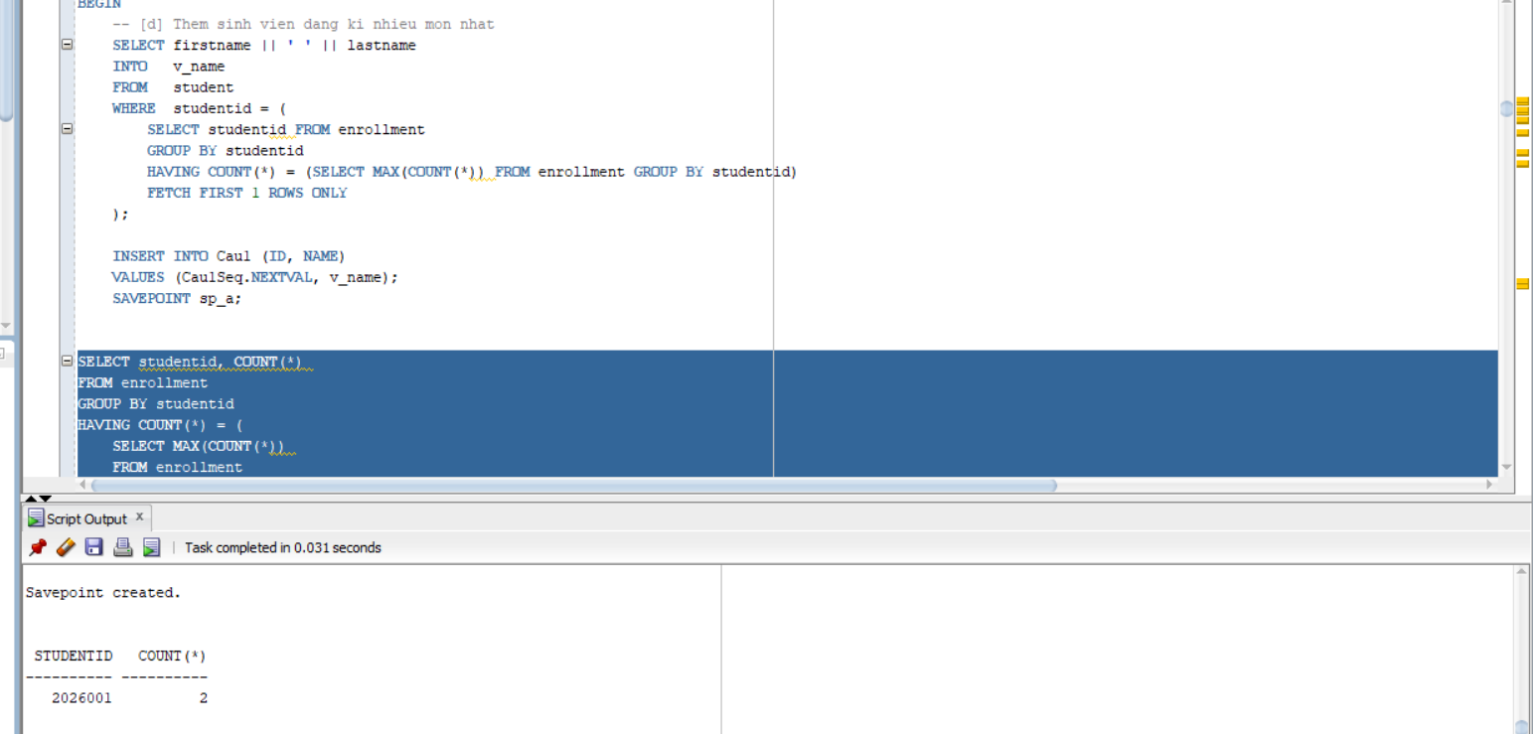
-- [e] Them sinh vien dang ki it mon nhat

SELECT firstname || ' ' || lastname
INTO v_name
FROM student
WHERE studentid = (
SELECT studentid FROM enrollment
GROUP BY studentid
HAVING COUNT(*) = (SELECT MIN(COUNT(*)) FROM enrollment GROUP BY studentid)
FETCH FIRST 1 ROWS ONLY
);

INSERT INTO Cau1 (ID, NAME)
VALUES (Cau1Seq.NEXTVAL, v_name);
SAVEPOINT sp_b; -- Savepoint B
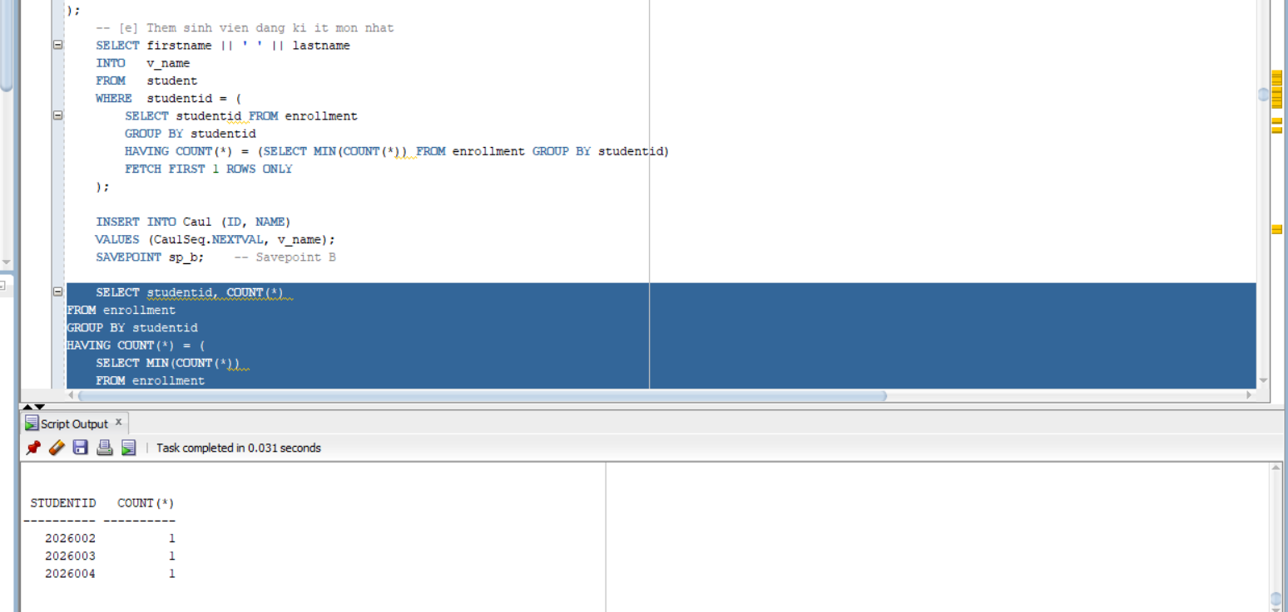

-- [f] Them giao vien day nhieu lop nhat

SELECT i.firstname || ' ' || i.lastname
INTO v_name
FROM instructor i
WHERE i.instructorid = (
SELECT instructorid FROM class
GROUP BY instructorid
HAVING COUNT(*) = (SELECT MAX(COUNT(*)) FROM class GROUP BY instructorid)
FETCH FIRST 1 ROWS ONLY
);

INSERT INTO Cau1 (ID, NAME)
VALUES (Cau1Seq.NEXTVAL, v_name);
SAVEPOINT sp_c; -- Savepoint C
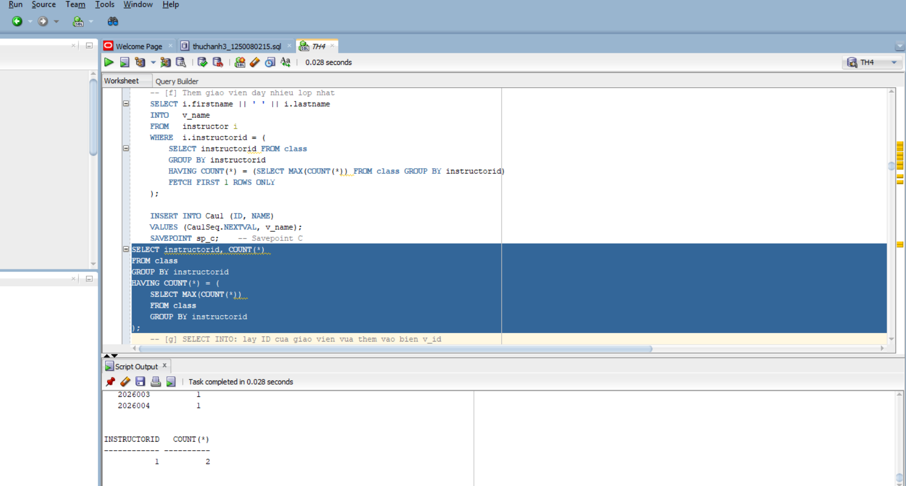

-- [g] SELECT INTO: lay ID cua giao vien vua them vao bien v_id

SELECT ID INTO v_id
FROM Cau1
WHERE NAME = v_name;

DBMS_OUTPUT.PUT_LINE('ID giao vien nhieu lop: ' || v_id);

-- [h] Rollback giao vien nhieu lop (ve Savepoint B)
ROLLBACK TO sp_b;

-- [i] Them giao vien it lop nhat, dung v_id da luu
SELECT i.firstname || ' ' || i.lastname
INTO v_name
FROM instructor i
WHERE i.instructorid = (
SELECT instructorid FROM class
GROUP BY instructorid
HAVING COUNT(*) = (SELECT MIN(COUNT(*)) FROM class GROUP BY instructorid)
FETCH FIRST 1 ROWS ONLY
);

INSERT INTO Cau1 (ID, NAME)
VALUES (v_id, v_name); -- Dung v_id (khong phai sequence)
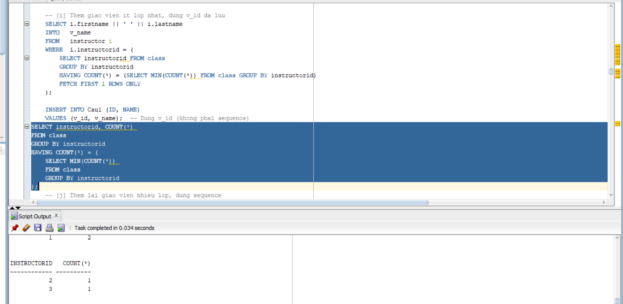

-- [j] Them lai giao vien nhieu lop, dung sequence

SELECT i.firstname || ' ' || i.lastname
INTO v_name
FROM instructor i
WHERE i.instructorid = (
SELECT instructorid FROM class
GROUP BY instructorid
HAVING COUNT(*) = (SELECT MAX(COUNT(*)) FROM class GROUP BY instructorid)
FETCH FIRST 1 ROWS ONLY
);

INSERT INTO Cau1 (ID, NAME)
VALUES (Cau1Seq.NEXTVAL, v_name); -- Dung sequence

COMMIT;
DBMS_OUTPUT.PUT_LINE('Hoan tat! Kiem tra: SELECT * FROM Cau1;');

EXCEPTION
WHEN NO_DATA_FOUND THEN
DBMS_OUTPUT.PUT_LINE('Loi: Khong tim thay du lieu!');
ROLLBACK;
WHEN OTHERS THEN
DBMS_OUTPUT.PUT_LINE('Loi: ' || SQLERRM);
ROLLBACK;
END;
/
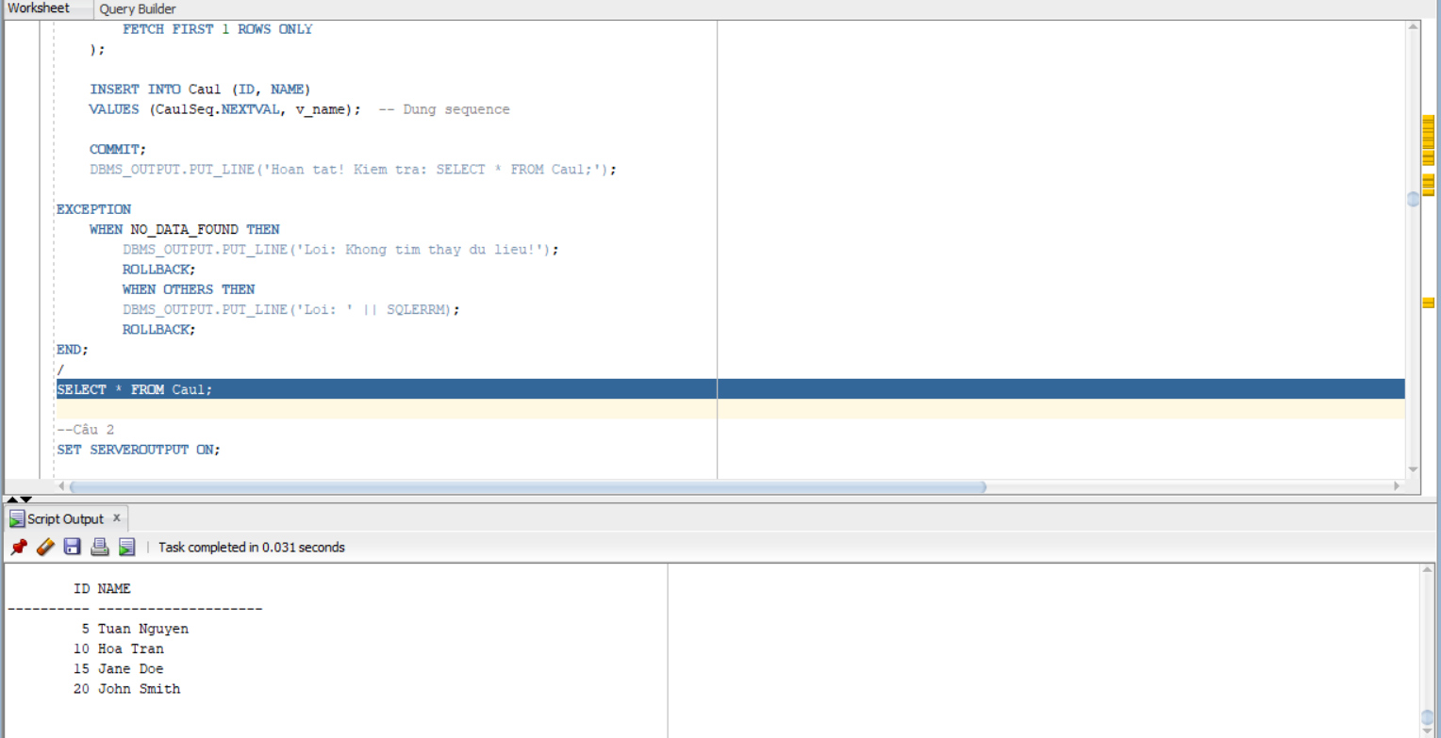

--Câu 2
SET SERVEROUTPUT ON;

DECLARE
v_sid NUMBER := &ma_sinh_vien;
v_fname VARCHAR2(25) := '&ho_sinh_vien';
v_lname VARCHAR2(25) := '&ten_sinh_vien';
v_addr VARCHAR2(50) := '&dia_chi';
v_found VARCHAR2(50);
v_classes NUMBER;
BEGIN
-- Thu tim sinh vien theo ma vua nhap
SELECT firstname || ' ' || lastname
INTO v_found
FROM student
WHERE studentid = v_sid;

-- Neu tim thay: dem so lop dang hoc
SELECT COUNT(*)
INTO v_classes
FROM enrollment
WHERE studentid = v_sid;

DBMS_OUTPUT.PUT_LINE('Ho ten: ' || v_found);
DBMS_OUTPUT.PUT_LINE('So lop dang hoc: ' || v_classes);

EXCEPTION
WHEN NO_DATA_FOUND THEN
-- Sinh vien chua ton tai: them moi
DBMS_OUTPUT.PUT_LINE('Sinh vien chua ton tai. Dang them moi...');
INSERT INTO student (studentid, firstname, lastname, address,
registrationdate, createdby, createddate,
modifiedby, modifieddate)
VALUES (v_sid, v_fname, v_lname, v_addr,
SYSDATE, USER, SYSDATE, USER, SYSDATE);

COMMIT;
DBMS_OUTPUT.PUT_LINE('Da them sinh vien moi: ' || v_fname || ' ' || v_lname);
END;
/

--Bài 2
--Câu 1
SET SERVEROUTPUT ON;

DECLARE
v_instructor_id NUMBER := &ma_giao_vien;
v_so_lop NUMBER;
BEGIN
-- Dem so lop giao vien dang day
SELECT COUNT(*)
INTO v_so_lop
FROM class
WHERE instructorid = v_instructor_id;

-- Phan nhanh theo ket qua
IF v_so_lop >= 5 THEN
DBMS_OUTPUT.PUT_LINE('Giao vien nay nen nghi ngoi!');
ELSE
DBMS_OUTPUT.PUT_LINE('So lop giao vien dang day: ' || v_so_lop);
END IF;

EXCEPTION
WHEN NO_DATA_FOUND THEN
DBMS_OUTPUT.PUT_LINE('Khong tim thay giao vien co ma: ' || v_instructor_id);
END;
/
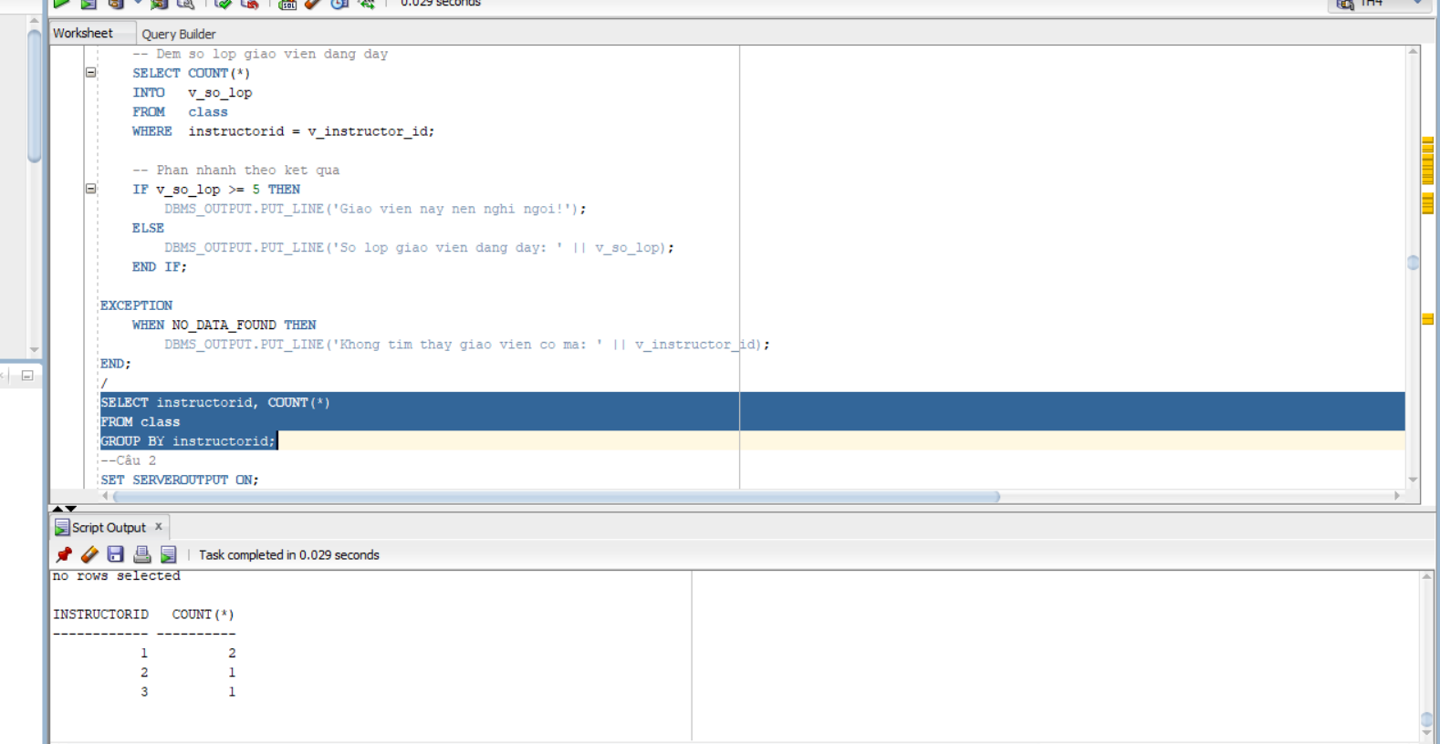

--Câu 2

SET SERVEROUTPUT ON;

DECLARE
v_sid NUMBER := &ma_sinh_vien;
v_cid NUMBER := &ma_lop;
v_score NUMBER;
v_grade VARCHAR2(2);
v_check NUMBER;
BEGIN
-- Kiem tra sinh vien ton tai
SELECT COUNT(*) INTO v_check
FROM student WHERE studentid = v_sid;

IF v_check = 0 THEN
DBMS_OUTPUT.PUT_LINE('Loi: Ma sinh vien ' || v_sid || ' khong ton tai!');
RETURN;
END IF;

-- Kiem tra lop ton tai
SELECT COUNT(*) INTO v_check
FROM class WHERE classid = v_cid;

IF v_check = 0 THEN
DBMS_OUTPUT.PUT_LINE('Loi: Ma lop ' || v_cid || ' khong ton tai!');
RETURN;
END IF;

-- Lay diem cua sinh vien trong lop
SELECT finalgrade
INTO v_score
FROM enrollment
WHERE studentid = v_sid AND classid = v_cid;

-- Quy doi diem so sang diem chu bang CASE
CASE
WHEN v_score >= 90 THEN v_grade := 'A';
WHEN v_score >= 80 THEN v_grade := 'B';
WHEN v_score >= 70 THEN v_grade := 'C';
WHEN v_score >= 50 THEN v_grade := 'D';
ELSE v_grade := 'F';
END CASE;

DBMS_OUTPUT.PUT_LINE('Diem so: ' || v_score || ' -> Diem chu: ' || v_grade);

EXCEPTION
WHEN NO_DATA_FOUND THEN
DBMS_OUTPUT.PUT_LINE('Sinh vien chua dang ky lop nay hoac chua co diem!');
END;
/
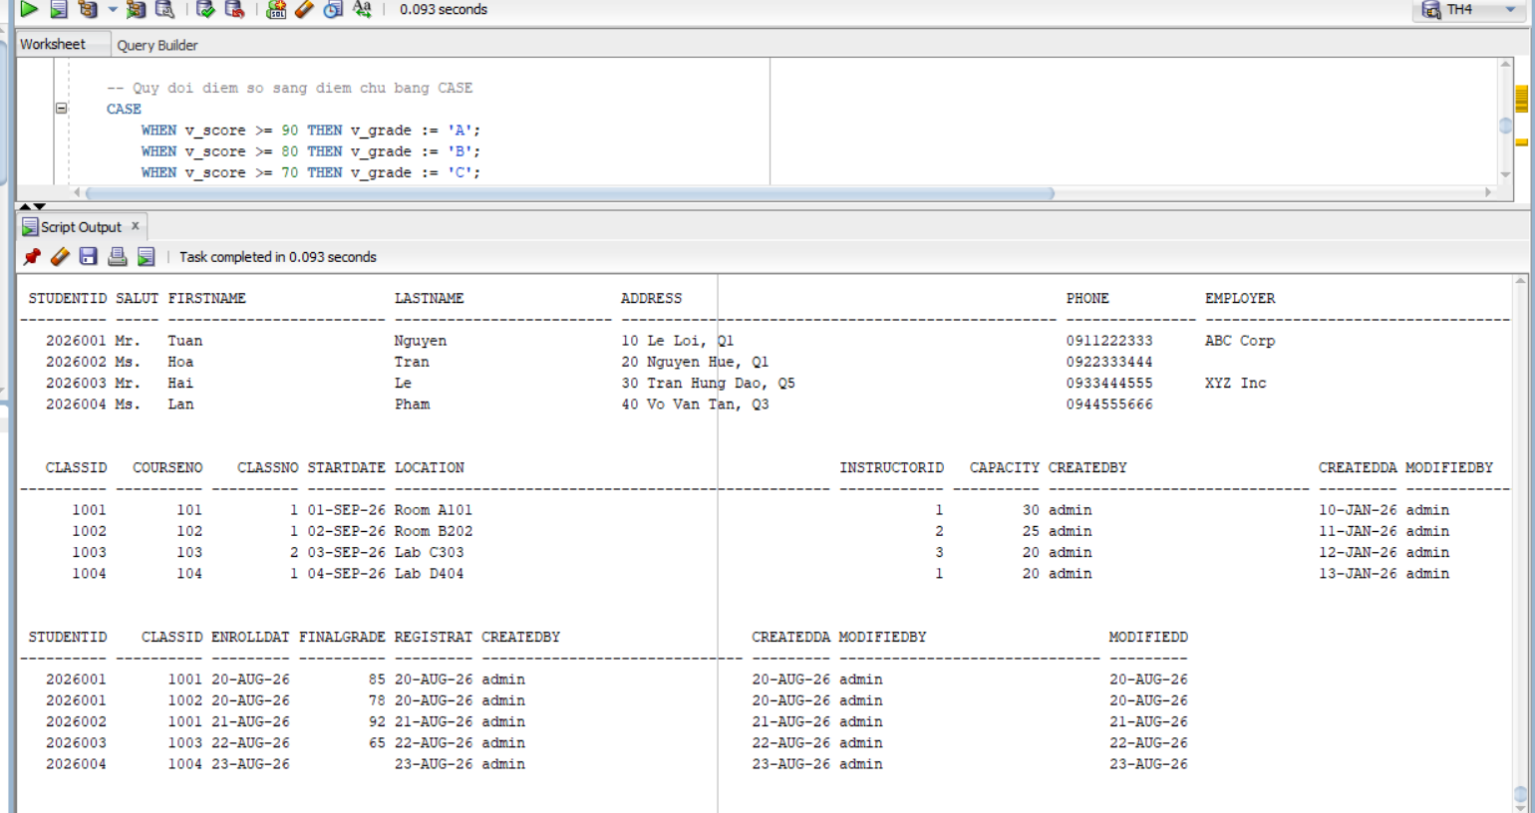

--Bài 3

SET SERVEROUTPUT ON;

DECLARE
-- Cursor 1: Duyet tung mon hoc
CURSOR cur_course IS
SELECT courseno, description
FROM course
ORDER BY courseno;

-- Cursor 2: Lay lop hoc cua mot mon (co doi so)
CURSOR cur_class (p_courseno NUMBER) IS
SELECT c.classno,
COUNT(e.studentid) AS so_sv
FROM class c
LEFT JOIN enrollment e ON c.classid = e.classid
WHERE c.courseno = p_courseno
GROUP BY c.classno
ORDER BY c.classno;

v_courseno course.courseno%TYPE;
v_desc course.description%TYPE;
v_classno class.classno%TYPE;
v_count NUMBER;

BEGIN
-- Duyet cursor ngoai: tung mon hoc
OPEN cur_course;
LOOP
FETCH cur_course INTO v_courseno, v_desc;
EXIT WHEN cur_course%NOTFOUND;

-- In ten mon hoc
DBMS_OUTPUT.PUT_LINE(v_courseno || ' ' || v_desc);

-- Mo cursor trong voi doi so la ma mon hoc hien tai
OPEN cur_class(v_courseno);
LOOP
FETCH cur_class INTO v_classno, v_count;
EXIT WHEN cur_class%NOTFOUND;

DBMS_OUTPUT.PUT_LINE('Lop: ' || v_classno ||
' co so luong sinh vien dang ki: ' || v_count);
END LOOP;
CLOSE cur_class;

END LOOP;
CLOSE cur_course;

EXCEPTION
WHEN OTHERS THEN
IF cur_course%ISOPEN THEN CLOSE cur_course; END IF;
IF cur_class%ISOPEN THEN CLOSE cur_class; END IF;
DBMS_OUTPUT.PUT_LINE('Co loi xay ra: ' || SQLERRM);
END;
/
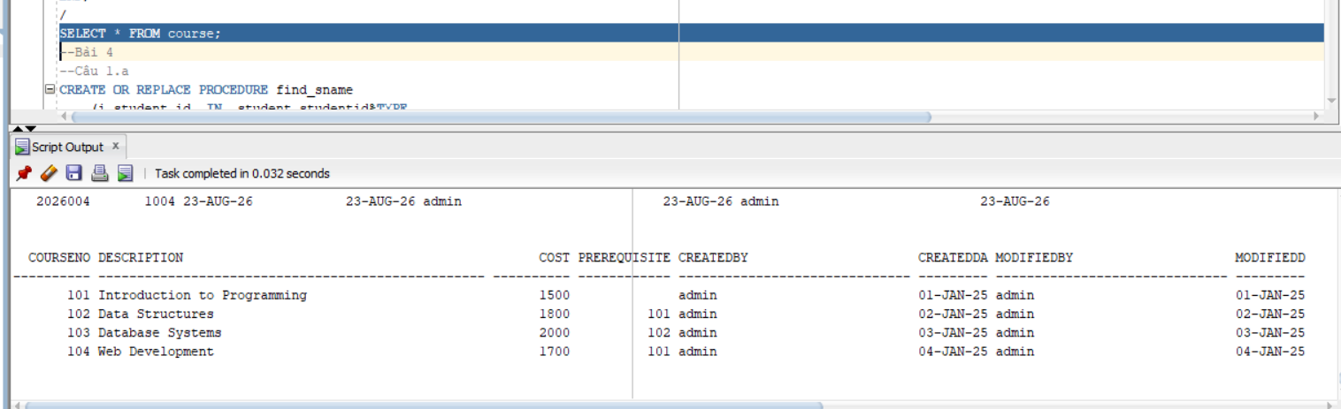
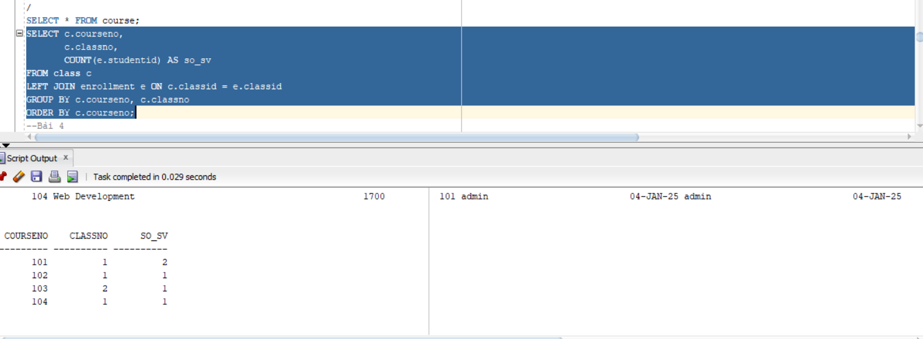
--Bài 4
--Câu 1.a
CREATE OR REPLACE PROCEDURE find_sname
(i_student_id IN student.studentid%TYPE,
o_first_name OUT student.firstname%TYPE,
o_last_name OUT student.lastname%TYPE)
IS
BEGIN
SELECT firstname, lastname
INTO o_first_name, o_last_name
FROM student
WHERE studentid = i_student_id;

EXCEPTION
WHEN NO_DATA_FOUND THEN
o_first_name := NULL;
o_last_name := NULL;
DBMS_OUTPUT.PUT_LINE('Khong tim thay sinh vien ID: ' || i_student_id);
END find_sname;
/

--Câu 1.b

CREATE OR REPLACE PROCEDURE print_student_name
(i_student_id IN student.studentid%TYPE)
IS
v_first student.firstname%TYPE;
v_last student.lastname%TYPE;
BEGIN
-- Goi thu tuc find_sname da co san
find_sname(i_student_id, v_first, v_last);

IF v_first IS NOT NULL OR v_last IS NOT NULL THEN
DBMS_OUTPUT.PUT_LINE('Ho ten sinh vien: ' || v_first || ' ' || v_last);
END IF;
END print_student_name;
/

-- Goi thu tuc de kiem tra:
BEGIN
print_student_name(101);
END;
/
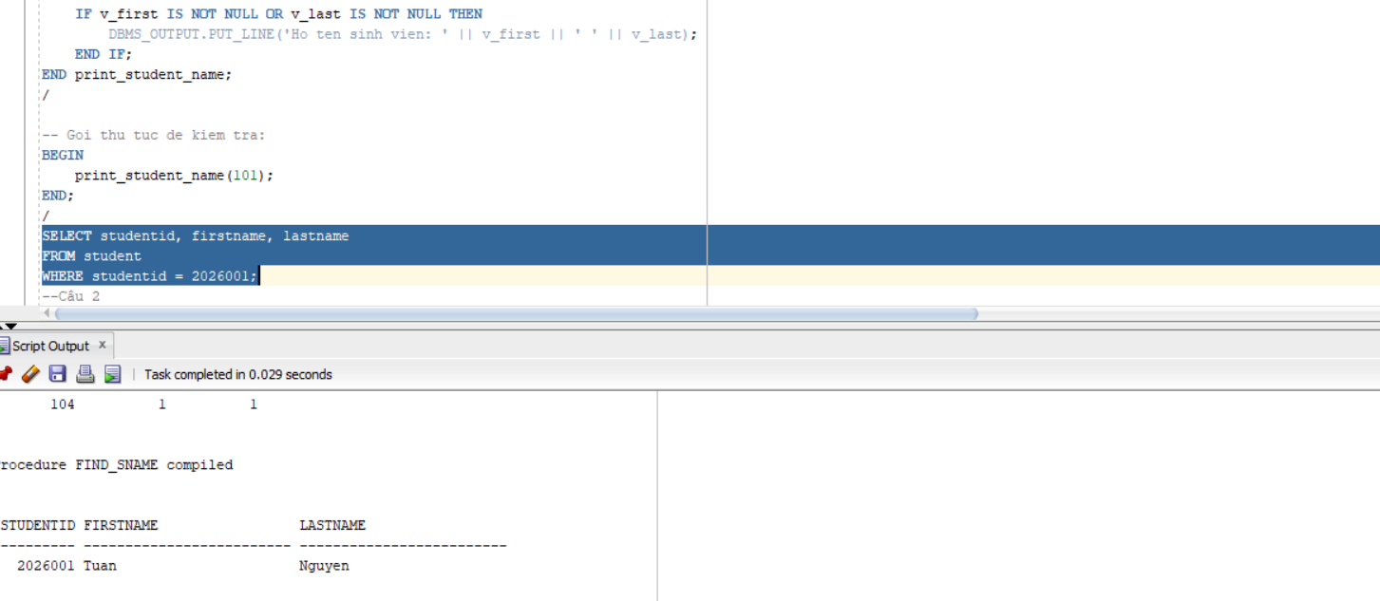

--Câu 2

CREATE OR REPLACE PROCEDURE Discount
IS
BEGIN
FOR rec IN (
SELECT c.courseno, c.description, c.cost
FROM course c
WHERE (SELECT COUNT(*) FROM enrollment e
JOIN class cl ON e.classid = cl.classid
WHERE cl.courseno = c.courseno) > 15
) LOOP
-- Giam gia 5%
UPDATE course
SET cost = cost * 0.95
WHERE courseno = rec.courseno;

DBMS_OUTPUT.PUT_LINE('Da giam gia mon hoc: ' || rec.description
|| ' | Gia cu: ' || rec.cost
|| ' | Gia moi: ' || ROUND(rec.cost * 0.95, 2));
END LOOP;

COMMIT;
DBMS_OUTPUT.PUT_LINE('Hoan tat giam gia.');
EXCEPTION
WHEN OTHERS THEN
ROLLBACK;
DBMS_OUTPUT.PUT_LINE('Loi: ' || SQLERRM);
END Discount;
/
-- Goi thu tuc:
BEGIN Discount; END;
/
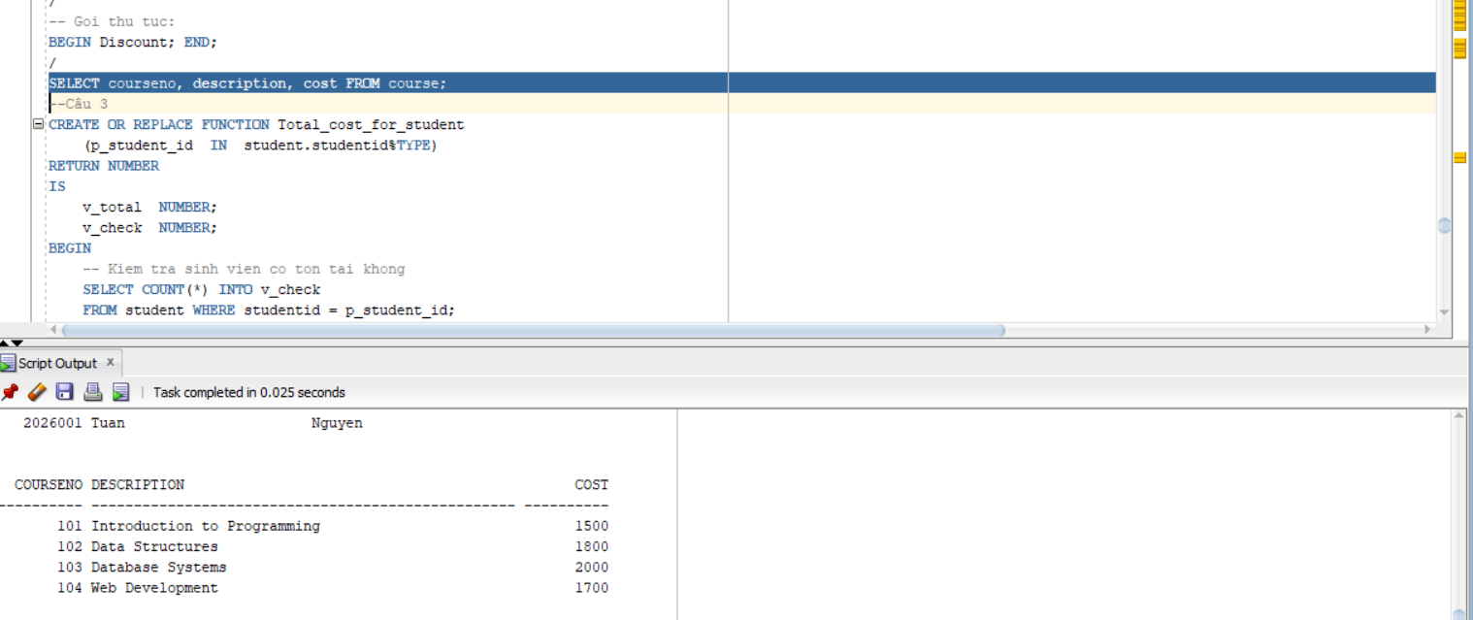
--Câu 3
CREATE OR REPLACE FUNCTION Total_cost_for_student
(p_student_id IN student.studentid%TYPE)
RETURN NUMBER
IS
v_total NUMBER;
v_check NUMBER;
BEGIN
-- Kiem tra sinh vien co ton tai khong
SELECT COUNT(*) INTO v_check
FROM student WHERE studentid = p_student_id;

IF v_check = 0 THEN
RETURN NULL; -- Sinh vien khong ton tai
END IF;

-- Tinh tong chi phi: sum(cost cua tung mon da dang ky)
SELECT NVL(SUM(co.cost), 0)
INTO v_total
FROM enrollment e
JOIN class cl ON e.classid = cl.classid
JOIN course co ON cl.courseno = co.courseno
WHERE e.studentid = p_student_id;

RETURN v_total;

EXCEPTION
WHEN OTHERS THEN
RETURN NULL;
END Total_cost_for_student;
/

-- Goi ham de kiem tra:
SELECT Total_cost_for_student(101) AS "Tong chi phi" FROM DUAL;

-- Hoac trong PL/SQL:
BEGIN
DBMS_OUTPUT.PUT_LINE('Tong chi phi: ' || Total_cost_for_student(101));
END;
/
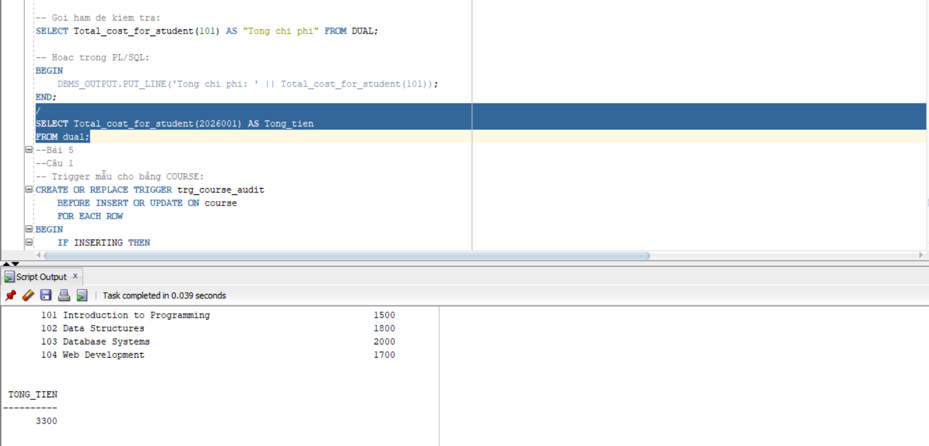
--Bài 5
--Câu 1

-- Trigger mẫu cho bảng COURSE:
CREATE OR REPLACE TRIGGER trg_course_audit
BEFORE INSERT OR UPDATE ON course
FOR EACH ROW
BEGIN
IF INSERTING THEN
:NEW.created_by := USER;
:NEW.created_date := SYSDATE;
END IF;

-- Luon cap nhat modified (ca khi INSERT lan UPDATE)
:NEW.modified_by := USER;
:NEW.modified_date := SYSDATE;
END trg_course_audit;
/

-- Trigger tương tự cho bảng CLASS:
CREATE OR REPLACE TRIGGER trg_class_audit
BEFORE INSERT OR UPDATE ON class
FOR EACH ROW
BEGIN
IF INSERTING THEN
:NEW.created_by := USER;
:NEW.created_date := SYSDATE;
END IF;

:NEW.modified_by := USER;
:NEW.modified_date := SYSDATE;
END trg_class_audit;
/

-- STUDENT
CREATE OR REPLACE TRIGGER trg_student_audit
BEFORE INSERT OR UPDATE ON student FOR EACH ROW
BEGIN
IF INSERTING THEN :NEW.created_by:=USER; :NEW.created_date:=SYSDATE; END IF;
:NEW.modified_by:=USER; :NEW.modified_date:=SYSDATE;
END; /

-- ENROLLMENT
CREATE OR REPLACE TRIGGER trg_enrollment_audit
BEFORE INSERT OR UPDATE ON enrollment FOR EACH ROW
BEGIN
IF INSERTING THEN :NEW.created_by:=USER; :NEW.created_date:=SYSDATE; END IF;
:NEW.modified_by:=USER; :NEW.modified_date:=SYSDATE;
END; /

-- INSTRUCTOR
CREATE OR REPLACE TRIGGER trg_instructor_audit
BEFORE INSERT OR UPDATE ON instructor FOR EACH ROW
BEGIN
IF INSERTING THEN :NEW.created_by:=USER; :NEW.created_date:=SYSDATE; END IF;
:NEW.modified_by:=USER; :NEW.modified_date:=SYSDATE;
END; /

-- GRADE
CREATE OR REPLACE TRIGGER trg_grade_audit
BEFORE INSERT OR UPDATE ON grade FOR EACH ROW
BEGIN
IF INSERTING THEN :NEW.created_by:=USER; :NEW.created_date:=SYSDATE; END IF;
:NEW.modified_by:=USER; :NEW.modified_date:=SYSDATE;
END; /

--Câu 2
CREATE OR REPLACE TRIGGER trg_max_enrollment
BEFORE INSERT ON enrollment
FOR EACH ROW
DECLARE
v_so_lop NUMBER;
BEGIN
-- Dem so lop sinh vien nay dang dang ky
SELECT COUNT(*)
INTO v_so_lop
FROM enrollment
WHERE studentid = :NEW.studentid;

-- Neu da co 3 lop tro len thi tu choi
IF v_so_lop >= 3 THEN
RAISE_APPLICATION_ERROR(
-20001,
'Sinh vien ' || :NEW.studentid ||
' da dang ky du 3 lop! Khong the dang ky them.'
);
END IF;
END trg_max_enrollment;
/

-- Kiem tra trigger:
-- Gia su sinh vien 101 da co 3 lop, thu them lop thu 4:
INSERT INTO enrollment (studentid, classid, enrolldate, createdby,
createddate, modifiedby, modifieddate)
VALUES (101, 999, SYSDATE, USER, SYSDATE, USER, SYSDATE);--

LAB4

-- COURSE
INSERT INTO COURSE VALUES (10,'DP Overview',100,NULL,USER,SYSDATE,USER,SYSDATE);
INSERT INTO COURSE VALUES (20,'Intro to Computers',150,NULL,USER,SYSDATE,USER,SYSDATE);

-- INSTRUCTOR
INSERT INTO INSTRUCTOR VALUES (1,'Mr','An','Nguyen','HCM','0901',USER,SYSDATE,USER,SYSDATE);
INSERT INTO INSTRUCTOR VALUES (2,'Ms','Lan','Tran','HCM','0902',USER,SYSDATE,USER,SYSDATE);
-- STUDENT
INSERT INTO STUDENT VALUES (1,'Mr','Nam','Le','HCM','111','ABC',SYSDATE,USER,SYSDATE,USER,SYSDATE);
INSERT INTO STUDENT VALUES (2,'Ms','Hoa','Pham','HCM','222','XYZ',SYSDATE,USER,SYSDATE,USER,SYSDATE);
INSERT INTO STUDENT VALUES (3,'Mr','Minh','Vo','HCM','333','DEF',SYSDATE,USER,SYSDATE,USER,SYSDATE);
-- CLASS
INSERT INTO CLASS VALUES (1,10,1,SYSDATE,'Room1',1,30,USER,SYSDATE,USER,SYSDATE);
INSERT INTO CLASS VALUES (2,20,1,SYSDATE,'Room2',2,30,USER,SYSDATE,USER,SYSDATE);
-- ENROLLMENT
INSERT INTO ENROLLMENT VALUES (1,1,SYSDATE,90,USER,SYSDATE,USER,SYSDATE);
INSERT INTO ENROLLMENT VALUES (1,2,SYSDATE,85,USER,SYSDATE,USER,SYSDATE);
INSERT INTO ENROLLMENT VALUES (2,2,SYSDATE,80,USER,SYSDATE,USER,SYSDATE);
INSERT INTO ENROLLMENT VALUES (3,2,SYSDATE,70,USER,SYSDATE,USER,SYSDATE);
COMMIT;

Bài 1: Khối lệnh PL/SQL cơ bản
Câu a

CREATE TABLE Cau1 (
ID NUMBER,
NAME VARCHAR2(50)
);

Câu b

CREATE SEQUENCE Cau1Seq
START WITH 1
INCREMENT BY 5;

Câu c

DECLARE
v_name VARCHAR2(50);
v_id NUMBER;
BEGIN
NULL;
END;
/
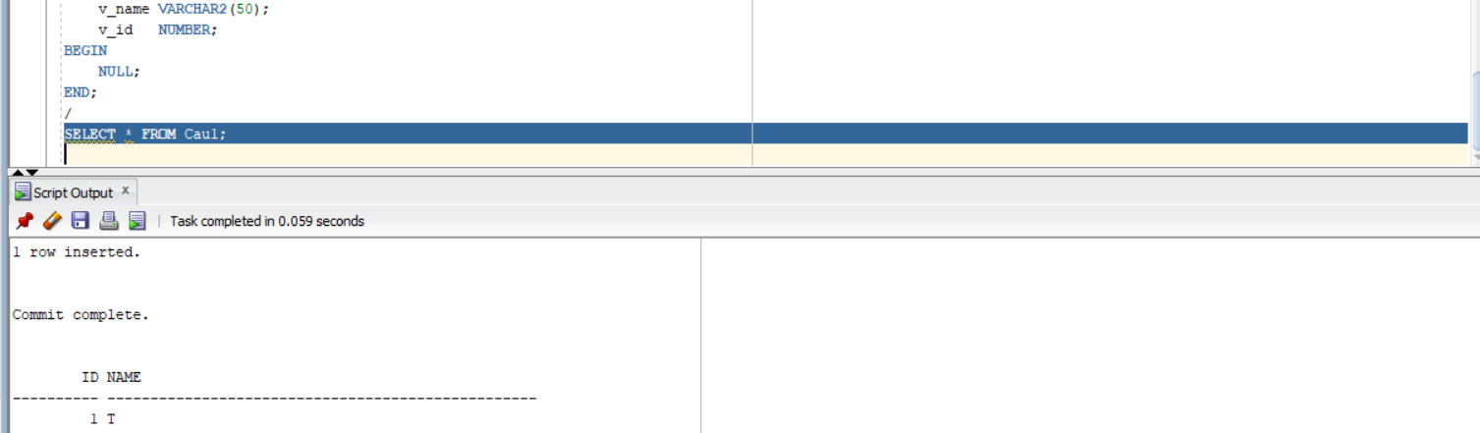
Câu d

DECLARE
v_name VARCHAR2(50);
v_id NUMBER;
BEGIN
SELECT s.FirstName || ' ' || s.LastName
INTO v_name
FROM STUDENT s
JOIN ENROLLMENT e ON s.StudentID = e.StudentID
GROUP BY s.StudentID, s.FirstName, s.LastName
ORDER BY COUNT(*) DESC
FETCH FIRST 1 ROWS ONLY;

v_id := Cau1Seq.NEXTVAL;

INSERT INTO Cau1 (ID, NAME)
VALUES (v_id, v_name);

SAVEPOINT A;

DBMS_OUTPUT.PUT_LINE('Da them: ' || v_name);
END;
/
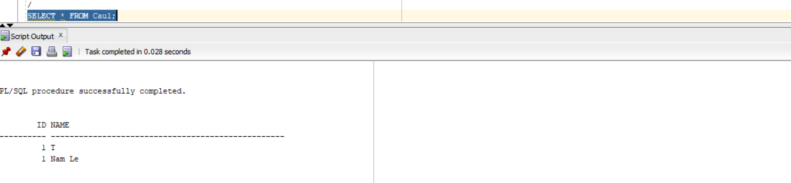

Câu e

DECLARE
v_name VARCHAR2(50);
v_id NUMBER;
BEGIN
SELECT s.FirstName || ' ' || s.LastName
INTO v_name
FROM STUDENT s
JOIN ENROLLMENT e ON s.StudentID = e.StudentID
GROUP BY s.StudentID, s.FirstName, s.LastName
ORDER BY COUNT(*) ASC
FETCH FIRST 1 ROWS ONLY;

v_id := Cau1Seq.NEXTVAL;

INSERT INTO Cau1 (ID, NAME)
VALUES (v_id, v_name);

SAVEPOINT B;

DBMS_OUTPUT.PUT_LINE('Da them (it nhat): ' || v_name);
END;
/
SELECT * FROM Cau1;
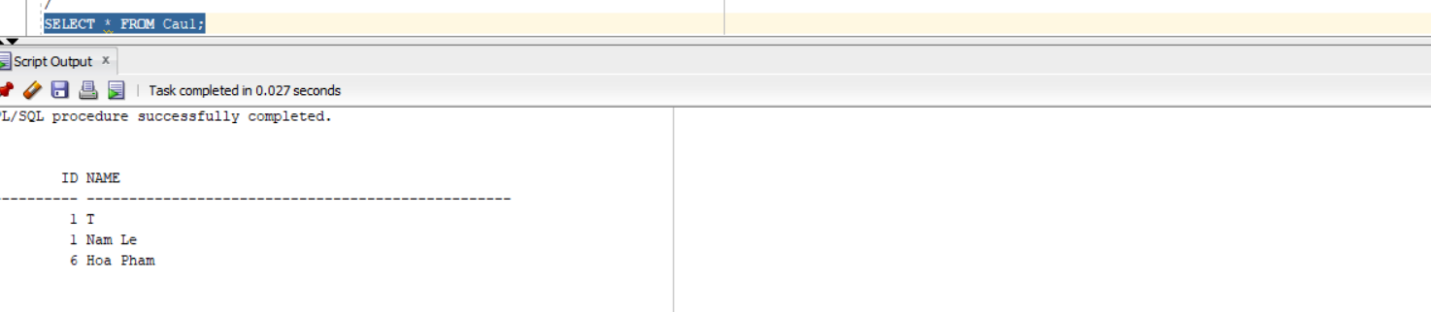

Câu f

DECLARE
v_name VARCHAR2(50);
v_id NUMBER;
BEGIN
SELECT i.FirstName || ' ' || i.LastName
INTO v_name
FROM INSTRUCTOR i
JOIN CLASS c ON i.InstructorID = c.InstructorID
GROUP BY i.InstructorID, i.FirstName, i.LastName
ORDER BY COUNT(*) DESC
FETCH FIRST 1 ROWS ONLY;

v_id := Cau1Seq.NEXTVAL;

INSERT INTO Cau1 (ID, NAME)
VALUES (v_id, v_name);

SAVEPOINT C;

DBMS_OUTPUT.PUT_LINE('GV nhieu lop nhat: ' || v_name);
END;
/
SELECT * FROM Cau1;
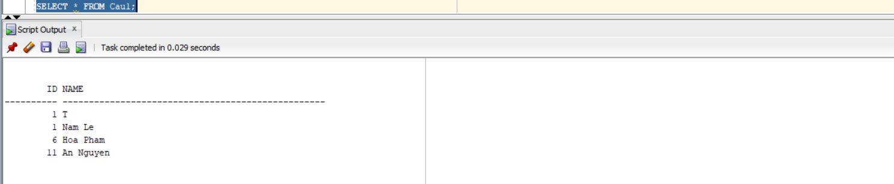

Câu g

DECLARE
v_name VARCHAR2(50) := 'An Nguyen';
v_id NUMBER;
BEGIN
SELECT InstructorID
INTO v_id
FROM INSTRUCTOR
WHERE FirstName || ' ' || LastName = v_name;

DBMS_OUTPUT.PUT_LINE('ID tim duoc: ' || v_id);
END;
/
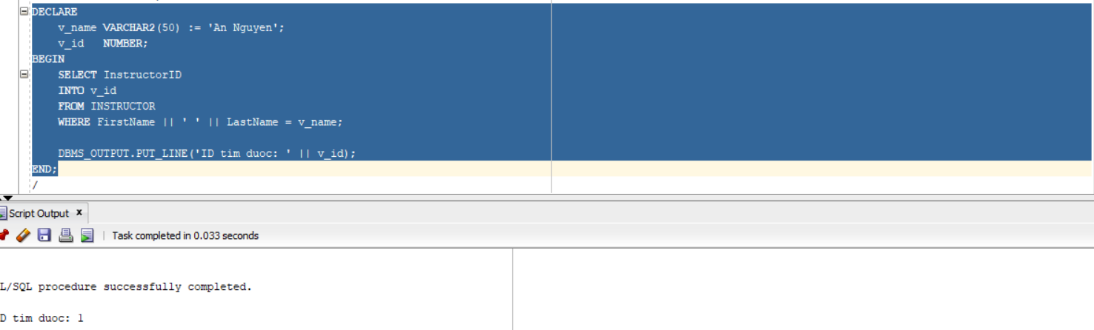

Câu h

BEGIN
ROLLBACK TO C;
DBMS_OUTPUT.PUT_LINE('Da rollback ve savepoint C');
END;
/

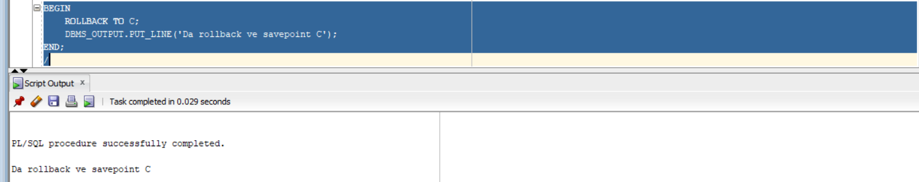

Câu i

DECLARE
v_name VARCHAR2(50);
v_id NUMBER := 11;
BEGIN
SELECT i.FirstName || ' ' || i.LastName
INTO v_name
FROM INSTRUCTOR i
JOIN CLASS c ON i.InstructorID = c.InstructorID
GROUP BY i.InstructorID, i.FirstName, i.LastName
ORDER BY COUNT(*) ASC
FETCH FIRST 1 ROWS ONLY;

INSERT INTO Cau1 (ID, NAME)
VALUES (v_id, v_name);

DBMS_OUTPUT.PUT_LINE('Da them: ' || v_name);
END;
/
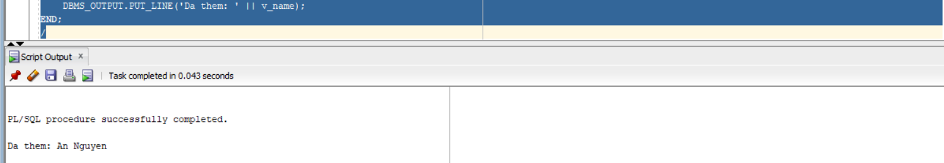

Câu j

DECLARE
v_name VARCHAR2(50);
v_id NUMBER;
BEGIN
-- GV dạy nhiều lớp nhất
SELECT i.FirstName || ' ' || i.LastName
INTO v_name
FROM INSTRUCTOR i
JOIN CLASS c ON i.InstructorID = c.InstructorID
GROUP BY i.InstructorID, i.FirstName, i.LastName
ORDER BY COUNT(*) DESC
FETCH FIRST 1 ROWS ONLY;
-- dùng sequence
v_id := Cau1Seq.NEXTVAL;
INSERT INTO Cau1 VALUES (v_id, v_name);
DBMS_OUTPUT.PUT_LINE('Da them lai GV nhieu lop nhat: ' || v_name);
END;
/
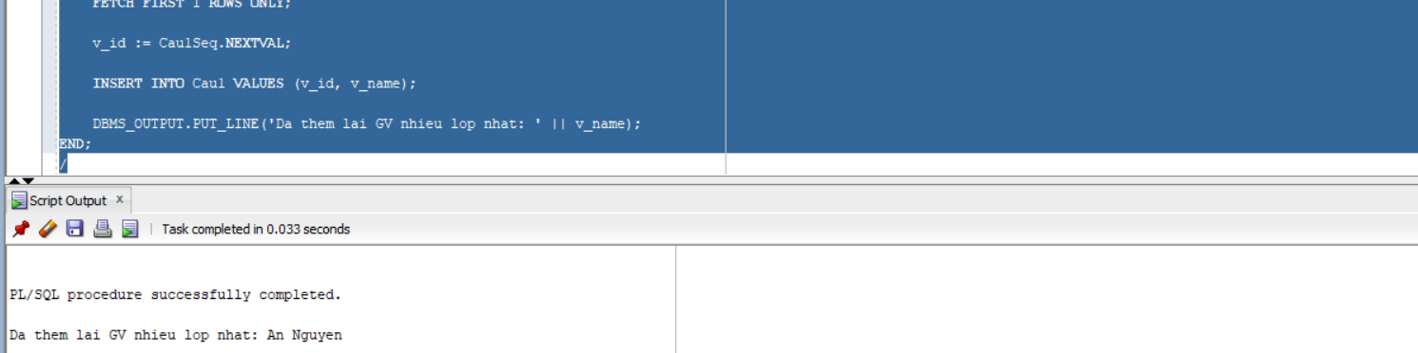

Bài 2: Các cấu trúc điều khiển

Câu 1

DECLARE
v_id NUMBER := &Nhap_Ma_GV;
v_count NUMBER;
BEGIN
SELECT COUNT(*)
INTO v_count
FROM CLASS
WHERE InstructorID = v_id;

IF v_count >= 5 THEN
DBMS_OUTPUT.PUT_LINE('Giao vien nay nen nghi ngoi!');
ELSE
DBMS_OUTPUT.PUT_LINE('So lop dang day: ' || v_count);
END IF;

END;
/
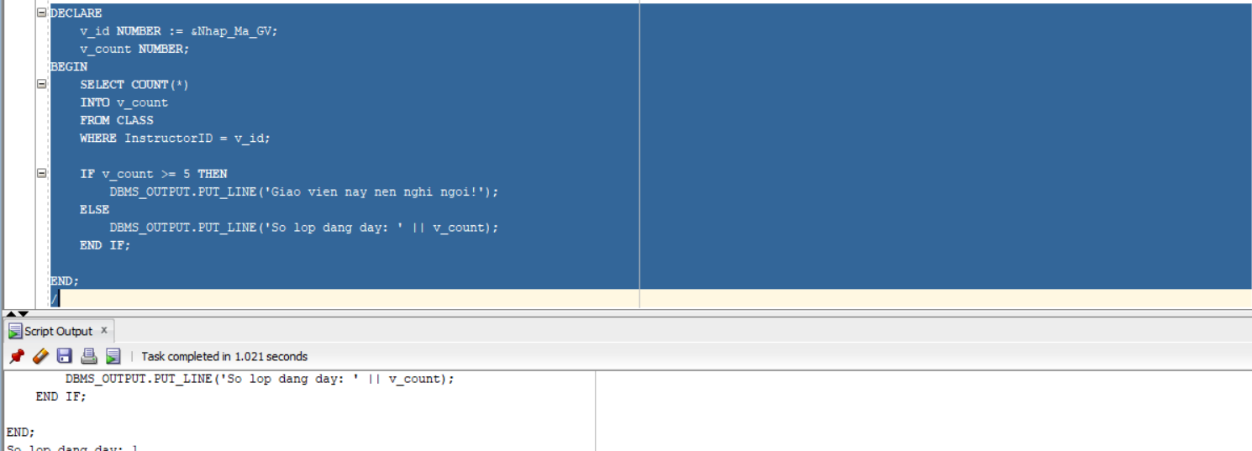

Câu 2
DECLARE
v_student_id NUMBER := &Nhap_Ma_SV;
v_class_id NUMBER := &Nhap_Ma_Lop;
v_grade NUMBER;
v_count NUMBER;
BEGIN
SELECT COUNT(*) INTO v_count
FROM STUDENT
WHERE StudentID = v_student_id;

IF v_count = 0 THEN
DBMS_OUTPUT.PUT_LINE('Khong ton tai sinh vien');
RETURN;
END IF;

SELECT COUNT(*) INTO v_count
FROM CLASS
WHERE ClassID = v_class_id;

IF v_count = 0 THEN
DBMS_OUTPUT.PUT_LINE('Khong ton tai lop');
RETURN;
END IF;

SELECT Grade INTO v_grade
FROM GRADE
WHERE StudentID = v_student_id
AND ClassID = v_class_id;

CASE
WHEN v_grade >= 90 THEN
DBMS_OUTPUT.PUT_LINE('Diem chu: A');
WHEN v_grade >= 80 THEN
DBMS_OUTPUT.PUT_LINE('Diem chu: B');
WHEN v_grade >= 70 THEN
DBMS_OUTPUT.PUT_LINE('Diem chu: C');
WHEN v_grade >= 50 THEN
DBMS_OUTPUT.PUT_LINE('Diem chu: D');
ELSE
DBMS_OUTPUT.PUT_LINE('Diem chu: F');
END CASE;

EXCEPTION
WHEN NO_DATA_FOUND THEN
DBMS_OUTPUT.PUT_LINE('Khong co diem cho sinh vien nay');
END;
/
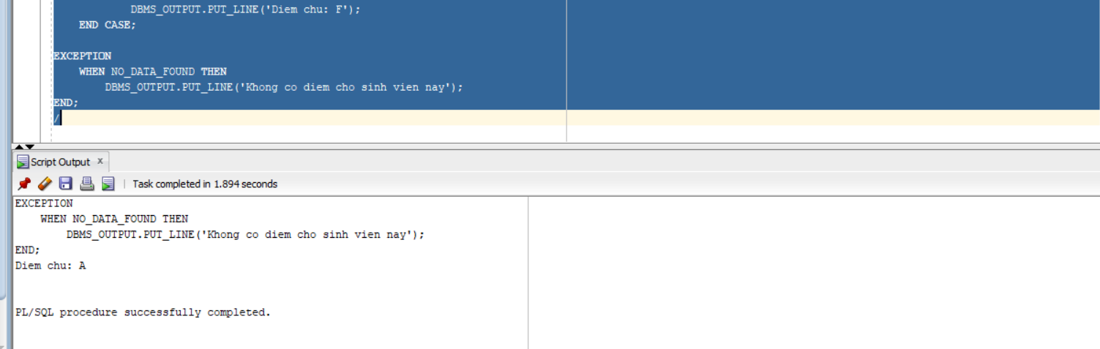

Bài 3: Cursor

DECLARE
CURSOR c_course IS
SELECT CourseNo, Description
FROM COURSE;

CURSOR c_class(p_courseNo NUMBER) IS
SELECT ClassID
FROM CLASS
WHERE CourseNo = p_courseNo;
v_count NUMBER;

BEGIN
FOR course_rec IN c_course LOOP
DBMS_OUTPUT.PUT_LINE(course_rec.CourseNo || ' ' || course_rec.Description);
FOR class_rec IN c_class(course_rec.CourseNo) LOOP

SELECT COUNT(*)
INTO v_count
FROM ENROLLMENT
WHERE ClassID = class_rec.ClassID;

DBMS_OUTPUT.PUT_LINE(' Lop: ' || class_rec.ClassID ||
' co so luong sinh vien dang ki: ' || v_count);
END LOOP;

END LOOP;
END;
/
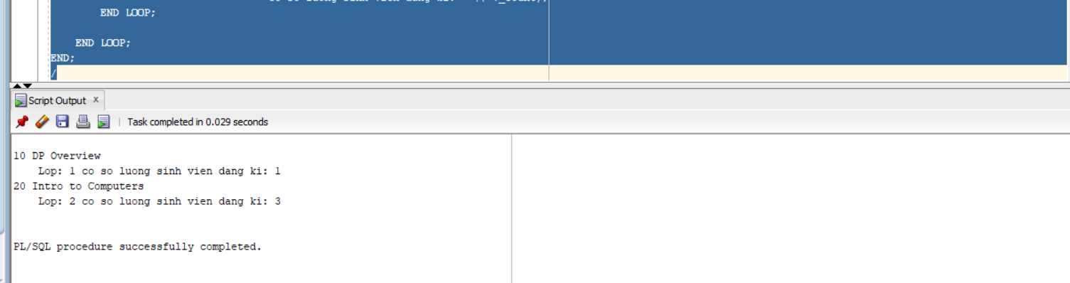
Bài 4: Các thủ tục và hàm

Câu 1

A)
CREATE OR REPLACE PROCEDURE find_sname (
i_student_id IN STUDENT.StudentID%TYPE,
o_first_name OUT STUDENT.FirstName%TYPE,
o_last_name OUT STUDENT.LastName%TYPE
)
IS
BEGIN
SELECT FirstName, LastName
INTO o_first_name, o_last_name
FROM STUDENT
WHERE StudentID = i_student_id;

EXCEPTION
WHEN NO_DATA_FOUND THEN
o_first_name := NULL;
o_last_name := NULL;
END;
/
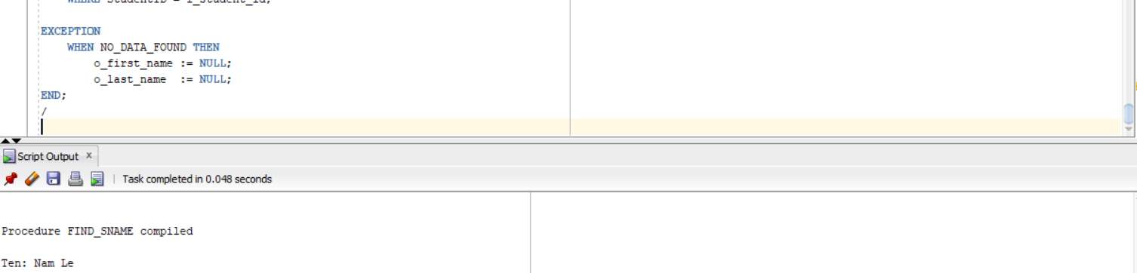

B)
CREATE OR REPLACE PROCEDURE print_student_name (
i_student_id IN STUDENT.StudentID%TYPE
)
IS
v_fname STUDENT.FirstName%TYPE;
v_lname STUDENT.LastName%TYPE;
BEGIN
SELECT FirstName, LastName
INTO v_fname, v_lname
FROM STUDENT
WHERE StudentID = i_student_id;

DBMS_OUTPUT.PUT_LINE('Ten sinh vien: ' || v_fname || ' ' || v_lname);

EXCEPTION
WHEN NO_DATA_FOUND THEN
DBMS_OUTPUT.PUT_LINE('Khong tim thay sinh vien');
END;
/

BEGIN
print_student_name(1);
END;
/
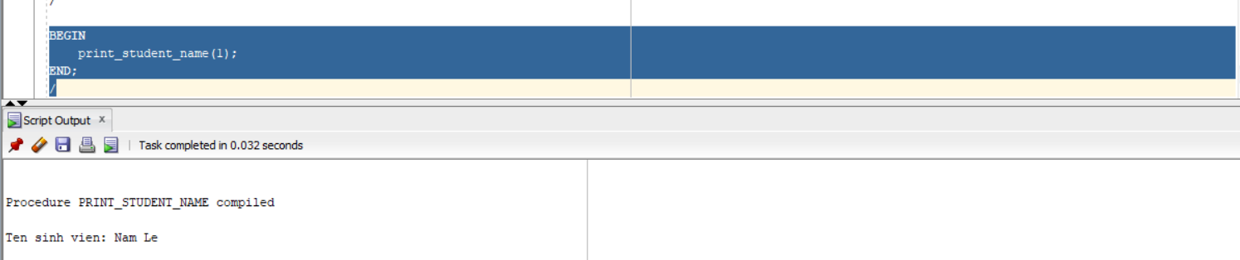

Câu 2
CREATE OR REPLACE PROCEDURE Discount
IS
BEGIN
FOR rec IN (
SELECT c.CourseNo, c.Description
FROM COURSE c
JOIN CLASS cl ON c.CourseNo = cl.CourseNo
JOIN ENROLLMENT e ON cl.ClassID = e.ClassID
GROUP BY c.CourseNo, c.Description
HAVING COUNT(e.StudentID) > 15
)
LOOP
UPDATE COURSE
SET Cost = Cost * 0.95
WHERE CourseNo = rec.CourseNo;

DBMS_OUTPUT.PUT_LINE('Da giam gia mon: ' || rec.Description);
END LOOP;

COMMIT;
END;
/

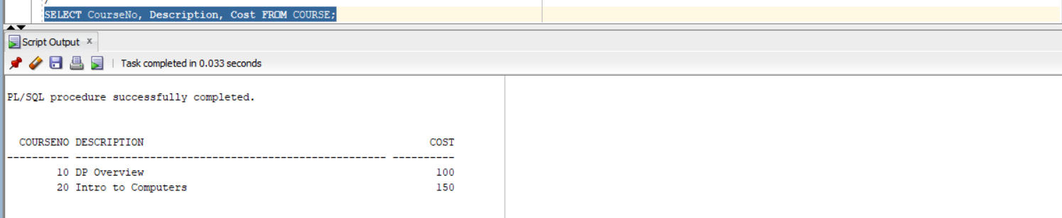

Câu 3
CREATE OR REPLACE FUNCTION Total_cost_for_student (
i_student_id IN STUDENT.StudentID%TYPE
)
RETURN NUMBER
IS
v_total NUMBER;
v_check NUMBER;
BEGIN
SELECT COUNT(*)
INTO v_check
FROM STUDENT
WHERE StudentID = i_student_id;

IF v_check = 0 THEN
RETURN NULL;
END IF;

SELECT SUM(c.Cost)
INTO v_total
FROM ENROLLMENT e
JOIN CLASS cl ON e.ClassID = cl.ClassID
JOIN COURSE c ON cl.CourseNo = c.CourseNo
WHERE e.StudentID = i_student_id;

RETURN v_total;

EXCEPTION
WHEN NO_DATA_FOUND THEN
RETURN NULL;
END;
/
SET SERVEROUTPUT ON;

DECLARE
v_total NUMBER;
BEGIN
v_total := Total_cost_for_student(1);

DBMS_OUTPUT.PUT_LINE('Tong hoc phi: ' || v_total);
END;
/
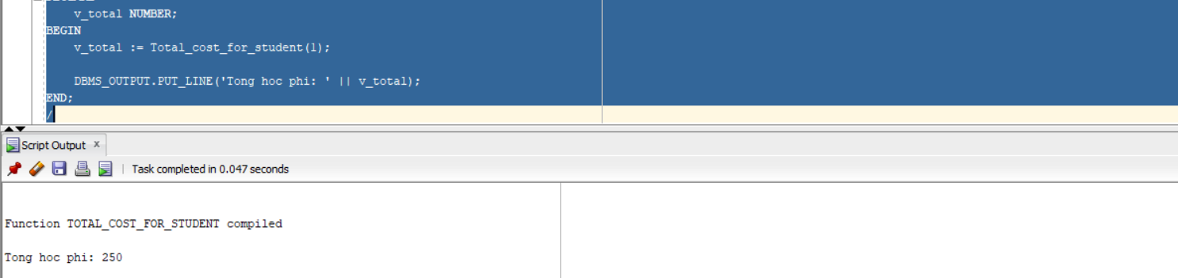

Bài 5: Trigger

Câu 1:

CREATE OR REPLACE TRIGGER trg_student_audit
BEFORE INSERT OR UPDATE ON STUDENT
FOR EACH ROW
BEGIN
IF INSERTING THEN
:NEW.created_by := USER;
:NEW.created_date := SYSDATE;
:NEW.modified_by := USER;
:NEW.modified_date := SYSDATE;
ELSE
:NEW.modified_by := USER;
:NEW.modified_date := SYSDATE;
END IF;
END;
/
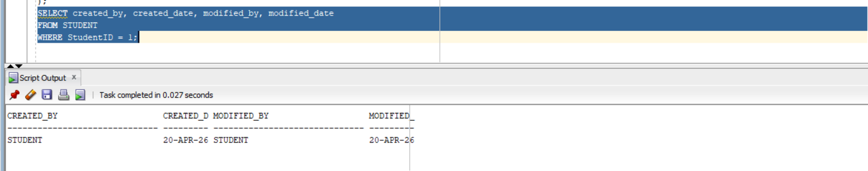
CREATE OR REPLACE TRIGGER trg_course_audit
BEFORE INSERT OR UPDATE ON COURSE
FOR EACH ROW
BEGIN
IF INSERTING THEN
:NEW.created_by := USER;
:NEW.created_date := SYSDATE;
:NEW.modified_by := USER;
:NEW.modified_date := SYSDATE;
ELSE
:NEW.modified_by := USER;
:NEW.modified_date := SYSDATE;
END IF;
END;
/
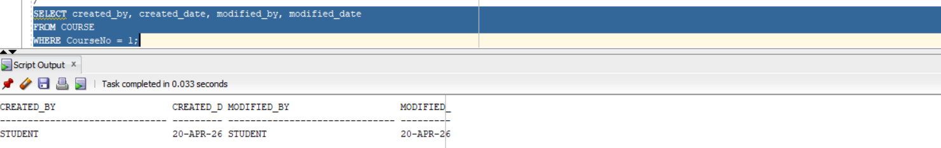
CREATE OR REPLACE TRIGGER trg_limit_subjects
BEFORE INSERT ON ENROLLMENT
FOR EACH ROW
DECLARE
v_count NUMBER;
BEGIN
SELECT COUNT(*)
INTO v_count
FROM ENROLLMENT
WHERE StudentID = :NEW.StudentID;

IF v_count >= 3 THEN
RAISE_APPLICATION_ERROR(-20001, 'Sinh vien khong duoc dang ky qua 3 mon hoc');
END IF;
END;
/

