TRƯỜNG ĐẠI HỌC TÀI NGUYÊN VÀ MÔI TRƯỜNG
KHOA CÔNG NGHỆ THÔNG TIN
Môn: Cơ Sở Dữ Liệu Nâng Cao

BÁO CÁO THỰC HÀNH
ORACLE SQL - BUỔI 3

Sinh viên thực hiện: Trần Thành Trung
MSSV: 1250080217
Lớp: 12_ĐH_CNTT4
Giảng viên hướng dẫn: Phạm Trọng Huynh
Ngày nộp báo cáo: 4/13/2026

Mục Lục
Phần A: Quan ly Khoa Hoc 2
1. Tạo bảng : 2
2. Nhập dữ liệu mẫu 3
3. Khối lệnh: 4

Phần A: Quan ly Khoa Hoc

LAB4

-- COURSE
INSERT INTO COURSE VALUES (10,'DP Overview',100,NULL,USER,SYSDATE,USER,SYSDATE);
INSERT INTO COURSE VALUES (20,'Intro to Computers',150,NULL,USER,SYSDATE,USER,SYSDATE);

-- INSTRUCTOR
INSERT INTO INSTRUCTOR VALUES (1,'Mr','An','Nguyen','HCM','0901',USER,SYSDATE,USER,SYSDATE);
INSERT INTO INSTRUCTOR VALUES (2,'Ms','Lan','Tran','HCM','0902',USER,SYSDATE,USER,SYSDATE);
-- STUDENT
INSERT INTO STUDENT VALUES (1,'Mr','Nam','Le','HCM','111','ABC',SYSDATE,USER,SYSDATE,USER,SYSDATE);
INSERT INTO STUDENT VALUES (2,'Ms','Hoa','Pham','HCM','222','XYZ',SYSDATE,USER,SYSDATE,USER,SYSDATE);
INSERT INTO STUDENT VALUES (3,'Mr','Minh','Vo','HCM','333','DEF',SYSDATE,USER,SYSDATE,USER,SYSDATE);
-- CLASS
INSERT INTO CLASS VALUES (1,10,1,SYSDATE,'Room1',1,30,USER,SYSDATE,USER,SYSDATE);
INSERT INTO CLASS VALUES (2,20,1,SYSDATE,'Room2',2,30,USER,SYSDATE,USER,SYSDATE);
-- ENROLLMENT
INSERT INTO ENROLLMENT VALUES (1,1,SYSDATE,90,USER,SYSDATE,USER,SYSDATE);
INSERT INTO ENROLLMENT VALUES (1,2,SYSDATE,85,USER,SYSDATE,USER,SYSDATE);
INSERT INTO ENROLLMENT VALUES (2,2,SYSDATE,80,USER,SYSDATE,USER,SYSDATE);
INSERT INTO ENROLLMENT VALUES (3,2,SYSDATE,70,USER,SYSDATE,USER,SYSDATE);
COMMIT;

Bài 1: Khối lệnh PL/SQL cơ bản
Câu a

CREATE TABLE Cau1 (
ID NUMBER,
NAME VARCHAR2(50)
);

Câu b

CREATE SEQUENCE Cau1Seq
START WITH 1
INCREMENT BY 5;

Câu c

DECLARE
v_name VARCHAR2(50);
v_id NUMBER;
BEGIN
NULL;
END;
/
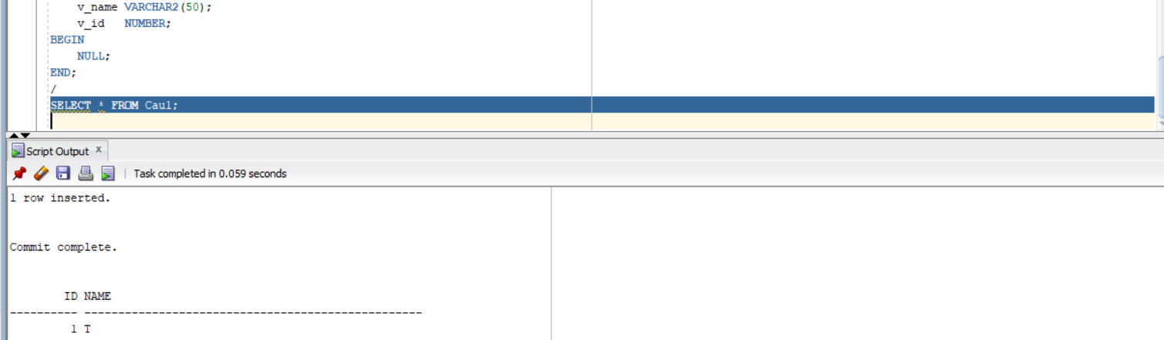
Câu d

DECLARE
v_name VARCHAR2(50);
v_id NUMBER;
BEGIN
SELECT s.FirstName || ' ' || s.LastName
INTO v_name
FROM STUDENT s
JOIN ENROLLMENT e ON s.StudentID = e.StudentID
GROUP BY s.StudentID, s.FirstName, s.LastName
ORDER BY COUNT(*) DESC
FETCH FIRST 1 ROWS ONLY;

v_id := Cau1Seq.NEXTVAL;

INSERT INTO Cau1 (ID, NAME)
VALUES (v_id, v_name);

SAVEPOINT A;

DBMS_OUTPUT.PUT_LINE('Da them: ' || v_name);
END;
/
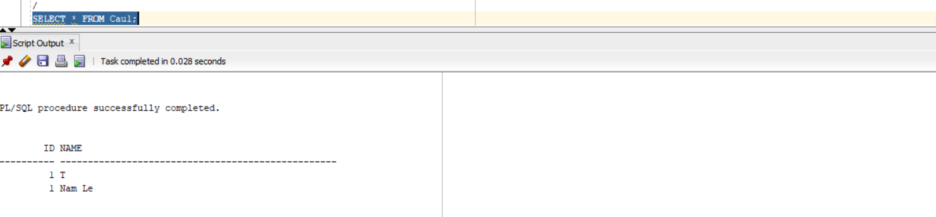

Câu e

DECLARE
v_name VARCHAR2(50);
v_id NUMBER;
BEGIN
SELECT s.FirstName || ' ' || s.LastName
INTO v_name
FROM STUDENT s
JOIN ENROLLMENT e ON s.StudentID = e.StudentID
GROUP BY s.StudentID, s.FirstName, s.LastName
ORDER BY COUNT(*) ASC
FETCH FIRST 1 ROWS ONLY;

v_id := Cau1Seq.NEXTVAL;

INSERT INTO Cau1 (ID, NAME)
VALUES (v_id, v_name);

SAVEPOINT B;

DBMS_OUTPUT.PUT_LINE('Da them (it nhat): ' || v_name);
END;
/
SELECT * FROM Cau1;
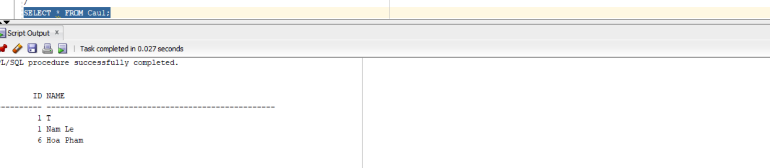

Câu f

DECLARE
v_name VARCHAR2(50);
v_id NUMBER;
BEGIN
SELECT i.FirstName || ' ' || i.LastName
INTO v_name
FROM INSTRUCTOR i
JOIN CLASS c ON i.InstructorID = c.InstructorID
GROUP BY i.InstructorID, i.FirstName, i.LastName
ORDER BY COUNT(*) DESC
FETCH FIRST 1 ROWS ONLY;

v_id := Cau1Seq.NEXTVAL;

INSERT INTO Cau1 (ID, NAME)
VALUES (v_id, v_name);

SAVEPOINT C;

DBMS_OUTPUT.PUT_LINE('GV nhieu lop nhat: ' || v_name);
END;
/
SELECT * FROM Cau1;
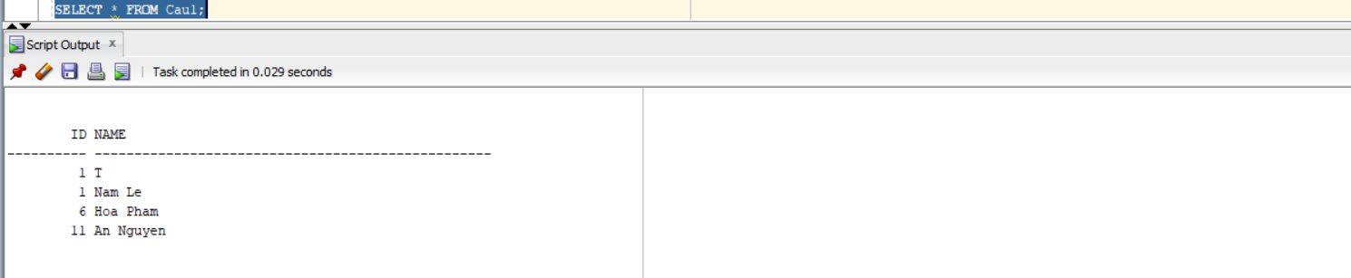

Câu g

DECLARE
v_name VARCHAR2(50) := 'An Nguyen';
v_id NUMBER;
BEGIN
SELECT InstructorID
INTO v_id
FROM INSTRUCTOR
WHERE FirstName || ' ' || LastName = v_name;

DBMS_OUTPUT.PUT_LINE('ID tim duoc: ' || v_id);
END;
/
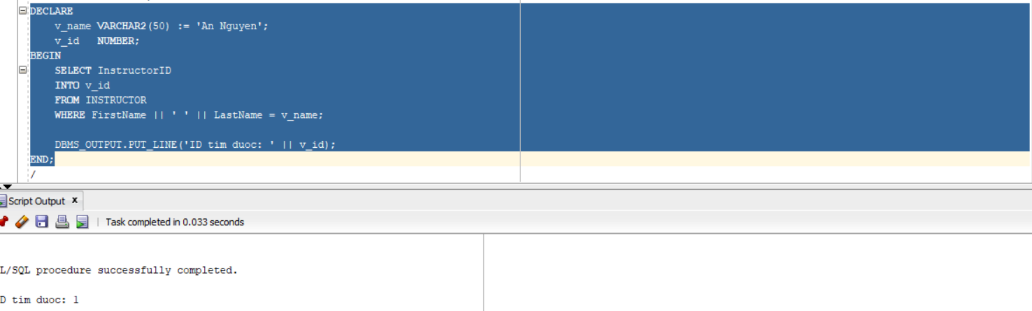

Câu h

BEGIN
ROLLBACK TO C;
DBMS_OUTPUT.PUT_LINE('Da rollback ve savepoint C');
END;
/

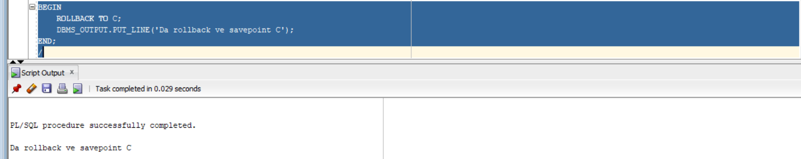

Câu i

DECLARE
v_name VARCHAR2(50);
v_id NUMBER := 11;
BEGIN
SELECT i.FirstName || ' ' || i.LastName
INTO v_name
FROM INSTRUCTOR i
JOIN CLASS c ON i.InstructorID = c.InstructorID
GROUP BY i.InstructorID, i.FirstName, i.LastName
ORDER BY COUNT(*) ASC
FETCH FIRST 1 ROWS ONLY;

INSERT INTO Cau1 (ID, NAME)
VALUES (v_id, v_name);

DBMS_OUTPUT.PUT_LINE('Da them: ' || v_name);
END;
/
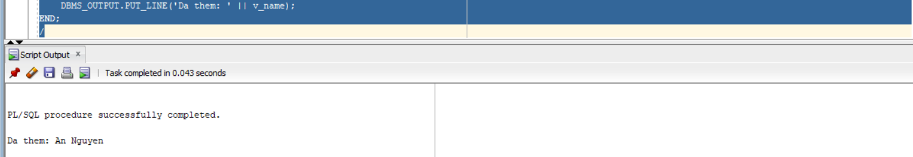

Câu j

DECLARE
v_name VARCHAR2(50);
v_id NUMBER;
BEGIN
-- GV dạy nhiều lớp nhất
SELECT i.FirstName || ' ' || i.LastName
INTO v_name
FROM INSTRUCTOR i
JOIN CLASS c ON i.InstructorID = c.InstructorID
GROUP BY i.InstructorID, i.FirstName, i.LastName
ORDER BY COUNT(*) DESC
FETCH FIRST 1 ROWS ONLY;
-- dùng sequence
v_id := Cau1Seq.NEXTVAL;
INSERT INTO Cau1 VALUES (v_id, v_name);
DBMS_OUTPUT.PUT_LINE('Da them lai GV nhieu lop nhat: ' || v_name);
END;
/
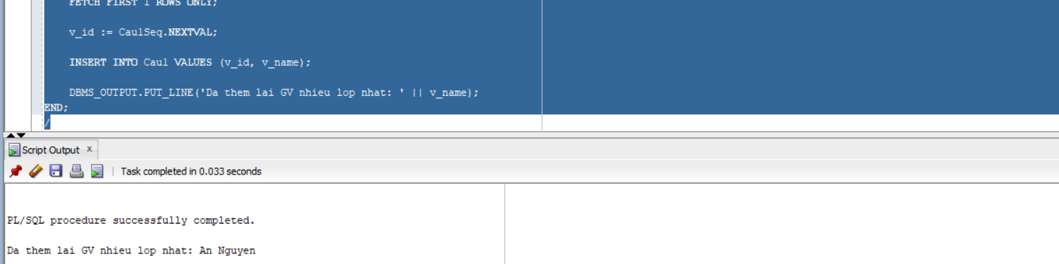

Bài 2: Các cấu trúc điều khiển

Câu 1

DECLARE
v_id NUMBER := &Nhap_Ma_GV;
v_count NUMBER;
BEGIN
SELECT COUNT(*)
INTO v_count
FROM CLASS
WHERE InstructorID = v_id;

IF v_count >= 5 THEN
DBMS_OUTPUT.PUT_LINE('Giao vien nay nen nghi ngoi!');
ELSE
DBMS_OUTPUT.PUT_LINE('So lop dang day: ' || v_count);
END IF;

END;
/
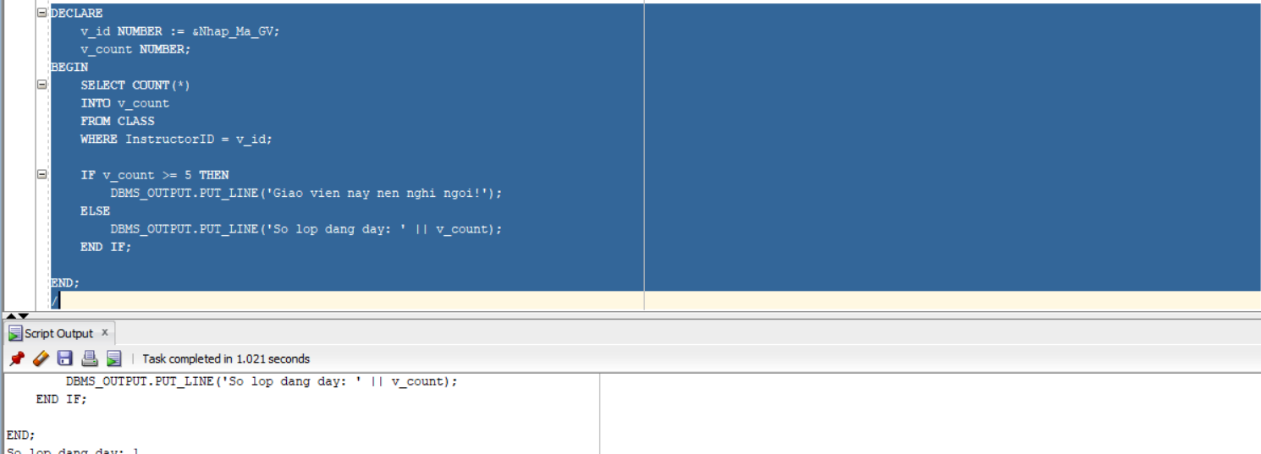

Câu 2
DECLARE
v_student_id NUMBER := &Nhap_Ma_SV;
v_class_id NUMBER := &Nhap_Ma_Lop;
v_grade NUMBER;
v_count NUMBER;
BEGIN
SELECT COUNT(*) INTO v_count
FROM STUDENT
WHERE StudentID = v_student_id;

IF v_count = 0 THEN
DBMS_OUTPUT.PUT_LINE('Khong ton tai sinh vien');
RETURN;
END IF;

SELECT COUNT(*) INTO v_count
FROM CLASS
WHERE ClassID = v_class_id;

IF v_count = 0 THEN
DBMS_OUTPUT.PUT_LINE('Khong ton tai lop');
RETURN;
END IF;

SELECT Grade INTO v_grade
FROM GRADE
WHERE StudentID = v_student_id
AND ClassID = v_class_id;

CASE
WHEN v_grade >= 90 THEN
DBMS_OUTPUT.PUT_LINE('Diem chu: A');
WHEN v_grade >= 80 THEN
DBMS_OUTPUT.PUT_LINE('Diem chu: B');
WHEN v_grade >= 70 THEN
DBMS_OUTPUT.PUT_LINE('Diem chu: C');
WHEN v_grade >= 50 THEN
DBMS_OUTPUT.PUT_LINE('Diem chu: D');
ELSE
DBMS_OUTPUT.PUT_LINE('Diem chu: F');
END CASE;

EXCEPTION
WHEN NO_DATA_FOUND THEN
DBMS_OUTPUT.PUT_LINE('Khong co diem cho sinh vien nay');
END;
/
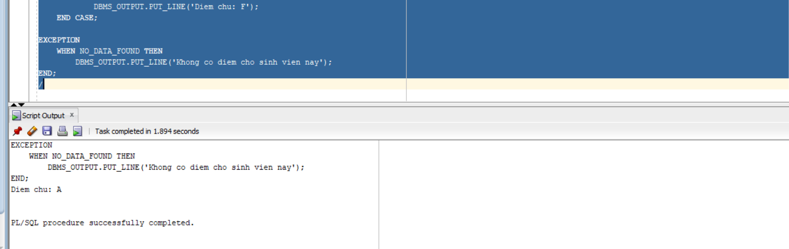

Bài 3: Cursor

DECLARE
CURSOR c_course IS
SELECT CourseNo, Description
FROM COURSE;

CURSOR c_class(p_courseNo NUMBER) IS
SELECT ClassID
FROM CLASS
WHERE CourseNo = p_courseNo;
v_count NUMBER;

BEGIN
FOR course_rec IN c_course LOOP
DBMS_OUTPUT.PUT_LINE(course_rec.CourseNo || ' ' || course_rec.Description);
FOR class_rec IN c_class(course_rec.CourseNo) LOOP

SELECT COUNT(*)
INTO v_count
FROM ENROLLMENT
WHERE ClassID = class_rec.ClassID;

DBMS_OUTPUT.PUT_LINE(' Lop: ' || class_rec.ClassID ||
' co so luong sinh vien dang ki: ' || v_count);
END LOOP;

END LOOP;
END;
/
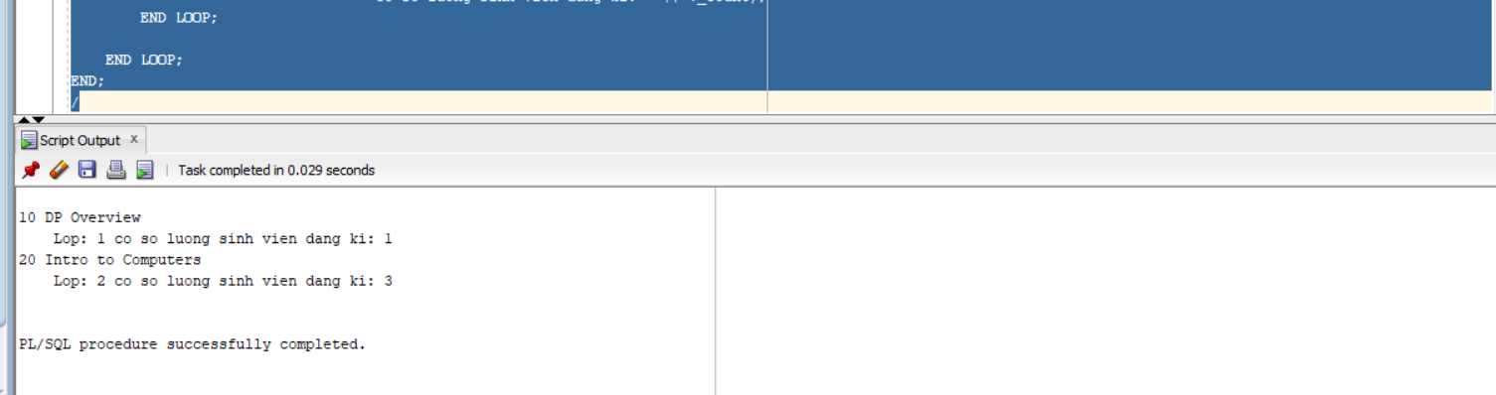
Bài 4: Các thủ tục và hàm

Câu 1

A)
CREATE OR REPLACE PROCEDURE find_sname (
i_student_id IN STUDENT.StudentID%TYPE,
o_first_name OUT STUDENT.FirstName%TYPE,
o_last_name OUT STUDENT.LastName%TYPE
)
IS
BEGIN
SELECT FirstName, LastName
INTO o_first_name, o_last_name
FROM STUDENT
WHERE StudentID = i_student_id;

EXCEPTION
WHEN NO_DATA_FOUND THEN
o_first_name := NULL;
o_last_name := NULL;
END;
/
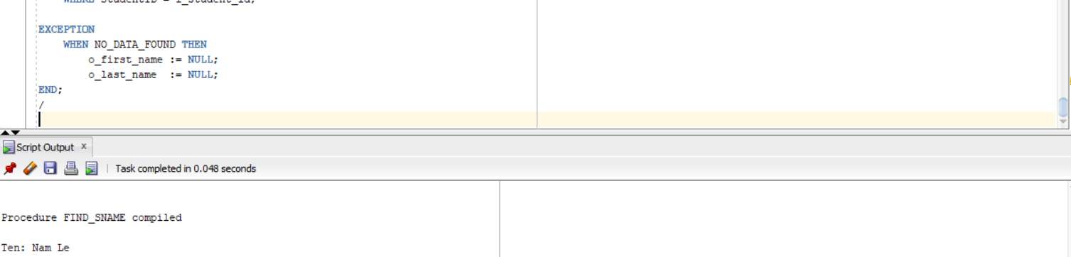

B)
CREATE OR REPLACE PROCEDURE print_student_name (
i_student_id IN STUDENT.StudentID%TYPE
)
IS
v_fname STUDENT.FirstName%TYPE;
v_lname STUDENT.LastName%TYPE;
BEGIN
SELECT FirstName, LastName
INTO v_fname, v_lname
FROM STUDENT
WHERE StudentID = i_student_id;

DBMS_OUTPUT.PUT_LINE('Ten sinh vien: ' || v_fname || ' ' || v_lname);

EXCEPTION
WHEN NO_DATA_FOUND THEN
DBMS_OUTPUT.PUT_LINE('Khong tim thay sinh vien');
END;
/

BEGIN
print_student_name(1);
END;
/
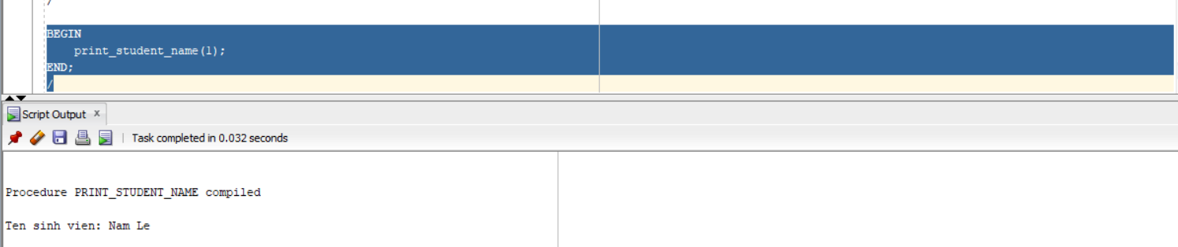

Câu 2
CREATE OR REPLACE PROCEDURE Discount
IS
BEGIN
FOR rec IN (
SELECT c.CourseNo, c.Description
FROM COURSE c
JOIN CLASS cl ON c.CourseNo = cl.CourseNo
JOIN ENROLLMENT e ON cl.ClassID = e.ClassID
GROUP BY c.CourseNo, c.Description
HAVING COUNT(e.StudentID) > 15
)
LOOP
UPDATE COURSE
SET Cost = Cost * 0.95
WHERE CourseNo = rec.CourseNo;

DBMS_OUTPUT.PUT_LINE('Da giam gia mon: ' || rec.Description);
END LOOP;

COMMIT;
END;
/

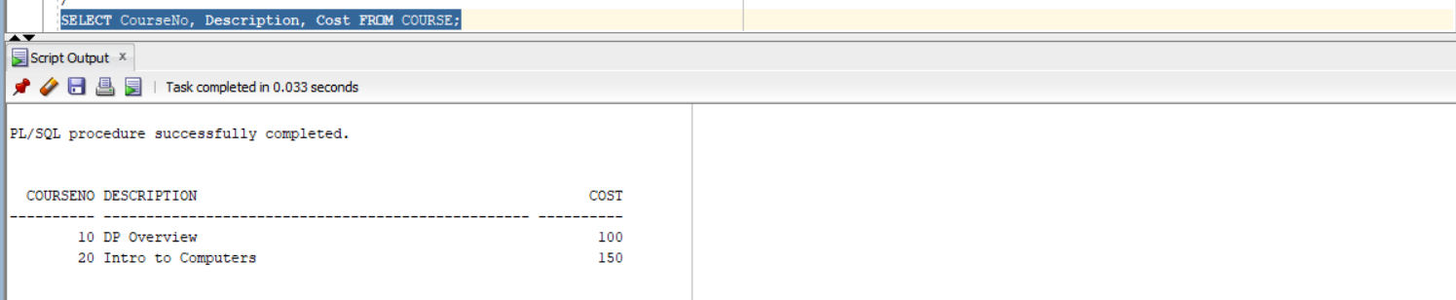

Câu 3
CREATE OR REPLACE FUNCTION Total_cost_for_student (
i_student_id IN STUDENT.StudentID%TYPE
)
RETURN NUMBER
IS
v_total NUMBER;
v_check NUMBER;
BEGIN
SELECT COUNT(*)
INTO v_check
FROM STUDENT
WHERE StudentID = i_student_id;

IF v_check = 0 THEN
RETURN NULL;
END IF;

SELECT SUM(c.Cost)
INTO v_total
FROM ENROLLMENT e
JOIN CLASS cl ON e.ClassID = cl.ClassID
JOIN COURSE c ON cl.CourseNo = c.CourseNo
WHERE e.StudentID = i_student_id;

RETURN v_total;

EXCEPTION
WHEN NO_DATA_FOUND THEN
RETURN NULL;
END;
/
SET SERVEROUTPUT ON;

DECLARE
v_total NUMBER;
BEGIN
v_total := Total_cost_for_student(1);

DBMS_OUTPUT.PUT_LINE('Tong hoc phi: ' || v_total);
END;
/
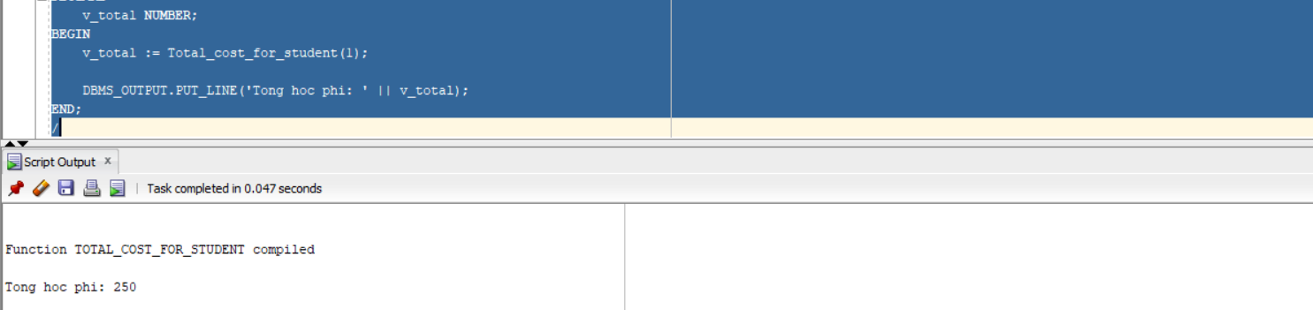

Bài 5: Trigger

Câu 1:

CREATE OR REPLACE TRIGGER trg_student_audit
BEFORE INSERT OR UPDATE ON STUDENT
FOR EACH ROW
BEGIN
IF INSERTING THEN
:NEW.created_by := USER;
:NEW.created_date := SYSDATE;
:NEW.modified_by := USER;
:NEW.modified_date := SYSDATE;
ELSE
:NEW.modified_by := USER;
:NEW.modified_date := SYSDATE;
END IF;
END;
/
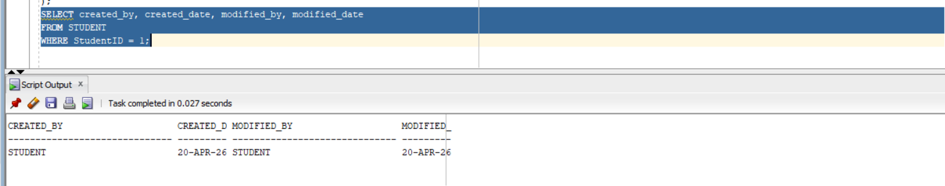
CREATE OR REPLACE TRIGGER trg_course_audit
BEFORE INSERT OR UPDATE ON COURSE
FOR EACH ROW
BEGIN
IF INSERTING THEN
:NEW.created_by := USER;
:NEW.created_date := SYSDATE;
:NEW.modified_by := USER;
:NEW.modified_date := SYSDATE;
ELSE
:NEW.modified_by := USER;
:NEW.modified_date := SYSDATE;
END IF;
END;
/
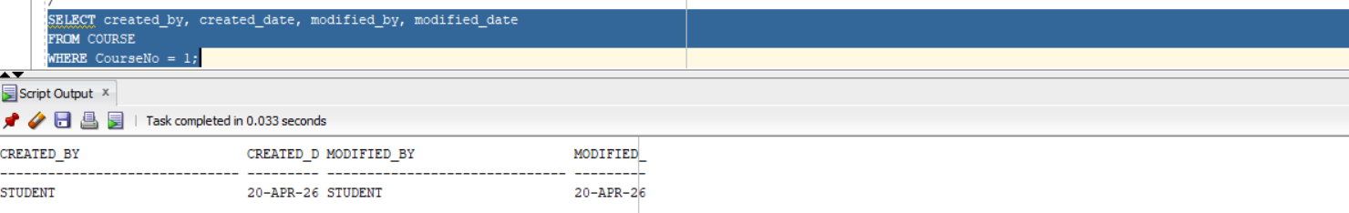
CREATE OR REPLACE TRIGGER trg_limit_subjects
BEFORE INSERT ON ENROLLMENT
FOR EACH ROW
DECLARE
v_count NUMBER;
BEGIN
SELECT COUNT(*)
INTO v_count
FROM ENROLLMENT
WHERE StudentID = :NEW.StudentID;

IF v_count >= 3 THEN
RAISE_APPLICATION_ERROR(-20001, 'Sinh vien khong duoc dang ky qua 3 mon hoc');
END IF;
END;
/

