МИНИСТЕРСТВО ОБРАЗОВАНИЯ И НАУКИ РФ
Пензенский государственный университет
Кафедра «Вычислительная техника»
Пенза 2022

ОТЧЕТ
по лабораторной работе №6
по курсу «Программирование на языке Java»
на тему «Сетевое взаимодействие в Java»
Вариант 4
Выполнили:
студенты группы 19ВВ2
Дорофеев А.А.
Павлов А.А.
Петров О.М.

Приняли:
Юрова О.В.
Карамышева Н.С.

Цель работы
Научиться создавать клиент-серверные приложения c использованием стандартных классов Java.
Лабораторное задание
Модифицировать приложение из предыдущей лабораторной работы, реализовав клиент-серверную архитектуру, обеспечивающую распределенное вычисление определенного интеграла на нескольких вычислительных узлах (клиентах) при этом каждый узел использует несколько нитей, как в предыдущей работе. Сервер не занимается вычислениями, а лишь реализует взаимодействие с пользователем и агрегацию результатов вычислений от клиентов. Нечетные варианты используют протокол UDP, а четные TCP.
4 вариант – протокол TCP.

Листинг
Проект Lab6 Client1
Модуль Client.java
package lab6.client;

import java.net.*;
import java.io.*;
import java.util.logging.Level;
import java.util.logging.Logger;

public class Client {

private Socket clientSocket;
private PrintWriter out;
private BufferedReader in;

public void startConnection(String ip, int port) {
try {
clientSocket = new Socket(ip, port);
out = new PrintWriter(clientSocket.getOutputStream(), true);
in = new BufferedReader(new InputStreamReader(clientSocket.getInputStream()));

System.out.println(" Соединение с сервером установлено ");
System.out.println();

String msg;

System.out.println(" Ждём данные для вычислений ");
while((msg = in.readLine()) != null )
{
if(".".equals(msg))
break;

String delimeter = " "; // Разделитель
String[] subStr;
subStr = msg.split(delimeter);

double lowLim = Double.parseDouble(subStr[0]);
double upLim = Double.parseDouble(subStr[1]);
double stepInteg = Double.parseDouble(subStr[2]);

System.out.println(" Полученные данные " + lowLim + " " + upLim + " " + stepInteg);
Calculate(lowLim, upLim, stepInteg);

System.out.println(" Ждём данные для вычислений ");

}

} catch (IOException ex) {
Logger.getLogger(Client.class.getName()).log(Level.SEVERE, null, ex);

}

finally{

stopConnection();

}
}

public void stopConnection() {
try {
in.close();
out.close();
clientSocket.close();

System.out.println();
System.out.println(" Клиент завершил работу ");

} catch (IOException ex) {
Logger.getLogger(Client.class.getName()).log(Level.SEVERE, null, ex);
}
}

public void Calculate(double lowLim, double upLim, double stepInteg)
{

int iteration = (int)( ((upLim - lowLim) / stepInteg) / 4.0);

MyThread thr1 = new MyThread(0, iteration, lowLim, upLim,
stepInteg, x -> {return Math.tan(x);});
MyThread thr2 = new MyThread(iteration, iteration * 2, lowLim, upLim,
stepInteg, x -> {return Math.tan(x);} );
MyThread thr3 = new MyThread( iteration * 2, iteration * 3, lowLim, upLim,
stepInteg, x -> {return Math.tan(x);} );
MyThread thr4 = new MyThread( iteration * 3, iteration * 4, lowLim, upLim,
stepInteg, x -> {return Math.tan(x);} );

thr1.start();
thr2.start();
thr3.start();
thr4.start();

try {
thr1.join();
thr2.join();
thr3.join();
thr4.join();

} catch (InterruptedException ex) {
Logger.getLogger(Client.class.getName()).log(Level.SEVERE, null, ex);
}

double area = thr1.GetArea() + thr2.GetArea() + thr3.GetArea() + thr4.GetArea();

System.out.println(" Полученный результат " + area);
System.out.println();

out.println(area);

}

public static void main(String[] args)
{
Client cl = new Client();
cl.startConnection("127.0.0.1", 6666);

}

interface Function {
public double func(double x);

}

}

Модуль MyThread.java
package lab6.client;

public class MyThread extends Thread {

private double area;
private double lowLim;
private double upLim;
private double stepInteg;
private int iteration;
private int endIteration;
private Client.Function function;

public boolean ret = false;

MyThread(int vIteration, int vEndIteration, double vLowLim, double vUpLim, double vStepInteg, Client.Function func){

iteration = vIteration;
endIteration = vEndIteration;
lowLim = vLowLim;
upLim = vUpLim;
stepInteg = vStepInteg;
function = func;

}

@Override
public void run(){

integralPartTrap();

}

public double GetArea(){

return area;

}

public void integralPartTrap() {
area = 0;

for (int i = iteration; i < endIteration; i++) {

System.out.println(iteration + " " + endIteration);

area += stepInteg * (0.5 * (function.func(lowLim + i * stepInteg)+function.func(lowLim+(i+1)* stepInteg)));
}

}

}
Проект Lab6 Server
Модуль Server.java
package my.numberaddition;
import java.net.*;
import java.io.*;
import java.util.logging.Level;
import java.util.logging.Logger;

public class Server implements Runnable {

private ServerSocket serverSocket;
private Socket clientSocket;
private PrintWriter out;
private BufferedReader in;
private int port;

public Server(int vPort){
port = vPort;
startServer(port);

}
public void run()
{
startServer(port);
System.out.println("сервер прям всё");
}

public double CalculationRequest(double vLowLim, double vUpLim, double vStepInteg)
{

double area = 0;

try {
out.println(vLowLim + " " + vUpLim + " " + vStepInteg);
System.out.println(" Делаем запрос на вычисление ");
area = Double.parseDouble(in.readLine());
System.out.println(" Полученный результат " + area);
System.out.println();
} catch (IOException ex) {
Logger.getLogger(Server.class.getName()).log(Level.SEVERE, null, ex);
}
return area; }
public void startServer(int port) {
try {
serverSocket = new ServerSocket(port);
System.out.println("Сервер ждёт");
clientSocket = serverSocket.accept();

out = new PrintWriter(clientSocket.getOutputStream(), true);
in = new BufferedReader(new InputStreamReader(clientSocket.getInputStream()));

System.out.println("Сервер запущен");
System.out.println();

} catch (IOException ex) {
Logger.getLogger(Server.class.getName()).log(Level.SEVERE, null, ex);
}
}

public void stopServer() {
try {
out.println(".");

in.close();
out.close();
clientSocket.close();
serverSocket.close();

System.out.println(" Сервер завершил работу ");

} catch (IOException ex) {
Logger.getLogger(Server.class.getName()).log(Level.SEVERE, null, ex);
}
}

}
Модуль IntegException.java

package my.numberaddition;

public class IntegException extends Exception {

public IntegException() {
}

public IntegException(String message) {
super(message);
}

public IntegException(String message, Throwable cause) {
super(message, cause);
}

public IntegException(Throwable cause) {
super(cause);
}

public IntegException(String message, Throwable cause, boolean enableSuppression, boolean writableStackTrace) {
super(message, cause, enableSuppression, writableStackTrace);
}

}

Модуль RecIntegral.java
package my.numberaddition;
import java.io.Serializable;

public class RecIntegral implements Serializable {
private double lowLim;
private double upLim;
private double stepInteg;
private double result;

public RecIntegral(){

lowLim = 0;
upLim = 0;
stepInteg = 0;
result = 0;

}

public RecIntegral(RecIntegral recCopy){

lowLim = recCopy.GetLowLim();
upLim = recCopy.GetUpLim();
stepInteg = recCopy.GetStepInteg();
result = recCopy.GetResult();

}

public RecIntegral(double vLowLim, double vUpLim, double vStInteg, double vRes) throws IntegException{

if((vLowLim <= 0.000001) || (vLowLim >= 1000000) ||
(vUpLim <= 0.000001) || (vUpLim >= 1000000) ||
(vStInteg <= 0.000001) || (vStInteg >= 1000000))
throw new IntegException("Вводимые числа должны быть в диапазоне от 0,000001 до 1000000");

lowLim = vLowLim;
upLim = vUpLim;
stepInteg = vStInteg;
result = vRes;

}

public void SetLowLim(double vLowLim) throws IntegException{
if((vLowLim <= 0.000001) || (vLowLim >= 1000000))
throw new IntegException("Вводимые числа должны быть в диапазоне от 0,000001 до 1000000");

lowLim = vLowLim;
}
public void SetUpLim(double vUpLim) throws IntegException{
if((vUpLim <= 0.000001) || (vUpLim >= 1000000))
throw new IntegException("Вводимые числа должны быть в диапазоне от 0,000001 до 1000000");
upLim = vUpLim;
}
public void SetStepInteg(double vStInteg) throws IntegException{
if(vStInteg == 0)
throw new IntegException("Шаг интегрирования не может быть равным нулю");

if((vStInteg <= 0.000001) || (vStInteg >= 1000000))
throw new IntegException("Вводимые числа должны быть в диапазоне от 0,000001 до 1000000");

if((upLim - lowLim) < vStInteg)
throw new IntegException("Шаг интегрирования не должен превышать диапазон вычисления");

stepInteg = vStInteg;
}
public void SetResult(double vRes){
result = vRes;
}

public double GetLowLim(){
return lowLim;
}
public double GetUpLim(){
return upLim;
}
public double GetStepInteg(){
return stepInteg;
}
public double GetResult(){
return result;

}

}
Модуль IntegrSearch.java
package my.numberaddition;
import javax.swing.table.DefaultTableModel;
import java.util.LinkedList;
import javax.swing.*;
import java.io.File;
import java.io.IOException;
import java.io.PrintWriter;
import java.io.BufferedReader;
import java.io.FileReader;
import java.io.ObjectOutputStream;
import java.io.FileOutputStream;
import java.io.ObjectInputStream;
import java.io.FileInputStream;

import java.net.*;

import java.util.logging.Level;
import java.util.logging.Logger;

import java.awt.event.WindowAdapter;
import java.awt.event.WindowEvent;

public class IntegrSearch extends javax.swing.JFrame {

public IntegrSearch() {
initComponents();
serv = new Server(6666);

this.addWindowListener(new WindowAdapter()
{
@Override
public void windowClosing(WindowEvent e)
{
serv.stopServer();
e.getWindow().dispose();
}
});

}

@SuppressWarnings("unchecked")
// <editor-fold defaultstate="collapsed" desc="Generated Code">
private void initComponents() {

jPanel1 = new javax.swing.JPanel();
jLabel1 = new javax.swing.JLabel();
jPanel2 = new javax.swing.JPanel();
jScrollPane1 = new javax.swing.JScrollPane();
jTable = new javax.swing.JTable();
jPanel3 = new javax.swing.JPanel();
jButtonAdd = new javax.swing.JButton();
jButtonDelete = new javax.swing.JButton();
jButtonСalculate = new javax.swing.JButton();
jPanel4 = new javax.swing.JPanel();
jTextField1 = new javax.swing.JTextField();
jTextField2 = new javax.swing.JTextField();
jTextField3 = new javax.swing.JTextField();
jLabel2 = new javax.swing.JLabel();
jLabel3 = new javax.swing.JLabel();
jLabel4 = new javax.swing.JLabel();
jPanel6 = new javax.swing.JPanel();
jButtonSerialize = new javax.swing.JButton();
jButtonDeserialize = new javax.swing.JButton();
jButtonWriteFile = new javax.swing.JButton();
jButtonReadFile = new javax.swing.JButton();
jButtonClear = new javax.swing.JButton();
jButtonFillTable = new javax.swing.JButton();

setDefaultCloseOperation(javax.swing.WindowConstants.EXIT_ON_CLOSE);

jLabel1.setFont(new java.awt.Font("Times New Roman", 1, 24)); // NOI18N
jLabel1.setText(" Интеграл tg(x)");

javax.swing.GroupLayout jPanel1Layout = new javax.swing.GroupLayout(jPanel1);
jPanel1.setLayout(jPanel1Layout);
jPanel1Layout.setHorizontalGroup(
jPanel1Layout.createParallelGroup(javax.swing.GroupLayout.Alignment.LEADING)
.addGroup(jPanel1Layout.createSequentialGroup()
.addGap(151, 151, 151)
.addComponent(jLabel1, javax.swing.GroupLayout.PREFERRED_SIZE, 243, javax.swing.GroupLayout.PREFERRED_SIZE)
.addContainerGap(142, Short.MAX_VALUE))
);
jPanel1Layout.setVerticalGroup(
jPanel1Layout.createParallelGroup(javax.swing.GroupLayout.Alignment.LEADING)
.addGroup(jPanel1Layout.createSequentialGroup()
.addGap(28, 28, 28)
.addComponent(jLabel1, javax.swing.GroupLayout.PREFERRED_SIZE, 42, javax.swing.GroupLayout.PREFERRED_SIZE)
.addContainerGap(43, Short.MAX_VALUE))
);

jTable.setModel(new javax.swing.table.DefaultTableModel(
new Object [][] {
{null, null, null, null}
},
new String [] {
"Нижняя граница интегрирования", "Верхняя граница интегрирования", "Шаг интегрирования", "Результат вычисления"
}
) {
Class[] types = new Class [] {
java.lang.Double.class, java.lang.Double.class, java.lang.Double.class, java.lang.Double.class
};
boolean[] canEdit = new boolean [] {
false, false, false, false
};

public Class getColumnClass(int columnIndex) {
return types [columnIndex];
}

public boolean isCellEditable(int rowIndex, int columnIndex) {
return canEdit [columnIndex];
}
});
jScrollPane1.setViewportView(jTable);

jButtonAdd.setText("Добавить");
jButtonAdd.addActionListener(new java.awt.event.ActionListener() {
public void actionPerformed(java.awt.event.ActionEvent evt) {
jButtonAddActionPerformed(evt);
}
});

jButtonDelete.setText("Удалить");
jButtonDelete.addActionListener(new java.awt.event.ActionListener() {
public void actionPerformed(java.awt.event.ActionEvent evt) {
jButtonDeleteActionPerformed(evt);
}
});

jButtonСalculate.setText("Вычислить");
jButtonСalculate.addActionListener(new java.awt.event.ActionListener() {
public void actionPerformed(java.awt.event.ActionEvent evt) {
jButtonСalculateActionPerformed(evt);
}
});

javax.swing.GroupLayout jPanel3Layout = new javax.swing.GroupLayout(jPanel3);
jPanel3.setLayout(jPanel3Layout);
jPanel3Layout.setHorizontalGroup(
jPanel3Layout.createParallelGroup(javax.swing.GroupLayout.Alignment.LEADING)
.addGroup(jPanel3Layout.createSequentialGroup()
.addContainerGap(javax.swing.GroupLayout.DEFAULT_SIZE, Short.MAX_VALUE)
.addComponent(jButtonAdd)
.addGap(18, 18, 18)
.addComponent(jButtonDelete)
.addGap(18, 18, 18)
.addComponent(jButtonСalculate)
.addGap(80, 80, 80))
);
jPanel3Layout.setVerticalGroup(
jPanel3Layout.createParallelGroup(javax.swing.GroupLayout.Alignment.LEADING)
.addGroup(javax.swing.GroupLayout.Alignment.TRAILING, jPanel3Layout.createSequentialGroup()
.addContainerGap(javax.swing.GroupLayout.DEFAULT_SIZE, Short.MAX_VALUE)
.addGroup(jPanel3Layout.createParallelGroup(javax.swing.GroupLayout.Alignment.BASELINE)
.addComponent(jButtonAdd)
.addComponent(jButtonDelete)
.addComponent(jButtonСalculate))
.addGap(28, 28, 28))
);

jTextField1.addActionListener(new java.awt.event.ActionListener() {
public void actionPerformed(java.awt.event.ActionEvent evt) {
jTextField1ActionPerformed(evt);
}
});

jTextField3.addActionListener(new java.awt.event.ActionListener() {
public void actionPerformed(java.awt.event.ActionEvent evt) {
jTextField3ActionPerformed(evt);
}
});

jLabel2.setText("Нижняя граница");

jLabel3.setText("Верхняя граница");

jLabel4.setText("Шаг интегрирования");

javax.swing.GroupLayout jPanel4Layout = new javax.swing.GroupLayout(jPanel4);
jPanel4.setLayout(jPanel4Layout);
jPanel4Layout.setHorizontalGroup(
jPanel4Layout.createParallelGroup(javax.swing.GroupLayout.Alignment.LEADING)
.addGroup(jPanel4Layout.createSequentialGroup()
.addGroup(jPanel4Layout.createParallelGroup(javax.swing.GroupLayout.Alignment.LEADING)
.addGroup(jPanel4Layout.createSequentialGroup()
.addGap(54, 54, 54)
.addComponent(jLabel2))
.addGroup(jPanel4Layout.createSequentialGroup()
.addGap(43, 43, 43)
.addComponent(jTextField1, javax.swing.GroupLayout.PREFERRED_SIZE, 116, javax.swing.GroupLayout.PREFERRED_SIZE)))
.addGap(55, 55, 55)
.addGroup(jPanel4Layout.createParallelGroup(javax.swing.GroupLayout.Alignment.TRAILING)
.addComponent(jTextField2, javax.swing.GroupLayout.PREFERRED_SIZE, 121, javax.swing.GroupLayout.PREFERRED_SIZE)
.addComponent(jLabel3, javax.swing.GroupLayout.PREFERRED_SIZE, 107, javax.swing.GroupLayout.PREFERRED_SIZE))
.addGap(46, 46, 46)
.addGroup(jPanel4Layout.createParallelGroup(javax.swing.GroupLayout.Alignment.TRAILING)
.addComponent(jTextField3, javax.swing.GroupLayout.PREFERRED_SIZE, 143, javax.swing.GroupLayout.PREFERRED_SIZE)
.addComponent(jLabel4, javax.swing.GroupLayout.PREFERRED_SIZE, 131, javax.swing.GroupLayout.PREFERRED_SIZE))
.addContainerGap(22, Short.MAX_VALUE))
);
jPanel4Layout.setVerticalGroup(
jPanel4Layout.createParallelGroup(javax.swing.GroupLayout.Alignment.LEADING)
.addGroup(jPanel4Layout.createSequentialGroup()
.addContainerGap()
.addGroup(jPanel4Layout.createParallelGroup(javax.swing.GroupLayout.Alignment.LEADING)
.addComponent(jLabel2, javax.swing.GroupLayout.Alignment.TRAILING, javax.swing.GroupLayout.DEFAULT_SIZE, 25, Short.MAX_VALUE)
.addGroup(jPanel4Layout.createParallelGroup(javax.swing.GroupLayout.Alignment.BASELINE)
.addComponent(jLabel4)
.addComponent(jLabel3)))
.addPreferredGap(javax.swing.LayoutStyle.ComponentPlacement.RELATED)
.addGroup(jPanel4Layout.createParallelGroup(javax.swing.GroupLayout.Alignment.LEADING)
.addComponent(jTextField2, javax.swing.GroupLayout.PREFERRED_SIZE, javax.swing.GroupLayout.DEFAULT_SIZE, javax.swing.GroupLayout.PREFERRED_SIZE)
.addComponent(jTextField1, javax.swing.GroupLayout.PREFERRED_SIZE, javax.swing.GroupLayout.DEFAULT_SIZE, javax.swing.GroupLayout.PREFERRED_SIZE)
.addComponent(jTextField3, javax.swing.GroupLayout.PREFERRED_SIZE, javax.swing.GroupLayout.DEFAULT_SIZE, javax.swing.GroupLayout.PREFERRED_SIZE))
.addGap(20, 20, 20))
);

jButtonSerialize.setText("Cериализовать");
jButtonSerialize.addActionListener(new java.awt.event.ActionListener() {
public void actionPerformed(java.awt.event.ActionEvent evt) {
jButtonSerializeActionPerformed(evt);
}
});

jButtonDeserialize.setText("Восстановить");
jButtonDeserialize.addActionListener(new java.awt.event.ActionListener() {
public void actionPerformed(java.awt.event.ActionEvent evt) {
jButtonDeserializeActionPerformed(evt);
}
});

jButtonWriteFile.setText("Записать в txt");
jButtonWriteFile.setPreferredSize(new java.awt.Dimension(87, 25));
jButtonWriteFile.addActionListener(new java.awt.event.ActionListener() {
public void actionPerformed(java.awt.event.ActionEvent evt) {
jButtonWriteFileActionPerformed(evt);
}
});

jButtonReadFile.setText("Прочитать из txt");
jButtonReadFile.addActionListener(new java.awt.event.ActionListener() {
public void actionPerformed(java.awt.event.ActionEvent evt) {
jButtonReadFileActionPerformed(evt);
}
});

jButtonClear.setText("Очистить");
jButtonClear.addActionListener(new java.awt.event.ActionListener() {
public void actionPerformed(java.awt.event.ActionEvent evt) {
jButtonClearActionPerformed(evt);
}
});

jButtonFillTable.setText("Заполнить");
jButtonFillTable.addActionListener(new java.awt.event.ActionListener() {
public void actionPerformed(java.awt.event.ActionEvent evt) {
jButtonFillTableActionPerformed(evt);
}
});

javax.swing.GroupLayout jPanel6Layout = new javax.swing.GroupLayout(jPanel6);
jPanel6.setLayout(jPanel6Layout);
jPanel6Layout.setHorizontalGroup(
jPanel6Layout.createParallelGroup(javax.swing.GroupLayout.Alignment.LEADING)
.addGroup(jPanel6Layout.createSequentialGroup()
.addContainerGap(14, Short.MAX_VALUE)
.addGroup(jPanel6Layout.createParallelGroup(javax.swing.GroupLayout.Alignment.TRAILING, false)
.addComponent(jButtonFillTable, javax.swing.GroupLayout.DEFAULT_SIZE, 135, Short.MAX_VALUE)
.addComponent(jButtonClear, javax.swing.GroupLayout.Alignment.LEADING, javax.swing.GroupLayout.DEFAULT_SIZE, javax.swing.GroupLayout.DEFAULT_SIZE, Short.MAX_VALUE)
.addComponent(jButtonReadFile, javax.swing.GroupLayout.DEFAULT_SIZE, 135, Short.MAX_VALUE)
.addComponent(jButtonWriteFile, javax.swing.GroupLayout.DEFAULT_SIZE, javax.swing.GroupLayout.DEFAULT_SIZE, Short.MAX_VALUE))
.addGroup(jPanel6Layout.createParallelGroup(javax.swing.GroupLayout.Alignment.LEADING)
.addGroup(jPanel6Layout.createSequentialGroup()
.addPreferredGap(javax.swing.LayoutStyle.ComponentPlacement.UNRELATED)
.addComponent(jButtonSerialize, javax.swing.GroupLayout.PREFERRED_SIZE, 126, javax.swing.GroupLayout.PREFERRED_SIZE))
.addGroup(javax.swing.GroupLayout.Alignment.TRAILING, jPanel6Layout.createSequentialGroup()
.addGap(12, 12, 12)
.addComponent(jButtonDeserialize, javax.swing.GroupLayout.PREFERRED_SIZE, 126, javax.swing.GroupLayout.PREFERRED_SIZE)))
.addContainerGap(javax.swing.GroupLayout.DEFAULT_SIZE, Short.MAX_VALUE))
);
jPanel6Layout.setVerticalGroup(
jPanel6Layout.createParallelGroup(javax.swing.GroupLayout.Alignment.LEADING)
.addGroup(jPanel6Layout.createSequentialGroup()
.addGap(16, 16, 16)
.addComponent(jButtonClear)
.addPreferredGap(javax.swing.LayoutStyle.ComponentPlacement.RELATED)
.addComponent(jButtonFillTable)
.addPreferredGap(javax.swing.LayoutStyle.ComponentPlacement.RELATED, 21, Short.MAX_VALUE)
.addGroup(jPanel6Layout.createParallelGroup(javax.swing.GroupLayout.Alignment.BASELINE)
.addComponent(jButtonWriteFile, javax.swing.GroupLayout.PREFERRED_SIZE, javax.swing.GroupLayout.DEFAULT_SIZE, javax.swing.GroupLayout.PREFERRED_SIZE)
.addComponent(jButtonSerialize))
.addPreferredGap(javax.swing.LayoutStyle.ComponentPlacement.RELATED)
.addGroup(jPanel6Layout.createParallelGroup(javax.swing.GroupLayout.Alignment.BASELINE)
.addComponent(jButtonDeserialize)
.addComponent(jButtonReadFile))
.addContainerGap())
);

javax.swing.GroupLayout jPanel2Layout = new javax.swing.GroupLayout(jPanel2);
jPanel2.setLayout(jPanel2Layout);
jPanel2Layout.setHorizontalGroup(
jPanel2Layout.createParallelGroup(javax.swing.GroupLayout.Alignment.LEADING)
.addGroup(jPanel2Layout.createSequentialGroup()
.addGroup(jPanel2Layout.createParallelGroup(javax.swing.GroupLayout.Alignment.TRAILING, false)
.addComponent(jScrollPane1, javax.swing.GroupLayout.PREFERRED_SIZE, 871, javax.swing.GroupLayout.PREFERRED_SIZE)
.addGroup(jPanel2Layout.createSequentialGroup()
.addGroup(jPanel2Layout.createParallelGroup(javax.swing.GroupLayout.Alignment.LEADING)
.addGroup(jPanel2Layout.createSequentialGroup()
.addContainerGap()
.addComponent(jPanel4, javax.swing.GroupLayout.DEFAULT_SIZE, javax.swing.GroupLayout.DEFAULT_SIZE, Short.MAX_VALUE))
.addGroup(jPanel2Layout.createSequentialGroup()
.addGap(82, 82, 82)
.addComponent(jPanel3, javax.swing.GroupLayout.DEFAULT_SIZE, javax.swing.GroupLayout.DEFAULT_SIZE, Short.MAX_VALUE)))
.addGap(18, 18, 18)
.addComponent(jPanel6, javax.swing.GroupLayout.PREFERRED_SIZE, javax.swing.GroupLayout.DEFAULT_SIZE, javax.swing.GroupLayout.PREFERRED_SIZE)))
.addGap(0, 0, Short.MAX_VALUE))
);
jPanel2Layout.setVerticalGroup(
jPanel2Layout.createParallelGroup(javax.swing.GroupLayout.Alignment.LEADING)
.addGroup(jPanel2Layout.createSequentialGroup()
.addComponent(jScrollPane1, javax.swing.GroupLayout.PREFERRED_SIZE, 190, javax.swing.GroupLayout.PREFERRED_SIZE)
.addPreferredGap(javax.swing.LayoutStyle.ComponentPlacement.RELATED, 28, Short.MAX_VALUE)
.addGroup(jPanel2Layout.createParallelGroup(javax.swing.GroupLayout.Alignment.LEADING)
.addGroup(jPanel2Layout.createSequentialGroup()
.addComponent(jPanel4, javax.swing.GroupLayout.PREFERRED_SIZE, javax.swing.GroupLayout.DEFAULT_SIZE, javax.swing.GroupLayout.PREFERRED_SIZE)
.addPreferredGap(javax.swing.LayoutStyle.ComponentPlacement.RELATED)
.addComponent(jPanel3, javax.swing.GroupLayout.PREFERRED_SIZE, 48, javax.swing.GroupLayout.PREFERRED_SIZE))
.addComponent(jPanel6, javax.swing.GroupLayout.PREFERRED_SIZE, javax.swing.GroupLayout.DEFAULT_SIZE, javax.swing.GroupLayout.PREFERRED_SIZE)))
);

javax.swing.GroupLayout layout = new javax.swing.GroupLayout(getContentPane());
getContentPane().setLayout(layout);
layout.setHorizontalGroup(
layout.createParallelGroup(javax.swing.GroupLayout.Alignment.LEADING)
.addComponent(jPanel2, javax.swing.GroupLayout.DEFAULT_SIZE, javax.swing.GroupLayout.DEFAULT_SIZE, Short.MAX_VALUE)
.addGroup(layout.createSequentialGroup()
.addGap(169, 169, 169)
.addComponent(jPanel1, javax.swing.GroupLayout.PREFERRED_SIZE, javax.swing.GroupLayout.DEFAULT_SIZE, javax.swing.GroupLayout.PREFERRED_SIZE)
.addContainerGap(javax.swing.GroupLayout.DEFAULT_SIZE, Short.MAX_VALUE))
);
layout.setVerticalGroup(
layout.createParallelGroup(javax.swing.GroupLayout.Alignment.LEADING)
.addGroup(layout.createSequentialGroup()
.addContainerGap()
.addComponent(jPanel1, javax.swing.GroupLayout.PREFERRED_SIZE, javax.swing.GroupLayout.DEFAULT_SIZE, javax.swing.GroupLayout.PREFERRED_SIZE)
.addPreferredGap(javax.swing.LayoutStyle.ComponentPlacement.RELATED)
.addComponent(jPanel2, javax.swing.GroupLayout.PREFERRED_SIZE, javax.swing.GroupLayout.DEFAULT_SIZE, javax.swing.GroupLayout.PREFERRED_SIZE)
.addContainerGap(javax.swing.GroupLayout.DEFAULT_SIZE, Short.MAX_VALUE))
);

pack();
}// </editor-fold>

private void jButtonAddActionPerformed(java.awt.event.ActionEvent evt) {

DefaultTableModel model = (DefaultTableModel)jTable.getModel();
model.addRow(new Object[]{});
}

private void jButtonСalculateActionPerformed(java.awt.event.ActionEvent evt) {

String str1 = jTextField1.getText();
String str2 = jTextField2.getText();
String str3 = jTextField3.getText();

if(!jTable.getSelectionModel().isSelectionEmpty() && Compare(str1) && Compare(str2) && Compare(str3)){

int selectedRow = jTable.getSelectedRow();

if(!jTextField1.getText().isEmpty() && !jTextField2.getText().isEmpty() && !jTextField3.getText().isEmpty()){

tabEnts.add(new RecIntegral());
int j = tabEnts.size() - 1;

try{

tabEnts.get(j).SetLowLim(Double.parseDouble(str1));
tabEnts.get(j).SetUpLim(Double.parseDouble(str2));
tabEnts.get(j).SetStepInteg(Double.parseDouble(str3));

double area = serv.CalculationRequest(tabEnts.get(j).GetLowLim(), tabEnts.get(j).GetUpLim(), tabEnts.get(j).GetStepInteg());

//JFrame Frame = new JFrame();
//JOptionPane.showMessageDialog(Frame," " + thr1.GetArea() + " + " + thr2.GetArea() + " + " + thr3.GetArea() + " + " + thr4.GetArea());

tabEnts.get(j).SetResult(area);

jTable.setValueAt(tabEnts.get(j).GetLowLim(), selectedRow, 0); // Double.parseDouble(jTextField1.getText()), selectedRow, 0
jTable.setValueAt(tabEnts.get(j).GetUpLim(), selectedRow, 1);
jTable.setValueAt(tabEnts.get(j).GetStepInteg(), selectedRow, 2);
jTable.setValueAt(tabEnts.get(j).GetResult(), selectedRow, 3);

}
catch(IntegException err){

tabEnts.remove(j);
JFrame errFrame = new JFrame();
JOptionPane.showMessageDialog(errFrame, err.getMessage());

}
}
}

}

public boolean Compare(String comp){

try{
int points = 0;

if((comp == null) || (comp.length() == 0))
return false;

for(int i = 0; i < comp.length(); i++){
char c = comp.charAt(i);
if(c == '.')
points++;

if((!Character.isDigit(c) && c != '.') || points > 1)
throw new IntegException("Вводимые поля должны содержать только числа");
}

return true;
}

catch(IntegException err){

JFrame errFrame = new JFrame();
JOptionPane.showMessageDialog(errFrame, err.getMessage());

return false;
}
}

private void jButtonDeleteActionPerformed(java.awt.event.ActionEvent evt) {

if(!jTable.getSelectionModel().isSelectionEmpty()){

DefaultTableModel model = (DefaultTableModel)jTable.getModel();
model.removeRow(jTable.getSelectedRow());

}
}

private void jTextField3ActionPerformed(java.awt.event.ActionEvent evt) {
// TODO add your handling code here:
}

private void jTextField1ActionPerformed(java.awt.event.ActionEvent evt) {
// TODO add your handling code here:
}

private void jButtonClearActionPerformed(java.awt.event.ActionEvent evt) {
// TODO add your handling code here:
DefaultTableModel model = (DefaultTableModel)jTable.getModel();
model.setRowCount(0);

}

private void jButtonFillTableActionPerformed(java.awt.event.ActionEvent evt) {
// TODO add your handling code here:
DefaultTableModel model = (DefaultTableModel)jTable.getModel();

model.setRowCount(0);

if(tabEnts != null){
for(int i = 0; i < tabEnts.size(); i++){

if( tabEnts.get(i).GetStepInteg() != 0 ){
model.addRow(new Object[]{tabEnts.get(i).GetLowLim(), tabEnts.get(i).GetUpLim(),
tabEnts.get(i).GetStepInteg(), tabEnts.get(i).GetResult()});
}

}
}

}

private void jButtonReadFileActionPerformed(java.awt.event.ActionEvent evt) {
// TODO add your handling code here:

BufferedReader br = null;
try{
JFileChooser fc = new JFileChooser();
fc.setFileSelectionMode(JFileChooser.FILES_ONLY);

fc.setCurrentDirectory(new java.io.File( System.getProperty("user.dir") ));
int ret = fc.showDialog(null, "Выберите файл для чтения");

if(ret == JFileChooser.APPROVE_OPTION){

File file = fc.getSelectedFile();
br = new BufferedReader(new FileReader(file));
String line;

int countStr = 0;
int countStrNew = 0;

while((line = br.readLine()) != null){

tabEnts.add(new RecIntegral());
int j = tabEnts.size() - 1;

try{

String[] subStr;
String delimeter = " "; // Разделитель
subStr = line.split(delimeter);

for(int i = 0; i < subStr.length; i++){
if(!Compare(subStr[i]))
continue;

if(Compare(subStr[i]) && Compare(subStr[i + 1]) && Compare(subStr[i + 2])){

tabEnts.get(j).SetLowLim(Double.parseDouble(subStr[i]));
tabEnts.get(j).SetUpLim(Double.parseDouble(subStr[i + 1]));
tabEnts.get(j).SetStepInteg(Double.parseDouble(subStr[i + 2]));
tabEnts.get(j).SetResult(Double.parseDouble(subStr[i + 3]));

//System.out.println(i + " " + (i+1) + " "+ (i+2) + " " + (i+3) + "\n");

countStr++;
break;
}
}

if(countStr == countStrNew)
tabEnts.remove(j);
else
countStrNew = countStr;

}
catch(IntegException err){

tabEnts.remove(j);
//JFrame errFrame = new JFrame();
//JOptionPane.showMessageDialog(errFrame, err.getMessage());

}

}

JFrame sFrame = new JFrame();
String sStr = "Успешно прочитано строк " + countStr;

JOptionPane.showMessageDialog(sFrame, sStr);

}

} catch(IOException err){
JFrame errFrame = new JFrame();
JOptionPane.showMessageDialog(errFrame, err.getMessage());

} finally{

try {
if(br != null)
br.close();
} catch (IOException ex) {
Logger.getLogger(IntegrSearch.class.getName()).log(Level.SEVERE, null, ex);
}
}

}

private void jButtonWriteFileActionPerformed(java.awt.event.ActionEvent evt) {
// TODO add your handling code here:

try{
JFileChooser fc = new JFileChooser();
fc.setFileSelectionMode(JFileChooser.FILES_ONLY);

fc.setCurrentDirectory(new java.io.File( System.getProperty("user.dir") ));
int ret = fc.showDialog(null, "Выберите файл для сохранения");

if(ret == JFileChooser.APPROVE_OPTION){

File file = fc.getSelectedFile();
try (PrintWriter pw = new PrintWriter(file)) {
if(tabEnts != null){
for(int i = 0; i < tabEnts.size(); i++){

pw.print(" " + tabEnts.get(i).GetLowLim() + " " + tabEnts.get(i).GetUpLim()
+ " " + tabEnts.get(i).GetStepInteg() + " " + tabEnts.get(i).GetResult() + "\n");
}
}
pw.close();
}
}

} catch(IOException err){
JFrame errFrame = new JFrame();
JOptionPane.showMessageDialog(errFrame, err.getMessage());

}
}

private void jButtonSerializeActionPerformed(java.awt.event.ActionEvent evt) {
// TODO add your handling code here:

try{
JFileChooser fc = new JFileChooser();
fc.setFileSelectionMode(JFileChooser.FILES_ONLY);

fc.setCurrentDirectory(new java.io.File( System.getProperty("user.dir") ));
int ret = fc.showDialog(null, "Выберите файл для сериализации");

if(ret == JFileChooser.APPROVE_OPTION){

try (FileOutputStream fos = new FileOutputStream(fc.getSelectedFile())) {
ObjectOutputStream oos = new ObjectOutputStream(fos);

if(tabEnts != null){
oos.writeObject(tabEnts);
}

fos.close();

}

}

} catch(IOException err){
JFrame errFrame = new JFrame();
JOptionPane.showMessageDialog(errFrame, err.getMessage());

}

}

private void jButtonDeserializeActionPerformed(java.awt.event.ActionEvent evt) {
// TODO add your handling code here:

try{
JFileChooser fc = new JFileChooser();
fc.setFileSelectionMode(JFileChooser.FILES_ONLY);

fc.setCurrentDirectory(new java.io.File( System.getProperty("user.dir") ));
int ret = fc.showDialog(null, "Выберите файл для десериализации");

if(ret == JFileChooser.APPROVE_OPTION){

try (FileInputStream fis = new FileInputStream(fc.getSelectedFile())) {

tabEnts = new LinkedList();
ObjectInputStream ois = new ObjectInputStream(fis);
try {
tabEnts = (LinkedList<RecIntegral>)ois.readObject();
} catch (ClassNotFoundException ex) {
Logger.getLogger(IntegrSearch.class.getName()).log(Level.SEVERE, null, ex);
}

fis.close();

}

}

} catch(IOException err){
JFrame errFrame = new JFrame();
JOptionPane.showMessageDialog(errFrame, err.getMessage());

}

}

/**
* @param args the command line arguments
*/
public static void main(String args[]) {
/* Set the Nimbus look and feel */
//<editor-fold defaultstate="collapsed" desc=" Look and feel setting code (optional) ">
/* If Nimbus (introduced in Java SE 6) is not available, stay with the default look and feel.
* For details see http://download.oracle.com/javase/tutorial/uiswing/lookandfeel/plaf.html
*/
try {
for (javax.swing.UIManager.LookAndFeelInfo info : javax.swing.UIManager.getInstalledLookAndFeels()) {
if ("Nimbus".equals(info.getName())) {
javax.swing.UIManager.setLookAndFeel(info.getClassName());
break;
}
}
} catch (ClassNotFoundException ex) {
java.util.logging.Logger.getLogger(IntegrSearch.class.getName()).log(java.util.logging.Level.SEVERE, null, ex);
} catch (InstantiationException ex) {
java.util.logging.Logger.getLogger(IntegrSearch.class.getName()).log(java.util.logging.Level.SEVERE, null, ex);
} catch (IllegalAccessException ex) {
java.util.logging.Logger.getLogger(IntegrSearch.class.getName()).log(java.util.logging.Level.SEVERE, null, ex);
} catch (javax.swing.UnsupportedLookAndFeelException ex) {
java.util.logging.Logger.getLogger(IntegrSearch.class.getName()).log(java.util.logging.Level.SEVERE, null, ex);
}
//</editor-fold>
//</editor-fold>
//</editor-fold>
//</editor-fold>

/* Create and display the form */
java.awt.EventQueue.invokeLater(new Runnable() {
public void run() {
new IntegrSearch().setVisible(true);

}

});

}

// Variables declaration - do not modify
private javax.swing.JButton jButtonAdd;
private javax.swing.JButton jButtonClear;
private javax.swing.JButton jButtonDelete;
private javax.swing.JButton jButtonDeserialize;
private javax.swing.JButton jButtonFillTable;
private javax.swing.JButton jButtonReadFile;
private javax.swing.JButton jButtonSerialize;
private javax.swing.JButton jButtonWriteFile;
private javax.swing.JButton jButtonСalculate;
private javax.swing.JLabel jLabel1;
private javax.swing.JLabel jLabel2;
private javax.swing.JLabel jLabel3;
private javax.swing.JLabel jLabel4;
private javax.swing.JPanel jPanel1;
private javax.swing.JPanel jPanel2;
private javax.swing.JPanel jPanel3;
private javax.swing.JPanel jPanel4;
private javax.swing.JPanel jPanel6;
private javax.swing.JScrollPane jScrollPane1;
private javax.swing.JTable jTable;
private javax.swing.JTextField jTextField1;
private javax.swing.JTextField jTextField2;
private javax.swing.JTextField jTextField3;
// End of variables declaration

public LinkedList<RecIntegral> tabEnts = new LinkedList();
public Server serv;
}

Пояснительный текст к программе
Программа была модифицирована под клиент-серверную архитектуру. Клиент-серверное взаимодействие было реализовано через протокол TCP – Transmission Control Protocol (протокол управления передачей). В Java сокеты обеспечивают механизм связи между двумя компьютерами, использующими TCP. Клиентская программа создает сокет на своем конце связи и пытается подключить этот сокет к серверу. При установлении соединения TCP между двумя компьютерами с использованием сокетов, выполняются следующие этапы:
- Сервер создает экземпляр объекта ServerSocket, определяющий, по какому номеру порта должна происходить связь.
- Сервер вызывает метод accept() класса ServerSocket. Этот метод ожидает, пока клиент не подключится к серверу по указанному порту.
- По завершению ожидания сервера клиент создает экземпляр объекта сокета, указывая имя сервера и номер порта подключения.
- Конструктор класса Socket осуществляет попытку подключить клиента к указанному серверу и номеру порта. Если связь установлена, у клиента теперь есть объект Socket, способный связываться с сервером.
- На стороне сервера метод accept() возвращает ссылку к новому сокету на сервере, который подключен к клиентскому сокету.
- После того, как соединения установлены, связь может происходить с использованием потоков входных/выходных данных. Каждый сокет имеет и OutputStream (поток выходных данных), и InputStream (поток входных данных). OutputStream клиента подключен к InputStream сервера, а InputStream клиента подключен к OutputStream сервера.
После соединения клиент и сервер могут общаться, записывая и считывая данные с потоков. Для этого используются объекты PrintWriter и BufferedReader.
Метод вычисления интеграла и класс MyThread на базе класса Thread из предыдущей работы были перенесены на сторону клиента. Сам сервер при вычислении только производит проверку корректности входящих данных и реализует взаимодействие с пользователем и агрегацию результатов вычислений от клиента.
При запуске сервера перед тем, как вывести интерфейс взаимодействия, приложение ждёт соединения с клиентом. Клиент же после запуска и подключения к серверу, находясь в цикле, ждёт данные на обработку. Сервер формирует строку, где через пробел указываются такие данные как верхняя граница, нижняя граница и шаг интегрирования, после чего записывает строку в поток. Клиент считывает эту строку из потока, разделяет строку по пробелам и парсирует данные в объекты типа double, после чего начинает работу, в которой происходит вычисление, аналогично пятой лабораторной работе, в 4 потоках промежутков одной четвёртой функции интеграла. После завершения вычислений, результаты суммируются и записываются в поток. Сервер считывает результат и заносит в таблицу.
Для корректного завершения программы на кнопку закрытия окна JFrame сервера был добавлен прослушиватель события, который вызывает метод остановки работы сервера. Сервер высылает клиенту специальный символ «.», который сигнализирует клиенту также завершать работу.

Результаты работы программы
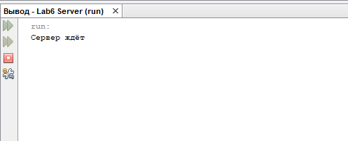
Рисунок 1 – Запуск сервера
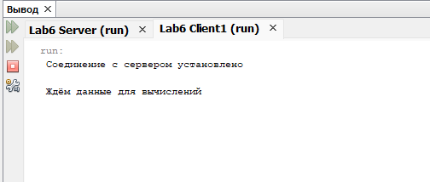
Рисунок 2 – Запуск клиента
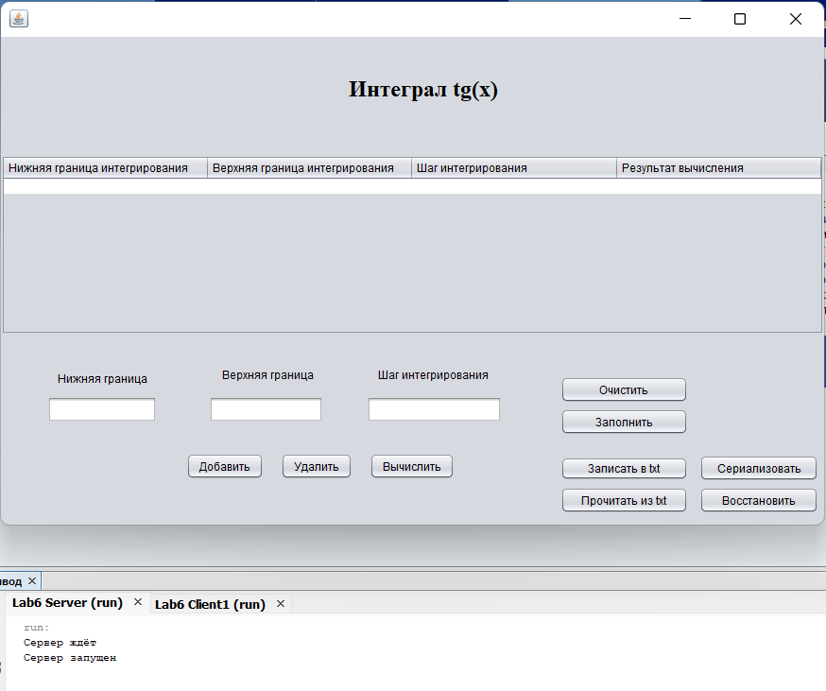
Рисунок 3 – Сервер после запуска клиента
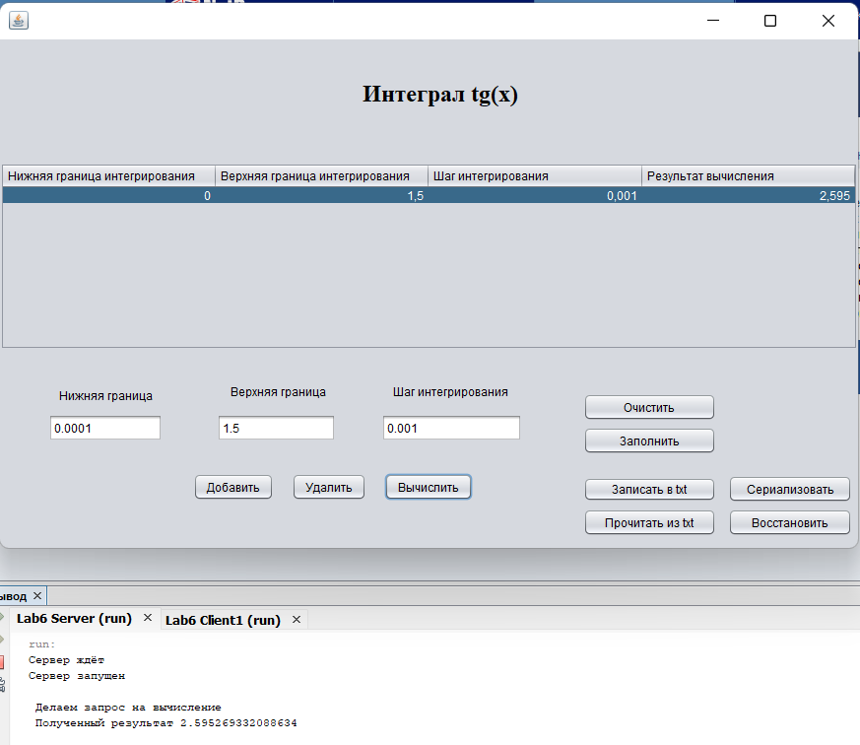
Рисунок 4 – Результат запроса на вычисление
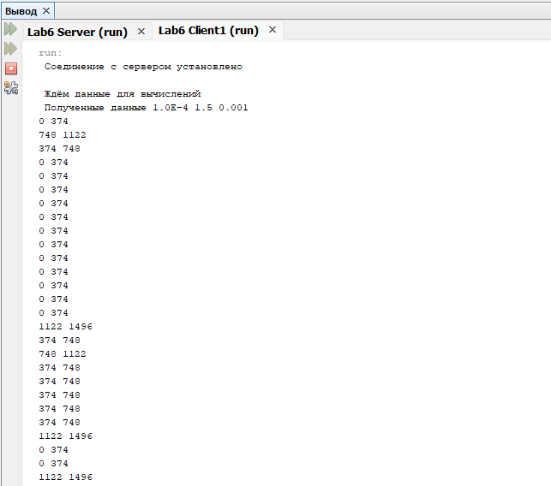
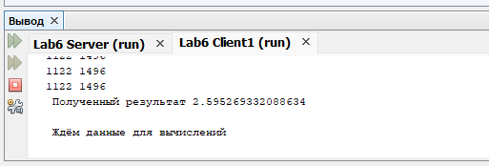
Рисунок 5 – Многопоточная обработка запроса на стороне клиента
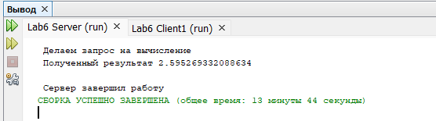
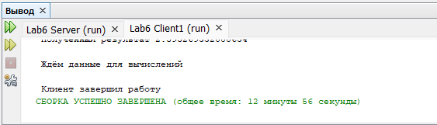
Рисунок 6 – Завершение работы
Вывод
В результате работы был получен опыт в создании клиент-серверных приложений c использованием стандартных классов Java.

