МИНИСТЕРСТВО ОБРАЗОВАНИЯ И НАУКИ РФ
Пензенский государственный университет
Кафедра «Вычислительная техника»
Пенза 2022

ОТЧЕТ
по лабораторной работе №4
по курсу «Программирование на языке Java»
на тему «Работа с файлами»
Вариант 4
Выполнили:
студенты группы 19ВВ2
Дорофеев А.А.
Павлов А.А.
Петров О.М.

Приняли:
Юрова О.В.
Карамышева Н.С.

Цель работы
Изучить работу с файлами и механизмы сериализации данных.
Лабораторное задание
Модифицировать приложение из предыдущей лабораторной работы, реализовав сохранение в файл и загрузку данных из файла. Предусмотреть сохранение данных, как в текстовом виде, так и в двоичном (с использованием механизма сериализации). Для этого нужно добавить 4 кнопки для сохранения и загрузки в текстовом и двоичном виде соответственно. Кроме того, в программе нужно предусмотреть использование стандартного диалога открытия файла (JFileChooser).

Листинг
Модуль IntegException.java

package my.numberaddition;

public class IntegException extends Exception {

public IntegException() {
}

public IntegException(String message) {
super(message);
}

public IntegException(String message, Throwable cause) {
super(message, cause);
}

public IntegException(Throwable cause) {
super(cause);
}

public IntegException(String message, Throwable cause, boolean enableSuppression, boolean writableStackTrace) {
super(message, cause, enableSuppression, writableStackTrace);
}

}

Модуль RecIntegral.java
package my.numberaddition;
import java.io.Serializable;

public class RecIntegral implements Serializable {
private double lowLim;
private double upLim;
private double stepInteg;
private double result;

public RecIntegral(){

lowLim = 0;
upLim = 0;
stepInteg = 0;
result = 0;

}

public RecIntegral(RecIntegral recCopy){

lowLim = recCopy.GetLowLim();
upLim = recCopy.GetUpLim();
stepInteg = recCopy.GetStepInteg();
result = recCopy.GetResult();

}

public RecIntegral(double vLowLim, double vUpLim, double vStInteg, double vRes) throws IntegException{

if((vLowLim <= 0.000001) || (vLowLim >= 1000000) ||
(vUpLim <= 0.000001) || (vUpLim >= 1000000) ||
(vStInteg <= 0.000001) || (vStInteg >= 1000000))
throw new IntegException("Вводимые числа должны быть в диапазоне от 0,000001 до 1000000");

lowLim = vLowLim;
upLim = vUpLim;
stepInteg = vStInteg;
result = vRes;

}

public void SetLowLim(double vLowLim) throws IntegException{
if((vLowLim <= 0.000001) || (vLowLim >= 1000000))
throw new IntegException("Вводимые числа должны быть в диапазоне от 0,000001 до 1000000");

lowLim = vLowLim;
}
public void SetUpLim(double vUpLim) throws IntegException{
if((vUpLim <= 0.000001) || (vUpLim >= 1000000))
throw new IntegException("Вводимые числа должны быть в диапазоне от 0,000001 до 1000000");
upLim = vUpLim;
}
public void SetStepInteg(double vStInteg) throws IntegException{
if(vStInteg == 0)
throw new IntegException("Шаг интегрирования не может быть равным нулю");

if((vStInteg <= 0.000001) || (vStInteg >= 1000000))
throw new IntegException("Вводимые числа должны быть в диапазоне от 0,000001 до 1000000");

if((upLim - lowLim) < vStInteg)
throw new IntegException("Шаг интегрирования не должен превышать диапазон вычисления");

stepInteg = vStInteg;
}
public void SetResult(double vRes){
result = vRes;
}

public double GetLowLim(){
return lowLim;
}
public double GetUpLim(){
return upLim;
}
public double GetStepInteg(){
return stepInteg;
}
public double GetResult(){
return result;

}

}
Модуль IntegrSearch.java
package my.numberaddition;
import javax.swing.table.DefaultTableModel;
import java.util.LinkedList;
import javax.swing.*;
import java.io.File;
import java.io.IOException;
import java.io.PrintWriter;
import java.io.BufferedReader;
import java.io.FileReader;
import java.io.ObjectOutputStream;
import java.io.FileOutputStream;
import java.io.ObjectInputStream;
import java.io.FileInputStream;

import java.util.logging.Level;
import java.util.logging.Logger;

public class IntegrSearch extends javax.swing.JFrame {

public IntegrSearch() {
initComponents();
}
@SuppressWarnings("unchecked")
// <editor-fold defaultstate="collapsed" desc="Generated Code">
private void initComponents() {

jPanel1 = new javax.swing.JPanel();
jLabel1 = new javax.swing.JLabel();
jPanel2 = new javax.swing.JPanel();
jScrollPane1 = new javax.swing.JScrollPane();
jTable = new javax.swing.JTable();
jPanel3 = new javax.swing.JPanel();
jButtonAdd = new javax.swing.JButton();
jButtonDelete = new javax.swing.JButton();
jButtonСalculate = new javax.swing.JButton();
jPanel4 = new javax.swing.JPanel();
jTextField1 = new javax.swing.JTextField();
jTextField2 = new javax.swing.JTextField();
jTextField3 = new javax.swing.JTextField();
jLabel2 = new javax.swing.JLabel();
jLabel3 = new javax.swing.JLabel();
jLabel4 = new javax.swing.JLabel();
jPanel6 = new javax.swing.JPanel();
jButtonSerialize = new javax.swing.JButton();
jButtonDeserialize = new javax.swing.JButton();
jButtonWriteFile = new javax.swing.JButton();
jButtonReadFile = new javax.swing.JButton();
jButtonClear = new javax.swing.JButton();
jButtonFillTable = new javax.swing.JButton();

setDefaultCloseOperation(javax.swing.WindowConstants.EXIT_ON_CLOSE);

jLabel1.setFont(new java.awt.Font("Times New Roman", 1, 24)); // NOI18N
jLabel1.setText(" Интеграл tg(x)");

javax.swing.GroupLayout jPanel1Layout = new javax.swing.GroupLayout(jPanel1);
jPanel1.setLayout(jPanel1Layout);
jPanel1Layout.setHorizontalGroup(
jPanel1Layout.createParallelGroup(javax.swing.GroupLayout.Alignment.LEADING)
.addGroup(jPanel1Layout.createSequentialGroup()
.addGap(151, 151, 151)
.addComponent(jLabel1, javax.swing.GroupLayout.PREFERRED_SIZE, 243, javax.swing.GroupLayout.PREFERRED_SIZE)
.addContainerGap(154, Short.MAX_VALUE))
);
jPanel1Layout.setVerticalGroup(
jPanel1Layout.createParallelGroup(javax.swing.GroupLayout.Alignment.LEADING)
.addGroup(jPanel1Layout.createSequentialGroup()
.addGap(28, 28, 28)
.addComponent(jLabel1, javax.swing.GroupLayout.PREFERRED_SIZE, 42, javax.swing.GroupLayout.PREFERRED_SIZE)
.addContainerGap(34, Short.MAX_VALUE))
);

jTable.setModel(new javax.swing.table.DefaultTableModel(
new Object [][] {
{null, null, null, null}
},
new String [] {
"Нижняя граница интегрирования", "Верхняя граница интегрирования", "Шаг интегрирования", "Результат вычисления"
}
) {
Class[] types = new Class [] {
java.lang.Double.class, java.lang.Double.class, java.lang.Double.class, java.lang.Double.class
};
boolean[] canEdit = new boolean [] {
false, false, false, false
};

public Class getColumnClass(int columnIndex) {
return types [columnIndex];
}

public boolean isCellEditable(int rowIndex, int columnIndex) {
return canEdit [columnIndex];
}
});
jScrollPane1.setViewportView(jTable);

jButtonAdd.setText("Добавить");
jButtonAdd.addActionListener(new java.awt.event.ActionListener() {
public void actionPerformed(java.awt.event.ActionEvent evt) {
jButtonAddActionPerformed(evt);
}
});

jButtonDelete.setText("Удалить");
jButtonDelete.addActionListener(new java.awt.event.ActionListener() {
public void actionPerformed(java.awt.event.ActionEvent evt) {
jButtonDeleteActionPerformed(evt);
}
});

jButtonСalculate.setText("Вычислить");
jButtonСalculate.addActionListener(new java.awt.event.ActionListener() {
public void actionPerformed(java.awt.event.ActionEvent evt) {
jButtonСalculateActionPerformed(evt);
}
});

javax.swing.GroupLayout jPanel3Layout = new javax.swing.GroupLayout(jPanel3);
jPanel3.setLayout(jPanel3Layout);
jPanel3Layout.setHorizontalGroup(
jPanel3Layout.createParallelGroup(javax.swing.GroupLayout.Alignment.LEADING)
.addGroup(jPanel3Layout.createSequentialGroup()
.addGap(48, 48, 48)
.addComponent(jButtonAdd)
.addGap(32, 32, 32)
.addComponent(jButtonDelete)
.addGap(30, 30, 30)
.addComponent(jButtonСalculate)
.addContainerGap(35, Short.MAX_VALUE))
);
jPanel3Layout.setVerticalGroup(
jPanel3Layout.createParallelGroup(javax.swing.GroupLayout.Alignment.LEADING)
.addGroup(javax.swing.GroupLayout.Alignment.TRAILING, jPanel3Layout.createSequentialGroup()
.addContainerGap(javax.swing.GroupLayout.DEFAULT_SIZE, Short.MAX_VALUE)
.addGroup(jPanel3Layout.createParallelGroup(javax.swing.GroupLayout.Alignment.BASELINE)
.addComponent(jButtonAdd)
.addComponent(jButtonDelete)
.addComponent(jButtonСalculate))
.addGap(28, 28, 28))
);

jTextField1.addActionListener(new java.awt.event.ActionListener() {
public void actionPerformed(java.awt.event.ActionEvent evt) {
jTextField1ActionPerformed(evt);
}
});

jTextField3.addActionListener(new java.awt.event.ActionListener() {
public void actionPerformed(java.awt.event.ActionEvent evt) {
jTextField3ActionPerformed(evt);
}
});

jLabel2.setText("Нижняя граница");

jLabel3.setText("Верхняя граница");

jLabel4.setText("Шаг интегрирования");

javax.swing.GroupLayout jPanel4Layout = new javax.swing.GroupLayout(jPanel4);
jPanel4.setLayout(jPanel4Layout);
jPanel4Layout.setHorizontalGroup(
jPanel4Layout.createParallelGroup(javax.swing.GroupLayout.Alignment.LEADING)
.addGroup(jPanel4Layout.createSequentialGroup()
.addGroup(jPanel4Layout.createParallelGroup(javax.swing.GroupLayout.Alignment.LEADING)
.addGroup(jPanel4Layout.createSequentialGroup()
.addGap(54, 54, 54)
.addComponent(jLabel2))
.addGroup(jPanel4Layout.createSequentialGroup()
.addGap(43, 43, 43)
.addComponent(jTextField1, javax.swing.GroupLayout.PREFERRED_SIZE, 116, javax.swing.GroupLayout.PREFERRED_SIZE)))
.addGap(55, 55, 55)
.addGroup(jPanel4Layout.createParallelGroup(javax.swing.GroupLayout.Alignment.TRAILING)
.addComponent(jTextField2, javax.swing.GroupLayout.PREFERRED_SIZE, 121, javax.swing.GroupLayout.PREFERRED_SIZE)
.addComponent(jLabel3, javax.swing.GroupLayout.PREFERRED_SIZE, 107, javax.swing.GroupLayout.PREFERRED_SIZE))
.addGap(46, 46, 46)
.addGroup(jPanel4Layout.createParallelGroup(javax.swing.GroupLayout.Alignment.TRAILING)
.addComponent(jTextField3, javax.swing.GroupLayout.PREFERRED_SIZE, 143, javax.swing.GroupLayout.PREFERRED_SIZE)
.addComponent(jLabel4, javax.swing.GroupLayout.PREFERRED_SIZE, 131, javax.swing.GroupLayout.PREFERRED_SIZE))
.addContainerGap(javax.swing.GroupLayout.DEFAULT_SIZE, Short.MAX_VALUE))
);
jPanel4Layout.setVerticalGroup(
jPanel4Layout.createParallelGroup(javax.swing.GroupLayout.Alignment.LEADING)
.addGroup(jPanel4Layout.createSequentialGroup()
.addContainerGap()
.addGroup(jPanel4Layout.createParallelGroup(javax.swing.GroupLayout.Alignment.LEADING)
.addComponent(jLabel2, javax.swing.GroupLayout.Alignment.TRAILING, javax.swing.GroupLayout.DEFAULT_SIZE, 25, Short.MAX_VALUE)
.addGroup(jPanel4Layout.createParallelGroup(javax.swing.GroupLayout.Alignment.BASELINE)
.addComponent(jLabel4)
.addComponent(jLabel3)))
.addPreferredGap(javax.swing.LayoutStyle.ComponentPlacement.RELATED)
.addGroup(jPanel4Layout.createParallelGroup(javax.swing.GroupLayout.Alignment.LEADING)
.addComponent(jTextField2, javax.swing.GroupLayout.PREFERRED_SIZE, javax.swing.GroupLayout.DEFAULT_SIZE, javax.swing.GroupLayout.PREFERRED_SIZE)
.addComponent(jTextField1, javax.swing.GroupLayout.PREFERRED_SIZE, javax.swing.GroupLayout.DEFAULT_SIZE, javax.swing.GroupLayout.PREFERRED_SIZE)
.addComponent(jTextField3, javax.swing.GroupLayout.PREFERRED_SIZE, javax.swing.GroupLayout.DEFAULT_SIZE, javax.swing.GroupLayout.PREFERRED_SIZE))
.addGap(20, 20, 20))
);

jButtonSerialize.setText("Cериализовать");
jButtonSerialize.addActionListener(new java.awt.event.ActionListener() {
public void actionPerformed(java.awt.event.ActionEvent evt) {
jButtonSerializeActionPerformed(evt);
}
});

jButtonDeserialize.setText("Восстановить");
jButtonDeserialize.addActionListener(new java.awt.event.ActionListener() {
public void actionPerformed(java.awt.event.ActionEvent evt) {
jButtonDeserializeActionPerformed(evt);
}
});

jButtonWriteFile.setText("Записать в txt");
jButtonWriteFile.setPreferredSize(new java.awt.Dimension(87, 25));
jButtonWriteFile.addActionListener(new java.awt.event.ActionListener() {
public void actionPerformed(java.awt.event.ActionEvent evt) {
jButtonWriteFileActionPerformed(evt);
}
});

jButtonReadFile.setText("Прочитать из txt");
jButtonReadFile.addActionListener(new java.awt.event.ActionListener() {
public void actionPerformed(java.awt.event.ActionEvent evt) {
jButtonReadFileActionPerformed(evt);
}
});

jButtonClear.setText("Очистить");
jButtonClear.addActionListener(new java.awt.event.ActionListener() {
public void actionPerformed(java.awt.event.ActionEvent evt) {
jButtonClearActionPerformed(evt);
}
});

jButtonFillTable.setText("Заполнить");
jButtonFillTable.addActionListener(new java.awt.event.ActionListener() {
public void actionPerformed(java.awt.event.ActionEvent evt) {
jButtonFillTableActionPerformed(evt);
}
});

javax.swing.GroupLayout jPanel6Layout = new javax.swing.GroupLayout(jPanel6);
jPanel6.setLayout(jPanel6Layout);
jPanel6Layout.setHorizontalGroup(
jPanel6Layout.createParallelGroup(javax.swing.GroupLayout.Alignment.LEADING)
.addGroup(jPanel6Layout.createSequentialGroup()
.addContainerGap(14, Short.MAX_VALUE)
.addGroup(jPanel6Layout.createParallelGroup(javax.swing.GroupLayout.Alignment.TRAILING, false)
.addComponent(jButtonFillTable, javax.swing.GroupLayout.DEFAULT_SIZE, 135, Short.MAX_VALUE)
.addGroup(jPanel6Layout.createParallelGroup(javax.swing.GroupLayout.Alignment.TRAILING, false)
.addComponent(jButtonClear, javax.swing.GroupLayout.Alignment.LEADING, javax.swing.GroupLayout.DEFAULT_SIZE, javax.swing.GroupLayout.DEFAULT_SIZE, Short.MAX_VALUE)
.addComponent(jButtonReadFile, javax.swing.GroupLayout.DEFAULT_SIZE, 135, Short.MAX_VALUE)
.addComponent(jButtonWriteFile, javax.swing.GroupLayout.DEFAULT_SIZE, javax.swing.GroupLayout.DEFAULT_SIZE, Short.MAX_VALUE)))
.addGroup(jPanel6Layout.createParallelGroup(javax.swing.GroupLayout.Alignment.LEADING)
.addGroup(jPanel6Layout.createSequentialGroup()
.addPreferredGap(javax.swing.LayoutStyle.ComponentPlacement.UNRELATED)
.addComponent(jButtonSerialize, javax.swing.GroupLayout.PREFERRED_SIZE, 126, javax.swing.GroupLayout.PREFERRED_SIZE))
.addGroup(javax.swing.GroupLayout.Alignment.TRAILING, jPanel6Layout.createSequentialGroup()
.addGap(12, 12, 12)
.addComponent(jButtonDeserialize, javax.swing.GroupLayout.PREFERRED_SIZE, 126, javax.swing.GroupLayout.PREFERRED_SIZE)))
.addContainerGap(javax.swing.GroupLayout.DEFAULT_SIZE, Short.MAX_VALUE))
);
jPanel6Layout.setVerticalGroup(
jPanel6Layout.createParallelGroup(javax.swing.GroupLayout.Alignment.LEADING)
.addGroup(jPanel6Layout.createSequentialGroup()
.addGap(16, 16, 16)
.addComponent(jButtonClear)
.addPreferredGap(javax.swing.LayoutStyle.ComponentPlacement.RELATED)
.addComponent(jButtonFillTable)
.addPreferredGap(javax.swing.LayoutStyle.ComponentPlacement.RELATED, 21, Short.MAX_VALUE)
.addGroup(jPanel6Layout.createParallelGroup(javax.swing.GroupLayout.Alignment.BASELINE)
.addComponent(jButtonWriteFile, javax.swing.GroupLayout.PREFERRED_SIZE, javax.swing.GroupLayout.DEFAULT_SIZE, javax.swing.GroupLayout.PREFERRED_SIZE)
.addComponent(jButtonSerialize))
.addPreferredGap(javax.swing.LayoutStyle.ComponentPlacement.RELATED)
.addGroup(jPanel6Layout.createParallelGroup(javax.swing.GroupLayout.Alignment.BASELINE)
.addComponent(jButtonDeserialize)
.addComponent(jButtonReadFile))
.addContainerGap())
);

javax.swing.GroupLayout jPanel2Layout = new javax.swing.GroupLayout(jPanel2);
jPanel2.setLayout(jPanel2Layout);
jPanel2Layout.setHorizontalGroup(
jPanel2Layout.createParallelGroup(javax.swing.GroupLayout.Alignment.LEADING)
.addGroup(jPanel2Layout.createSequentialGroup()
.addGroup(jPanel2Layout.createParallelGroup(javax.swing.GroupLayout.Alignment.TRAILING, false)
.addComponent(jScrollPane1, javax.swing.GroupLayout.PREFERRED_SIZE, 871, javax.swing.GroupLayout.PREFERRED_SIZE)
.addGroup(jPanel2Layout.createSequentialGroup()
.addGroup(jPanel2Layout.createParallelGroup(javax.swing.GroupLayout.Alignment.LEADING)
.addGroup(jPanel2Layout.createSequentialGroup()
.addGap(82, 82, 82)
.addComponent(jPanel3, javax.swing.GroupLayout.PREFERRED_SIZE, javax.swing.GroupLayout.DEFAULT_SIZE, javax.swing.GroupLayout.PREFERRED_SIZE)
.addPreferredGap(javax.swing.LayoutStyle.ComponentPlacement.RELATED, javax.swing.GroupLayout.DEFAULT_SIZE, Short.MAX_VALUE))
.addGroup(jPanel2Layout.createSequentialGroup()
.addContainerGap()
.addComponent(jPanel4, javax.swing.GroupLayout.DEFAULT_SIZE, javax.swing.GroupLayout.DEFAULT_SIZE, Short.MAX_VALUE)
.addGap(18, 18, 18)))
.addComponent(jPanel6, javax.swing.GroupLayout.PREFERRED_SIZE, javax.swing.GroupLayout.DEFAULT_SIZE, javax.swing.GroupLayout.PREFERRED_SIZE)))
.addGap(0, 0, Short.MAX_VALUE))
);
jPanel2Layout.setVerticalGroup(
jPanel2Layout.createParallelGroup(javax.swing.GroupLayout.Alignment.LEADING)
.addGroup(jPanel2Layout.createSequentialGroup()
.addComponent(jScrollPane1, javax.swing.GroupLayout.PREFERRED_SIZE, 190, javax.swing.GroupLayout.PREFERRED_SIZE)
.addPreferredGap(javax.swing.LayoutStyle.ComponentPlacement.RELATED, 28, Short.MAX_VALUE)
.addGroup(jPanel2Layout.createParallelGroup(javax.swing.GroupLayout.Alignment.LEADING)
.addGroup(jPanel2Layout.createSequentialGroup()
.addComponent(jPanel4, javax.swing.GroupLayout.PREFERRED_SIZE, javax.swing.GroupLayout.DEFAULT_SIZE, javax.swing.GroupLayout.PREFERRED_SIZE)
.addPreferredGap(javax.swing.LayoutStyle.ComponentPlacement.RELATED)
.addComponent(jPanel3, javax.swing.GroupLayout.PREFERRED_SIZE, 48, javax.swing.GroupLayout.PREFERRED_SIZE))
.addComponent(jPanel6, javax.swing.GroupLayout.PREFERRED_SIZE, javax.swing.GroupLayout.DEFAULT_SIZE, javax.swing.GroupLayout.PREFERRED_SIZE)))
);

javax.swing.GroupLayout layout = new javax.swing.GroupLayout(getContentPane());
getContentPane().setLayout(layout);
layout.setHorizontalGroup(
layout.createParallelGroup(javax.swing.GroupLayout.Alignment.LEADING)
.addGroup(layout.createSequentialGroup()
.addGap(158, 158, 158)
.addComponent(jPanel1, javax.swing.GroupLayout.PREFERRED_SIZE, javax.swing.GroupLayout.DEFAULT_SIZE, javax.swing.GroupLayout.PREFERRED_SIZE)
.addContainerGap(javax.swing.GroupLayout.DEFAULT_SIZE, Short.MAX_VALUE))
.addComponent(jPanel2, javax.swing.GroupLayout.DEFAULT_SIZE, javax.swing.GroupLayout.DEFAULT_SIZE, Short.MAX_VALUE)
);
layout.setVerticalGroup(
layout.createParallelGroup(javax.swing.GroupLayout.Alignment.LEADING)
.addGroup(layout.createSequentialGroup()
.addContainerGap()
.addComponent(jPanel1, javax.swing.GroupLayout.PREFERRED_SIZE, javax.swing.GroupLayout.DEFAULT_SIZE, javax.swing.GroupLayout.PREFERRED_SIZE)
.addPreferredGap(javax.swing.LayoutStyle.ComponentPlacement.RELATED)
.addComponent(jPanel2, javax.swing.GroupLayout.PREFERRED_SIZE, javax.swing.GroupLayout.DEFAULT_SIZE, javax.swing.GroupLayout.PREFERRED_SIZE)
.addContainerGap(javax.swing.GroupLayout.DEFAULT_SIZE, Short.MAX_VALUE))
);

pack();
}// </editor-fold>

private void jButtonAddActionPerformed(java.awt.event.ActionEvent evt) {

DefaultTableModel model = (DefaultTableModel)jTable.getModel();
model.addRow(new Object[]{});
}

private void jButtonСalculateActionPerformed(java.awt.event.ActionEvent evt) {

String str1 = jTextField1.getText();
String str2 = jTextField2.getText();
String str3 = jTextField3.getText();

if(!jTable.getSelectionModel().isSelectionEmpty() && Compare(str1) && Compare(str2) && Compare(str3)){

int selectedRow = jTable.getSelectedRow();

if(!jTextField1.getText().isEmpty() && !jTextField2.getText().isEmpty() && !jTextField3.getText().isEmpty()){

tabEnts.add(new RecIntegral());
int j = tabEnts.size() - 1;

try{

tabEnts.get(j).SetLowLim(Double.parseDouble(str1));
tabEnts.get(j).SetUpLim(Double.parseDouble(str2));
tabEnts.get(j).SetStepInteg(Double.parseDouble(str3));

double area;
area = integralTrap(tabEnts.get(j).GetLowLim(),tabEnts.get(j).GetUpLim(),
tabEnts.get(j).GetStepInteg(),
x -> {return Math.tan(x);});

tabEnts.get(j).SetResult(area);

jTable.setValueAt(tabEnts.get(j).GetLowLim(), selectedRow, 0); // Double.parseDouble(jTextField1.getText()), selectedRow, 0
jTable.setValueAt(tabEnts.get(j).GetUpLim(), selectedRow, 1);
jTable.setValueAt(tabEnts.get(j).GetStepInteg(), selectedRow, 2);
jTable.setValueAt(tabEnts.get(j).GetResult(), selectedRow, 3);

}
catch(IntegException err){

tabEnts.remove(j);
JFrame errFrame = new JFrame();
JOptionPane.showMessageDialog(errFrame, err.getMessage());

}
}
}

}

public boolean Compare(String comp){

try{
int points = 0;

if((comp == null) || (comp.length() == 0))
return false;

for(int i = 0; i < comp.length(); i++){
char c = comp.charAt(i);
if(c == '.')
points++;

if((!Character.isDigit(c) && c != '.') || points > 1)
throw new IntegException("Вводимые поля должны содержать только числа");
}

return true;
}

catch(IntegException err){

JFrame errFrame = new JFrame();
JOptionPane.showMessageDialog(errFrame, err.getMessage());

return false;
}
}

private void jButtonDeleteActionPerformed(java.awt.event.ActionEvent evt) {

if(!jTable.getSelectionModel().isSelectionEmpty()){

DefaultTableModel model = (DefaultTableModel)jTable.getModel();
model.removeRow(jTable.getSelectedRow());

}
}

private void jTextField3ActionPerformed(java.awt.event.ActionEvent evt) {
// TODO add your handling code here:
}

private void jTextField1ActionPerformed(java.awt.event.ActionEvent evt) {
// TODO add your handling code here:
}

private void jButtonClearActionPerformed(java.awt.event.ActionEvent evt) {
// TODO add your handling code here:
DefaultTableModel model = (DefaultTableModel)jTable.getModel();
model.setRowCount(0);

}

private void jButtonFillTableActionPerformed(java.awt.event.ActionEvent evt) {
// TODO add your handling code here:
DefaultTableModel model = (DefaultTableModel)jTable.getModel();

model.setRowCount(0);

if(tabEnts != null){
for(int i = 0; i < tabEnts.size(); i++){

if( tabEnts.get(i).GetStepInteg() != 0 ){
model.addRow(new Object[]{tabEnts.get(i).GetLowLim(), tabEnts.get(i).GetUpLim(),
tabEnts.get(i).GetStepInteg(), tabEnts.get(i).GetResult()});
}

}
}

}

private void jButtonReadFileActionPerformed(java.awt.event.ActionEvent evt) {
// TODO add your handling code here:

BufferedReader br = null;
try{
JFileChooser fc = new JFileChooser();
fc.setFileSelectionMode(JFileChooser.FILES_ONLY);

fc.setCurrentDirectory(new java.io.File( System.getProperty("user.dir") ));
int ret = fc.showDialog(null, "Выберите файл для чтения");

if(ret == JFileChooser.APPROVE_OPTION){

File file = fc.getSelectedFile();
br = new BufferedReader(new FileReader(file));
String line;

int countStr = 0;
int countStrNew = 0;

while((line = br.readLine()) != null){

tabEnts.add(new RecIntegral());
int j = tabEnts.size() - 1;

try{

String[] subStr;
String delimeter = " "; // Разделитель
subStr = line.split(delimeter);

for(int i = 0; i < subStr.length; i++){
if(!Compare(subStr[i]))
continue;

if(Compare(subStr[i]) && Compare(subStr[i + 1]) && Compare(subStr[i + 2])){

tabEnts.get(j).SetLowLim(Double.parseDouble(subStr[i]));
tabEnts.get(j).SetUpLim(Double.parseDouble(subStr[i + 1]));
tabEnts.get(j).SetStepInteg(Double.parseDouble(subStr[i + 2]));
tabEnts.get(j).SetResult(Double.parseDouble(subStr[i + 3]));

//System.out.println(i + " " + (i+1) + " "+ (i+2) + " " + (i+3) + "\n");

countStr++;
break;
}
}

if(countStr == countStrNew)
tabEnts.remove(j);
else
countStrNew = countStr;

}
catch(IntegException err){

tabEnts.remove(j);
//JFrame errFrame = new JFrame();
//JOptionPane.showMessageDialog(errFrame, err.getMessage());

}

}

JFrame sFrame = new JFrame();
String sStr = "Успешно прочитано строк " + countStr;

JOptionPane.showMessageDialog(sFrame, sStr);

}

} catch(IOException err){
JFrame errFrame = new JFrame();
JOptionPane.showMessageDialog(errFrame, err.getMessage());

} finally{

try {
if(br != null)
br.close();
} catch (IOException ex) {
Logger.getLogger(IntegrSearch.class.getName()).log(Level.SEVERE, null, ex);
}
}

}

private void jButtonWriteFileActionPerformed(java.awt.event.ActionEvent evt) {
// TODO add your handling code here:

try{
JFileChooser fc = new JFileChooser();
fc.setFileSelectionMode(JFileChooser.FILES_ONLY);

fc.setCurrentDirectory(new java.io.File( System.getProperty("user.dir") ));
int ret = fc.showDialog(null, "Выберите файл для сохранения");

if(ret == JFileChooser.APPROVE_OPTION){

File file = fc.getSelectedFile();
try (PrintWriter pw = new PrintWriter(file)) {
if(tabEnts != null){
for(int i = 0; i < tabEnts.size(); i++){

pw.print(" " + tabEnts.get(i).GetLowLim() + " " + tabEnts.get(i).GetUpLim()
+ " " + tabEnts.get(i).GetStepInteg() + " " + tabEnts.get(i).GetResult() + "\n");
}
}
pw.close();
}
}

} catch(IOException err){
JFrame errFrame = new JFrame();
JOptionPane.showMessageDialog(errFrame, err.getMessage());

}
}

private void jButtonSerializeActionPerformed(java.awt.event.ActionEvent evt) {
// TODO add your handling code here:

try{
JFileChooser fc = new JFileChooser();
fc.setFileSelectionMode(JFileChooser.FILES_ONLY);

fc.setCurrentDirectory(new java.io.File( System.getProperty("user.dir") ));
int ret = fc.showDialog(null, "Выберите файл для сериализации");

if(ret == JFileChooser.APPROVE_OPTION){

try (FileOutputStream fos = new FileOutputStream(fc.getSelectedFile())) {
ObjectOutputStream oos = new ObjectOutputStream(fos);

if(tabEnts != null){
oos.writeObject(tabEnts);
}

fos.close();

}

}

} catch(IOException err){
JFrame errFrame = new JFrame();
JOptionPane.showMessageDialog(errFrame, err.getMessage());

}

}

private void jButtonDeserializeActionPerformed(java.awt.event.ActionEvent evt) {
// TODO add your handling code here:

try{
JFileChooser fc = new JFileChooser();
fc.setFileSelectionMode(JFileChooser.FILES_ONLY);

fc.setCurrentDirectory(new java.io.File( System.getProperty("user.dir") ));
int ret = fc.showDialog(null, "Выберите файл для десериализации");

if(ret == JFileChooser.APPROVE_OPTION){

try (FileInputStream fis = new FileInputStream(fc.getSelectedFile())) {

tabEnts = new LinkedList();
ObjectInputStream ois = new ObjectInputStream(fis);
try {
tabEnts = (LinkedList<RecIntegral>)ois.readObject();
} catch (ClassNotFoundException ex) {
Logger.getLogger(IntegrSearch.class.getName()).log(Level.SEVERE, null, ex);
}

fis.close();

}

}

} catch(IOException err){
JFrame errFrame = new JFrame();
JOptionPane.showMessageDialog(errFrame, err.getMessage());

}

}

public static void main(String args[]) {
/* Set the Nimbus look and feel */
//<editor-fold defaultstate="collapsed" desc=" Look and feel setting code (optional) ">
/* If Nimbus (introduced in Java SE 6) is not available, stay with the default look and feel.
* For details see http://download.oracle.com/javase/tutorial/uiswing/lookandfeel/plaf.html
*/
try {
for (javax.swing.UIManager.LookAndFeelInfo info : javax.swing.UIManager.getInstalledLookAndFeels()) {
if ("Nimbus".equals(info.getName())) {
javax.swing.UIManager.setLookAndFeel(info.getClassName());
break;
}
}
} catch (ClassNotFoundException ex) {
java.util.logging.Logger.getLogger(IntegrSearch.class.getName()).log(java.util.logging.Level.SEVERE, null, ex);
} catch (InstantiationException ex) {
java.util.logging.Logger.getLogger(IntegrSearch.class.getName()).log(java.util.logging.Level.SEVERE, null, ex);
} catch (IllegalAccessException ex) {
java.util.logging.Logger.getLogger(IntegrSearch.class.getName()).log(java.util.logging.Level.SEVERE, null, ex);
} catch (javax.swing.UnsupportedLookAndFeelException ex) {
java.util.logging.Logger.getLogger(IntegrSearch.class.getName()).log(java.util.logging.Level.SEVERE, null, ex);
}
//</editor-fold>
//</editor-fold>
//</editor-fold>
//</editor-fold>

/* Create and display the form */
java.awt.EventQueue.invokeLater(new Runnable() {
public void run() {
new IntegrSearch().setVisible(true);

}
});
}

public double integralTrap(double vLowLim, double vUpLim, double vStepInteg, Function function) {
double area = 0;

for (int i = 0; i < (vUpLim - vLowLim) / vStepInteg; i++) {
area += vStepInteg * (0.5 * (function.func(vLowLim + i * vStepInteg)+function.func(vLowLim+(i+1)* vStepInteg)));
}
return area;
}

// Variables declaration - do not modify
private javax.swing.JButton jButtonAdd;
private javax.swing.JButton jButtonClear;
private javax.swing.JButton jButtonDelete;
private javax.swing.JButton jButtonDeserialize;
private javax.swing.JButton jButtonFillTable;
private javax.swing.JButton jButtonReadFile;
private javax.swing.JButton jButtonSerialize;
private javax.swing.JButton jButtonWriteFile;
private javax.swing.JButton jButtonСalculate;
private javax.swing.JLabel jLabel1;
private javax.swing.JLabel jLabel2;
private javax.swing.JLabel jLabel3;
private javax.swing.JLabel jLabel4;
private javax.swing.JPanel jPanel1;
private javax.swing.JPanel jPanel2;
private javax.swing.JPanel jPanel3;
private javax.swing.JPanel jPanel4;
private javax.swing.JPanel jPanel6;
private javax.swing.JScrollPane jScrollPane1;
private javax.swing.JTable jTable;
private javax.swing.JTextField jTextField1;
private javax.swing.JTextField jTextField2;
private javax.swing.JTextField jTextField3;
// End of variables declaration
public double lowLim;
public double upLim;
public double stepInteg;
public LinkedList<RecIntegral> tabEnts = new LinkedList();

interface Function {
public double func(double x);

}

}

Пояснительный текст к программе
В программу были добавлены четыре кнопки, сохраняющие коллекцию в файл, как в текстовом виде, так и в двоичном (с использованием механизма сериализации), и загружающие её из файла. Выбор файла осуществляется с помощью стандартного диалога открытия файла (JFileChooser).

Результаты работы программы
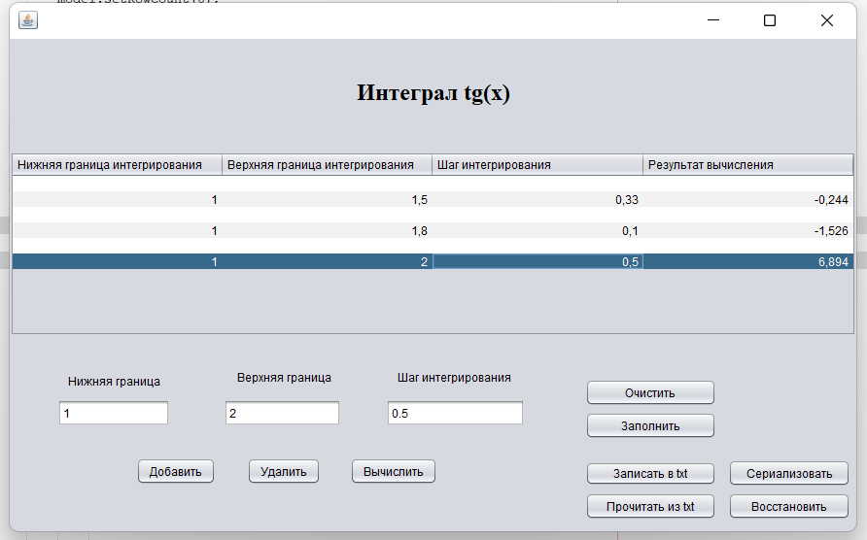
Рисунок 1 – Исходные данные
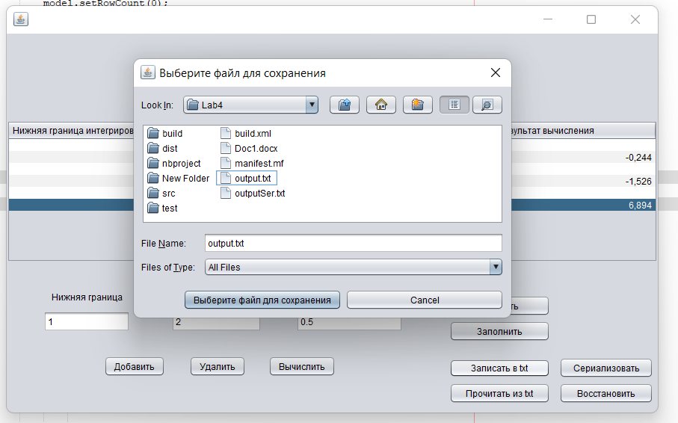
Рисунок 2 – Выбор текстового файла для записи с помощью стандартного диалога открытия файла (JFileChooser)
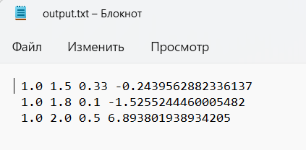
Рисунок 3 – Результат записи в текстовый файл
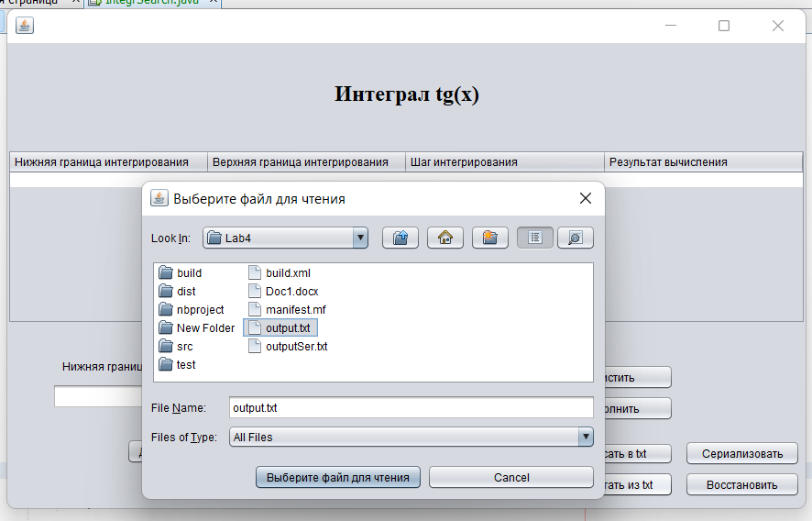
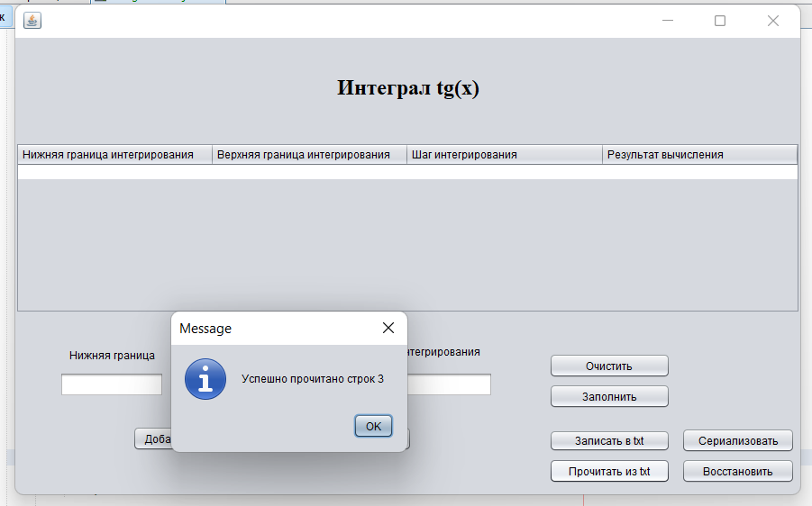
Рисунки 4-5 – Чтение текстового файла
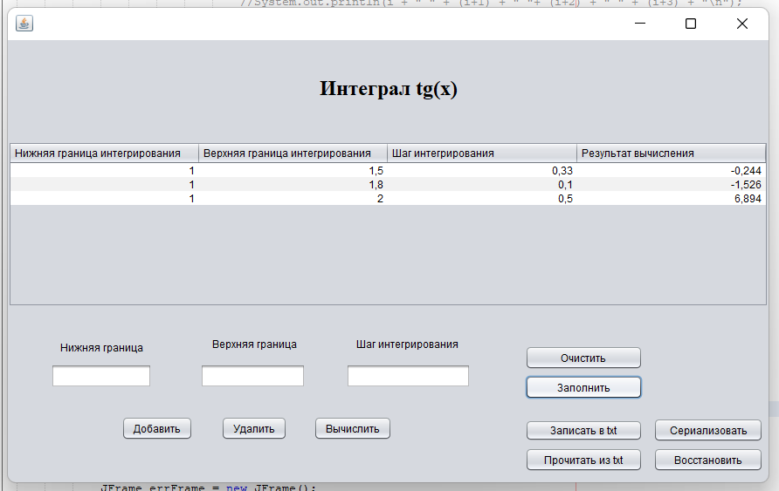
Рисунок 7 – Заполнение таблицы прочитанными данными
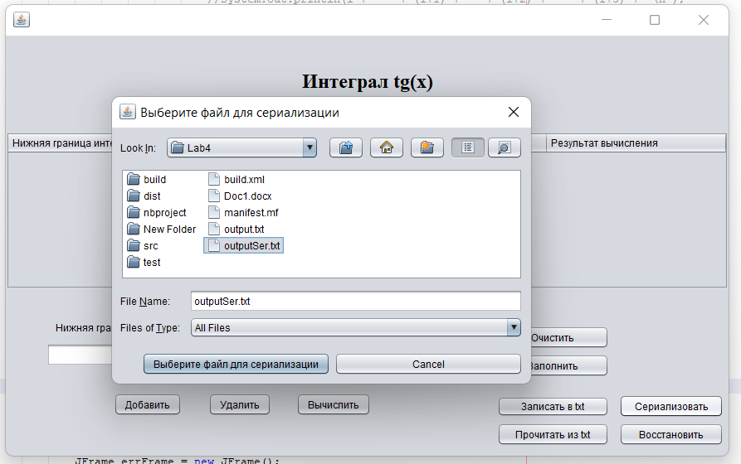
Рисунок 8 – Выбор файла для сериализации

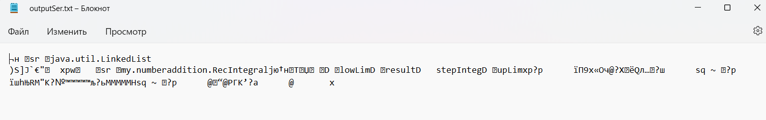
Рисунок 9 –Результат сериализации
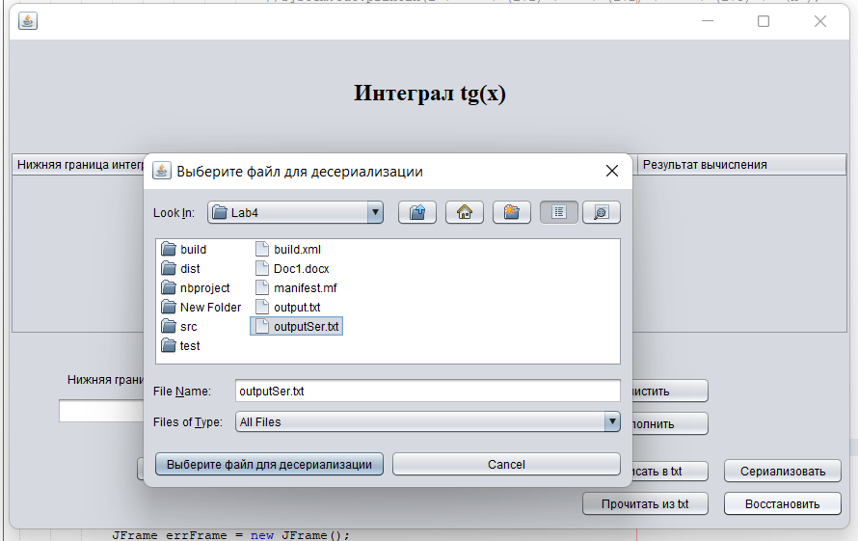
Рисунок 10 – Выбор файла для восстановления
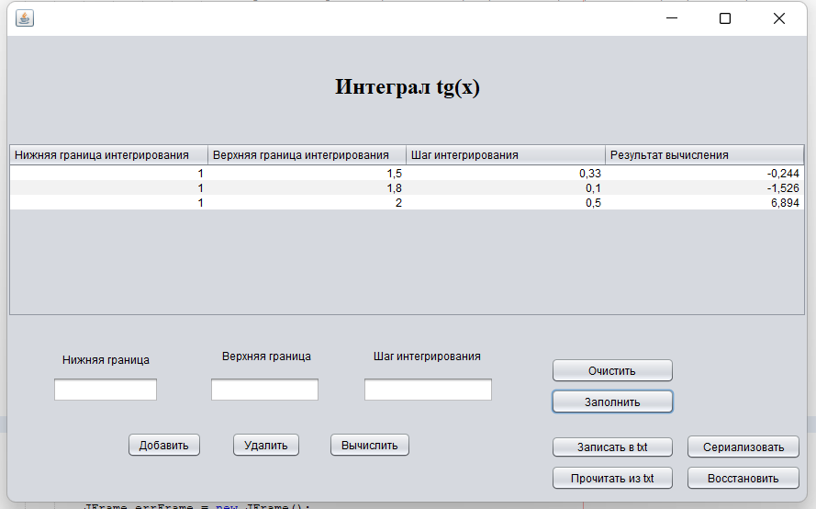
Рисунок 11 – Заполнение таблицы десериализованными данными
Вывод
В результате работы была изучена работа с файлами и механизмы сериализации данных.

