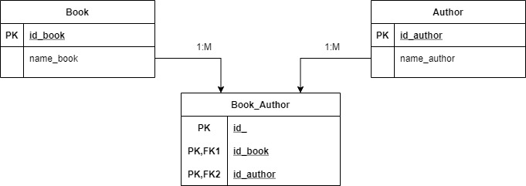

SQLite:

select name_book as "название книги",

count(name_author) as "Количество со-авторов" from book

Join Book_Author on Book_Author.id_book=Book.id_book

Join Author on Author.id_author=Book_Author.id_author

group by Book.name_book

having count(name_author)>=3;

Вывод:

