**WaterFront**

This variable says if the house has a view to a waterfront or not.

In our dataset there are way more house without waterfront(21450) than with watherfront (163).

**Basic statistics**

There are the statistics for houses price ($) acording of waterfont :

|  |  |  |
| --- | --- | --- |
|  | WaterFront | NoWaterFront |
| Mean | 1 660 000 | 530 000 |
| Median | 1 400 000 | 450 000 |
| Variance | 1,2*10^12 | 1,2*10^11 |
| Std Deviation | 1 100 000 | 340 000 |
| Minimum | 285 000 | 75 000 |
| Maximum | 7 000 000 | 7 700 000 |
| Range | 6 715 000 | 7 625 000 |

WaterFront houses seem to be more expensive.

**Distribution of prices**

Below, there is the histogram of the price for the houses without Waterfront.

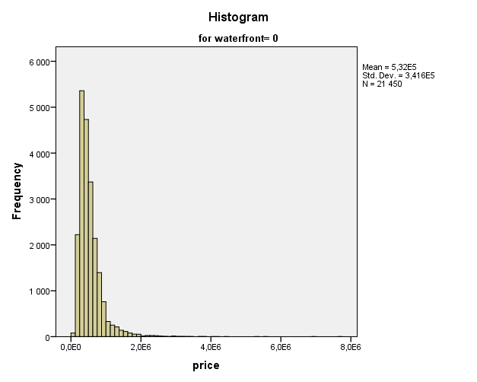

A huge majority of the house seem to have a price below 2 000 000$ and 50% of the house have a price below 450 000$ (median).

Below, there is the histogram of the price for the houses with Waterfront.

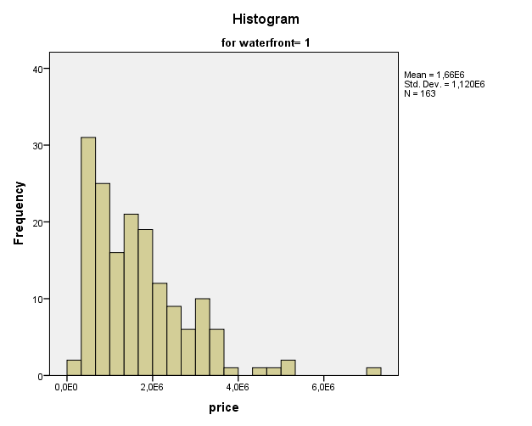

A huge majority of the house seem to have a price below 4 000 000$ and 50% of the house have a price below 1 400 000$ (median).

Both histogram seem to have the same patern, when the price increases, the number of house decreases.

**Outliers**

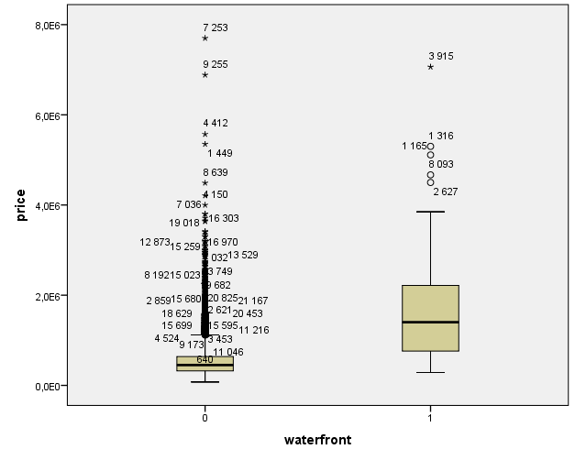

With this graphic we can see there is not below outliers. It’s probably because an house can’t be sold below 0. In fact range between the lowest and median is around 400k$ (1 000k$ with WaterFront) whereas range between the Highest and the median is around 7 000k$ (5 5000k$ with WaterFront).

There are a lot of outliers in absolute value for the house without WaterFront (around 40) but in percentage it’s low 0.1%.

The are 5 outliers for the house with WaterFront, it’s 3%.

Below, the 5 highest outliers for houses price with and without WaterFront

|  |  |  |  |
| --- | --- | --- | --- |
| Without WaterFront | | With WaterFront | |
| Id | Price ($) | Id | Price ($) |
| 7253 | 7 700 000 | 3915 | 7 062 500 |
| 9255 | 6 885 000 | 1316 | 5 300 000 |
| 4412 | 5 570 000 | 1165 | 5 110 800 |
| 1449 | 5 350 000 | 8093 | 4 668000 |
| 8639 | 4 489 000 | 2627 | 4 500 000 |