QUESTION 1
You are a data engineer implementing a lambda architecture on Microsoft Azure. You use an open-source big data solution to collect, process, and maintain data. The analytical data store performs poorly.
You must implement a solution that meets the following requirements:
Provide data warehousing
Reduce ongoing management activities
Deliver SQL query responses in less than one second You need to create an HDInsight cluster to meet the requirements.
Which type of cluster should you create?
- Interactive Query
- Apache Hadoop
- Apache HBase
- Apache Spark
Correct Answer: D
Section: (none) Explanation
Explanation/Reference:
Explanation:
Lambda Architecture with Azure:
Azure offers you a combination of following technologies to accelerate real-time big data analytics:
- Azure Cosmos DB, a globally distributed and multi-model database service.
- Apache Spark for Azure HDInsight, a processing framework that runs large-scale data analyticsapplications.
- Azure Cosmos DB change feed, which streams new data to the batch layer for HDInsight to process.
- The Spark to Azure Cosmos DB Connector
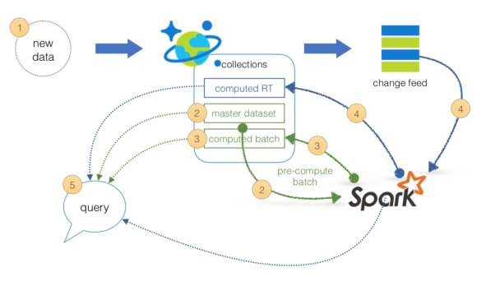
Note: Lambda architecture is a data-processing architecture designed to handle massive quantities of data by taking advantage of both batch processing and stream processing methods, and minimizing the latency involved in querying big data.
References: https://sqlwithmanoj.com/2018/02/16/what-is-lambda-architecture-and-what-azure-offers-with-its-new-cosmosdb/
QUESTION 2
DRAG DROP
You develop data engineering solutions for a company. You must migrate data from Microsoft Azure Blob storage to an Azure SQL Data Warehouse for further transformation. You need to implement the solution.
Which four actions should you perform in sequence? To answer, move the appropriate actions from the list of actions to the answer area and arrange them in the correct order.
Select and Place:
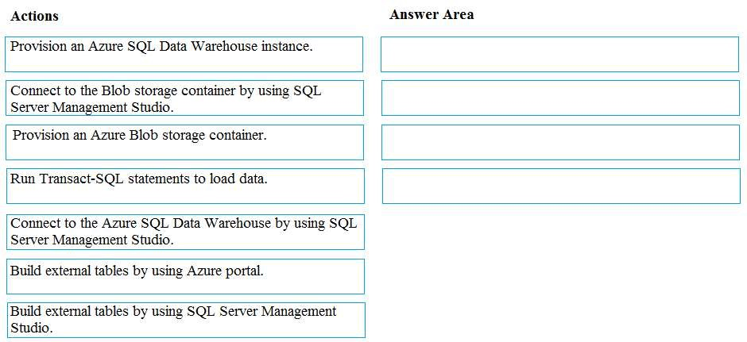
Correct Answer:
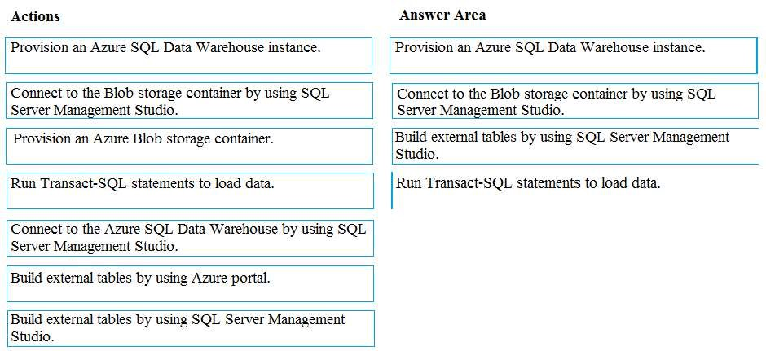
Section: (none) Explanation
Explanation/Reference: Explanation:
Step 1: Provision an Azure SQL Data Warehouse instance. Create a data warehouse in the Azure portal.
Step 2: Connect to the Azure SQL Data warehouse by using SQL Server Management Studio
Connect to the data warehouse with SSMS (SQL Server Management Studio)
Step 3: Build external tables by using the SQL Server Management Studio Create external tables for data in Azure blob storage.
You are ready to begin the process of loading data into your new data warehouse. You use external tables to load data from the Azure storage blob.
Step 4: Run Transact-SQL statements to load data.
You can use the CREATE TABLE AS SELECT (CTAS) T-SQL statement to load the data from Azure Storage Blob into new tables in your data warehouse.
References:
https://github.com/MicrosoftDocs/azure-docs/blob/master/articles/sql-data-warehouse/load-data-from-azureblob-storage-using-polybase.md
QUESTION 3
You develop data engineering solutions for a company. The company has on-premises Microsoft SQL Server databases at multiple locations.
The company must integrate data with Microsoft Power BI and Microsoft Azure Logic Apps. The solution must avoid single points of failure during connection and transfer to the cloud. The solution must also minimize latency.
You need to secure the transfer of data between on-premises databases and Microsoft Azure.
What should you do?
- Install a standalone on-premises Azure data gateway at each location
- Install an on-premises data gateway in personal mode at each location
- Install an Azure on-premises data gateway at the primary location
- Install an Azure on-premises data gateway as a cluster at each location
Correct Answer: D
Section: (none) Explanation
Explanation/Reference:
Explanation:
You can create high availability clusters of On-premises data gateway installations, to ensure your organization can access on-premises data resources used in Power BI reports and dashboards. Such clusters allow gateway administrators to group gateways to avoid single points of failure in accessing on-premises data resources. The Power BI service always uses the primary gateway in the cluster, unless it’s not available. In that case, the service switches to the next gateway in the cluster, and so on.
References: https://docs.microsoft.com/en-us/power-bi/service-gateway-high-availability-clusters
QUESTION 4
You are a data architect. The data engineering team needs to configure a synchronization of data between an on-premises Microsoft SQL Server database to Azure SQL Database.
Ad-hoc and reporting queries are being overutilized the on-premises production instance. The synchronization process must:
Perform an initial data synchronization to Azure SQL Database with minimal downtime Perform bi-directional data synchronization after initial synchronization
You need to implement this synchronization solution.
Which synchronization method should you use?
- transactional replication
- Data Migration Assistant (DMA)
- backup and restore
- SQL Server Agent job
- Azure SQL Data Sync
Correct Answer: E
Section: (none) Explanation
Explanation/Reference:
Explanation:
SQL Data Sync is a service built on Azure SQL Database that lets you synchronize the data you select bidirectionally across multiple SQL databases and SQL Server instances.
With Data Sync, you can keep data synchronized between your on-premises databases and Azure SQL databases to enable hybrid applications.
Compare Data Sync with Transactional Replication
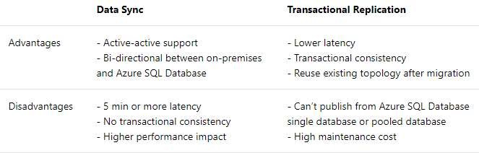
References: https://docs.microsoft.com/en-us/azure/sql-database/sql-database-sync-data
QUESTION 5
An application will use Microsoft Azure Cosmos DB as its data solution. The application will use the Cassandra API to support a column-based database type that uses containers to store items.
You need to provision Azure Cosmos DB. Which container name and item name should you use? Each correct answer presents part of the solutions.
NOTE: Each correct answer selection is worth one point.
- collection
- rows
- graph
- entities
- table
Correct Answer: BE
Section: (none) Explanation
Explanation/Reference:
Explanation:
B: Depending on the choice of the API, an Azure Cosmos item can represent either a document in a collection, a row in a table or a node/edge in a graph. The following table shows the mapping between API-specific entities to an Azure Cosmos item:
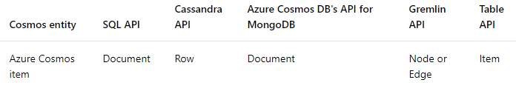
E: An Azure Cosmos container is specialized into API-specific entities as follows:
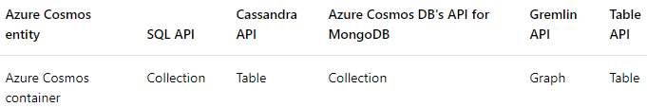
References: https://docs.microsoft.com/en-us/azure/cosmos-db/databases-containers-items
QUESTION 6
A company has a SaaS solution that uses Azure SQL Database with elastic pools. The solution contains a
dedicated database for each customer organization. Customer organizations have peak usage at different periods during the year.
You need to implement the Azure SQL Database elastic pool to minimize cost.
Which option or options should you configure?
- Number of transactions only
- eDTUs per database only
- Number of databases only
- CPU usage only
- eDTUs and max data size
Correct Answer: E
Section: (none) Explanation
Explanation/Reference:
Explanation:
The best size for a pool depends on the aggregate resources needed for all databases in the pool. This involves determining the following:
Maximum resources utilized by all databases in the pool (either maximum DTUs or maximum vCores depending on your choice of resourcing model).
Maximum storage bytes utilized by all databases in the pool.
Note: Elastic pools enable the developer to purchase resources for a pool shared by multiple databases to accommodate unpredictable periods of usage by individual databases. You can configure resources for the pool based either on the DTU-based purchasing model or the vCore-based purchasing model.
References: https://docs.microsoft.com/en-us/azure/sql-database/sql-database-elastic-pool
QUESTION 7
HOTSPOT
You are a data engineer. You are designing a Hadoop Distributed File System (HDFS) architecture. You plan to use Microsoft Azure Data Lake as a data storage repository.
You must provision the repository with a resilient data schema. You need to ensure the resiliency of the Azure Data Lake Storage. What should you use? To answer, select the appropriate options in the answer area.
NOTE: Each correct selection is worth one point.
Hot Area:
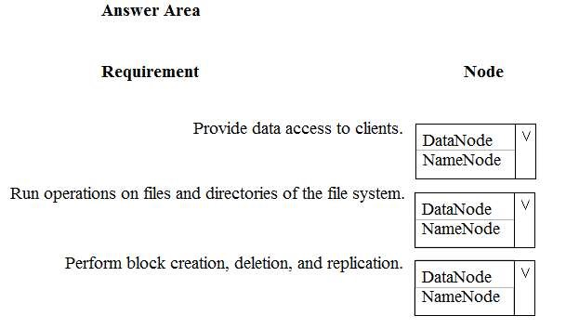
Correct Answer:
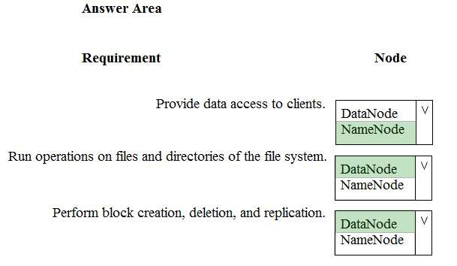
Section: (none)
Explanation
Explanation/Reference: Explanation:
Box 1: NameNode
An HDFS cluster consists of a single NameNode, a master server that manages the file system namespace and regulates access to files by clients.
Box 2: DataNode
The DataNodes are responsible for serving read and write requests from the file system’s clients.
Box 3: DataNode
The DataNodes perform block creation, deletion, and replication upon instruction from the NameNode.
Note: HDFS has a master/slave architecture. An HDFS cluster consists of a single NameNode, a master server that manages the file system namespace and regulates access to files by clients. In addition, there are a number of DataNodes, usually one per node in the cluster, which manage storage attached to the nodes that they run on. HDFS exposes a file system namespace and allows user data to be stored in files. Internally, a file is split into one or more blocks and these blocks are stored in a set of DataNodes. The NameNode executes file system namespace operations like opening, closing, and renaming files and directories. It also determines the mapping of blocks to DataNodes. The DataNodes are responsible for serving read and write requests from the file system’s clients. The DataNodes also perform block creation, deletion, and replication upon instruction from the NameNode.
References: https://hadoop.apache.org/docs/r1.2.1/hdfs_design.html#NameNode+and+DataNodes
QUESTION 8
DRAG DROP
You are developing the data platform for a global retail company. The company operates during normal working hours in each region. The analytical database is used once a week for building sales projections.
Each region maintains its own private virtual network.
Building the sales projections is very resource intensive and generates upwards of 20 terabytes (TB) of data.
Microsoft Azure SQL Databases must be provisioned.
Database provisioning must maximize performance and minimize cost
The daily sales for each region must be stored in an Azure SQL Database instance
Once a day, the data for all regions must be loaded in an analytical Azure SQL Database instance
You need to provision Azure SQL database instances.
How should you provision the database instances? To answer, drag the appropriate Azure SQL products to the correct databases. Each Azure SQL product may be used once, more than once, or not at all. You may need to drag the split bar between panes or scroll to view content.
NOTE: Each correct selection is worth one point.
Select and Place:
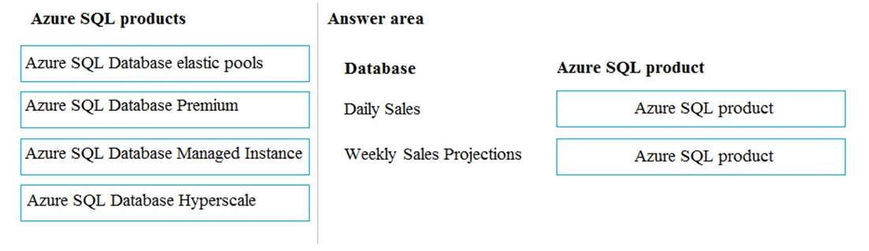
Correct Answer:
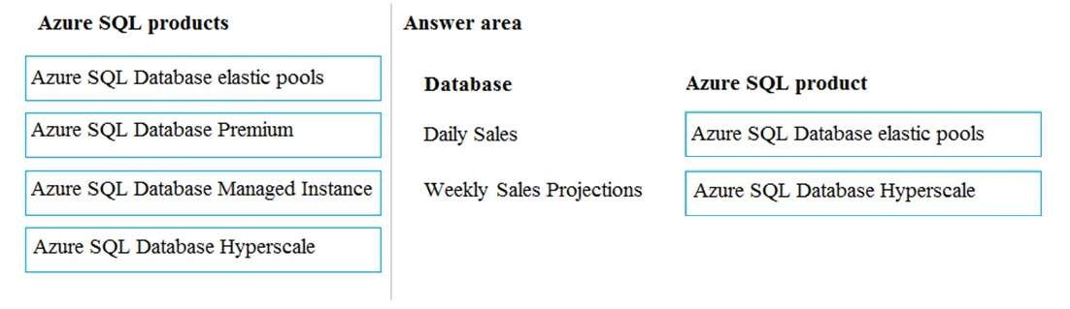
Section: (none) Explanation
Explanation/Reference: Explanation:
Box 1: Azure SQL Database elastic pools
SQL Database elastic pools are a simple, cost-effective solution for managing and scaling multiple databases that have varying and unpredictable usage demands. The databases in an elastic pool are on a single Azure SQL Database server and share a set number of resources at a set price. Elastic pools in Azure SQL Database enable SaaS developers to optimize the price performance for a group of databases within a prescribed budget while delivering performance elasticity for each database.
Box 2: Azure SQL Database Hyperscale
A Hyperscale database is an Azure SQL database in the Hyperscale service tier that is backed by the Hyperscale scale-out storage technology. A Hyperscale database supports up to 100 TB of data and provides high throughput and performance, as well as rapid scaling to adapt to the workload requirements. Scaling is transparent to the application – connectivity, query processing, and so on, work like any other SQL database.
Incorrect Answers:
Azure SQL Database Managed Instance: The managed instance deployment model is designed for customers looking to migrate a large number of apps from on-premises or IaaS, self-built, or ISV provided environment to fully managed PaaS cloud environment, with as low migration effort as possible.
References: https://docs.microsoft.com/en-us/azure/sql-database/sql-database-elastic-pool https://docs.microsoft.com/en-us/azure/sql-database/sql-database-service-tier-hyperscale-faq
QUESTION 9
A company manages several on-premises Microsoft SQL Server databases.
You need to migrate the databases to Microsoft Azure by using a backup process of Microsoft SQL Server.
Which data technology should you use?
- Azure SQL Database single database
- Azure SQL Data Warehouse
- Azure Cosmos DB
- Azure SQL Database Managed Instance
Correct Answer: D
Section: (none) Explanation
Explanation/Reference:
Explanation:
Managed instance is a new deployment option of Azure SQL Database, providing near 100% compatibility with the latest SQL Server on-premises (Enterprise Edition) Database Engine, providing a native virtual network (VNet) implementation that addresses common security concerns, and a business model favorable for onpremises SQL Server customers. The managed instance deployment model allows existing SQL Server customers to lift and shift their on-premises applications to the cloud with minimal application and database changes.
References: https://docs.microsoft.com/en-us/azure/sql-database/sql-database-managed-instance
QUESTION 10
The data engineering team manages Azure HDInsight clusters. The team spends a large amount of time creating and destroying clusters daily because most of the data pipeline process runs in minutes.
You need to implement a solution that deploys multiple HDInsight clusters with minimal effort.
What should you implement?
- Azure Databricks
- Azure Traffic Manager
- Azure Resource Manager templates
- Ambari web user interface
Correct Answer: C
Section: (none) Explanation
Explanation/Reference:
Explanation:
A Resource Manager template makes it easy to create the following resources for your application in a single, coordinated operation:
HDInsight clusters and their dependent resources (such as the default storage account). Other resources (such as Azure SQL Database to use Apache Sqoop).
In the template, you define the resources that are needed for the application. You also specify deployment parameters to input values for different environments. The template consists of JSON and expressions that you use to construct values for your deployment.
References: https://docs.microsoft.com/en-us/azure/hdinsight/hdinsight-hadoop-create-linux-clusters-arm-templates
QUESTION 11
You are the data engineer for your company. An application uses a NoSQL database to store data. The database uses the key-value and wide-column NoSQL database type.
Developers need to access data in the database using an API.
You need to determine which API to use for the database model and type.
Which two APIs should you use? Each correct answer presents a complete solution.
NOTE: Each correct selection is worth one point.
- Table API
- MongoDB API
- Gremlin API
- SQL API
- Cassandra API
Correct Answer: BE
Section: (none) Explanation
Explanation/Reference:
Explanation:
B: Azure Cosmos DB is the globally distributed, multimodel database service from Microsoft for mission-critical applications. It is a multimodel database and supports document, key-value, graph, and columnar data models.
E: Wide-column stores store data together as columns instead of rows and are optimized for queries over large datasets. The most popular are Cassandra and HBase.
References:
https://docs.microsoft.com/en-us/azure/cosmos-db/graph-introduction https://www.mongodb.com/scale/types-of-nosql-databases
QUESTION 12
A company is designing a hybrid solution to synchronize data and on-premises Microsoft SQL Server database to Azure SQL Database.
You must perform an assessment of databases to determine whether data will move without compatibility issues. You need to perform the assessment.
Which tool should you use?
- SQL Server Migration Assistant (SSMA)
- Microsoft Assessment and Planning Toolkit
- SQL Vulnerability Assessment (VA)
- Azure SQL Data Sync
- Data Migration Assistant (DMA)
Correct Answer: E
Section: (none) Explanation
Explanation/Reference:
Explanation:
The Data Migration Assistant (DMA) helps you upgrade to a modern data platform by detecting compatibility issues that can impact database functionality in your new version of SQL Server or Azure SQL Database. DMA recommends performance and reliability improvements for your target environment and allows you to move your schema, data, and uncontained objects from your source server to your target server.
References: https://docs.microsoft.com/en-us/sql/dma/dma-overview
QUESTION 13
DRAG DROP
You manage a financial computation data analysis process. Microsoft Azure virtual machines (VMs) run the process in daily jobs, and store the results in virtual hard drives (VHDs.)
The VMs product results using data from the previous day and store the results in a snapshot of the VHD. When a new month begins, a process creates a new VHD.
You must implement the following data retention requirements:
Daily results must be kept for 90 days
Data for the current year must be available for weekly reports
Data from the previous 10 years must be stored for auditing purposes
Data required for an audit must be produced within 10 days of a request.
You need to enforce the data retention requirements while minimizing cost.
How should you configure the lifecycle policy? To answer, drag the appropriate JSON segments to the correct locations. Each JSON segment may be used once, more than once, or not at all. You may need to drag the split bat between panes or scroll to view content.
NOTE: Each correct selection is worth one point.
Select and Place:
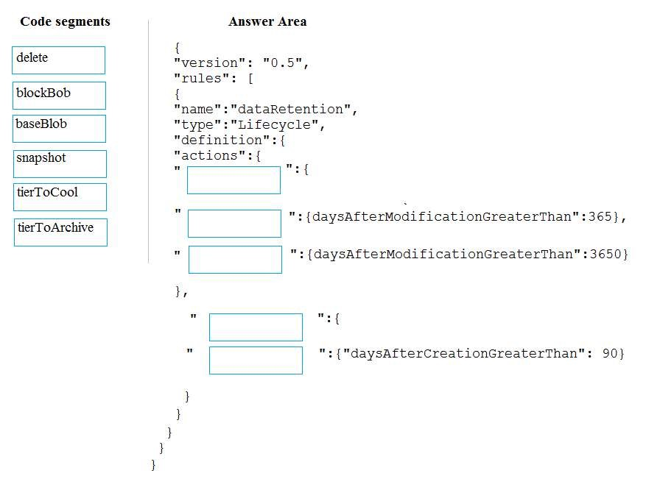
Correct Answer:
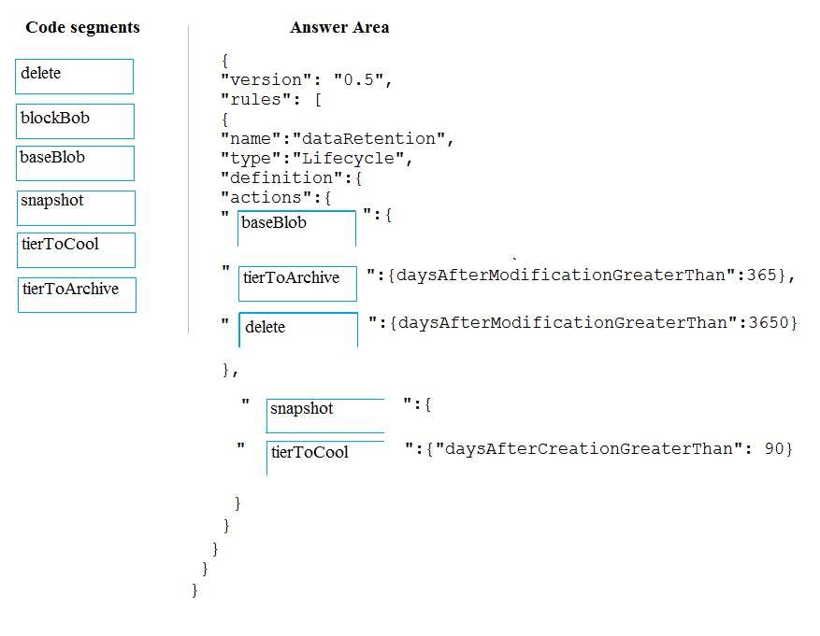
Section: (none) Explanation
Explanation/Reference: Explanation:
The Set-AzStorageAccountManagementPolicy cmdlet creates or modifies the management policy of an Azure Storage account.
Example: Create or update the management policy of a Storage account with ManagementPolicy rule objects.
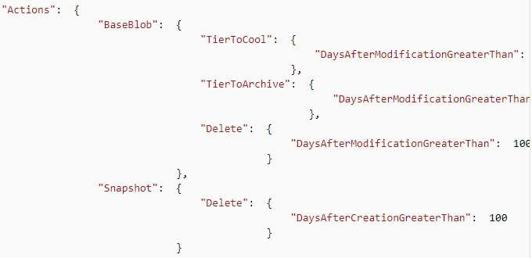
Action -BaseBlobAction Delete -daysAfterModificationGreaterThan 100
PS C:\>$action1 = Add-AzStorageAccountManagementPolicyAction -InputObject $action1 -BaseBlobAction
TierToArchive -daysAfterModificationGreaterThan 50
PS C:\>$action1 = Add-AzStorageAccountManagementPolicyAction -InputObject $action1 -BaseBlobAction TierToCool -daysAfterModificationGreaterThan 30
PS C:\>$action1 = Add-AzStorageAccountManagementPolicyAction -InputObject $action1 -SnapshotAction
Delete -daysAfterCreationGreaterThan 100
PS C:\>$filter1 = New-AzStorageAccountManagementPolicyFilter -PrefixMatch ab,cd
PS C:\>$rule1 = New-AzStorageAccountManagementPolicyRule -Name Test -Action $action1 -Filter $filter1
PS C:\>$action2 = Add-AzStorageAccountManagementPolicyAction -BaseBlobAction Delete daysAfterModificationGreaterThan 100
PS C:\>$filter2 = New-AzStorageAccountManagementPolicyFilter
References: https://docs.microsoft.com/en-us/powershell/module/az.storage/set-azstorageaccountmanagementpolicy
QUESTION 14
A company plans to use Azure SQL Database to support a mission-critical application.
The application must be highly available without performance degradation during maintenance windows.
You need to implement the solution.
Which three technologies should you implement? Each correct answer presents part of the solution.
NOTE: Each correct selection is worth one point.
- Premium service tier
- Virtual machine Scale Sets
- Basic service tier
- SQL Data Sync
- Always On availability groups
- Zone-redundant configuration
Correct Answer: AEF
Section: (none) Explanation Explanation/Reference:
Explanation:
A: Premium/business critical service tier model that is based on a cluster of database engine processes. This architectural model relies on a fact that there is always a quorum of available database engine nodes and has minimal performance impact on your workload even during maintenance activities.
E: In the premium model, Azure SQL database integrates compute and storage on the single node. High availability in this architectural model is achieved by replication of compute (SQL Server Database Engine process) and storage (locally attached SSD) deployed in 4-node cluster, using technology similar to SQL Server Always On Availability Groups.
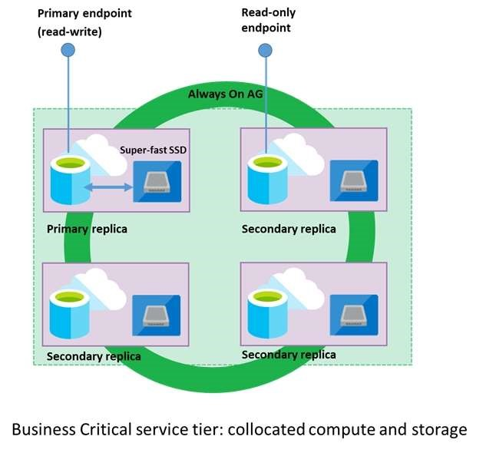
F: Zone redundant configuration
By default, the quorum-set replicas for the local storage configurations are created in the same datacenter. With the introduction of Azure Availability Zones, you have the ability to place the different replicas in the quorum-sets to different availability zones in the same region. To eliminate a single point of failure, the control ring is also duplicated across multiple zones as three gateway rings (GW).
References: https://docs.microsoft.com/en-us/azure/sql-database/sql-database-high-availability
QUESTION 15
A company plans to use Azure Storage for file storage purposes. Compliance rules require:
A single storage account to store all operations including reads, writes and deletes Retention of an on-premises copy of historical operations
You need to configure the storage account.
Which two actions should you perform? Each correct answer presents part of the solution.
NOTE: Each correct selection is worth one point.
- Configure the storage account to log read, write and delete operations for service type Blob
- Use the AzCopy tool to download log data from $logs/blob
- Configure the storage account to log read, write and delete operations for service-type table
- Use the storage client to download log data from $logs/table
- Configure the storage account to log read, write and delete operations for service type queue
Correct Answer: AB
Section: (none) Explanation
Explanation/Reference:
Explanation:
Storage Logging logs request data in a set of blobs in a blob container named $logs in your storage account. This container does not show up if you list all the blob containers in your account but you can see its contents if you access it directly.
To view and analyze your log data, you should download the blobs that contain the log data you are interested in to a local machine. Many storage-browsing tools enable you to download blobs from your storage account; you can also use the Azure Storage team provided command-line Azure Copy Tool (AzCopy) to download your log data.
References: https://docs.microsoft.com/en-us/rest/api/storageservices/enabling-storage-logging-and-accessing-log-data
QUESTION 16 DRAG DROP
You are developing a solution to visualize multiple terabytes of geospatial data.
The solution has the following requirements:
Data must be encrypted.
Data must be accessible by multiple resources on Microsoft Azure.
You need to provision storage for the solution.
Which four actions should you perform in sequence? To answer, move the appropriate action from the list of actions to the answer area and arrange them in the correct order.
Select and Place:
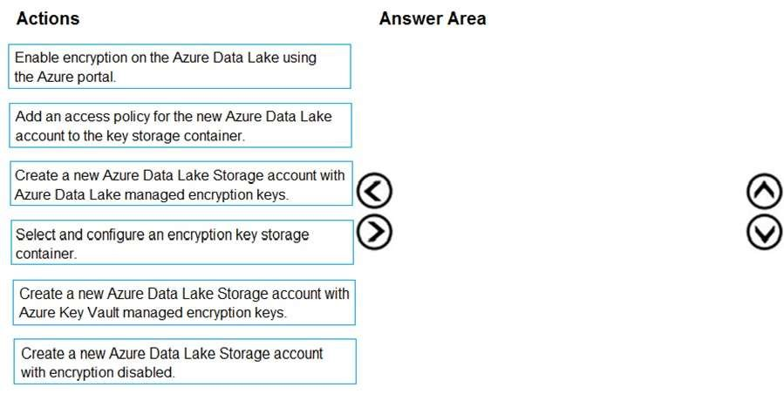
Correct Answer:
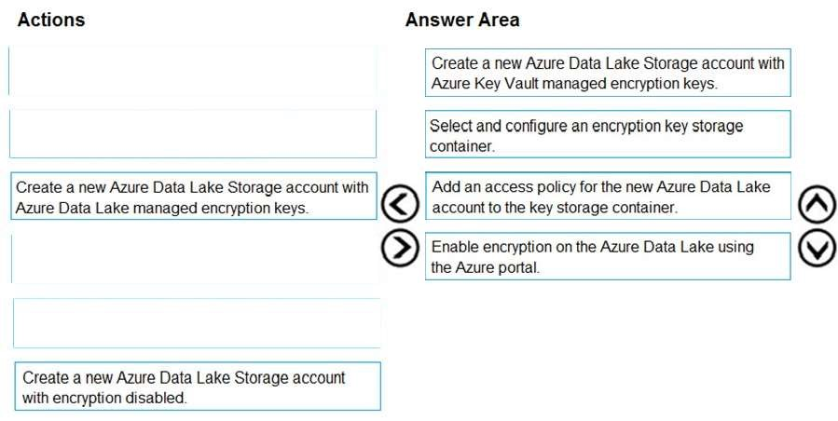
Section: (none) Explanation
Explanation/Reference: Explanation:
Create a new Azure Data Lake Storage account with Azure Data Lake managed encryption keys
For Azure services, Azure Key Vault is the recommended key storage solution and provides a common management experience across services. Keys are stored and managed in key vaults, and access to a key vault can be given to users or services. Azure Key Vault supports customer creation of keys or import of customer keys for use in customer-managed encryption key scenarios.
Note: Data Lake Storage Gen1 account Encryption Settings. There are three options:
Do not enable encryption.
Use keys managed by Data Lake Storage Gen1, if you want Data Lake Storage Gen1 to manage your encryption keys.
Use keys from your own Key Vault. You can select an existing Azure Key Vault or create a new Key Vault. To use the keys from a Key Vault, you must assign permissions for the Data Lake Storage Gen1 account to access the Azure Key Vault.
References: https://docs.microsoft.com/en-us/azure/security/fundamentals/encryption-atrest
QUESTION 17
You are developing a data engineering solution for a company. The solution will store a large set of key-value pair data by using Microsoft Azure Cosmos DB.
The solution has the following requirements:
Data must be partitioned into multiple containers.
Data containers must be configured separately.
Data must be accessible from applications hosted around the world. The solution must minimize latency.
You need to provision Azure Cosmos DB.
Which three actions should you perform? Each correct answer presents part of the solution.
NOTE: Each correct selection is worth one point.
- Configure account-level throughput.
- Provision an Azure Cosmos DB account with the Azure Table API. Enable geo-redundancy.
- Configure table-level throughput.
- Replicate the data globally by manually adding regions to the Azure Cosmos DB account.
- Provision an Azure Cosmos DB account with the Azure Table API. Enable multi-region writes.
Correct Answer: E
Section: (none) Explanation
Explanation/Reference:
Explanation:
Scale read and write throughput globally. You can enable every region to be writable and elastically scale reads and writes all around the world. The throughput that your application configures on an Azure Cosmos database or a container is guaranteed to be delivered across all regions associated with your Azure Cosmos account.
The provisioned throughput is guaranteed up by financially backed SLAs.
Reference:
https://docs.microsoft.com/en-us/azure/cosmos-db/distribute-data-globally
QUESTION 18
A company has a SaaS solution that uses Azure SQL Database with elastic pools. The solution will have a
dedicated database for each customer organization. Customer organizations have peak usage at different periods during the year.
Which two factors affect your costs when sizing the Azure SQL Database elastic pools? Each correct answer presents a complete solution.
NOTE: Each correct selection is worth one point.
- maximum data size
- number of databases
- eDTUs consumption
- number of read operations
- number of transactions
Correct Answer: AC
Section: (none) Explanation
Explanation/Reference:
Explanation:
A: With the vCore purchase model, in the General Purpose tier, you are charged for Premium blob storage that you provision for your database or elastic pool. Storage can be configured between 5 GB and 4 TB with 1 GB increments. Storage is priced at GB/month.
C: In the DTU purchase model, elastic pools are available in basic, standard and premium service tiers. Each tier is distinguished primarily by its overall performance, which is measured in elastic Database Transaction Units (eDTUs).
References:
https://azure.microsoft.com/en-in/pricing/details/sql-database/elastic/
QUESTION 19
You are developing a solution using a Lambda architecture on Microsoft Azure.
The data at rest layer must meet the following requirements:
Data storage:
Serve as a repository for high volumes of large files in various formats.
Implement optimized storage for big data analytics workloads.
Ensure that data can be organized using a hierarchical structure.
Batch processing:
Use a managed solution for in-memory computation processing.
Natively support Scala, Python, and R programming languages.
Provide the ability to resize and terminate the cluster automatically.
Analytical data store:
Support parallel processing.
Use columnar storage.
Support SQL-based languages.
You need to identify the correct technologies to build the Lambda architecture.
Which technologies should you use? To answer, select the appropriate options in the answer area.
NOTE: Each correct selection is worth one point.
Hot Area:
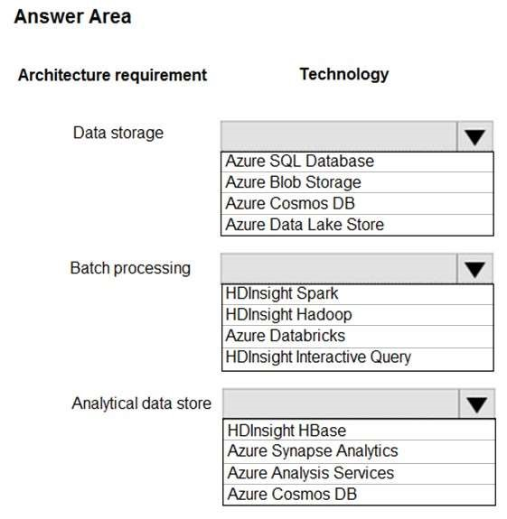
Correct Answer:
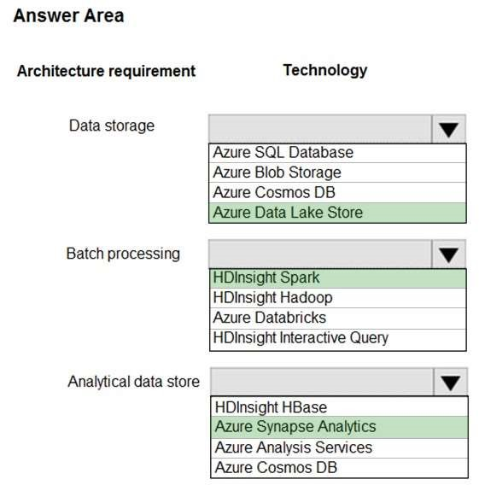
Section: (none) Explanation
Explanation/Reference: Explanation:
Data storage: Azure Data Lake Store
A key mechanism that allows Azure Data Lake Storage Gen2 to provide file system performance at object storage scale and prices is the addition of a hierarchical namespace. This allows the collection of objects/files within an account to be organized into a hierarchy of directories and nested subdirectories in the same way that the file system on your computer is organized. With the hierarchical namespace enabled, a storage account becomes capable of providing the scalability and cost-effectiveness of object storage, with file system semantics that are familiar to analytics engines and frameworks.
Batch processing: HD Insight Spark
Aparch Spark is an open-source, parallel-processing framework that supports in-memory processing to boost the performance of big-data analysis applications.
HDInsight is a managed Hadoop service. Use it deploy and manage Hadoop clusters in Azure. For batch processing, you can use Spark, Hive, Hive LLAP, MapReduce.
Languages: R, Python, Java, Scala, SQL
Analytic data store: Azure Synapse Analytics
Azure Synapse Analytics Warehouse is a cloud-based Enterprise Data Warehouse (EDW) that uses Massively Parallel Processing (MPP).
Azure Synapse Analytics stores data into relational tables with columnar storage.
Note: As of November 2019, Azure SQL Data Warehouse is now Azure Synapse Analytics.
References: https://docs.microsoft.com/en-us/azure/storage/blobs/data-lake-storage-namespace https://docs.microsoft.com/en-us/azure/architecture/data-guide/technology-choices/batch-processing https://docs.microsoft.com/en-us/azure/sql-data-warehouse/sql-data-warehouse-overview-what-is
QUESTION 20 DRAG DROP
Your company has an on-premises Microsoft SQL Server instance.
The data engineering team plans to implement a process that copies data from the SQL Server instance to Azure Blob storage once a day. The process must orchestrate and manage the data lifecycle.
You need to create Azure Data Factory to connect to the SQL Server instance.
Which three actions should you perform in sequence? To answer, move the appropriate actions from the list of actions to the answer area and arrange them in the correct order.
Select and Place:
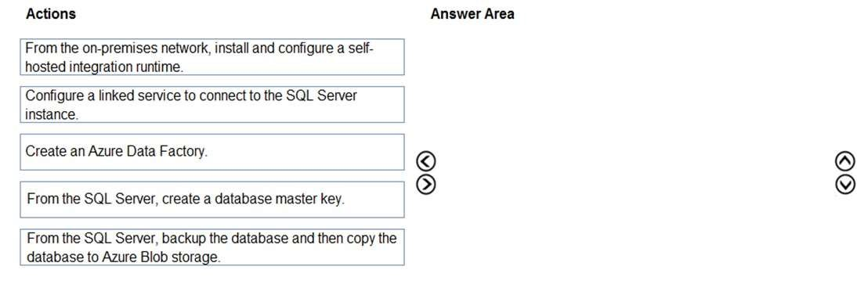
Correct Answer:
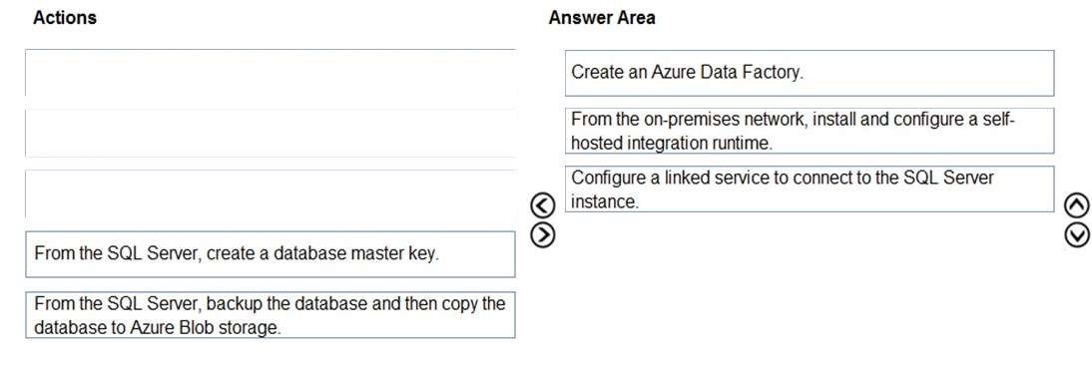
Section: (none) Explanation
Explanation/Reference: Explanation:
Step 1: Create an Azure Data Factory
You need to create a data factory and start the Data Factory UI to create a pipeline in the data factory.
Step 2: From the on-premises network, install and configure a self-hosted runtime.
To use copy data from a SQL Server database that isn't publicly accessible, you need to set up a self-hosted integration runtime.
Step 3: Configure a linked service to connect to the SQL Server instance.
Reference: https://docs.microsoft.com/en-us/azure/data-factory/connector-sql-server
https://www.mssqltips.com/sqlservertip/5812/connect-to-onpremises-data-in-azure-data-factory-with-theselfhosted-integration-runtime--part-1/
QUESTION 21
A company runs Microsoft SQL Server in an on-premises virtual machine (VM).
You must migrate the database to Azure SQL Database. You synchronize users from Active Directory to Azure Active Directory (Azure AD).
You need to configure Azure SQL Database to use an Azure AD user as administrator.
What should you configure?
- For each Azure SQL Database, set the Access Control to administrator.
- For each Azure SQL Database server, set the Active Directory to administrator.
- For each Azure SQL Database, set the Active Directory administrator role.
- For each Azure SQL Database server, set the Access Control to administrator.
Correct Answer: C
Section: (none) Explanation
Explanation/Reference:
Explanation:
There are two administrative accounts (Server admin and Active Directory admin) that act as administrators.
One Azure Active Directory account, either an individual or security group account, can also be configured as an administrator. It is optional to configure an Azure AD administrator, but an Azure AD administrator must be configured if you want to use Azure AD accounts to connect to SQL Database.
References: https://docs.microsoft.com/en-us/azure/sql-database/sql-database-manage-logins
QUESTION 22
Note: This question is part of a series of questions that present the same scenario. Each question in the series contains a unique solution that might meet the stated goals. Some question sets might have more than one correct solution, while others might not have a correct solution.
After you answer a question in this section, you will NOT be able to return to it. As a result, these questions will not appear in the review screen.
You have an Azure SQL database named DB1 that contains a table named Table1. Table1 has a field named Customer_ID that is varchar(22).
You need to implement masking for the Customer_ID field to meet the following requirements:
The first two prefix characters must be exposed. The last four suffix characters must be exposed. All other characters must be masked.
Solution: You implement data masking and use a credit card function mask.
Does this meet the goal?
- Yes
- No
Correct Answer: B
Section: (none) Explanation
Explanation/Reference:
Explanation:
Must use Custom Text data masking, which exposes the first and last characters and adds a custom padding string in the middle.
Reference:
https://docs.microsoft.com/en-us/azure/sql-database/sql-database-dynamic-data-masking-get-started
QUESTION 23
Note: This question is part of a series of questions that present the same scenario. Each question in the series contains a unique solution that might meet the stated goals. Some question sets might have more than one correct solution, while others might not have a correct solution.
After you answer a question in this section, you will NOT be able to return to it. As a result, these questions will not appear in the review screen.
You have an Azure SQL database named DB1 that contains a table named Table1. Table1 has a field named Customer_ID that is varchar(22).
You need to implement masking for the Customer_ID field to meet the following requirements:
The first two prefix characters must be exposed. The last four suffix characters must be exposed. All other characters must be masked.
Solution: You implement data masking and use an email function mask.
Does this meet the goal?
- Yes
- No
Correct Answer: B
Section: (none) Explanation
Explanation/Reference:
Explanation:
Must use Custom Text data masking, which exposes the first and last characters and adds a custom padding string in the middle.
References: https://docs.microsoft.com/en-us/azure/sql-database/sql-database-dynamic-data-masking-get-started
QUESTION 24
Note: This question is part of a series of questions that present the same scenario. Each question in the series contains a unique solution that might meet the stated goals. Some question sets might have more than one correct solution, while others might not have a correct solution.
After you answer a question in this section, you will NOT be able to return to it. As a result, these questions will not appear in the review screen.
You have an Azure SQL database named DB1 that contains a table named Table1. Table1 has a field named Customer_ID that is varchar(22).
You need to implement masking for the Customer_ID field to meet the following requirements:
The first two prefix characters must be exposed. The last four suffix characters must be exposed. All other characters must be masked.
Solution: You implement data masking and use a random number function mask.
Does this meet the goal?
- Yes
- No
Correct Answer: B
Section: (none) Explanation
Explanation/Reference:
Explanation:
Must use Custom Text data masking, which exposes the first and last characters and adds a custom padding string in the middle.
References: https://docs.microsoft.com/en-us/azure/sql-database/sql-database-dynamic-data-masking-get-started
QUESTION 25 DRAG DROP You are responsible for providing access to an Azure Data Lake Storage Gen2 account.
Your user account has contributor access to the storage account, and you have the application ID and access key.
You plan to use PolyBase to load data into an enterprise data warehouse in Azure Synapse Analytics.
You need to configure PolyBase to connect the data warehouse to the storage account.
Which three components should you create in sequence? To answer, move the appropriate components from the list of components to the answer are and arrange them in the correct order.
Select and Place:
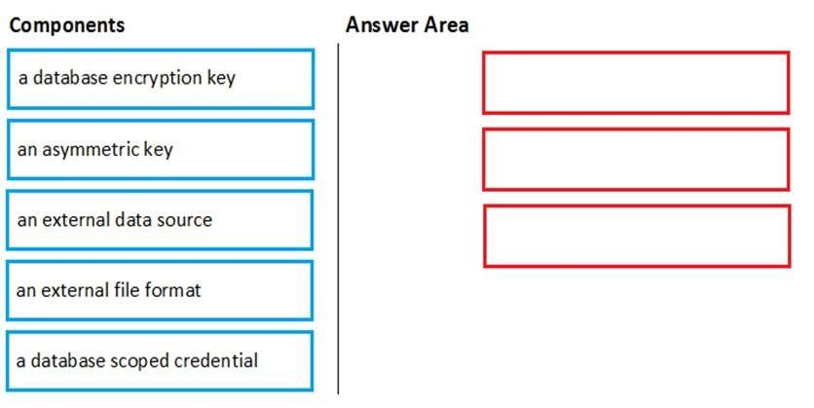
Correct Answer:
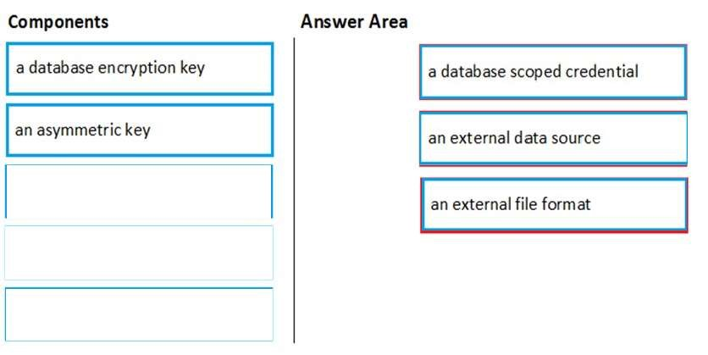
Section: (none) Explanation Explanation/Reference:
Explanation:
Step 1: a database scoped credential
To access your Data Lake Storage account, you will need to create a Database Master Key to encrypt your credential secret used in the next step. You then create a database scoped credential.
Step 2: an external data source
Create the external data source. Use the CREATE EXTERNAL DATA SOURCE command to store the location of the data. Provide the credential created in the previous step.
Step 3: an external file format
Configure data format: To import the data from Data Lake Storage, you need to specify the External File Format. This object defines how the files are written in Data Lake Storage.
Reference:
https://docs.microsoft.com/en-us/azure/sql-data-warehouse/sql-data-warehouse-load-from-azure-data-lakestore
QUESTION 26
You plan to create a dimension table in Azure Synapse Analytics that will be less than 1 GB.
You need to create the table to meet the following requirements:
Provide the fastest query time.
Minimize data movement during queries.
Which type of table should you use?
- hash distributed
- heap
- replicated
- round-robin
Correct Answer: D
Section: (none) Explanation
Explanation/Reference:
Explanation:
Usually common dimension tables or tables that doesn’t distribute evenly are good candidates for round-robin distributed table.
Note: Dimension tables or other lookup tables in a schema can usually be stored as round-robin tables. Usually these tables connect to more than one fact tables and optimizing for one join may not be the best idea. Also usually dimension tables are smaller which can leave some distributions empty when hash distributed. Roundrobin by definition guarantees a uniform data distribution.
Reference:
https://blogs.msdn.microsoft.com/sqlcat/2015/08/11/choosing-hash-distributed-table-vs-round-robin-distributedtable-in-azure-sql-dw-service/
QUESTION 27
You have an enterprise data warehouse in Azure Synapse Analytics.
Using PolyBase, you create an external table named [Ext].[Items] to query Parquet files stored in Azure Data Lake Storage Gen2 without importing the data to the data warehouse.
The external table has three columns.
You discover that the Parquet files have a fourth column named ItemID.
Which command should you run to add the ItemID column to the external table?
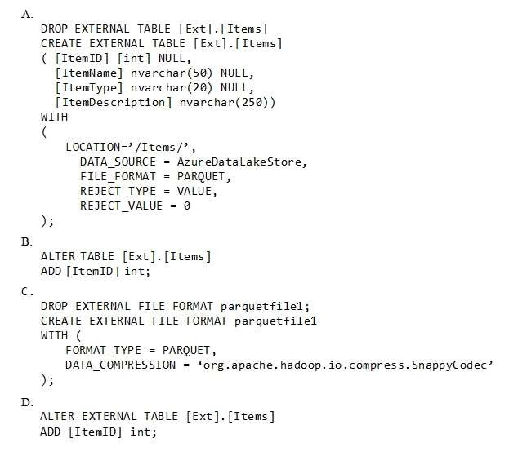
- Option A
- Option B
- Option C
- Option D
Correct Answer: A
Section: (none) Explanation
Explanation/Reference:
Explanation:
Incorrect Answers:
B, D: Only these Data Definition Language (DDL) statements are allowed on external tables:
CREATE TABLE and DROP TABLE
CREATE STATISTICS and DROP STATISTICS
CREATE VIEW and DROP VIEW
Reference:
https://docs.microsoft.com/en-us/sql/t-sql/statements/create-external-table-transact-sql
QUESTION 28
DRAG DROP
You have a table named SalesFact in an enterprise data warehouse in Azure Synapse Analytics. SalesFact contains sales data from the past 36 months and has the following characteristics:
Is partitioned by month
Contains one billion rows
Has clustered columnstore indexes
At the beginning of each month, you need to remove data from SalesFact that is older than 36 months as quickly as possible.
Which three actions should you perform in sequence in a stored procedure? To answer, move the appropriate actions from the list of actions to the answer area and arrange them in the correct order.
Select and Place:
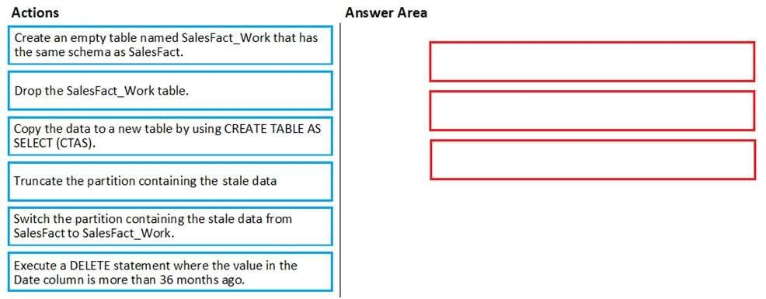
Correct Answer:
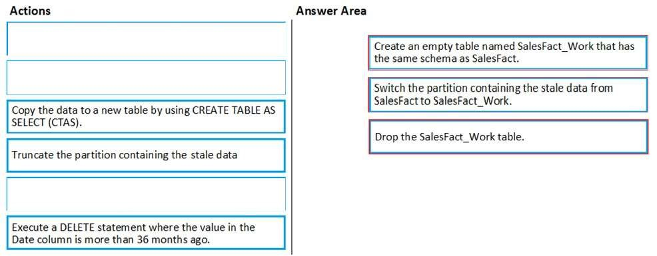
Section: (none)
Explanation
Explanation/Reference: Explanation:
Step 1: Create an empty table named SalesFact_work that has the same schema as SalesFact.
Step 2: Switch the partition containing the stale data from SalesFact to SalesFact_Work.
SQL Data Warehouse supports partition splitting, merging, and switching. To switch partitions between two tables, you must ensure that the partitions align on their respective boundaries and that the table definitions match.
Loading data into partitions with partition switching is a convenient way stage new data in a table that is not visible to users the switch in the new data.
Step 3: Drop the SalesFact_Work table.
Reference:
https://docs.microsoft.com/en-us/azure/sql-data-warehouse/sql-data-warehouse-tables-partition
QUESTION 29
You plan to implement an Azure Cosmos DB database that will write 100,000,000 JSON records every 24 hours. The database will be replicated to three regions. Only one region will be writable.
You need to select a consistency level for the database to meet the following requirements:
Guarantee monotonic reads and writes within a session.
Provide the fastest throughput. Provide the lowest latency.
Which consistency level should you select?
- Strong
- Bounded Staleness
- Eventual
- Session
- Consistent Prefix
Correct Answer: D
Section: (none) Explanation
Explanation/Reference:
Explanation:
Session: Within a single client session reads are guaranteed to honor the consistent-prefix (assuming a single “writer” session), monotonic reads, monotonic writes, read-your-writes, and write-follows-reads guarantees. Clients outside of the session performing writes will see eventual consistency.
Reference:
https://docs.microsoft.com/en-us/azure/cosmos-db/consistency-levels
QUESTION 30
Note: This question is part of a series of questions that present the same scenario. Each question in the series contains a unique solution that might meet the stated goals. Some question sets might have more than one correct solution, while others might not have a correct solution.
After you answer a question in this section, you will NOT be able to return to it. As a result, these questions will not appear in the review screen.
You have an Azure SQL database named DB1 that contains a table named Table1. Table1 has a field named Customer_ID that is varchar(22).
You need to implement masking for the Customer_ID field to meet the following requirements:
The first two prefix characters must be exposed. The last four suffix characters must be exposed. All other characters must be masked.
Solution: You implement data masking and use a custom text mask.
Does this meet the goal?
- Yes
- No
Correct Answer: A
Section: (none) Explanation
Explanation/Reference:
Explanation:
We must use Custom Text data masking, which exposes the first and last characters and adds a custom padding string in the middle.
Reference:
https://docs.microsoft.com/en-us/azure/sql-database/sql-database-dynamic-data-masking-get-started
QUESTION 31
Note: This question is part of a series of questions that present the same scenario. Each question in the series contains a unique solution that might meet the stated goals. Some question sets might have more than one correct solution, while others might not have a correct solution.
After you answer a question in this section, you will NOT be able to return to it. As a result, these questions will not appear in the review screen.
You have an Azure Storage account that contains 100 GB of files. The files contain text and numerical values. 75% of the rows contain description data that has an average length of 1.1 MB.
You plan to copy the data from the storage account to an enterprise data warehouse in Azure Synapse Analytics.
You need to prepare the files to ensure that the data copies quickly.
Solution: You modify the files to ensure that each row is less than 1 MB.
Does this meet the goal?
- Yes
- No
Correct Answer: B
Section: (none) Explanation
Explanation/Reference:
Explanation:
Instead convert the files to compressed delimited text files.
Reference:
https://docs.microsoft.com/en-us/azure/sql-data-warehouse/guidance-for-loading-data
QUESTION 32
Note: This question is part of a series of questions that present the same scenario. Each question in the series contains a unique solution that might meet the stated goals. Some question sets might have more than one correct solution, while others might not have a correct solution.
After you answer a question in this section, you will NOT be able to return to it. As a result, these questions will not appear in the review screen.
You have an Azure Storage account that contains 100 GB of files. The files contain text and numerical values. 75% of the rows contain description data that has an average length of 1.1 MB.
You plan to copy the data from the storage account to an Azure SQL data warehouse.
You need to prepare the files to ensure that the data copies quickly.
Solution: You modify the files to ensure that each row is more than 1 MB.
Does this meet the goal?
- Yes
- No
Correct Answer: B
Section: (none) Explanation
Explanation/Reference:
Explanation:
Instead modify the files to ensure that each row is less than 1 MB.
References: https://docs.microsoft.com/en-us/azure/sql-data-warehouse/guidance-for-loading-data
QUESTION 33
Note: This question is part of a series of questions that present the same scenario. Each question in the series contains a unique solution that might meet the stated goals. Some question sets might have more than one correct solution, while others might not have a correct solution.
After you answer a question in this section, you will NOT be able to return to it. As a result, these questions will not appear in the review screen.
You have an Azure Storage account that contains 100 GB of files. The files contain text and numerical values. 75% of the rows contain description data that has an average length of 1.1 MB.
You plan to copy the data from the storage account to an enterprise data warehouse in Azure Synapse Analytics.
You need to prepare the files to ensure that the data copies quickly.
Solution: You copy the files to a table that has a columnstore index.
Does this meet the goal?
- Yes
- No
Correct Answer: B
Section: (none) Explanation
Explanation/Reference:
Explanation:
Instead convert the files to compressed delimited text files.
Reference: https://docs.microsoft.com/en-us/azure/sql-data-warehouse/guidance-for-loading-data
QUESTION 34
You plan to deploy an Azure Cosmos DB database that supports multi-master replication.
You need to select a consistency level for the database to meet the following requirements:
Provide a recovery point objective (RPO) of less than 15 minutes. Provide a recovery time objective (RTO) of zero minutes.
What are three possible consistency levels that you can select? Each correct answer presents a complete solution.
NOTE: Each correct selection is worth one point.
- Strong
- Bounded Staleness
- Eventual
- Session
- Consistent Prefix
Correct Answer: CDE
Section: (none) Explanation
Explanation/Reference:Explanation:
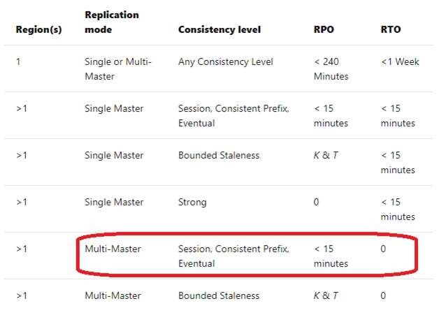
Reference: https://docs.microsoft.com/en-us/azure/cosmos-db/consistency-levels-choosing
QUESTION 35
You have the following Azure Stream Analytics query.
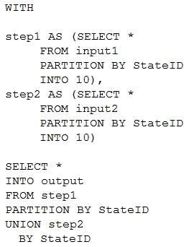
For each of the following statements, select Yes if the statement is true. Otherwise, select No.
NOTE: Each correct selection is worth one point.
Hot Area:
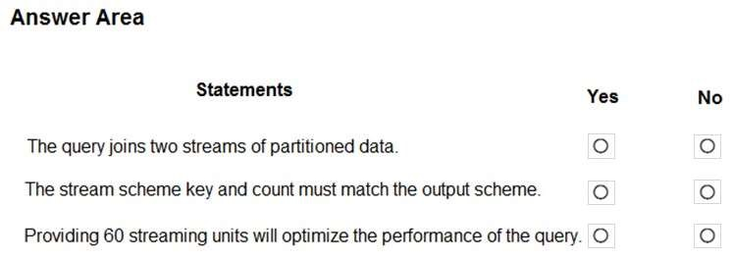
Correct Answer:
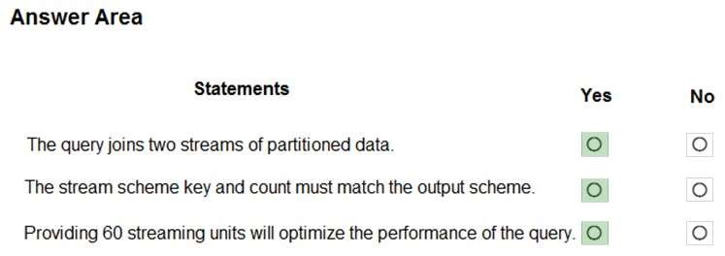
Section: (none) Explanation
Explanation/Reference: Explanation:
Box 1: Yes
You can now use a new extension of Azure Stream Analytics SQL to specify the number of partitions of a stream when reshuffling the data.
The outcome is a stream that has the same partition scheme. Please see below for an example:
WITH step1 AS (SELECT * FROM [input1] PARTITION BY DeviceID INTO 10), step2 AS (SELECT * FROM [input2] PARTITION BY DeviceID INTO 10)
SELECT * INTO [output] FROM step1 PARTITION BY DeviceID UNION step2 PARTITION BY DeviceID
Note: The new extension of Azure Stream Analytics SQL includes a keyword INTO that allows you to specify the number of partitions for a stream when performing reshuffling using a PARTITION BY statement.
Box 2: Yes
When joining two streams of data explicitly repartitioned, these streams must have the same partition key and partition count.
Box 3: Yes
Streaming Units (SUs) represents the computing resources that are allocated to execute a Stream Analytics job. The higher the number of SUs, the more CPU and memory resources are allocated for your job.
In general, the best practice is to start with 6 SUs for queries that don't use PARTITION BY. Here there are 10 partitions, so 6x10 = 60 SUs is good.
Note: Remember, Streaming Unit (SU) count, which is the unit of scale for Azure Stream Analytics, must be adjusted so the number of physical resources available to the job can fit the partitioned flow. In general, six SUs is a good number to assign to each partition. In case there are insufficient resources assigned to the job, the system will only apply the repartition if it benefits the job.
Reference:
https://azure.microsoft.com/en-in/blog/maximize-throughput-with-repartitioning-in-azure-stream-analytics/ https://docs.microsoft.com/en-us/azure/stream-analytics/stream-analytics-streaming-unit-consumption
QUESTION 36 DRAG DROP
You have an Azure SQL database named DB1 in the East US 2 region.
You need to build a secondary geo-replicated copy of DB1 in the West US region on a new server.
Which three actions should you perform in sequence? To answer, move the appropriate actions from the list of actions to the answer area and arrange them in the correct order.
Select and Place:
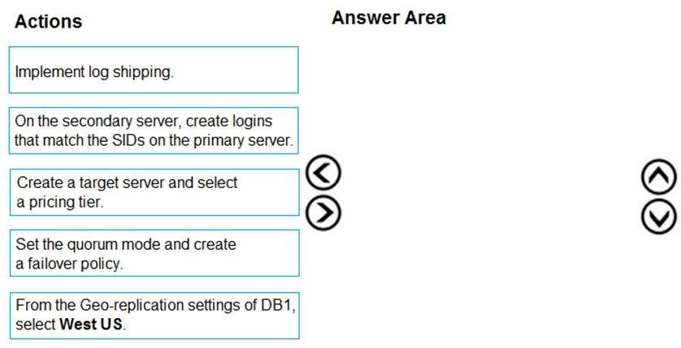
Correct Answer:
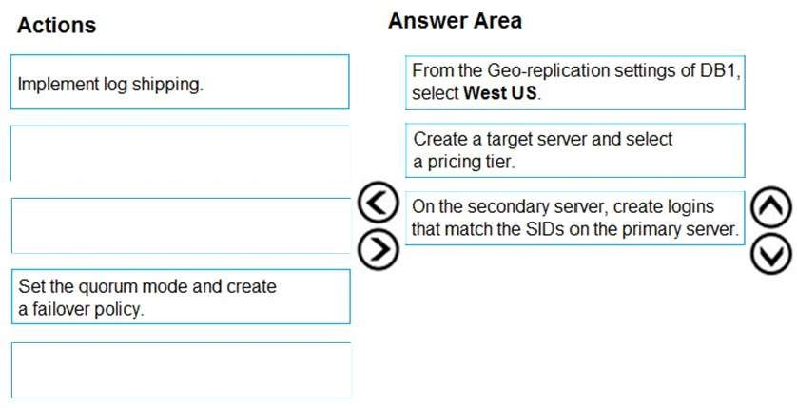
Section: (none) Explanation
Explanation/Reference: Explanation:
Step 1: From the Geo-replication settings of DB1, select West US
The following steps create a new secondary database in a geo-replication partnership.
- In the Azure portal, browse to the database that you want to set up for geo-replication.
- (Step 1) On the SQL database page, select geo-replication, and then select the region to create thesecondary database.
- (Step 2-3) Select or configure the server and pricing tier for the secondary database.
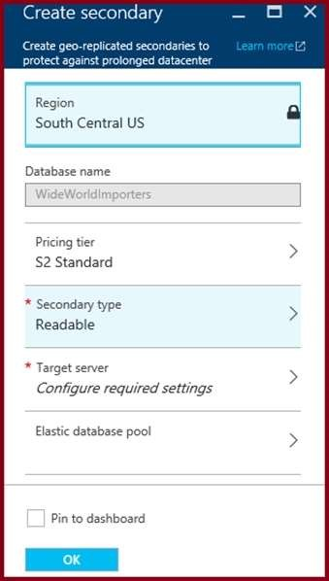
Step 2: Create a target server and select a pricing tier
Step 3: On the secondary server, create logins that match the SIDs on the primary server.
Incorrect Answers:
Not log shipping: Replication is used.
References: https://docs.microsoft.com/en-us/azure/sql-database/sql-database-active-geo-replication-portal
QUESTION 37
You have an Azure SQL database that contains a table named Employee. Employee contains sensitive data in a decimal (10,2) column named Salary.
You need to ensure that nonprivileged users can view the table data, but Salary must display a number from 0 to 100.
What should you configure? To answer, select the appropriate options in the answer area.
NOTE: Each correct selection is worth one point.
Hot Area:
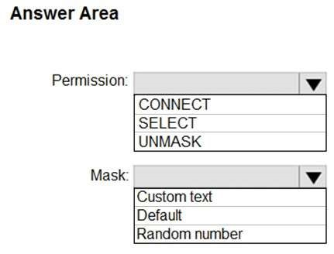
Correct Answer:
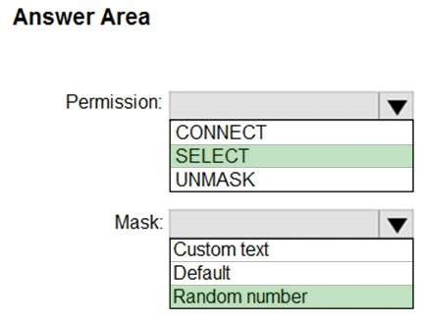
Section: (none) Explanation
Explanation/Reference: Explanation:
Box 1: SELECT
Users with SELECT permission on a table can view the table data. Columns that are defined as masked, will display the masked data.
Incorrect:
Grant the UNMASK permission to a user to enable them to retrieve unmasked data from the columns for which masking is defined.
The CONTROL permission on the database includes both the ALTER ANY MASK and UNMASK permission.
Box 2: Random number
Random number: Masking method, which generates a random number according to the selected boundaries and actual data types. If the designated boundaries are equal, then the masking function is a constant number.
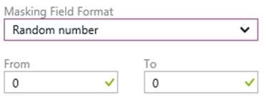
QUESTION 38
Note: This question is part of a series of questions that present the same scenario. Each question in the series contains a unique solution that might meet the stated goals. Some questions sets might have more than one correct solution, while others might not have a correct solution.
After you answer a question in this section, you will NOT be able to return to it. As a result, these questions will not appear in the review screen.
You have an Azure subscription that contains an Azure Storage account.
You plan to implement changes to a data storage solution to meet regulatory and compliance standards.
Every day, Azure needs to identify and delete blobs that were NOT modified during the last 100 days.
Solution: You apply an Azure policy that tags the storage account.
Does this meet the goal?
- Yes
- No
Correct Answer: B
Section: (none) Explanation
Explanation/Reference:
Explanation:
Instead apply an Azure Blob storage lifecycle policy.
Reference:
https://docs.microsoft.com/en-us/azure/storage/blobs/storage-lifecycle-management-concepts?tabs=azureportal
QUESTION 39
Note: This question is part of a series of questions that present the same scenario. Each question in the series contains a unique solution that might meet the stated goals. Some questions sets might have more than one correct solution, while others might not have a correct solution.
After you answer a question in this section, you will NOT be able to return to it. As a result, these questions will not appear in the review screen.
You have an Azure subscription that contains an Azure Storage account.
You plan to implement changes to a data storage solution to meet regulatory and compliance standards.
Every day, Azure needs to identify and delete blobs that were NOT modified during the last 100 days.
Solution: You apply an expired tag to the blobs in the storage account.
Does this meet the goal?
- Yes
- No
Correct Answer: B
Section: (none) Explanation
Explanation/Reference:
Explanation:
Instead apply an Azure Blob storage lifecycle policy.
Reference: https://docs.microsoft.com/en-us/azure/storage/blobs/storage-lifecycle-management-concepts?tabs=azureportal
QUESTION 40
Note: This question is part of a series of questions that present the same scenario. Each question in the series contains a unique solution that might meet the stated goals. Some questions sets might have more than one correct solution, while others might not have a correct solution.
After you answer a question in this section, you will NOT be able to return to it. As a result, these questions will not appear in the review screen.
You have an Azure subscription that contains an Azure Storage account.
You plan to implement changes to a data storage solution to meet regulatory and compliance standards.
Every day, Azure needs to identify and delete blobs that were NOT modified during the last 100 days.
Solution: You apply an Azure Blob storage lifecycle policy.
Does this meet the goal?
- Yes
- No
Correct Answer: A
Section: (none) Explanation
Explanation/Reference:
Explanation:
Azure Blob storage lifecycle management offers a rich, rule-based policy for GPv2 and Blob storage accounts.
Use the policy to transition your data to the appropriate access tiers or expire at the end of the data's lifecycle.
The lifecycle management policy lets you:
Transition blobs to a cooler storage tier (hot to cool, hot to archive, or cool to archive) to optimize for performance and cost
Delete blobs at the end of their lifecycles
Define rules to be run once per day at the storage account level
Apply rules to containers or a subset of blobs (using prefixes as filters)
Reference:
https://docs.microsoft.com/en-us/azure/storage/blobs/storage-lifecycle-management-concepts?tabs=azureportal
QUESTION 41
Note: This question is part of a series of questions that present the same scenario. Each question in the series contains a unique solution that might meet the stated goals. Some question sets might have more than one correct solution, while others might not have a correct solution.
After you answer a question in this section, you will NOT be able to return to it. As a result, these questions will not appear in the review screen.
You have an Azure SQL database named DB1 that contains a table named Table1. Table1 has a field named Customer_ID that is varchar(22).
You need to implement masking for the Customer_ID field to meet the following requirements:
The first two prefix characters must be exposed. The last four suffix characters must be exposed. All other characters must be masked.
Solution: You implement data masking and use a custom string function mask.
Does this meet the goal?
- Yes
- No
Correct Answer: B
Section: (none) Explanation
Explanation/Reference:
Explanation:
Must use Custom Text data masking, which exposes the first and last characters and adds a custom padding string in the middle.
Reference:
https://docs.microsoft.com/en-us/azure/sql-database/sql-database-dynamic-data-masking-get-started
QUESTION 42
Note: This question is part of a series of questions that present the same scenario. Each question in the series contains a unique solution that might meet the stated goals. Some questions sets might have more than one correct solution, while others might not have a correct solution.
After you answer a question in this section, you will NOT be able to return to it. As a result, these questions will not appear in the review screen.
You have an Azure subscription that contains an Azure Storage account.
You plan to implement changes to a data storage solution to meet regulatory and compliance standards.
Every day, Azure needs to identify and delete blobs that were NOT modified during the last 100 days.
Solution: You schedule an Azure Data Factory pipeline.
Does this meet the goal?
- Yes
- No
Correct Answer: B
Section: (none) Explanation
Explanation/Reference:
Explanation:
Instead apply an Azure Blob storage lifecycle policy.
Reference: https://docs.microsoft.com/en-us/azure/storage/blobs/storage-lifecycle-management-concepts?tabs=azureportal
QUESTION 43
Note: This question is part of a series of questions that present the same scenario. Each question in the series contains a unique solution that might meet the stated goals. Some question sets might have more than one correct solution, while others might not have a correct solution.
After you answer a question in this section, you will NOT be able to return to it. As a result, these questions will not appear in the review screen.
You have an Azure Storage account that contains 100 GB of files. The files contain text and numerical values. 75% of the rows contain description data that has an average length of 1.1 MB.
You plan to copy the data from the storage account to an enterprise data warehouse in Azure Synapse Analytics.
You need to prepare the files to ensure that the data copies quickly.
Solution: You convert the files to compressed delimited text files.
Does this meet the goal?
- Yes
- No
Correct Answer: A
Section: (none) Explanation
Explanation/Reference:
Explanation:
All file formats have different performance characteristics. For the fastest load, use compressed delimited text files.
Reference:
https://docs.microsoft.com/en-us/azure/sql-data-warehouse/guidance-for-loading-data
QUESTION 44
You are designing an enterprise data warehouse in Azure Synapse Analytics. You plan to load millions of rows of data into the data warehouse each day.
You must ensure that staging tables are optimized for data loading.
You need to design the staging tables.
What type of tables should you recommend?
- Round-robin distributed table
- Hash-distributed table
- Replicated tableD. External table
Correct Answer: A
Section: (none) Explanation
Explanation/Reference:
Background
Proseware, Inc, develops and manages a product named Poll Taker. The product is used for delivering public opinion polling and analysis.
Polling data comes from a variety of sources, including online surveys, house-to-house interviews, and booths at public events.
Polling data
Polling data is stored in one of the two locations:
An on-premises Microsoft SQL Server 2019 database named PollingData Azure Data Lake Gen 2
Data in Data Lake is queried by using PolyBase
Poll metadata
Each poll has associated metadata with information about the poll including the date and number of respondents. The data is stored as JSON.
Phone-based polling
Security
Phone-based poll data must only be uploaded by authorized users from authorized devices
Contractors must not have access to any polling data other than their own
Access to polling data must set on a per-active directory user basis
Data migration and loading
All data migration processes must use Azure Data Factory
All data migrations must run automatically during non-business hours
Data migrations must be reliable and retry when needed
Performance
After six months, raw polling data should be moved to a storage account. The storage must be available in the event of a regional disaster. The solution must minimize costs.
Deployments
All deployments must be performed by using Azure DevOps. Deployments must use templates used in multiple environments
No credentials or secrets should be used during deployments
Reliability
All services and processes must be resilient to a regional Azure outage.
Monitoring
All Azure services must be monitored by using Azure Monitor. On-premises SQL Server performance must be monitored.
QUESTION 45
DRAG DROP
You need to ensure that phone-based polling data can be analyzed in the PollingData database.
Which three actions should you perform in sequence? To answer, move the appropriate actions from the list of actions to the answer are and arrange them in the correct order.
Select and Place:
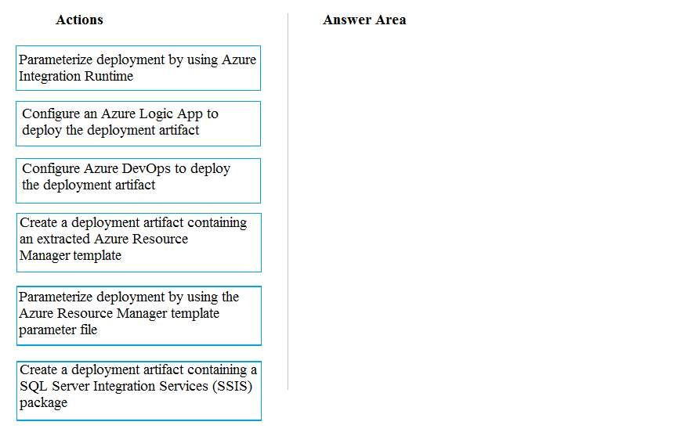
Correct Answer:
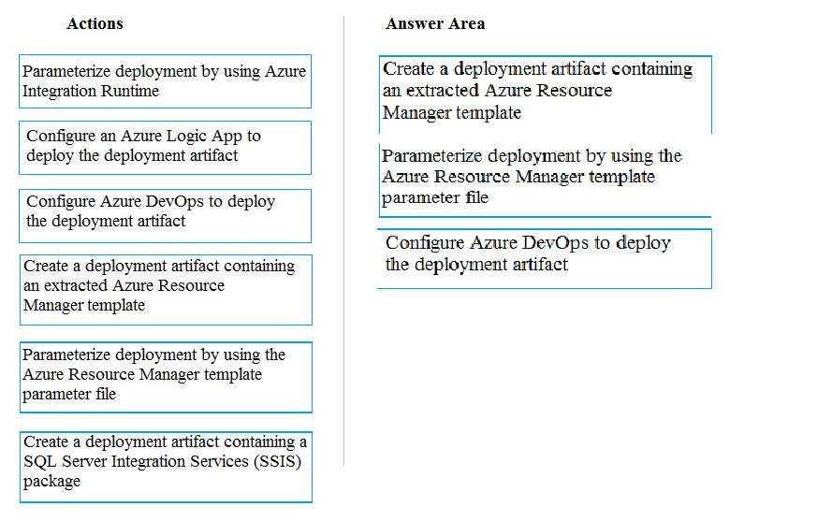
Section: (none) Explanation
Explanation/Reference:
Explanation:
Scenario:
All deployments must be performed by using Azure DevOps. Deployments must use templates used in multiple environments
No credentials or secrets should be used during deployments
QUESTION 46
DRAG DROP
You need to provision the polling data storage account.
How should you configure the storage account? To answer, drag the appropriate Configuration Value to the correct Setting. Each Configuration Value may be used once, more than once, or not at all. You may need to drag the split bar between panes or scroll to view content.
NOTE:Each correct selection is worth one point.
Select and Place:
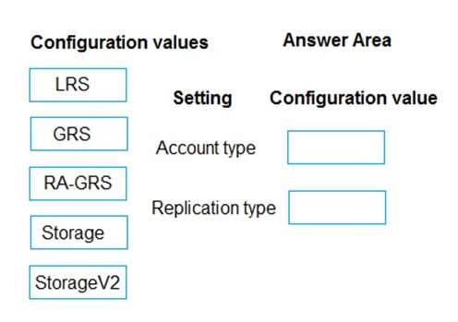
Correct Answer:
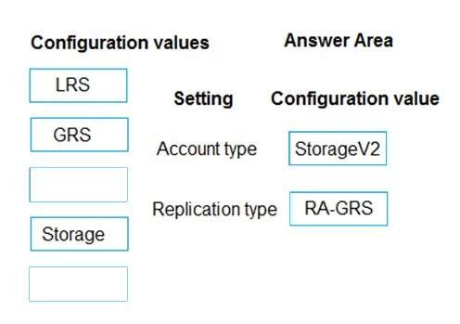
Section: (none) Explanation
Explanation/Reference: Explanation:
Account type: StorageV2
You must create new storage accounts as type StorageV2 (general-purpose V2) to take advantage of Data Lake Storage Gen2 features.
Scenario: Polling data is stored in one of the two locations:
An on-premises Microsoft SQL Server 2019 database named PollingData Azure Data Lake Gen 2
Data in Data Lake is queried by using PolyBase
Replication type: RA-GRS
Scenario: All services and processes must be resilient to a regional Azure outage.
Geo-redundant storage (GRS) is designed to provide at least 99.99999999999999% (16 9's) durability of objects over a given year by replicating your data to a secondary region that is hundreds of miles away from the primary region. If your storage account has GRS enabled, then your data is durable even in the case of a complete regional outage or a disaster in which the primary region isn't recoverable.
If you opt for GRS, you have two related options to choose from:
GRS replicates your data to another data center in a secondary region, but that data is available to be read only if Microsoft initiates a failover from the primary to secondary region.
Read-access geo-redundant storage (RA-GRS) is based on GRS. RA-GRS replicates your data to another data center in a secondary region, and also provides you with the option to read from the secondary region. With RA-GRS, you can read from the secondary region regardless of whether Microsoft initiates a failover from the primary to secondary region.
References:
https://docs.microsoft.com/bs-cyrl-ba/azure/storage/blobs/data-lake-storage-quickstart-create-account https://docs.microsoft.com/en-us/azure/storage/common/storage-redundancy-grs
QUESTION 47
You need to build a solution to collect the telemetry data for Race Central.
What should you use? To answer, select the appropriate options in the answer area.
NOTE: Each correct selection is worth one point.
Hot Area:
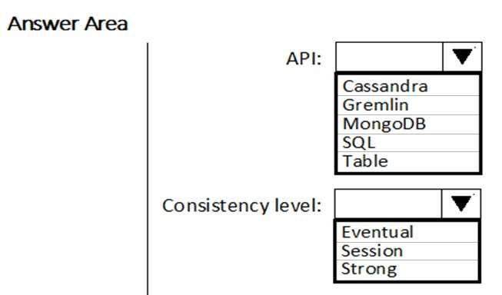
Correct Answer:
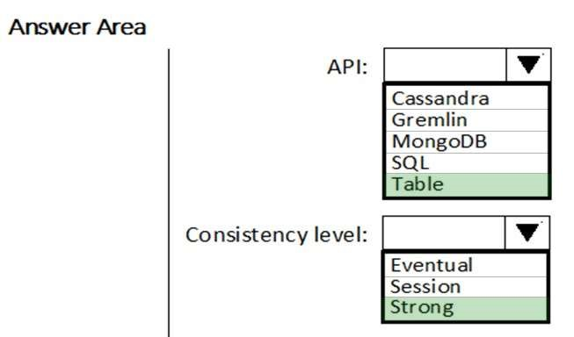
Section: (none) Explanation
Explanation/Reference: Explanation:
API: Table
Azure Cosmos DB provides native support for wire protocol-compatible APIs for popular databases. These include MongoDB, Apache Cassandra, Gremlin, and Azure Table storage.
Scenario: The telemetry data must migrate toward a solution that is native to Azure.
Consistency level: Strong
Use the strongest consistency Strong to minimize convergence time.
Scenario: The data must be written to the Azure datacenter closest to each race and must converge in the least amount of time.
Reference: https://docs.microsoft.com/en-us/azure/cosmos-db/consistency-levels
QUESTION 48
On which data store should you configure TDE to meet the technical requirements?
- Cosmos DB
- Azure Synapse Analytics
- SQL Database
Correct Answer: B
Section: (none) Explanation
Explanation/Reference:
Explanation:
Scenario: Transparent data encryption (TDE) must be enabled on all data stores, whenever possible. The database for Mechanical Workflow must be moved to Azure Synapse Analytics.
Incorrect Answers:
A: Cosmos DB does not support TDE.
QUESTION 49
You are building the data store solution for Mechanical Workflow.
How should you configure Table1? To answer, select the appropriate options in the answer area.
NOTE: Each correct selection is worth one point.
Hot Area:
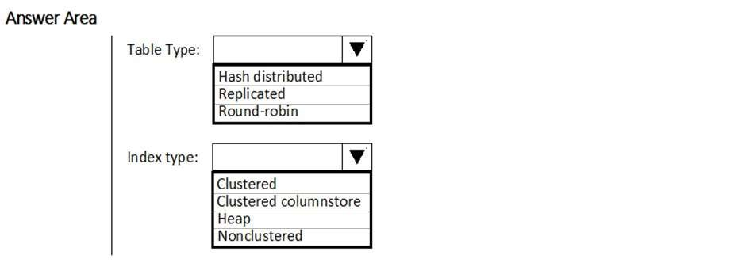
Correct Answer:
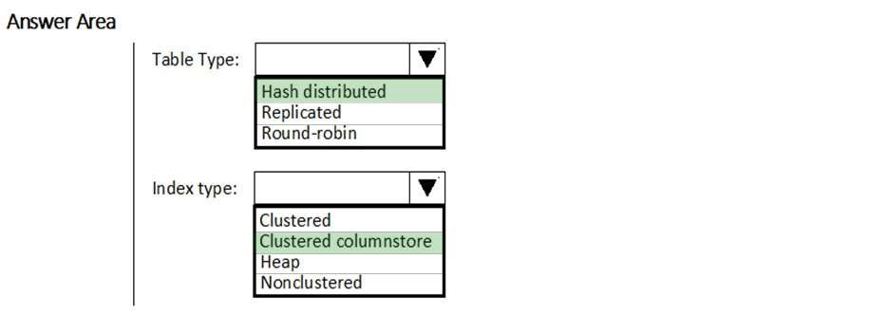
Section: (none) Explanation
Explanation/Reference:
Table Type: Hash distributed.
Hash-distributed tables improve query performance on large fact tables.
Index type: Clusted columnstore
Scenario:
Mechanical Workflow has a named Table1 that is 1 TB. Large aggregations are performed on a single column of Table 1.
References: https://docs.microsoft.com/en-us/azure/sql-data-warehouse/sql-data-warehouse-tables-distribute
QUESTION 50
A company plans to use Platform-as-a-Service (PaaS) to create the new data pipeline process. The process must meet the following requirements:
Ingest:
Access multiple data sources.
Provide the ability to orchestrate workflow.
Provide the capability to run SQL Server Integration Services packages.
Store:
Optimize storage for big data workloads Provide encryption of data at rest. Operate with no size limits.
Prepare and Train:
Provide a fully-managed and interactive workspace for exploration and visualization.
Provide the ability to program in R, SQL, Python, Scala, and Java. Provide seamless user authentication with Azure Active Directory.
Model & Serve:
Implement native columnar storage.
Support for the SQL language.
Provide support for structured streaming.
You need to build the data integration pipeline.
Which technologies should you use? To answer, select the appropriate options in the answer area.
NOTE: Each correct selection is worth one point.
Hot Area:
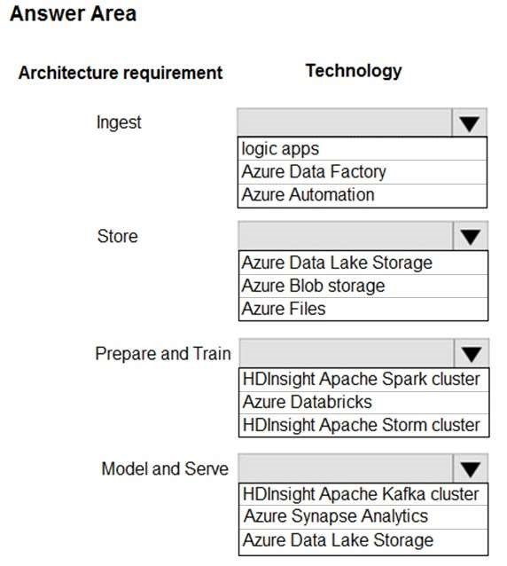
Correct Answer:
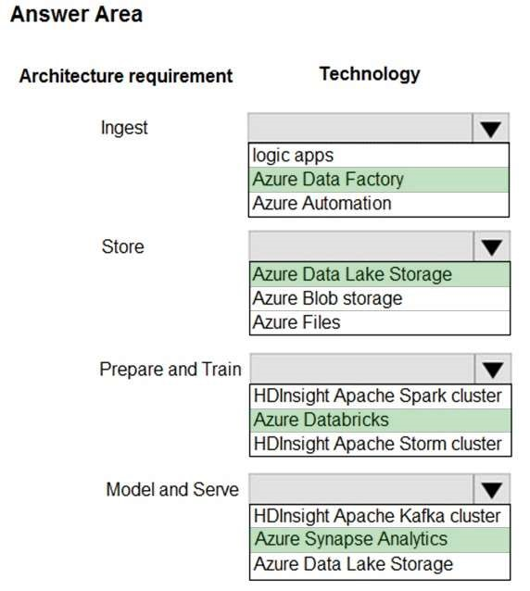
Section: (none) Explanation
Explanation/Reference: Explanation:
Ingest: Azure Data Factory
Azure Data Factory pipelines can execute SSIS packages.
In Azure, the following services and tools will meet the core requirements for pipeline orchestration, control flow, and data movement: Azure Data Factory, Oozie on HDInsight, and SQL Server Integration Services (SSIS).
Store: Data Lake Storage
Data Lake Storage Gen1 provides unlimited storage.
Note: Data at rest includes information that resides in persistent storage on physical media, in any digital format. Microsoft Azure offers a variety of data storage solutions to meet different needs, including file, disk, blob, and table storage. Microsoft also provides encryption to protect Azure SQL Database, Azure Cosmos DB, and Azure Data Lake.
Prepare and Train: Azure Databricks
Azure Databricks provides enterprise-grade Azure security, including Azure Active Directory integration. With Azure Databricks, you can set up your Apache Spark environment in minutes, autoscale and collaborate on shared projects in an interactive workspace. Azure Databricks supports Python, Scala, R, Java and SQL, as well as data science frameworks and libraries including TensorFlow, PyTorch and scikit-learn.
Model and Serve: Azure Synapse Analytics
Azure Synapse Analytics/ SQL Data Warehouse stores data into relational tables with columnar storage.
Azure SQL Data Warehouse connector now offers efficient and scalable structured streaming write support for SQL Data Warehouse. Access SQL Data Warehouse from Azure Databricks using the SQL Data Warehouse connector.
Note: Note: As of November 2019, Azure SQL Data Warehouse is now Azure Synapse Analytics.
References: https://docs.microsoft.com/bs-latn-ba/azure/architecture/data-guide/technology-choices/pipeline-orchestrationdata-movement https://docs.microsoft.com/en-us/azure/azure-databricks/what-is-azure-databricks

