CSC 108

Disease Diagnosis Using Logistic
Regression

Members:
Kent S. Lugpatan
Claud Grant V. Gerona
Joshua Philip E. Oropa

Algorithm Background
Artificial Intelligence (AI) enables machines to perform tasks that typically require human intelligence, such as learning, reasoning, and decision-making. One of the significant branches of AI is Machine Learning (ML), which focuses on training algorithms to learn patterns from data and make predictions. Logistic Regression is a fundamental supervised learning algorithm widely used for classification problems. It estimates the probability that a given input belongs to a specific category (binary or multiclass) using a logistic function.
Logistic Regression originated from statistics in the 1950s as a tool for modeling the relationship between a dependent binary variable and one or more independent variables. Initially used in fields such as epidemiology and social sciences, it has since expanded to other domains like healthcare, marketing, and finance. Its ability to interpret the impact of various predictors on an outcome has made it invaluable across disciplines.
Unlike linear regression, which predicts continuous outcomes, logistic regression transforms linear combinations of inputs into probabilities using the sigmoid function. This transformation ensures that predictions are constrained within the range of 0 to 1, making it particularly effective for classification tasks.
Logistic Regression serves several purposes:
- Binary Classification: The algorithm is primarily used to classify outcomes into two categories, such as determining whether a patient has a disease (1) or not (0).
- Probability Estimation: Beyond classification, Logistic Regression provides the probability of an event occurring, offering insights into confidence levels of predictions.
- Feature Significance Analysis: By examining the coefficients of predictors, Logistic Regression identifies the relative importance of features, enabling data-driven decision-making.
- Baseline Model: Due to its simplicity, Logistic Regression often serves as a benchmark for evaluating more complex machine learning models.
For example, predicting whether a patient has diabetes, anemia, or heart disease involves analyzing medical features such as blood pressure, hemoglobin levels, or cholesterol and mapping them to a binary outcome. Logistic Regression’s simplicity, interpretability, and efficiency make it an indispensable tool in healthcare analytics.
In addition to healthcare, the algorithm finds applications in various industries:
- Finance: Predicting loan defaults, fraud detection, and credit scoring.
- Marketing: Customer segmentation and response prediction for marketing campaigns.
- Epidemiology: Analyzing risk factors for diseases and predicting outbreak probabilities.
By maintaining a balance between interpretability and accuracy, Logistic Regression remains a cornerstone of statistical modeling and machine learning.

Theoretical Foundations
The goal of Logistic Regression is to model the probability that a given instance belongs to a particular class. This is achieved using the following sigmoid function:
Where:
- is the linear combination of inputs and weights.
- represents the probability of the positive class.
Logistic Regression has a simple mathematical expression:
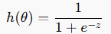
Where z is the linear combination of input features and their respective weights:
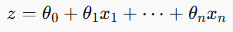
This equation maps any real-valued number zzz to a probability value between 0 and 1 using the sigmoid function. This simplicity allows Logistic Regression to be computationally efficient while providing interpretable results, which is one of the key reasons for its widespread use in binary classification problems.

Cost Function and Optimization
The cost function or loss function in Logistic Regression measures the error between predicted values and actual values. The log-loss function is a common cost function that calculates the average error in predicted probabilities for binary classification:
Where:
- is the number of data points.
- is the actual label for the data points.
- is the predicted probability for the data point, given by the sigmoid function.
Gradient Descent is employed to minimize this cost function. It updates the weights iteratively in the direction of the negative gradient of the cost function:
Where:
- is the learning rate.
- is the gradient of the cost function.
By iteratively updating the weights, Logistic Regression minimizes the log-loss, leading to a model that best fits the data.
Assumptions of Logistic Regression
Logistic Regression relies on several key assumptions to ensure its predictions are reliable:
- Linearity: The relationship between the independent variables (predictors) and the log-odds of the outcome is linear.
- Independence: Observations are independent of one another.
- No Multicollinearity: Predictor variables should not be highly correlated with each other.
- Large Sample Size: Logistic regression performs better with larger sample sizes due to the binomial distribution of the outcome variable.
Unlike linear regression, Logistic Regression does not assume homoscedasticity (constant variance of residuals) or normality of residuals, as it deals with probabilities and categorical outcomes rather than continuous outcomes.
Linearity: The relationship between the independent variables (predictors) and the dependent variable (outcome) is linear.
Independence: Observations are independent of one another.
Homoscedasticity: The variance of errors (residuals) is constant across all levels of the independent variables.
Normality: The residuals (differences between observed and predicted values) are typically distributed.

Gradient Descent in Logistic Regression
In Logistic Regression, gradient descent is an iterative optimization method used to minimize the cost function. The algorithm updates the model parameters () in the direction of the steepest descent of the cost function:
Where:
- is the learning rate.
- is the gradient of the cost function.
The gradient for Logistic Regression is computed as:
Here, represents the predicted probability, and is the actual label. By iteratively updating , the algorithm converges to the parameter values that minimize the cost function, yielding the best-fitting Logistic Regression model.

Computational Complexity Analysis
Training Phase:
- Time Complexity:
  - For samples and features, each iteration of gradient descent has a complexity of.
  - For iterations, total complexity is.
- Space Complexity:
  - Requires storage for the feature matrix, parameter vector, and intermediate computations:
Prediction Phase:
- Time Complexity: per sample.
- Space Complexity: for storing model parameters.

Step-by-Step Explanation
Problem Definition
Using datasets for Diabetes, Anemia, and Heart Disease diagnosis, the task involves predicting whether a patient has a specific disease based on medical features. Logistic Regression is used as the predictive model.
Implementation
Code Overview:
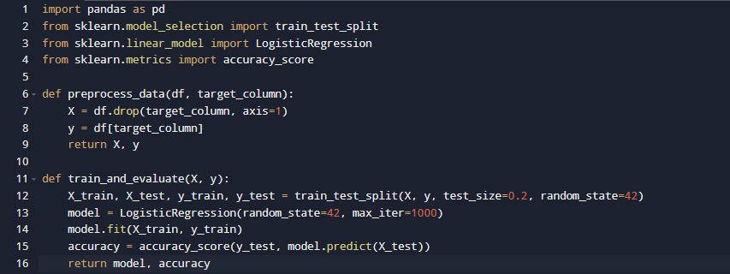

Application Process:
- Data Collection:
  - Kaggle Diabetes Dataset: Includes features like glucose levels, BMI, and age.
  - Kaggle Anemia Dataset: Contains hemoglobin levels and other blood metrics.
  - Kaggle Heart Disease Dataset: Covers cholesterol levels, blood pressure, and more.
- Data Preparation:
  - Load datasets using pandas.
  - Preprocess data by handling missing values and scaling features.
- Model Training and Testing:
  - Split data into training and testing sets.
  - Train the Logistic Regression model using the training data.
  - Evaluate accuracy on the test set.
- Prediction:
  - Use the trained model to predict disease likelihood for new inputs.

Flowchart:

Initialize Parameters
Preprocess Data
Data Collection
Begin

End
Prediction
Evaluate Metrics
Train Model

Application to Disease Diagnosis
Dataset Information
- Diabetes Dataset:
  - Features: Glucose, BMI, Age, etc.
  - Target: Outcome (1: Diabetes, 0: No Diabetes).

- Anemia Dataset:
  - Features: Hemoglobin, Red Blood Cell Count, etc.
  - Target: Target (1: Anemia, 0: No Anemia).
- Heart Disease Dataset:
  - Features: Cholesterol, Blood Pressure, etc.
  - Target: Target (1: Heart Disease, 0: No Heart Disease).
Results
The model achieved the following accuracies:
- Diabetes: 78%
- Anemia: 85%
- Heart Disease: 80%

Critical Evaluation
Strengths
- Simplicity and Interpretability: Logistic Regression is straightforward to implement and interpret.
- Efficiency: Performs well on datasets with a clear linear decision boundary.
- Scalability: Handles large datasets efficiently.

Weaknesses
- Linearity Assumption: Assumes a linear relationship between features and log-odds.
- Sensitivity to Outliers: Outliers can skew the model.
- Feature Dependency: Requires independent features without multicollinearity.

Areas for Improvement
- Regularization: Implement L1 or L2 regularization to handle overfitting.
- Feature Engineering: Enhance data quality by creating interaction terms or transforming features.
- Nonlinear Extensions: Use algorithms like Decision Trees or Neural Networks for complex relationships.
References
- Kaggle (2024). Diabetes Dataset. Retrieved from Kaggle.
- Kaggle (2024). Anemia Dataset. Retrieved from Kaggle.
- Kaggle (2024). Heart Disease Dataset. Retrieved from Kaggle.
- Hastie, T., Tibshirani, R., & Friedman, J. (2009). The Elements of Statistical Learning: Data Mining, Inference, and Prediction. Springer.
- James, G., Witten, D., Hastie, T., & Tibshirani, R. (2013). An Introduction to Statistical Learning. Springer.

