ECLIPSE
(Design and Architecture)

Name:Syam Kumar Patnala
RollNo: IS201301018

What is Eclipse?

Eclipse is a popular open source IDE initially developed by IBM. It is primarily used for Java development, but it supports a wide variety of other programming languages. Eclipse is written in Java.
Eclipse provides a common user interface (UI) model for working with tools. It is designed to run on multiple operating systems while providing robust integration with each underlying OS. Plug-ins can program to the Eclipse portable APIs and run unchanged on any of the supported operating systems.

Platform architecture:

The Eclipse platform is structured around the concept of plug-ins. Plug-ins are structured bundles of code and/or data that contribute functionality to the system. Functionality can be contributed in the form of code libraries (Java classes with public API), platform extensions, or even documentation. Plug-ins can define extension points, well-defined places where other plug-ins can add functionality.

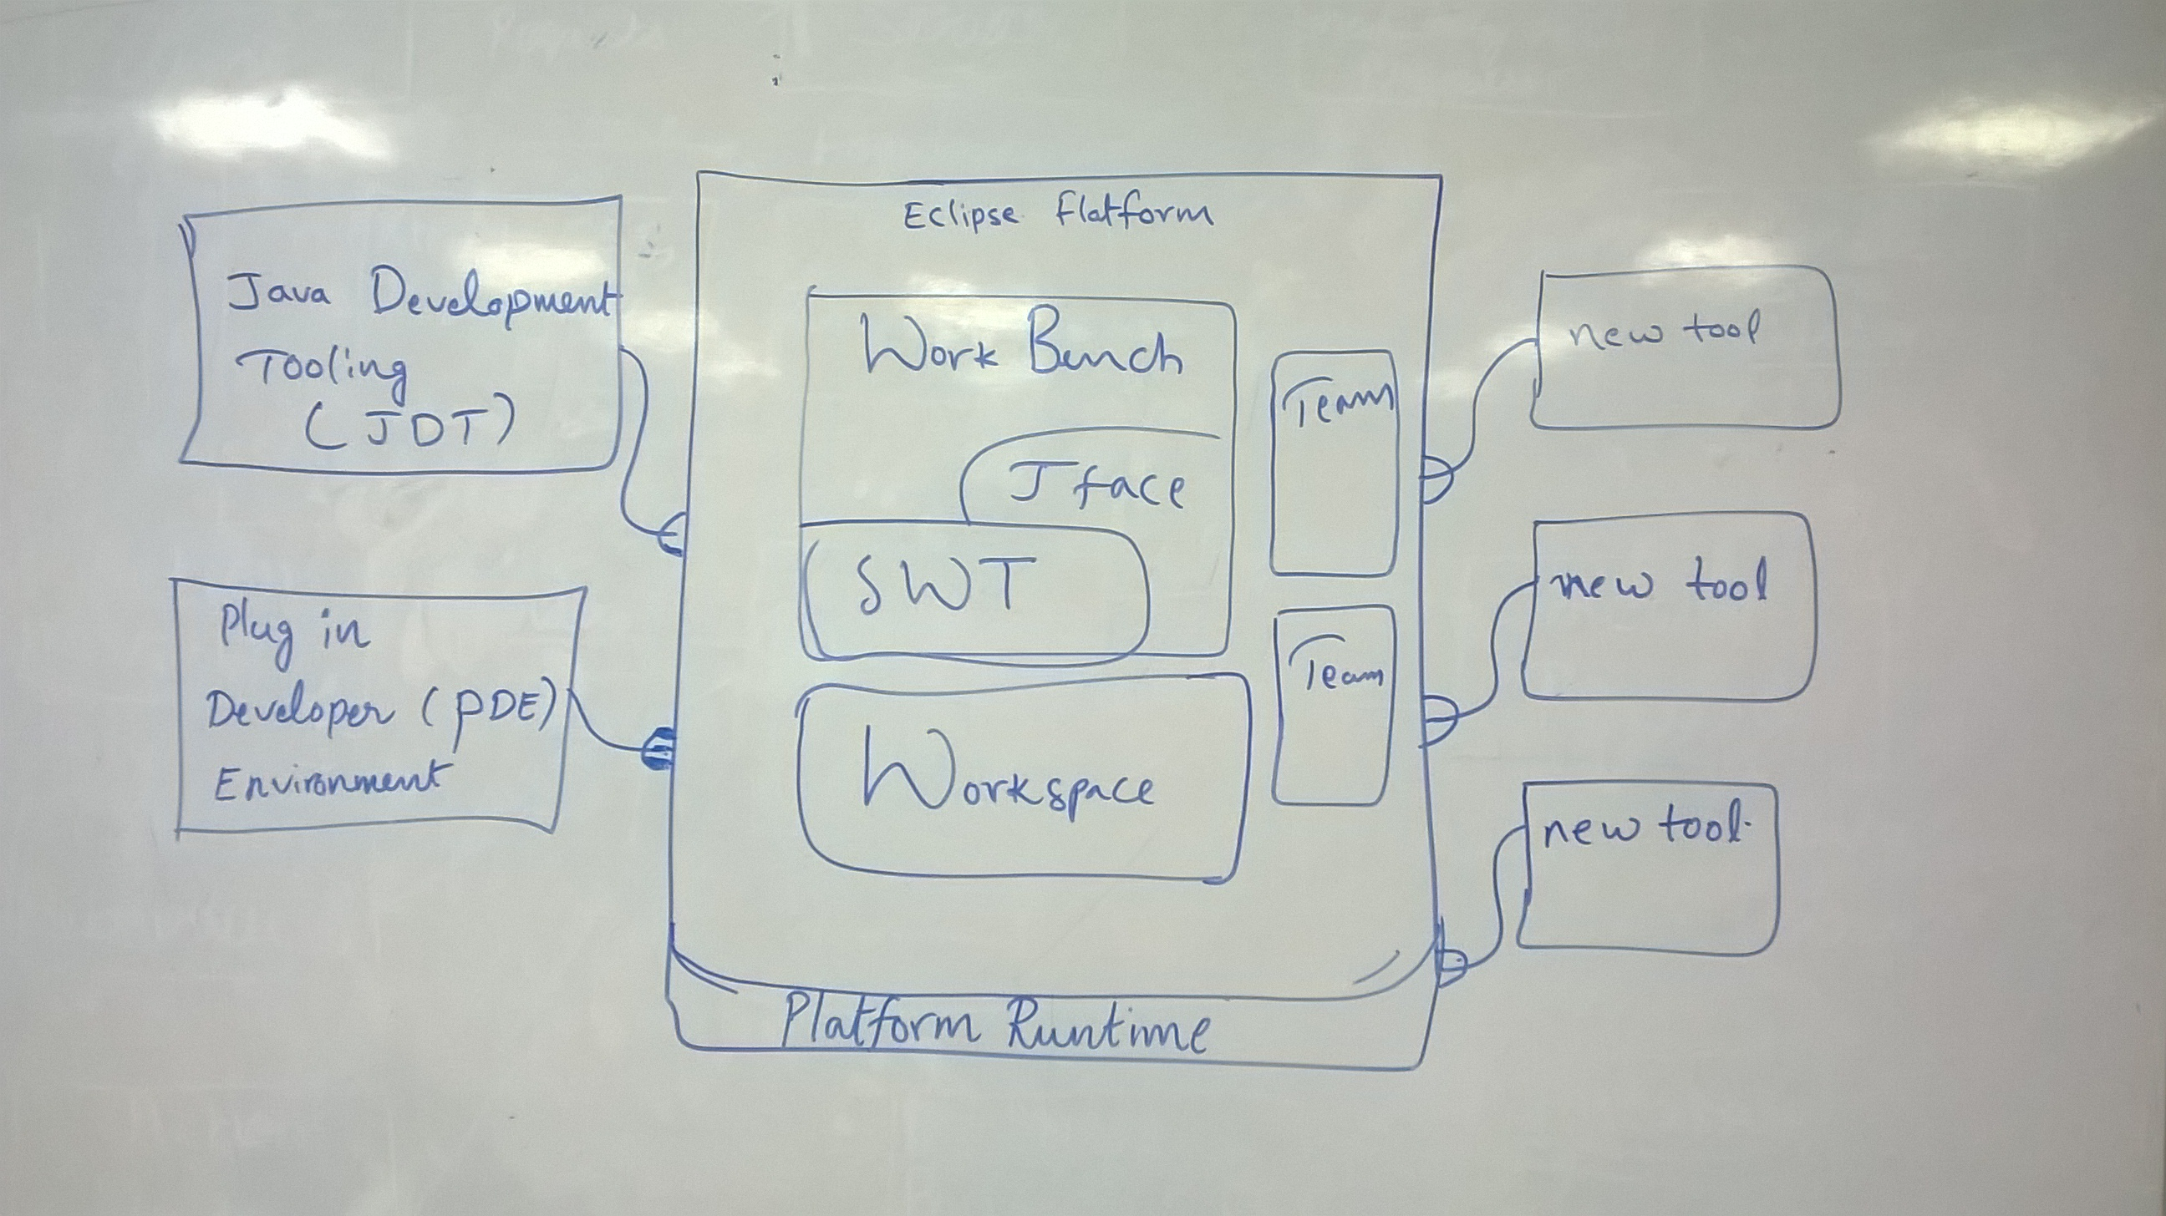

Each subsystem in the platform is itself structured as a set of plug-ins that implement some key function. Some plug-ins add visible features to the platform using the extension model. Others supply class libraries that can be used to implement system extensions.

The Eclipse SDK includes the basic platform plus two major tools that are useful for plug-in development. The Java development tools (JDT) implement a full featured Java development environment. The Plug-in Developer Environment (PDE) adds specialized tools that streamline the development of plug-ins and extensions.

These tools not only serve a useful purpose, but also provide a great example of how new tools can be added to the platform by building plug-ins that extend the system.

Functional Requirements:

Provides a common user interface (UI) model for working with tools

Since Eclipse is an integrated development environment (IDE) it should support all plugin for all newly evolved programing language.

Should support adding of new types of editors.

Should support new types of views.

It should interact with the file system of the computer to store the projects which are created using the eclipse flatform.

Should support new perspectives, which arrange old and new views to suit new user tasks.

Non Functional Requirements:

Application Services:

->One of the goals is to simplify the API for consumers so that it was easy to implement common services.
-> The list of simple services came to be known as "the twenty things" and are known as the Eclipse Application services.
-> The goal is to offer standalone APIs that clients can use without having to have a deep understanding of all the APIs available.
-> They are structured as individual services so that they can also be used in other languages other than Java, such as Javascript.

An alternative design for eclipse:

Eclipse is an extensible development platform with runtimes and application frameworks for building, deploying and managing software across the entire software lifecycle. Many people know Eclipse as a Java IDE, but it is much more than that- Eclipse actually consists of over 60 different open-source projects, organized into 6 different categories:

*. Enterprise Development
*. Embedded and Device Development
*. Rich Client Platform
*. Rich Internet Applications
*. Application Frameworks
*. Application Lifecycle Management (ALM)
*. Service Oriented Architecture (SOA)

There are appllications such as vim,netbeans,gedit,Microsoft visual studio, Geany, aptana studio, GNU Emacs, IntelliJ IDEA, TextMate ,Coda ,Php Storm ... like this there are many alternative softwares are there as an alternative for Eclipse but Eclipse can alone let us allow to use all the above softwares by providing plug in for sdk.

