727721euit173

Usha k

CA 01

QNO:1

**package** com.CA1.CA1;

**import** org.openqa.selenium.By;

**import** org.openqa.selenium.WebDriver;

**import** org.openqa.selenium.chrome.ChromeDriver;

**import** org.openqa.selenium.chrome.ChromeOptions;

**import** io.github.bonigarcia.wdm.WebDriverManager;

**public** **class** QNO_01 {

**public** **static** **void** main(String[] args) **throws** InterruptedException{

// **TODO** Auto-generated method stub

ChromeOptions co=**new** ChromeOptions();

co.addArguments("--remote-allow-origins=*");

WebDriverManager.*chromedriver*().setup();

WebDriver driver=**new** ChromeDriver(co);

driver.get("https://www.amazon.in/2022-Apple-MacBook-Laptop-chip/dp/B0B3BQ11LP/ref=sr_1_1?pf_rd_i=1375424031&pf_rd_m=A1K21FY43GMZF8&pf_rd_p=34d0241f-2443-4c3b-b9aa-68c67855509c&pf_rd_r=M6K80EMA2F1ZF69VHMN2&pf_rd_s=merchandised-search-9&pf_rd_t=101&qid=1681288015&sr=8-1");

driver.manage().window().maximize();

String currentUrl=driver.getCurrentUrl();

String expectedUrl="https://www.amazon.in/2022-Apple-MacBook-Laptop-chip/dp/B0B3BQ11LP/ref=sr_1_1?pf_rd_i=1375424031&pf_rd_m=A1K21FY43GMZF8&pf_rd_p=34d0241f-2443-4c3b-b9aa-68c67855509c&pf_rd_r=M6K80EMA2F1ZF69VHMN2&pf_rd_s=merchandised-search-9&pf_rd_t=101&qid=1681288015&sr=8-1";

**if**(currentUrl.equals(expectedUrl)) {

System.***out***.println("URL MATCHED");

}

**else** {

System.***out***.println("URL NOT MATCHED");

}

Thread.*sleep*(5000);

driver.findElement(By.*xpath*("//*[@id=\"add-to-cart-button\"]")).click();

Thread.*sleep*(5000);

driver.findElement(By.*xpath*("//*[@id=\"attach-close_sideSheet-link\"]")).click();

Thread.*sleep*(5000);

driver.findElement(By.*xpath*("//*[@id=\"nav-cart-count-container\"]/span[2]")).click();

Thread.*sleep*(5000);

driver.findElement(By.*xpath*("//*[@id=\"a-autoid-0-announce\"]")).click();

Thread.*sleep*(5000);

driver.findElement(By.*xpath*("//*[@id=\"quantity_0\"]")).click();

Thread.*sleep*(5000);

driver.findElement(By.*xpath*("//*[@id=\"anonCarousel1\"]/ol/li[1]/div/a[1]/div/img")).click();

Thread.*sleep*(5000);

driver.findElement(By.*xpath*("//*[@id=\"add-to-cart-button\"]")).click();

Thread.*sleep*(5000);

driver.findElement(By.*xpath*("//*[@id=\"attach-close_sideSheet-link\"]")).click();

Thread.*sleep*(5000);

driver.findElement(By.*xpath*("//*[@id=\"nav-cart\"]")).click();

Thread.*sleep*(5000);

driver.findElement(By.*xpath*("//*[@id=\"a-autoid-0-announce\"]")).click();

Thread.*sleep*(5000);

driver.findElement(By.*xpath*("//*[@id=\"quantity_2\"]")).click();

Thread.*sleep*(5000);

driver.findElement(By.*xpath*("//*[@id=\"sc-buy-box-ptc-button\"]/span/input")).click();

Thread.*sleep*(5000);

}

}

O/P:

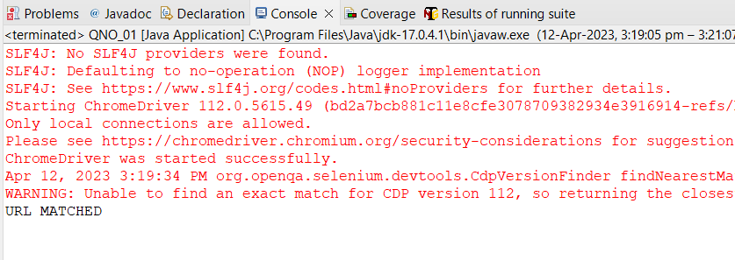

QNO:2

**package** com.CA1.CA1;

**import** java.util.List;

**import** org.openqa.selenium.By;

**import** org.openqa.selenium.Keys;

**import** org.openqa.selenium.WebDriver;

**import** org.openqa.selenium.WebElement;

**import** org.openqa.selenium.chrome.ChromeDriver;

**import** org.openqa.selenium.chrome.ChromeOptions;

**import** io.github.bonigarcia.wdm.WebDriverManager;

**public** **class** QNO2 {

**public** **static** **void** main(String[] args) {

// **TODO** Auto-generated method stub

ChromeOptions co=**new** ChromeOptions();

co.addArguments("--remote-allow-origins=*");

WebDriverManager.*chromedriver*().setup();//setting up chrome driver

WebDriver driver=**new** ChromeDriver();

driver.get("https://www.amazon.in");

driver.findElement(By.*xpath*("//*[@id=\"twotabsearchtextbox\"]")).sendKeys("Mobiles");

driver.findElement(By.*xpath*("//*[@id=\"twotabsearchtextbox\"]")).sendKeys(Keys.***ENTER***);

String a=driver.getTitle();

**if**(a.equals("Amazon.in : Mobiles")) {

System.***out***.print("Title is Matched\n");

}

**else** {

System.***out***.print("Title is Mismatched");

}

List<WebElement> li=driver.findElements(By.*className*("s-line-clamp-2"));

**for**(**int** i=0;i<5;i++) {

System.***out***.println(li.get(i).getText());

}

driver.findElement(By.*xpath*("//*[@id=\"p_36/1318505031\"]/span/a/span")).click();

//try {

// Thread.sleep(5000);

//} catch (InterruptedException e) {

// // **TODO** Auto-generated catch block

// e.printStackTrace();

//}

WebElement b=driver.findElement(By.*xpath*("//*[@id=\"search\"]/div[1]/div[1]/div/span[1]/div[1]/div[2]/div/div/div/div/div/div/div/div[2]/div/div/div[3]/div[1]/div/div[1]/div[2]/a/span[1]/span[2]/span[2]"));

System.***out***.print("Price 5,000-10,000 :"+b.getText());

driver.findElement(By.*xpath*("//*[@id=\"p_89/Samsung\"]/span/a/div/label/i")).click();

WebElement c=driver.findElement(By.*xpath*("//*[@id=\"search\"]/div[1]/div[1]/div/span[1]/div[1]/div[2]/div/div/div/div/div/div[2]/div/div/div[1]/h2/a/span"));

System.***out***.print("Price 5,000-10,000 & Samsung: "+ c.getText());

}

}

O/P:

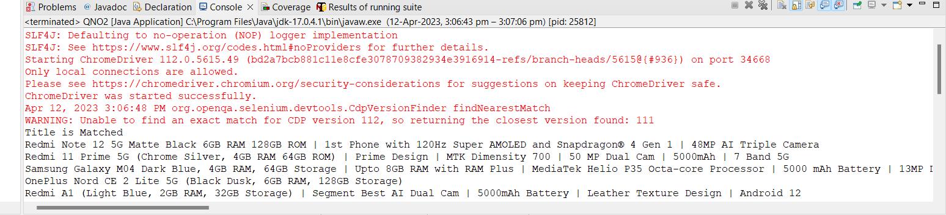

QNO:3

package com.CA1.CA1;

import org.openqa.selenium.By;

import org.openqa.selenium.WebDriver;

import org.openqa.selenium.WebElement;

import org.openqa.selenium.chrome.ChromeDriver;

import org.openqa.selenium.chrome.ChromeOptions;

import io.github.bonigarcia.wdm.WebDriverManager;

public class QNO3 {

public static void main(String[] args) throws InterruptedException{

// TODO Auto-generated method stub

WebDriverManager.chromedriver().setup();

ChromeOptions co=new ChromeOptions();

co.addArguments("--remote-allow-origins=*");

WebDriver driver=new ChromeDriver(co);

driver.get("https://www.amazon.in/");

driver.get("https://www.amazon.in/ap/signin?openid.pape.max_auth_age=0&openid.return_to=https%3A%2F%2Fwww.amazon.in%2F%3Fref_%3Dnav_ya_signin&openid.identity=http%3A%2F%2Fspecs.openid.net%2Fauth%2F2.0%2Fidentifier_select&openid.assoc_handle=inflex&openid.mode=checkid_setup&openid.claimed_id=http%3A%2F%2Fspecs.openid.net%2Fauth%2F2.0%2Fidentifier_select&openid.ns=http%3A%2F%2Fspecs.openid.net%2Fauth%2F2.0&");

driver.findElement(By.xpath("//*[@id=\"ap_email\"]")).click();

driver.findElement(By.xpath("//*[@id=\"ap_email\"]")).sendKeys("ushasasi114@gmail.com");

driver.findElement(By.xpath("//*[@id=\"continue\"]")).click();

driver.findElement(By.xpath("//*[@id=\"ap_password\"]")).click();

driver.findElement(By.xpath("//*[@id=\"ap_password\"]")).sendKeys("sasi@2701");

driver.findElement(By.xpath("//*[@id=\"signInSubmit\"]")).click();

Thread.sleep(3000);

driver.findElement(By.xpath("//*[@id=\"nav-link-accountList\"]")).click();

WebElement acc=driver.findElement(By.xpath("//*[@id=\"a-page\"]/div[2]/div/div[1]/h1"));

String actual=acc.getText();

String expected="Your Account";

if(actual.equals(expected)) {

System.out.println("Your Account page is displayed");

}

driver.findElement(By.xpath("//*[@id=\"a-page\"]/div[2]/div/div[2]/div[1]/a/div")).click();

WebElement ord=driver.findElement(By.xpath("//*[@id=\"a-page\"]/section/div[1]/div[2]/div[1]/h1"));

String act=ord.getText();

String exp="Your Orders";

if(act.equals(exp)) {

System.out.println("Your Order page is displayed");

}

String act1=ord.getText();

String exp1="Your orders";

if(act.equals(exp)) {

System.out.println("User is able to track package");

}

System.out.println("User is able to view their products");

}

}

O/P:

