TYPES OF INHERITANCE:

1)Single Inheritance

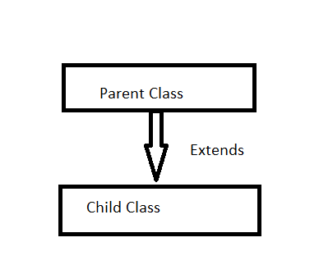

2)Multilevel Inheritance:

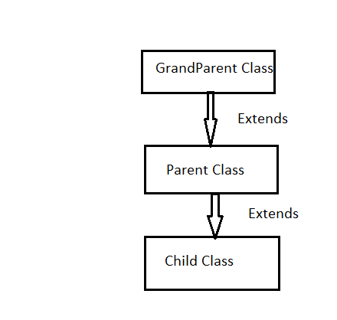

3)Hierarchical Inheritance:

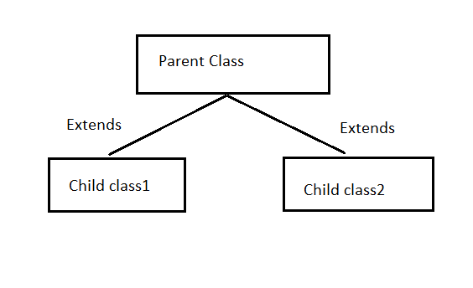

4) Hybrid Inheritance:

