**EXPERIMENT NO:10**

**Divhya Gnanasekar-118A1021**

**Sandhiya Kanthakumar-118A1031**

**Usha Konar-118A1035**

AIM: Develop test cases for case study testing.

**IMPLEMENTATION:**

|  |  |  |  |  |  |  |
| --- | --- | --- | --- | --- | --- | --- |
| **#** | | **TS1** | | | | |
| **Title** | | **User Login functionality** | | | | |
| **Description** | | **To test the scenarios while user is trying to login.** | | | | |
|  | | | | | | |
| **#** | **Summary** | **Dependency** | **Pre-condition** | **Post-condition** | **Execution Steps** | **Expected Output** |
| TC1 | Login with valid user name and password. | A user must Sign-Up before login. | The user has valid combination of Email and Password. | The user has successfully login to the system. | 1. Launch the website. 2. Navigate to the login page. 3. Provide valid Email/Username. 4. Provide valid password. 5. Click on login button. | If user has entered correct user name and password the application must allow him to login successfully. |
| TC2 | Login with invalid user name and password. | A user must not Sign-Up before Login. | User has invalid Email & Password. | User did not login to the system. | 1. Navigate to the login page. 2. Enter Invalid Email/Username. 3. Enter Invalid Password. 4. Click on login button. | User should not be able to login. |
| TC3 | Login with empty username & Password. | A user must not Sign-Up before Login. | Both fields are empty. | User failed to login and a message generated that user name and password are empty. | 1. Navigate to the login page. 2. Do not enter any value in username & password field. 3. Click on login button. | User should not be able to login. |

|  |  |  |  |  |  |  |  |
| --- | --- | --- | --- | --- | --- | --- | --- |
| **#** | | | **TS2** | | | | |
| **Title** | | | **Verify “Payment” functionality** | | | | |
| **Description** | | | **To test various scenarios that might arise while an user is performing payment process** | | | | |
|  | | | | | | | |
| **#** | **Summary** | **Dependency** | | **Pre-condition** | **Post-**  **condition** | **Execution**  **Steps** | **Expected**  **Output** |
| TC1 | If the user uses a credit/debit card which is expired. | An user must use a credit/debit card which is valid. | | If a card crosses expiry date then payment will not be proceeded. | Payment process can be executed only with card with valid date. | 1.Launch the website.  2.Login to the site.  3.Add the products to cart.  4.Proceed to pay.  5.Enter valid credentials. | If user has entered valid credentials of the card which is valid then the payment process will be completed successfully. |
| TC2 | If the user enters invalid OTP. | If an user is proceeding any payment by any banking options then he must provide the valid OTP. | | If an user will enter an invalid OTP then the payment request will be rejected. | Payment request will be granted with valid OTP. | 1.Launch the website.  2.Login to the site.  3.Add the products to cart.  4.Proceed to pay.  5.Enter valid credentials.  6.Enter invalid OTP. | If the users provide invalid or wrong OTP then the payment process will be rejected. |
| TC3 | If the user uses invalid coupon then the payment will not be executed. | If the user is using any kind of coupons then if the coupon is expired and if it is invalid then payment will be hindered. | | An expired or invalid coupons will not allow the users to proceed with the payment. | A coupon with valid date will be proceed the payment process. | 1.Launch the website.  2.Login to the site.  3.Add the products to cart.  4.Proceed to pay.  5.Enter valid coupon  credentials. | If the user uses the coupons then it must be used before the expiry date and must be valid and your payment will be successful. |

|  |  |  |  |  |  |  |
| --- | --- | --- | --- | --- | --- | --- |
| **#** | | **TS3** | | | | |
| **Title** | | **Cart functionality** | | | | |
| **Description** | | **To test the scenarios while customer is adding and deleting items from the cart.** | | | | |
|  | | | | | | |
| **#** | **Summary** | **Dependency** | **Pre-condition** | **Post-condition** | **Execution Steps** | **Expected Output** |
| TC1 | Logged in account and add item | Must be logged in | The user has valid combination of Email and Password. | Item successfully added to cart. | 1. Launch the website. 2. Login with username and password. 3. Add items to cart | The system will accept the added item. |
| TC2 | Not logged in and add items |  | The user has not logged-in. | The items will not be added. | 1. Launch the website. 2. Browse catalogue and select item to add into cart. | The system will not accept the add item command, will put error, “Please Log-in”. |
| TC3 | Cart empty and clicking proceed to pay |  | The user has no items in cart. | The user will fail to proceed to pay. | 1. Launch the website. 2. Login with username and password. 3. Click proceed to pay. | The system will throw error, “Cart is empty”. |
| TC4 | Item out of stock or not available in that size. |  | The user has chosen an item for buying. | The user will fail to add the item. | 1. Launch the website. 2. Login with username and password 3. Select size of item and add to cart. | The system will say “Please choose another size we are out of stock on your chosen size”. |

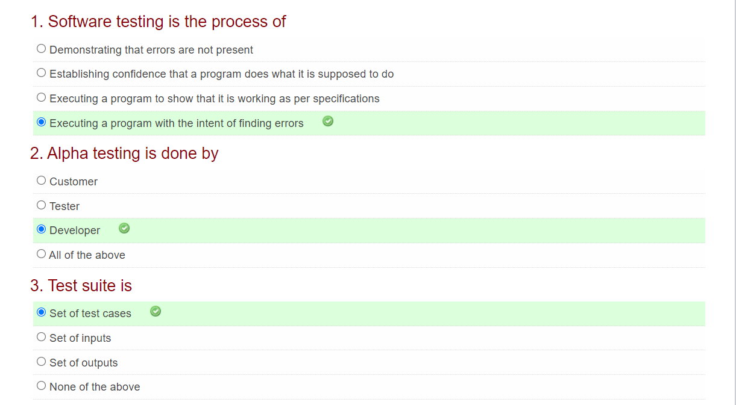

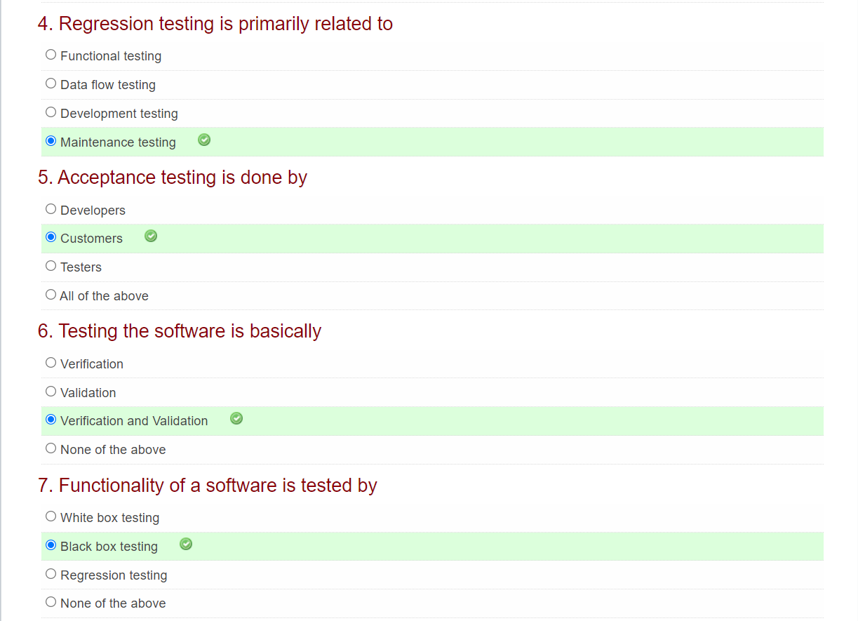

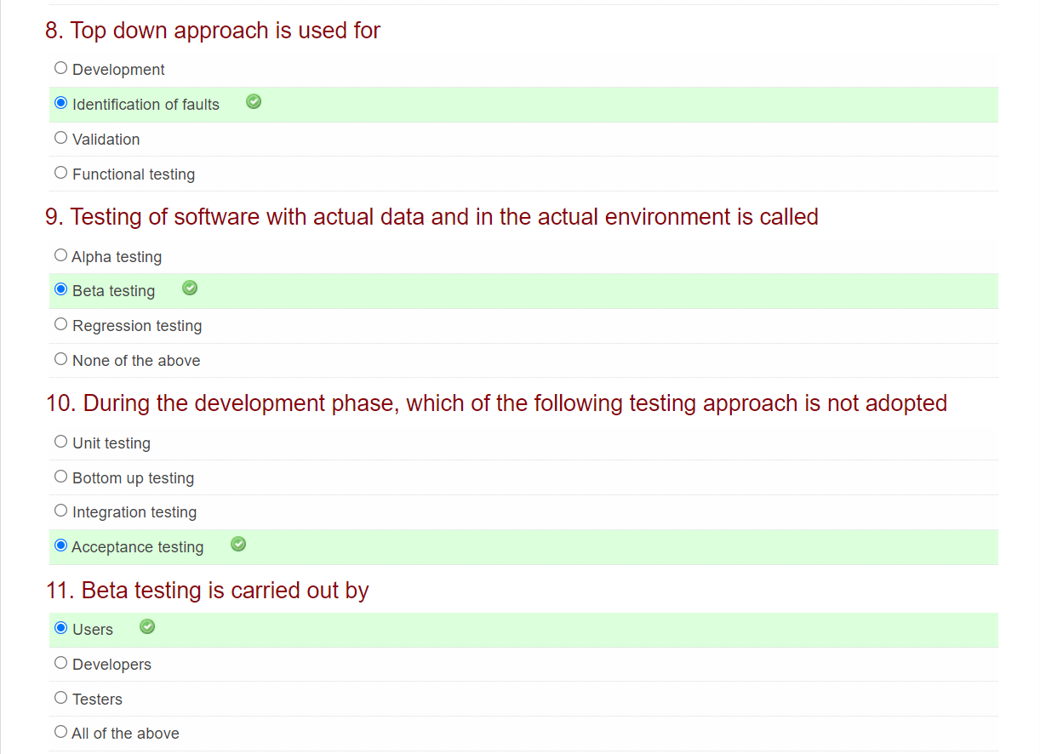

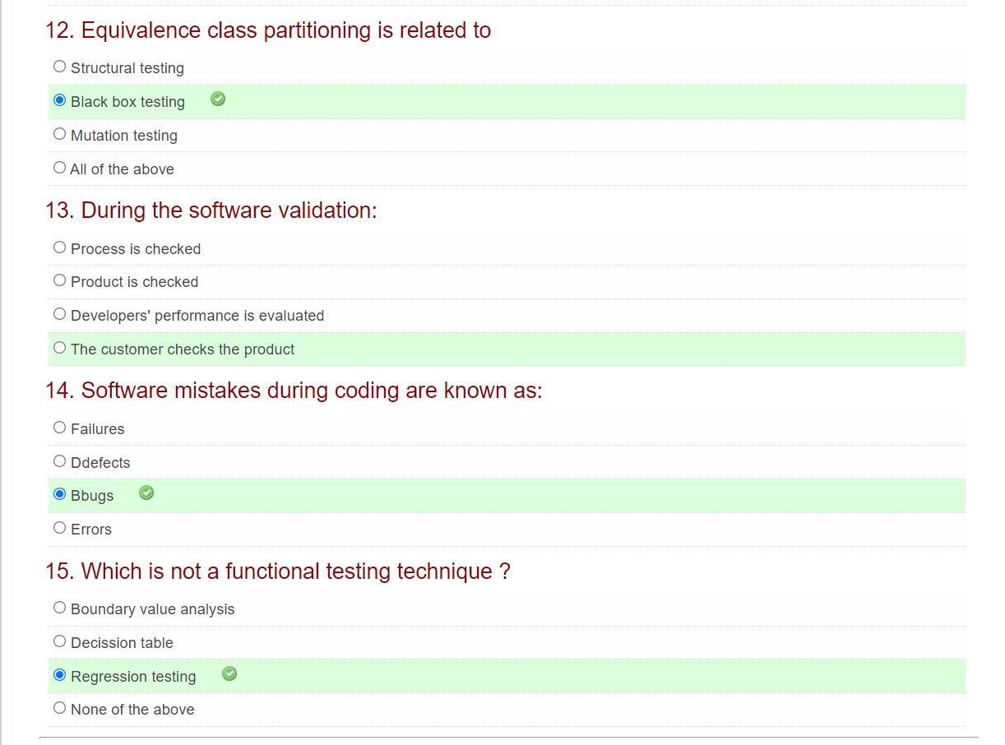

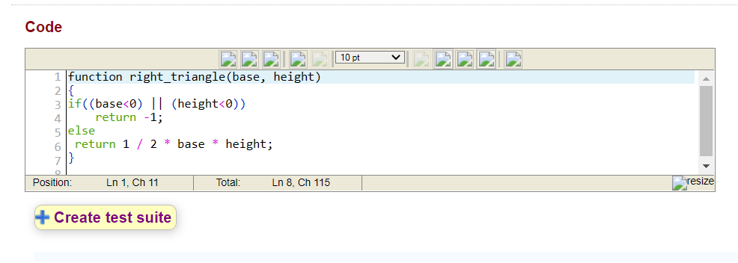

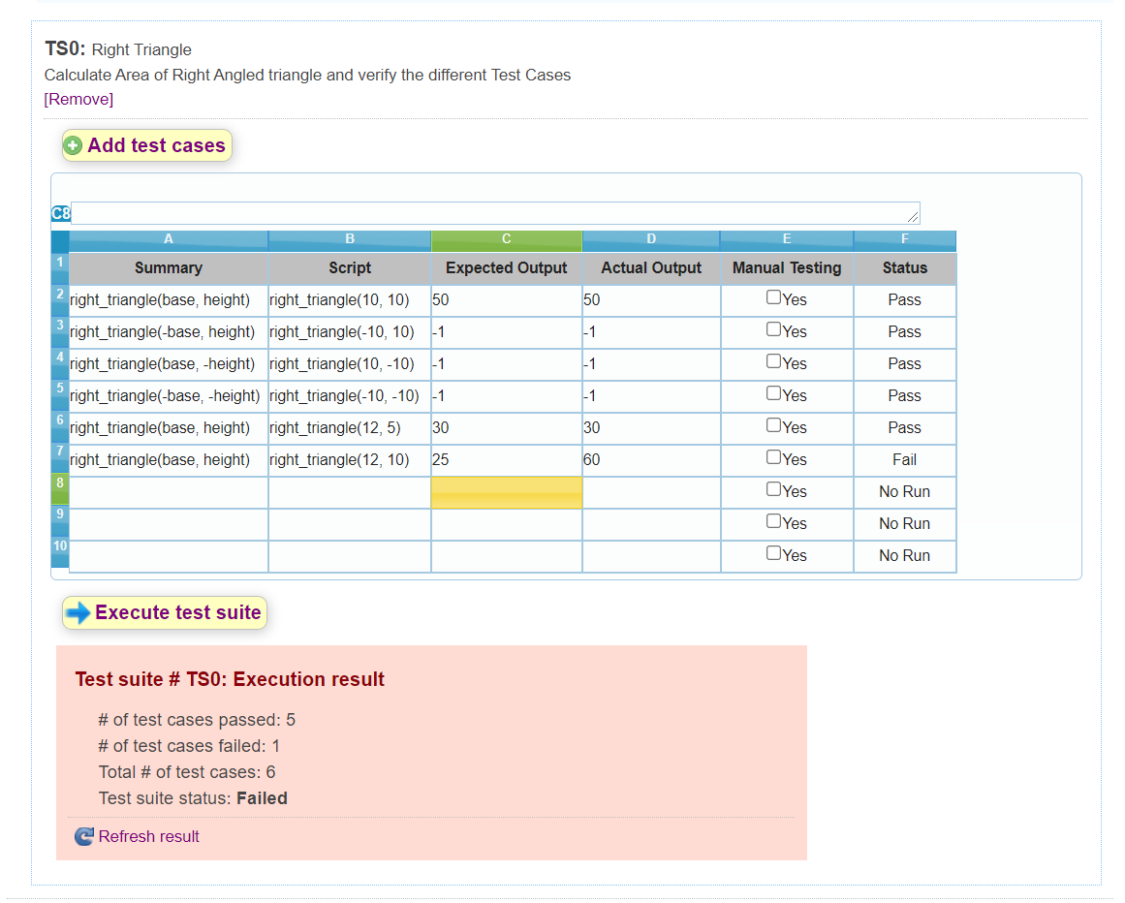

CONCLUSION: Thus, the test cases for testing our case study are successfully developed.