

Social Media and Online Learning: Youth in Uganda, Tanzania, Rwanda, Kenya, Ethiopia, Lebanon and Canada

Organization Contact

Name, Position

Report Prepared by

Karmen, Coursolve participant

Year #

2016

Grant #000000

#### Executive Summary

1. This report draws conclusions about youth in Uganda, Lebanon, Kenya, Tanzania, Rwanda, Ethiopia and Canada and their use of technology and Internet. A random sample of 567 young people over 15 years of age was gathered from these countries. They were asked about their access to computers, tablets, smartphones, their access to Internet and the way they use technology in their daily lives. Methods of statistics, such as Cochran-Mantel-Haenszel test, Woolf test, logistic regression and correction for multiple testing were used. The graphs were drawn using the ggplot2 library in R.
2. Analysis showed that men are more likely than women to have generated some income with the use of social media. Other than that, there is no difference between men and women in the use of social media for work, learning or exercising their initiative in their immediate or wider community. People with more education, who live in cities, students, parents or caregivers, employed, especially if they are casual of day-laborers, self-employed or enterpreneurs tend to use work related technology more frequently than underemployed people. Country isn’t in any way predictive of the frequency of use of work related technology of its citizens, when controlled for things like education, employment, occupation.
3. When it comes to online learning, the cost of data traffic, instable internet connection and power supply are the greatest obstacle, since prevents even access to free content.

Contents

Social media and gender 3

Work 3

Income 3

Learning 4

Leadership 6

Employment 7

Social media and income 8

Barriers and incentives to online learning 10

# Social media and gender

How does use of social media for work, income, learning, leadership, and employment vary by gender?

## Work

Men and women tend to use similar digital devices and tools for work. Emails and calls seem to be the favorites to both genders

1. 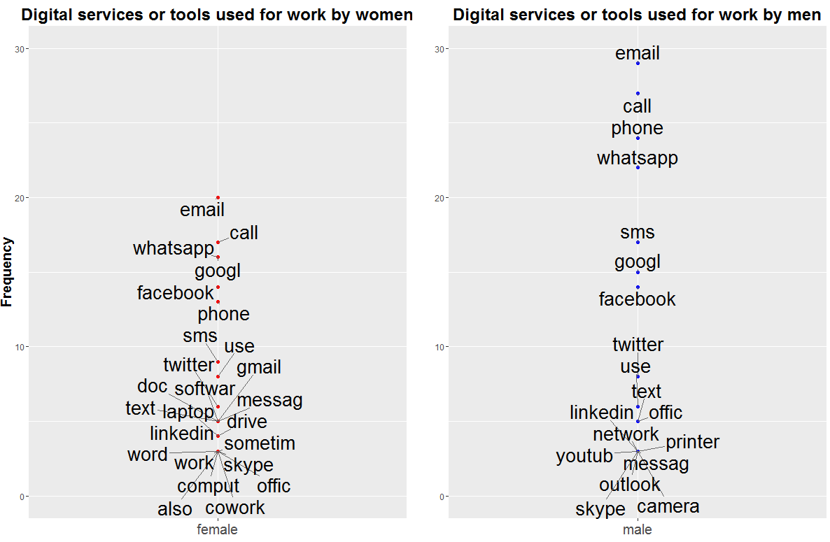

Figure 1: Frequency of mentioning of particular words in free input style question “What digital services or tools do you use for work?”. Graph on the left is for women, and the one on the right is for men.

## Income

Although the percentage of people who used social media to generate income is relatively low, at most 15.7 % for a type of social media (social networks like Facebook, Twitter), there are statistically significant (even after correcting for multiple comparisons, p-value = 0.00114) differences between men and women: men are more likely to have used social media to generate income.

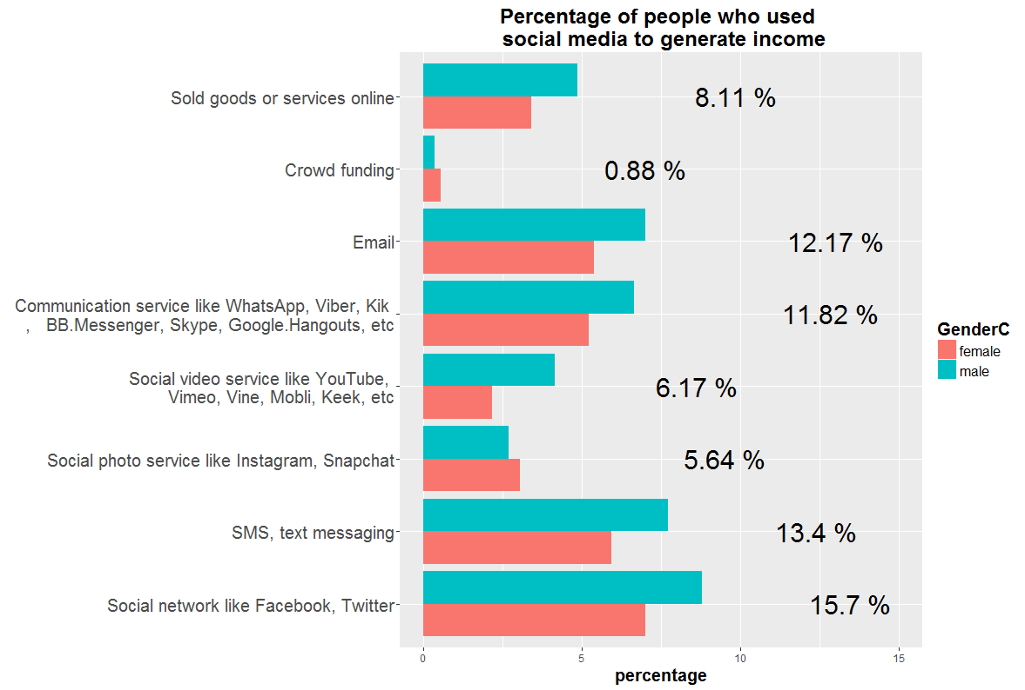

Figure 2: Percentage of people who used social media to generate income.

## Learning

1. Both genders have Google for their favorite digital service or tool for learning and work related learning. Apart from that, women seem to like Facebook and Wikipedia more than their male counterparts.
2. 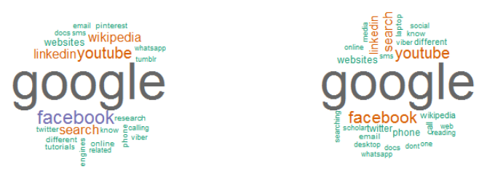

Figure 3: Word cloud for favorite digital service or tool for learning and work related learning. Word cloud for women is on the left and on the right is the word cloud for men.

#### 

Figure 4 Frequency of use of the digital services or tools for learning: Very often, by gender. Notice how one option, Paid online courses, is completely missing from the graph: there was not a single participant whose very often choice for digital service or tool for learning is was paid online course.

When asked what digital service or tool *use very often* for learning, Facebook was the most prominent choice, followed by YouTube and Google. When digital services/tools are stratified across different frequencies of use, there is no statistically significant difference between genders: both males and females use similar digital services with similar frequency (p-value = 0.51). However, when same data is stratified across genders, and association is researched between different digital services (independent variable) and frequency of use (dependent variable), there is a highly significant association between those two variables (p-value < 2.2e-16). This association isn’t surprising, since some digital tools are more popular and/or valued than others, and for some, like paid online courses, a price can be quite steep (not all paid online courses are MOOCs).

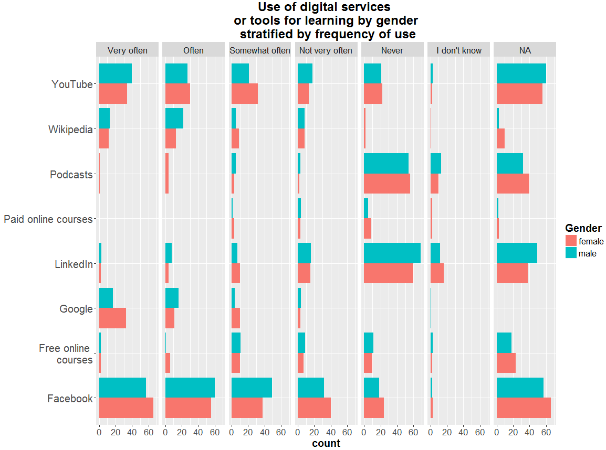

Figure 5: Association between gender and different digital tools used for learning, stratified by frequency. Within each stratum of frequency there is no statistically significant association between gender and variety of different digital tools or services. Some digital services are notably rarely used.

## Leadership

Leadership can take many forms, some are more direct, others are more indirect. To explore the use of social media for leadership, I’ve looked into (free input) responses for favorite digital service or tool for these activities:

* Getting news out to your friends
* Getting news out to your family
* Getting news out to your community
* Influencing other people
* Sharing your ideas
* Raising money for a cause
* Raising awareness for a cause

Separate female and male word clouds show that both men and women like to use Facebook for their leadership activities.

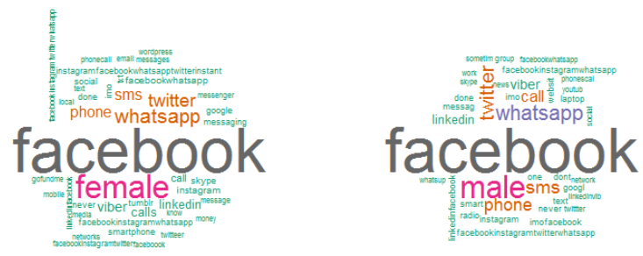

Figure 6: Leadership and social media. Female word cloud on the left, and male word cloud on the right for favorite digital service or tool for a variety of activities that can be regarded as leadership in their immediate family or wider community.

## Employment

There is no significant difference in having access to looking for or applying for job over the internet (p-value = 0.1567) between genders. Also, there are no statistically significant differences in access to the same service between genders in different countries that participated in this research (p-value = 0.1232), nor is there significant difference in access to the same service when the data is compared across different geographical levels, i.e. closeness to urban area (p-value = 0.1336).

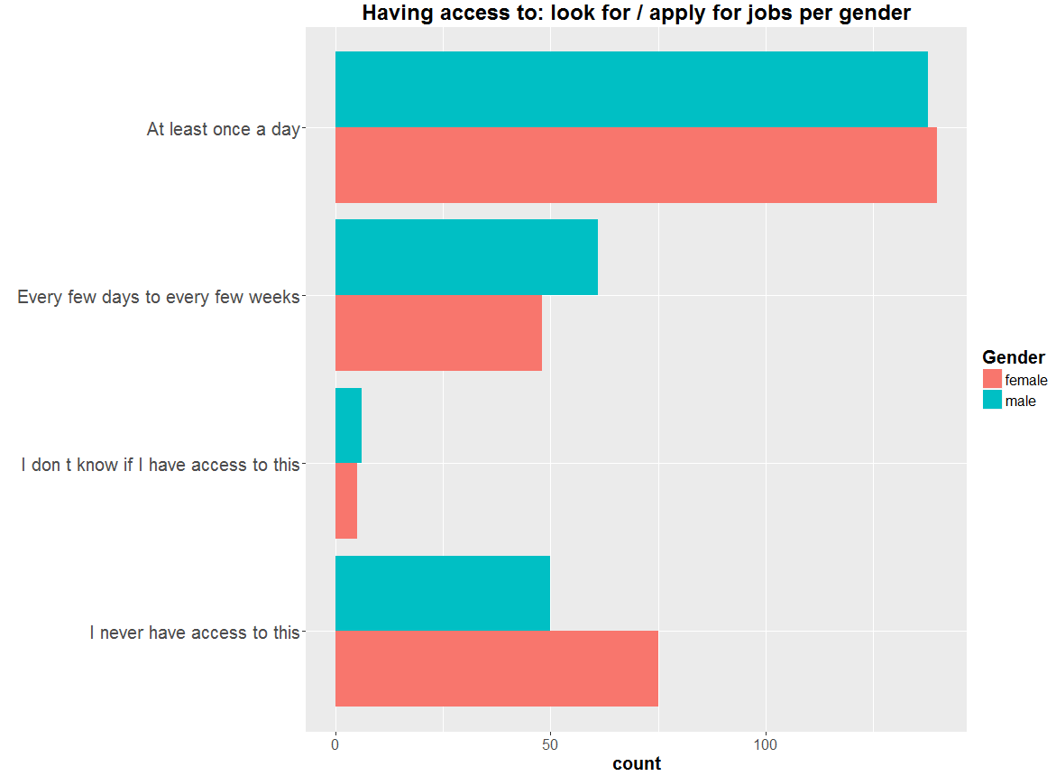

Figure 7: Access to digital services or tools that are related to job seeking or job application.

# Social media and income

In what ways are youth in these countries using technology and social media to supplement income, or to support primary incomes?

In many professions, occupations and jobs it is necessary to use at least a phone, a word processor and email just to “get things done”. Graph “Work related technology” lists some of the common services and tools used in contemporary working environment, along with the frequency of their use simplified to two instances: “Pretty Often” and “Rarely ever”.

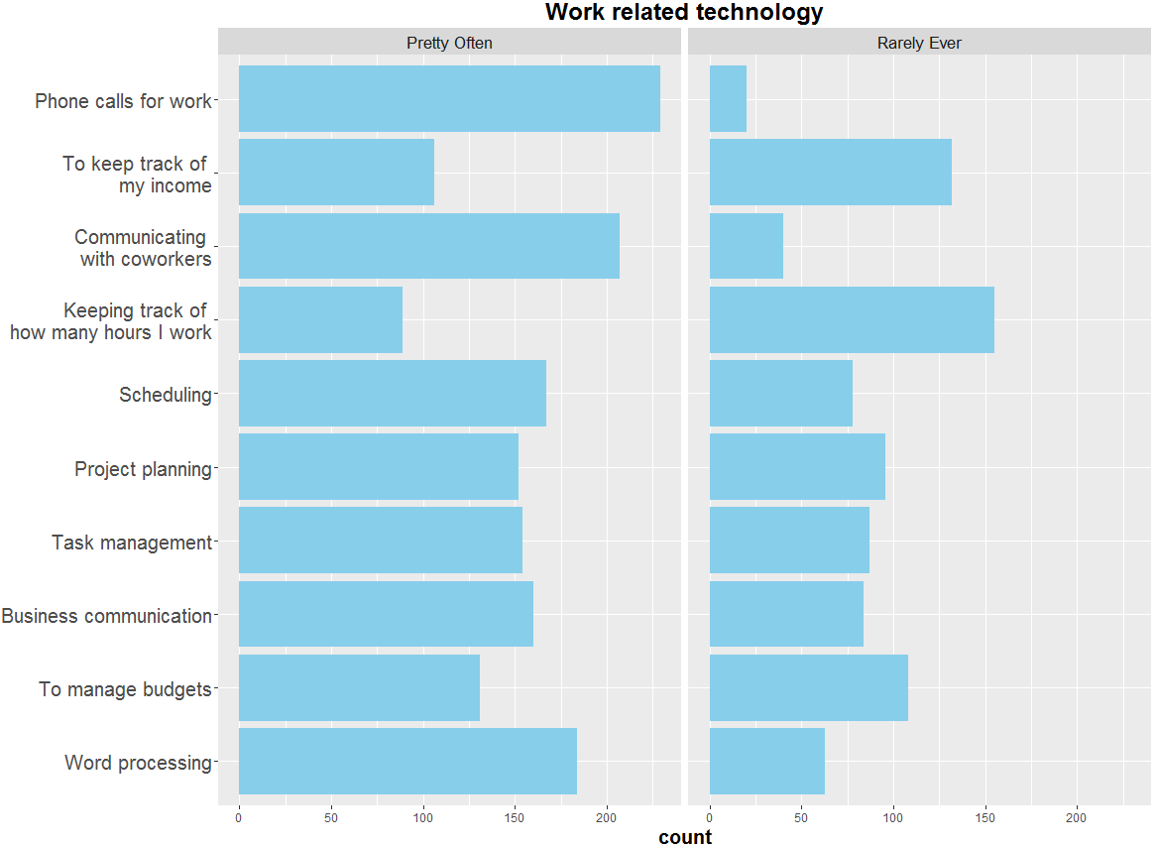

Figure 8: Use of electronic devices for the named work related activities. Some activities cannot be performed without some form of technology while others can be done without the help of any electronic device. The question was: “How often do you use any electronic devices for the following work related activities?”

The more people are educated, the more their jobs are complex and all kinds of situations more easily arise where the technology can be of help. However, next graph shows that university graduates are more likely to use working related technology than their academically more advanced counterparts, and that trend can be observed in all countries that participated in this research.

But in general, secondary school graduates and above, as well as various kinds of professionals and students are positively associated with frequent use of work related technology, while underemployed are strongly negatively associated.

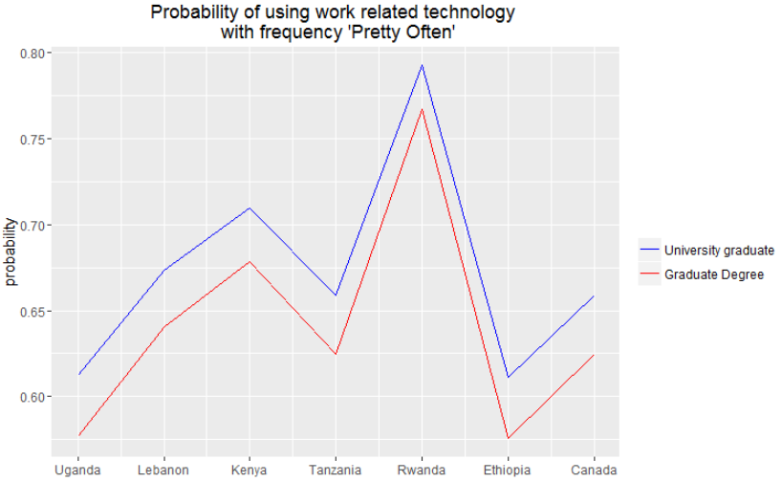

Figure 9: This graph shows probabilities of frequently using work related technology for male person of more than 31 years of age. The blue line is for University graduate, and the red line is for a person with a graduate degree. Probabilities are obtained using logistic regression.

While urban area is positively associated with its residents’ frequency of use of work related technology, rural area and refugee camps are negatively associated, but that association isn’t statistically significant.

Casual or day-laborers are very positively associated with the use of work related technology, which isn’t surprising since their employment form is highly addicted to communication. Also, parents or family caregivers are positively associated with the frequency of use.

Country of residence of respondent isn’t in any way predictive of the frequency of use of work related technology of its young inhabitants.

# Barriers and incentives to online learning

What barriers and incentives to online learning are there among the surveyed youth?

One of the most prominent incentives to online learning is the availability of massive open online courses, popularly called MOOCs: MOOCs are free and available to anyone. They are recorded, so they are available at any time, and at any place that has Internet connection. This is their advantage, and at the same time their flaw, since time management can become an issue, for many reasons.

Expensive data traffic is often listed as one of the challenges to greater participation in massive open online courses that are free. Instable internet connection, or even instable power supply is another frequent obstacle. Some participants named high tuitions, since not all courses are MOOCs, neither MOOCs cover all possible educational needs.

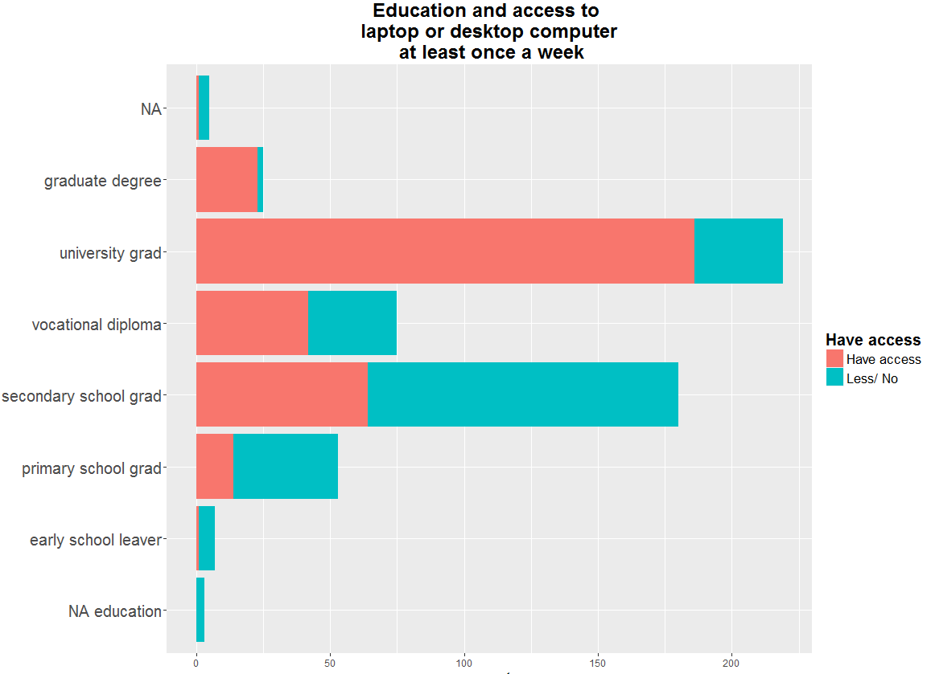

Figure 10: Access to desktop or laptop computer at least once a week. At least once a week was chosen because free online courses, the cheapest form of education, usually take place in weekly rhythm, and not all tasks can be done over smartphone or even tablet, such as programming. So the person should have at least once a week access to laptop or desktop computer to do homework.

These graphs show that people have at least some minimum of meaningful access to devices, but the price of data traffic is still an important obstacle. This reflects also in the fact that Facebook is the most frequent choice for digital service or tool for learning (see Figure 4, Learning).

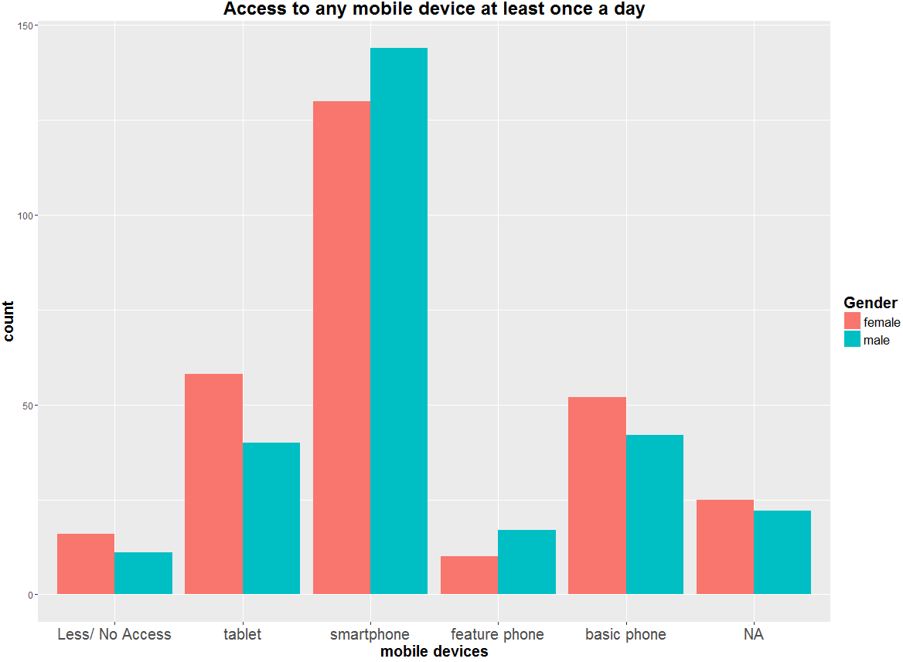

Figure 11: Access to any mobile device at least once a day. Mobile devices are necessary for basic things such as phone calls, but also can be used for browsing the Web, payments, reading books and articles, accessing

social networks etc.



It was free but still too expensive as it consumed a lot of data due to volumes of downloads involved, and the many videos.





Time management. I had to adjust my working time in such a way that I can attend the online course. Also electricity was a problem since many times the power went off and I couldn’t use my laptop.