**Initial UI Design**

1. **Login Page**

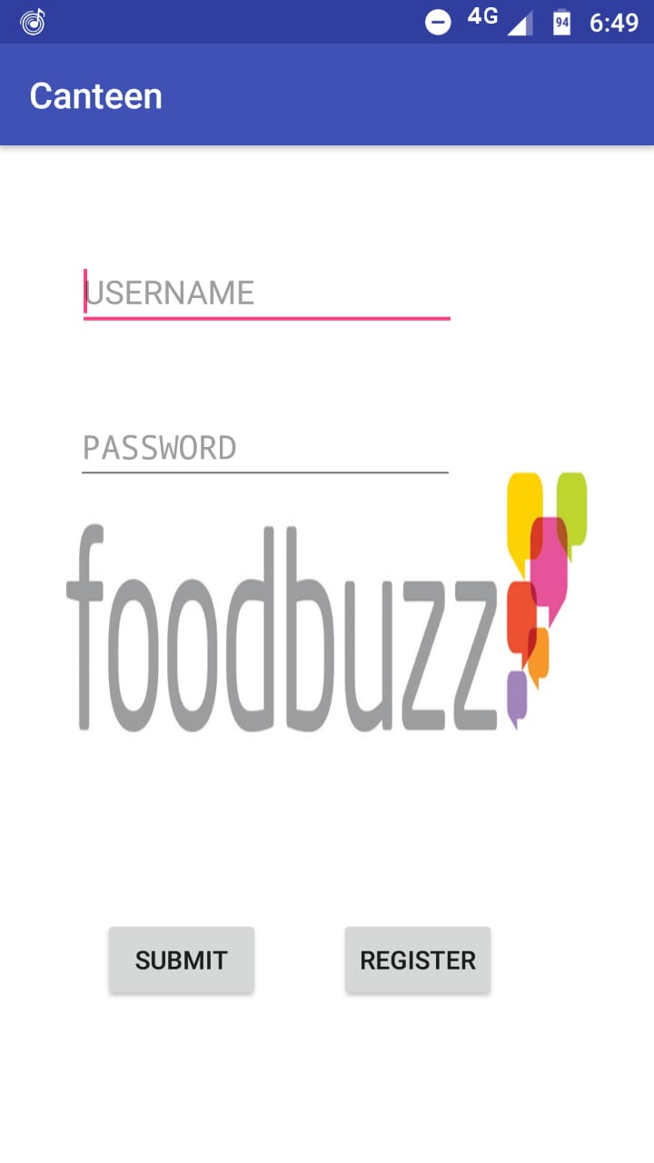

1. **Registration Page**

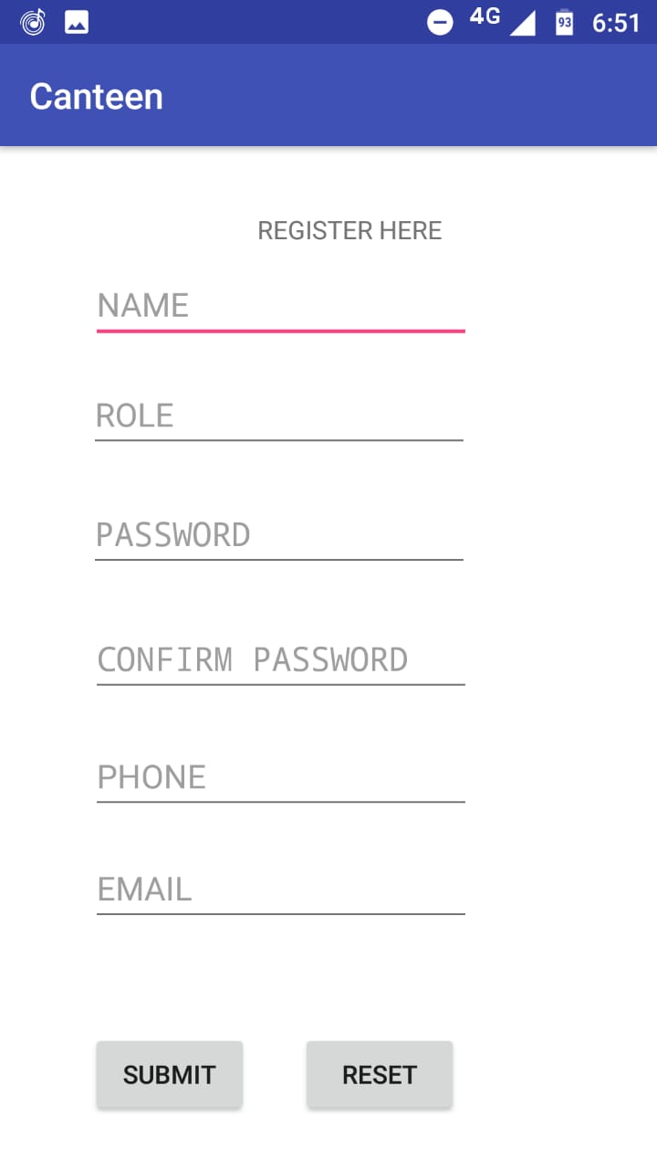

1. **Items Available in Canteen**

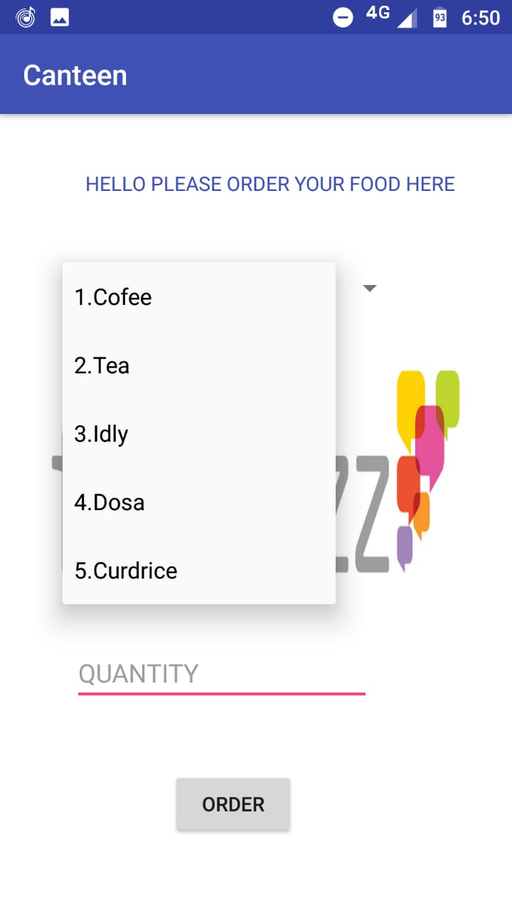

1. **Placing Order**

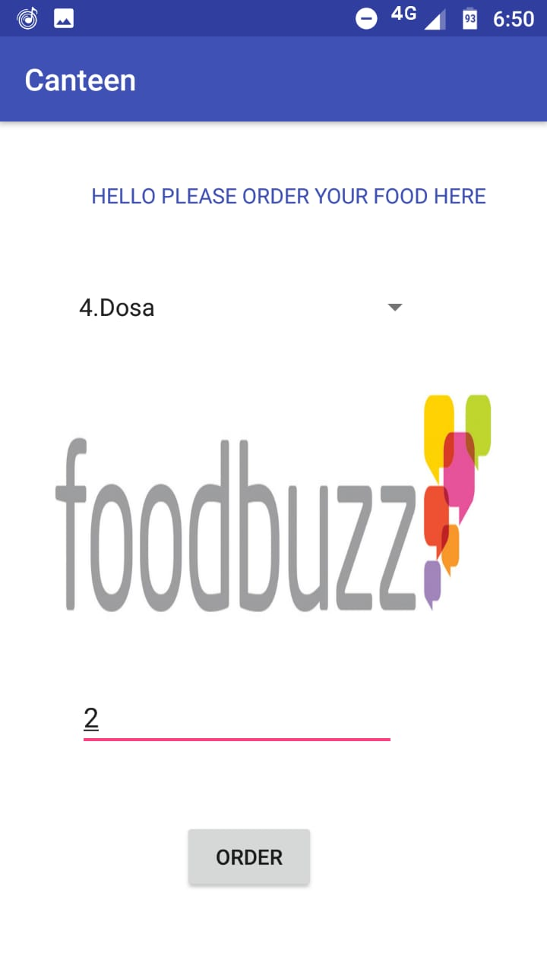

1. **Order Confirmation Message**

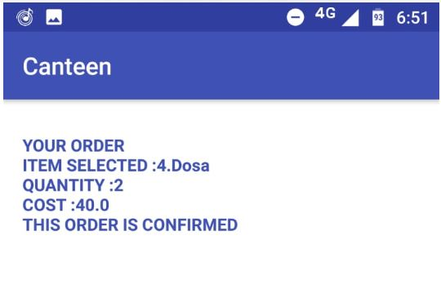

1. **Order Preparation Message**

