CHAPTER 1
INTRODUCTION
1.1 Overview of the Internship
The internship program provided an excellent opportunity to gain practical knowledge and hands-on experience in Full Stack Development, with a primary focus on Java technologies. Over the course of one month, I was able to strengthen my understanding of both frontend and backend development, along with database connectivity, which is essential in building real-world applications.
The internship followed a structured learning path, starting from the fundamentals of core Java programming, where I learned about data types, control structures, arrays, object-oriented concepts, and exception handling. This foundation helped in understanding the logic building required for developing the Inventory Management System. I then explored JavaFX to design interactive and visually appealing user interfaces, enabling the creation of a responsive desktop application that allows users to manage and prioritize tasks efficiently.
The backend learning was enhanced with Java data handling and file management concepts, where I explored data structures such as priority queues, arrays, and collections to manage and organize tasks efficiently. Finally, I integrated these concepts within the JavaFX application, implementing logic for task prioritization, scheduling, and dynamic updates, which enabled the system to perform key operations like adding, updating, deleting, and displaying tasks effectively.
The internship concluded with a mini project – Inventory Management System, where I applied all the concepts learned during the training. The project involved developing a JavaFX-based desktop application that allows users to add, view, edit, and prioritize tasks using Java, data structures, and object-oriented programming principles for efficient task management.
This internship not only improved my technical skills but also enhanced my ability to work systematically, follow coding standards, and think logically while solving problems.

CHAPTER 2
COMPANY PROFILE
2.1 Company Information

R Tech Solutions, based in Perambalur, was established in 2024. The company has been dedicated to helping a wide range of clients, from small nonprofits to large corporate firms, achieve success in their online business endeavors. They specialize in a variety of services including web design, e-commerce development, custom website design, SEO, digital marketing, and open-source development. R Tech Solutions is known for their tailored strategies that cater to the unique needs of each client, ensuring effective and customized solutions for various industries.
We are a team of dedicated website designers, web developers, SEO experts and logo designers eager to take on challenges that come along with the project and beat them with the design and technologies in which we have expertise. The range of our services span from vibrant aesthetic logos and mobile responsive web designs, fast loading Google AMP website, website redesign with amp html page version , existing old websites to mobile responsive websites, website optimization, website redesigning with new dynamic features, search engine optimization - SEO and monthly or annual website maintenance services and web related services like Hosting, Domain name Renewal, Business Email, website malware removal etc., R Tech Solutions well known as a complete digital marketing company.
R Tech Solutions Our web quality control team makes sure about all important factors of your website like mobile responsive, a user-friendly user interface, optimised meta tags, page text content with keywords for potential visitors, search engine friendly coding, quick loading and dynamic features of the website.
R Tech Solutions, known as one of the best logo and website design company in Chennai, enriched with the skilled and experienced team of best website designers, website Developer, Logo Designers, Graphic Designers, PHP Programmers, SEO Experts, Website SEO Analysts, website AdWords specialists and Creative SEO Content Writers.



NAME : R TECH SOLUTION

FINAL PRODUCT : INVENTORY MANAGEMENT SYSTEM
PROJECT

PROPRIETOR : RAJA M

MANAGING DIRECTOR : RAJA M

CLASS OF COMPANY : IT INDUSTRY

ADDRESS : No.206A, 2nd Floor, Second Cross Road, Vivekanandhar Street, Post Office Salai, PERAMBALUR, TAMILNADU,621212
YEAR ESTABLISHED : 202
PHONE NO : +919345442659

CHAPTER 3
INDUSTRIAL TRAINING
3.1 Software Tools
During the internship, several software tools and technologies were utilized for learning, development, and project implementation. These tools played a vital role in understanding the concepts of Full Stack Development and applying them in real-world scenarios.
- HTML (HyperText Markup Language)
  - Used to structure web pages by defining headings, paragraphs, links, images, tables, and forms.
  - Provided the foundation for creating the frontend layout of applications.
- CSS (Cascading Style Sheets)
  - Applied to style and format web pages.
  - Used for designing layouts, applying colors, fonts, animations, and ensuring responsive design for different devices.
- JavaScript
  - Added interactivity to web pages.
  - Used for form validation, DOM manipulation, event handling, and creating dynamic content.
- Java Programming Language
  - Acted as the core backend programming language.
  - Helped in understanding object-oriented concepts such as inheritance, polymorphism, abstraction, and encapsulation.
- Java Database Connectivity (JDBC)
  - Provided a bridge between Java applications and databases.
  - Used to establish connections, execute SQL queries, and perform CRUD (Create, Read, Update, Delete) operations.
- SQL (Structured Query Language)
  - Used to create and manage relational databases.
  - Helped in understanding queries, joins, constraints, and data manipulation.

- IDE (Integrated Development Environment)
  - Eclipse / IntelliJ IDEA were used for writing and testing Java programs.
  - Provided debugging tools, project organization, and productivity features.
- Database Tool
  - MySQL was used as the relational database management system (RDBMS).
  - MySQL Workbench helped in creating schemas, writing queries, and visualizing database structures.
- Version Control System
  - Git & GitHub were used to manage source code, track changes, and collaborate effectively.
- Build & Dependency Management Tool
  - Apache Maven (optional) was used for managing dependencies and automating the build process in Java projects.

3.2 Training Exposure (Area, Scope)
The internship program provided extensive training in the Java Full Stack Development domain, covering both frontend and backend technologies, along with database management and integration. The training exposure was designed to gradually build up from the basics to advanced concepts, ensuring a strong foundation in software development.

Areas of Training Exposure
- Frontend Development
  - Learned the structure of web pages using HTML.
  - Styled and formatted content using CSS to create responsive and visually appealing layouts.
  - Used JavaScript for adding interactivity, client-side validations, and DOM manipulation.
- Backend Development with Java
  - Gained hands-on experience in Java fundamentals such as data types, arrays, operators, and control structures.
  - Understood Object-Oriented Programming (OOP) concepts including encapsulation, inheritance, polymorphism, and abstraction.
  - Explored advanced Java features such as exception handling and collections.

- Database Management
  - Learned to design, create, and manipulate databases using SQL.
  - Worked with DDL, DML, and DQL commands to handle data.
  - Understood concepts of joins, constraints, transactions, and query optimization.
- Java Database Connectivity (JDBC)
  - Acquired practical knowledge in integrating Java applications with relational databases.
  - Established database connections, executed SQL queries, and implemented CRUD operations.
  - Applied JDBC concepts in building a mini-project to manage data effectively.
- Project Work
  - Applied the knowledge gained during training in developing a Bus Reservation System.
  - The project allowed integration of frontend (HTML, CSS, JS) with backend (Java) and database (SQL + JDBC).
  - Developed modules for adding, viewing, and deleting student details, thereby simulating a real-world application.

Scope of Training
- The training provided end-to-end exposure to full stack development.
- Strengthened problem-solving, logical thinking, and debugging skills.
- Developed the ability to design and implement interactive, scalable, and database-driven applications.
- Enhanced knowledge of industry-standard tools such as Eclipse/IntelliJ, MySQL, and Git.
Prepared for professional roles such as Java Developer, Full Stack Developer, or Software Engineer by bridging the gap between academic knowledge and industrial requirements.

CHAPTER 4
PROJECT WORK
4.1 Technology Stack
HARDWARE REQUIREMENTS:
- Processor: Intel Core i3 or higher
- RAM: 4 GB or higher
- Hard Disk: 100 GB free space
- Monitor: Standard resolution monitor (1024x768 or higher)
- Peripherals: Keyboard, Mouse, Printer (optional)
SOFTWARE REQUIREMENTS:
- Operating System: Windows/Linux/MacOS
- Database: MySQL or PostgreSQL
- Backend: Java (JavaFX, Core Java, Priority Queue Implementation)
- Frontend: JavaFX (FXML, CSS for UI Styling)
- Build Tool: Apache Maven
- IDE: IntelliJ IDEA, Eclipse, or Visual Studio Code
4.2 Design Principles
The Inventory Management System follows the MVC (Model–View–Controller) architecture to ensure clear separation of concerns and maintain a structured codebase.
The design emphasizes modularity, efficiency, and user-friendliness, ensuring smooth user interaction through an intuitive JavaFX interface and a robust backend that handles task prioritization and scheduling effectively.
4.3 Key UI Components
- Task creation and priority assignment.
- Task editing, updating, and deletion.
- Task list display with automatic priority ordering.
- Task completion status and progress tracking
- User-friendly dashboard for efficient task management

4.4 Source Code
Main.java
package application;
import javafx.application.Application;
import javafx.fxml.FXMLLoader;
import javafx.scene.Scene;
import javafx.stage.Stage;

public class Main extends Application {
@Override
public void start(Stage primaryStage) {
try {
FXMLLoader loader = new FXMLLoader(getClass().getResource("/view/Dashboard.fxml"));
Scene scene = new Scene(loader.load());
primaryStage.setTitle("Inventory Management System");
primaryStage.setScene(scene);
primaryStage.show();
} catch(Exception e) {
e.printStackTrace();
}
}

public static void main(String[] args) {
launch(args);
}
}
Task.java
package model;
public class Task {
private String title;
private String description;
private int priority;

public Task(String title, String description, int priority) {
this.title = title;
this.description = description;
this.priority = priority;
}

public String getTitle() { return title; }
public void setTitle(String title) { this.title = title; }

public String getDescription() { return description; }
public void setDescription(String description) { this.description = description; }

public int getPriority() { return priority; }
public void setPriority(int priority) { this.priority = priority; }
}
TaskManager.java
package controller;

import model.Task;
import java.util.PriorityQueue;
import java.util.Comparator;

public class TaskManager {
private PriorityQueue<Task> tasks;

public TaskManager() {
tasks = new PriorityQueue<>(Comparator.comparingInt(Task::getPriority).reversed());
}

public void addTask(Task task) {
tasks.add(task);
}

public Task getNextTask() {
return tasks.poll();
}

public boolean removeTask(Task task) {
return tasks.remove(task);
}

public PriorityQueue<Task> getAllTasks() {
return tasks;
}
}
DashboardController.java
package controller;

import javafx.fxml.FXML;
import javafx.scene.control.*;
import model.Task;

public class DashboardController {

@FXML private TextField txtTitle;
@FXML private TextArea txtDescription;
@FXML private Spinner<Integer> spPriority;
@FXML private ListView<String> taskList;

private TaskManager taskManager = new TaskManager();

@FXML
private void addTask() {
String title = txtTitle.getText();
String desc = txtDescription.getText();
int priority = spPriority.getValue();
Task task = new Task(title, desc, priority);
taskManager.addTask(task);
updateTaskList();
}

private void updateTaskList() {
taskList.getItems().clear();
taskManager.getAllTasks().forEach(t ->
taskList.getItems().add(t.getTitle() + " - Priority: " + t.getPriority())
);
}
}
Dashboard.fxml
<?xml version="1.0" encoding="UTF-8"?>
<?import javafx.scene.control.*?>
<?import javafx.scene.layout.*?>

<VBox xmlns="http://javafx.com/javafx/17" xmlns:fx="http://javafx.com/fxml/1" fx:controller="controller.DashboardController" spacing="10" alignment="CENTER">
<TextField fx:id="txtTitle" promptText="Task Title"/>
<TextArea fx:id="txtDescription" promptText="Task Description"/>
<Spinner fx:id="spPriority" min="1" max="5" value="1"/>
<Button text="Add Task" onAction="#addTask"/>
<ListView fx:id="taskList"/>
</VBox>

CHAPTER 5
CASE STUDY
5.1 Challenges and Solution
Challenge 1: Database Connectivity Issues
Description: While establishing a connection between Java and MySQL, errors like ClassNotFoundException and SQLException occurred due to missing JDBC drivers and incorrect connection strings.
Solution: The issue was resolved by adding the MySQL JDBC driver (mysql-connector-j.jar) to the project library and using the correct connection URL format:jdbc:mysql://localhost:3306/inventory_db
Proper username and password credentials were also configured in the code.
Challenge 2: Data Consistency and Validation
Description: During multiple stock updates, duplicate entries and incorrect product quantities were being saved in the database, leading to inconsistent inventory data. Solution: Data validation was implemented at both the frontend (JSP) and backend (Servlet) levels.Primary key and unique constraints were applied in MySQL to prevent duplication, and transactions were used to ensure reliable updates.
Challenge 3: UI and Backend Integration The data submitted through JSP forms was not correctly passed to the backend Servlets, resulting in empty fields or failed database entries. Solution: Added input validation, alert dialogs, and exception handling in JavaFX to manage errors gracefully and maintain data integrity.
Challenge 4: Project Deployment Errors
Description: While deploying the web project on Apache Tomcat, the application failed to load or displayed “HTTP 404” errors.
Solution: The folder structure (WEB-INF, web.xml, and JSP files) was checked carefully.The project was cleaned and rebuilt, then redeployed on Apache Tomcat using the correct context path, resolving the issue successfully.

5.2 Project snapshot
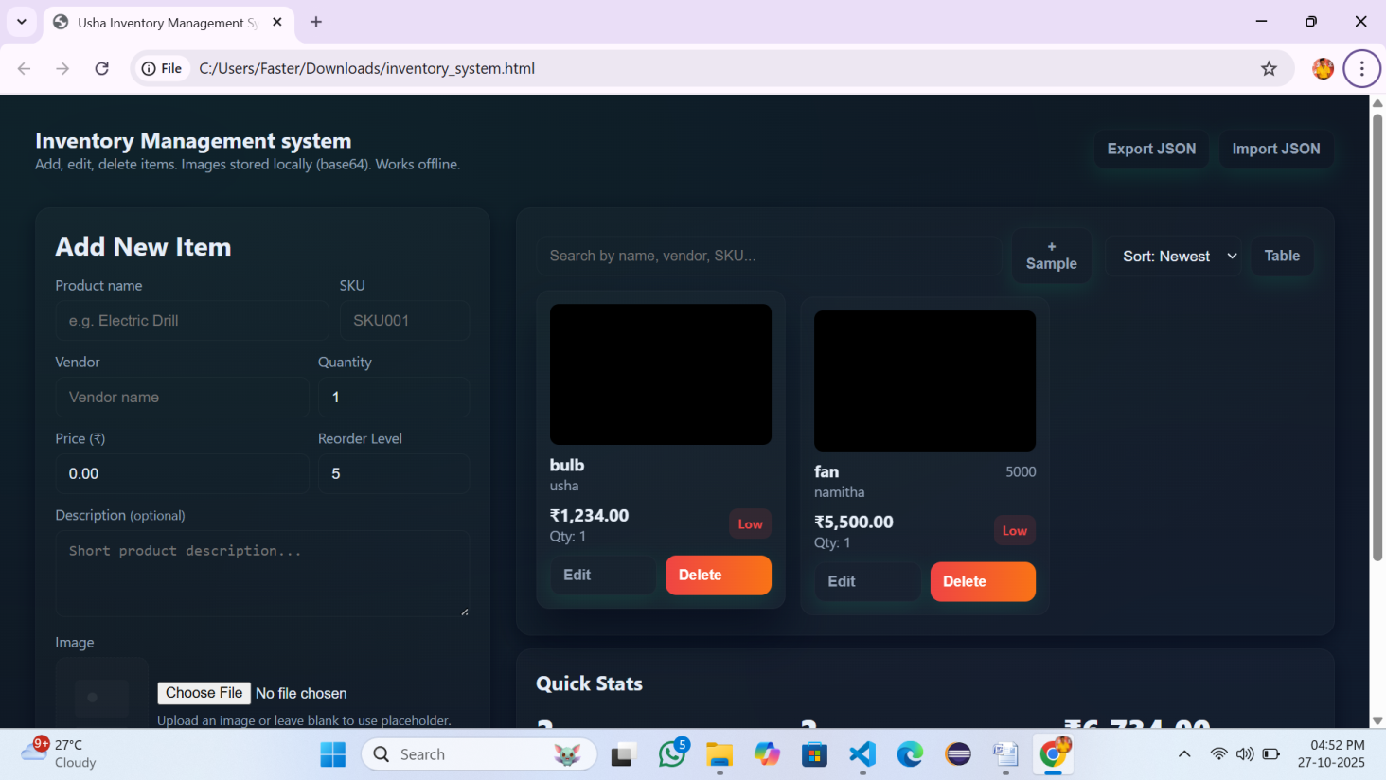
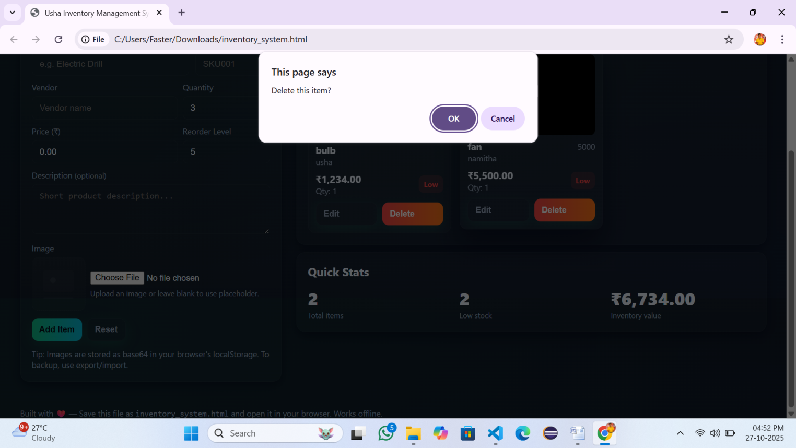

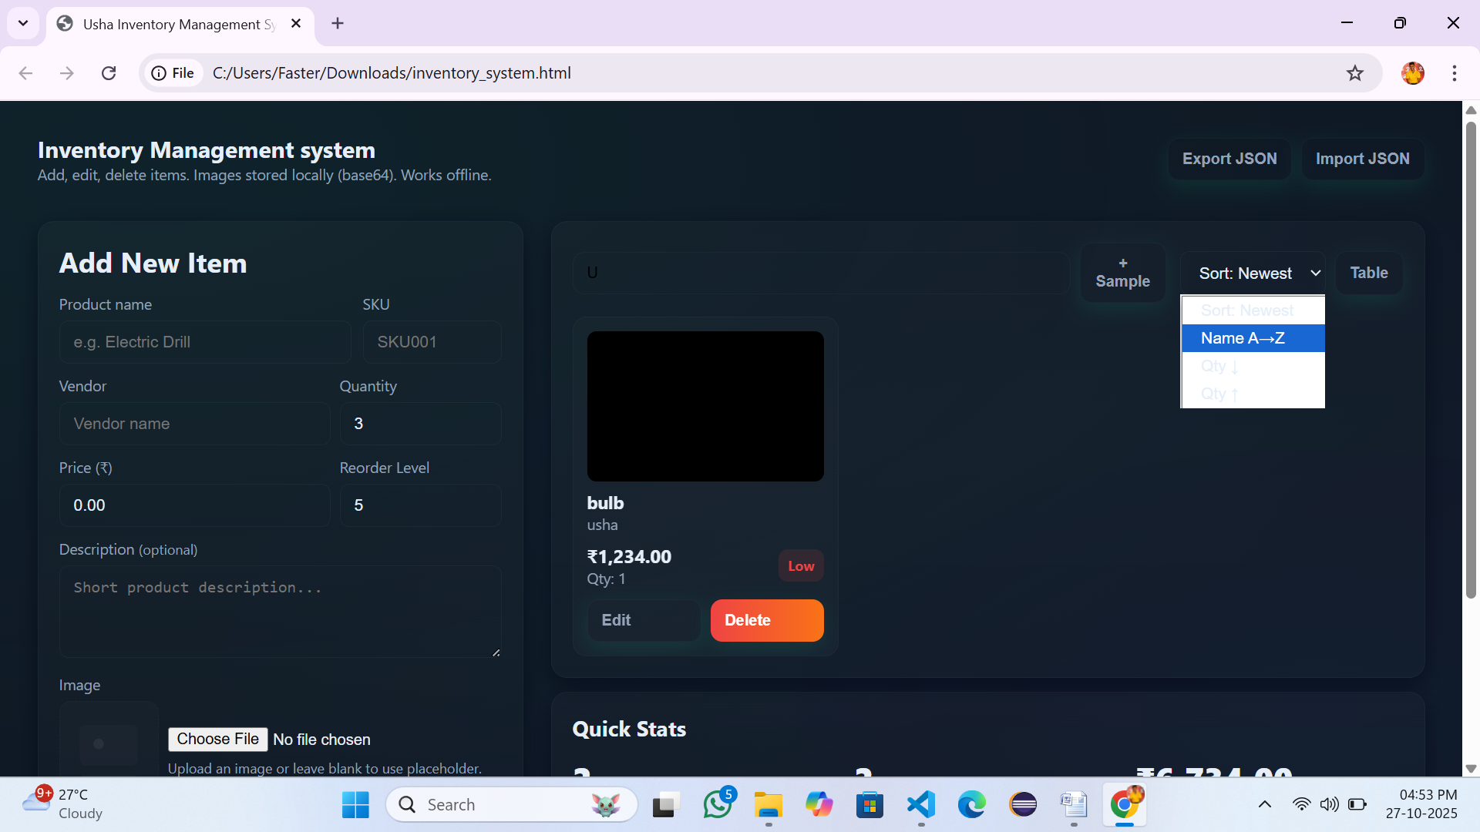

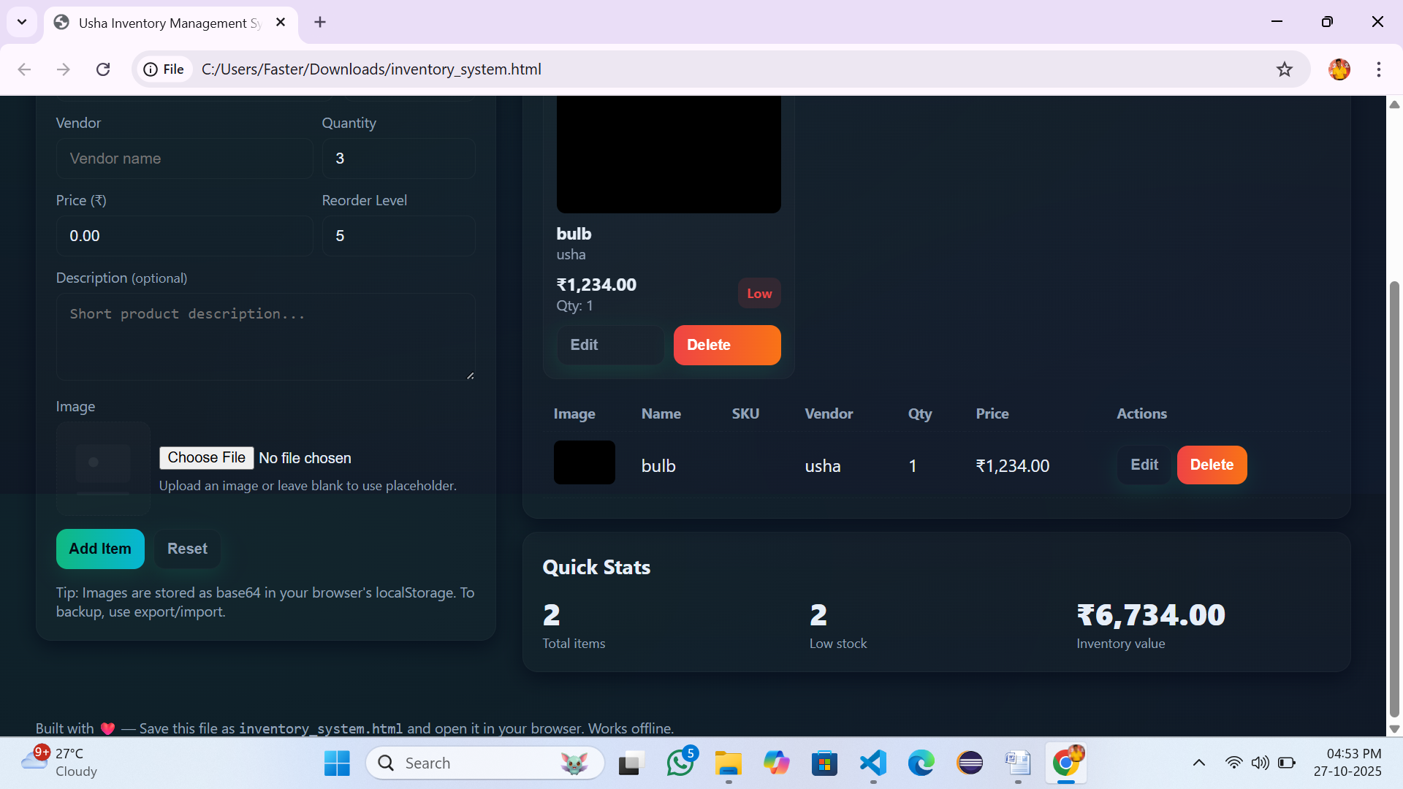

5.3 Completion Certificate
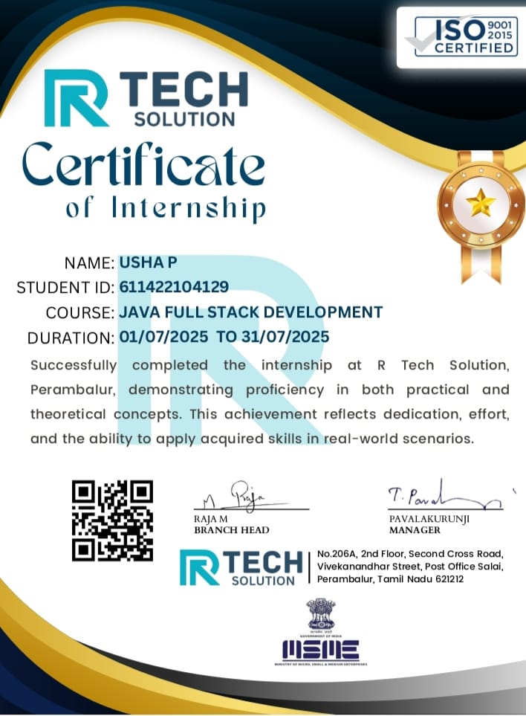

CHAPTER 6
CONCLUSION
The Inventory Management System project has been a valuable and practical learning experience that enhanced my understanding of desktop application development using Java and JavaFX technologies. This system provides an efficient, user-friendly, and reliable platform for managing and prioritizing tasks, reducing the need for manual task tracking and improving productivity. Through this project, I have successfully demonstrated the integration of front-end interfaces with backend logic and data management components to create a complete and functional desktop application.
This internship at R Tech has given me invaluable exposure to real-world software development practices, including version control, debugging, and team collaboration. I learned how to connect multiple technologies to build a robust system, handle exceptions effectively, and optimize performance. Working in the Java Full Stack domain has improved my understanding of enterprise-level frameworks, REST APIs, database integration, and deployment techniques.
Furthermore, the project strengthened my ability to analyze the user requirements, design efficient solutions, and translate theoretical knowledge into practical implementation. It also highlighted the importance of usability, interface design, and iterative testing in software development.
In conclusion, the Inventory Management System is not only a technical but also a reflection of my growth as a developer.

CHAPTER 7
REFERENCES

- JavaTPoint: “Java Tutorial.”
Available at: https://www.javatpoint.com/java-tutorial
- GeeksforGeeks: “JavaFX Tutorial.”
Available at: https://www.geeksforgeeks.org/javafx-tutorial/
- W3Schools: “HTML, CSS, and JavaScript Tutorials.”
Available at: https://www.w3schools.com.
- TutorialsPoint: “JavaFX, MVC, and Java Collections Tutorial.”
Available at: https://www.tutorialspoint.com/javafx/index.htm

