Module: 7PAM2016-0509-2025 — Advanced Research Topics in Data Science
MSc Data Science — University of Hertfordshire
German Electricity Demand Forecasting:
A Time Series Modelling Case Study
Student Name: Usha Chandaka
Student ID: 24075990
Tutor Name: Dr William Alston
Date: 10 July 2026

1. Introduction
Electricity demand forecasting predicts future consumption from historical demand and related covariates such as weather. Accurate forecasts underpin generation scheduling, reserve planning, and the balancing of increasingly weather-dependent renewable supply, so forecast error translates directly into operational cost or risk. Germany is used as the case study here because its demand series shows strong, learnable seasonal structure alongside a genuine, unpredictable shock — the COVID-19 lockdowns of 2020 — that falls inside the test window used throughout this report, giving a realistic test of how each modelling approach copes with a real structural break rather than only routine repetition.
This report uses hourly German electricity load from Open Power System Data (Jan 2015 – Oct 2020), aggregated to weekly resolution for the classical and machine-learning models and used at hourly resolution for the recurrent networks. Ten forecasting approaches are compared on an identical 104-week held-out test period: four naive benchmarks, SARIMA and SARIMAX (with Berlin temperature), Random Forest and Gradient Boosting, and a Stacked LSTM and Bidirectional LSTM. All models are scored on RMSE, MAE and MAPE against the actual demand subsequently observed in that period, and against a Seasonal Naive skill score, so that added model complexity can be judged against a genuinely competitive, cost-free alternative rather than in isolation.

2. Data Preparation and Exploratory Analysis
Hourly German load (DE_load_actual_entsoe_transparency, ENTSO-E via OPSD) had zero missing values across the 50,400-hour window, so no imputation was needed. Resampling to weekly means gave 301 observations (mean 55,484 MW, SD 3,763 MW). Weekly resolution was chosen for the classical/ML models so that annual seasonality could be represented with a manageable seasonal period (s = 52) rather than s = 8,760 hourly, which would make SARIMA estimation infeasible; the LSTMs instead use the raw hourly series (Section 6) since recurrent networks can learn the daily cycle without an explicit seasonal parameter.
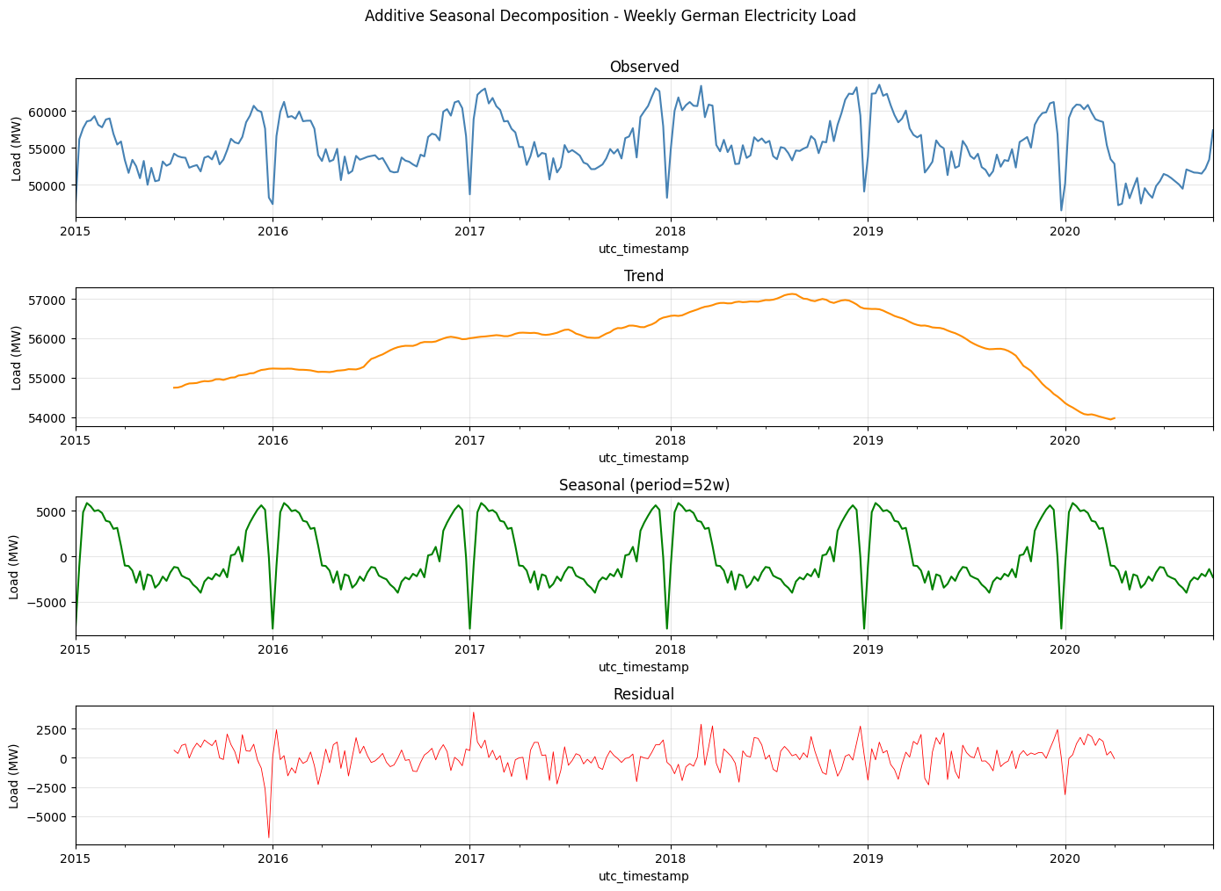
Figure 1. Additive seasonal decomposition of weekly demand: observed, trend, seasonal, residual.
The decomposition shows the annual seasonal component is by far the largest source of variation — demand peaks in December/January and troughs in July/August, repeatably across all six years (confirmed by narrow interquartile ranges in monthly boxplots, not shown). The trend declines only gradually. Critically, the residual shows one dominant spike in early 2020: the COVID-19 lockdown is an irregular shock sitting outside the normal seasonal envelope, which is precisely what no purely historical, autoregressive model can anticipate — a limitation that recurs throughout the model comparison in Section 7.
Stationarity was tested formally rather than assumed. On the raw weekly series, ADF rejected the unit-root null (stat = -4.05, p = 0.0012) and KPSS failed to reject stationarity (stat = 0.16, p ≈ 0.10): both agree the series is already stationary, so d = 0. Seasonally differencing at lag 52 did not improve this — KPSS then rejected stationarity (stat = 1.34, p = 0.01) — indicating the annual cycle is better captured by a seasonal AR term than by seasonal differencing, so D = 0 also. Figure 2 shows the corresponding ACF/PACF: a strong, isolated spike at lag 52 with fast short-lag decay, consistent with a low-order AR process plus a seasonal AR term rather than one requiring heavy differencing.
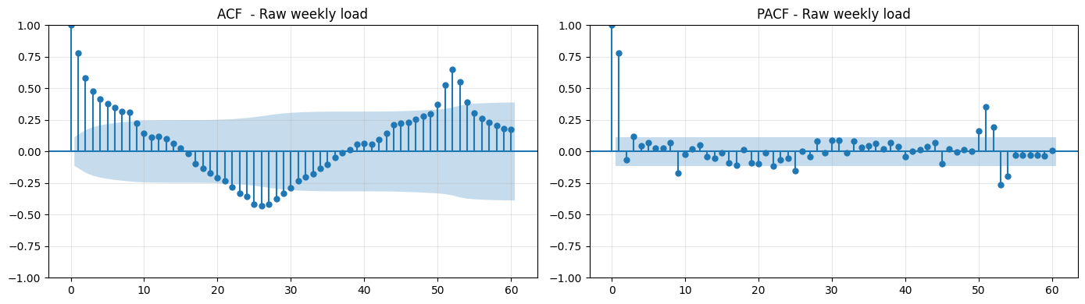
Figure 2. Autocorrelation and partial autocorrelation of the raw weekly demand series.

3. Benchmark Models
Mean, Naive, Seasonal Naive and Drift were fitted with no estimation, following standard practice of establishing a cost-free floor that any parameterised model must beat to justify its complexity (Hyndman and Athanasopoulos, 2021). All models are trained on the first 197 weeks (Jan 2015–Oct 2018) and tested on the following 104 weeks (Oct 2018–Oct 2020), a window deliberately chosen to include the COVID-19 shock.
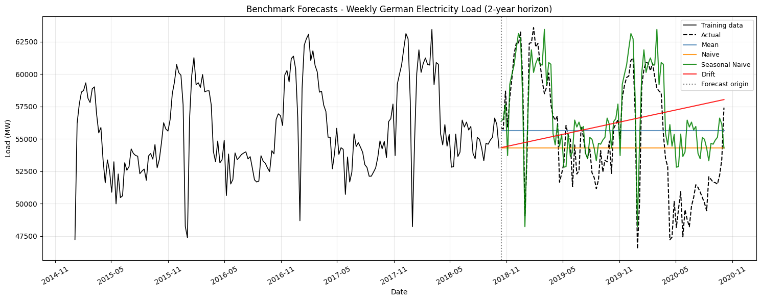
Figure 3. Benchmark forecasts against demand actually observed in the test period.
Seasonal Naive is the strongest benchmark (RMSE 3006.8 MW vs 4397–5118 MW for the others) — a direct consequence of the annual regularity established in Section 2: simply repeating last year’s value for the same week is highly competitive. Comparing the forecasts to the actual subsequent data in Figure 3, Seasonal Naive tracks the broad seasonal shape reasonably well but, having no mechanism to anticipate an unprecedented event, still misses the depth of the COVID-19 trough by a wide margin. Every model below is judged first against this benchmark, since only genuine added information — not just added complexity — should be expected to beat it.

4. SARIMA and SARIMAX
SARIMA(p,d,q)(P,D,Q)52 order was selected via stepwise AIC search (p,q = 0–6, d = 0–2) using pmdarima (Hyndman and Khandakar, 2008), which balances fit against parameter count rather than simply maximising fit. Consistent with Section 2.3, the search selected d = D = 0, giving SARIMA(3,0,1)(1,0,0)[52]. The dominant coefficient is the seasonal AR term (ar.S.L52 = 0.72), numerically confirming that last year’s value is the strongest single predictor — the same conclusion the EDA and feature-importance analysis (Section 5) reach independently.
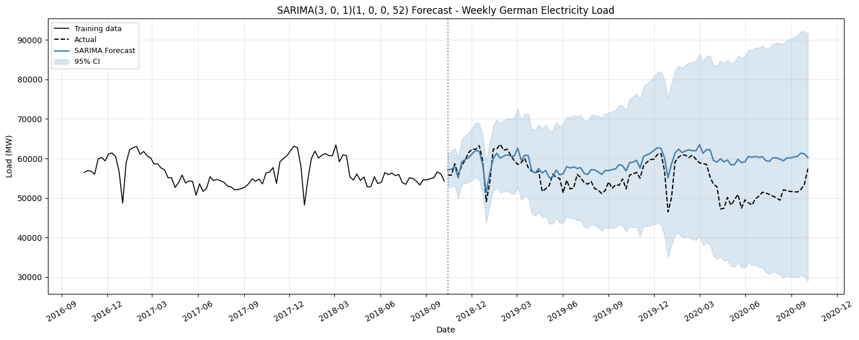
Figure 4. SARIMA forecast with 95% confidence intervals against actual demand.
Against the actual data collected in the test window, SARIMA tracks well through 2019 but its confidence interval and point forecast diverge sharply once the series enters the COVID-19 period, and it ends up performing worse (RMSE 5585.0 MW) than even the Mean benchmark. This is not a symptom of poor order selection — residual diagnostics (not shown) confirm the fit is well specified for a linear, purely historical model — but a structural limitation: SARIMA assumes future dynamics resemble past dynamics, and has no mechanism for a shock never seen in training.
SARIMAX adds Berlin weekly temperature to test whether an explanatory covariate can close this gap. An initial version using three collinear, unscaled temperature features with numerical constraints relaxed diverged badly out-of-sample (RMSE 34,626.9 MW) because of near-singular covariance from collinearity — an instructive failure showing that adding covariates carelessly can make a model worse than doing nothing. Correcting this by standardising features on the training window only and retaining just temp_lag1 and temp_sq (dropping the collinear temp_lag4) restored a stable fit.
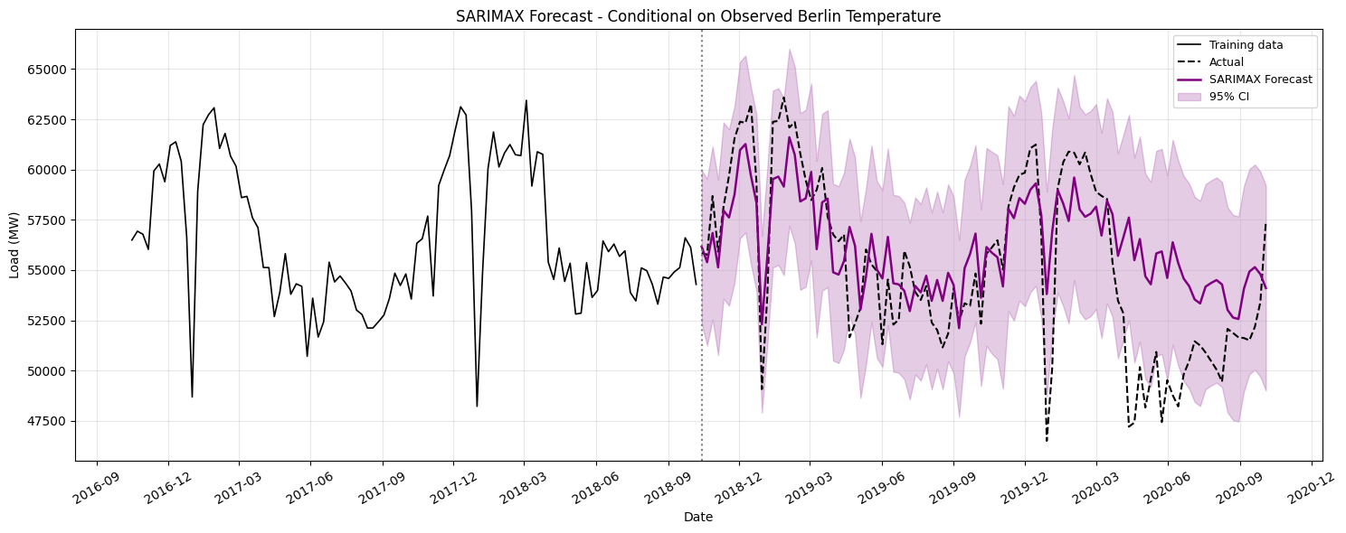
Figure 5. Corrected SARIMAX forecast (temperature covariates) against actual demand.
SARIMAX reduces RMSE to 3223.1 MW — a 42% improvement on SARIMA, confirming temperature carries genuine predictive information via heating/cooling load — but still falls short of Seasonal Naive, showing temperature alone cannot fully substitute for the richer feature set used by the tree-based models below. This is a conditional forecast (it uses observed, not forecast, future temperature) and one coefficient (temp_lag1) has an undefined standard error due to residual collinearity, so its individual significance should be read cautiously even though the forecast itself is stable.

5. Feature-Based Regression: Random Forest and Gradient Boosting
Tree-based ensembles were chosen because, unlike SARIMA/SARIMAX, they impose no fixed linear form and can learn interactions (e.g. temperature effects differing by season) automatically from a rich engineered feature set: calendar features (cyclically-encoded week-of-year, month, year), load lags (1, 2, 4, 8, 52 weeks), rolling means (4, 8, 52 weeks, shifted to avoid leakage), and temperature lags/squared temperature. Random Forest (500 trees; Breiman, 2001) averages many de-correlated trees to reduce variance; Gradient Boosting (300 stages, learning rate 0.05, depth 4; Friedman, 2001) instead fits trees sequentially to residual errors, trading a little more overfitting risk for potentially finer pattern capture.
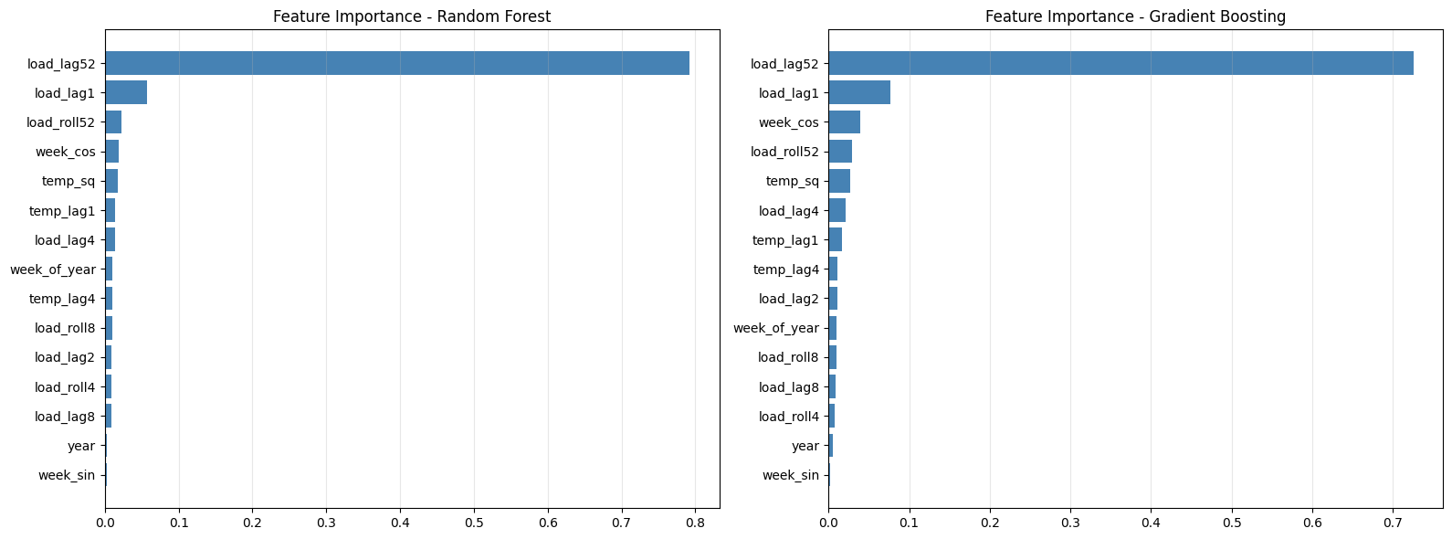
Figure 6. Random Forest and Gradient Boosting feature importance rankings.
Both models place load_lag52 far above every other feature (Figure 6), independently reproducing the same conclusion SARIMA’s seasonal-AR coefficient reached in Section 4: annual repetition is the dominant signal in this series regardless of model family. Cyclical week encodings and short load lags form a clear second tier, while temperature features rank comparatively low — directly explaining why SARIMAX (temperature alone) could not overtake Seasonal Naive, whereas these models, which also see recent load lags, can.
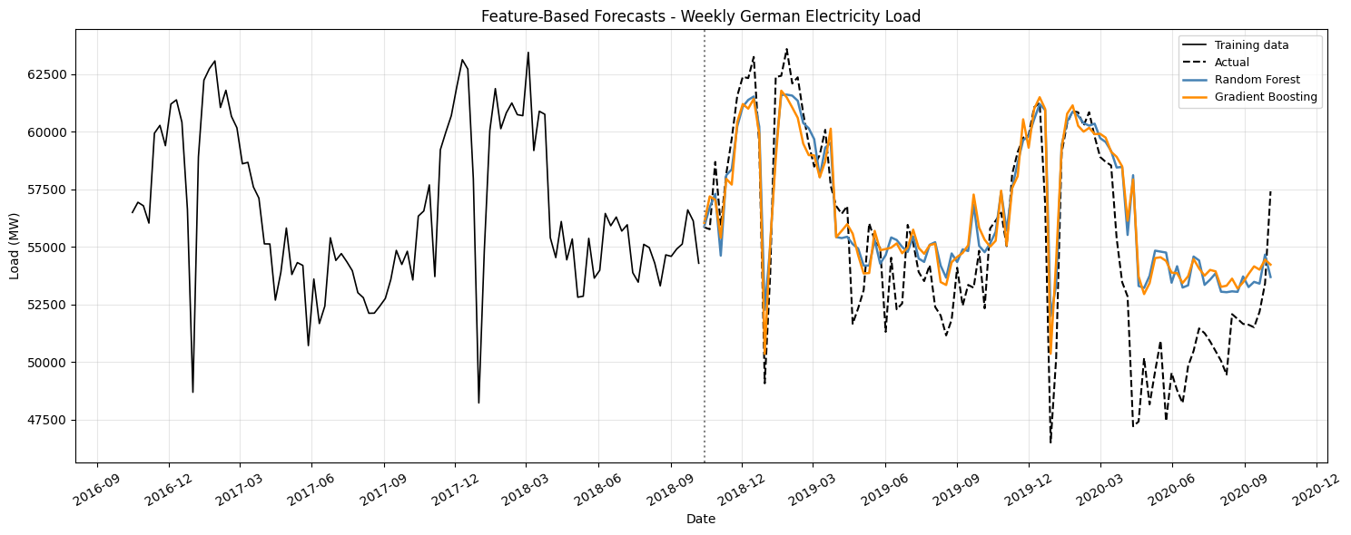
Figure 7. Random Forest and Gradient Boosting forecasts against actual demand.
Both models beat Seasonal Naive by about 11% (RF: RMSE 2663.0 MW; GB: RMSE 2680.5 MW), and Figure 7 shows both track the actual COVID-19 dip and recovery considerably more closely than SARIMA/SARIMAX (Figures 4-5), because the load-lag features let them anchor directly to the most recent actual observations rather than relying purely on a fixed seasonal pattern. Random Forest is marginally more accurate than Gradient Boosting; given the difference is small (0.7% RMSE), the choice between them is better made on operational grounds (Section 8) than accuracy alone.

6. LSTM Neural Networks
LSTM networks (Hochreiter and Schmidhuber, 1997) use gated memory cells to overcome the vanishing-gradient problem that limits standard RNNs on long sequences, making them well suited to demand data with structure at multiple scales (daily, weekly, annual) without hand-engineered features. Uniquely among the models here, both networks were trained directly on the hourly series using 24-hour input windows, scaled to [0,1] on the training portion only. A Stacked LSTM (64→32 units, dropout 0.2, Adam, MSE loss, batch 256, early stopping) and a Bidirectional LSTM (32→16 units per direction) were trained; the stacked model ran the full 20 epochs with validation loss falling smoothly from 0.025 to 0.0006, while the BiLSTM stopped early at epoch 5.
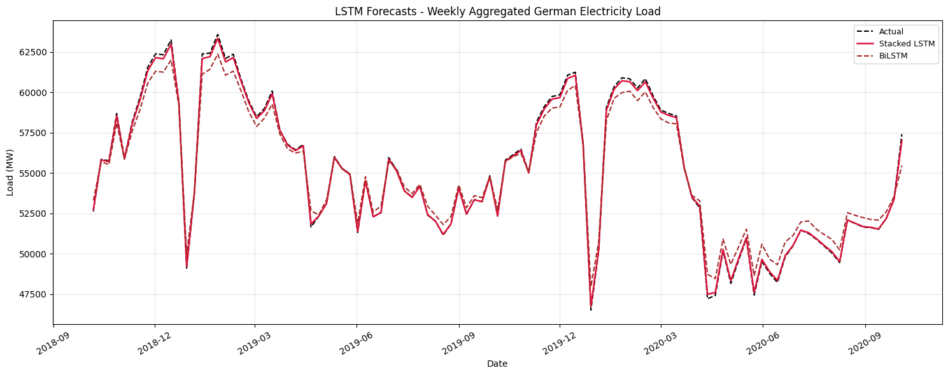
Figure 8. Weekly-aggregated LSTM and BiLSTM forecasts against actual demand.
Aggregated to weekly means for comparison, the Stacked LSTM achieves the lowest error of any model (RMSE 128.7 MW) and the BiLSTM is second (RMSE 704.3 MW), both tracking the actual test-period data, including the COVID-19 dip, far more tightly than any other model (Figure 8). Part of this advantage is a genuine result of the network learning fine-grained hourly structure, but part is a measurement artefact: aggregating hourly predictions to weekly means smooths out random hourly error, deflating the resulting weekly RMSE relative to models that forecast directly at weekly resolution, so this comparison is informative but not perfectly like-for-like. The BiLSTM is also not operationally realistic as configured, since it uses both past and future context within each window, which is unavailable at real forecast time; it is included here as a representational-capacity benchmark rather than a deployable design. Both networks carry materially higher computational cost and much lower interpretability than every other model in this report.

7. Model Comparison and Critical Discussion
Model | RMSE (MW) | MAE (MW) | MAPE (%) | Skill vs Seas. Naive
Stacked LSTM | 128.7 | 100.3 | 0.18 | +0.96
Bidirectional LSTM | 704.3 | 592.3 | 1.08 | +0.77
Random Forest | 2663.0 | 1963.0 | 3.77 | +0.11
Gradient Boosting | 2680.5 | 2028.3 | 3.87 | +0.11
Seasonal Naive | 3006.8 | 2318.5 | 4.41 | 0.00
SARIMAX + Temperature | 3223.1 | 2476.4 | 4.69 | -0.07
Mean | 4397.3 | 3788.8 | 6.97 | -0.46
Naive | 4459.1 | 3783.2 | 6.79 | -0.48
Drift | 5118.0 | 4339.9 | 8.05 | -0.70
SARIMA | 5585.0 | 4373.2 | 8.40 | -0.86
Table 1. Forecast accuracy of all ten models on the 104-week test period, ranked by RMSE.
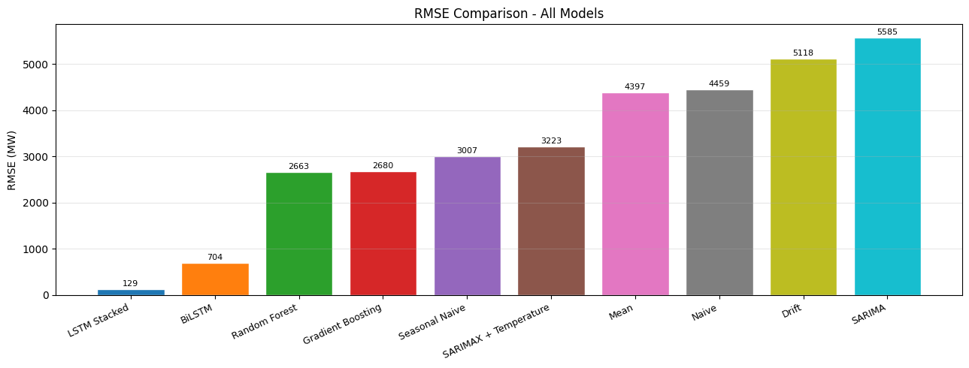
Figure 9. RMSE comparison across all ten forecasting models.
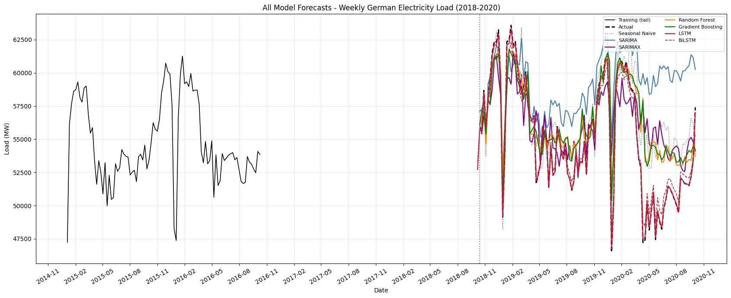
Figure 10. All model forecasts plotted together against the actual demand observed in the test period.
Table 1 and Figure 10 divide the ten models into three tiers. The two neural networks lead by a wide margin, though as discussed in Section 6 this is partly inflated by weekly aggregation of hourly forecasts. Random Forest, Gradient Boosting and Seasonal Naive form a tight middle cluster around 2,600–3,000 MW RMSE. Every remaining statistical/naive model, including both SARIMA and SARIMAX, falls below the parameter-free Seasonal Naive benchmark. This is not a failure of estimation; it reflects a genuine property of this dataset: German demand is dominated by such a strong, repeatable annual cycle that a model must capture meaningfully more than seasonality alone — via rich lag/calendar features or direct sequence learning from raw hourly data — to add real value over simply repeating last year’s value.
Comparing every forecast directly to the actual data subsequently observed (Figures 3-5, 7-8) shows a consistent pattern: models relying only on a fixed historical structure (SARIMA, SARIMAX, the naive benchmarks) diverge most sharply from the real data precisely during the COVID-19 trough, since none had any mechanism to anticipate an event outside their training history, while models with direct access to recent actual observations through lag features (Random Forest, Gradient Boosting) or through sequence learning (the LSTMs) track the real, unprecedented drop and recovery far more closely. This is the central empirical finding of the report: for this series, recency of information matters more than model sophistication per se — a simple model with the right recent inputs outperforms a sophisticated model without them.
Weighing accuracy against interpretability, computational cost and maintenance together, Random Forest is judged the best candidate for operational deployment: it beats Seasonal Naive by 11% without requiring hourly data, GPU infrastructure, or the aggregation step that partly explains the LSTM’s lower reported error, its feature importances are transparent and physically sensible, and it retrains in minutes on standard hardware. The Stacked LSTM remains attractive where the lower error is genuinely needed and the operational overhead of maintaining a deep-learning pipeline is acceptable.

8. Future Improvements
Public and school holiday indicators were not included despite being known in advance and plausibly affecting demand; adding them is a natural low-cost extension. A single fixed train/test split was used throughout; a rolling-origin evaluation, retraining periodically as new data arrives, would give a more realistic picture of sustained operational accuracy (Hewamalage, Bergmeir and Bandara, 2021). None of the tree-based or neural models here produce calibrated prediction intervals; conformal prediction or quantile regression could add this alongside SARIMA/SARIMAX’s existing parametric intervals. Renewable generation and broader economic indicators could be added as further covariates, and hybrid approaches combining a statistical seasonal component with a learned residual correction, or transformer-based sequence models, represent a promising direction for capturing both the interpretability of the classical approach and the accuracy of the learned approaches evaluated here (Makridakis, Spiliotis and Assimakopoulos, 2018).

References
Box, G.E.P., Jenkins, G.M., Reinsel, G.C. and Ljung, G.M. (2015) Time Series Analysis: Forecasting and Control. 5th edn. Hoboken: Wiley.
Breiman, L. (2001) ‘Random Forests’, Machine Learning, 45(1), pp. 5–32.
Friedman, J.H. (2001) ‘Greedy Function Approximation: A Gradient Boosting Machine’, Annals of Statistics, 29(5), pp. 1189–1232.
Hewamalage, H., Bergmeir, C. and Bandara, K. (2021) ‘Recurrent Neural Networks for Time Series Forecasting’, International Journal of Forecasting, 37(1), pp. 388–427.
Hochreiter, S. and Schmidhuber, J. (1997) ‘Long Short-Term Memory’, Neural Computation, 9(8), pp. 1735–1780.
Hyndman, R.J. and Athanasopoulos, G. (2021) Forecasting: Principles and Practice. 3rd edn. Melbourne: OTexts.
Hyndman, R.J. and Khandakar, Y. (2008) ‘Automatic Time Series Forecasting: The forecast Package for R’, Journal of Statistical Software, 27(3), pp. 1–22.
Makridakis, S., Spiliotis, E. and Assimakopoulos, V. (2018) ‘Statistical and Machine Learning Forecasting Methods’, PLOS ONE, 13(3), e0194889.
Open-Meteo (2024) Historical Weather API. Available at: https://open-meteo.com/ (Accessed: 9 July 2026).
Open Power System Data (2020) Data Package: Time series. Version 2020-10-06. Available at: https://data.open-power-system-data.org/time_series/ (Accessed: 9 July 2026).

