# Introduction

## Introduction of the project

The online job portal system, all are known it’s like a big career management board system. This system helps to job seekers (candidate) to find the suitability and best job their qualification. And also Employer’s (company) find their good employer and best team partner. This system manage and provide a large amount range of jobs and seekers in different platforms.

Job Portal Management System have a different applications and services to solve or reduce various type job related problem. Main purpose of this system is an information sharing through internet.

Now a days Job Portal Management System is a most popular and efficient way from job searching into the internet? Job portals is a one of the jobs related trending sites. It helps where you post jobs and find and get candidate resumes. It helps to find the best candidate for the jobs. Job seekers can apply for their suitable jobs. During this recession where Fresher’s, Experienced everyone’s are search for job. The “Job Portal Management System” can helps to upload their CV and apply suitable jobs on of their qualifications.

This system helps to verity of companies (like private, government, non-government, etc.) are join and post their jobs and manage their own accounts. Other job advertise medium (papers or walk interviews or social media) are unable to reach their fulfill expectations of candidate and job providers. This system can be maximum satisfied their expectations and reduce their value of time consuming.

I'm choosing my final project to develop a job portal management system (JPMS). It’s created like a web application model .its help to Job-Providers (company) and Job-Seekers (Candidates) and job-banks. This system help to directly interact with each other’s.

Company (Job Provider) unable to add own profile but their create account contact with admin (Project owner). After account created they can directly access their own profile and provide job details and contact details and check applied documents (CV).

Every user has access via their user ID and may submit applications for several positions at once Job seeker can create and manage own account and apply jobs and upload CV and search jobs.

Admin also Manage job-seeker and Company (Job Provider) and Job Application and Job Applied details and their own details. Admin can create the company account after they access their own account.

## Problem of the statement

Here situation’s, all places are accept for new technology’s and that systems are successfully handles their errors and going to make effective and efficient systems. In this situation lots of people are growing their hard skills of technological side.so that job seekers are facing lots of challenges for finding suitability jobs. Numbers of jobless are still facing this jobless issued in the developing countries.

In the current system, job seekers must look for vacancies in print and visual media. Candidates must submit their applications for jobs through traditional procedures and show up for interviews on a specific date at a specific location. Employers must post job openings, organize candidate information, carry out selection processes, and finish the formalities. This course of action is time-consuming and expensive. There is a demand for an online employment board where job seekers can see openings and employers can find qualified applications.

Traditional methods are slow and longtime process and lots of challenges for get job information. Today this site have many different platforms of job are here .and easily apply for job and providers are filter and find best candidates for that jobs. But portal system also have some issue faced by job-Seeker and Job Provides.

Other sites operate unsatisfactory without reliable information between job seekers and employers. Employers are waiting for long time for suitable candidate for that oppounity.as well as job seeker are waiting for their qualification suitability job.

Everyone can see lots of Varity category of many vacancies are available the one page in the job portals. Some vacancies posts are not still posting so job seekers ae always struggle for find the opportunity. Current situation Sri Lanka couldn't be do old methods for search candidates and they using job portals like (tobjobs.lk.) this type of job portals will reduce unwanted application process and find suitability candidates.

1. Job Seeker:-

* Fake company: - Some sites can job provider create own account without verification. So they add job post and theft candidate information. They give a fake structure of their industries on the job portal.
* Duplication of jobs: - Sometimes job seekers could not reach the employers who originally posted the job. They give same details of another job. Many jobs are still fake. It’s way help to theft candidate information.
* You don't receive interviews: - There are times when it feels that no matter how many CVs you send out or jobs you apply for, you will never get that elusive interview.
* Incorrect job portals or target audience
* Fake Post Jobs in Social Apps: - Some fake Job Provider creation and post jobs in websites and Social Apps. Some jobseekers apply in wrongs post so they theft their details. Because portal may be not take responsible for job seeker share information.
* Spend lot of money and time.

1. Job Providers

They want to check each of applications and their profiles and qualifications in job portals. Because company want a good co-worker.

* Seeker can give a fake Qualification on the job-portals.
* Some time they cannot be update their profiles.
* Get too many applications in job.
* Effect their staff economic

## Solution

The proposed system is a web-based application that allows the employer and the candidates to register their details. The primary goal of this project is to fix some of the issues with the old system. It serves as a complete portal for both companies and job seekers. It is a unique career portal created exclusively to help job searchers. Candidate can browse job without registration Employer need to register own profile through admin after posting their vacancy.

* Admin can manage job provides and customer details.
* Admin can only Register Job Provides. After Job Provides can manage their own Profile.
* Company (Job Provider) can manage their profiles and job posting and show applied candidates.
* Job Providers have to post their vacancy after registering own profile through admin.
* Job seekers can manage their own profile
* Job seekers can search and apply jobs their own needs
* Job seekers can show their applied applications
* Easily Filter, Search facility for job seekers according to their required vacancy.
* Communication between employers and job applicants.

## Aim

The fundamental goal of a job portal is to give job seekers the ability to find a job quickly. As a result, it makes it easy for job seekers to look for openings and for employers to identify qualified candidates.

The main aim of the project designing job Portal Management system id give the job seekers platform for finding a suitable and a satisfactory job according to their qualification. This system is developed for job seekers and to facilitate the job-advertiser (members of the organization) to interact with relevant members.

## Objective

* Its help to improve their business efficient and effectively.
* Job seekers can register own account and apply for many vacancy through this web sites.
* Members of the group receive job advertisements and information from the organization.
* So that job searchers always receive the most recent information, admin and employers can keep job listings constantly updated.
* Post Resume: - its help to Company (Job Provider) easily analyze your qualification and contact details and its help to they decide you are suitable or not for this job.
* Share company Details:-Its helps for ask any other information’s directly them.
* Additionally, it links job searchers with significant agencies.
* Company (Job Provider) can decide for their salary scale based on their Qualifications.

## Scope

Portal provides a role based access for administrator, Job-Providers, Job-Seekers. Below I mentioned common scope of my project. Module section I will explain each modules.

* Maintain Job Seeker and Employer records.
* Maintain uploaded Resumes.
* Provide Customized Job Postings.
* Maintain Job Posting details.

# Literature Review

In this situation lots of people are growing their hard skills of technological side.so that job seekers are facing lots of challenges for finding suitability jobs. During this recession many of people are searching jobs their suitable for different ways. That ways include the “Job Portal Management Systems”. During this recession where Fresher’s, Experienced everyone’s are search for job. The “Job Portal Management System” can helps to upload their CV and apply suitable jobs on of their qualifications.

The fundamental goal of a job portal is to give job seekers the ability to find a job quickly. As a result, it makes it easy for job seekers to look for openings and for employers to identify qualified candidates. Below some expel for job Portal system:-

1. ‘ikman’.lk

‘ikman’ JOBS is the perfect place to go if you are an employer, a hiring company, or a job seeker. The largest job board in Sri Lanka, ‘ikman’, has over 6593 listings. A sizable pool of prospects will respond to your posting of your company's recruiting needs. Job seekers can sign up to ‘ikman’ JOBS and begin browsing the various categories provided there to find the ideal position.

1. TopJobs.lk

With the help of top jobs, firms may post job openings online and manage online applications from job seekers. To make hiring quick, simple, and effective, top jobs completes and automates the entire hiring process. It also provides an electronic "back-office."

# Study of this system

## What is the System

## Why is it important

## Purpose of the project

## GUI

## Module

## Job seeker

For job seekers, this module offers functionalities. Candidates may publish resumes that include both personal and professional information. Additionally, they can update the résumé as often as necessary. The candidate has the option of looking through the current openings. When their resumes are chosen by employers, job seekers can also receive messages in this regard.

## Company (Job Provider)

Employer-related functionalities are provided by this module. Employers can publish job opening information and update it as needed. The resumes of applicants are viewable by employers.

## Administration:

Functionalities relating to administrators are provided by this module. The administrator oversees the entire application and keeps up with the profiles of job seekers, employers, and their own profile.

## Limitation

## Design Overview

## Advantage

# System Analysis and Design

## System Analysis

It is an important section of the SDLC (Software Development Life Cycle). This section include collecting requirement and understanding of functionality of developed this system.

## Existing system

The existing system for hiring people for jobs uses time-consuming and stressful traditional approaches including employment agencies, newspaper, radio, and television advertising, college fairs, etc.

As the internet has developed, job searchers increasingly rely on online job boards, which facilitates job searching. Again, the majority of them are only available as web or desktop applications, which is not convenient for job hunters since it necessitates a laptop or desktop that is online.

Existing System Company can register without admin permission. Some sites doesn’t provide job details of company. Some company does not mention end date. Wrong email address.

## Disadvantage

* Time consume
* Waste of money
* Not trusted
* Damage some brands name
* Resume send traditional methods
* Each application resume must add
* Provide fake company structure

## Requirement gathering

Requirement is one of task in SDLC. It’s consumed for amount time period for collection and ordering data for the development. It’s also consider seekers requirements and job provider’s requirement. This step do very carefully otherwise this system goes to failure. Any doubt in the requirement’s need to be clear and analyze more details for project develop successfully.

## Fact finding technique

1. Research other sites

Search the internet job portal websites and study that websites for understanding their process and user roles.

1. Monitoring

This way include newspapers and advertisement its help to develop skill for seekers.

## Requirements analysis

## Analysis ongoing system

## Purposed system

### Explanation

### Assumptions of this system

### Requirement for new system

### Project environment

#### Language

1. Front end

* PHP
* HTM
* CSS
* JavaScript
* Bootstrap

1. Backend

* MYSQL

#### Development Tools

1. Visual Studio Code

Visual Studio Code is a most popular IDE for development. It’s also Free and open source editor for multiple Programming language .this editor is available and work in different OS. This IDE allows to features:-

* Syntax high light
* Bracket matches
* Use extensions and support tools developing in PHP.
* Maintain your code nice and easy to follow.
* Easily check code validation:-Problems are highlighted in the code editor and listed in the "Problems" box.

1. XAMP SERVER

XAMPP server is a one of the cross-platform web server it’s free and open-source software. Its include Apache, MySQL, PHP, Perl. This is allows to write and test their codes on local host their own computer.

#### Functional requirements

1. Admin
   1. Can be create company account
   2. Manage company details
   3. Create job post
   4. Manage seeker details
2. Job – Providers (company)
   1. Login own Profile
   2. Create job post
   3. Create and manage category & job types
   4. Search own jobs
   5. Category wise jobs Search
   6. Company wise jobs search
   7. View already applied jobs.
3. Job – Seekers
   1. Create their own profile
   2. Login own Profile
   3. Search jobs
   4. Category wise jobs Search
   5. Company wise jobs search
   6. Search company details
   7. Apply for jobs
   8. Job seekers can view jobs they have already applied.

#### Nonfunctional requirements

* Secure user identification and password access to private information.
* Because nobody will be able to view a user's profile without knowing his private password if they log out of a session, this application is safe for all types of users.
* Better component design for improved peak performance.
* This database is strong, dependable, and quick. As a result, users will only have to wait a little while for the outcome.

#### Software and Hardware Requirements

##### Software

Software plays an important role in any project development. One should understand which software to use to develop the project. Windows 10 is used as an operating system. The application is developed using:

* Database: MySQL
* IDE : VISUAL STUDIO Code
* Server : XAMPP Server

##### Hardware

* Microsoft Windows 10
* Processor: 2.6 GHz Intel Pentium IV or equivalent
* Memory: 2 GB
* Disk space: 1 GB of free disk space

## System Design

### Design overview

## Data Model

## Introduction

## Diagrams

## Symbol

## Diagrams type and pc

#### Use case diagrams

#### DFDs

#### Class diagram

#### Sequence diagram

#### Activity diagram

#### ERD

## Database Design

I used MySQL Database to develop this web-application system. My Database name is ‘job_portal’.this database is easy and faster to manage data. This database run on XAMPP SERVER.The database can export and import data in two different formats (csv, sql).

I used 9 table for store below Details.

* “tbl_admin”- store Administration details.
* “tbl_aboutus” – Store add and displays front-end news.
* “contact_us” – Store users contact form details Contact us.
* “tbl_company” - Store Company Details.
* “tbl_seeker” - Store Job-Seeker Details
* “tbl_job” - Store Job Details
* “tbl_job_cat” - Store Job Category Details
* “tbl_job_type” - Store Job Type Details
* “tbl_job_application” - Store Application Details

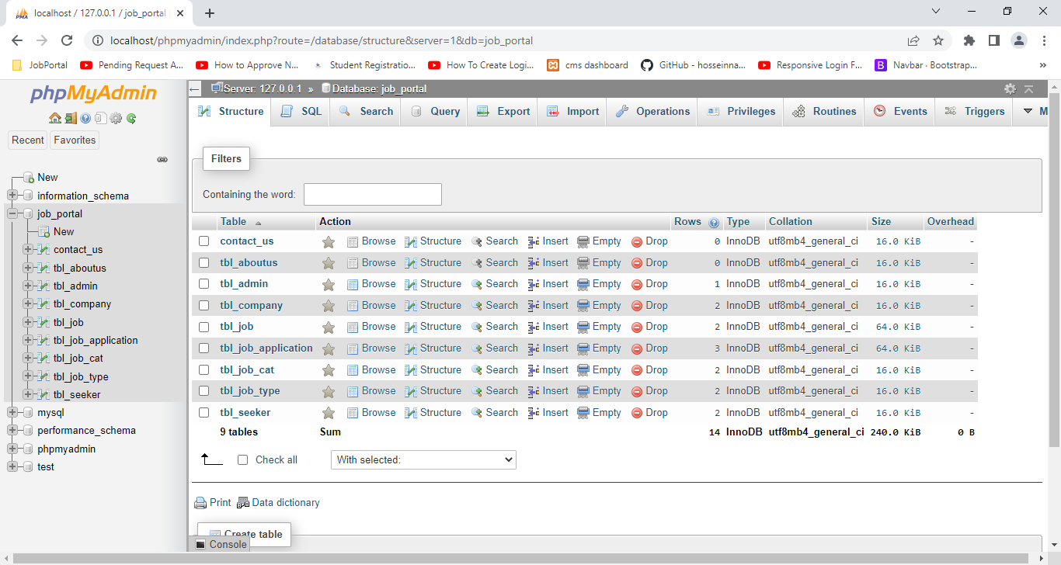

#### Table

1. Structure of Admin Table

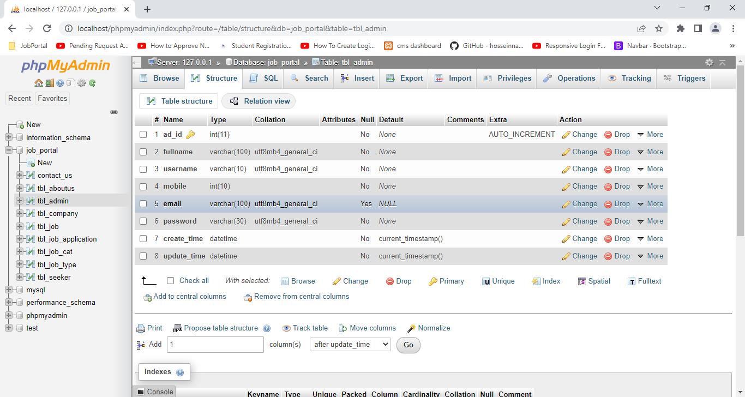

1. Structure of About Us Table

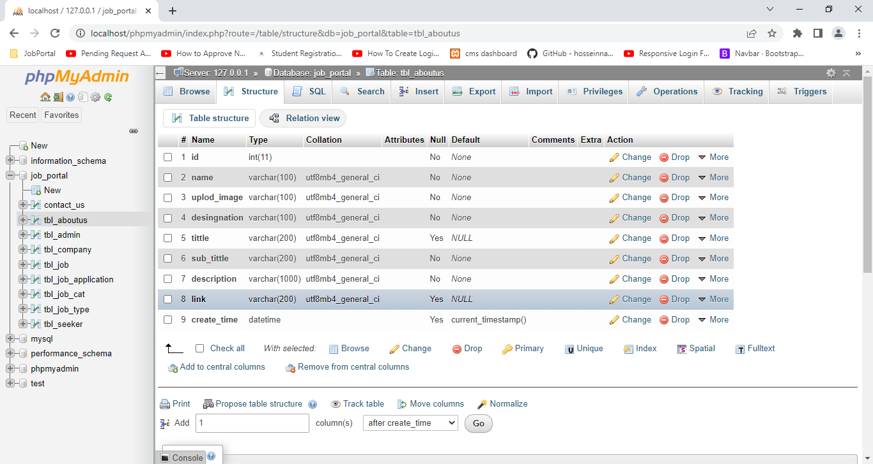

1. Structure of Contact Us Table

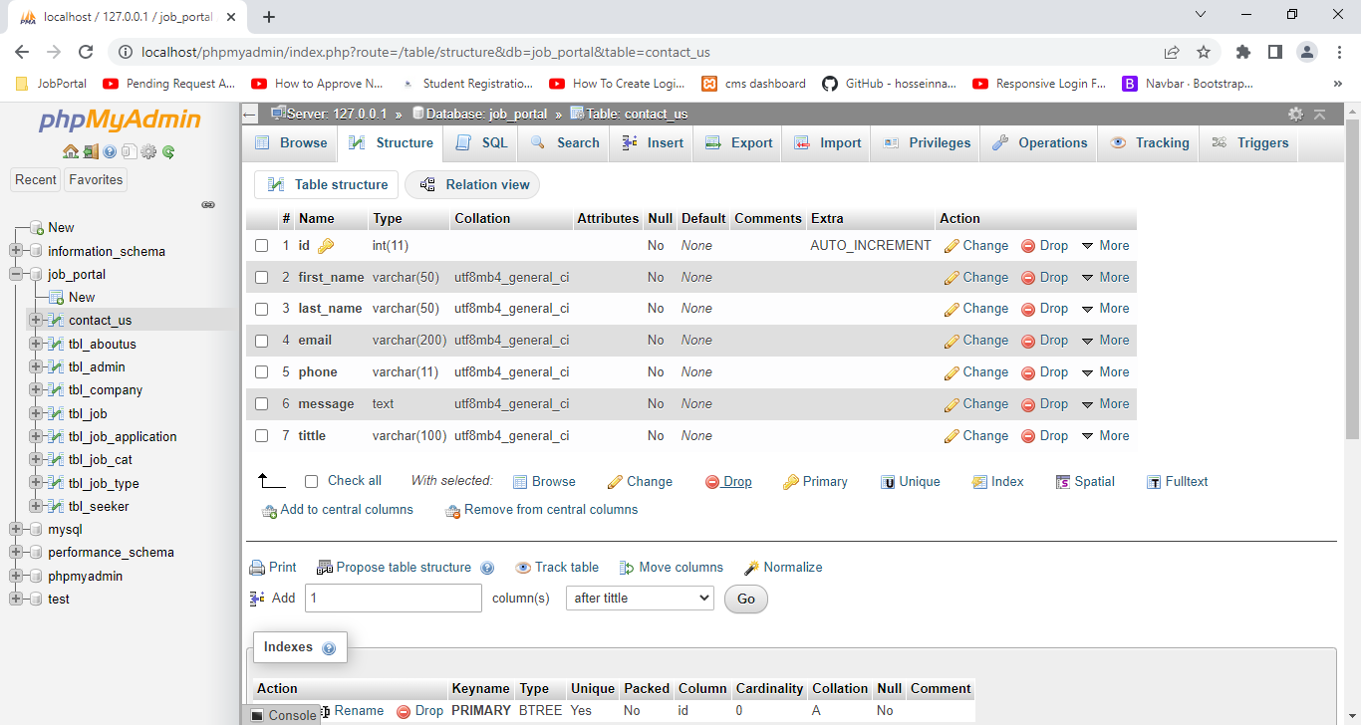

1. Structure of Company (job-Providers) Table

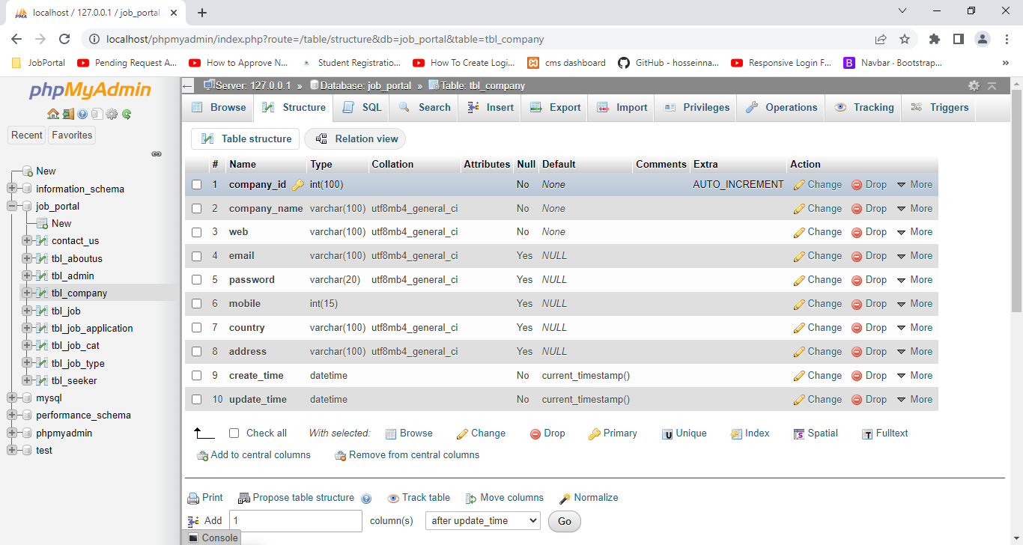

1. Structure Job-Seeker of Table

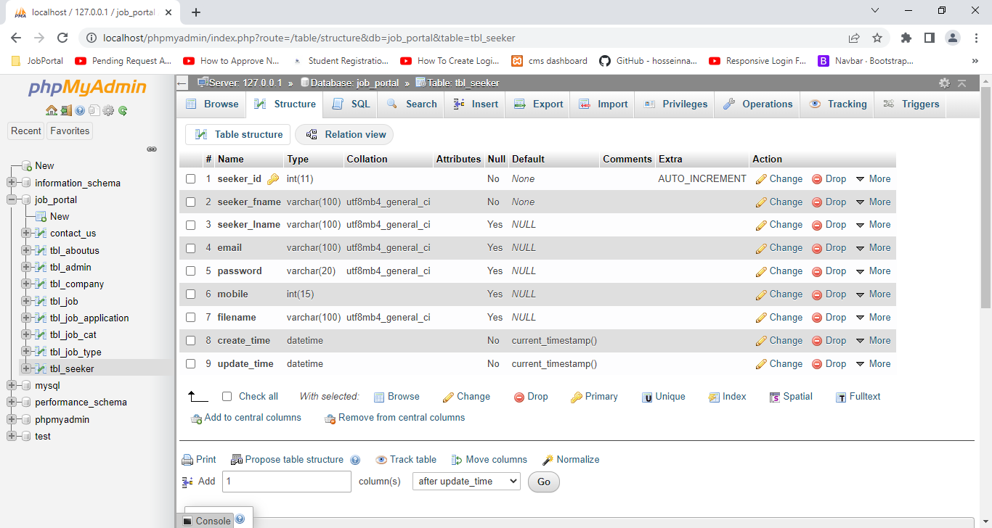

1. Structure of Job Type Table

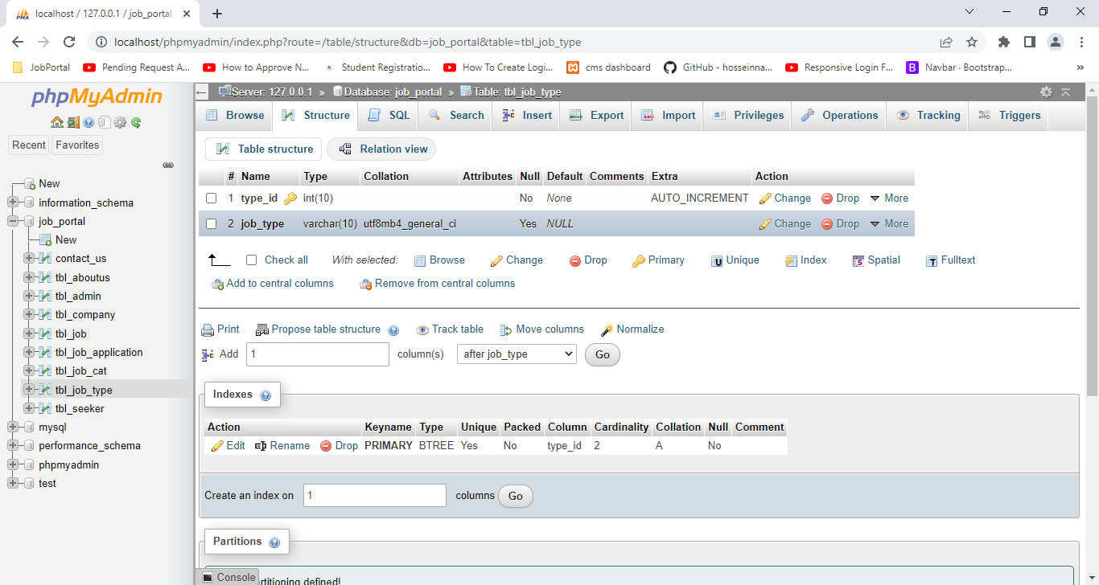

1. Structure of Job Category Table

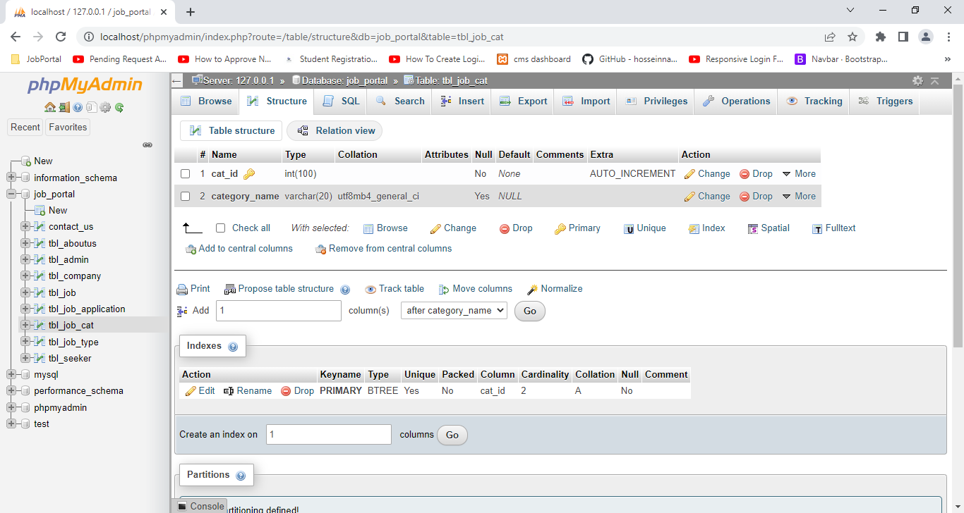

1. Structure of Job Table

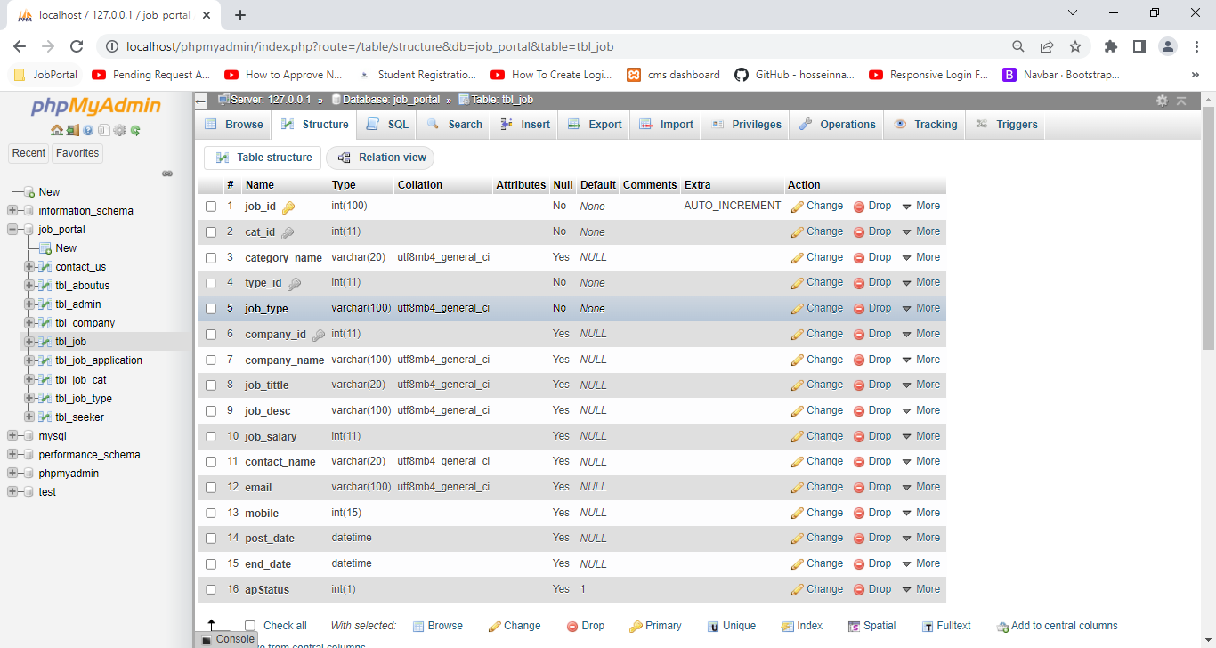

1. Structure of Application Table

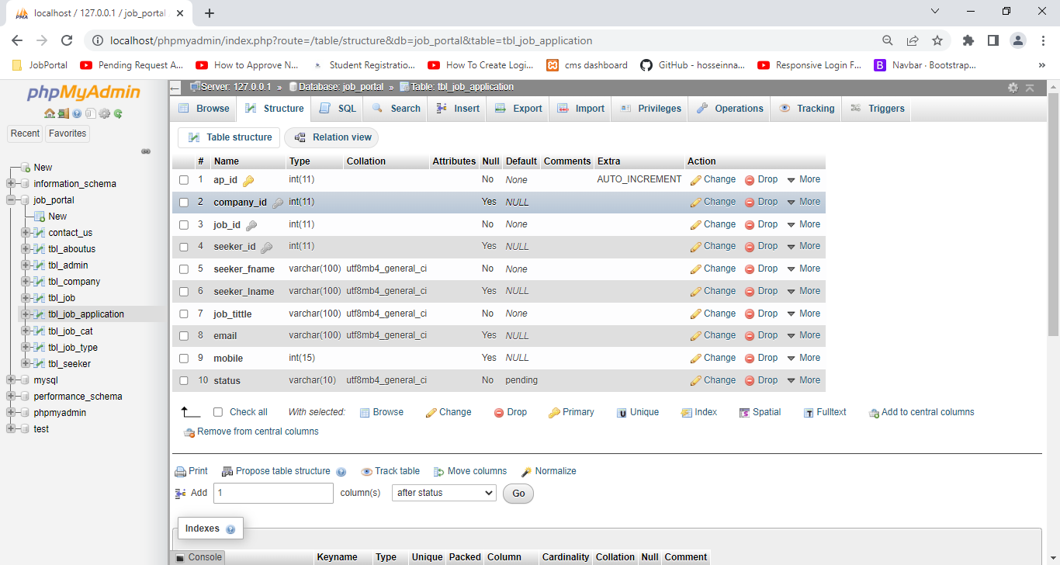

#### Relationship

1. Job with Company , job Category ,Job Type

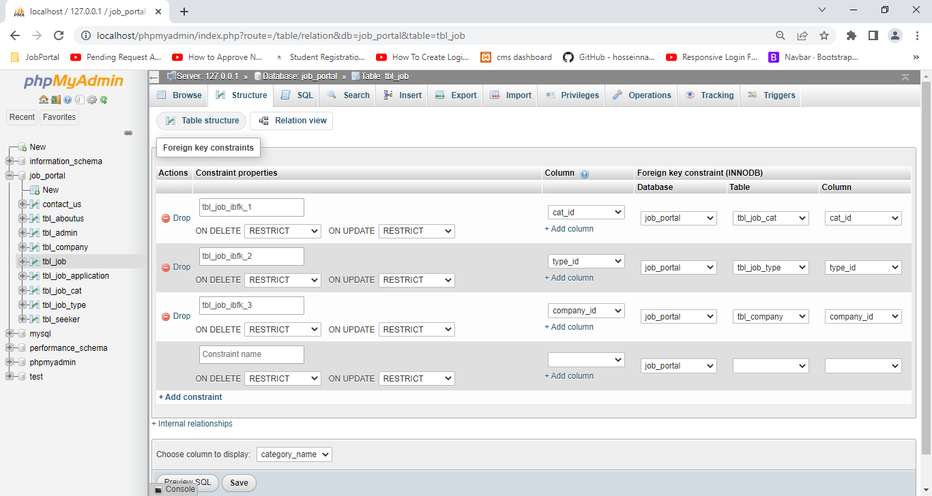

* “tbl_job” table join with three tables.
* “tbl_job” table “company_id” = “tbl_company” table “company_id” filed
* “tbl_job” table “cat_id” = “tbl_job_cat” table “cat_id” filed
* “tbl_job” table “type_id” =”tbl_ job_type” table “type_id” filed

1. Job Application with Company , job and seeker

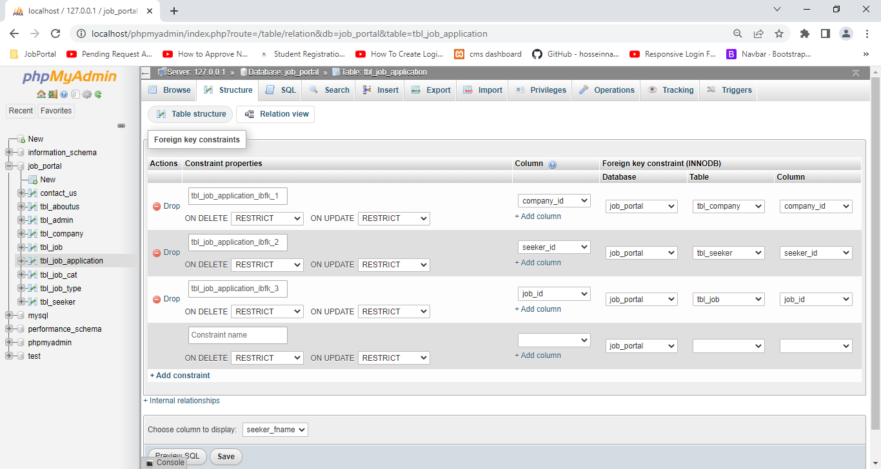

* “tbl_job_application” table join with three tables.
* “tbl_job_application” table “company_id” = tbl_company table “company_id” filed
* “tbl_job_application” table “job_id” = “tbl_job” table “job_id” filed
* “tbl_job_application” table “seeker_id” =tbl_seeker” table “seeker_id” filed

## User Interface

#### Front End

#### Admin

#### Company

#### Seeker

1. Register

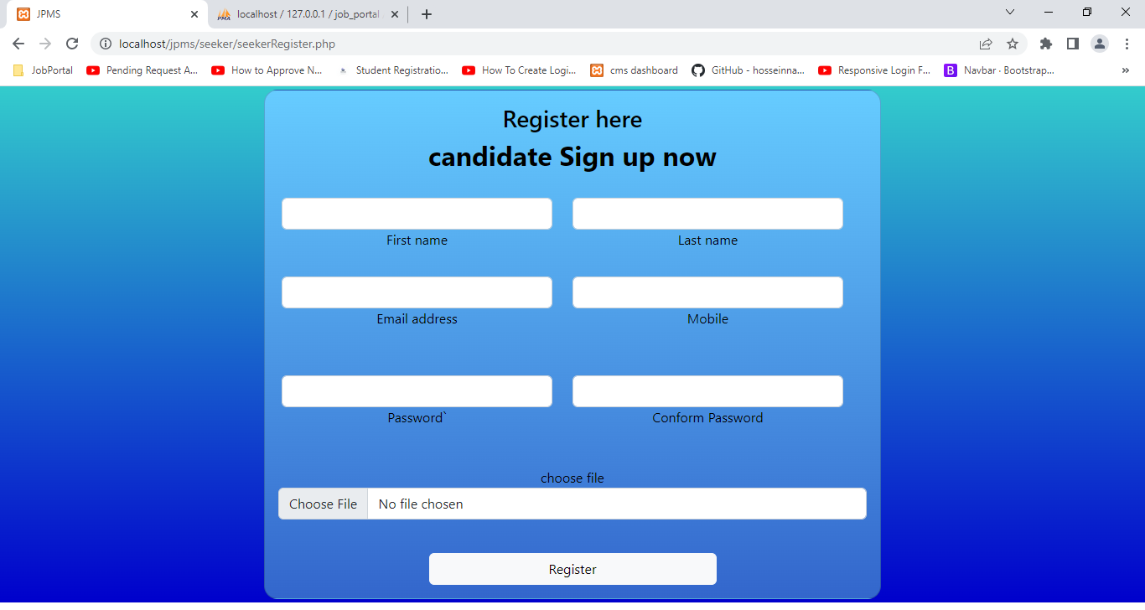

1. Login

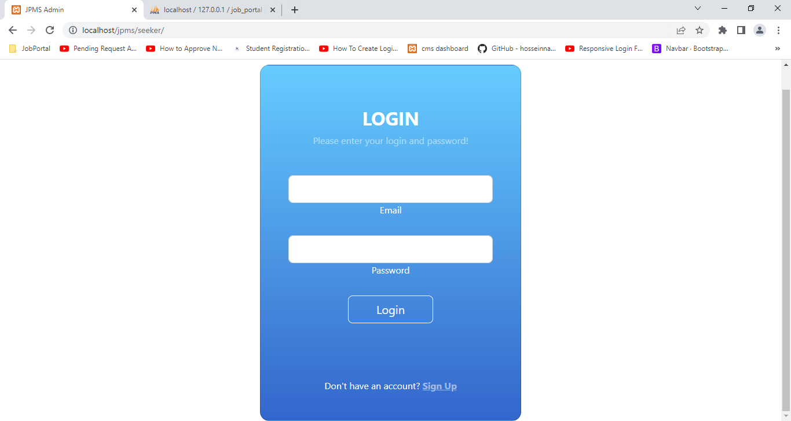

1. Dashboard

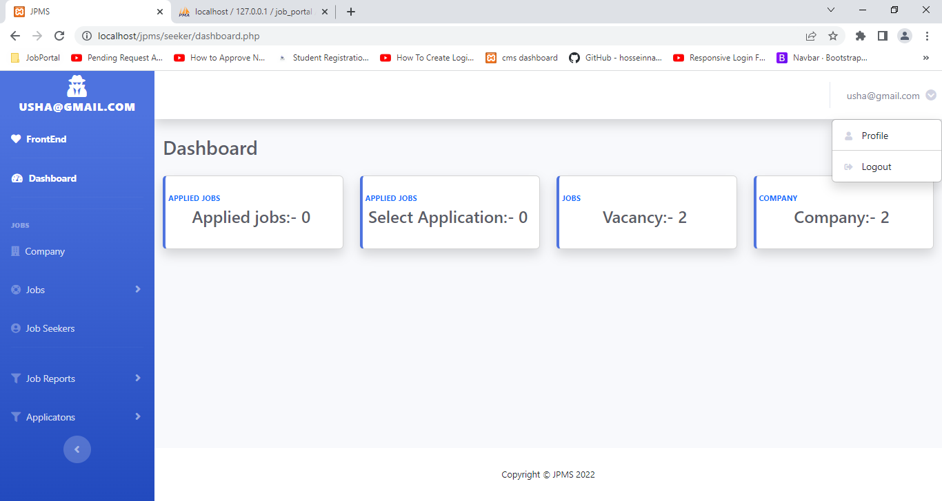

1. Profile

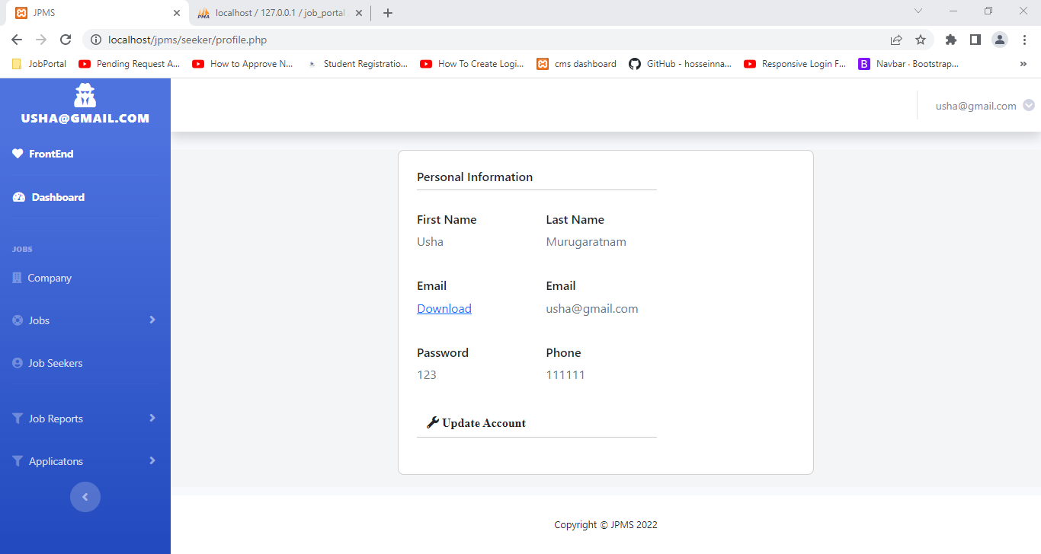

1. Profile update

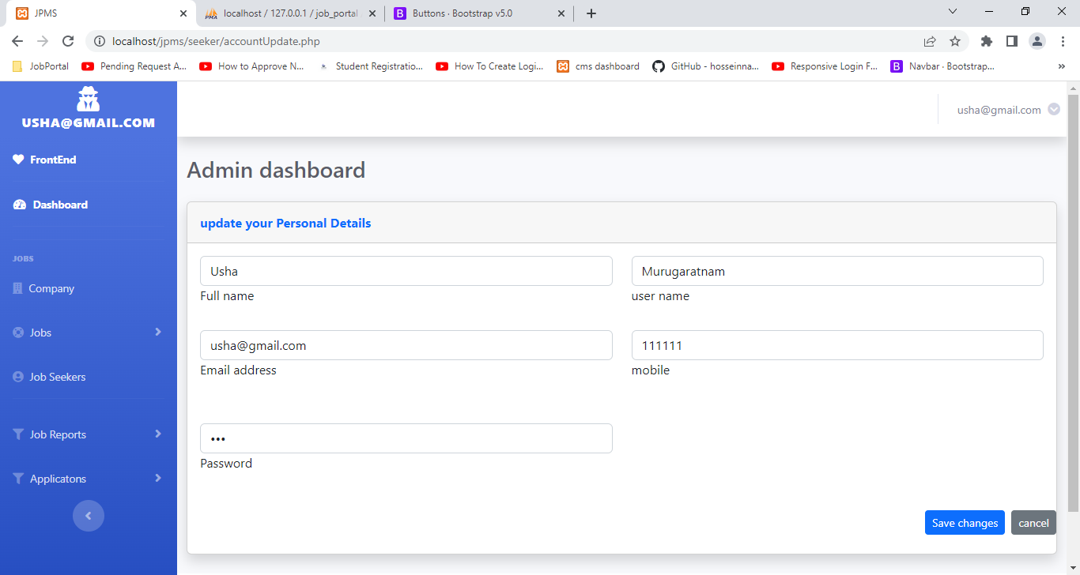

1. Jobs
2. Apply jobs

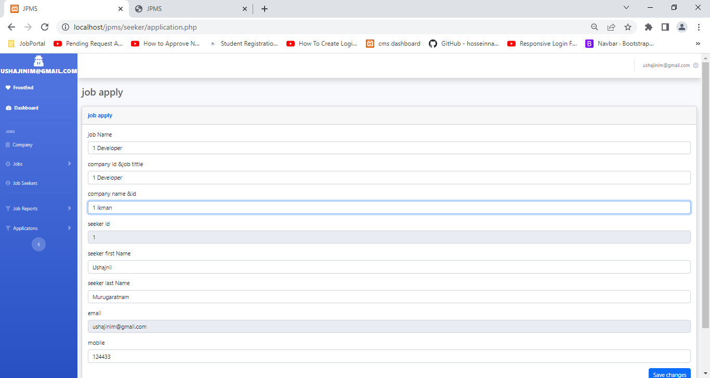

1. Job Application

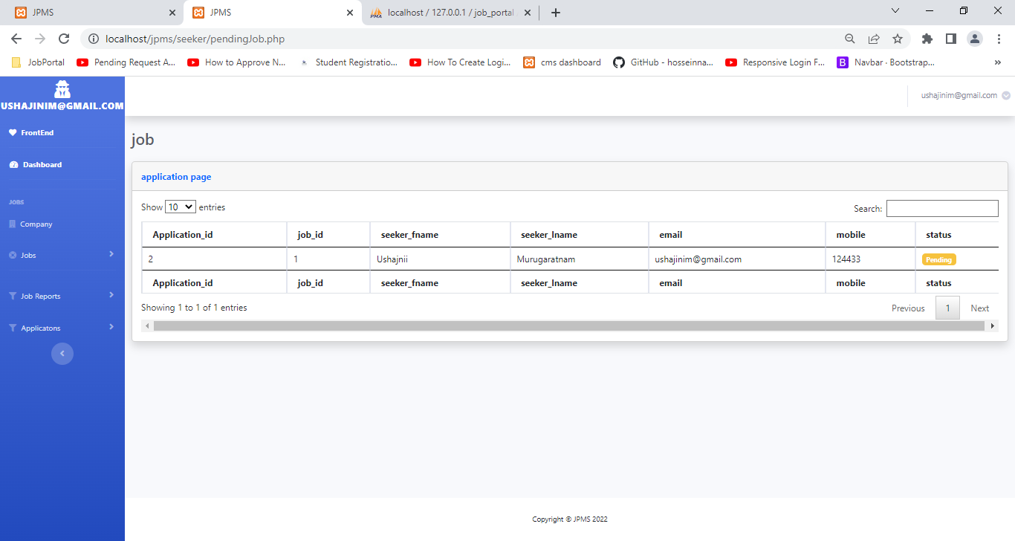

1. Company

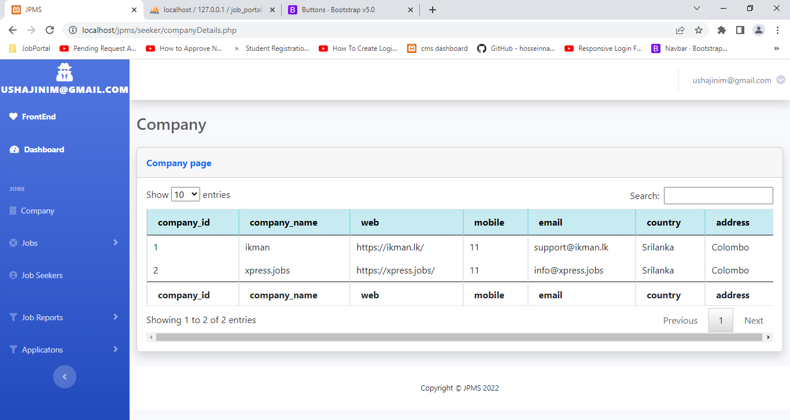

Report

Job

Pending application

Reject application

Select application

## Feasibility study

# Domain Investigation

## Decision theory

## Decision tree

# Implementations

## Introduction

## Implementation Overview

## Software and Hardware Requirements for implementation

## Core system components and their implementation

## Deployment instructions

## System Installation Guide

# Analysis and Design

## Analysis Model (Use model)

## System work flow

## System overview

## Home page

## Login alert

# Technology and tools

# Software and hardware Configuration

# Schedule Planning

## WBS

## Cost plan Milestone

## Gant chart

## Work distribution

## Deliverable

# Evaluation and Testing

## Testing Overview

## Test case

## System strength

## Weakness

# Risk Management

# Project Summary

## Solution Evaluation

## System limitation

## Benefit

* It is a web based application.
* Very simple and user friendly interface
* Most of the sections are validated
* Get regular job updates
* Manage many job-Seekers profiles
* Cost and Time efficient
* Company Brands promotion
* Easy job searches
* Resourceful
* Job seeker can manage their CV and applied job details and able to see many jobs
* Limitations
* Database manual backups
* Day by day increase the jobs and job-seekers so database size also increased no limits. So system may be struggling working time. So do manual backup the database
* Company can’t register directly
* Avoid fake company register

## Learning

## Future improvement

# Conclusion

# References

# Annex

## System Documentation

Title: - Online Job Portal Management System

Web Based Application

This document includes how to this system implemented information and other technical information’s for developers. Other can understand how to successfully configure and run this system.

## Software and hardware requirements

Installation related information’s are here

#### Hardware Requirements

* Processor Intel -CPU @ 2.20GHz
* RAM –RAM 6.00 GB

#### Software Requirements

* Operation System- windows 10
* Server :- XAMPP Server
* Web server – Apache 2.4.53
* PHP-7.4 or later
* Database- MySQL
* Web Brower- Chrome (rec), Opera and Edge
* Text Editor: - VSCODE

## Configuration

Installation related information’s are here

* Install XAMPP SERVER
* I will show some important steps only
* Select windows OS and download XAMPP SERVER
* Install XAMPP .exe file
* Check this category are already selected
* Select file path (default in C folder)
* After installation show this window
* Run Apache and MySQL Module
* Install VSCODE

## User Documentation

1. Admin:-
   1. Admin Login page
   2. Profile
      1. Profile update
      2. Profile Delete
   3. Contact us
   4. About us
      1. Add about us
      2. Edit about us
      3. Delete about us
   5. Company
      1. Company Register
      2. Job Type
         1. Add job Type
         2. Edit job Type
         3. Delete Job Type
      3. Job Category
         1. Add job Category
         2. Edit job Category
         3. Delete Job Category
      4. Job
         1. Add job
         2. Edit job
         3. Delete Job
         4. Show all company applied jobs
   6. Job-Seeker
      1. Add job-SEEKER
      2. view
      3. Download CV
2. Company
   1. Company Login page
   2. Profile
      1. Profile update
   3. Job Type
      1. Add job Type
      2. Edit job Type
      3. Delete Job Type
   4. Job Category
      1. Add job Category
      2. Edit job Category
      3. Delete Job Category
   5. Job
      1. Add job
      2. Edit job
      3. Delete Job
   6. Job-Seeker
      1. view
      2. Download CV
      3. Only company jobs -Show applied jobs
3. Seeker
   1. Job-Seeker Register with CV
   2. Job-Seeker Login page
   3. Profile
      1. Profile update
   4. Show jobs Details
   5. Apply jobs
   6. Show company Details
   7. Show all company applied jobs