**Assignment for GMAT Scores:**

**Code:**

#To read csv files

Gmatscores <- read.csv(file = 'C:/Users/sony/Desktop/data.csv')

attach(Gmatscores)

#1st Assignment (Work Years):

#Histogram:

h=hist(work_yrs,xlab = "Work years",col = "yellow",border = "blue",xlim = c(0,25), ylim = c(0,250), breaks = 5)

#To plot mid points

clsmark=seq(2.5,22.5,length.out = 5)

#Frequency Polygon:

lines(clsmark,h$counts)

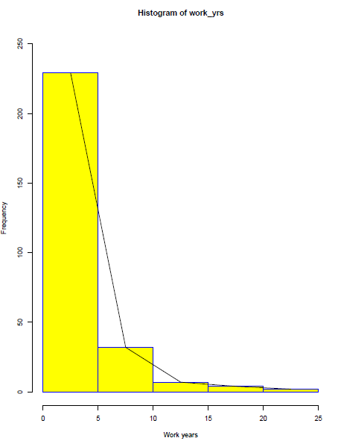

#Ogive:

# To find out how many classes

breaksss=seq(1,25,by=5)

#To find out the value comes under which class. Right=FALSE represents it is open at right.

work_yrs.cut=cut(work_yrs,breaksss,right=FALSE)

#To aggregate the values and generate a Frequency distribution table:

work_yrs.table=table(work_yrs.cut)

# Generate a Cumulative Frequency distribution table:

work_yrs.cumfreq=cumsum(work_yrs.table)

#To include 0 in it

work_yrs.cumfreq0=c(0,work_yrs.cumfreq)

# To trace the points

plot(breaksss, work_yrs.cumfreq0, main="Ogive", xlab='work years', ylab='cumulative frequency')

#To draw the lines

lines(breaksss,work_yrs.cumfreq0)

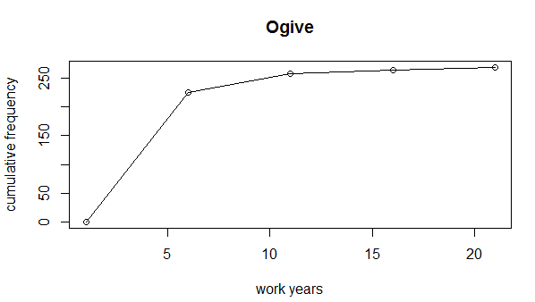

**#2nd Assignment (Gmat_TPC)**

mean_tpc=mean(gmat_tpc)

median_tpc=median(gmat_tpc)

Mode <- function(x) {

uni <- unique(x)

uni[which.max(tabulate(match(x, uni)))]

}

mode_tpc=Mode(gmat_tpc)

variance_tpc=var(gmat_tpc)

sd_tpc=sqrt(var(gmat_tpc))

q25=quantile(gmat_tpc,.25)

q75=quantile(gmat_tpc,.75)

IQR_tpc=IQR(gmat_tpc)

sprintf("Mean Value of TPC : %s",mean_tpc)

sprintf("Median of TPC : %s",median_tpc)

sprintf("Mode of TPC : %s",mode_tpc)

sprintf("First Quantile of TPC : %s",q25)

sprintf("Third Quantile of TPC : %s",q75)

sprintf("IQR of TPC : %s",IQR_tpc)

sprintf("Std deviation of TPC : %s",sd_tpc)

sprintf("Variance of TPC : %s",variance_tpc)

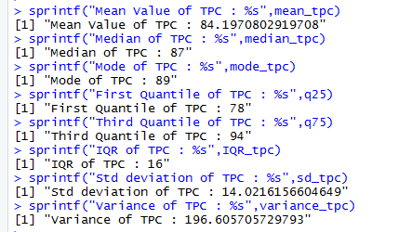

**Insights:**

The data for TPC represents Mean<Median<Mode. The distribution is left Skewed.

The data of Work years represent that GMAT test is taken mostly by 0-5 years’ experience guys.