ok so hijo maile jaha samma chodeko thye tyo tei samma xa hai,

so your job is to make estai khal ko div haru 5 6 wota ani harek div ma images or videos haru halne

doesnt matter about the looks haina just add them

add chahi k garne bhane a div similar to this div with the id="wishing-page", aba to summarize i have added a bootstrap ko cdn as well haina,

esle chahi k garxa bhane bootstrap ko layout haru use garna milne banaunxa bhanum na



Esma maile je add gareko xu ni this is the link for bootstrap ko min ko css file

You can click the link if you want to hai to see

Ani similarly eskai js nix a which is



Ok ani maile hamro photoAlbum bhanera css ra js respectively bhanako xu tyo ni kasari gare tala xa hai





Ok now maile since bootstrap ko classes haru haleko xu I can use some bootstrap class, aaile lai just understand ki row bhanne class halyo bhane tesle euta row nai linxa ani tesma aru kura auna didaina, ani col bhanne classes haru xa, aaile lai col-12, col-6 use garira xu ni , basically bootstrap le k bhanxa bahne, the screen has a total column ko 12 boxes ani col-1, col-2 use garnu bhaneko tyo div lai kati wota boxes dinu ho hai , so lets say if I am using col-6 it wll take half the space of the full space, ani so on hai ta. Ani lastly I have used a container class haina,  this esko kaam chahi k ho bhanera malai ni thaha xaina, it just makes a little padding ( padding ra margin are kinda similar, taile garis ki nai hai aaile samma, but padding bhaneko inside the div ko space dinu ra margin bhaneko outside hai ta to summarize). Ani there are some other classes I have used which are , d-flex, justify-content-center, align-items-center so ini haru chahi k ho bhane the later duita chahi depends on the d-flex class jasto lagyo , aba d-flex bhaneko k ho bhane it makes the div flex, malai jaha samma thaha xa, div haru tin tarika ko hunxa, block , grid ani flex ani the reason I used flex is to use justify-content-center bhanne class ra align-items-center bhanne class, esko kaam bhaneko make the items on the center, ani I don’t think tyo justify wala class pani chahinxa, but anyways haldeko ho, ani there’s a inline style I have used which is height:100vh, which means height 100 view height ko hunu parxa, now tero task :

1. 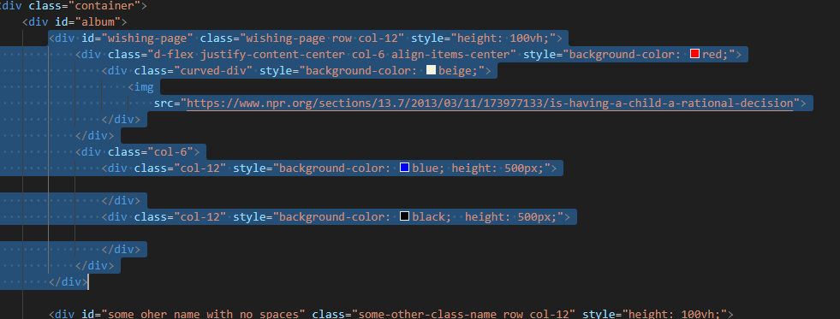
2. Jun to highlighted portion xa, tesko duplicate banaundai jane, play around with col classes, flex classes, bujhena bhane google or ask me, ani try to make multiple div ani within each div try to add your contents hai ta, doesn’t matter how it looks aile tara try it hai ta.