OPTIMIZING LECTURE HALL UTILIZATION WITH MACHINE LEARNING DRIVEN SCHEDULING AND MULTI AI AGENTS

A dissertation

presented to the Faculty of Computing

NSBM Green University

in partial fulfillment of the requirements for the degree of

Bsc (Hons) in Software Engineering

by

Ushani Priyamanthi

March, 2025

© 2025 by Ushani Priyamanthi

Table of Contents

List of Tables v

List of Figures vi

CHAPTER 1: INTRODUCTION 1

1.1. Chapter Overview 1

1.2. Problem Background 1

1.2.1. Creating the Platform for Discussion/Argument 2

1.3. Problem Statement 2

1.3.1. General Problem 3

1.3.2. Specific Problem 3

1.4. Research Question 4

1.5. Research Motivation 5

1.7. Research Objectives 5

1.8. Rich Picture of the Proposed Solution 6

1.9. Resource Requirements 7

1.9.1. Hardware 7

1.9.2. Software 7

1.10. Project Scope 9

1.11. Chapter Summary 9

REFERENCES 10

APPENDICES 14

Appendix A: Questionnaire/interview guide sample 14

Appendix B: output tables 18

Appendix C: Meeting Record Forms 23

# List of Tables

Table 1: Project Scope 9

# List of Figures

Figure 1:system architecture 6

Figure 2:conceptual model 6

Figure 3:question 01,02 14

Figure 4:question 03,04 14

Figure 5:question 05,06 15

Figure 6:question 07 15

Figure 7:question 08,09,10,11 16

Figure 8:question 12 17

Figure 9:answers for question 01,02,03 18

Figure 10:answers for question 04,05,06 19

Figure 11:answers for question 08,09 20

Figure 12:answers for question 09,10,11 21

Figure 13:answers for question 12 22

Figure 14:meeting record 01 23

Figure 15:meeting record 02 24

Figure 16:meeting record 03 25

# CHAPTER 1: INTRODUCTION

## Chapter Overview

This chapter gives a basic outline of research of machine learning-based scheduling of diffuse lecture halls. It explains the background and motivation of the research problem, giving context regarding the difficulties educational institutions face in effectively assigning lecture halls. In conclusion, the chapter presents the problem statement by outlining the shortcomings of current methods of scheduling and stressing the necessity of an automated, data-driven approach.[1]

Research questions and objectives are established to articulate the findings from the study, exploring the potential of machine learning techniques in improving the scheduling process. The study's motivation describes how this research will be a steppingstone toward proper resource management in academic institutions. The proposed project has defined scope, indicating what will be included.[2]

## Problem Background

Scheduling lecture halls is complicated work that takes into consideration student needs, faculty availability, and institutional resources.[3] Conventional manual scheduling approaches frequently fall short of adapting to these dynamic and interconnected elements, resulting in inefficiencies like over-booked rooms, underused areas, and scheduling clashes. These complications hamper the educational process and create frustration among students and staff alike, as well as potentially damaging the institution's reputation. So, to overcome these issues educational institutes going for data oriented analysis like using analytical models/methods such that we can able to find better planning strategy such as applying analytical models/methods on existing problems which need to be solve in order to improve and make it highly optimized solution.[4]

### Creating the Platform for Discussion/Argument

One key aspect of optimal management of such a logistical constraint is effective scheduling of auditioning logs, which ultimately affect the quality of education as well as proper resource management.[5] Universities have traditionally employed either manual or semi-automated scheduling systems, both of which tend to be chaotic and ill-fitted to the elaborate and evolving needs of modern academia.[6] Balancing student needs, faculty availability, and limited resources often leads to inefficiencies double-booked rooms, underused spaces, and scheduling conflicts.[7]

The scheduling practices became more challenging due to the COVID-19 pandemic as many institutions quickly moved to online learning models.[8] This evolution came at the cost of emptier lecture halls and alarms over falling educational standards and the loss of the traditional campus experience. Universities like Adelaide, Curtin, Murdoch, the University of the Sunshine Coast and the University of Tasmania discontinued face-to-face teaching, with discussions about whether they should choose feasibility over quality.[9]

However, to respond these issues, a massive interest is raised on the application of advanced analytics and machine learning (ML) to enhance class scheduling. [10] ML algorithms can perform data mining on thousands of pieces of data to find patterns and trends, which can help institutions address important questions, including:

* Are we offering the right classes at the right time to meet student needs?
* When is the best time to offer a capstone course?
* Are students performing better or worse in classes offered at specific times of the day?

By addressing these questions, ML can help institutions improve scheduling efficiency, enhance student satisfaction, and optimize resource utilization.[11]

## Problem Statement

Educational institutions face a difficult task scheduling the classroom time which must take into account availability of students, faculty and resources for the lecture halls.[12] By eliminating the traditional manual scheduling methods that lead to double-booked rooms, unused spaces, and scheduling conflicts, which disrupt the educational process and frustrate students and staff, a new approach opens a new way.[13]

### General Problem

The problem of inefficient scheduling of lecture halls has a broad spectrum of issues that go beyond logistical hurdles and the most significant impact of this would be on the educational institutions, society, and the plethora of stakeholders that are involved with it.[14]

Impact on Educational Institutions

* **Resource Underutilization:** Suboptimal scheduling can lead to underused facilities, resulting in financial inefficiencies.[15] Misaligned course offerings and room assignments may cause some classes to be over-enrolled while others are under-enrolled, leading to wasted space and unnecessary spending.[16]
* **Administrative Burden:** Manual resolution of scheduling conflicts requires significant time and effort from administrative staff, diverting resources from other essential tasks.[17]

Impact on Students and Faculty

* **Academic Disruptions:** Errors in scheduling such as double-booked rooms and overlapping classes disrupt the academic process,[18] causing confusion among students and faculty.[19] Such interruptions could cause classes to lag behind and hinder the opportunity to absorb information.[20]
* **Equity Concerns:** Traditional timetabling practices may disproportionately affect[21]

### Specific Problem

The application of AI and ML technologies can be advantageous and challenging for universities as schools look to schedule lecture halls. [22] Although ML has been successfully used to solve many scheduling problems, its adoption in academic scheduling tools is still very limited.[23]

**Research Gap**

Existing studies have explored ML techniques in scheduling.[24] However, their application to university lecture hall scheduling is underrepresented. [25] A comprehensive survey highlights the potential of ML in academic scheduling but also points out the need for further research to address specific constraints and dynamic requirements unique to educational institutions.[26]

**Need for Immediate Research Attention:**

Addressing this research gap is crucial for several reasons:

* **Educational Quality:** Efficient scheduling directly impacts the quality of education by ensuring optimal resource utilization and minimizing disruptions.[27]
* **Technological Advancement:** Integrating ML into scheduling processes aligns with the broader trend of digital transformation in education, promoting innovation and efficiency.[28]

## Research Question

How can machine learning algorithms be utilized to enhance the efficiency and effectiveness of lecture hall scheduling in universities?

**Sub-Questions**

1. What machine learning techniques are most effective in predicting lecture hall usage patterns based on historical and real-time data?
2. How can a machine learning-based scheduling system be designed to accommodate dynamic constraints and preferences of students, faculty, and administrative staff?
3. What metrics should be employed to evaluate the performance of a machine learning-driven lecture hall scheduling system compared to traditional scheduling methods?

## Research Motivation

The motivation for this research arises from the observed inefficiencies in university lecture hall scheduling, such as underutilized spaces and scheduling conflicts, which disrupt academic activities and strain institutional resources.[29] Traditional scheduling methods, often reliant on manual processes or basic software, lack the sophistication to manage complex scheduling scenarios effectively. Integrating machine learning (ML) techniques offers a promising solution to these challenges. ML algorithms can analyze historical and real-time data to predict lecture hall usage patterns, leading to more efficient scheduling and resource utilization.[30] Recent studies have demonstrated the potential of ML in academic scheduling, highlighting its capacity to adapt to dynamic constraints and improve operational efficiency.

* 1. **Research Aim**

This study's goal is to contribute to the research and design of a machine learning-based automated management[31] system specifically for lecture halls, by tracking bookings and predicting hall allocations through real-time student and room data usage.[32] The aim of this system is to improve the use of resources in academic institutions, reduce allocation conflicts, and lessen the administrative workload.[33] The research finds its significance in reorganizing the demonstration of conventional timetable generation techniques by integrating predictive analytics and enhancing the overall efficiency and effectiveness in scheduling lecture theaters.

## Research Objectives

* **To identify** key factors contributing to inefficiencies in current lecture hall scheduling processes within academic institutions.
* **To analyze** existing machine learning-based scheduling systems to determine their applicability and effectiveness in the context of lecture hall management.
* **To develop** a machine learning-powered lecture hall management system capable of automating bookings and predicting optimal hall assignments based on real-time and historical data.
* **To evaluate** the performance, effectiveness, and usability of the developed system in comparison to traditional scheduling methods, focusing on metrics such as resource utilization, scheduling conflicts, and administrative workload.

## A diagram of a system AI-generated content may be incorrect.Rich Picture of the Proposed Solution

Figure 1:system architecture

Figure 2:conceptual model

## Resource Requirements

### Hardware

* Standard computing system - A mid to high-end computer with at least 16GB RAM and 8 cores for running multiple AI agents and handling parallel processing tasks
* Database server - For MySQL and ChromaDB (vector database)
* Web server - For hosting the FastAPI-based web interface
* Storage - At least 2GB for storing models, datasets, visualizations, and vector embeddings
* GPU (Optional) - For faster processing of AI models

### Software

Programming Languages

Python (3.9+) - Primary development language

Multi-Agent System Components

LangGraph - For building and orchestrating the multi-agent system

OpenAI API - For LLM capabilities (requires API key)

Sonnet API - For additional AI capabilities (requires API key)

Database Systems

MySQL - Relational database for structured data storage

ChromaDB - Vector database for embedding storage and similarity search

RAG (Retrieval-Augmented Generation) Components:

Vector embeddings libraries (e.g., sentence-transformers)

Document processing tools (e.g., LangChain, Unstructured)

Workflow Orchestration

Apache Airflow - For scheduling and managing workflow tasks

**Libraries and Frameworks**

API Framework

FastAPI - High-performance web framework for building APIs

Uvicorn/Hypercorn - ASGI server for FastAPI

Pydantic - Data validation and settings management

Data Processing

Pandas - For data manipulation and analysis

NumPy - For numerical computations

Machine Learning

Scikit-learn - For model building, preprocessing, and evaluation

Joblib - For model serialization and persistence

Imbalanced-learn (imblearn) - For addressing class imbalance with SMOTE

## Project Scope

Table 1: Project Scope

|  |  |
| --- | --- |
| **In-Scope** | **Out-of-Scope** |
| Developing a multi-AI agentic system for lecture hall management using ML | Deploying a real-time commercial version due to limited university data |
| Optimizing scheduling and resource allocation using AI agents | Extending the system to universities with different infrastructures |
| Evaluating performance using available university data | Integrating third-party commercial APIs for real-time automation |
| Testing AI agent collaboration within a controlled environment | Scaling the system beyond the university’s operational constraints |
| Implementing ML models for timetable optimization and hall usage prediction | Ensuring deployment-ready security and compliance measures |

## Chapter Summary

This chapter introduced the research topic, highlighting the challenges faced in lecture hall management due to inefficient traditional scheduling methods. The background established the growing need for an intelligent, automated system, identifying gaps in existing solutions, particularly the lack of machine learning integration for predictive scheduling. The problem statement was refined into general and specific problems, emphasizing the impact on educational institutions and the need for innovation. The research questions, aim, and objectives were defined to align with the proposed solution, outlining a structured approach to addressing the issue. Additionally, the chapter included a rich picture of the proposed solution, illustrating the workflow. This research is motivated by the need for efficiency, accuracy, and intelligent resource management in educational institutions, ensuring optimized lecture hall allocations and reducing administrative burdens.

# REFERENCES

[1] A. M. Hambali, Y. A. Olasupo, and M. Dalhatu, “Automated university lecture timetable using Heuristic Approach,” *Nigerian Journal of Technology*, vol. 39, no. 1, pp. 1–14, Apr. 2020, doi: 10.4314/njt.v39i1.1.

[2] A. Alias and A. M. Zainuddin, “Innovation for Better Teaching and Learning: Adopting the Learning Management System,” *Malaysian Online Journal of Instructional Technology*, vol. 2, no. 2, pp. 27–40, 2005.

[3] S. Jun and A. Dissertation, “SCHEDULING AND CONTROL WITH MACHINE LEARNING IN MANUFACTURING SYSTEMS,” 2020.

[4] V. Toporkov, D. Yemelyanov, and A. Bulkhak, “Machine Learning-Based Scheduling and Resources Allocation in Distributed Computing,” in *Lecture Notes in Computer Science (including subseries Lecture Notes in Artificial Intelligence and Lecture Notes in Bioinformatics)*, Springer Science and Business Media Deutschland GmbH, 2022, pp. 3–16. doi: 10.1007/978-3-031-08760-8_1.

[5] K. Acharya, “HALL BOOKING SYSTEM PROJECT REPORT”, doi: 10.13140/RG.2.2.16927.57766.

[6] N. George, B. K. Anoop, and V. P. Vijayan, “Multicriteria generalized regressive neural federated learning for cloud computing task scheduling and resource allocation,” in *E3S Web of Conferences*, EDP Sciences, May 2024. doi: 10.1051/e3sconf/202452904017.

[7] M. M. Rahman, S. Islam, M. Kamruzzaman, and Z. H. Joy, “ADVANCED QUERY OPTIMIZATION IN SQL DATABASES FOR REAL-TIME BIG DATA ANALYTICS,” *ACADEMIC JOURNAL ON BUSINESS ADMINISTRATION, INNOVATION & SUSTAINABILITY*, vol. 4, no. 3, pp. 1-1–14, Jun. 2024, doi: 10.69593/ajbais.v4i3.77.

[8] Z. Hu, C. Wang, Helen, Paik, Y. Shu, and L. Zhu, “Learning Interpretable Scheduling Algorithms for Data Processing Clusters,” May 2024, [Online]. Available: http://arxiv.org/abs/2405.19131

[9] K. M. P. B. N. Perera, “LECTURE HALL SCHEDULING AND TIMETABLE MANAGEMENT SYSTEM A dissertation submitted for the Degree of Master of Information Technology.”

[10] C. N. Abeyrathne and S. Sadeepa, “Hotel Booking Cancellation Prediction System using Machine Learning,” 2024, doi: 10.13140/RG.2.2.27726.68161.

[11] O. Zarichuk, “Security in cloud computing: Methods for ensuring privacy and integration in modern applications,” *Development management*, vol. 23, no. 1, pp. 37–45, Feb. 2024, doi: 10.57111/devt/1.2024.37.

[12] K. Acharya, “Hall Booking Management System Project Report,” *SSRN Electronic Journal*, 2024, doi: 10.2139/ssrn.4841055.

[13] E. Sandrin, G. Leitner, and C. Forza, “User Interface Expert for Configurators,” 2023. [Online]. Available: https://www.researchgate.net/publication/377776471

[14] Y. Zhang, Y. Zou, and X. Zhao, “Manufacturing Resource Scheduling Based on Deep Q-Network,” *Wuhan University Journal of Natural Sciences*, vol. 27, no. 6, pp. 531–538, Dec. 2022, doi: 10.1051/wujns/2022276531.

[15] “BEST PRACTICES IN COURSE SCHEDULING,” 2018. [Online]. Available: http://www.purdue.edu/registrar/faculty/scheduling/class_scheduling.html

[16] O. Zanevych and V. Kukharskyy, “OVERVIEW OF MACHINE LEARNING METHODS FOR ACADEMIC SCHEDULING,” *Electronics and Information Technologies*, vol. 27, p. 770, 2024, doi: 10.30970/eli.27.8.

[17] “guiding-principles-for-classroom-and-academic-scheduling”.

[18] J. C. Conti, E. L. Ursini, P. Martins, J. C. Conti, and P. S. Martins, “MODELING OF A CLOUD-BASED RESERVATION SYSTEM.” [Online]. Available: https://www.researchgate.net/publication/332672755

[19] U. Butkar, R. Mahajan, D. S. Thosar, and S. Mahajan, “Application of Internet of Things and Machine Learning in Smart Farming for Efficient Resource Management,” *ShodhKosh: Journal of Visual and Performing Arts*, vol. 5, no. 1, pp. 573–578, 2024, doi: 10.29121/shodhkosh.v5.i1.2024.1910.

[20] W. T. Tsai, Q. Shao, Y. Huang, and X. Bai, “Towards a scalable and robust multi-tenancy SaaS,” in *Proceedings of the 2nd Asia-Pacific Symposium on Internetware, Internetware 2010*, 2010. doi: 10.1145/2020723.2020731.

[21] M. J. Shaw, + Sang, C. Park, and N. Raman, “Intelligent Scheduling with Machine Learning Capabilities: The Induction of Scheduling Knowledge §.”

[22] K. Jane, “Intuitive Design Tools: Developing user-friendly interfaces for automated design tools.” [Online]. Available: https://www.researchgate.net/publication/384399616

[23] S. Alangaram and S. P. Balakannan, “Optimizing Task Scheduling in Cloud Data Centres with Dynamic Resource Allocation Using Genetic Algorithm (TSOGA),” 2024.

[24] J. Nahar *et al.*, “OPTIMIZING SQL DATABASES FORBIG DATA WORKLOADS: TECHNIQUES AND BEST PRACTICES ACADEMIC JOURNAL ON BUSINESS ADMINISTRATION, INNOVATION & SUSTAINABILITY OPTIMIZING SQL DATABASES FOR BIG DATA WORKLOADS: TECHNIQUES AND BEST PRACTICES 1,” *ACADEMIC JOURNAL ON BUSINESS ADMINISTRATION, INNOVATION & SUSTAINABILITY*, vol. 04, 2024, doi: 10.69593/ajbais.v4i3.78.

[25] J. Steven and Z. Kayson, “AI-Powered Energy-Efficient Resource Scheduling in Cloud and Fog Computing,” 2024, doi: 10.13140/RG.2.2.14214.59208.

[26] L. Knutsäter and D. Sandh, “Teknik och samhälle Datavetenskap och medieteknik Examensarbete University Course Scheduling Optimization under Uncertainty based on a Probability Model.”

[27] “Determinants of Online Hotel Booking Adoption in Jordan: A Modified UTAUT2 Model with Trust and Risk Factors,” *Journal of Logistics, Informatics and Service Science*, Jun. 2024, doi: 10.33168/jliss.2024.0922.

[28] S. Azizi, G. Nair, R. Rabiee, and T. Olofsson, “Application of Internet of Things in academic buildings for space use efficiency using occupancy and booking data,” *Build Environ*, vol. 186, Dec. 2020, doi: 10.1016/j.buildenv.2020.107355.

[29] M. Kuchnik, J. Woo Park, C. Cranor, E. Moore, N. DeBardeleben, and G. Amvrosiadis, “This is why ML-driven cluster scheduling remains widely impractical,” 2019. [Online]. Available: http://www.

[30] O. Zanevych and V. Kukharskyy, “OVERVIEW OF MACHINE LEARNING METHODS FOR ACADEMIC SCHEDULING,” *Electronics and Information Technologies*, vol. 27, p. 770, 2024, doi: 10.30970/eli.27.8.

[31] I. Walsh, T. Titma, and F. E. Psomopoulos, “DOME: Recommendations for supervised machine learning validation in biology.” [Online]. Available: https://www.researchgate.net/publication/344900141

[32] J. Soyemi, A. J. Lekan, A. S. Oloruntoba, J. Akinode, and S. Oloruntoba, “Electronic Lecture Time-Table Scheduler Using Genetic Algorithm,” 2017, doi: 10.1109/DASC-PICom-DataCom-CyberSciTec.2017.124.

[33] T. Mohan, “Streamlining Seminar Hall Booking and E Notice Board: A Tech-Driven Solution for Efficient Booking and Communication,” *Article in International Journal of Science and Research*, 2024, doi: 10.5281/zenodo.10674814.

# APPENDICES

### Appendix A: Questionnaire/interview guide sample

Figure 3:question 01,02

Figure 4:question 03,04

Figure 5:question 05,06

Figure 6:question 07

Figure 7:question 08,09,10,11

Figure 8:question 12

### Appendix B: output tables

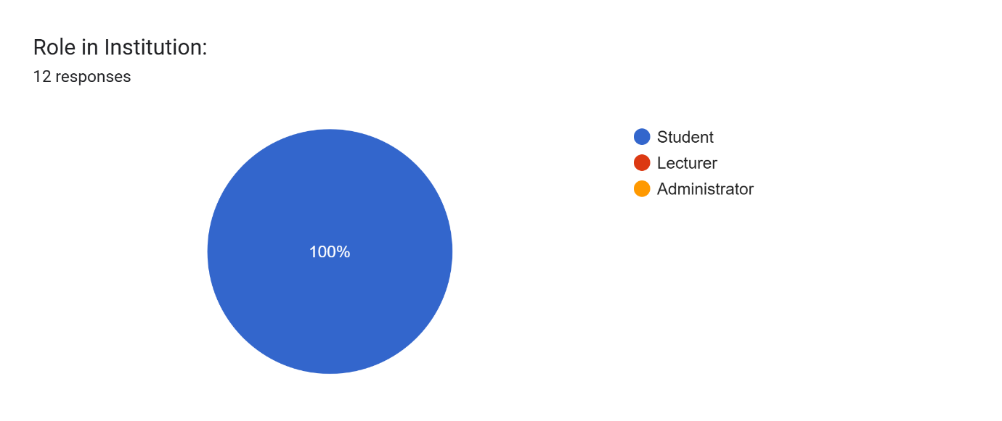

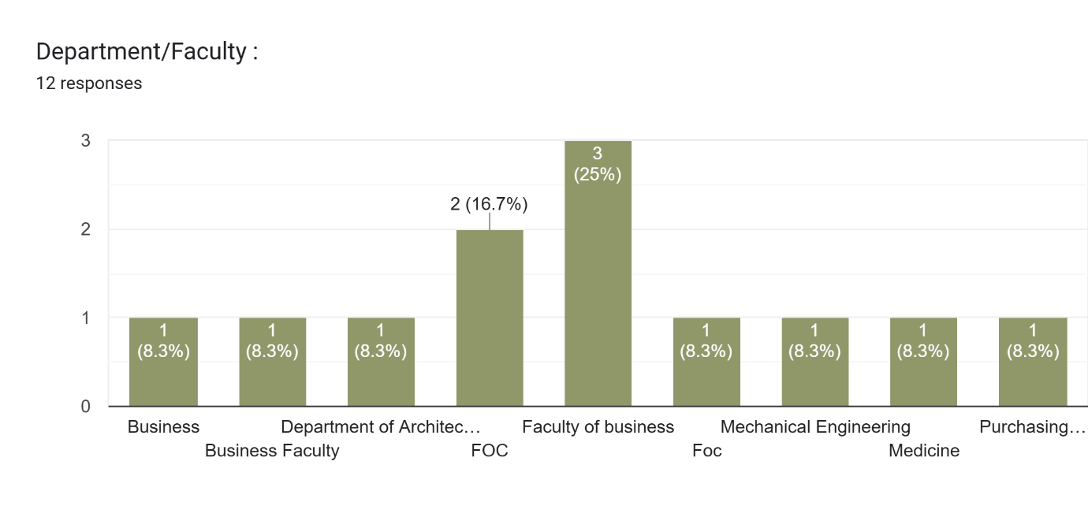

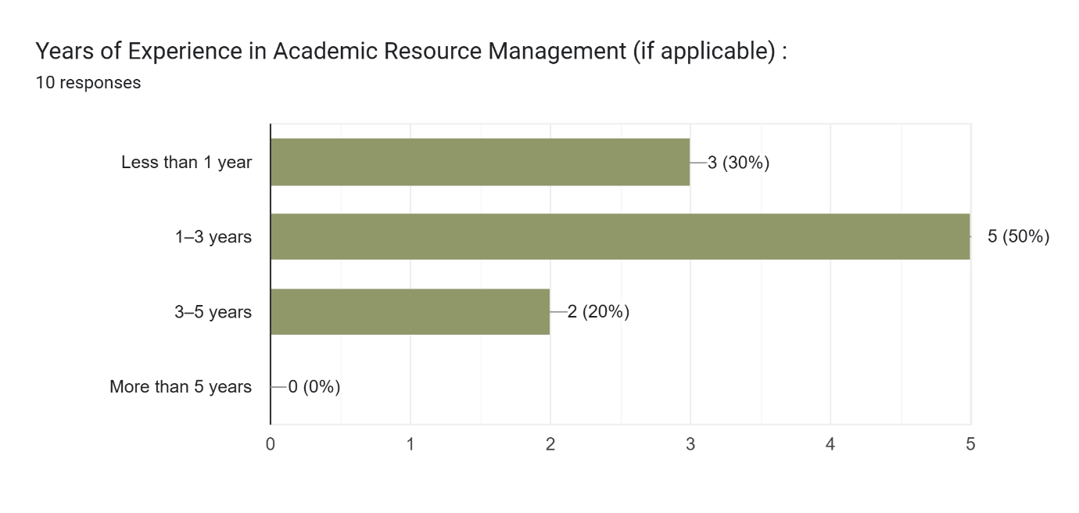

Figure 9:answers for question 01,02,03

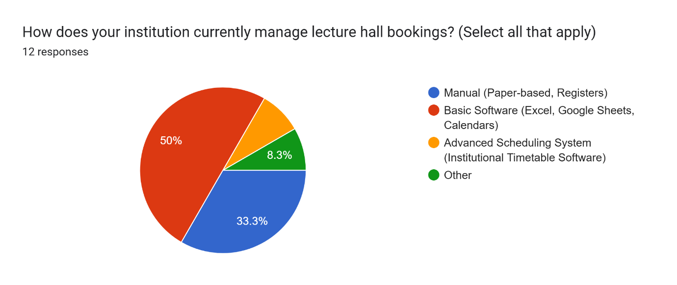

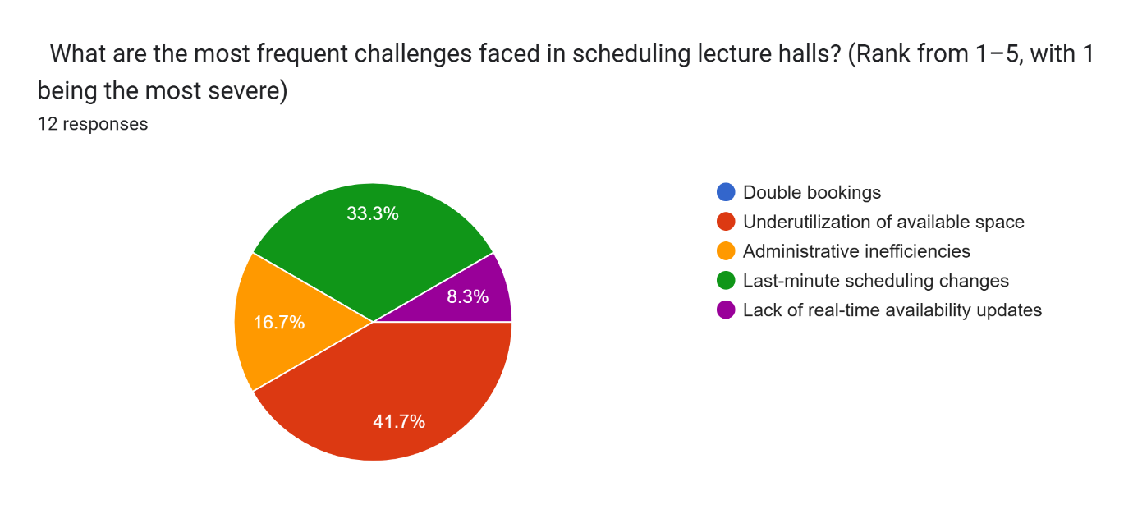

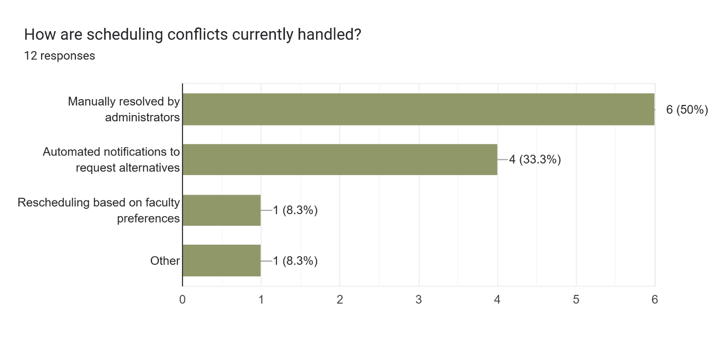

Figure 10:answers for question 04,05,06

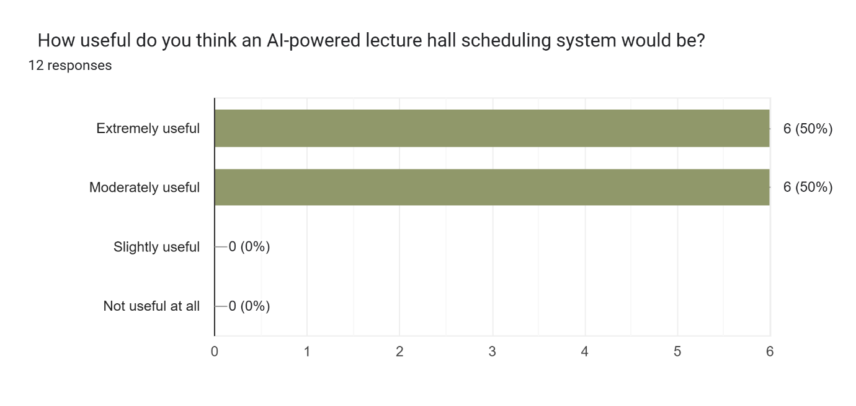

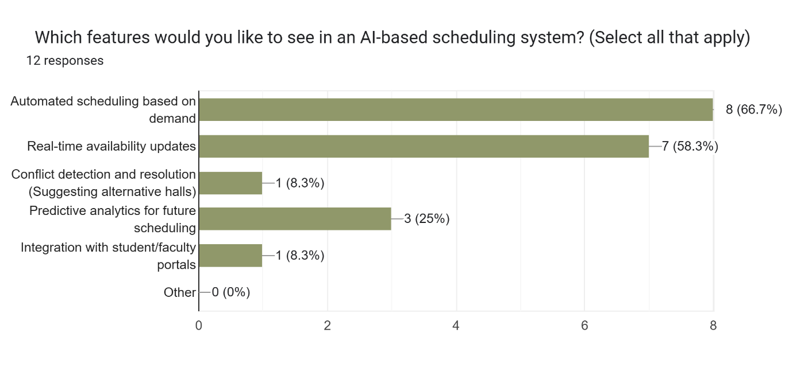

Figure 11:answers for question 08,09

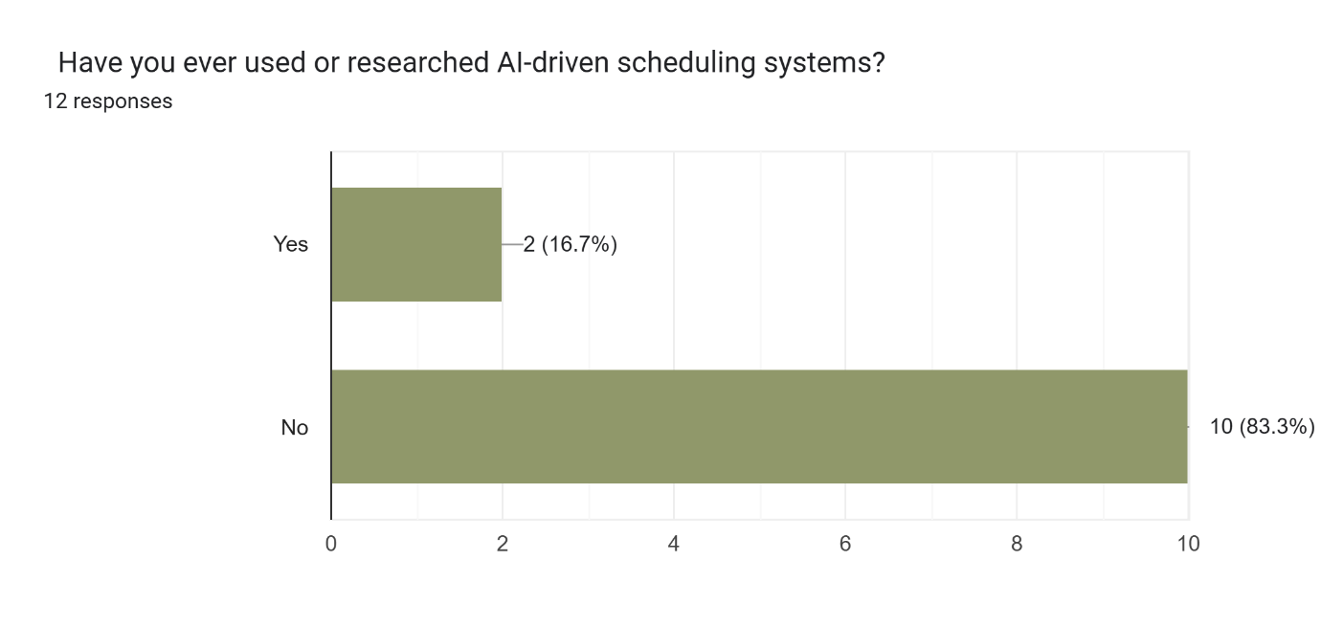

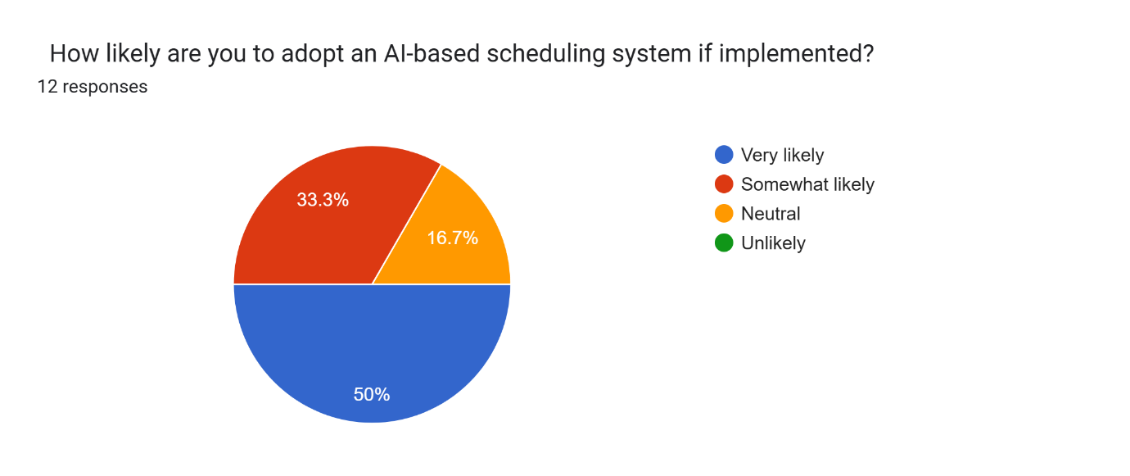

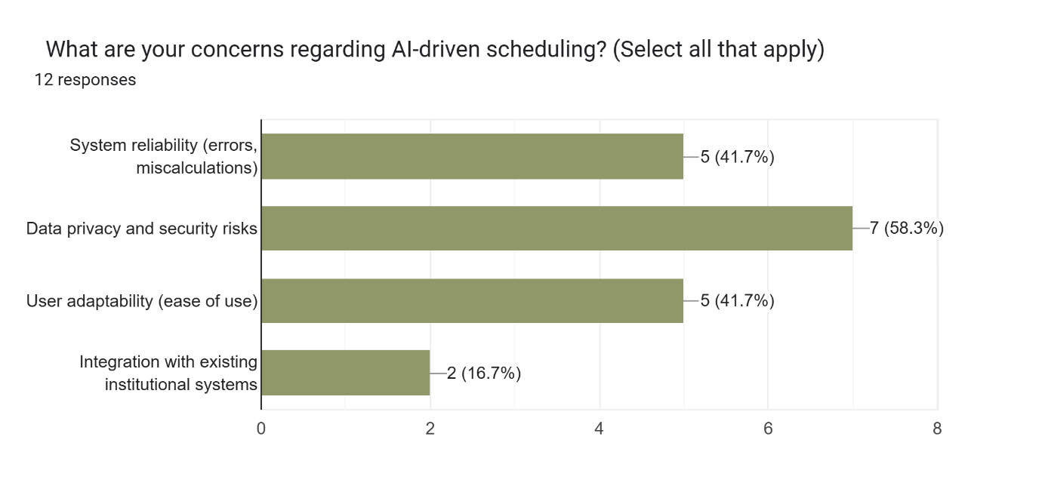

Figure 12:answers for question 09,10,11

Figure 13:answers for question 12

### Appendix C: Meeting Record Forms

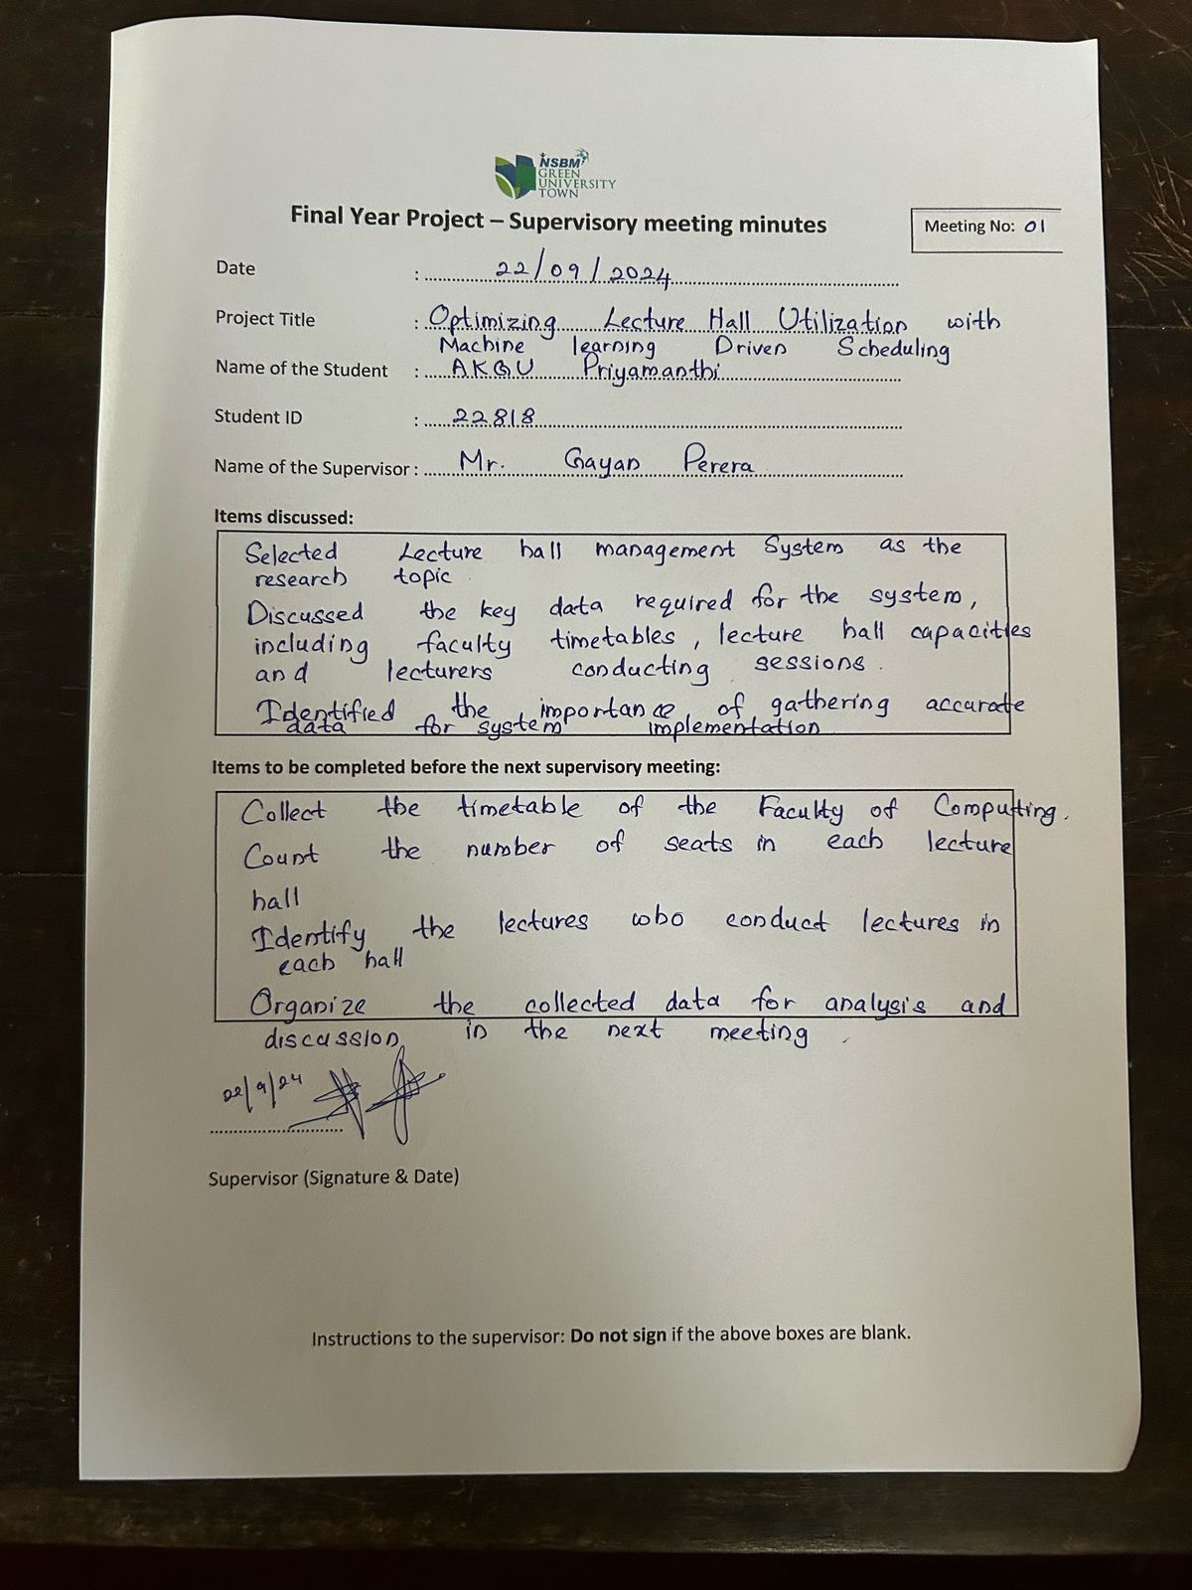

Figure 14:meeting record 01

Figure 15:meeting record 02

Figure 16:meeting record 03