REPORT
Team ID | PNT2022TMIDxxxxxx
Project Name | Smartphone Usage, Digital Addiction & Well-being Analysis
Maximum Marks | 5 Marks
A report is a comprehensive document that provides a detailed and structured account of data analysis, findings, and insights. It is typically used for in-depth analysis, documentation, and communication of results. Reports are suitable for a diverse audience, including decision-makers, analysts, and stakeholders who need a comprehensive understanding of the data.
Designing a report in Power BI involves connecting to data sources, creating visualizations like charts and graphs, customizing their appearance and interactivity, organizing them logically on the canvas, formatting elements for consistency and clarity, and optionally creating dashboards for a summarized view. Throughout the process, it's essential to consider the audience's needs and ensure the report effectively communicates insights from the data. Finally, iterate based on feedback to continually improve the report's design and usefulness.
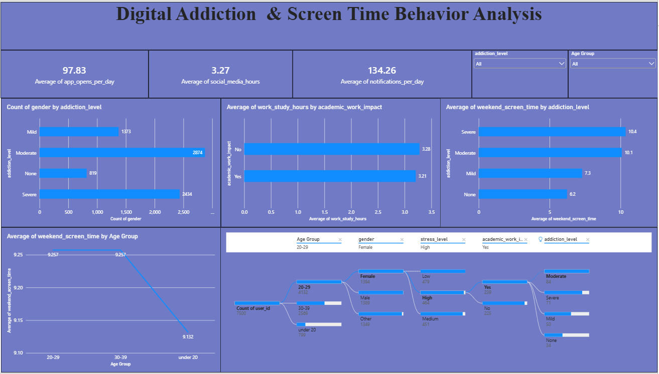

Observations Drawn from the Power BI Dashboard :Observations drawn from reports in Power BI provide valuable insights into behavioral indicators, screen time dynamics, and digital addiction metrics relative to mental well-being outcomes.
- 1. Trends Over Time: Analyze how key metrics (e.g., daily screen hours, unlock frequencies, or notification counts) change over different time periods (daily, weekly, monthly) to identify usage spikes, weekend vs. weekday behavioral shifts, or seasonal dependencies.
- 2. Performance Comparisons: Compare digital engagement and mental health tracking parameters across different demographic groups, app categories (social media, gaming, productivity), or age intervals to determine which variables correlate heavily with high dependency.
- 3. User Segmentation: Assess demographic data (age groups, occupation profiles, gender representation) to understand high-risk segments vulnerable to digital addiction, tailoring psychological framing or corporate wellness programs accordingly.
- 4. Goal Achievement: Measure progress against established well-being KPIs (e.g., screen time reduction milestones, targeted sleep hour preservation, physical activity correlation) to assess whether behavioral interventions are successfully being met.
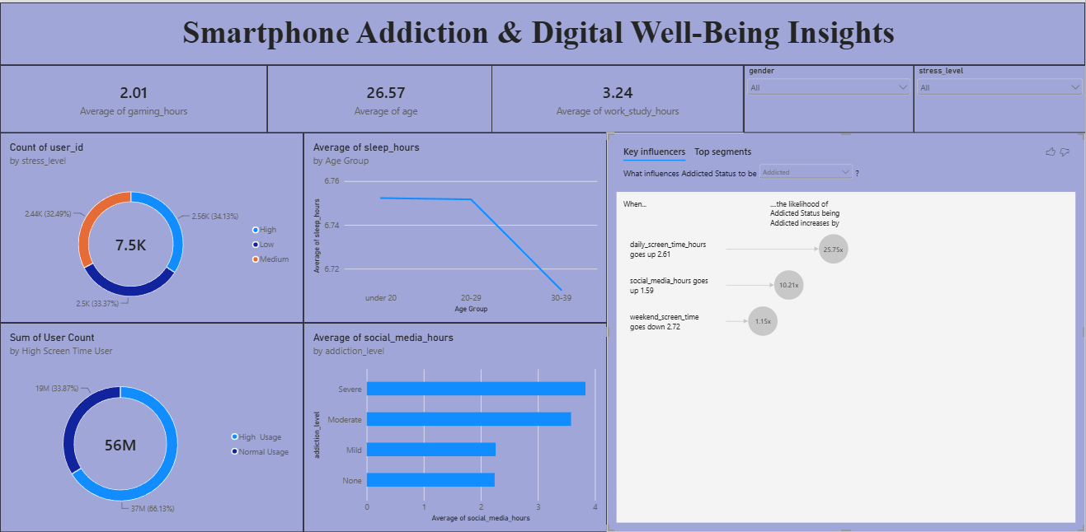

- Example Core Metrics & Analytical Case Breakdowns
Gender & Demographic Engagement Distribution:
The analytics dashboard demonstrates a higher concentration of intensive digital usage markers among male respondents compared to female cohorts, indicating targeted intervention strategies might be needed for specific user demographics.
Age Group & Vulnerability Analysis:
Among all tracked brackets, the youth demographic exhibits the highest average duration of uninterrupted phone usage sessions, indicating significant susceptibility to continuous app engagement loops. This suggests tailored policy frameworks to encourage healthy boundary-setting for younger users.
App-Category Friction & Addiction Hotspots:
Social media and gaming modules present the highest correlation with elevated anxiety indicators and low subjective well-being scores. Addressing specific UX engagement patterns within these categories could drastically alleviate chronic digital fatigue.
High Well-being Score Benchmarks:
Cohorts actively managing screen time constraints under specific boundaries show robust psychological resilience indicators. Successful individuals and group behavioral practices should be thoroughly studied to formalize widespread corporate and educational digital health blueprints.
- Addiction Severity:
- Moderate and Severe users form the largest addiction groups, while weekend screen time is substantially higher among these groups than among Mild and None users.
- Age, Sleep and Weekend Usage:
- Weekend screen time varies by age group, with the 20–29 group around 9.25 hrs and a lower average for older users; average sleep also shows a mild decline with age.
- Engagement and Usage:
- High Usage accounts for 66.8% of users. Average daily app opens are 97.83, notifications are 134.26, and social media use is 3.27 hrs.
- Stress and Academic/Work Impact:
- Stress levels are nearly balanced across High (34.13%), Low (33.37%), and Medium (32.49%). Average work/study hours are 3.3 hrs for users reporting No academic/work impact and 3.2 hrs for Yes.

