DARSHAN EASE TICKET BOOKING APP

Project Submitted to APSCHE
Bachelor of Technology
In
Electronics and Communication Engineering

Submitted By
CH.Sandhya
G.Meghana
D.Sireesha
G.Ushasri
Varshini sree

INTRODUCTION :
DarshanEase is an online temple darshan ticket booking platform designed to simplify booking process for devotees. It enables users to register, log in, browse temples, and
reserve darshan slots securely from anywhere.

DESCRIPTION

DarshanEase is a web-based Temple Darshan Ticket Booking System designed to simplify the process of booking darshan tickets for devotees. Traditionally, devotees had to stand in long queues or visit temples in person to reserve darshan slots, which was often time-consuming and inconvenient. DarshanEase addresses this challenge by providing a secure and user-friendly online platform where users can register, log in, explore various temples, view available darshan schedules, select preferred time slots, and book tickets from anywhere at any time. The system enhances the overall pilgrimage experience by making the booking process faster, more efficient, and easily accessible.

The application is developed using the MERN Stack (MongoDB, Express.js, React.js, and Node.js) to deliver a modern, responsive, and scalable solution. It includes separate modules for Customers and Administrators, where customers can manage their profiles, book and track darshan tickets, while administrators can manage temples, darshan slots, bookings, and user information through a dedicated dashboard. With features such as secure authentication, online booking, booking history, QR code generation, and an intuitive interface, DarshanEase offers a reliable and hassle-free digital solution for temple darshan management, benefiting both devotees and temple authorities.

It consists of some key features which include:

For your DarshanEase – Temple Darshan Ticket Booking System, you can write the features in a similar format as follows:

User Registration and Login: Users can create an account, securely log in, and manage their personal profiles using authenticated access.

Temple Browsing and Darshan Booking: Users can browse available temples, view temple details, select darshan types, choose preferred dates and time slots, and book tickets online.

Booking Management: Users can view their booking history, track the status of booked tickets, download booking confirmations, and cancel bookings (if permitted).

Admin Management: Administrators can add, update, and delete temple information, manage darshan slots, monitor bookings, and oversee user accounts through a dedicated admin dashboard.

Booking Confirmation and Notifications: After a successful booking, the system generates a unique booking ID and confirmation details. Users can receive booking notifications and reminders via email or SMS (if integrated).

Security and Data Protection: The system ensures secure authentication, encrypted password storage, role-based access control, and protection of user and booking data using industry-standard security practices.

Here is a more professional and academic version of your Scenario-Based Case Study that is suitable for a project report.

Scenario-Based Case Study: DarshanEase – Temple Darshan Ticket Booking System

Scenario

Ramesh, a devotee from Hyderabad, wishes to visit Tirumala Tirupati Temple with his family during a festival. Since temple visits are usually crowded, he decides to use the DarshanEase – Temple Darshan Ticket Booking System to book his darshan tickets online in advance. The system enables him to complete the entire booking process conveniently from home while allowing the temple administration to efficiently manage bookings and available time slots.

1. User Registration and Login

Ramesh visits the DarshanEase website and selects the "Register" option to create a new account.

He enters his personal details, including his full name, email address, mobile number, and password.

After successful registration, he logs into the system using his registered email and password.

Upon successful authentication, he is redirected to the customer dashboard, where he can access all available services.

2. Temple Selection and Ticket Booking

Ramesh browses the list of available temples and selects Tirumala Tirupati Temple.

He views temple information, darshan categories, available dates, and time slots.

He chooses Special Darshan, selects his preferred date and time, specifies the number of devotees, and enters the required devotee details.

After reviewing the booking information, he confirms the reservation and completes the online payment.

The system securely stores the booking details in the database.

3. Booking Confirmation and Tracking

After successful payment, the system generates a unique Booking ID and confirms the reservation.

Ramesh receives a confirmation email containing the booking details and a downloadable ticket with a QR code.

Through the "My Bookings" section, he can view his booking history, upcoming darshan schedules, and the current booking status.

If any changes occur in the booking schedule, the system immediately notifies him via email.

4. Interaction with the Temple Administration

The temple administrator reviews all incoming bookings through the admin dashboard.

If there is any modification to the darshan schedule or slot availability, the administrator updates the booking details in the system.

Ramesh receives instant notifications regarding any changes and can access the updated booking information through his dashboard.

The administrator ensures that all available slots are managed efficiently to avoid overcrowding and maintain smooth temple operations.

5. Darshan Completion and Feedback

On the scheduled date, Ramesh visits the temple and presents his booking confirmation or QR code at the entrance for verification.

After completing the darshan successfully, he logs into the DarshanEase portal and submits his feedback regarding the booking experience and temple services.

The collected feedback helps the temple administration improve service quality and enhance the overall user experience for future devotees.

6. Admin Management

The administrator manages all registered users, temples, bookings, and available darshan slots through the admin dashboard.

The admin can add, edit, or remove temple information, update darshan schedules, approve or cancel bookings, and monitor daily booking activities.

The system also generates reports on booking statistics, temple-wise visitor counts, and user activities, enabling efficient decision-making and resource management.

By ensuring secure authentication, role-based access control, and organized booking management, DarshanEase provides a reliable and user-friendly platform for both devotees and temple administrators.

TECHNICAL ARCHITECTURE

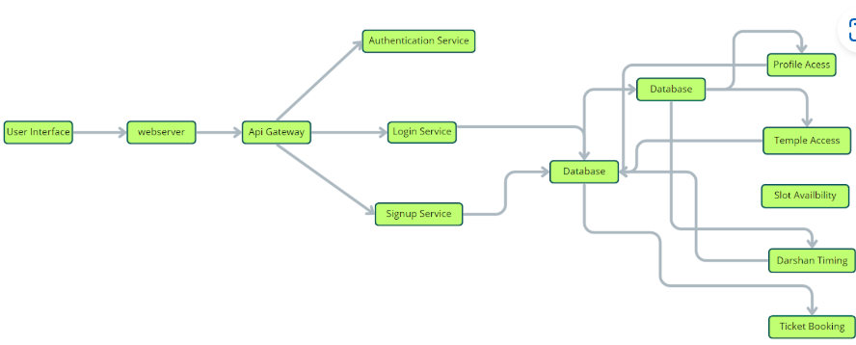

The technical architecture of our online complaint registration and management app follows a client-server model, where the front end serves as the client and the back endbackend acts as the server. The front end encompasses the user interface

and presentation and incorporates the Axios library to connect with the backend easily by using RESTful Apis.
The front end utilizes the bootstrap and material UI library to establish a real-time and better UI experience for any user whether it is an agent, admin, or ordinary user working on it.

On the backend side, we employ Express.js frameworks to handle the server-side logic and communication.
For data storage and retrieval, our backend relies on MongoDB. MongoDB allows for efficient and scalable storage of user data, including user profiles, complaints registration, etc. It ensures reliable and quick access to the necessary information during registration of users or any complaints.
Together, the frontend and backend components, along with socket.io, Express.js, WebRTC API, and MongoDB, form a comprehensive technical architecture for our video conference app. This architecture enables real-time communication, efficient data exchange, and seamless integration, ensuring a smooth and immersive video conferencing experience for all users.

ER DIAGRAM

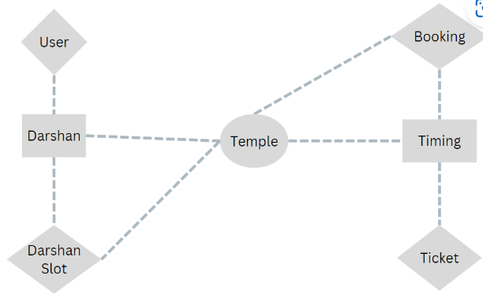

User-Booking Relationship: One-to-Many relationship between User and Booking (One user can make multiple bookings)

Foreign Key: UserID in Booking

Temple-DarshanSlot Relationship: One-to-Many relationship between Temple and DarshanSlot (One temple can have multiple darshan slots)

Foreign Key: TempleID in DarshanSlot

Booking-DarshanSlot Relationship: One-to-Many relationship between DarshanSlot and Booking (One darshan slot can have multiple bookings)

Foreign Keys: SlotID in Booking, TempleID in DarshanSlot

The foreign key relationships are established between the entities using the primary keys from the respective tables.

PRE-REQUISITES:

Here are the key prerequisites for developing a full-stack application using Node.js, Express.js, MongoDB, and React.js:

Node.js and npm:
Node.js is a powerful JavaScript runtime environment that allows you to run JavaScript code on the server side. It provides a scalable and efficient platform for building network applications.
Install Node.js and npm on your development machine, as they are required to run JavaScript on the server side.
Download: https://nodejs.org/en/download/

Express.js:
Express.js is a fast and minimalist web application framework for Node.js. It simplifies the process of creating robust APIs and web applications, offering features like routing, middleware support, and modular architecture.
Install Express.js, a web application framework for Node.js, which handles server-side routing, middleware, and API development.
Installation: Open your command prompt or terminal and run the following command:

npm install express MongoDB:
MongoDB is a flexible and scalable NoSQL database that stores data in a JSON-like format. It provides high performance, horizontal scalability, and seamless integration with Node.js, making it ideal for handling large amounts of structured and unstructured data.
Set up a MongoDB database to store your application's data. Download: https://www.mongodb.com/try/download/community

React.js:
React.js is a popular JavaScript library for building user interfaces. It enables developers to create interactive and reusable UI components, making it easier to build dynamic and responsive web applications.
Install React.js, a JavaScript library for building user interfaces.
HTML, CSS, and JavaScript: Basic knowledge of HTML for creating the structure of your app, CSS for styling, and JavaScript for client-side interactivity is essential.
Database Connectivity: Use a MongoDB driver or an Object-Document Mapping (ODM) library like Mongoose to connect your Node.js server with the MongoDB database and perform CRUD (Create, Read, Update, Delete) operations. To Connect the Database with Node JS go through the below provided link: https://www.section.io/engineering-education/nodejs- mongoosejs-mongodb/
Front-end Framework: Utilize Reactjs to build the user-facing part of the application, including entering complaints, the status of the complaints, and user interfaces for the admin dashboard.
To make better UI we have also used some libraries like Material UI and Bootstrap.
Version Control: Use Git for version control, enabling collaboration and tracking changes throughout the development process. Platforms like GitHub or Bitbucket can host your repository.
Git: Download and installation instructions can be found at: https://git-scm.com/downloads
Development Environment: Choose a code editor or Integrated Development Environment (IDE) that suits your preferences, such as Visual Studio Code, Sublime Text, or WebStorm.

- Visual Studio Code: Download from https://code.visualstudio.com/download To run the existing Video Conference App project downloaded from GitHub: Follow the below steps:
Clone the Repository:
  - Open your terminal or command prompt.
  - Navigate to the directory where you want to store the e-commerce app.

Install Dependencies:

- Navigate into the cloned repository directory: cd complaint-register
- Install the required dependencies by running the following commands: cd frontend
npm install cd ../backend npm install
Start the Development Server:
- To start the development server, execute the following command: npm start
- The online complaint registration and management app will be accessible at http://localhot:5173
You have successfully installed and set up the online complaint registration and management app on your local machine. You can now proceed with further customization, development, and testing as needed

PROJECT STRUCTURE:

Frontend (React.js):
  - src
    - components – Reusable UI components like Navbar, Footer, Login, Signup, Dashboard, etc. components – Reusable UI components like Navbar, Footer, Login, Signup, Dashboard, etc.
    - pages – Page-level components like HomePage, UserDashboard, AdminPanel, AgentPanel.
    - routes – Route definitions for user, admin, and agent navigation.
    - services – Axios API calls for interacting with the backend.
    - App.js – Root component handling routing and layout.
    - index.js – Entry point of the React app.

- Backend (Node.js + Express.js):
  - controllers – Contains logic for handling requests (e.g., userController, complaintController).
  - models – Mongoose schemas for User, Complaint, etc.
  - routes – Defines all REST API routes (userRoutes, complaintRoutes, adminRoutes).
  - middlewares – Middleware functions for authentication and role-based access control.
  - server.js – Main entry point that sets up the Express server and MongoDB connection.

Database (MongoDB):
  - Stores data in collections such as:
    - Users – Stores user/admin/agent information.
    - Complaints – Stores complaint details, status, timestamps, and assigned agent.
    - Sessions/Tokens – (Optional) For managing login sessions or refresh tokens.

Project Flow:
- User signs up or logs in via the frontend.
- Complaint data is submitted and sent to the backend via Axios API.
- Backend validates and stores the complaint in MongoDB.
- Admin can view all complaints and assign them to specific agents.
- Agents update the complaint status, which the user can track on their dashboard.

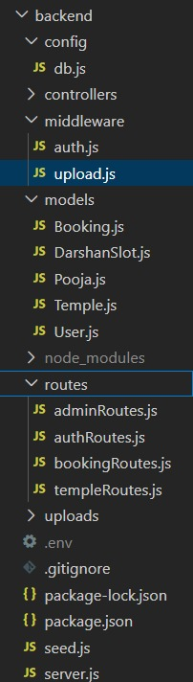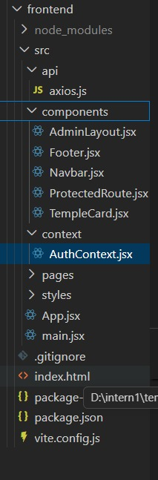

The first image is of frontend part which shows all the files and folders that have been used in UI development

The second image is of the Backend part which shows all the files and folders that have been used in the backend development

APPLICATION FLOW:

For your DarshanEase – Temple Darshan Ticket Booking System, you can replace the above content with the following:

DarshanEase – Temple Darshan Ticket Booking System
1. Customer (Devotee)
Role: Register, log in, browse temples, book darshan tickets, manage bookings, and update profile information.
1. Registration and Login
- Create a new account by providing personal details such as name, email address, mobile number, and password.
- Log in securely using the registered email and password.
- Reset the password using the "Forgot Password" option if required.
2. Temple Browsing and Ticket Booking
- Browse the list of available temples and view their details.
- Select the preferred temple, darshan type, date, and available time slot.
- Enter devotee details and complete the booking process.
- Make online payments (if payment integration is enabled).
3. Booking Management
- View all booked darshan tickets in the My Bookings section.
- Track booking status and view booking history.
- Download or print the booked ticket with the booking ID or QR code.
- Cancel bookings according to the temple's cancellation policy.
4. Notifications
- Receive booking confirmation through email or SMS.
- Get notifications regarding booking updates, cancellations, or schedule changes.
5. Profile Management
- View and update personal information.
- Change password and manage account details.
- Maintain booking history and profile information securely.

2. Administrator
Role: Manage temples, bookings, users, darshan schedules, and monitor the overall functioning of the booking system.
1. Admin Login
- Log in securely using administrator credentials.
- Access the admin dashboard after successful authentication.
2. Temple Management
- Add new temples with descriptions, images, and location details.
- Update temple information, darshan categories, and available slots.
- Delete outdated or inactive temple records.
3. Booking Management
- View all bookings made by devotees.
- Approve, modify, or cancel bookings when required.
- Manage darshan schedules and available time slots.
4. User Management
- View registered user details.
- Update or deactivate user accounts when necessary.
- Monitor user activities and booking history.
5. Reports and Monitoring
- Generate reports based on daily, weekly, and monthly bookings.
- Monitor temple-wise visitor statistics.
- Analyze booking trends for better resource planning.
6. System Management
- Ensure smooth operation of the application.
- Maintain data security and role-based access control.
- Monitor system performance and resolve administrative issues.

3. System Features
Role: Provide secure, efficient, and user-friendly online temple darshan booking services.
1. Secure Authentication
- JWT-based user authentication.
- Encrypted password storage using bcrypt.
- Role-based access for customers and administrators.
2. Online Darshan Booking
- Real-time availability of darshan slots.
- Instant booking confirmation.
- Unique Booking ID and QR Code generation.
3. Notifications
- Email confirmations after successful booking.
- Notifications for booking updates and schedule changes.
4. Search and Filter
- Search temples by name or location.
- Filter temples based on state or darshan type.
5. Responsive Design
- Accessible on desktop, tablet, and mobile devices.
- Simple and user-friendly interface for all age groups.
6. Data Security
- Secure storage of user and booking information.
- Protection against unauthorized access.
- Reliable database management using Mongo DB
Milestone 1:
Project Setup and Configuration:
1. Create project folders and files:
Now, firstly create the folders for frontend and backend to write the respective code and install the essential libraries.
    - Client folders.
    - Server folders

2. Install required tools and software:
For the backend to function well, we use the libraries mentioned in the prerequisites. Those libraries include
    - Node.js.
    - MongoDB.
    - Bcrypt
    - Body-parser
Also, for the frontend we use the libraries such as
    - React Js.
    - Material UI
    - Bootstrap
    - Axios
After the installation of all the libraries, the package.json files for the front end look like the one mentioned below.

After the installation of all the libraries, the package.json files for the backend look like the one mentioned below.

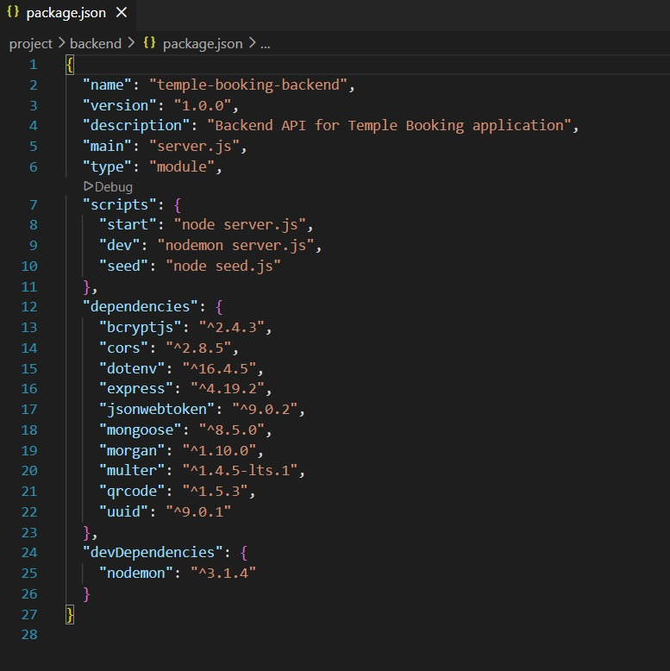

Milestone 2:
Backend Development:

- Set Up Project Structure:
  - Create a new directory for your project and set up a package.json file using npm init command.
  - Install necessary dependencies such as Express.js, Mongoose, and other required packages.

Set Up Project Structure:
  - Create a new directory for your project and set up a package.json file using npm init command.
  - Install necessary dependencies such as Express.js, Mongoose, and other required packages.

Create Express.js Server:
  - Set up an Express.js server to handle HTTP requests and serve API endpoints.
  - Configure middleware such as body-parser for parsing request bodies and cors for handling cross-origin requests.

Define API Routes:
  - Create separate route files for different API functionalities such as authentication, creating, assigning complaints, and chat window.
  - Implement route handlers using Express.js to handle requests and interact with the database.

Implement Data Models:
  - Create corresponding Mongoose models to interact with the MongoDB database.
  - Implement CRUD operations (Create, Read, Update, Delete) for each model to perform database operations.

User Authentication:
  - Implement user authentication using strategies like JSON Web

Tokens (JWT).
  - Create routes and middleware for user registration, login, and logout.
  - Set up authentication middleware to protect routes that require user authentication.

Admin Functionality:
  - Implement routes and controllers specific to admin functionalities such as fetching all the data regarding users, complaints, agents.

Error Handling:
  - Implement error handling middleware to catch and handle any errors that occur during the API requests.
  - Return appropriate error responses with relevant error messages and HTTP status codes.
Milestone 3:
Database Development
- User Schema:
  - The user schema defines the structure of user data stored in the database. It includes fields such as name, email, password, phone, and userType.
  - Each user must provide a name, email, password, phone number, and userType (e.g., customer, agent, admin).
  - User data is stored in the "user_Schema" collection in the MongoDB database.

Complaint Schema:
  - The complaint schema specifies the format of complaint data registered by users.
  - It contains fields like userId, name, address, city, state, pincode, comment, and status.

  - Complaints are associated with users through the userId field, and each complaint must have a name, address, city, state, pincode, comment, and status.
  - Complaint data is stored in the "complaint_schema" collection in the MongoDB database.

Assigned Complaint Schema:
  - The assigned complaint schema defines how complaints are assigned to agents for resolution.
  - It includes fields such as agentId, complaintId, status, and agentName.
  - Each assigned complaint is linked to a specific agent (identified by agentId) and complaint (identified by complaintId).
  - The status field indicates the current status of the assigned complaint.
  - Assigned complaint data is stored in the "assigned_complaint" collection in the MongoDB database.

Chat Window Schema:
  - The chat window schema governs the structure of messages exchanged between users and agents regarding specific complaints.
  - It comprises fields like name, message, and complaintId.
  - Messages are associated with a complaint through the complaintId field, allowing for easy tracking and retrieval of chat history for each complaint.
  - Message data is stored in the "message" collection in the MongoDB database.
Milestone 4:
Frontend Development:
1. Setup React Application:
Bringing Customer Care Registry to life involves a three-step development process. First, a solid foundation is built using React.js. This includes creating the initial application structure, installing necessary libraries, and organizing

the project files for efficient development. Next, the user interface (UI) comes to life. To start the development process for the front end, follow the below steps.
- Install required libraries.
- Create the structure directories.

2.Design UI components:
Reusable components will be created for all the interactive elements you'll see on the screen, from stock listings and charts to buttons and user profiles. Next, we'll implement a layout and styling scheme to define the overall look and feel of the application. This ensures a visually appealing and intuitive interface. Finally, a navigation system will be integrated, allowing you to effortlessly explore different sections of the Customer Care Registry, like making specific complaints or managing your Product complaints.

3.Implement frontend logic:
In the final leg of the front-end development, we'll bridge the gap between the visual interface and the underlying data. It involves the following stages.
- Integration with API endpoints.
- Implement data binding.

Milestone 5:
Project Implementation:
On completing the development part, we then ran the application one last time to verify all the functionalities and look for any bugs in it. The user interface of the application looks a bit like the one provided below

- Landing Page
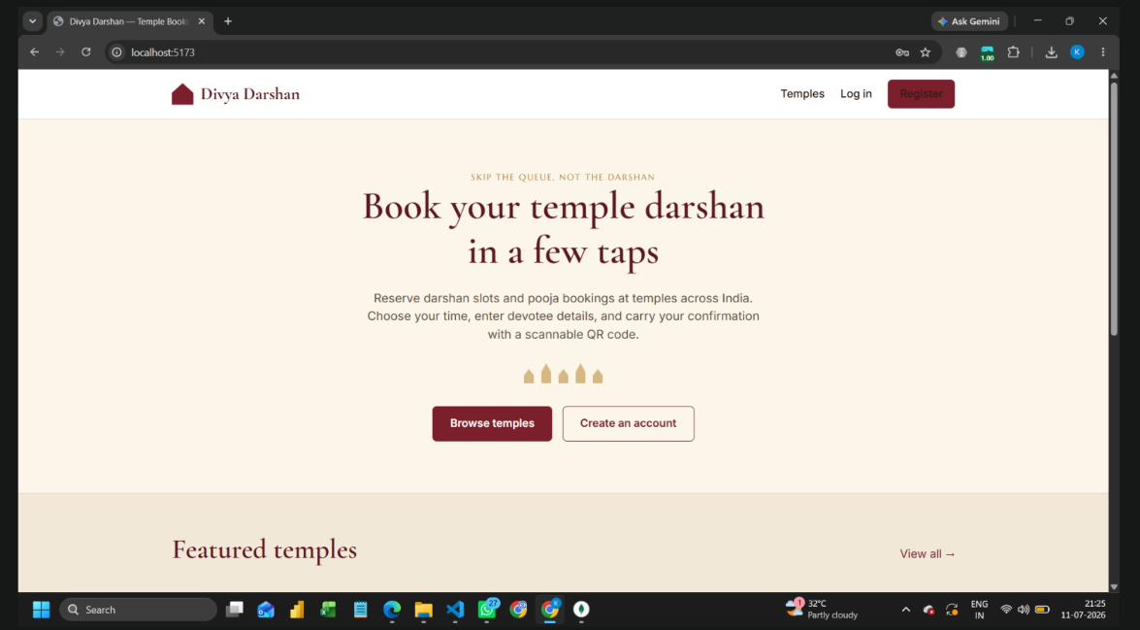

- Login Page
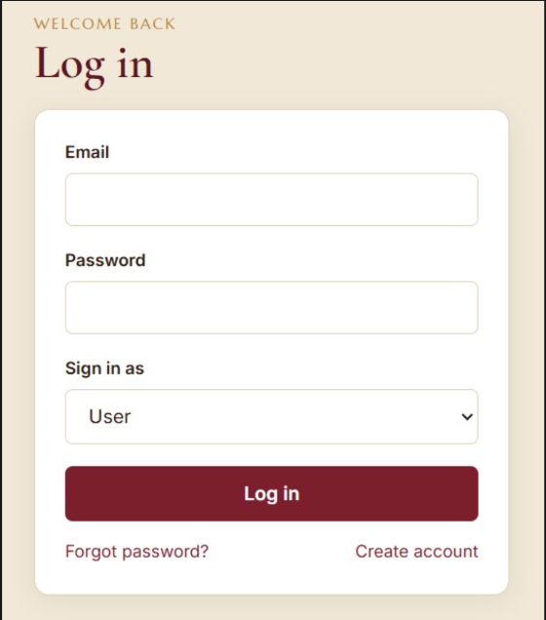

- Registration Page
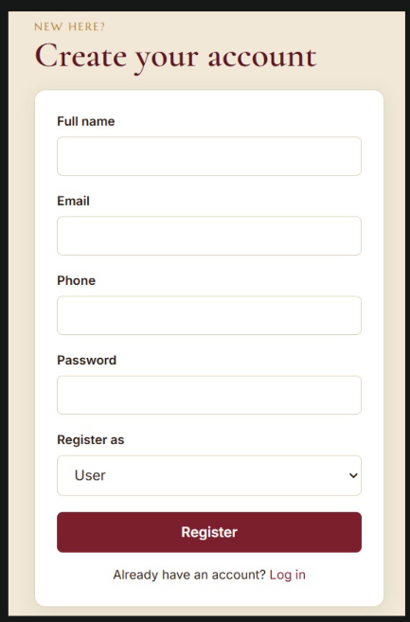

- User Dashboard

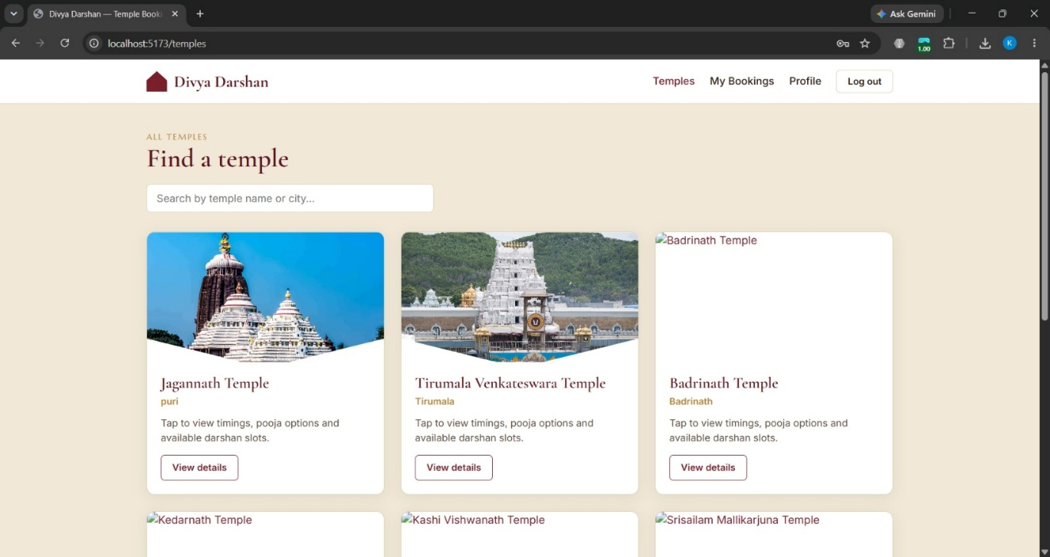
  - Admin Dashboard

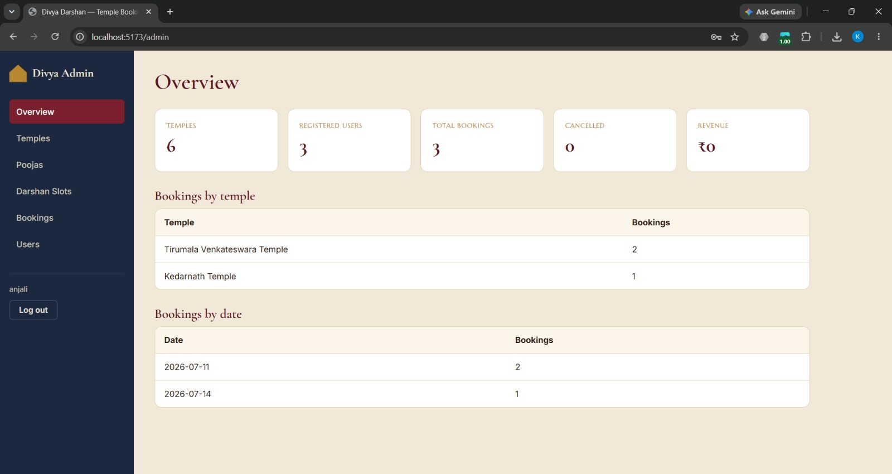

- User profile

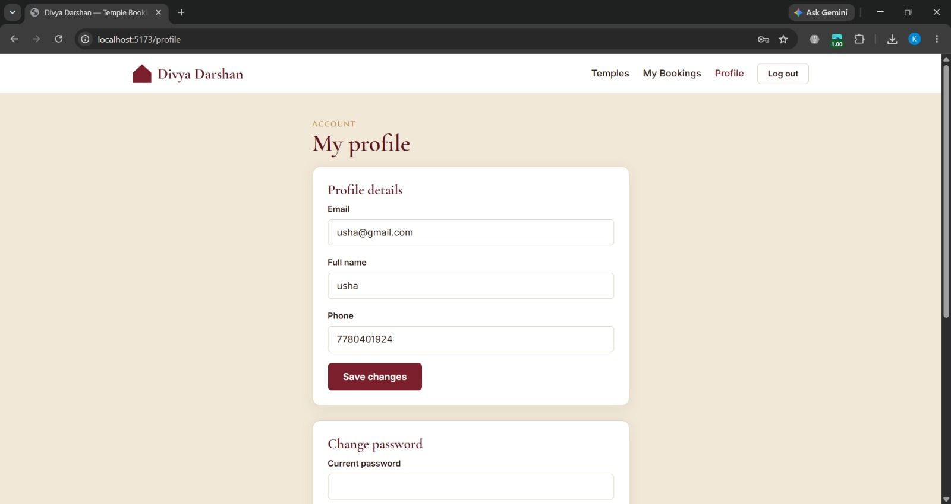

- User bookings

