**HEALTH INFO STANDARDS AND TERMS**

**Project sprint 4**

**Team Name- The Avengers**

Lavanya Ranganatham | Prathik Reddy Kotha | Rupasri Pamulapati | Teja Pavani  
Jyesta | Ushaswini Sunkara

April 20, 2024

In our case, we have selected OpenEMR for both system A and system B, with JSON as the chosen interchange and representation formats.

We have identified the Vital signs, problems, medications, and patient demographics sections from the CCDA document for exchange.

XSLT stylesheets that select the specific sections are:

**1.Medications XSLT:**

<?xml version="1.0" encoding="UTF-8"?>  
<xsl:stylesheet version="1.0" xmlns:xsl="http://www.w3.org/1999/XSL/Transform" xmlns:n1="urn:hl7-org:v3">  
 <xsl:output method="html"/>  
   
 <xsl:template match="/">  
 <html>  
 <body>  
 <h2>  
 <xsl:value-of select="//n1:component/n1:section[n1:code/*@code*='10160-0']/n1:title"/>  
 </h2>  
 <table border="1">  
 <tr>  
 <th>Medication</th>  
 <th>Indications</th>  
 </tr>  
 <xsl:for-each select="//n1:component/n1:section[n1:code/*@code*='10160-0']/n1:text/n1:table/n1:tbody/n1:tr">  
   
 <tr>  
 <td>  
 <xsl:value-of select="n1:td[1]"/>  
   
 </td>  
 <td>  
 <xsl:value-of select="n1:td[2]"/>  
 </td>  
 </tr>  
 </xsl:for-each>  
 </table>  
 </body>  
 </html>  
 </xsl:template>  
   
</xsl:stylesheet>

**1. Medications JSON**

{

"html": {

"xmlns:n1": "urn:hl7-org:v3",

"body": {

"h2": "MEDICATIONS",

"table": {

"border": 1,

"tr": [

{

"th": [

"Medication",

"Indications"

]

},

{

"td": [

"Clonidine 0.2 mg",

"Hypertension"

]

}

]

}

}

}

}

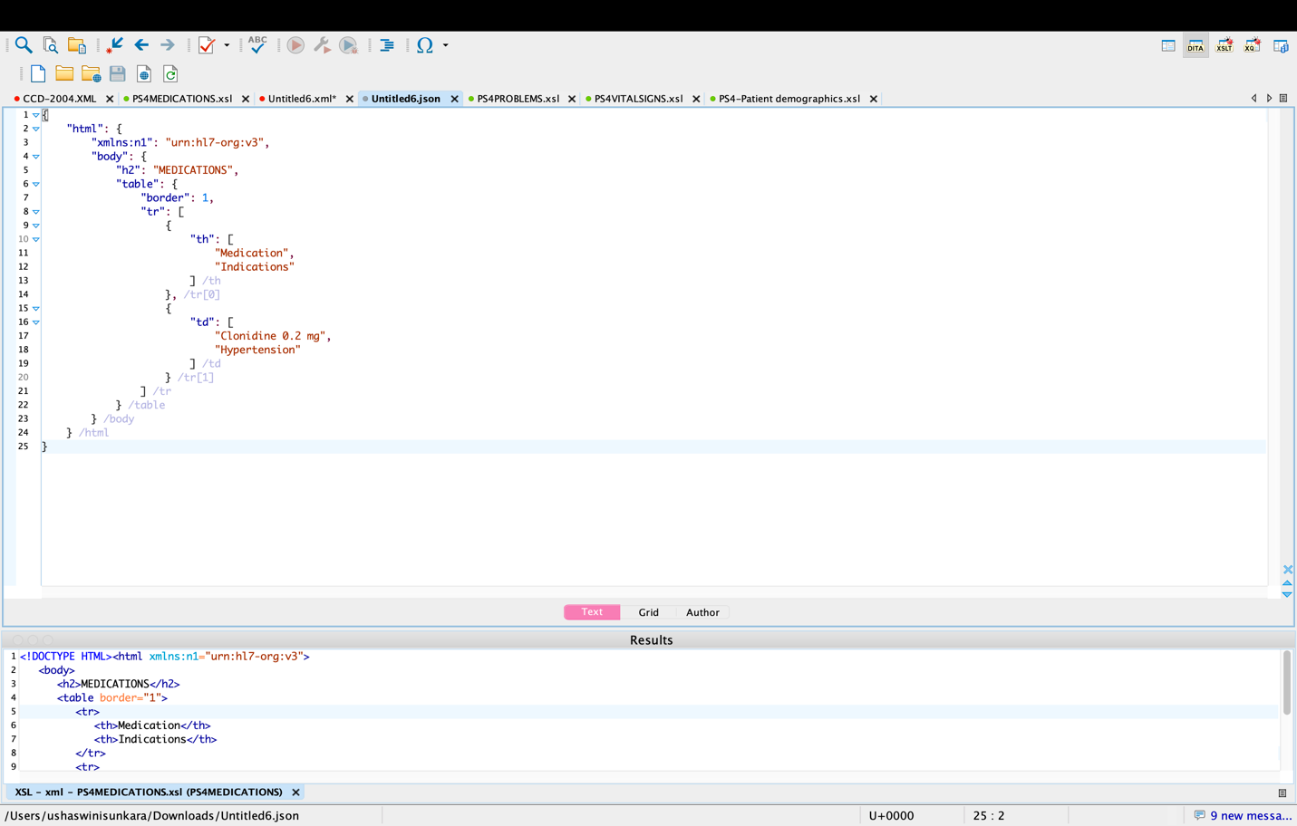

**2.Patient demographics XSLT:**

<xsl:stylesheet version="1.0"  
 xmlns:xsl="http://www.w3.org/1999/XSL/Transform"  
 xmlns:hl7="urn:hl7-org:v3"  
 exclude-result-prefixes="hl7">  
   
 <xsl:output method="html" indent="yes" encoding="UTF-8"/>  
   
 <xsl:template match="/">  
 <html>  
   
 <title>Patient Chart Summary</title>  
   
 <body>  
 <div id="patient-details">  
 <h1>Patient Chart Summary</h1>  
 <xsl:apply-templates select="//hl7:patientRole"/>  
 </div>  
 </body>  
 </html>  
 </xsl:template>  
   
 <xsl:template match="hl7:patientRole">  
 <div>  
 <strong>Patient Name: </strong>  
 <xsl:value-of select="hl7:patient/hl7:name/hl7:given"/>  
 <xsl:text> </xsl:text>  
 <xsl:value-of select="hl7:patient/hl7:name/hl7:family"/>  
 </div>  
 <div>  
 <strong>Date of Birth: </strong>  
 <xsl:value-of select="hl7:patient/hl7:birthTime/*@value*"/>  
 </div>  
 <div>  
 <strong>Sex: </strong>  
 <xsl:value-of select="hl7:patient/hl7:administrativeGenderCode/*@displayName*"/>  
 </div>  
 <div>  
 <strong>Address: </strong>  
 <xsl:value-of select="hl7:addr/hl7:streetAddressLine"/>  
 <xsl:text>, </xsl:text>  
 <xsl:value-of select="hl7:addr/hl7:city"/>  
 <xsl:text>, </xsl:text>  
 <xsl:value-of select="hl7:addr/hl7:state"/>  
 <xsl:text> </xsl:text>  
 <xsl:value-of select="hl7:addr/hl7:postalCode"/>  
 </div>  
 <div>  
 <strong>Contact: </strong>  
 <xsl:value-of select="hl7:telecom/*@value*"/>  
 </div>  
 <div>  
 <strong>Patient ID: </strong>  
 <xsl:value-of select="hl7:id/*@extension*"/>  
 </div>  
 </xsl:template>  
   
</xsl:stylesheet>

**2.Patient Demographics JSON:**

{

"html": {

"title": "Patient Chart Summary",

"body": {

"div": {

"id": "patient-details",

"h1": "Patient Chart Summary",

"div": [

{

"strong": "Patient Name: ",

"#text": "Eve Betterhalf"

},

{

"strong": "Date of Birth: ",

"#text": 19590501

},

{

"strong": "Sex: ",

"#text": "Male"

},

{

"strong": "Address: ",

"#text": "2222 Home Street, Beaverton, OR 97867"

},

{

"strong": "Contact: ",

"#text": "tel:+1(555)555-2003"

},

{

"strong": "Patient ID: ",

"#text": 444222222

}

]

}

}

}

}

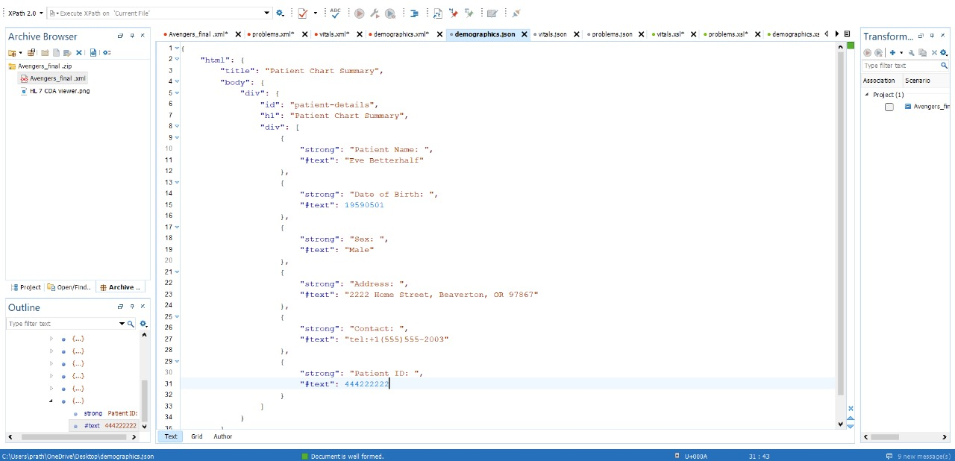

**3.Problems XSLT:**

<?xml version="1.0" encoding="UTF-8"?>  
<xsl:stylesheet version="1.0" xmlns:xsl="http://www.w3.org/1999/XSL/Transform" xmlns:n1="urn:hl7-org:v3">  
 <xsl:output method="html"/>  
   
 <xsl:template match="/">  
 <html>  
 <body>  
 <h2>  
 <xsl:value-of select="//**n1:component**/**n1:section**[**n1:code**/***@code***='11450-4']/**n1:title**"/>  
 </h2>  
 <table border="1">  
 <tr>  
 <th>Name</th>  
 <th>Status</th>  
 </tr>  
 <xsl:for-each select="//**n1:component**/**n1:section**[**n1:code**/***@code***='11450-4']/**n1:text**/**n1:table**/**n1:tbody**/**n1:tr**">  
   
 <tr>  
 <td>  
 <xsl:value-of select="**n1:td**[1]"/>  
   
 </td>  
 <td>  
 <xsl:value-of select="**n1:td**[2]"/>  
 </td>  
 </tr>  
 </xsl:for-each>  
 </table>  
 </body>  
 </html>  
 </xsl:template>  
   
</xsl:stylesheet>

**3. Problems JSON:**

{

"html": {

"xmlns:n1": "urn:hl7-org:v3",

"body": {

"h2": "PROBLEMS",

"table": {

"border": 1,

"tr": [

{

"th": [

"Name",

"Status"

]

},

{

"td": [

" Headache",

"Chief Complaint"

]

}

]

}

}

}

}

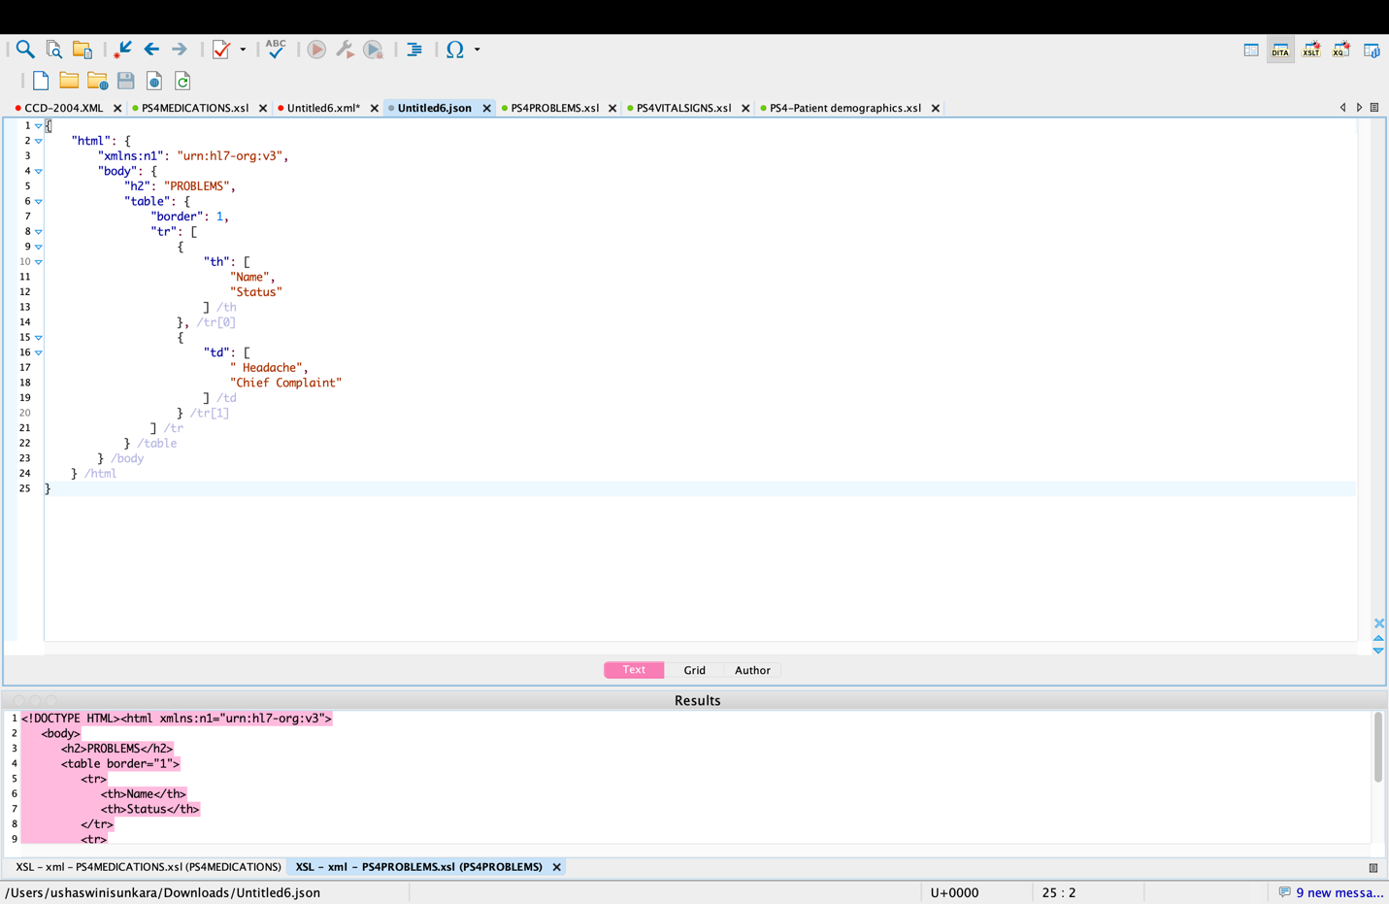

**4.Vital signs XSLT:**

<?xml version="1.0" encoding="UTF-8"?>  
<xsl:stylesheet version="1.0" xmlns:xsl="http://www.w3.org/1999/XSL/Transform" xmlns:n1="urn:hl7-org:v3">  
 <xsl:output method="html"/>  
   
 <xsl:template match="/">  
 <html>  
 <body>  
 <h2>  
 <xsl:value-of select="//**n1:component**/**n1:section**[**n1:code**/***@code***='8716-3']/**n1:title**"/>  
 </h2>  
 <table border="1" width="100%">  
 <thead>  
 <tr>  
 <th align="left">Date / Time: </th>  
 <th align="left">  
 <xsl:value-of select="//**n1:component**/**n1:section**[**n1:code**/***@code***='8716-3']/**n1:text**/**n1:table**/**n1:thead**/**n1:tr**/**n1:th**[2]"/>  
 </th>  
 </tr>  
 </thead>  
 <tbody>  
 <xsl:for-each select="//**n1:component**/**n1:section**[**n1:code**/***@code***='8716-3']/**n1:text**/**n1:table**/**n1:tbody**/**n1:tr**">  
 <tr>  
 <th align="left">  
 <xsl:value-of select="**n1:th**"/>  
 </th>  
 <td>  
 <xsl:value-of select="**n1:td**"/>  
 </td>  
 </tr>  
 </xsl:for-each>  
 </tbody>  
 </table>  
 </body>  
 </html>  
 </xsl:template>  
   
</xsl:stylesheet>

**4. Vital signs JSON:**

{

"html": {

"xmlns:n1": "urn:hl7-org:v3",

"body": {

"h2": "VITAL SIGNS",

"table": {

"border": 1,

"width": "100%",

"thead": {

"tr": {

"th": [

{

"align": "left",

"#text": "Date / Time: "

},

{

"align": "left",

"#text": "April 2, 2024"

}

]

}

},

"tbody": {

"tr": {

"th": {

"align": "left",

"#text": "Blood Pressure"

},

"td": "130/90 mmHg"

}

}

}

}

}

}

