**Problem Statement:**

In bustling urban environments, particularly during peak hours, the challenge of finding a parking spot intensifies, causing significant stress and wasted time for drivers. The lack of real-time information on available parking spaces exacerbates the issue, contributing to traffic congestion. A pressing need exists for innovative parking management solutions to alleviate this problem and enhance the overall urban driving experience.

**Project Objectives:**

**1. Optimize Parking Space Utilization:**

Ensure efficient use of available parking spaces to reduce congestion and minimize the time spent searching for parking.

**2. Reduce Traffic Congestion and Environmental Impact:**

Minimize the environmental impact of vehicles circling for parking by reducing traffic congestion, fuel consumption, and emissions.

**3.Enhance User Experience:**

Provide real-time information to drivers about available parking spaces, enabling them to easily find and reserve spots.

**4. Increase Revenue for Operators:**

Maximize revenue for parking operators by optimizing space utilization, reducing instances of unpaid parking, and utilizing data analytics for new pricing models.

**5. Eliminate Human Intervention:**

Automate every step of the parking process to provide a smooth experience with minimal human intervention.

**6. Reduce Infrastructure Costs:**

Optimize existing parking infrastructure to increase efficiency, potentially reducing the need for additional parking facilities.

**7. Improve Security:**

Enhance security through the monitoring of parking facilities using cameras and sensors, reducing the risk of vandalism and theft.

**8. Promote Smart City Initiatives:**

Align with broader smart city objectives by integrating smart parking solutions with other IoT projects and technologies for holistic urban development.

**9. Enhance User Convenience:**

Offer convenient payment options, such as mobile payment apps, and enable users to reserve parking spaces in advance.

**10. Adapt to Changing Demands:**

Be flexible and scalable to accommodate changes in parking demand, such as special events, holidays, or shifts in transportation habits.

**General Design Approach:**

**Understanding Requirement:**

Initiate the project by gaining a comprehensive understanding of the needs and challenges faced by both parking operators and users. Conduct interviews and observations to gain insights into valuable data and its presentation in the mobile app. Consider factors such as user experience, data accuracy, and scalability.

**Define:**

Clearly articulate the data that needs to be collected, the frequency of collection, and the actions to be taken based on the data. Develop user personas to represent the various stakeholders involved in the smart parking system.

**Ideate:**

Generate creative ideas for the integration approach, considering the types of sensors required (e.g., ultrasonic, infrared, cameras), communication protocols (e.g., Wi-Fi, Bluetooth, LoRa), and data storage solutions (e.g., databases, cloud services). Contemplate how Raspberry Pi will interface with these components.

**Prototype:**

Create a prototype or proof of concept to test the integration. Set up a Raspberry Pi with sample sensors, establish communication between the sensors and the Raspberry Pi, and develop a simple mobile app interface to visualize the collected data.

**Test:**

Gather feedback from potential users by testing the prototype. Identify any issues or limitations in data collection, sensor accuracy, or user interaction. Refine the integration based on user feedback to enhance overall system efficiency.

**Develop:**

Once the prototype is validated, proceed with developing the full-scale integration. This includes setting up the hardware infrastructure with sensors and Raspberry Pi, as well as writing the software to collect and process data.

**Integrate with Mobile App:**

Ensure seamless integration between the developed system and the mobile app. Develop or update the mobile app to receive and display data from the Raspberry Pi, providing a user-friendly interface.

**Test and Iterate:**

Thoroughly test the complete integration in real-world scenarios. Monitor data accuracy, system performance, and user satisfaction. Make iterative improvements based on user feedback and evolving requirements to optimize the system.

**Deploy:**

Deploy the integrated system in the parking facility or urban environment. Ensure that all components are operational and that data is being collected and updated correctly.

**Scale and Maintain:**

Monitor the performance and scalability of the system post-deployment. Implement regular maintenance routines to address any hardware or software issues. Plan for future expansions or upgrades as needed to accommodate growing demands.

**Gather Feedback:**

Establish mechanisms for continuously gathering feedback from users and stakeholders. Use this feedback to make ongoing improvements to the system, ensuring its effectiveness and user satisfaction.

**Adapt to Changing Needs:**

Be prepared to adapt the system to changing parking demands, technological advancements, and evolving user expectations. This adaptability ensures the longevity and relevance of the smart parking solution in dynamic urban environments.

**IoT Sensor Design:**

1. Node mcu esp8266
2. IR sensor (E18-D80NK)
3. 16*2 LCD display
4. Servo Motor
5. **NodeMCU:**

NodeMCU, powered by the ESP8266 module, acts as the central intelligence and connectivity hub in our smart parking system. Its versatile capabilities contribute significantly to enhancing system efficiency and user experience.

**Sensor Integration and Data Collection:**

NodeMCU seamlessly interfaces with the proposed infrared sensor (E18-D80NK) via GPIO pins. This integration allows NodeMCU to efficiently collect critical data, including parking space availability, occupancy status, and even vehicle type.

**Real-time Monitoring:**

The continuous monitoring of parking spaces by NodeMCU enables real-time updates on parking status. This information is easily accessible to users through a web interface or mobile app, allowing them to quickly identify available parking spots.

**Notifications:**

NodeMCU enhances user convenience by sending timely notifications. Users receive alerts when parking spaces become available or when their reserved time is approaching expiration. These notifications, delivered via push notifications through a mobile app, streamline the parking experience.

**Data Logging:**

The system's data logging capability, facilitated by NodeMCU, captures historical data on parking occupancy and usage patterns. This information serves as a valuable resource for analytics, aiding in optimizing parking space allocation and enhancing overall system efficiency.

**Integration with Payment Systems:**

NodeMCU facilitates seamless integration with payment gateways in scenarios involving paid parking. This integration enables cashless transactions and automates the payment process, providing users with a hassle-free and efficient parking experience.

**Scalability:**

The system's scalability is ensured through NodeMCU, allowing for the addition of more devices as needed. This scalability feature accommodates larger parking areas and addresses increasing user demand, making the system versatile and responsive to evolving requirements.

1. **IR Sensor (E18-D80NK):**

The IR sensor plays a pivotal role in the smart parking system by providing reliable and efficient vehicle detection capabilities.

**Detection Mechanism:**

Positioned strategically within each parking space, the IR sensor emits a modulated IR signal when a car enters its field of view. The reflected signal is promptly collected by the sensor's receiver, allowing accurate detection of vehicle presence or absence.

**Adjustable Range:**

The sensor's adjustable range, spanning from 3 cm to 80 cm, ensures flexibility and adaptability to different parking space sizes. This crucial information is transmitted as a digital output, updating the central system in real-time.

**Cost-Effective and Integration:**

With its low cost, minimal susceptibility to external interference, and ease of integration, the IR sensor significantly enhances the efficiency and accuracy of the smart parking system. Users can easily locate available parking spots, thereby improving the overall parking experience.

1. **Servo Motor:**

Servo motors contribute to the efficiency and functionality of the smart parking system, specifically in Barrier/Gate Control.

**Gate Control:**

Servo motors are employed to control barriers or gates at the entrance and exit of a parking facility. They raise and lower the gates based on user authentication, ticketing, or occupancy status.

**Enhanced Security:**

This mechanical control adds an extra layer of security to parking facilities, reducing the risk of unauthorized access, vandalism, and theft.

1. **16x2 LCD Display:**

The LCD display enhances user convenience and provides important information in the smart parking system.

**Parking Space Availability:**The LCD display shows real-time information about the availability of parking spaces, allowing drivers to make informed decisions quickly.

**Payment Information:** If the parking system charges fees, the LCD display provides information about payment methods, rates, parking duration, and instructions for making payments.

In summary, the integration of NodeMCU, IR sensor, servo motor, and LCD display creates a comprehensive IoT sensor design for the smart parking system. Each component plays a specific and crucial role in addressing the challenges of parking space management in urban environments.

**Real-time Transit Information Platform:**

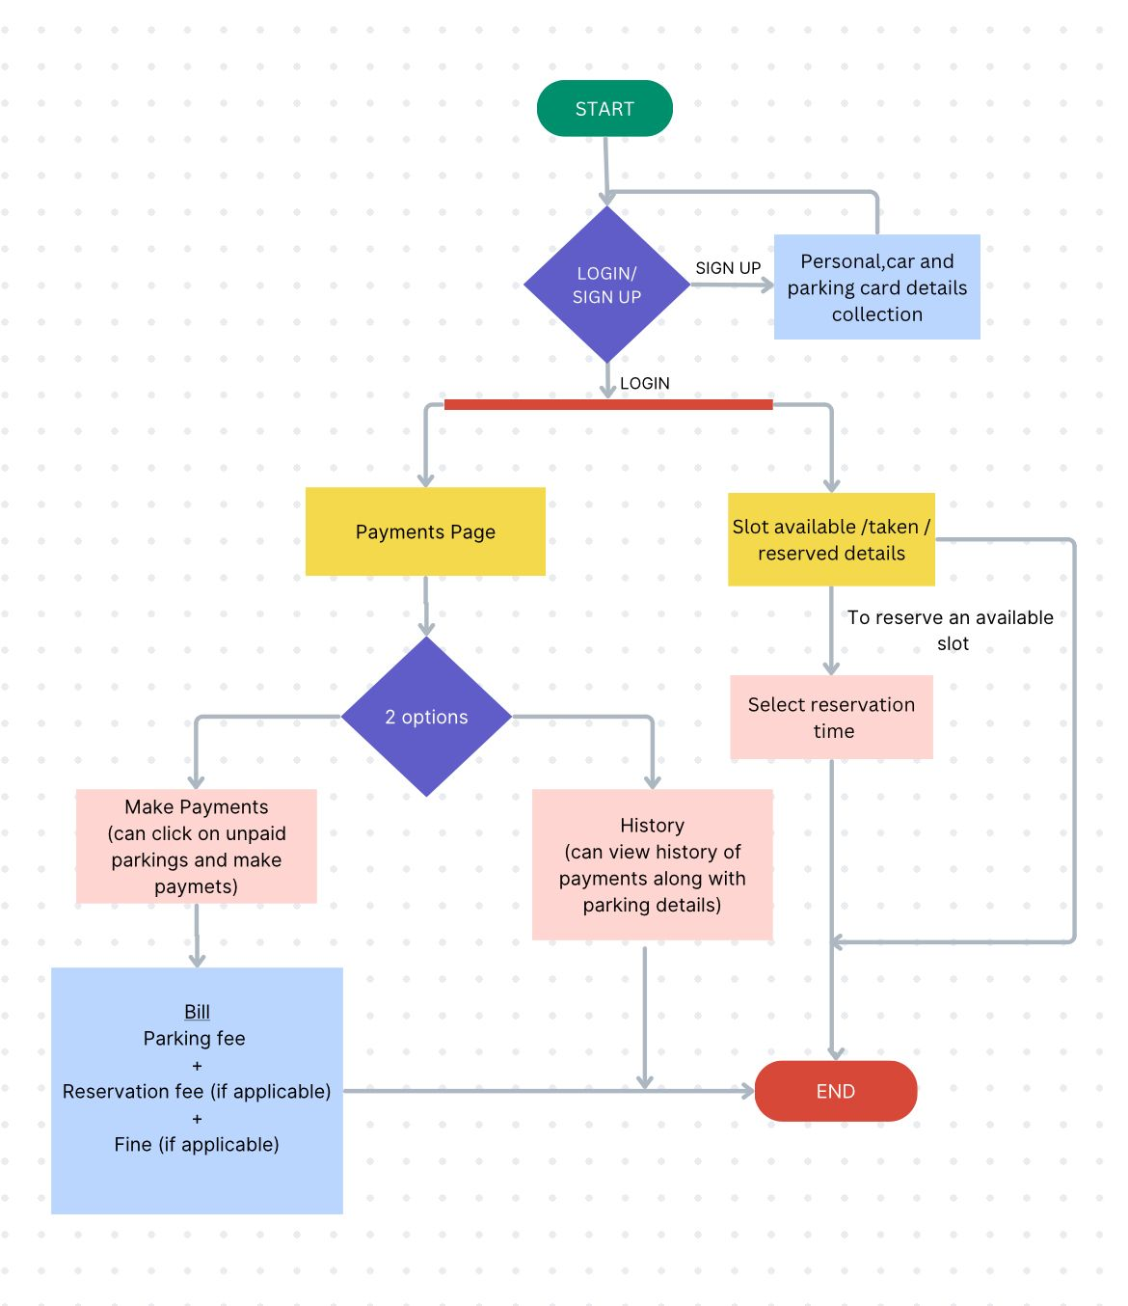

**Integration Approach**

**Data Collection:**

Raspberry Pi is employed to collect data from sensors utilizing GPIO pins, USB connections, or other compatible interfaces. Code is developed to read data from these sensors, ensuring accurate and timely information.

**Data Processing:**

The gathered sensor data undergoes processing on the Raspberry Pi. This involves data filtering, aggregation, and conversion as necessary. Scripts or programs are executed on the Raspberry Pi to perform these tasks efficiently.

**Integration Part Delving:**

The integration process of the smart parking system, involving Raspberry Pi, sensor data, and the mobile app, is a crucial aspect that demands in-depth exploration.

**Data Transmission:**

This phase revolves around establishing a secure communication link between the Raspberry Pi and the mobile app to enable real-time data transmission and updates. The following steps guide this process:

**Choose Communication Protocols:**

Selection of an appropriate communication protocol is vital for effective data exchange. Common options include:

**MQTT (Message Queuing Telemetry Transport):**

A lightweight and efficient protocol suitable for IoT applications like smart parking. The Raspberry Pi publishes parking space data, and the mobile app subscribes to updates.

**RESTful APIs (Application Programming Interfaces):**

Standard web service communication method. RESTful endpoints are created on the Raspberry Pi to expose data, and the mobile app makes HTTP requests to fetch updates.

**WebSocket:**

Provides real-time, full-duplex communication channels over a single TCP connection. Ideal for scenarios requiring instant updates. The Raspberry Pi maintains WebSocket connections with the mobile app for continuous data **streaming**.

**Error Handling and Resilience:**

The communication layer is designed to gracefully handle errors. Mechanisms for reconnecting in case of connection loss, along with implementing timeouts and retries, are crucial to ensuring reliable data transmission.

**Mobile App Integration:**

Development or updating of the mobile app is undertaken to receive and display data from the Raspberry Pi. The objective is to create a user-friendly interface presenting real-time parking space availability, pricing information, and navigation assistance. Emphasis is placed on ensuring the app can handle data updates responsively.

This comprehensive integration approach forms the backbone of the smart parking system, seamlessly connecting hardware components, data processing, and user interfaces to provide an efficient and user-friendly parking experience.

**Workflow:**

Users have the convenience of accessing the mobile app to check the real-time availability of parking slots whenever needed. For added convenience, users can also reserve a parking slot in advance before arriving at the parking facility. Upon reaching the parking area, the app assists users in locating an available parking slot, providing seamless navigation to the chosen spot. Once a user parks in an available slot, dedicated sensors capture this information and promptly update the app.

Similarly, when a user departs from the parking slot, the sensor system registers this change, marking the respective slot as available within the app. The sensors also record the duration of parking, ensuring accurate tracking of each user's parking activity, and this duration is promptly updated in the app.

To enhance the user experience further, each user possesses a smart parking card kept in their vehicle. This card is linked to their user profile in the app. Leveraging the chip embedded in the card, sensors capture relevant details such as parking duration and parking slot specifics. This information plays a crucial role in generating the parking bill. Users can conveniently view and settle their parking bills through the app, streamlining the entire process.