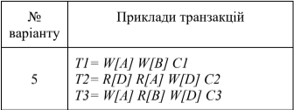

1.1 H_{T1, Т2, Т3} = X1[A] W1[A] R2[D] X3[A] – Wait X1[B] W1[B] R2[A] X2[D] W2[D]
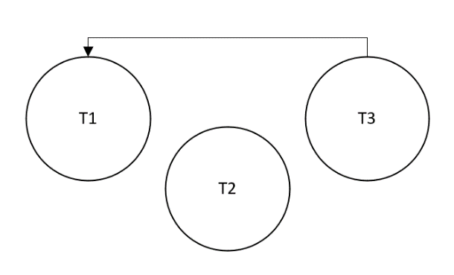
1.2

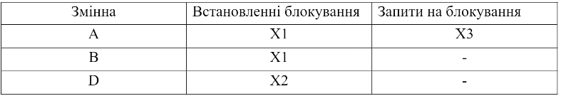

1.3 H_{T1, Т2, Т3} = X1[A] W1[A] S2[D] R2[D] X3[A] – Wait X1[B] W1[B] S2[A] – Wait

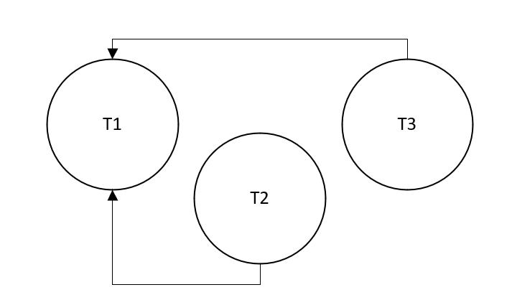
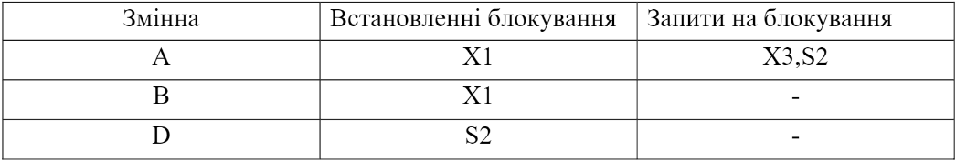
1.4

