Addressing Table

|  |  |  |
| --- | --- | --- |
| Device name | Interface | IP address/prefix |
| Router | G0/0 | 130.40.40.65 |
| Switch | VLAN1 | 130.40.40.94 |
| PC1 | NIC | 130.40.40.66 |
| PC2 | NIC | 130.40.40.67 |
| PC3 | NIC | 130.40.40.68 |
| PC4 | NIC | 130.40.40.69 |

|  |  |  |
| --- | --- | --- |
|  |  | Password |
| Router | Privileged EXEC (encrypted password) | $1$mERr$wZMkJsj2RVk4hay2C4T32 |
| Switch | Privileged EXEC (encrypted password) | $1$mERr$o1YRSRaFfyl66XAQedal6. |

|  |  |  |
| --- | --- | --- |
|  | Username | Password |
| Router | admin | admin1234 |
| Switch | admin | admin1234 |

PrintScreen of telnet and SSH to the router:

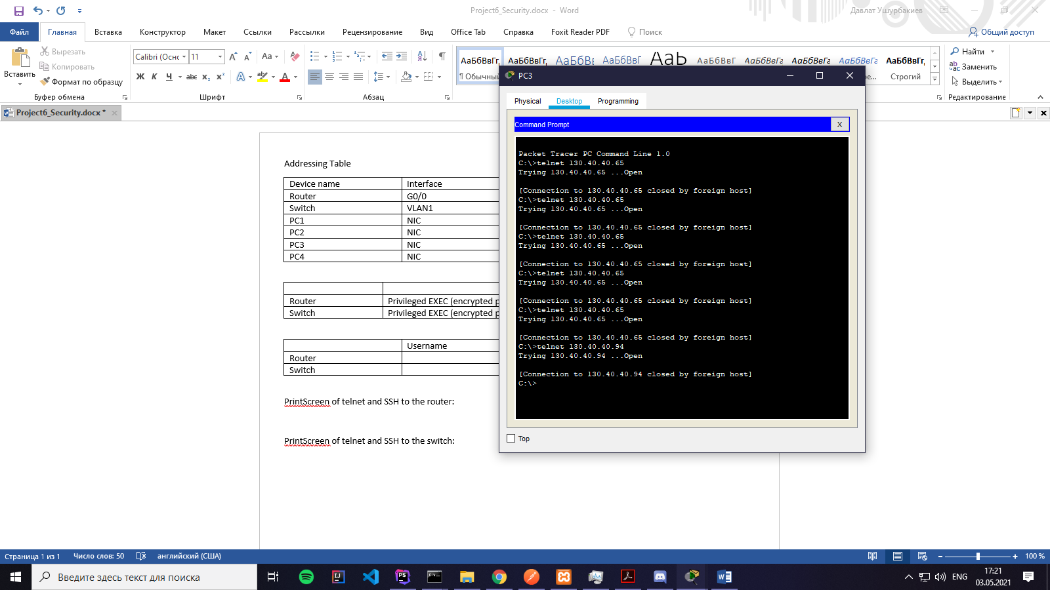

PrintScreen of telnet and SSH to the switch:

