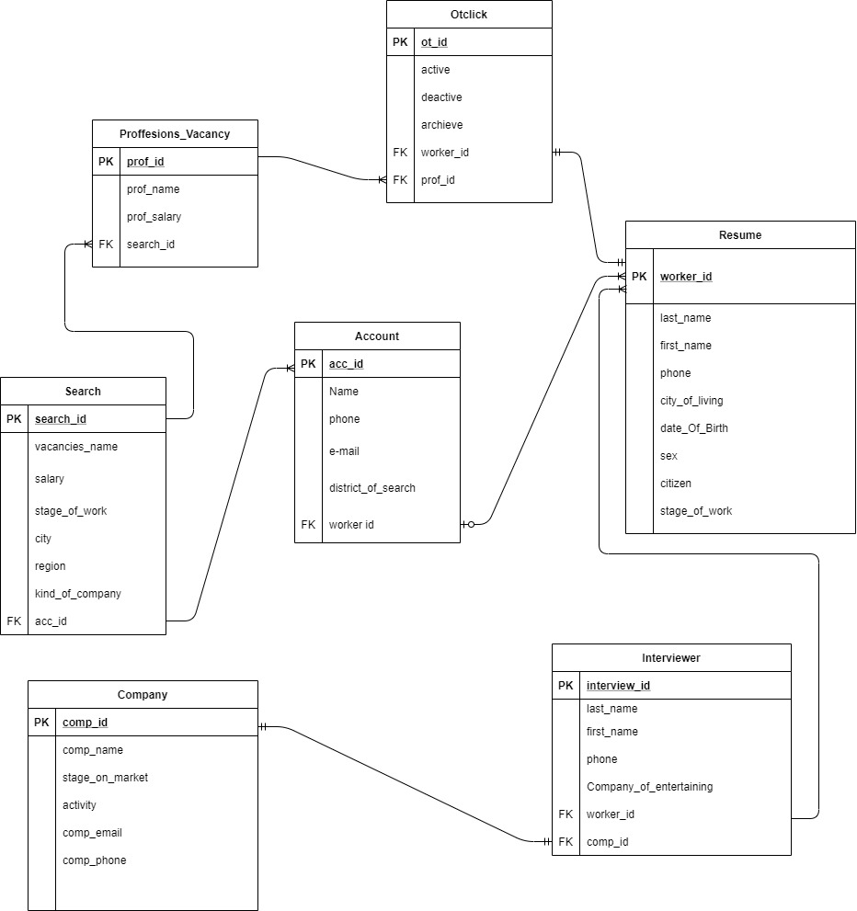

2)

Dependencies:

One Account has many Resume.

One Search has many Accounts.

One Search has many Proffesion_Vacancies.

One Proffesion_Vacancy has many Otclicks.

One Otclick has one Resume

One Company has One Interviewer

One Interviewer has many Resume

3)

To achieve 3NF comparing with the part 2 I changed relation Entity from table Search to Proffesions_Vacancy, from “many to many” to “one to one”.

Also From table Search to table Account from many to many to one to one.

Examples :

UNF -> 1NF

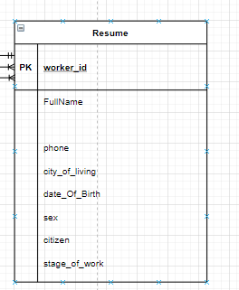 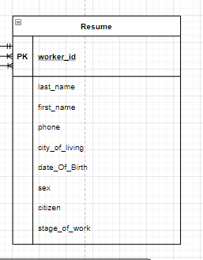

1NF -> 2NF

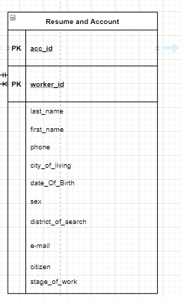 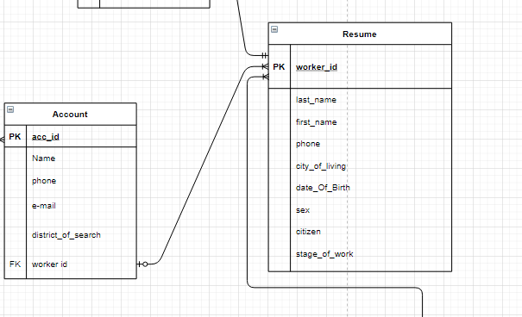

2NF -> 3NF

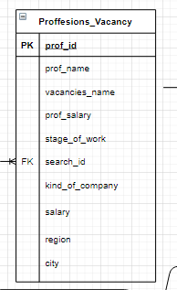 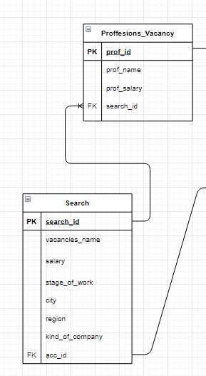

Account entity:

|  |  |  |  |
| --- | --- | --- | --- |
| Field’s content | Field’s name | Type, length | Note(constraints) |
| Account ID | **acc_id** | N(10) | PK |
| Name | Name | C(10) | NOT NULL |
| phone | phone | N(50) | NOT NULL |
| E-mail | e-mail | C(50) | NOT NULL |
| District of search | district_of_search | C(50) | NOT NULL |
| Worker id | worker id | N(10) | FK to Resume |

|  |  |  |  |
| --- | --- | --- | --- |
| Field’s content | Field’s name | Type, length | Note(constraints) |
| Worker id | **worker_id** | N(10) | PK |
| Last name | last_name | C(10) | NOT NULL |
| First name | first_name | N(10) | NOT NULL |
| Phone | phone | N(10) | NOT NULL |
| City | city_of_living | C(10) | NOT NULL |
| Birth Date | date_Of_Birth | D | NOT NULL |
| Sex | sex | C(10) | NOT NULL |
| Citizen | citizen | B | NOT NULL |
| Stage | stage_of_work | N(3) | NOT NULL |

Resume entity:

Otclick entity:

|  |  |  |  |
| --- | --- | --- | --- |
| Field’s content | Field’s name | Type, length | Note(constraints) |
| Otclick id | **ot_id** | N(10) | PK |
| Active | active | B | NOT NULL |
| Deactive | deactive | B | NOT NULL |
| Acrchieve | archieve | B | NOT NULL |
| Worker id | worker_id | N(10) | FK to Resume |
| Prof id | prof_id | N(10) | FK to Proffesions |

Interviewer entity:

|  |  |  |  |
| --- | --- | --- | --- |
| Field’s content | Field’s name | Type, length | Note(constraints) |
| Interviewer id | **interview_id** | N(10) | PK |
| Last name | last_name | C(50) | NOT NULL |
| First name | first_name | C(50) | NOT NULL |
| Phone | phone | N(10) | NOT NULL |
| Company | Company_of_entertaining | C(10) | NOT NULL |
| Worker id | worker_id | N(10) | FK to Resume |
| Comp id | comp_id | N(10) | FK to Company |

Proffesions_vacancy:

|  |  |  |  |
| --- | --- | --- | --- |
| Field’s content | Field’s name | Type, length | Note(constraints) |
| Proffesion id | **prof_id** | N(10) | PK |
| Proffesion name | prof_name | D | NOT NULL |
| Proffesion salary | prof_salary | N(6) | NOT NULL |
| Search id | search_id | N(10) | NOT NULL |

Search entity:

|  |  |  |  |
| --- | --- | --- | --- |
| Field’s content | Field’s name | Type, length | Note(constraints) |
| Search id | **search_id** | N(10) | PK |
| Vacancy name | vacancies_name | N(10) | NOT NULL |
| Salary | salary | N(5) | NOT NULL |
| Stage | stage_of_work | N(4) | NOT NULL |
| City | city | C(10) | NOT NULL |
| Region | region | C(10) | NOT NULL |
| Company kind | kind_of_company | C(10) | NOT NULL |

Company entity:

|  |  |  |  |
| --- | --- | --- | --- |
| Field’s content | Field’s name | Type, length | Note(constraints) |
| Company id | **comp_id** | N(10) | PK |
| Company Name | comp_name | C(50) | NOT NULL |
| Stage | stage_on_market | N(10) | NOT NULL |
| Activity | activity | B | NOT NULL |
| Company email | comp_email | C(60) | NOT NULL |
| Company phone | comp_phone | N(10) | NOT NULL |