***Davlatbek Ushurbakiyev is presenting : Course work part 7-8.***

1 query about how to integrate data from two tables to one

SELECT name,phone,email FROM account

UNION

SELECT last_name,phone,company_of_entertaining FROM interviewer

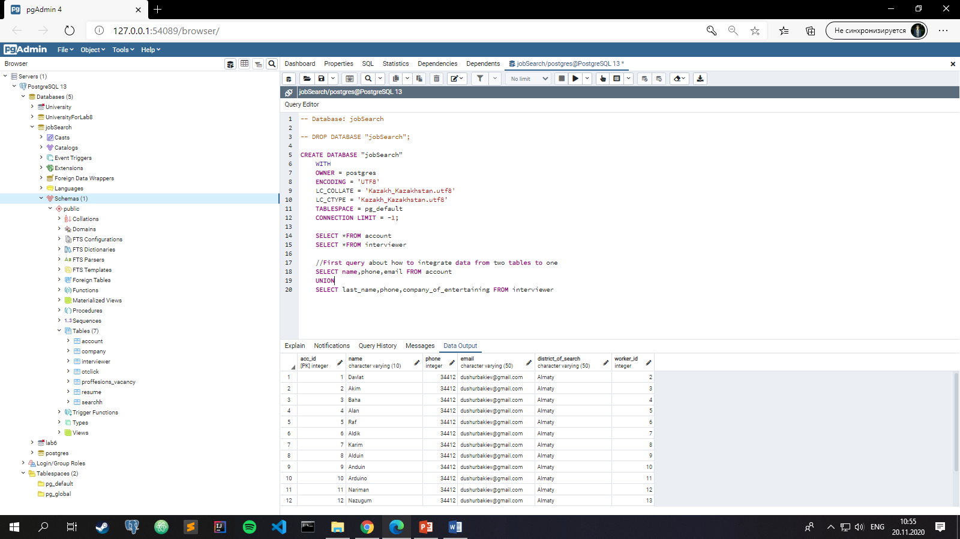

2 query about how to integrate data to table without data from definite table

SELECT name,phone,email FROM account

EXCEPT

SELECT last_name,phone,company_of_entertaining FROM interviewer

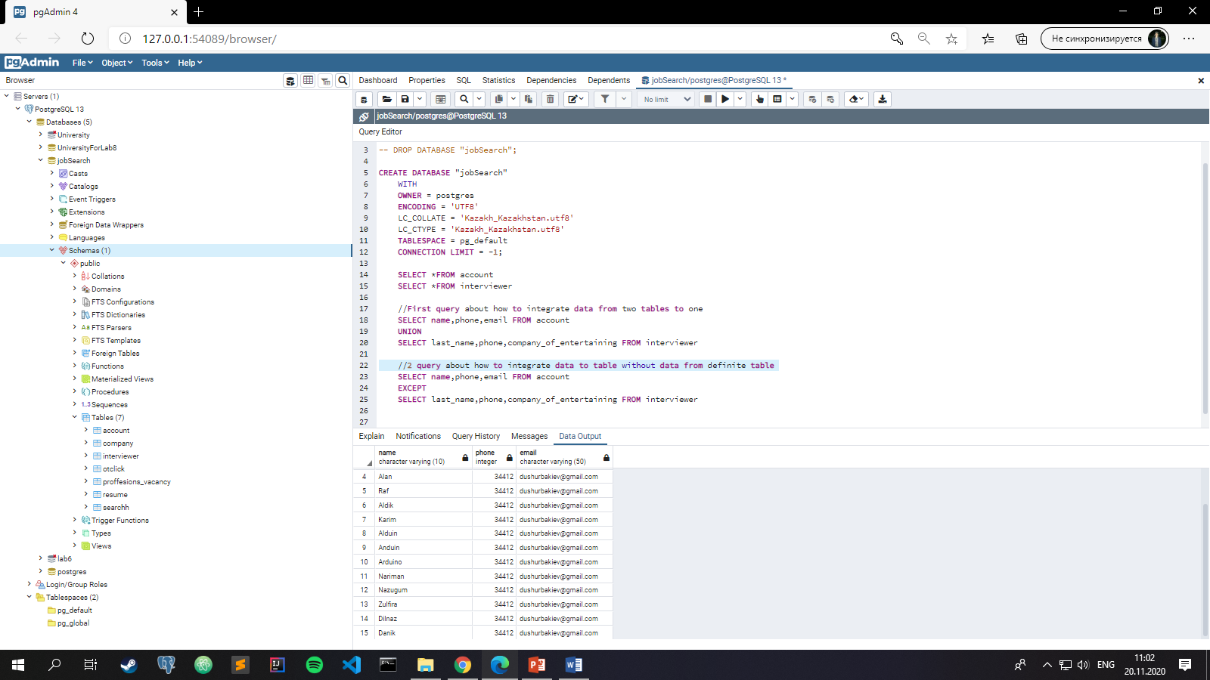

3 query about how to show the correlate data between bind tables

SELECT resume.sex,account.name,account.phone

FROM account

INNER JOIN resume

ON account.worker_id = resume.worker_id

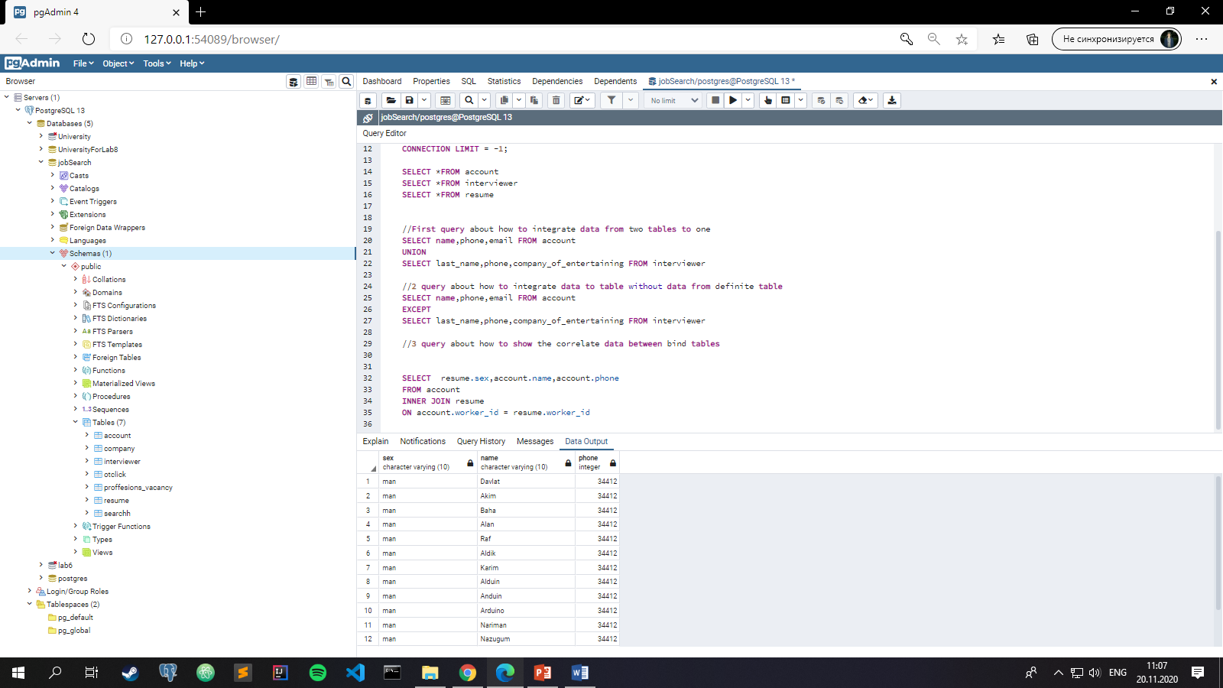

4 query about how integrate data for each row by crossing them

SELECT resume.data_of_birth,account.name,account.phone

FROM account

CROSS JOIN resume

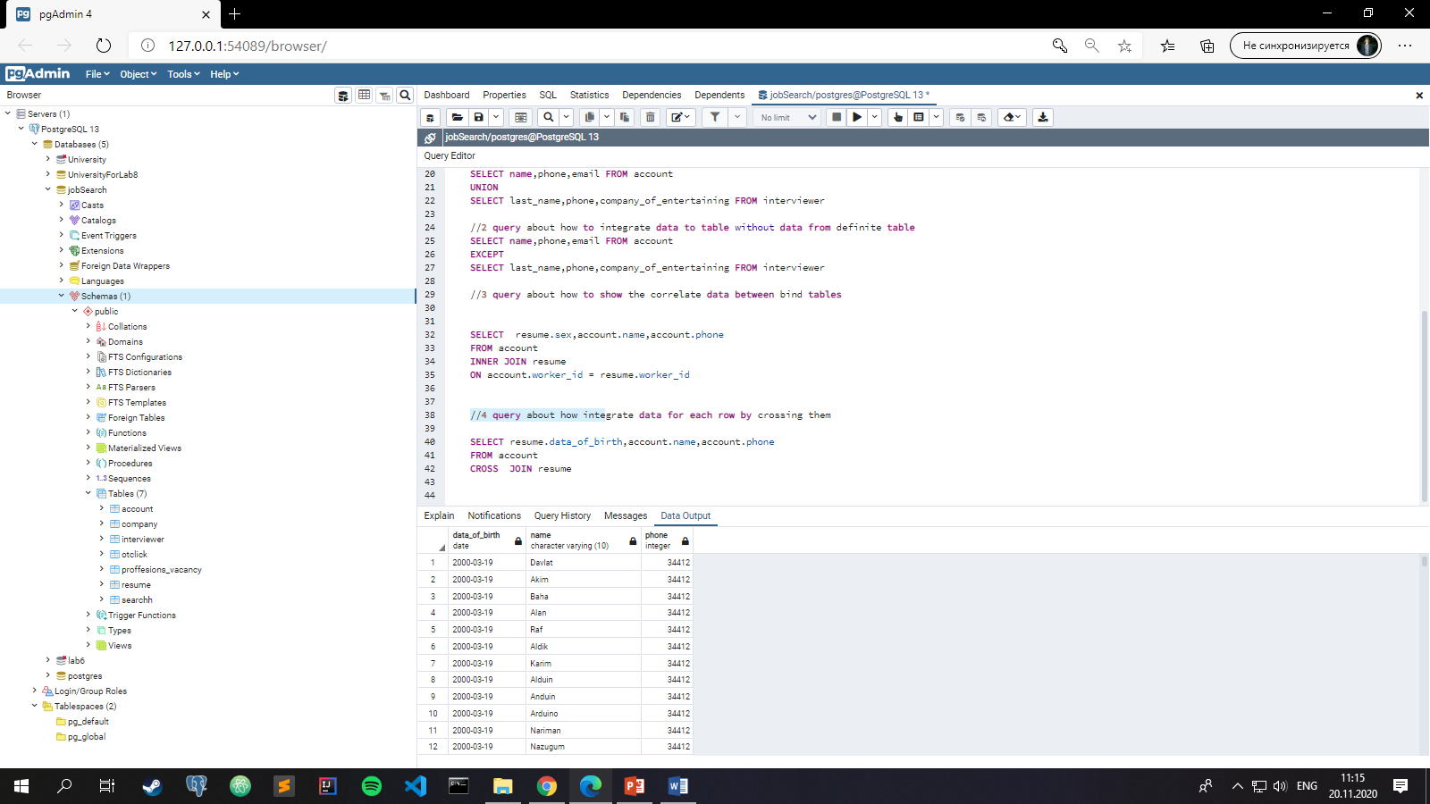

//5 query about how to use Aliasing and also group data with help of it

SELECT c.comp_name,c.stage_on_market, i.last_name

FROM company c,interviewer i

WHERE c.comp_id = i.comp_id

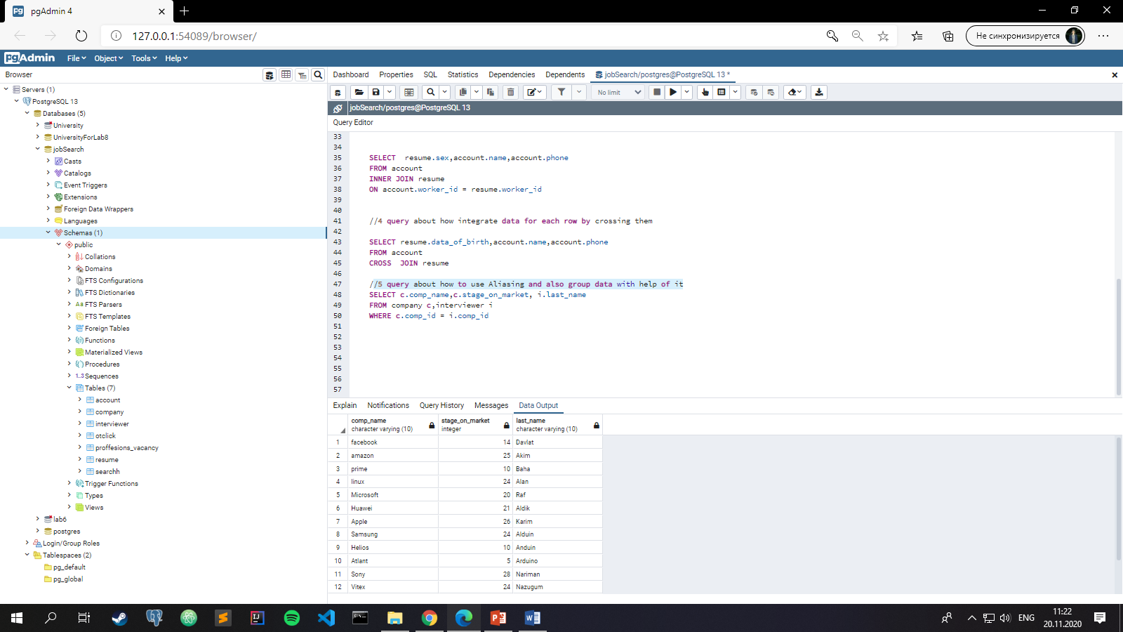

//6 query is about how to manage data according to different attributes

SELECT comp_name

FROM company

WHERE stage_on_market BETWEEN 10 and 30

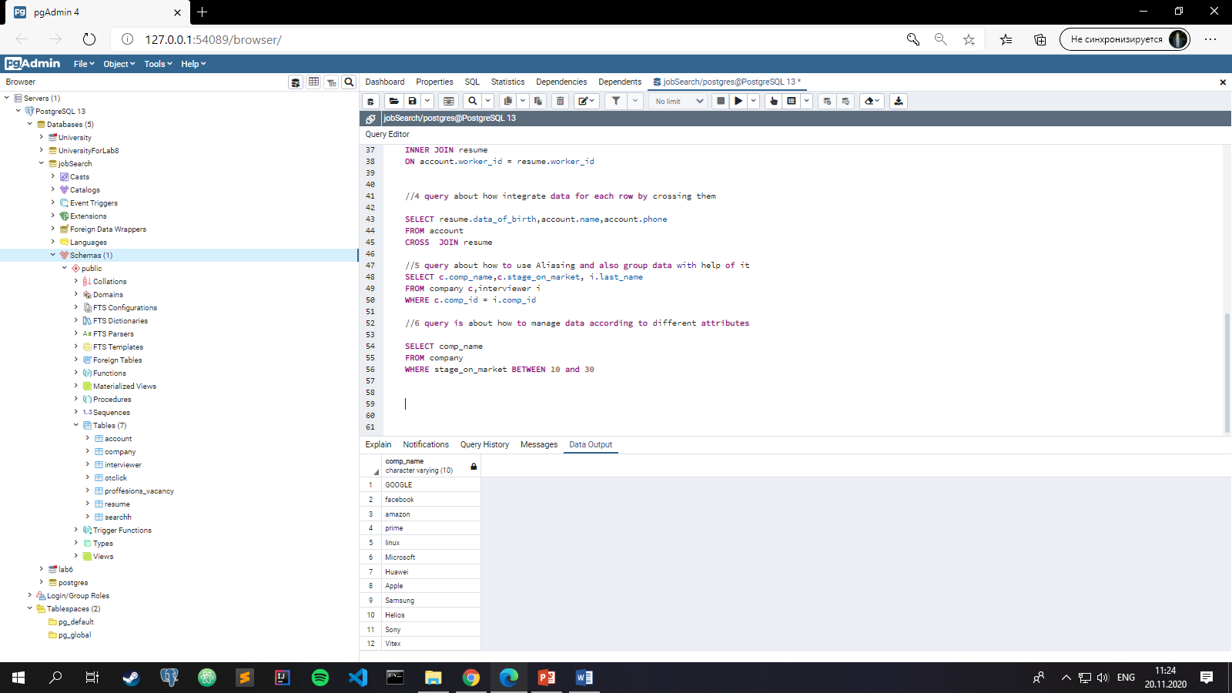

//7 query is about how to sort string datatype by first letter

SELECT last_name

FROM resume

WHERE last_name LIKE 'D%'

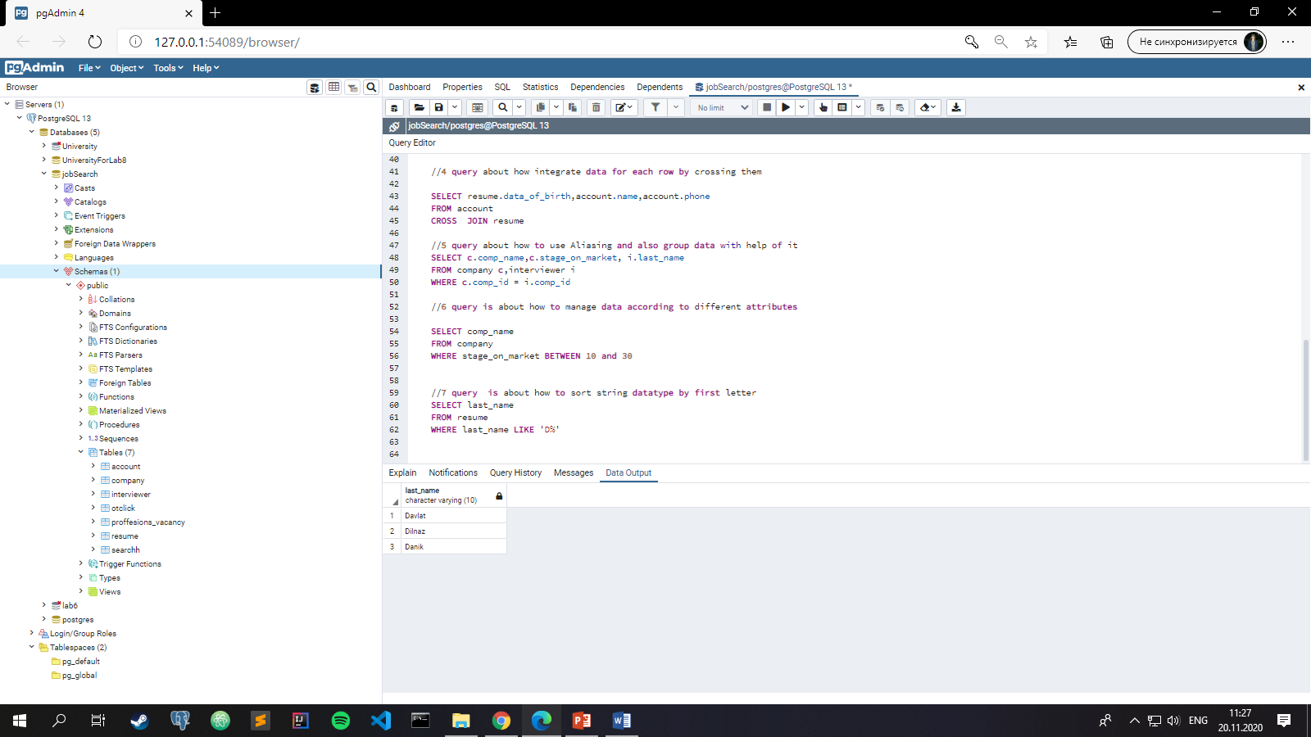

//8 query is about how to change datatype from one to another

SELECT CAST(stage_on_market AS VARCHAR(20))

FROM company

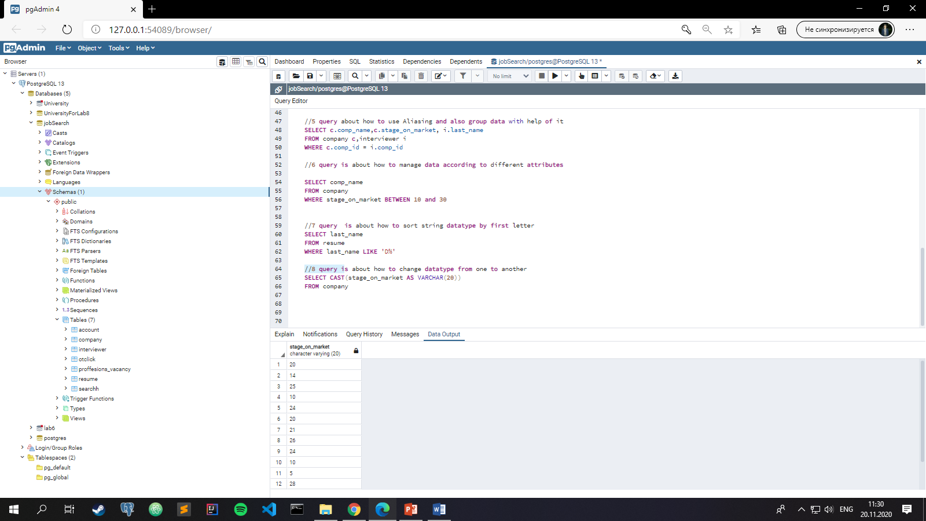

//9 query is about how to union attributes to one with saving data to it

SELECT active, deactive || ' ' || archieve AS inactive

FROM otclick

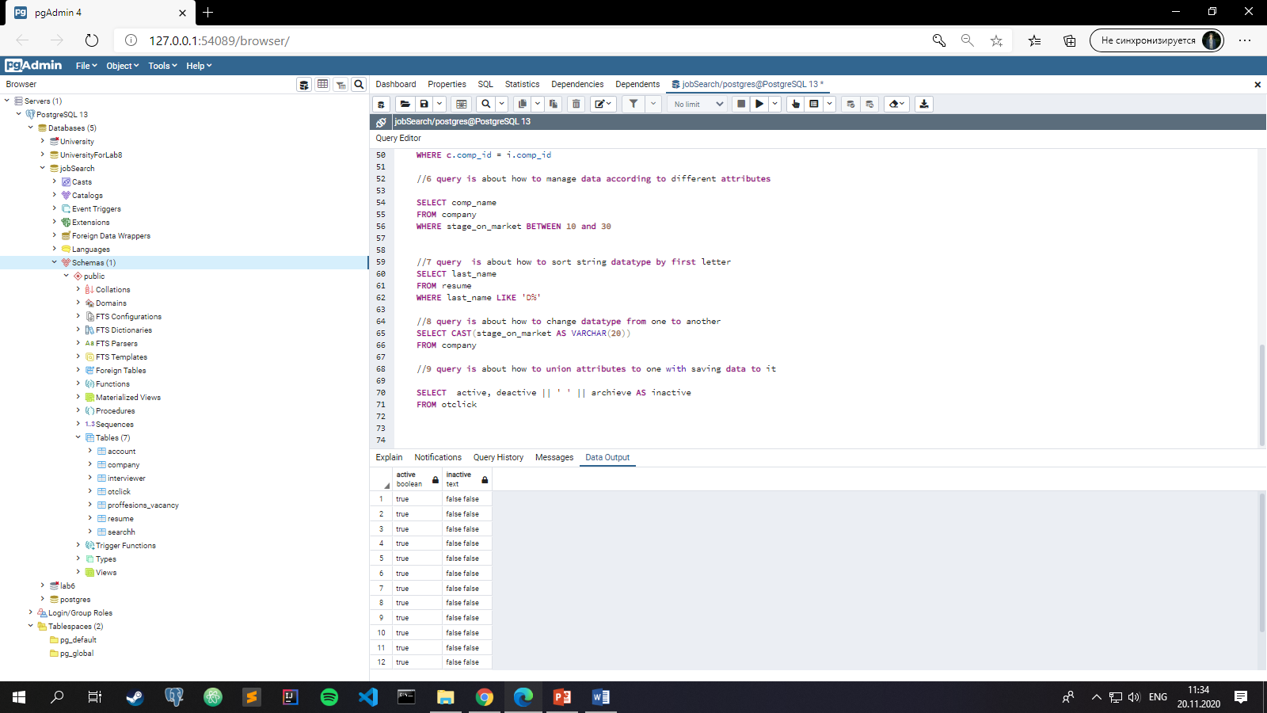

//10 query is about how to show grouped data by different attributes

SELECT a.name, a.phone, a.email, a.district_of_search

FROM account a

GROUP BY a.name,a.phone,a.email,a.district_of_search

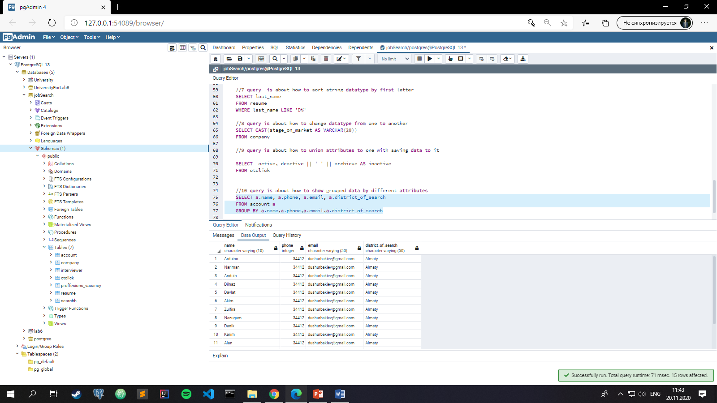

//11 query is about how to show ordered data in Descending order

SELECT a.name

FROM account a

ORDER BY a.name DESC

