MINISTRY OF EDUCATION AND SCIENCE OF THE REPUBLIC OF KAZAKHSTAN

INTERNATIONAL INFORMATION TECHNOLOGY UNIVERSITY

COMPUTER ENGINEERING AND INFORMATION SECURITY DEPARTMENT

COURSE WORK

Designing Databases. Introduction to SQL

Done by student: Ushurbakiyev Davlatbek

Group: ITSE-1909r

Almaty 2020

1 DESIGNING DATABASE

* 1. Subject area analysis (part 1)

--Font type Times New Roman 12, Interval 1,15

1. The DB is designed to hold information relating to/ about **job search**.
2. 7 entities:

Resume (worker_id, last_name,first_name,phone,city_of_living,dateOfBirth,sex,citizen,stageOfWork);

Interviewer (interview_id,last_name,first_name,phone,Company_of_entertaining);

Company (comp_id, comp_name, stage_on_market,activity,comp_email,comp_phone);

Proffesions_Vacancy (prof_id,prof_name,prof_condition,prof_salary);

Account (acc_id, , name,phone ,e-mail,socialMedia,district_of_search);

Otclik(ot_id,active,deactive,archieve,all)

Search(search_id,vacancies_name,salary,stage_of_work,city,region,kind_of_company,

Workschedule);

1. One Account can has many Resume also can has many Search.

One Interviewer can check many Resume.

One Company can has many Interviewers and many Proffesions_Vacancies.

One Search can has many Account.

One Proffesion_Vacancy can has many Search.

One Resume can has many Otclicks.

1. Account`s date of birth must be earlier than 2003.

Company`s activity should be legal.

Proffesions_Vacancy name,prof_condition,prof_salary should not be an empty.

Otclick archieve should not be an empty.

1. The Database is designed for Job Search site workers who has access to personal data of Resumes/Company and admin panel.
2. Find Account by first name.

Sort Resumes by stageOfWork.

Find Company by its activity.

Sort Search by region of WorkSchedule.

Find only active Otclick.

* 1. ER diagram (part 2)

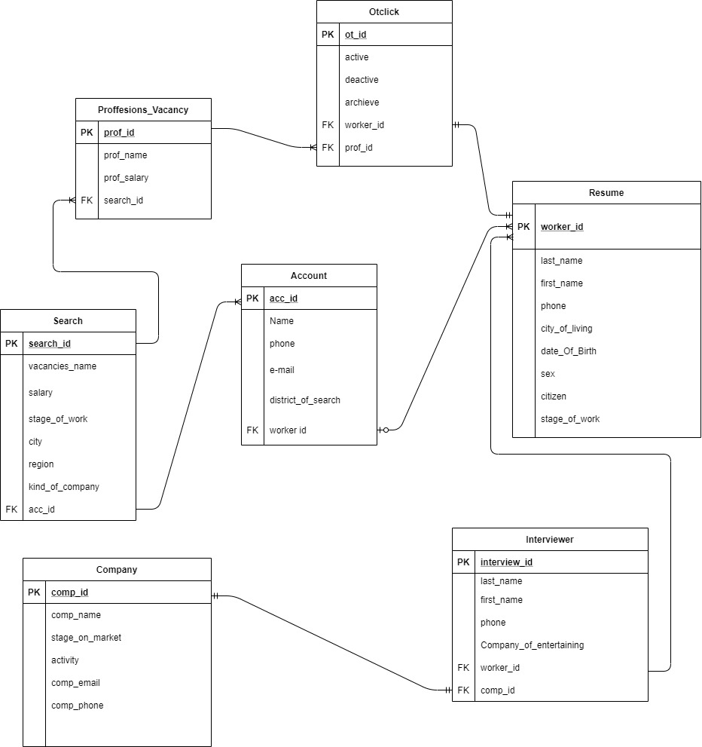

* 1. Logical design (part 3)

Dependencies:

One Account has many Resume.

One Search has many Accounts.

One Search has many Proffesion_Vacancies.

One Proffesion_Vacancy has many Otclicks.

One Otclick has one Resume

One Company has One Interviewer

One Interviewer has many Resume

3)To achieve 3NF comparing with the part 2 I changed relation Entity from table Search to Proffesions_Vacancy, from “many to many” to “one to one”.

Also From table Search to table Account from many to many to one to one.

Examples :

UNF -> 1NF

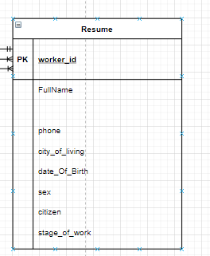 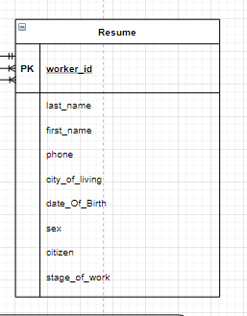

1NF -> 2NF

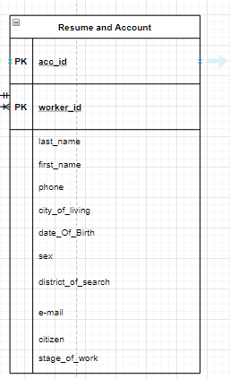 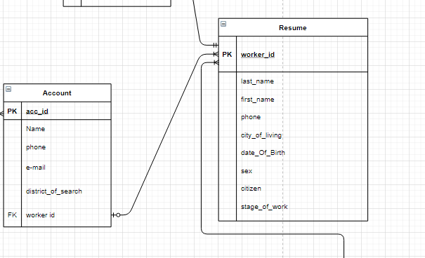

2NF -> 3NF

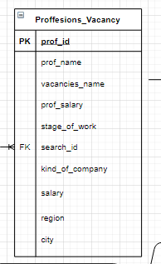 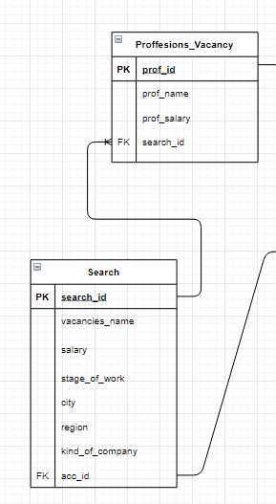

Account entity:

|  |  |  |  |
| --- | --- | --- | --- |
| Field’s content | Field’s name | Type, length | Note(constraints) |
| Account ID | **acc_id** | N(10) | PK |
| Name | Name | C(10) | NOT NULL |
| phone | phone | N(50) | NOT NULL |
| E-mail | e-mail | C(50) | NOT NULL |
| District of search | district_of_search | C(50) | NOT NULL |
| Worker id | worker id | N(10) | FK to Resume |

|  |  |  |  |
| --- | --- | --- | --- |
| Field’s content | Field’s name | Type, length | Note(constraints) |
| Worker id | **worker_id** | N(10) | PK |
| Last name | last_name | C(10) | NOT NULL |
| First name | first_name | N(10) | NOT NULL |
| Phone | phone | N(10) | NOT NULL |
| City | city_of_living | C(10) | NOT NULL |
| Birth Date | date_Of_Birth | D | NOT NULL |
| Sex | sex | C(10) | NOT NULL |
| Citizen | citizen | B | NOT NULL |
| Stage | stage_of_work | N(3) | NOT NULL |

Resume entity:

Otclick entity:

|  |  |  |  |
| --- | --- | --- | --- |
| Field’s content | Field’s name | Type, length | Note(constraints) |
| Otclick id | **ot_id** | N(10) | PK |
| Active | active | B | NOT NULL |
| Deactive | deactive | B | NOT NULL |
| Acrchieve | archieve | B | NOT NULL |
| Worker id | worker_id | N(10) | FK to Resume |
| Prof id | prof_id | N(10) | FK to Proffesions |

Interviewer entity:

|  |  |  |  |
| --- | --- | --- | --- |
| Field’s content | Field’s name | Type, length | Note(constraints) |
| Interviewer id | **interview_id** | N(10) | PK |
| Last name | last_name | C(50) | NOT NULL |
| First name | first_name | C(50) | NOT NULL |
| Phone | phone | N(10) | NOT NULL |
| Company | Company_of_entertaining | C(10) | NOT NULL |
| Worker id | worker_id | N(10) | FK to Resume |
| Comp id | comp_id | N(10) | FK to Company |

Proffesions_vacancy:

|  |  |  |  |
| --- | --- | --- | --- |
| Field’s content | Field’s name | Type, length | Note(constraints) |
| Proffesion id | **prof_id** | N(10) | PK |
| Proffesion name | prof_name | D | NOT NULL |
| Proffesion salary | prof_salary | N(6) | NOT NULL |
| Search id | search_id | N(10) | NOT NULL |

Search entity:

|  |  |  |  |
| --- | --- | --- | --- |
| Field’s content | Field’s name | Type, length | Note(constraints) |
| Search id | **search_id** | N(10) | PK |
| Vacancy name | vacancies_name | N(10) | NOT NULL |
| Salary | salary | N(5) | NOT NULL |
| Stage | stage_of_work | N(4) | NOT NULL |
| City | city | C(10) | NOT NULL |
| Region | region | C(10) | NOT NULL |
| Company kind | kind_of_company | C(10) | NOT NULL |

Company entity:

|  |  |  |  |
| --- | --- | --- | --- |
| Field’s content | Field’s name | Type, length | Note(constraints) |
| Company id | **comp_id** | N(10) | PK |
| Company Name | comp_name | C(50) | NOT NULL |
| Stage | stage_on_market | N(10) | NOT NULL |
| Activity | activity | B | NOT NULL |
| Company email | comp_email | C(60) | NOT NULL |
| Company phone | comp_phone | N(10) | NOT NULL |