///1 Well, we can use some kind of ariphmetic operations with the attribute that we want to use for achieve some definite result like this:

SELECT last_name

FROM resume

WHERE worker_id = (

SELECT worker_id-1

FROM account

WHERE acc_id = 1

)

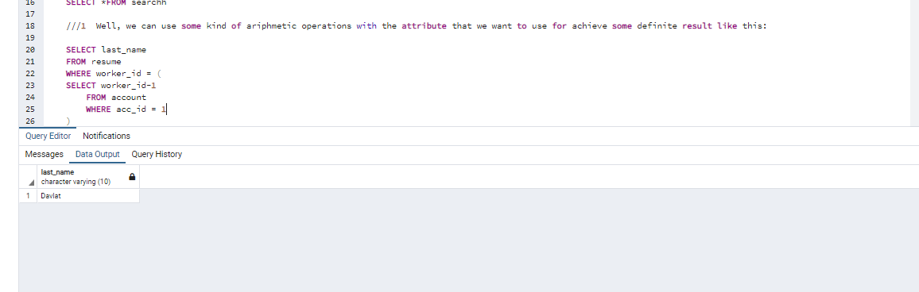

2) For example we need to find all names and sex of those people whose stage of work less than 5 to make some research work.

SELECT a.name, r.sex

FROM account a , resume r

WHERE a.worker_id = r.worker_id

AND r.worker_id IN (

SELECT r.worker_id

FROM resume r

WHERE r.stage_of_work < 5

)

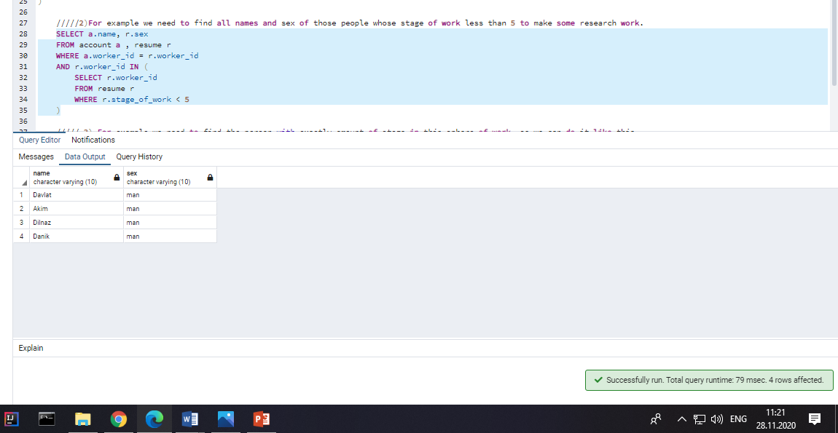

///// 3) For example we need to find the person with exactly amount of stage in this sphere of work, so we can do it like this

SELECT a.name, r.sex

FROM account a , resume r

WHERE a.worker_id = r.worker_id

AND EXISTS(

SELECT*

FROM account ,resume

WHERE r.stage_of_work = 10

)

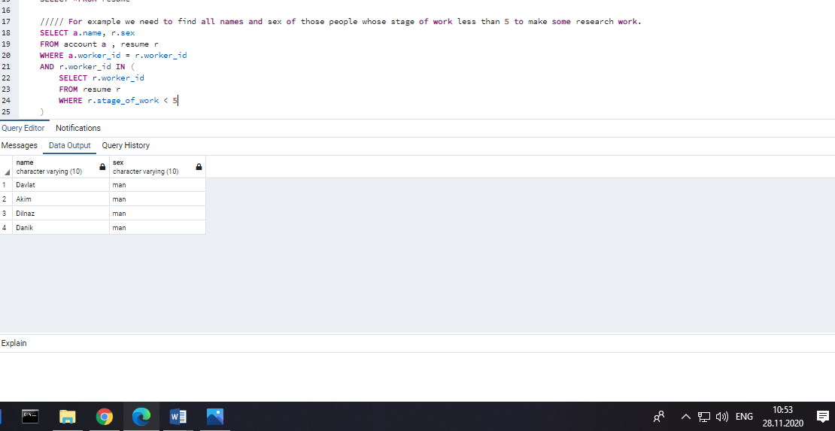

///// 4) Let`s consider this situation when we need to find Any people from Almaty for example

SELECT a.name, r.city_of_living ,r.sex

FROM account a , resume r

WHERE a.worker_id = r.worker_id

AND a.district_of_search = ANY(

SELECT a.district_of_search

FROM account a

WHERE a.district_of_search = 'Almaty'

)

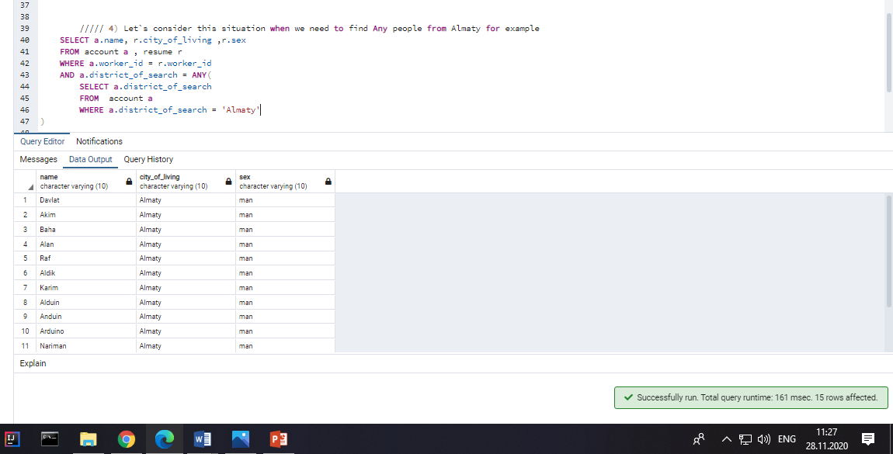

///// 5) Let`s consider this situation when we need to find All men from the list of candidates

SELECT a.name, r.sex

FROM account a , resume r

WHERE a.worker_id = r.worker_id

AND r.sex = ALL(

SELECT r.sex

FROM resume r

WHERE r.sex = 'man'

)

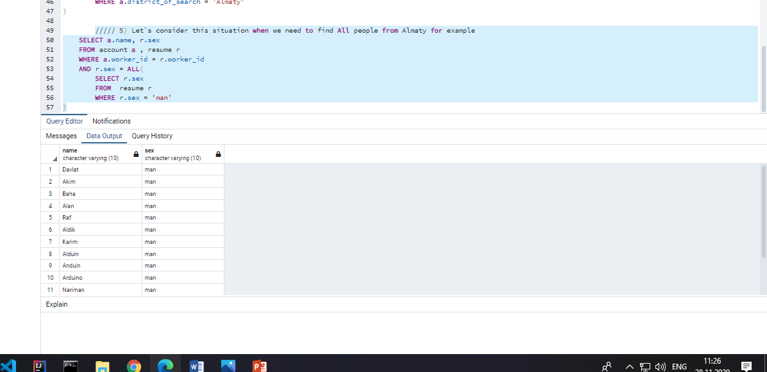

// 6) Look, we can use subquery in FROM operator like this and for help of it we can choose what we need to find using alias of FROM operator

SELECT name_of_worker

FROM (

SELECT a.name AS name_of_worker

FROM account a

GROUP BY a.name

) WorkerNum

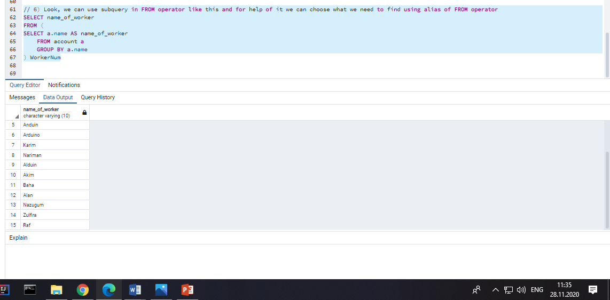

//7) We need to paste the information about workers who are citizens into account , not a problem we can do it ,but we need to be more accurate because of type of data and number of keys.

INSERT INTO account(acc_id,name,phone,email,district_of_search,worker_id)

(SELECT worker_id+15,last_name,phone,first_name,city_of_living,worker_id

FROM resume WHERE citizen = true

)

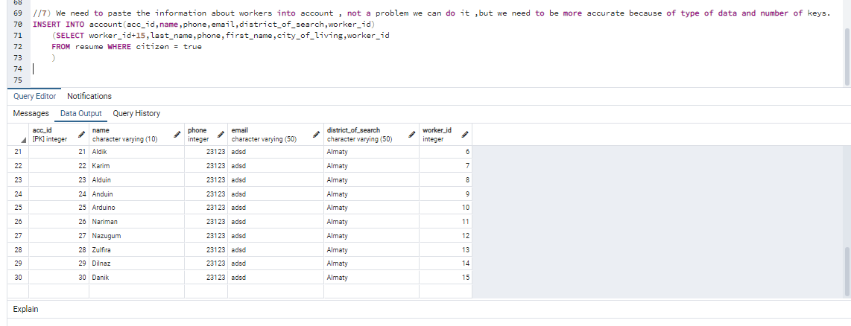

/////8) We need to delete some account because user decided to remove it from our site, well we can do it in one query with his id and account table

DELETE

FROM account

WHERE acc_id = (

SELECT acc_id FROM account

WHERE acc_id = 15

)

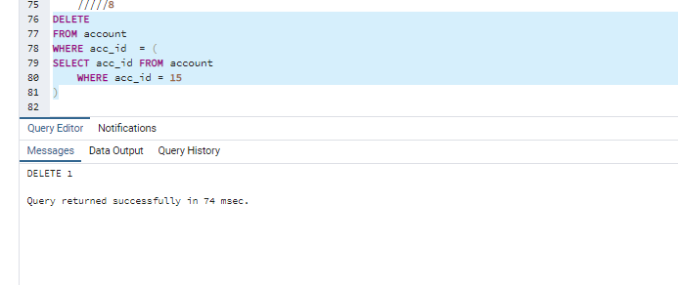

/// 9) For example we need to update id of some sort of users and we can do it like this

UPDATE account

SET acc_id = acc_id +101

WHERE acc_id = ANY(

SELECT acc_id

FROM account

WHERE acc_id > 15

)

