//1 PROJECTION

SELECT acc_id FROM account

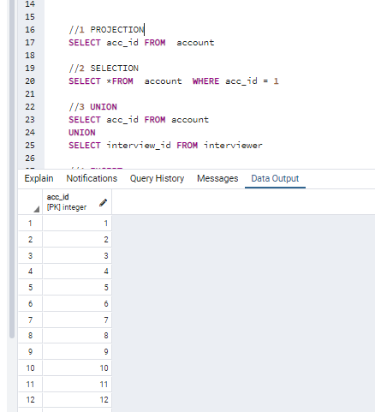

//2 SELECTION

SELECT *FROM account WHERE acc_id = 1

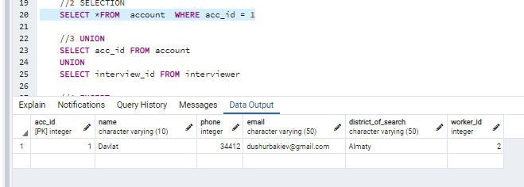

//3 UNION

SELECT acc_id FROM account

UNION

SELECT interview_id FROM interviewer

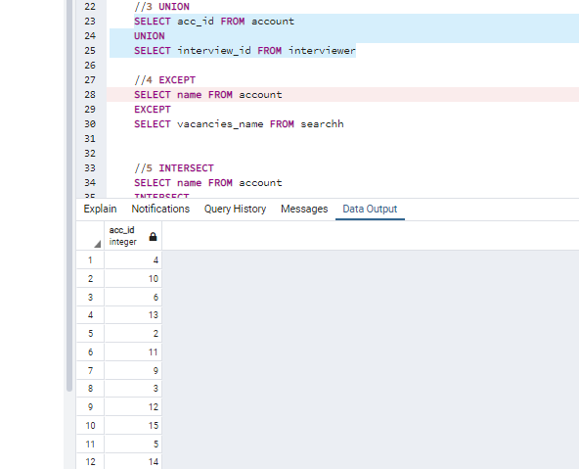

//4 EXCEPT

SELECT name FROM account

EXCEPT

SELECT vacancies_name FROM searchh

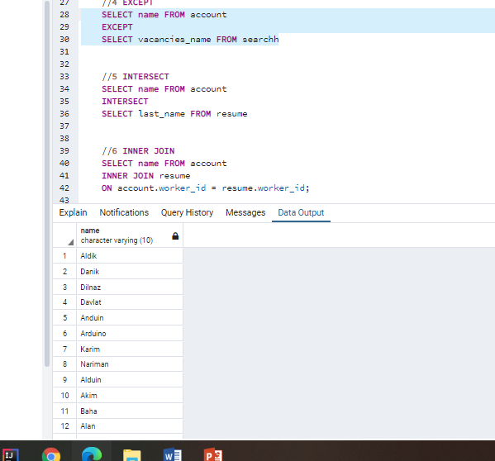

//5 INTERSECT

SELECT name FROM account

INTERSECT

SELECT last_name FROM resume

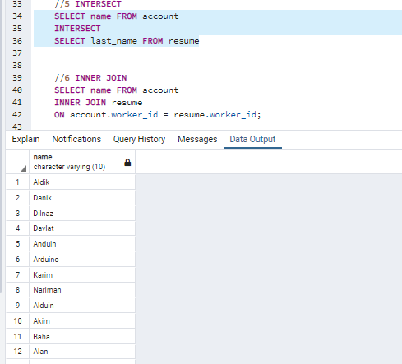

//6 INNER JOIN

SELECT name FROM account

INNER JOIN resume

ON account.worker_id = resume.worker_id;

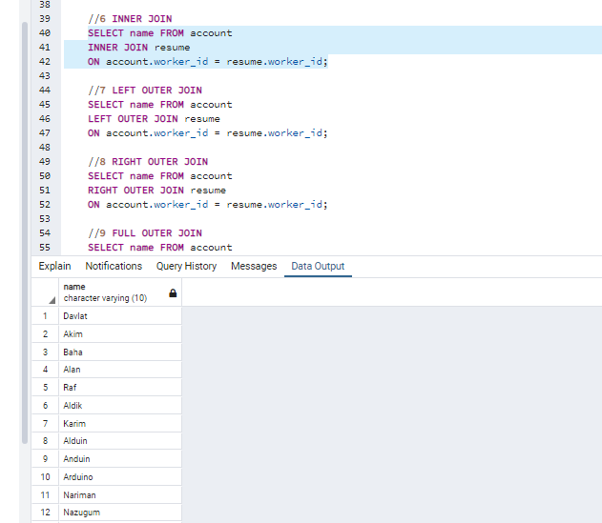

//7 LEFT OUTER JOIN

SELECT name FROM account

LEFT OUTER JOIN resume

ON account.worker_id = resume.worker_id;

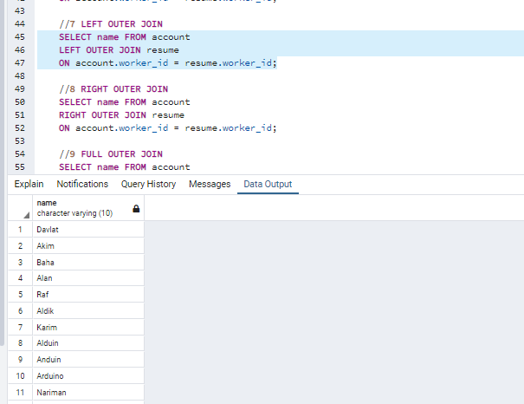

//8 RIGHT OUTER JOIN

SELECT name FROM account

RIGHT OUTER JOIN resume

ON account.worker_id = resume.worker_id;

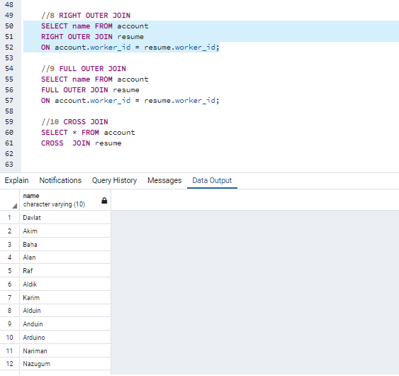

//9 FULL OUTER JOIN

SELECT name FROM account

FULL OUTER JOIN resume

ON account.worker_id = resume.worker_id;

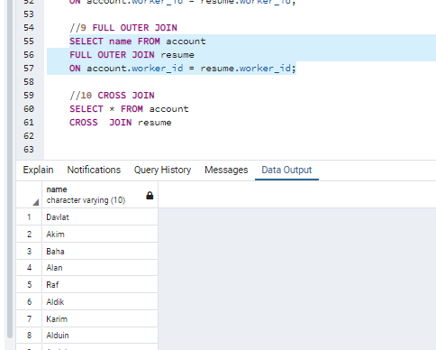

//10 CROSS JOIN

SELECT * FROM account

CROSS JOIN resume

