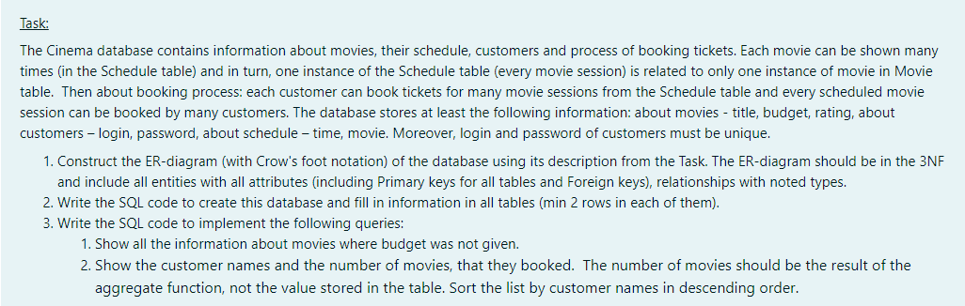

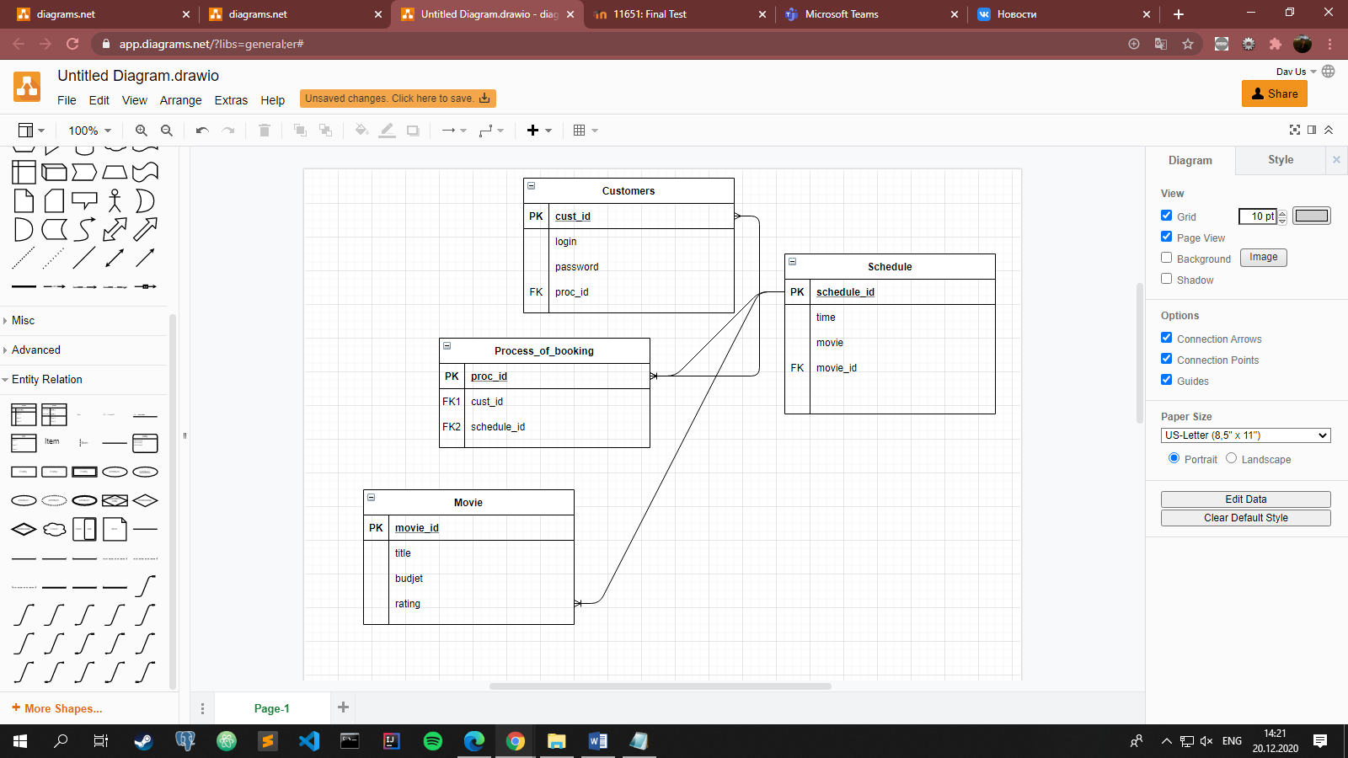

-- Database: Final

-- DROP DATABASE "Final";

CREATE DATABASE "Final"

WITH

OWNER = postgres

ENCODING = 'UTF8'

LC_COLLATE = 'Kazakh_Kazakhstan.utf8'

LC_CTYPE = 'Kazakh_Kazakhstan.utf8'

TABLESPACE = pg_default

CONNECTION LIMIT = -1;

CREATE TABLE Customers (cust_id int Primary key,

login VARCHAR(10),

password VARCHAR(10)

)

CREATE TABLE Schedule (schedule_id int Primary key,

time int,

movie VARCHAR(10)

)

CREATE TABLE Process_of_booking (proc_id int Primary key,

cust_id int,

schedule_id int

)

ALTER TABLE Process_of_booking ADD FOREIGN KEY (cust_id) REFERENCES Customers (cust_id);

ALTER TABLE Process_of_booking ADD FOREIGN KEY (schedule_id) REFERENCES Schedule (schedule_id);

CREATE TABLE Movie (movie_id int Primary key,

title Varchar(10),

budjet int,

rating int

)

SELECT *FROM Customers

SELECT *FROM Schedule

SELECT *FROM Process_of_booking

SELECT *FROM Movie

INSERT INTO Customers VALUES(1,'Davlat','dada2000')

INSERT INTO Customers VALUES(2,'Davla2t','dada332000')

INSERT INTO Customers VALUES(4,'Davlats','dada200202')

INSERT INTO Schedule VALUES(1,800,'Alladin')

INSERT INTO Schedule VALUES(2,930,'Alladin1')

INSERT INTO Schedule VALUES(3,1000,'Alladin2')

INSERT INTO Process_of_booking VALUES(1,1,1)

INSERT INTO Process_of_booking VALUES(2,2,2)

INSERT INTO Process_of_booking VALUES(4,1,2)

INSERT INTO Process_of_booking VALUES(5,2,1)

INSERT INTO Process_of_booking VALUES(6,4,1)

INSERT INTO Movie VALUES(1,'Alladin',1000,10)

INSERT INTO Movie VALUES(2,'Alladin1',1500,8)

INSERT INTO Movie VALUES(3,'Alladin2',2500,10)

INSERT INTO Movie VALUES(4,'Alladin45',null,0)

/1

SELECT *FROM Movie

WHERE budjet is null

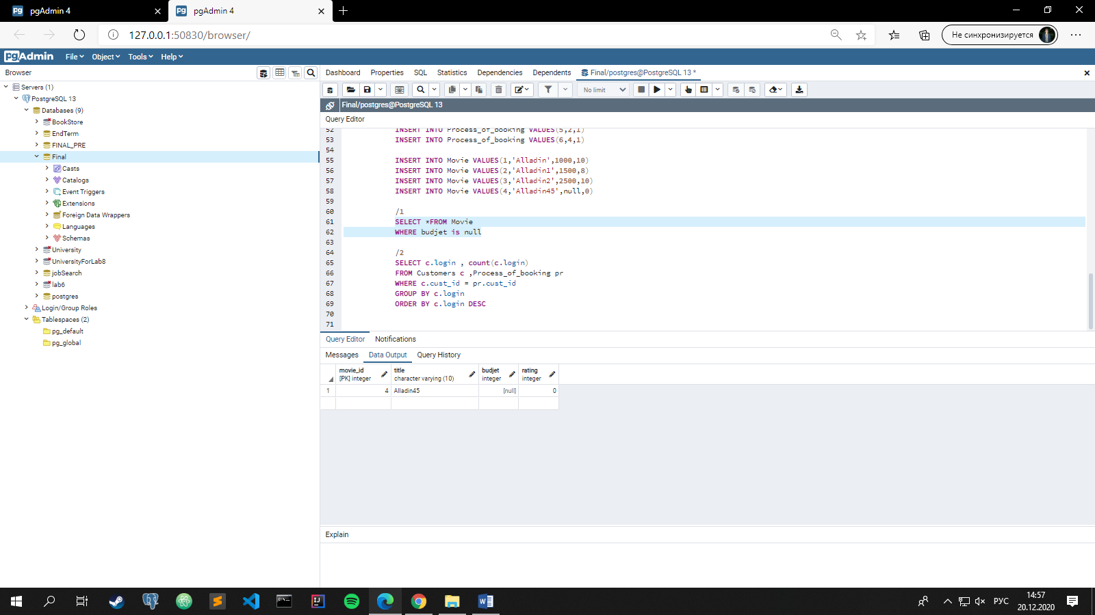

/2

SELECT c.login , count(c.login)

FROM Customers c ,Process_of_booking pr

WHERE c.cust_id = pr.cust_id

GROUP BY c.login

ORDER BY c.login DESC

