**Lab 3:Normalization.**

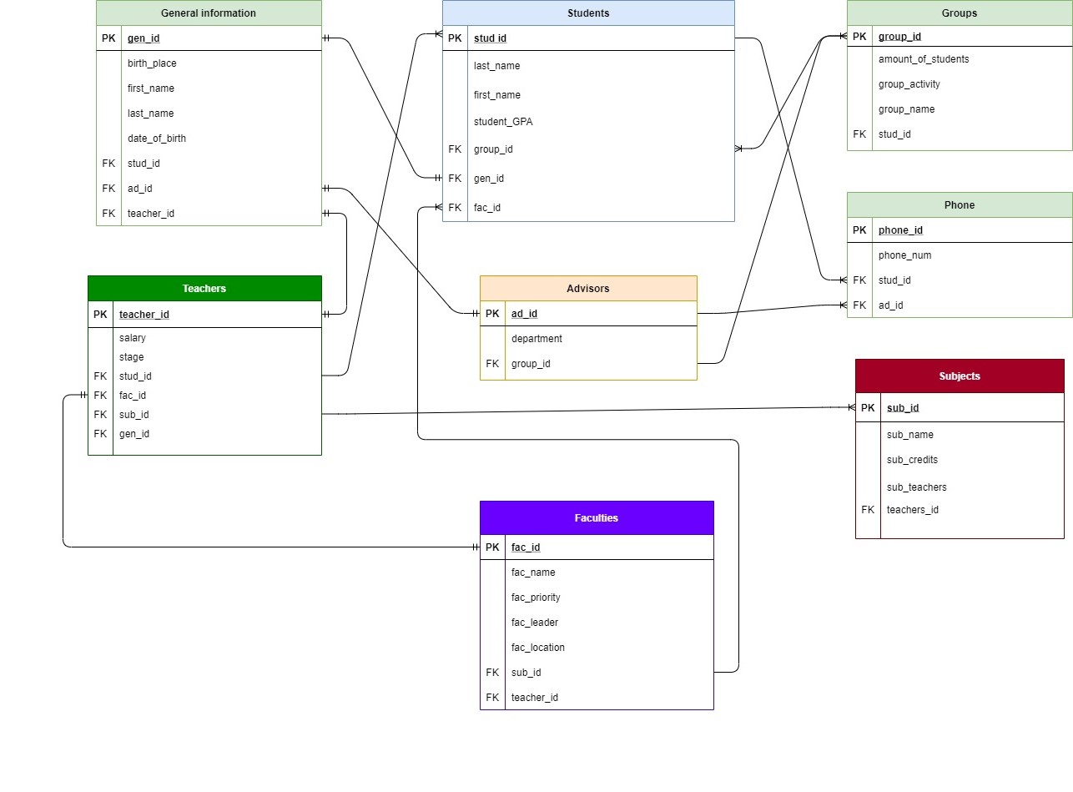

Student entity:

|  |  |  |  |
| --- | --- | --- | --- |
| Field’s content | Field’s name | Type, length | Note(constraints) |
| Student ID | stud_id | N(4) | PK |
| First name | first_name | C(50) | NOT NULL |
| Last name | last_name | C(50) | NOT NULL |
| Student_Gpa | student_GPA | N(2) |  |
| Group number id | group_id | N(5) | FK to Groups |
| General Information id | gen_id | N(5) | FK to General Information |

|  |  |  |  |
| --- | --- | --- | --- |
| Field’s content | Field’s name | Type, length | Note(constraints) |
| Group ID | group_id | N(5) | PK |
| Amount of students | Amount_of_students | C(10) | NOT NULL |
| Group_activity | group_activity | N(10) | NOT NULL |
| Group_name | group_name | N(5) | NOT NULL |
| Student_id | stud_id | N(4) | FK to Students |

Groups entity:

Phone entity:

|  |  |  |  |
| --- | --- | --- | --- |
| Field’s content | Field’s name | Type, length | Note(constraints) |
| Phone id | Phone_id | N(5) | PK |
| Phone number | phone_num | C(50) | NOT NULL |
| Student id | stud_id | N(4) | FK to Students |
| Advisors id | ad_id | N(5) | FK to Advisors |

Advisors entity:

|  |  |  |  |
| --- | --- | --- | --- |
| Field’s content | Field’s name | Type, length | Note(constraints) |
| Advisor ID | add_id | N(5) | PK |
| Department | department | C(50) | NOT NULL |
| Group id | group_id | N(5) | FK to Groups |

General information:

|  |  |  |  |
| --- | --- | --- | --- |
| Field’s content | Field’s name | Type, length | Note(constraints) |
| General ID | gen_id | N(5) | PK |
| Birth place | birth_place | D | NOT NULL |
| First name | first_name | C(50) | NOT NULL |
| Last name | last_name | C(50) | NOT NULL |
| Date of birth | date_of_birth | D | NOT NULL |
| Student id | stud_id | N(4) | FK to Students |
| Advisor id | ad_id | N(5) | FK to Advisors |
| Teacher id | teacher_id | N(5) | FK to Teachers |

Teachers entity:

|  |  |  |  |
| --- | --- | --- | --- |
| Field’s content | Field’s name | Type, length | Note(constraints) |
| Teacher id | teacher_id | N(5) | PK |
| Salary | salary | N(10) | NOT NULL |
| Stage | stage | N(5) | NOT NULL |
| Student id | stud_id | N(4) | FK to Student |
| Faculties ID | fac_id | N(5) | FK to Faculties |
| Subject ID | sub_id | N(5) | FK to Subjects |
| General ID | gen_id | N(5) | FK to General Information |

Faculties entity:

|  |  |  |  |
| --- | --- | --- | --- |
| Field’s content | Field’s name | Type, length | Note(constraints) |
| Faculties ID | fac_id | N(5) | PK |
| Faculties name | fac_name | C(50) | NOT NULL |
| Faculties priority | fac_priority | B | NOT NULL |
| Faculties leader | fac_leader | C(60) | NOT NULL |
| Faculties location | fac_location | C(60) | NOT NULL |
| Subject ID | sub_id | N(5) | FK to Subjects |
| Teacher id | teacher_id | N(5) | FK to Teachers |

Subjects entity:

|  |  |  |  |
| --- | --- | --- | --- |
| Field’s content | Field’s name | Type, length | Note(constraints) |
| Subject id | sub_id | N(5) | PK |
| Subject name | sub_name | C(50) | NOT NULL |
| Subject credits | sub_credits | N(5) | NOT NULL |
| Teachers id | teachers_id | N(5) | FK to Teachers |