//1

SELECT max(teach_id) FROM teachers

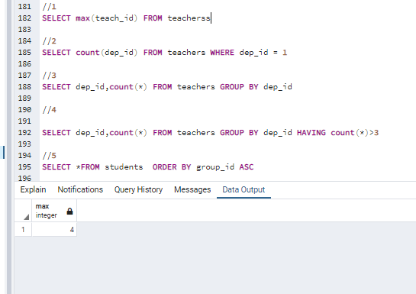

//2

SELECT count(dep_id) FROM teachers WHERE dep_id = 1

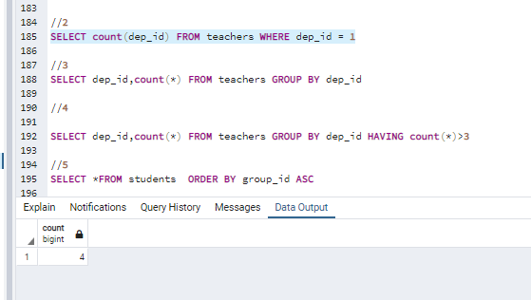

//3

SELECT dep_id,count(*) FROM teachers GROUP BY dep_id

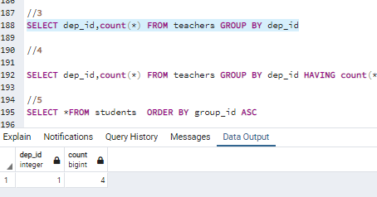

//4

SELECT dep_id,count(*) FROM teachers GROUP BY dep_id HAVING count(*)>3

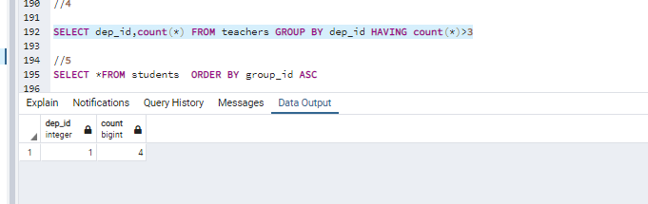

//5

SELECT *FROM students ORDER BY group_id ASC

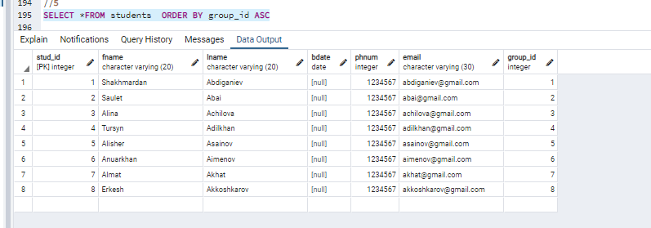

//6

SELECT fname, lname FROM students ORDER BY lname ASC , fname DESC

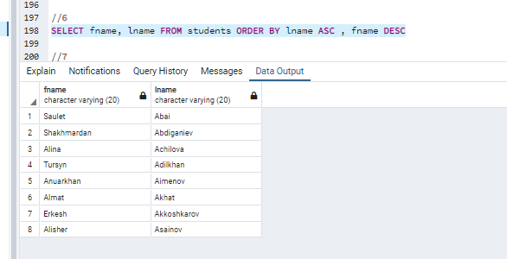

//7

SELECT g.group_name , s.subj_name , sch.room , sch.sch_time , sch.day_of_week , t.lname

FROM schedule sch , groups g , ed_process e , subjects s , teachers t , classes c

WHERE sch.class_id = c.class_id AND sch.teach_id = t.teach_id AND sch.proc_id = e.proc_id

AND e.subj_id = s.subj_id AND e.group_id = g.group_id

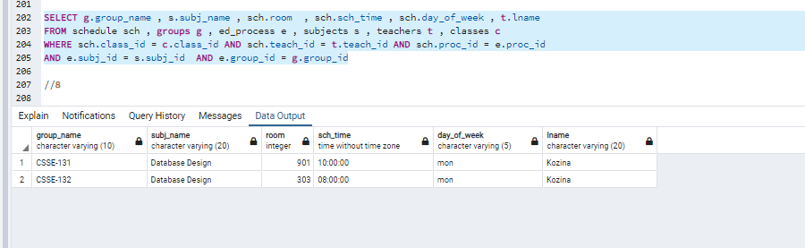

//8

SELECT DISTINCT t.lname || ' ' || t.fname AS full_name , s.subj_name , prog.rk1 , prog.rk2 , prog.rk_avg, prog.exam, prog.final

FROM progress prog, teachers t, subjects s

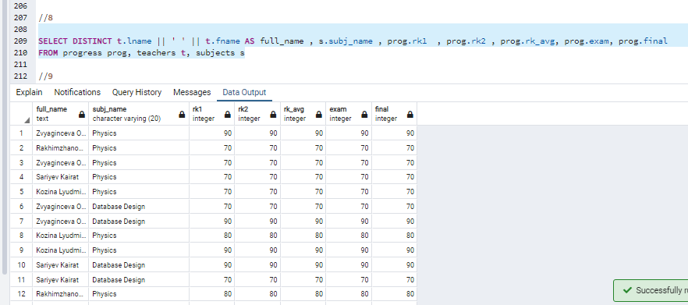

//9

SELECT DISTINCT t.lname || ' ' || t.fname AS full_name , s.subj_name , prog.rk1 , prog.rk2 , prog.rk_avg, prog.exam, prog.final

FROM progress prog, teachers t, subjects s

WHERE prog.final > 74 AND prog.final <101

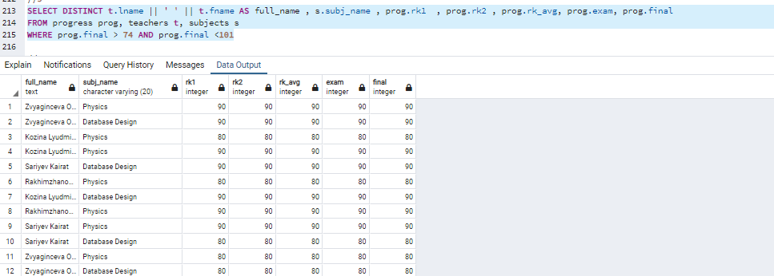

//10

SELECT g.group_name , s.subj_name, avg(prog.final)

FROM ed_process e, groups g , subjects s, progress prog , students st

WHERE e.group_id = g.group_id AND e.subj_id = s.subj_id AND e.proc_id = prog.proc_id AND st.stud_id = prog.stud_id

GROUP BY g.group_name,s.subj_name

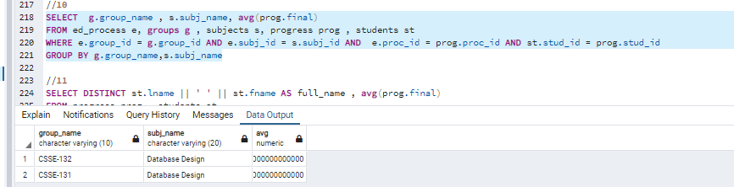

//11

SELECT DISTINCT st.lname || ' ' || st.fname AS full_name , avg(prog.final)

FROM progress prog , students st

WHERE st.stud_id = prog.stud_id

GROUP BY full_name

HAVING avg(prog.final) >= 90

ORDER BY full_name ASC

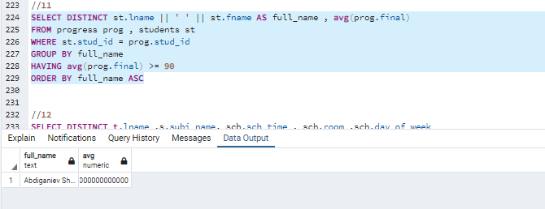

//12

SELECT DISTINCT t.lname ,s.subj_name, sch.sch_time , sch.room ,sch.day_of_week

FROM schedule sch , groups g , ed_process e , subjects s , teachers t , classes c

WHERE sch.class_id = c.class_id AND sch.teach_id = t.teach_id AND sch.proc_id = e.proc_id AND sch.day_of_week = 'mon'

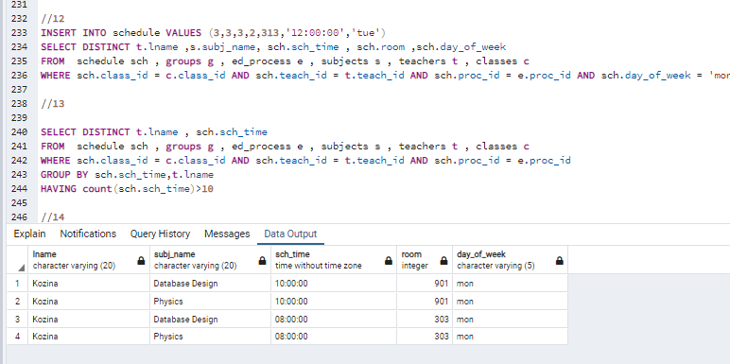

//13

SELECT t.lname , sum(cr.total_hours / 15) AS "TOTAL HOURS"

FROM schedule sch , ed_process e , subjects s , teachers t , credits cr

WHERE sch.teach_id = t.teach_id AND sch.proc_id = e.proc_id AND cr.cred_num = s.cred_num AND s.subj_id = e.subj_id

GROUP BY t.lname

HAVING sum(cr.total_hours / 15) >= 10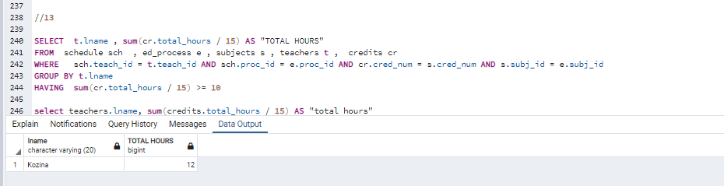

//14

SELECT DISTINCT g.group_name, e.term , sum(s.cred_num)

FROM schedule sch , groups g , ed_process e , subjects s , teachers t , classes c

WHERE g.group_id = e.group_id AND s.subj_id = e.subj_id

GROUP BY g.group_id ,e.term

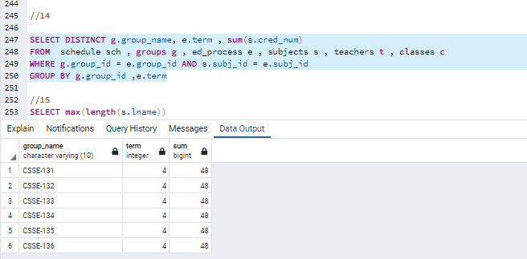

//15

SELECT max(length(s.lname))

FROM students s

