Usiel Figueroa

Module 6.2 Assignment: Movies: Setup

CSD310-A311 Database Development and Use

November 18, 2024

GitHub link: <https://github.com/Usiel-Figueroa/csd-310>

Run Script

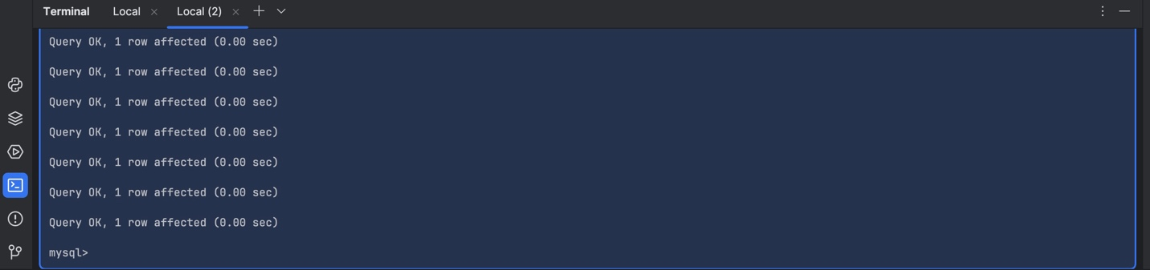

Show Tables

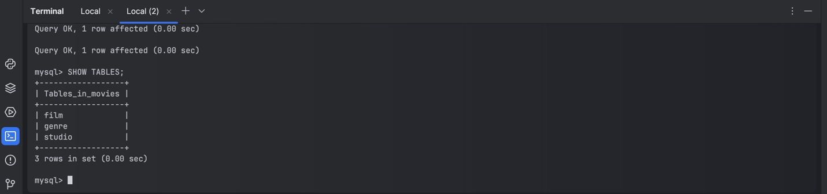

Connection Test Code

