Usiel Figueroa

Module 2.3 Assignment: Data Models

CSD310-A311 Database Development and Use

October 28, 2024

**ERD Graphic**

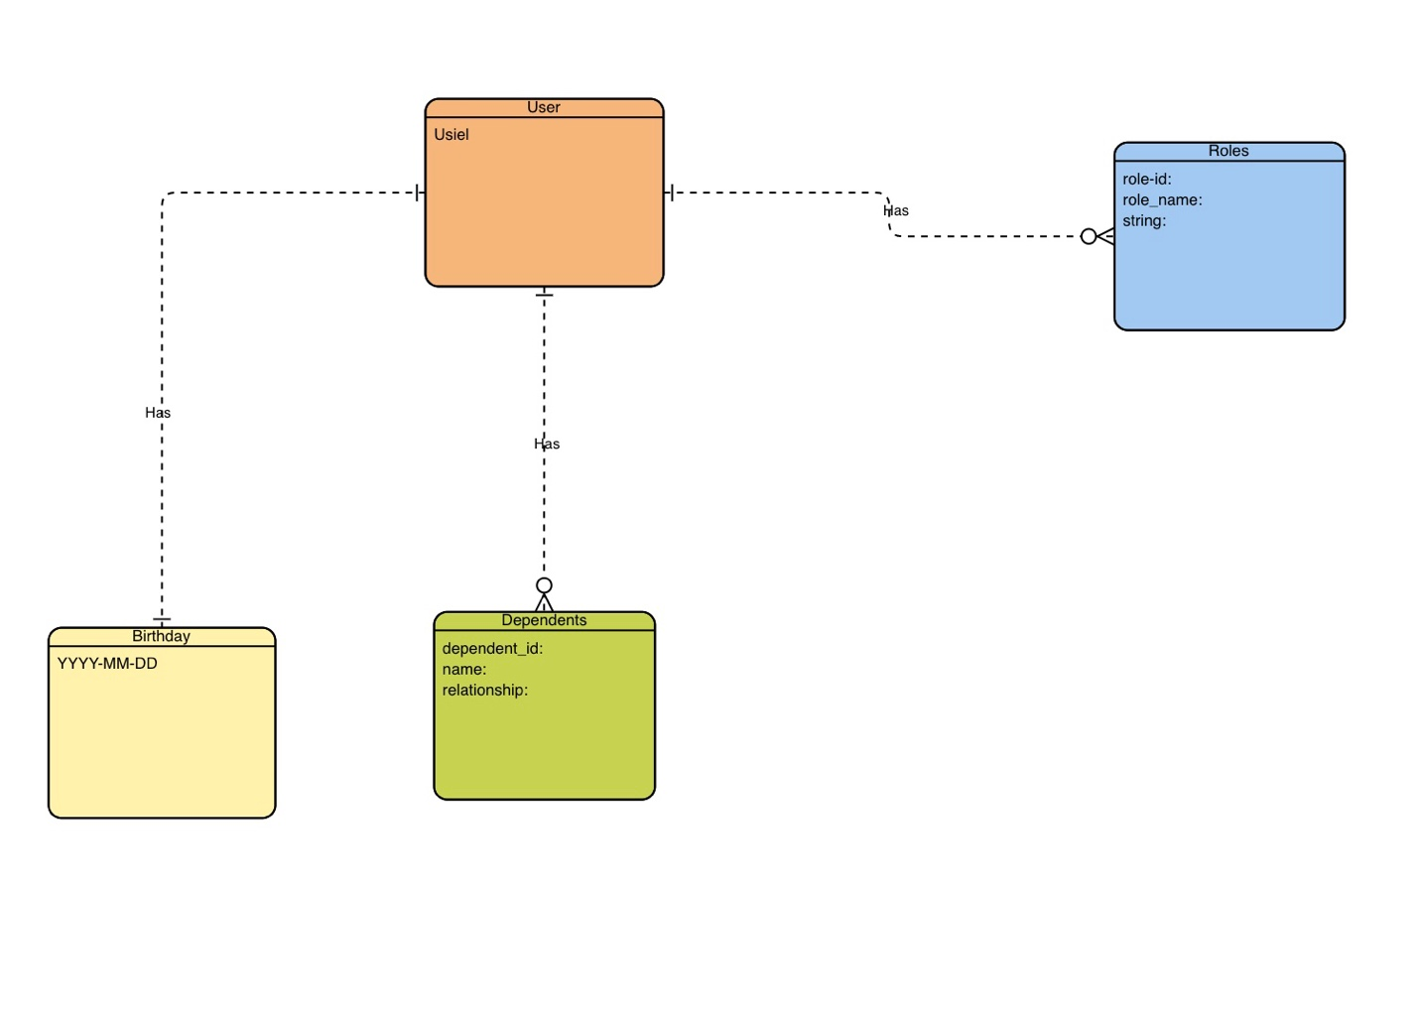

**NoSQL Data**

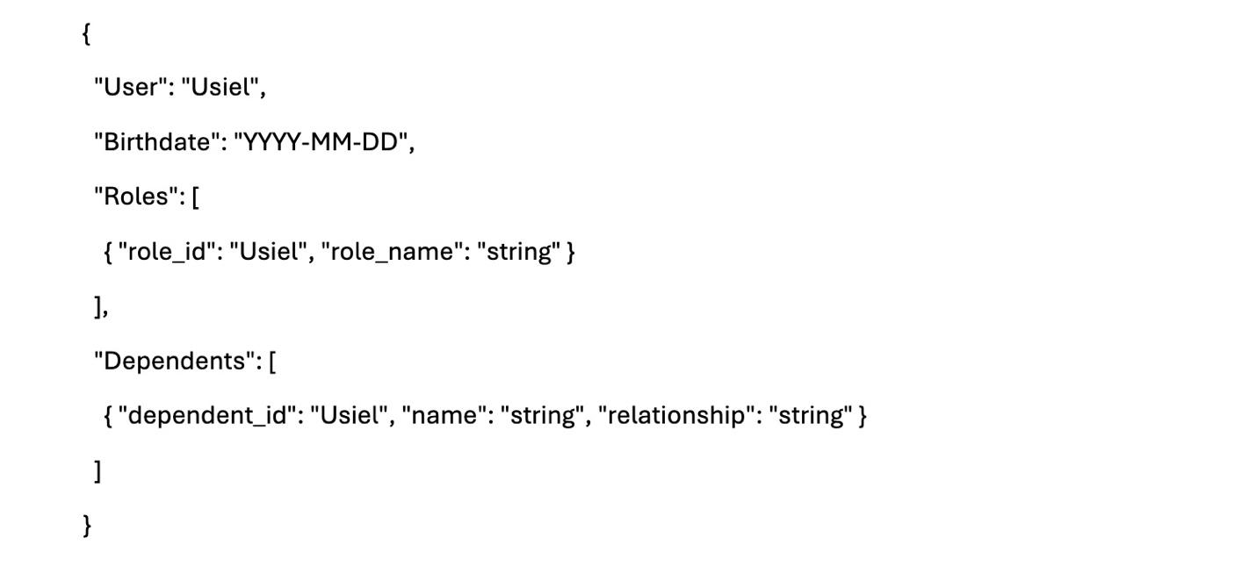

**Reference**

(n.d.). *Online ERD Tool*. Visual Paradigm. Retrieved October 26, 2024, from <https://online.visual-paradigm.com/diagrams/features/erd-tool/>