Usiel Figueroa

Module 3.2 Assignment: Normalized Tables

CSD310-A311 Database Development and Use

November 4, 2024

**Assignment Data Fields:**

|  |  |  |  |
| --- | --- | --- | --- |
| publisher_ | publisher_ID | publisher_address | book_isbn |
| book_name | book_price | author_first_name | author_last_name |
| author_phone | author_email | publisher_email | author_address |

**3NF (Third Normal Form)**

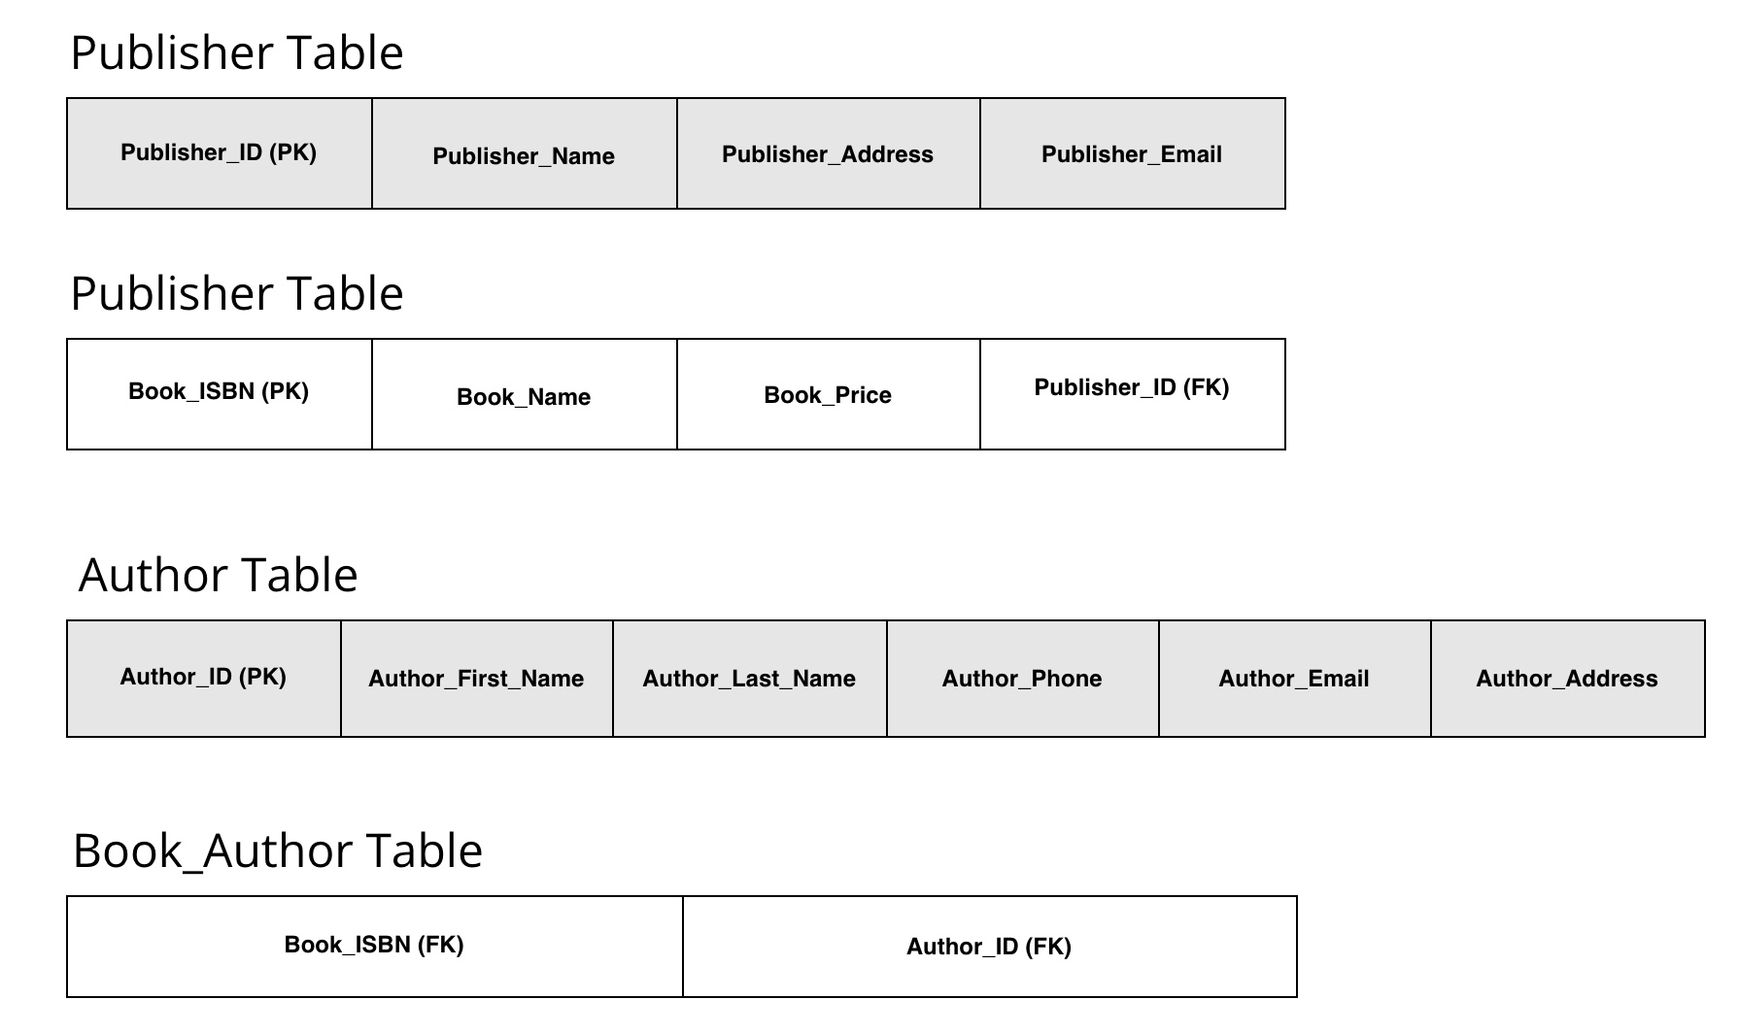

In 1NF, I organize data, so each field contains atomic values, with no repeating groups.

In 2NF, I eliminate partial dependencies, so fields depend only on the primary key.

In 3NF, I remove transitive dependencies, where non-key attributes depend only on primary keys.

**Assumptions**

Books have multiple authors – hence the need for a Book_Author relationship table.

Publishers can have multiple books, while each book is linked to one publisher, leading to a Publisher_ID foreign key in the Book table.

**Reference**

[Learn Learn Scratch Tutorials]. (2020, February 25). 1st, 2nd and 3rd Normal Form (Database Normalisation) [Video]. YouTube. <https://www.youtube.com/watch?v=J-drts33N8g>