Usiel Figueroa

Module 4.2 Assignment: MySQL Install

CSD310-A311 Database Development and Use

November 11, 2024

**Initial Database Connection**

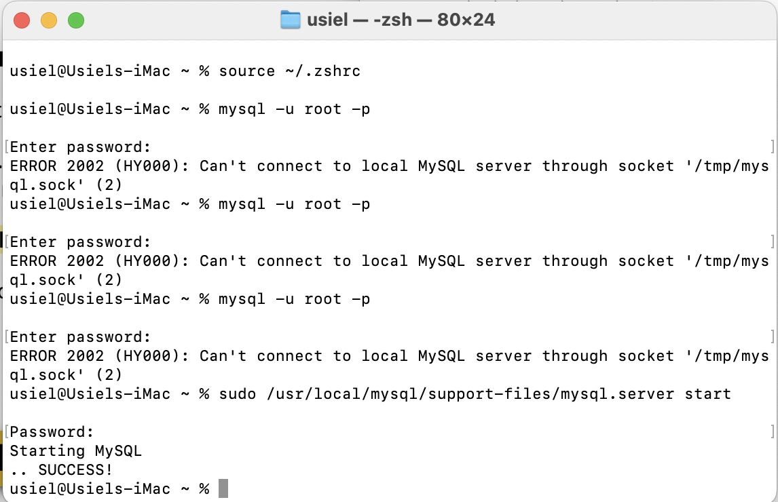

**Show Database**

