Usiel Figueroa

Module 5.2 Assignment: MySQL Functions

CSD310-A311 Database Development and Use

November 6, 2024

**MySQL Functions**

### **1. AVG() - Average**

* **Use**: The AVG() function calculates the average value of a numeric column. It can be used when you need to calculate the average of a set of values, such as average sales, average score, or average price.
* **SQL Screenshot**:

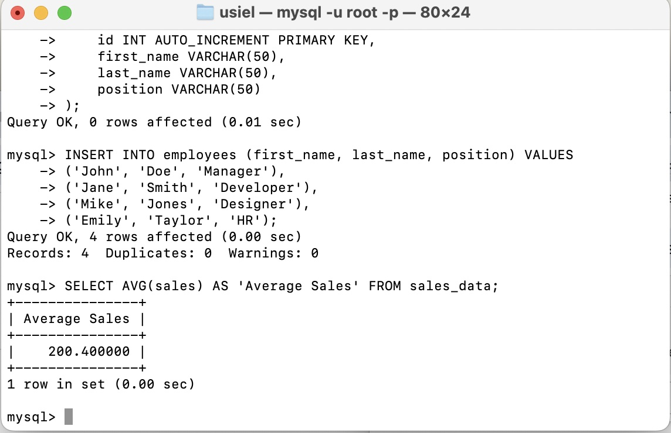

SELECT AVG(sales) AS 'Average Sales' FROM sales_data;

* **Explanation**: In this case, AVG(sales) will calculate the average of the values in the sales column, and the result will be displayed with the column header Average Sales.

### **2. COUNT() - Count of Records**

* **Use**: The COUNT() function returns the number of rows in a table or the number of non-NULL values in a column. It’s useful when you want to know how many records exist, for example, counting how many customers made a purchase in a month.
* **SQL Screenshot**:

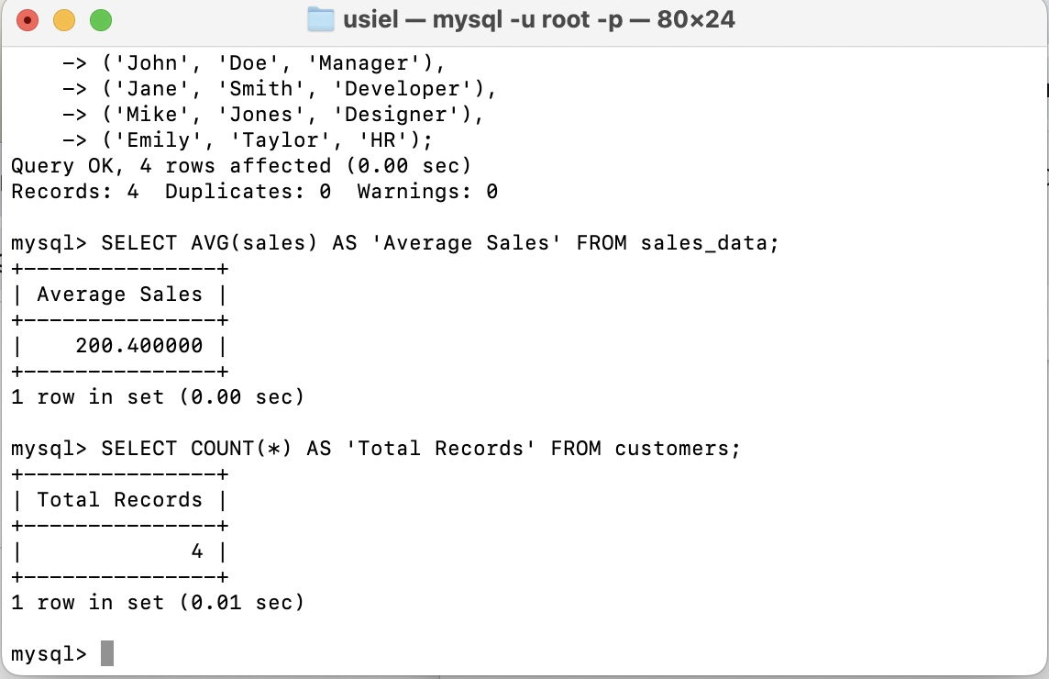

SELECT COUNT(*) AS 'Total Records' FROM customers;

* **Explanation**: Here, COUNT(*) counts all the rows in the customers table, and the result will be displayed with the column header Total Records.

### **3. CONCAT() - Concatenate Strings**

* **Use**: The CONCAT() function is used to combine multiple string values into one. It’s helpful when you want to combine first name and last name into a full name or merge other string data.
* **SQL Screenshot**:

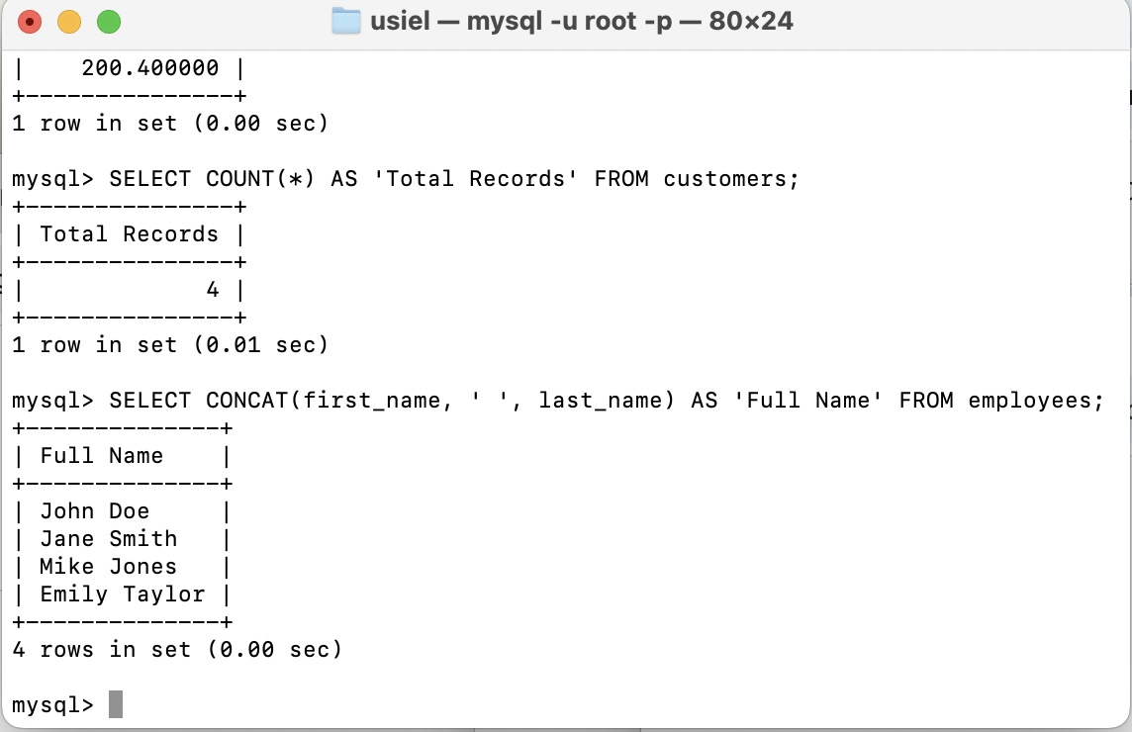

SELECT CONCAT(first_name, ' ', last_name) AS 'Full Name' FROM employees;

* **Explanation**: This will concatenate the first_name and last_name columns, adding a space between them, and display the result under the alias Full Name.

**Reference**

(n.d.). *MySQL Aliases*. W3schools. Retrieved November 7, 2024, from <https://www.w3schools.com/mysql/mysql_alias.asp>

(n.d.). *MySQL Functions*. W3schools. Retrieved November 7, 2024, from <https://www.w3schools.com/sql/sql_ref_mysql.asp>