Usiel Figueroa

Module 5.3 Assignment: Movies!

CSD310-A311 Database Development and Use

November 8, 2024

**ERD**

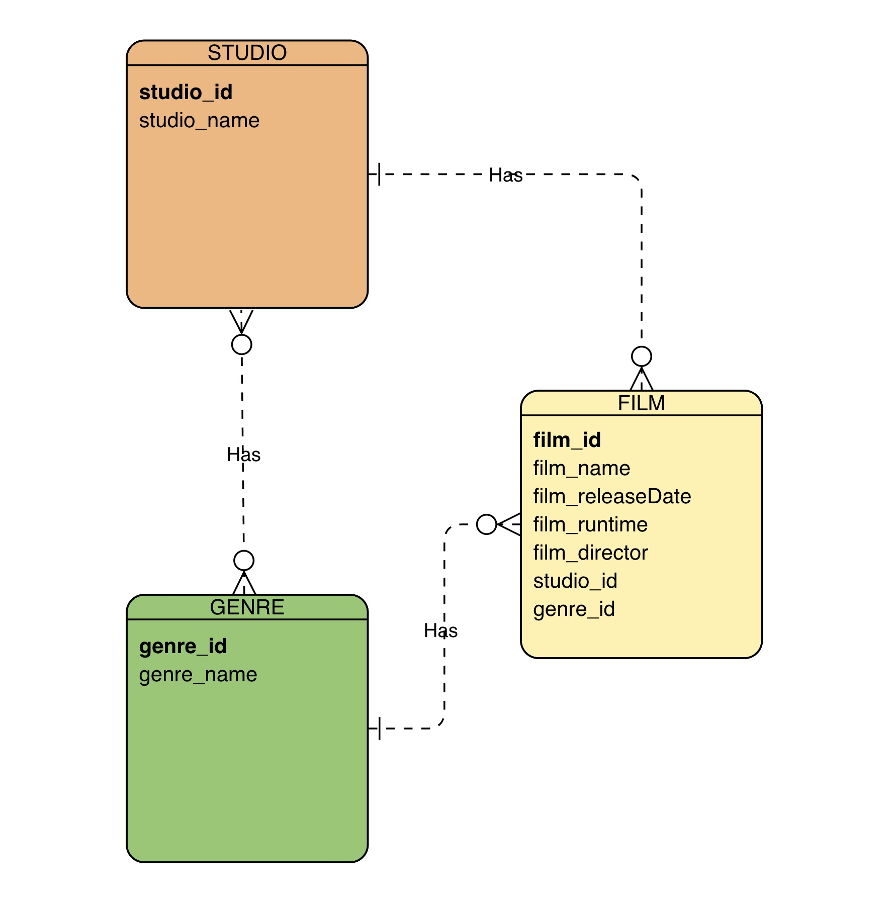

**Source: https://online.visual-paradigm.com/diagrams/features/erd-tool/**

**References**

(n.d.). *MySQL Aliases*. W3schools. Retrieved November 7, 2024, from <https://www.w3schools.com/mysql/mysql_alias.asp>

(n.d.). *MySQL Functions*. W3schools. Retrieved November 7, 2024, from <https://www.w3schools.com/sql/sql_ref_mysql.asp>