Usiel Figueroa

Module 10.2 Assignment: GUI ToDo

CSD325-A311 Advanced Python

December 03, 2024

**Listing 2.2 Our Scrolling To-Do**

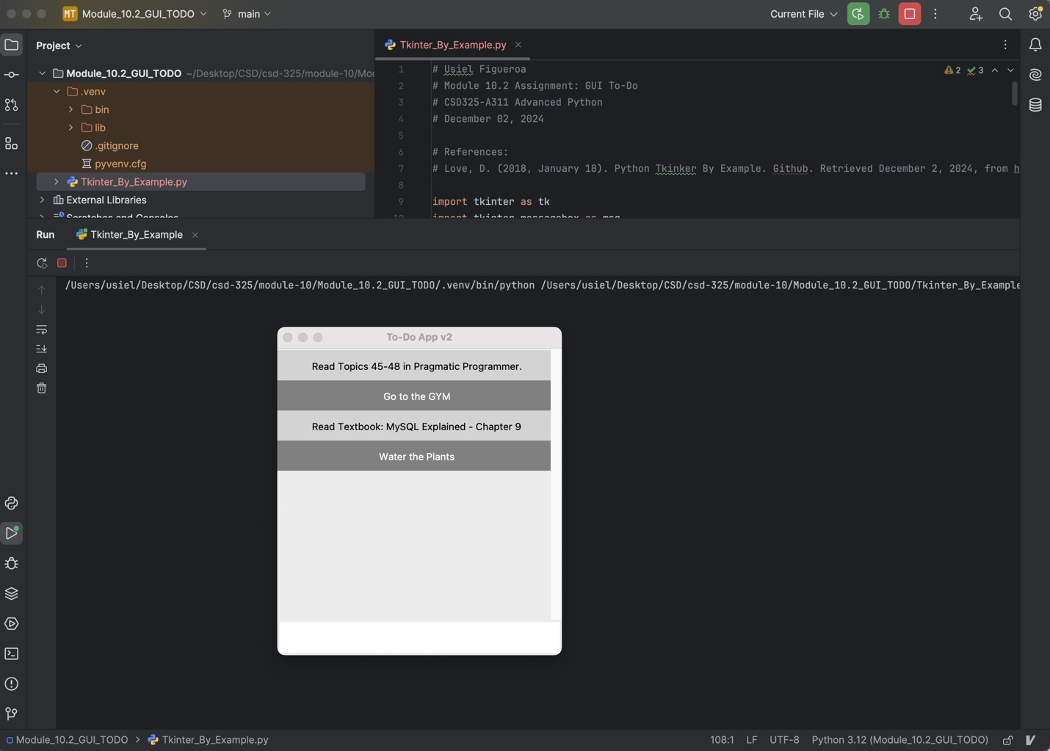

**Figueroa To Do’s**

Screenshot of Figueroa Tasks

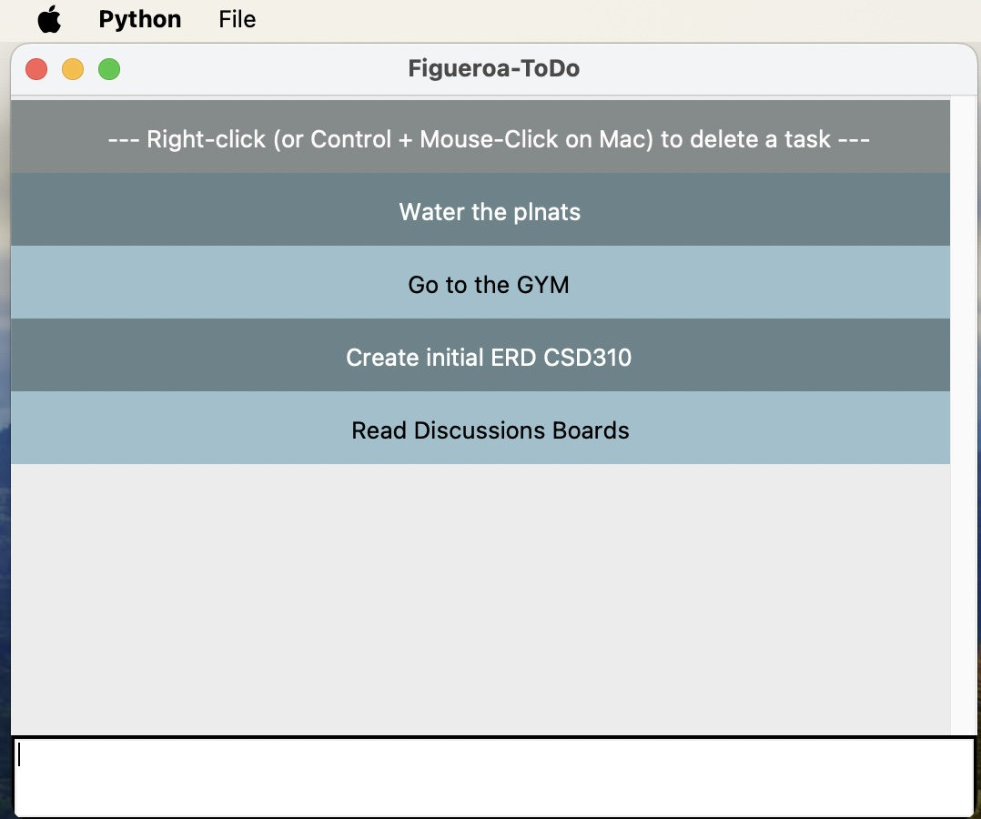

Screenshot of delete a task

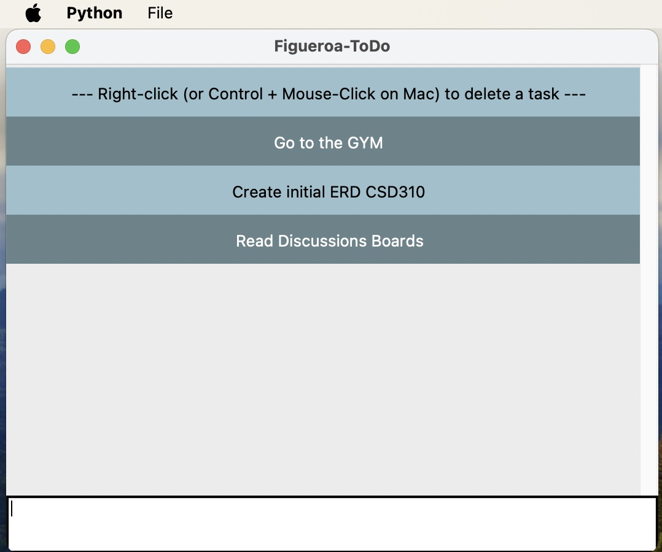

**References**

Love, D. (2018, January 18). Python Tkinker By Example. Github. Retrieved December 2, 2024, from <https://github.com/Dvlv/Tkinter-By-Example/blob/master/Tkinter-By-Example.pdf>

(n.d.). Tkinter color chart. Cs111.Wellesley.edu. Retrieved December 2, 2024, from https://cs111.wellesley.edu/archive/cs111_fall14/public_html/labs/lab12/tkintercolor.html

(2023, September 13). Python Tkinter menu example - Create menu options. W3resource. Retrieved December 2, 2024, from https://www.w3resource.com/python-exercises/tkinter/python-tkinter-events-and-event-handling-exercise-11.php