Usiel Figueroa

Module 11.2 Assignment: Django Basics

CSD325-A311 Advanced Python

December 07, 2024

**Screenshot of the page the install worked successfully**

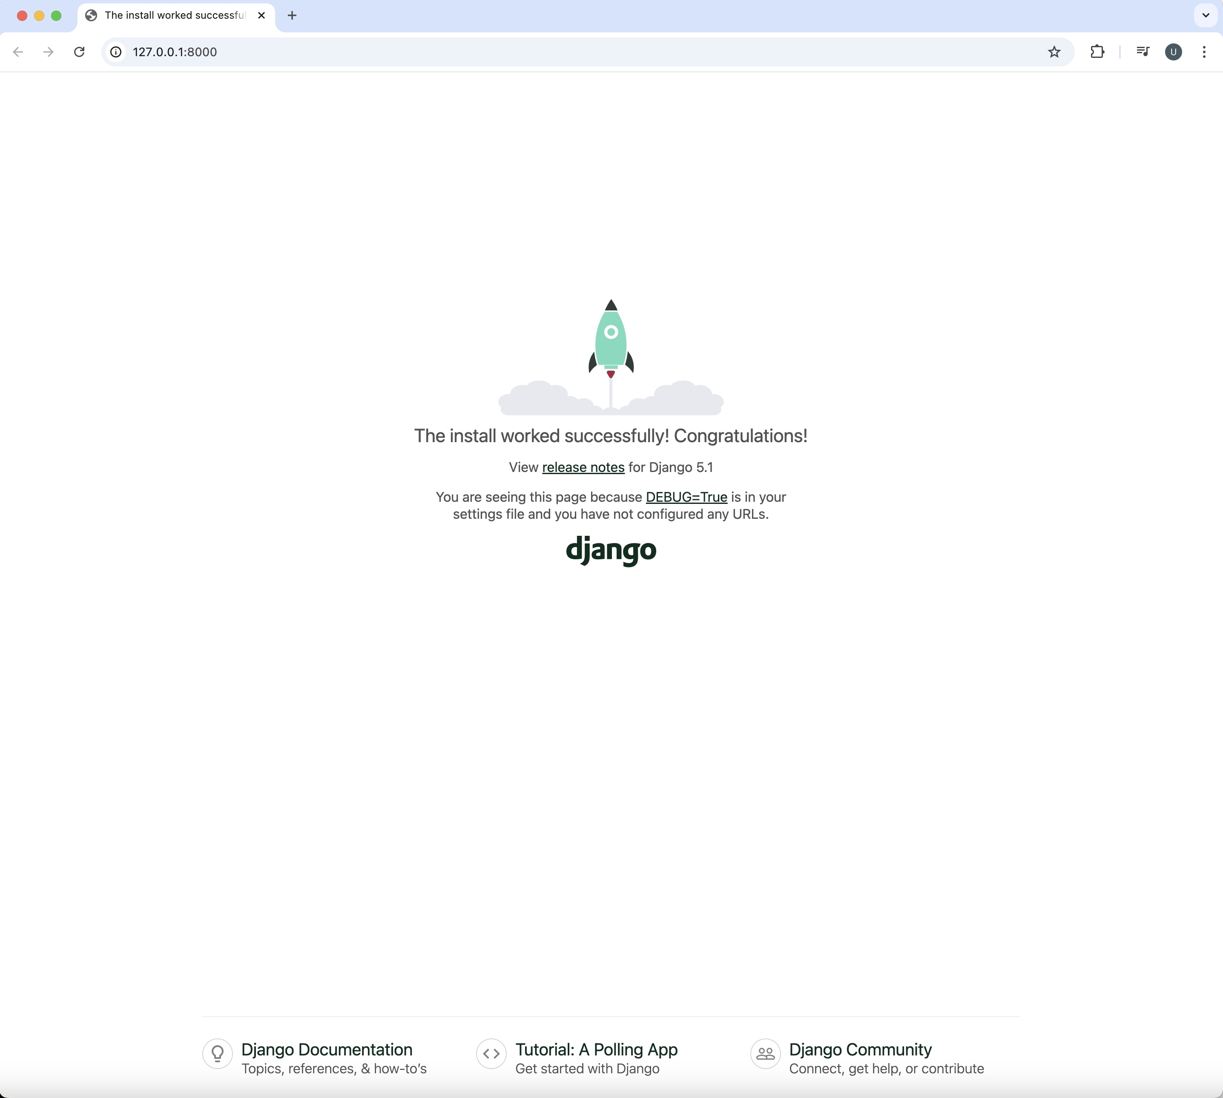

**Figueroa says Hello! Screenshot**

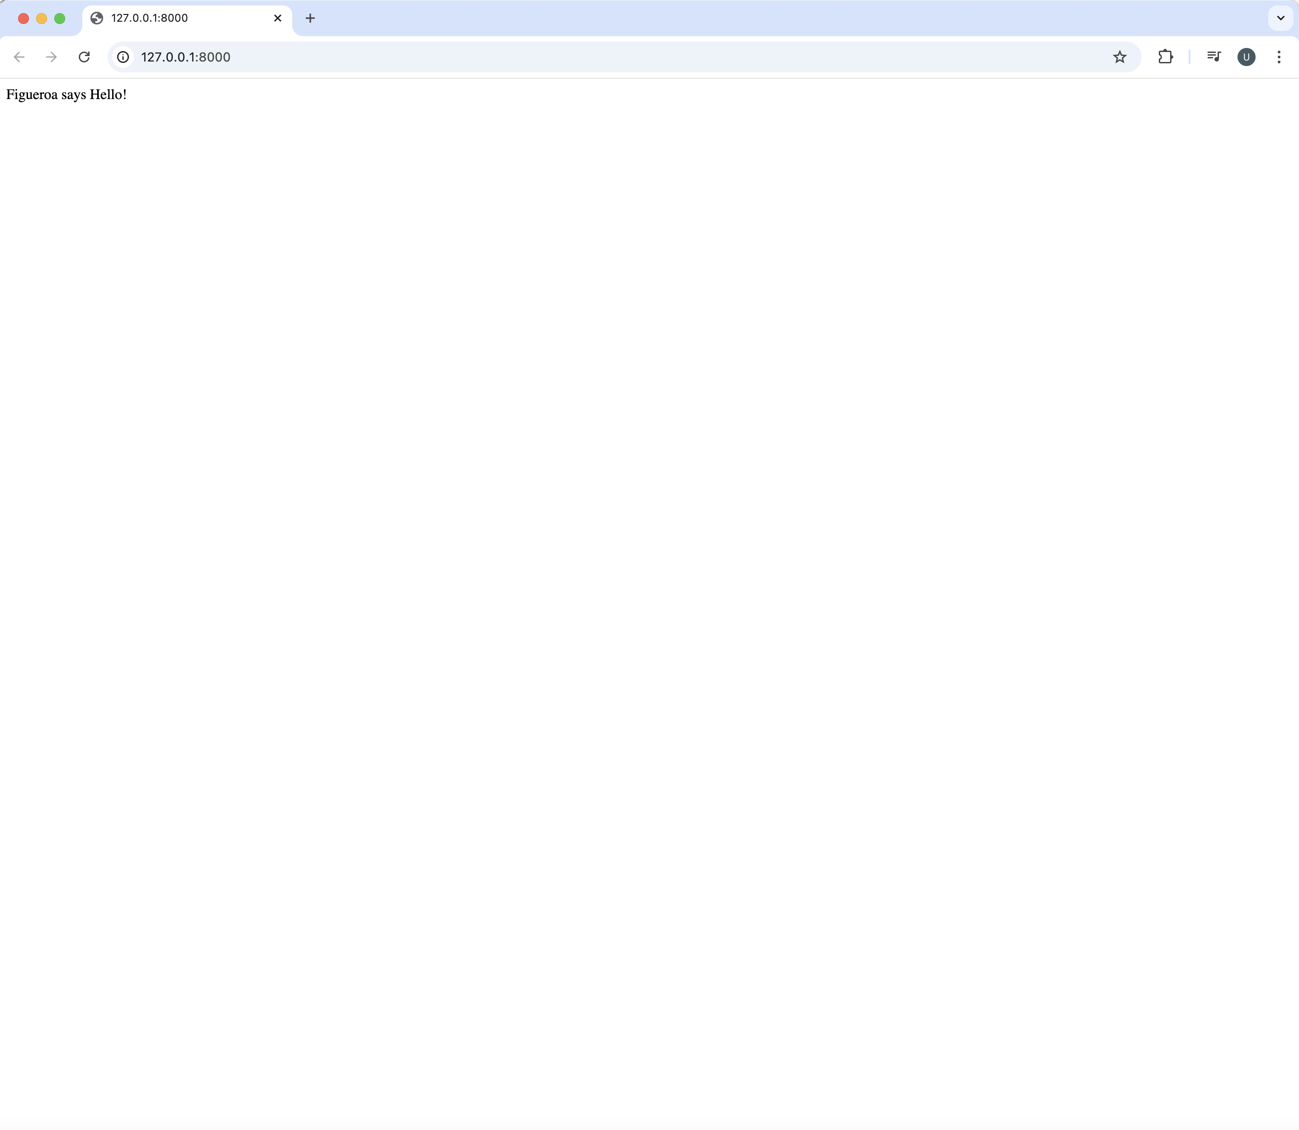

**References**

[Tech With Tim]. (2023, July 29). Learn Django in 20 Minutes!! [Video]. YouTube. <https://www.youtube.com/watch?v=nGIg40xs9e4>

[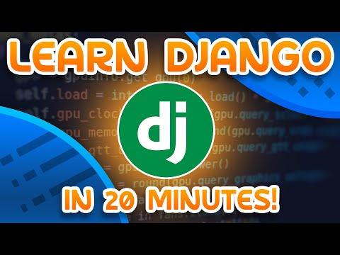](https://www.youtube.com/watch?v=nGIg40xs9e4)

(n.d.). Django Introduction. W3Schools.com. Retrieved December 7, 2024, from https://www.w3schools.com/django/django_intro.php