Usiel Figueroa

December 15, 2024

Module 12.2 Assignment: Redo Assignment: Module 1.3 Assignment: On the Wall + Flowchart(s)

CSD325 Advanced Python

Hello Professor, I hope you are doing great. Thank you for the opportunity to redo an assignment. I will be redoing the Module 1.3 flowchart. This was one of the only assignments I had five points deducted because I did not show iteration in the countdown of the beer bottles on the flowchart. Thank you.

Original Flowchart:

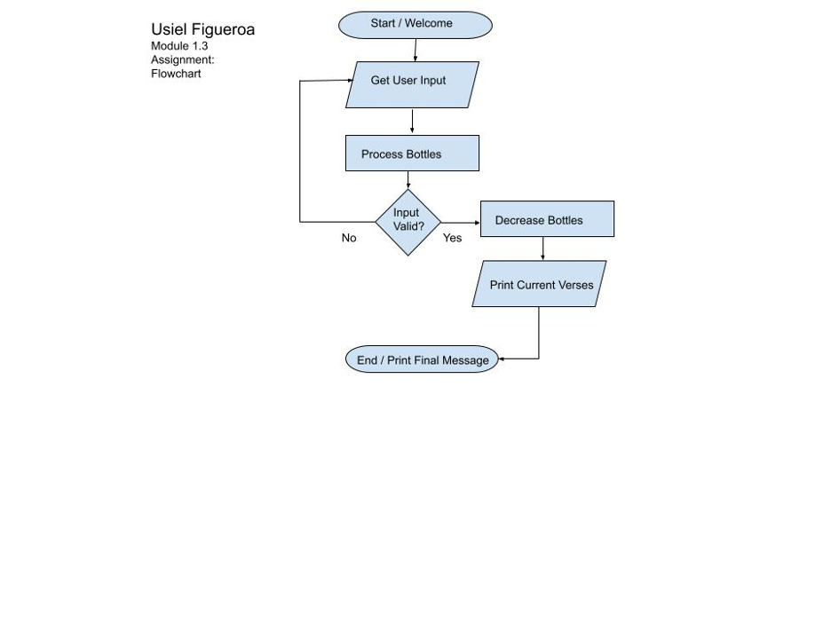

Redo Flowchart

