Usiel Figueroa

October 22, 2024

Module 2.2 Assignment: Documenting Debugging

CSD325 Advanced Python

Original Code

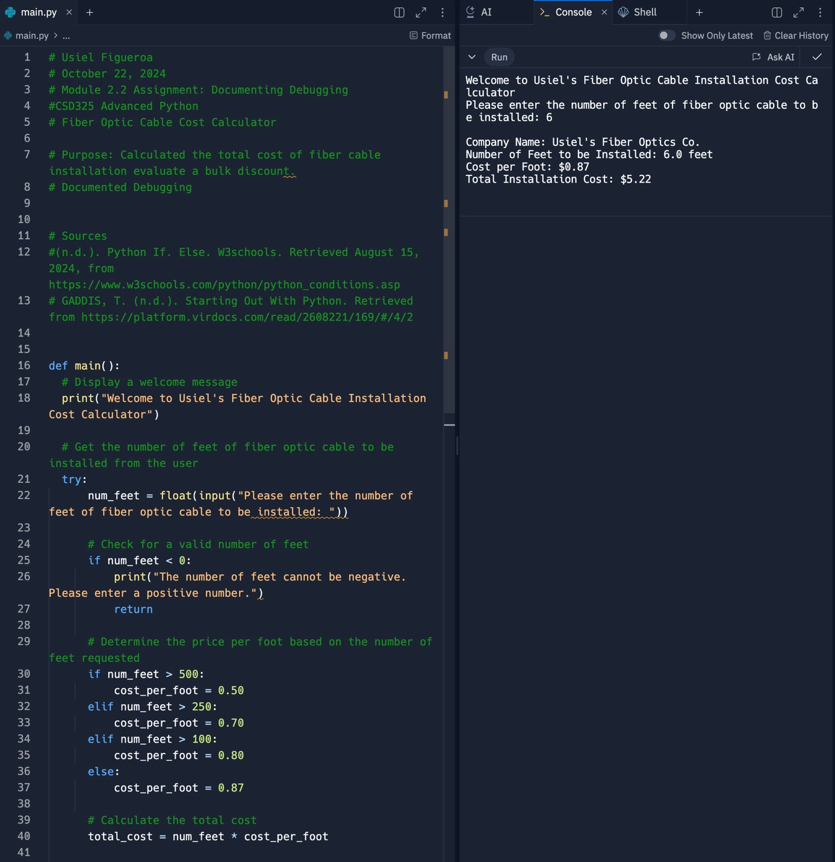

Break Point process

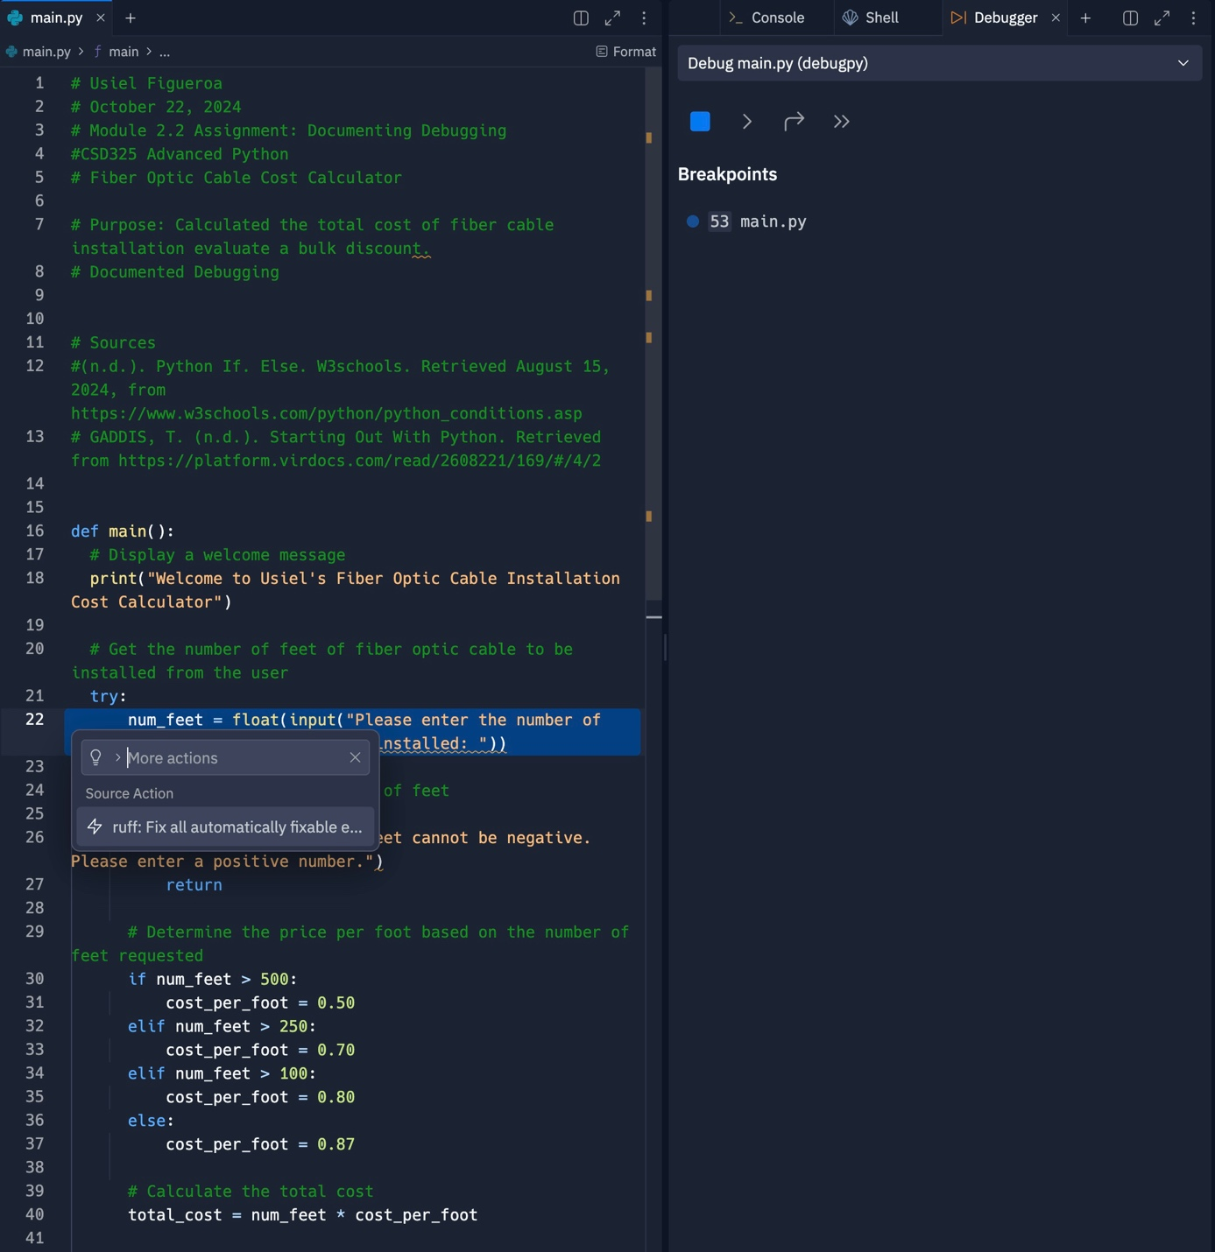

Step into the function

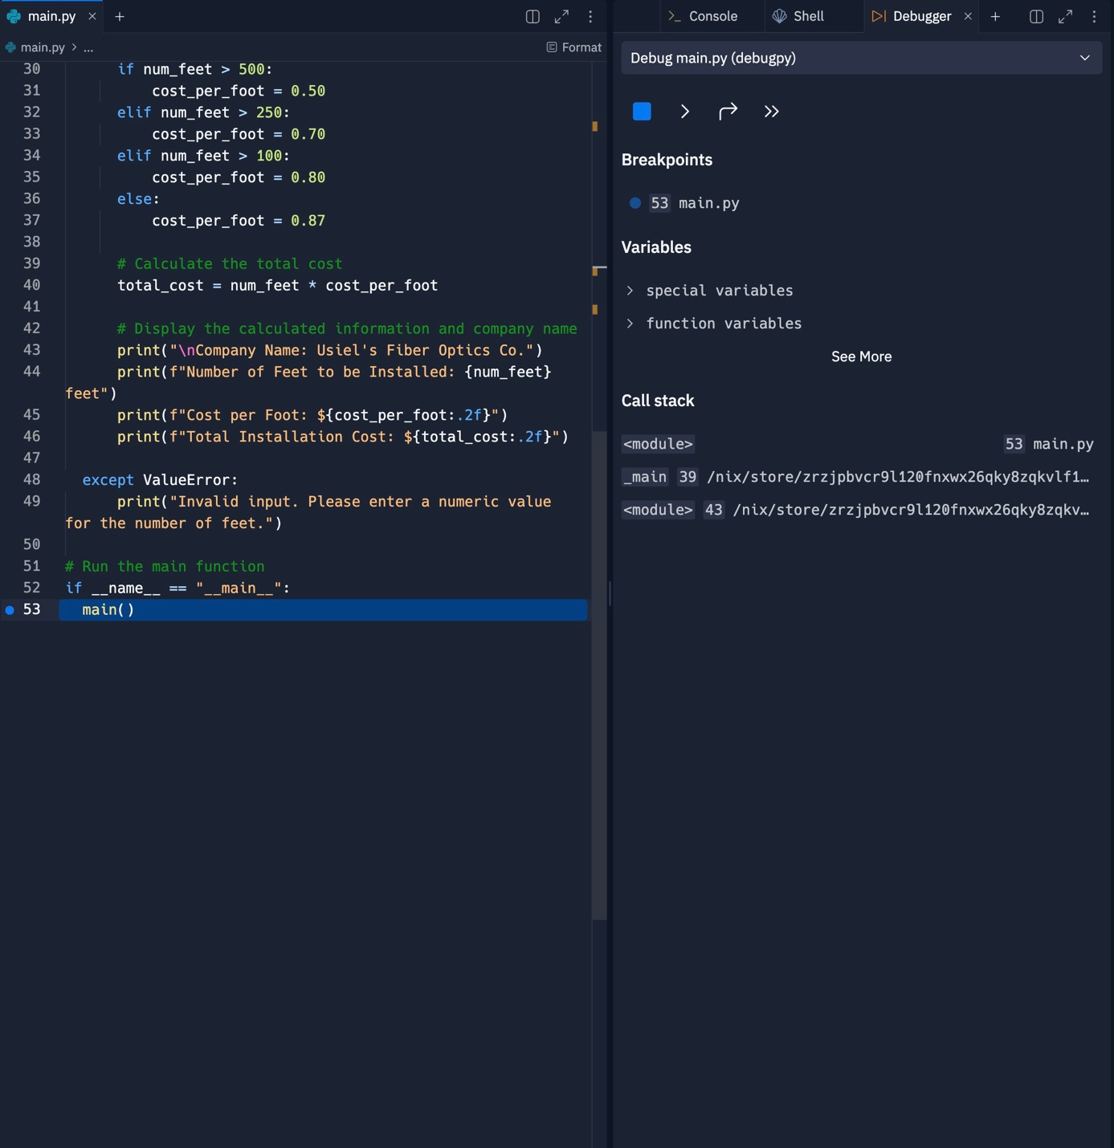

Adding Errors

Indentation Error

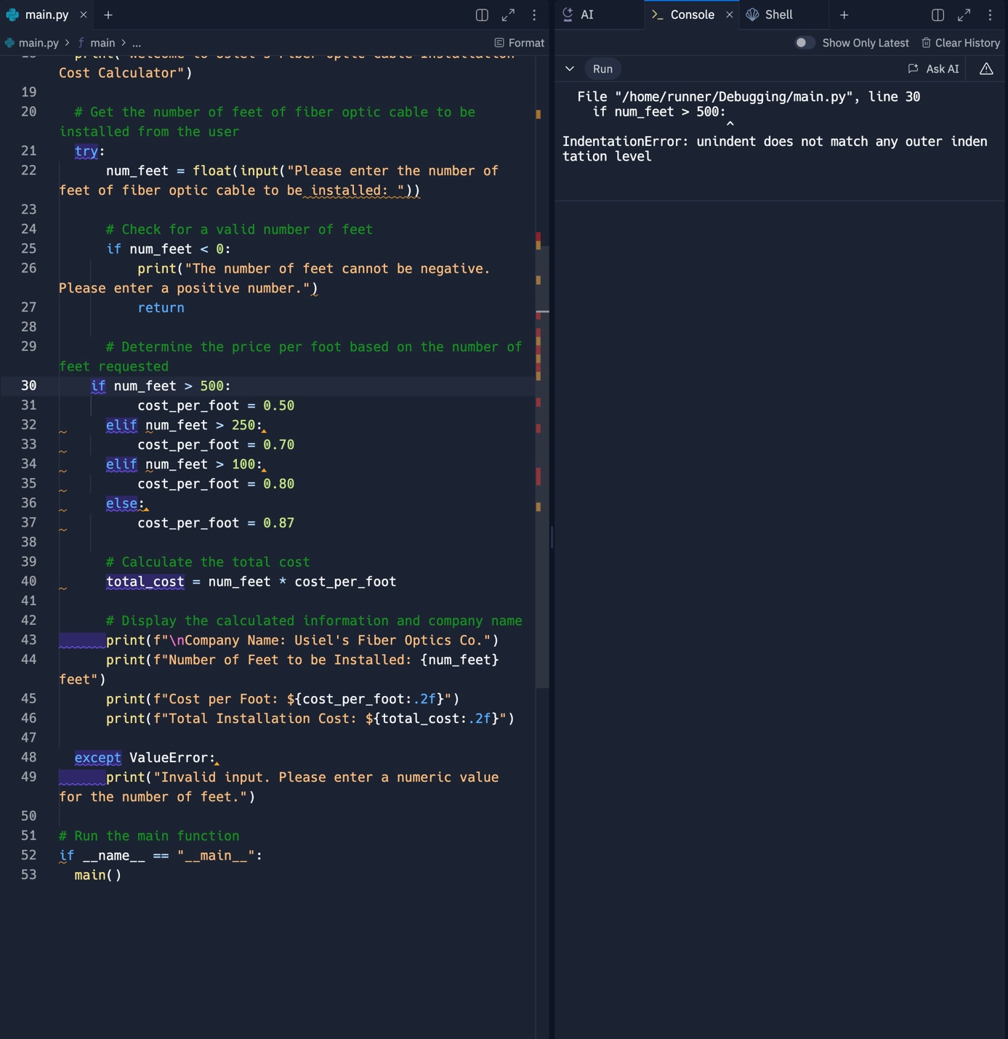

Syntax Error

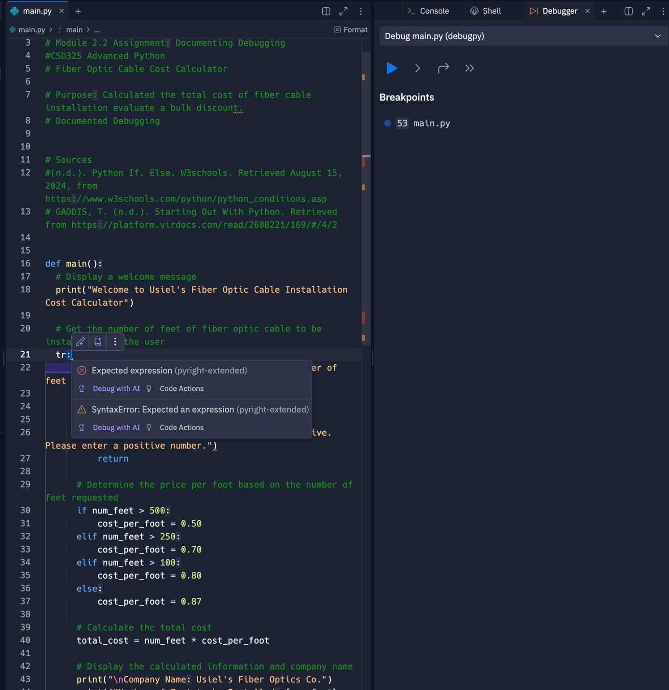

References

[Profsuesam]. (2024, February 19). *Debug* [Video]. YouTube. https://www.youtube.com/watch?v=2sS5xIZeF5k

Abiola, O. (2017, July 10). *Debugging in Python*. Codementor. Retrieved October 22, 2024, from <https://www.codementor.io/@gbozee/debugging-in-python-9ia7lof32>