Usiel Figueroa

Module 4.2 Assignment: High/Low Temperatures

CSD325-A311 Advanced Python

November 6, 2024

**Flowchart**

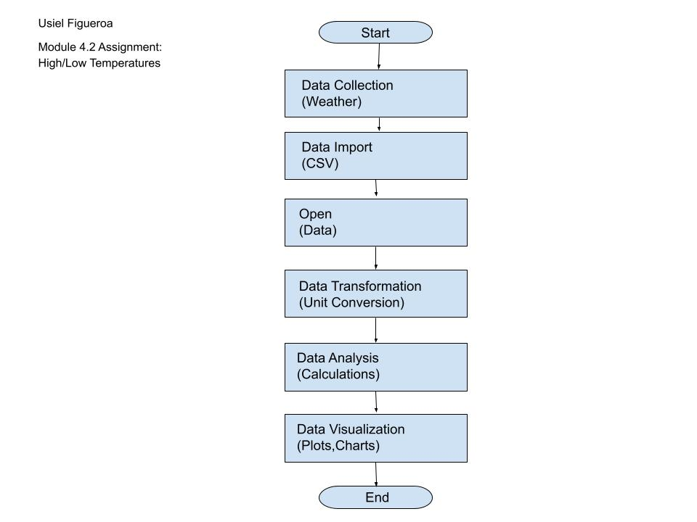

**Flowchart Revised**

