Usiel Figueroa

November 11, 2024

Module 5.2 Assignment: Forest Fire Simulation: Flowchart

CSD325 Advanced Python

**Green Team Flowchart**

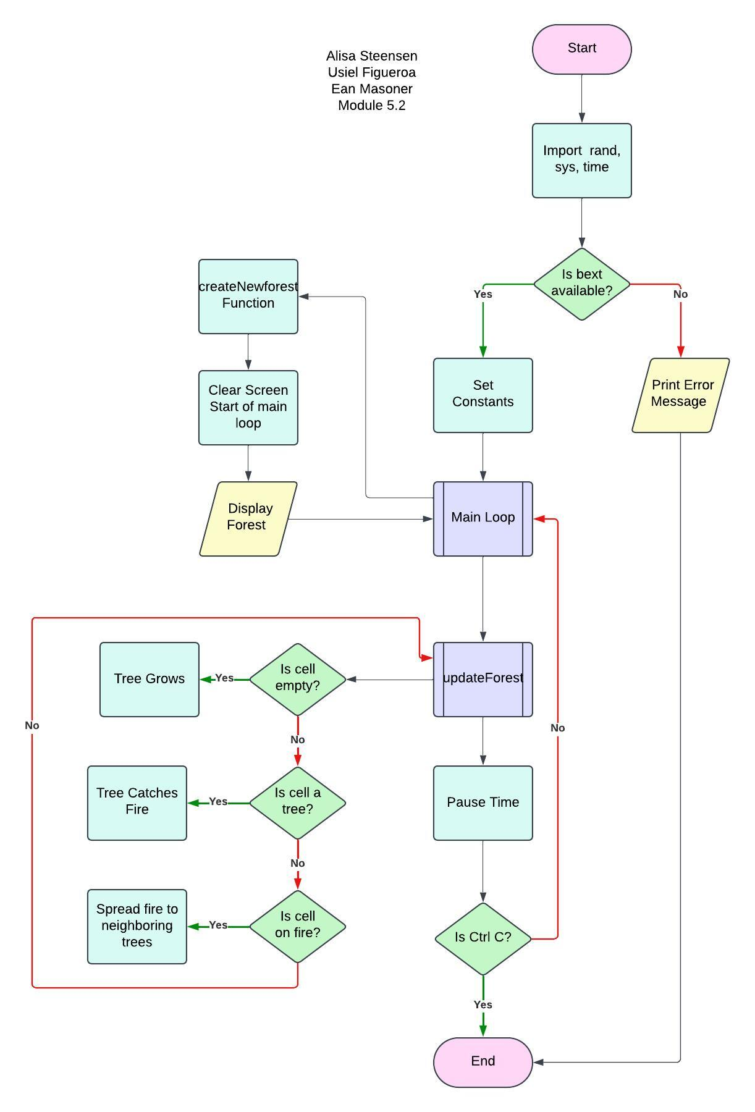

**Alternative**

**Additional step: Rules of pixels.**

Simulating environments with pixels (such as forests or ecosystems), each pixel can represented a state, like "tree," "fire," or "empty."

1. Initial Population Rules

Random Placement: Each pixel might randomly start as a "tree," "fire," or "empty," based on predefined probabilities.

Growth Rate: Some simulations allow a growth rate for trees, where a certain percentage of empty pixels are randomly assigned as trees.

2. Interaction Rules

Fire Spread: If a pixel is "fire," it can ignite neighboring "tree" pixels. The rules might specify that fire spreads to adjacent or nearby pixels.

Burnout: Fire pixels may change to "empty" after a certain time, indicating the fire has burned out in that spot.

3. External Influence Rules

Lightning Chance: There might be a chance that a random pixel catches fire due to a "lightning strike," which ignites a tree pixel even if it's not near any fire.

Environmental Factors: You could include factors like wind or moisture, affecting how quickly fire spreads.

4. Iteration and State Updates

In each cycle (or "time step"), every pixel’s state is updated based on these rules.

For example, a tree pixel might turn to fire if it's next to a fire pixel, and after one time step as fire, it might turn to empty.

The different random placements and parameters (like growth and lightning rates) will lead to varied results each time the program runs.

**Reference**

[Profsuesam]. (2024, January 18). *Mod5 cartesian* [Video]. YouTube. <https://www.youtube.com/watch?v=x4QJM230tKw>